Additional file 5
Orthopedic procedures under general anaesthesia compared to general anaesthesia combined with local regional technique, 48 to 72 hours postoperative
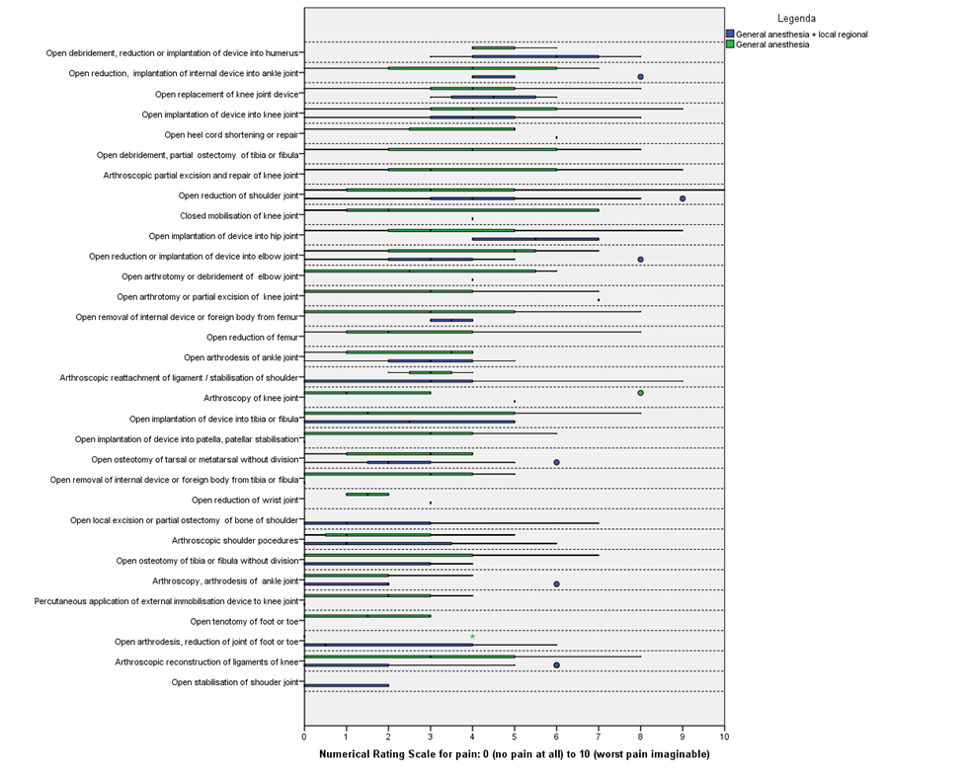
*procedures are sorted from highest to lowest median NRS

