Additional file 6
Orthopedic procedures under spinal anaesthesia compared to spinal anaesthesia combined with local regional technique, 3 to 24 hours postoperative
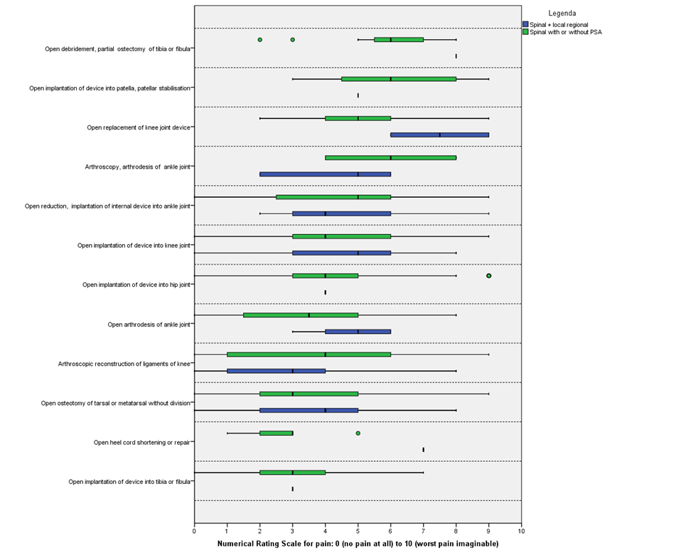
*procedures are sorted from highest to lowest median NRS

