Additional file 4
Orthopedic procedures under general anaesthesia compared to general anaesthesia combined with local regional technique, 24 to 48 hours postoperative
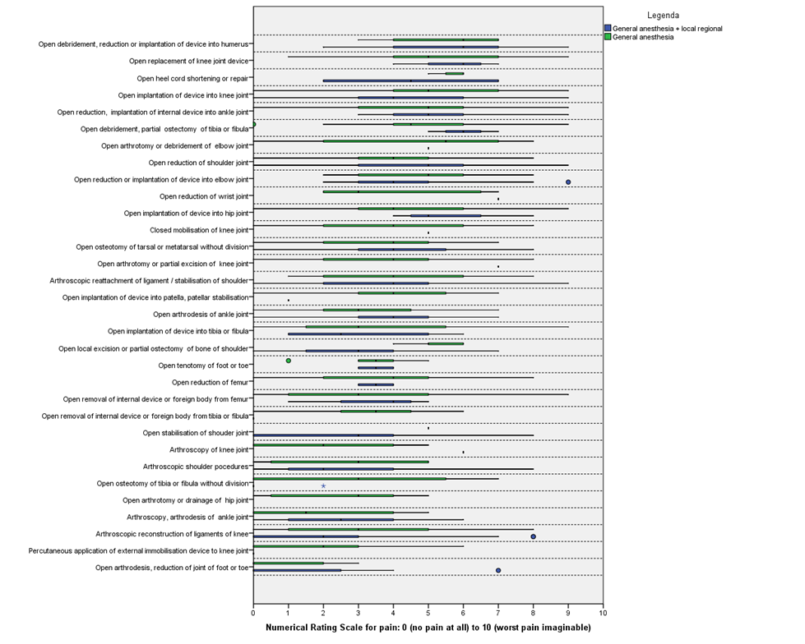
*procedures are sorted from highest to lowest median NRS

