Additional file 8
Orthopedic procedures under spinal anaesthesia compared to spinal anaesthesia combined with local regional technique, 48 to 72 hours postoperative
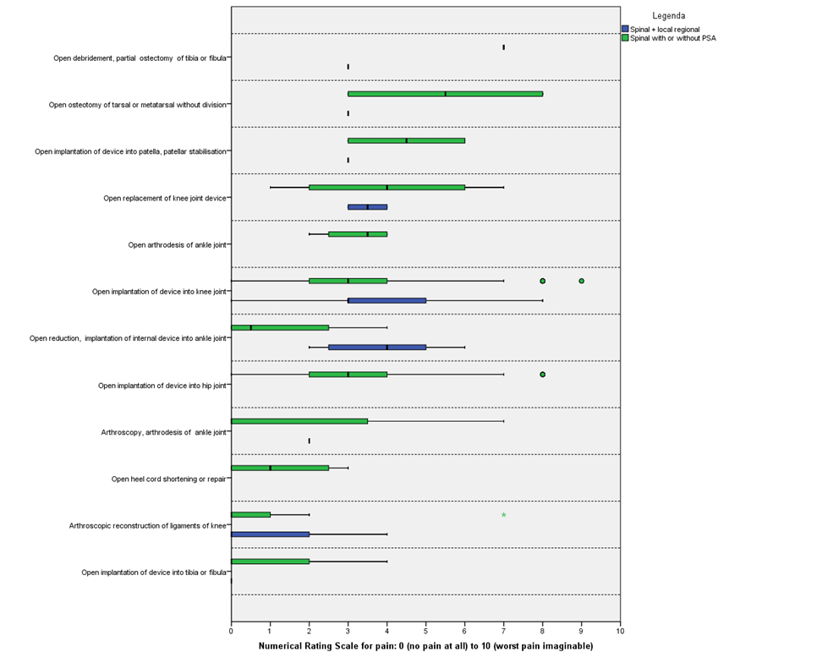
*procedures are sorted from highest to lowest median NRS

