Additional file 7
Orthopedic procedures under spinal anaesthesia compared to spinal anaesthesia combined with local regional technique, 24 to 48 hours postoperative
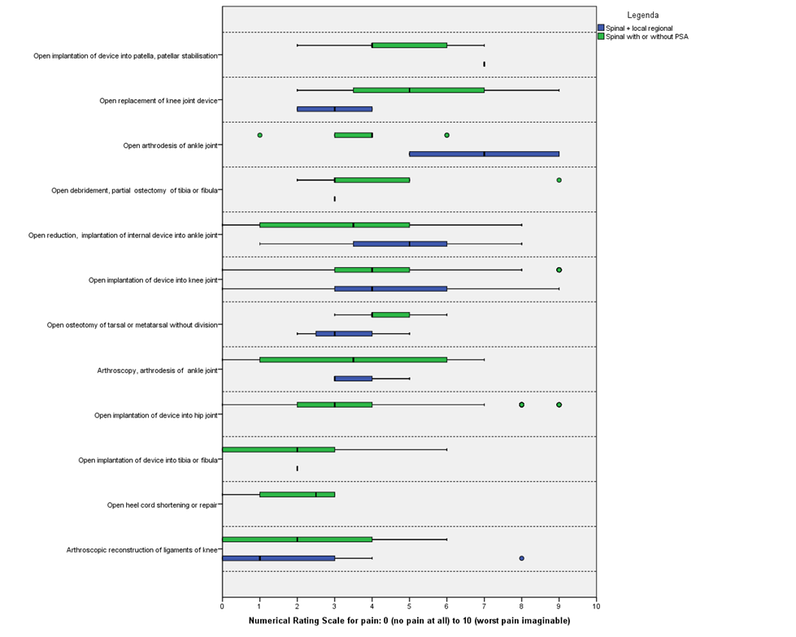
*procedures are sorted from highest to lowest median

