Additional file 3
Orthopedic procedures under general anaesthesia compared to general anaesthesia combined with local regional technique, 3 to 24 hours postoperative
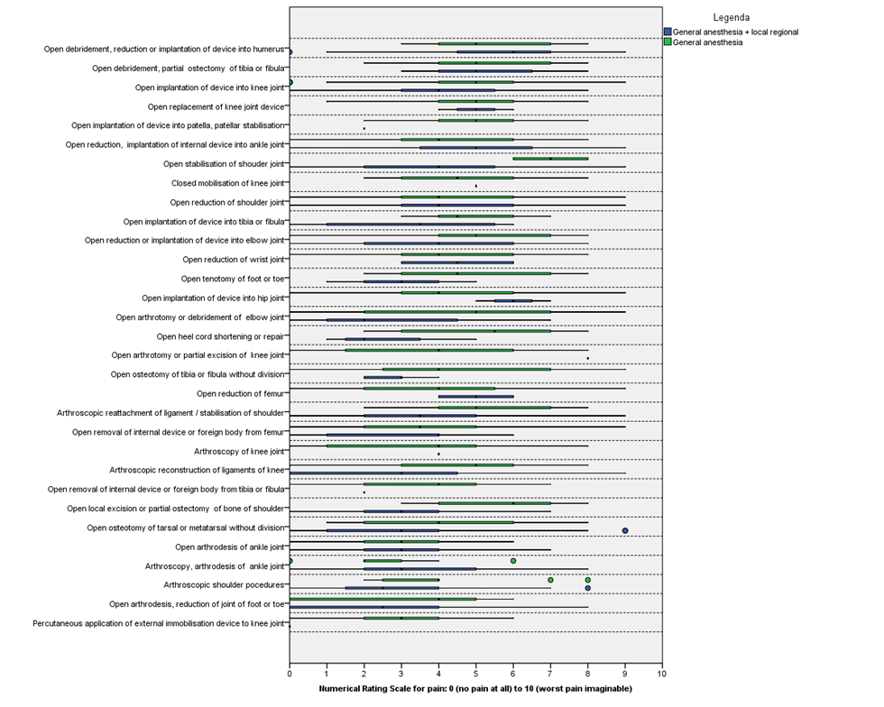
*procedures are sorted from highest to lowest median NRS

