Supplementary information
Engineering the catalyst interface enables high carbon efficiency in both cation-exchange and bipolar membrane electrolyzers
Huali Wu*¹, Bonito Aristide Karamoko¹, Wensen Wang¹, Jiefeng Liu¹, Eddy Petit¹, Suming Li¹, Chrystelle Salameh¹, Damien Voiry*¹
¹ Institut Européen des Membranes, IEM, UMR 5635, Université Montpellier, ENSCM, CNRS, Montpellier 34000, France

Note S1. Mechanism of carbonate formation in anion-exchange membrane (AEM) during CO₂ electroreduction 4
Figure S1. SEM image of spray-coated commercial Ag on gas diffusion layer(a), and the related electrochemical performance in BPM-based MEA electrolyzers with 1M CsOH anolyte under reversed bias(b) and forward bias(c). 5
Figure S2. Faradaic efficiency (a) and total current density, CO energy efficiency(b) over glass fiber-based buffering layer (3M CsHCO₃) on Ag catalyst as a functional of cell voltages in BPM-based MEA electrolyzers with 1M CsOH anolyte. 5
Figure S3. SEM images of Ag/buffering electrodes with various PEI concentrations: 0.5%(a), 1.5%(b), 2.1%(c), and 3.4%(d), as well as 2.1% PEI on pure gas diffusion layer(e). Fourier transformed infrared (FTIR) spectra of the pristine Ag-GDL, Ag/0.5% PEI, Ag/1.5% PEI, Ag/2.1% PEI, and Ag/3.4% PEI electrodes (f). 6
Figure S4. BET measurements: N₂ adsorption-desorption curves (a) and pore size distributions on 0.5% PEI, 1.5% PEI, 2.1% PEI, and 3.4% PEI hydrogels. 7
Figure S5. The air-contact angle of 0.5%(a), 1.5%(b), 3.4%(c)- PEI derived buffer layers. And the photo of measuring air-contact angle (d). 8
Figure S6. The performance of different loadings of PEI derived buffer layers: 0.5%(a), 1.5%(b), 2.1%(c) and 3.4%-3M CsHCO₃(d) in BPM-MEA with 1 M CsOH anolyte. 9
Figure S7. The total current density of different loading of PEI derived buffer layer (0.5%, 1.5%, 2.1% and 3.4%-3M CsHCO₃) in BPM-MEA with 1 M CsOH anolyte. 10
Figure S8. The comparison of carbon efficiency: SPU (a) and SPC(b), on different loading of PEI derived buffer layer (0.5%, 1.5%, 2.1% and 3.4%-3M CsHCO₃) in BPM-MEA with 1 M CsOH anolyte. 11
Figure S9. Faradaic efficiency over Ag/2.1%-PEI catalysts as a function of applied cell voltages measured with different buffering catholyte: DI water(a), 3 M NaHCO₃ (b), 3 M KHCO₃ (c), and 3 M CsHCO₃ (d). The total (e) and CO partial current density (f) comparison with different buffering catholyte in BPM-based MEA electrolyzers. 12
Figure S10. Faradaic efficiency and total current density over Ag/buffering catalysts as a function of applied cell voltages measured in H₂SO₄ with a pH value of 0.5. 13
Figure S11. Faradaic efficiency and CO partial current density over Ag/buffering catalysts as a function of applied cell voltages measured in different anolyte (0.5 M K₂SO₄ + H₂SO₄) with pH=1.0 (a), pH=0.5 (a), and pH=0.25 (c) in CEM-based MEA electrolyzers. The error bars represent standard deviation from three independent measurements. 14
Figure S12. The schematic of one dimensional COMSOL modelling in BPM-based MEA electrolyzers. GDL refers to gas diffusion layer. 15
Figure S13. The bicarbonate concentration profiles from finite-element numerical simulation results of the buffering layers with 3 M CsHCO₃ and PEI concentration from 0.5 to 3.4% in BPM-based MEA configurations. 16
Figure S14. Finite-element numerical simulation results of 2.1% PEI- buffering layers in CEM-based MEA configuration with different 0.5 M K₂SO₄+ H₂SO₄ anolytes (pH=0.25, 0.5 and 1). (a) The pH profiles. (b) The bicarbonate concentration profiles. 17
Figure S15. The relationships among flow rate, current density and CO₂ conversion efficiency in BPM-based MEA with an optimized Ag/buffer cathode(a), CEM-based MEA with an optimized Ag/buffer cathode (b) and AEM-based MEA electrolyzers with a pure Ag cathode (c) 18
Figure S16. The FE and full cell voltage for neutral MEA with Ag catalyst. 19
Table S1. Comparison of the CO₂ Single-pass conversion rate (SPC, %), Single-pass utilization rate (SPU, %) in BPM/CEM-based MEA electrolyzers and this work. 20
Table S2. The chemical reactions at the catholyte region and the corresponding forward k_{f} rate constants and reverse k_{r} rate constants used in simulation⁷. 21
Table S3. The species diffusion coefficients used in simulation⁸⁻¹¹. 22
Table S4. The sechenov coefficients used in simulation ¹². 23
References: 23

Note S1. Mechanism of carbonate formation in anion-exchange membrane (AEM) during CO₂ electroreduction
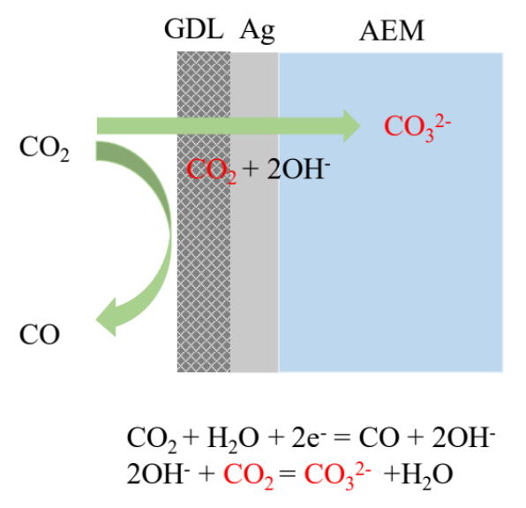
To produce 1M CO by CO₂RR, 2M OH⁻ would be generated which will react with another 1M CO₂ to form CO₃²⁻. Therefore, the total consumed CO₂ are 2M. If the CO FE is 100%, the CO₂-to-CO single-pass conversion is limited to 50%.

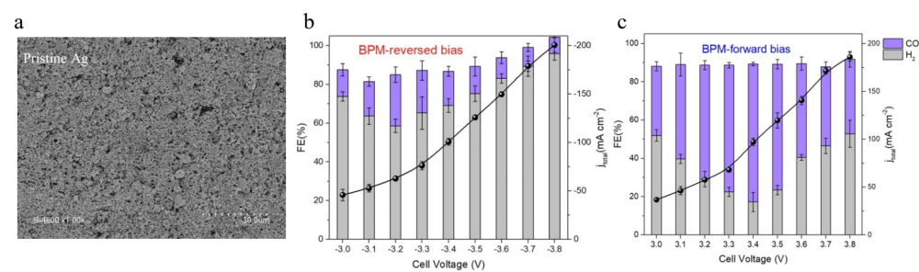

Figure S1. SEM image of spray-coated commercial Ag on gas diffusion layer(a), and the related electrochemical performance in BPM-based MEA electrolyzers with 1M CsOH anolyte under reversed bias(b) and forward bias(c).

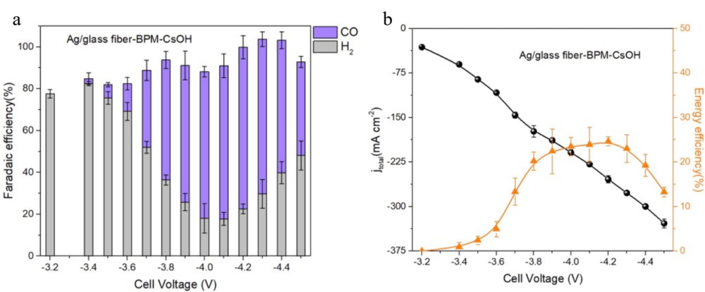

Figure S2. Faradaic efficiency (a) and total current density, CO energy efficiency(b) over glass fiber-based buffering layer (3M CsHCO₃) on Ag catalyst as a functional of cell voltages in BPM-based MEA electrolyzers with 1M CsOH anolyte.

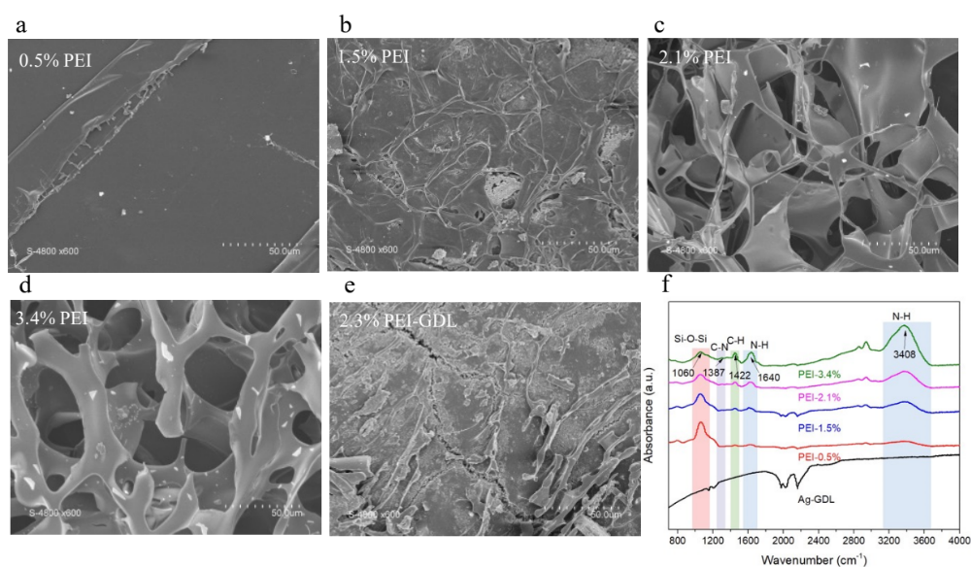

Figure S3. SEM images of Ag/buffering electrodes with various PEI concentrations: 0.5%(a), 1.5%(b), 2.1%(c), and 3.4%(d), as well as 2.1% PEI on pure gas diffusion layer(e). Fourier transformed infrared (FTIR) spectra of the pristine Ag-GDL, Ag/0.5% PEI, Ag/1.5% PEI, Ag/2.1% PEI, and Ag/3.4% PEI electrodes (f).

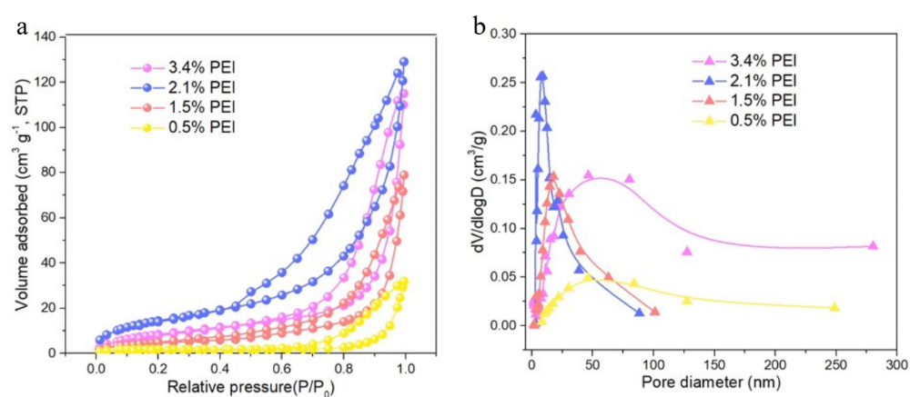

Figure S4. BET measurements: N₂ adsorption-desorption curves (a) and pore size distributions on 0.5% PEI, 1.5% PEI, 2.1% PEI, and 3.4% PEI hydrogels.

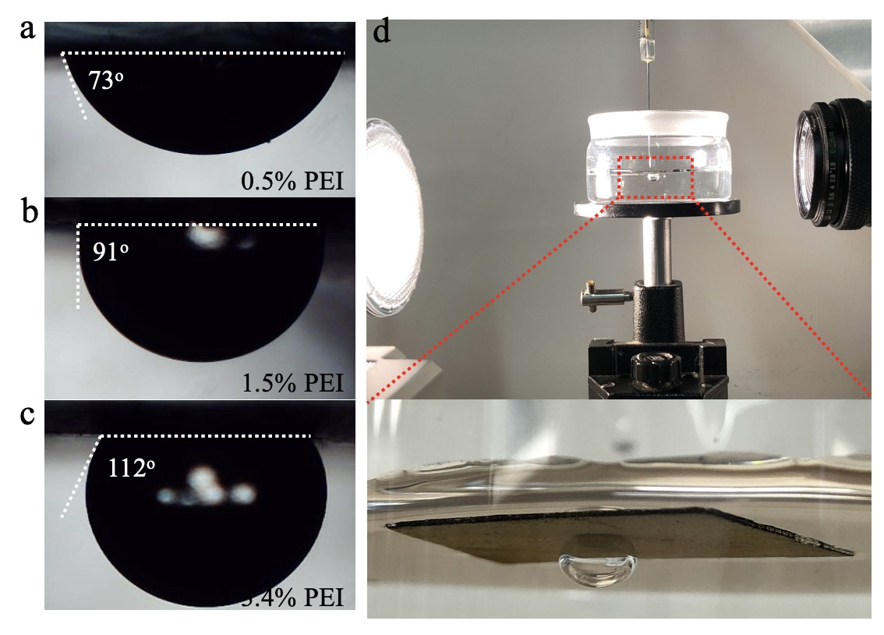

Figure S5. The air-contact angle of 0.5%(a), 1.5%(b), 3.4%(c)- PEI derived buffer layers. And the photo of measuring air-contact angle (d).

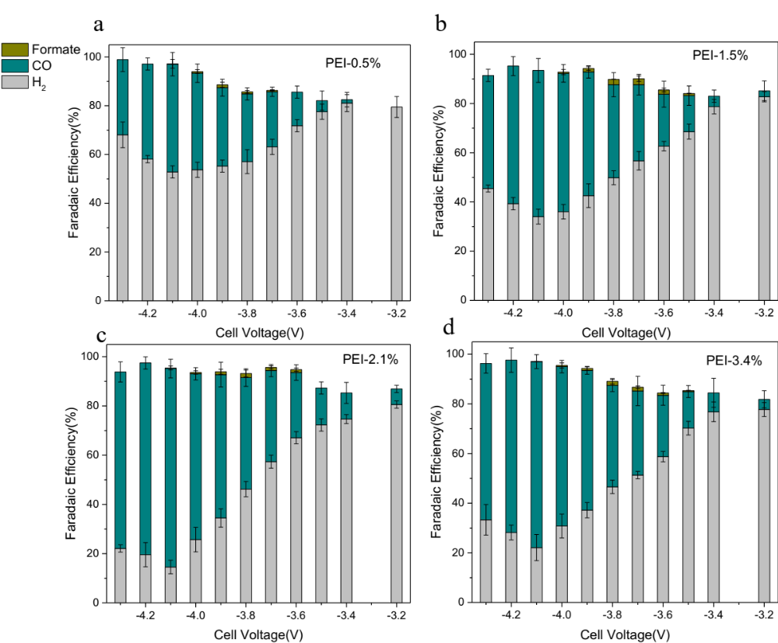

Figure S6. The performance of different loadings of PEI derived buffer layers: 0.5%(a), 1.5%(b), 2.1%(c) and 3.4%-3M CsHCO₃(d) in BPM-MEA with 1 M CsOH anolyte.

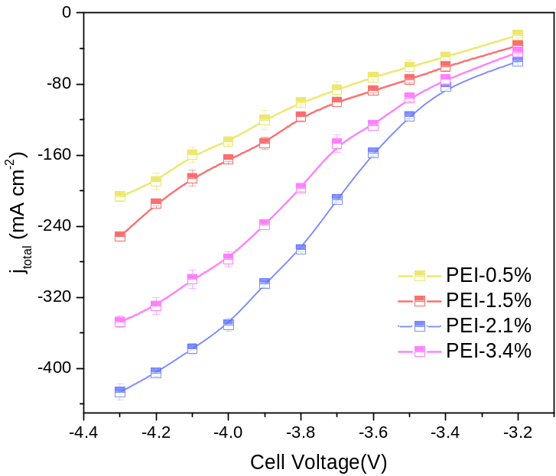

Figure S7. The total current density of different loading of PEI derived buffer layer (0.5%, 1.5%, 2.1% and 3.4%-3M CsHCO₃) in BPM-MEA with 1 M CsOH anolyte.

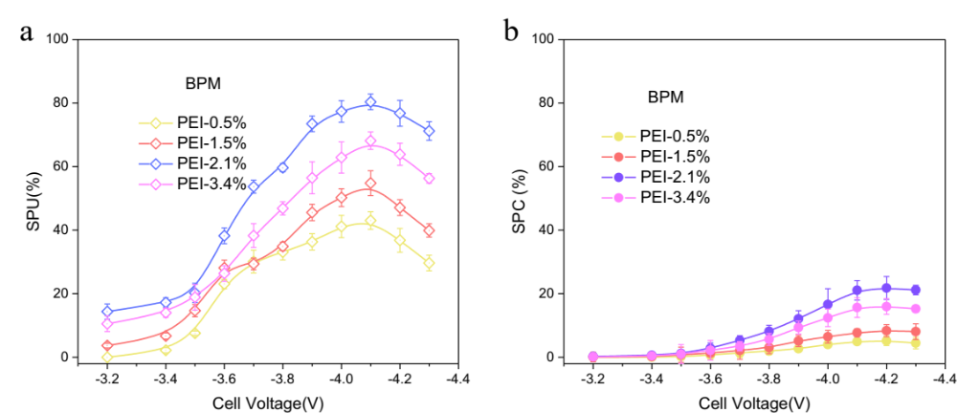

Figure S8. The comparison of carbon efficiency: SPU (a) and SPC(b), on different loading of PEI derived buffer layer (0.5%, 1.5%, 2.1% and 3.4%-3M CsHCO₃) in BPM-MEA with 1 M CsOH anolyte.

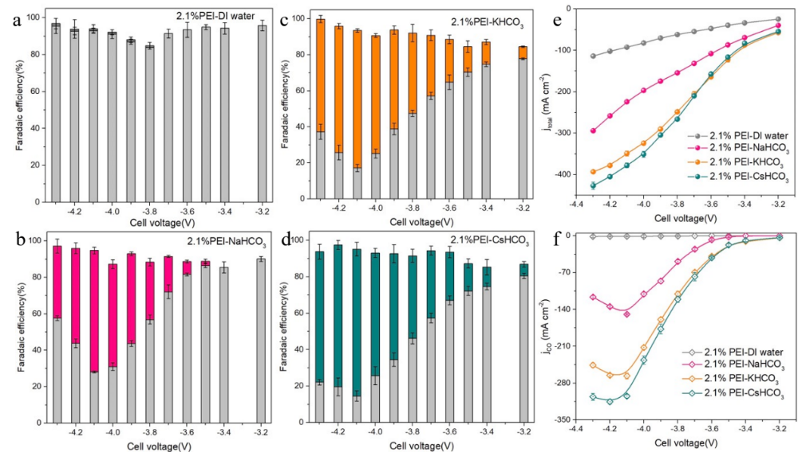

Figure S9. Faradaic efficiency over Ag/2.1%-PEI catalysts as a function of applied cell voltages measured with different buffering catholyte: DI water(a), 3 M NaHCO₃ (b), 3 M KHCO₃ (c), and 3 M CsHCO₃ (d). The total (e) and CO partial current density (f) comparison with different buffering catholyte in BPM-based MEA electrolyzers.

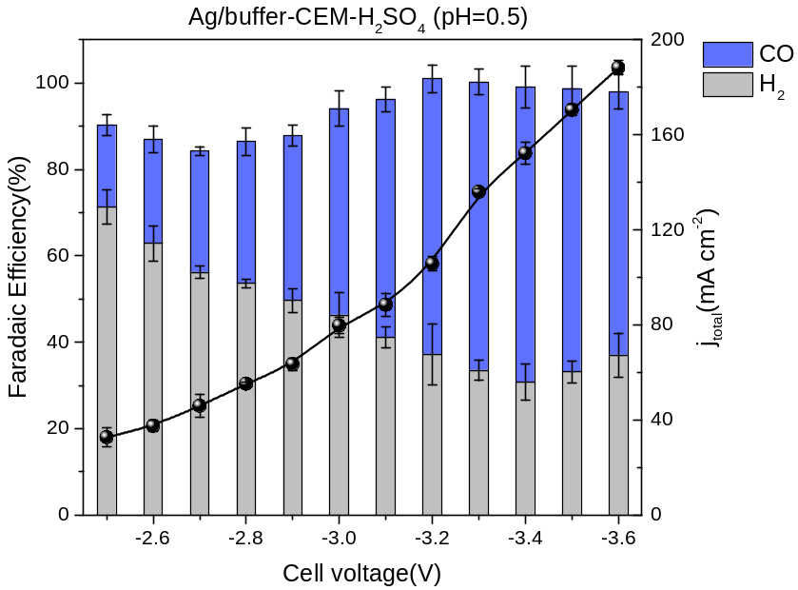

Figure S10. Faradaic efficiency and total current density over Ag/buffering catalysts as a function of applied cell voltages measured in H₂SO₄ with a pH value of 0.5.

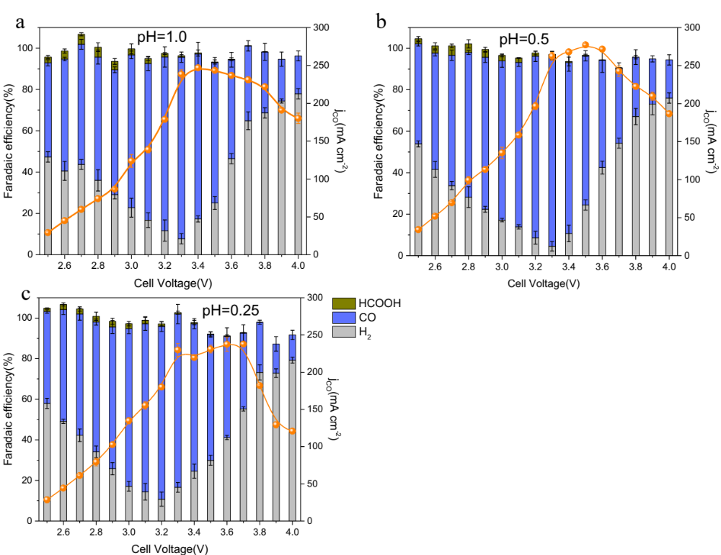

Figure S11. Faradaic efficiency and CO partial current density over Ag/buffering catalysts as a function of applied cell voltages measured in different anolyte (0.5 M K₂SO₄ + H₂SO₄) with pH=1.0 (a), pH=0.5 (a), and pH=0.25 (c) in CEM-based MEA electrolyzers. The error bars represent standard deviation from three independent measurements.

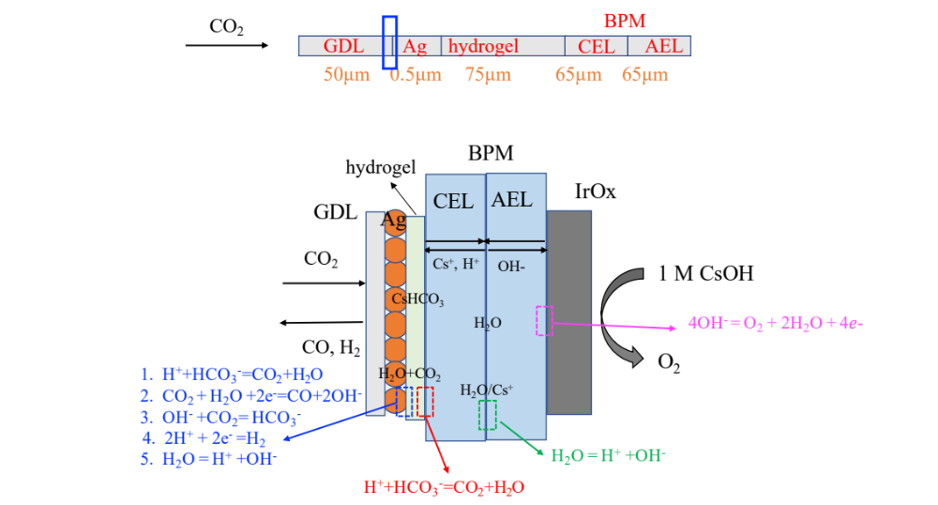

Figure S12. The schematic of one dimensional COMSOL modelling in BPM-based MEA electrolyzers. GDL refers to gas diffusion layer.

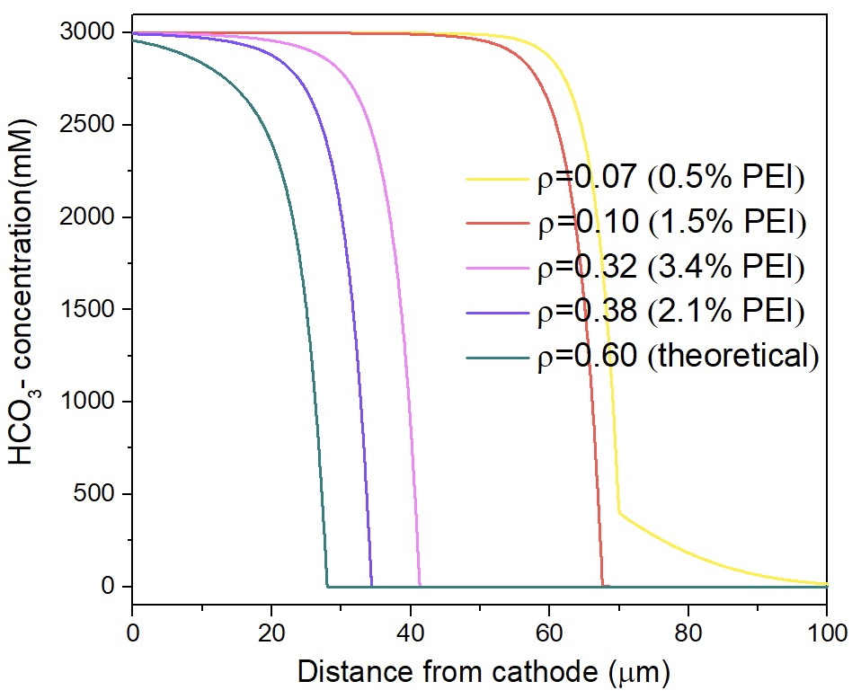

Figure S13. The bicarbonate concentration profiles from finite-element numerical simulation results of the buffering layers with 3 M CsHCO₃ and PEI concentration from 0.5 to 3.4% in BPM-based MEA configurations.

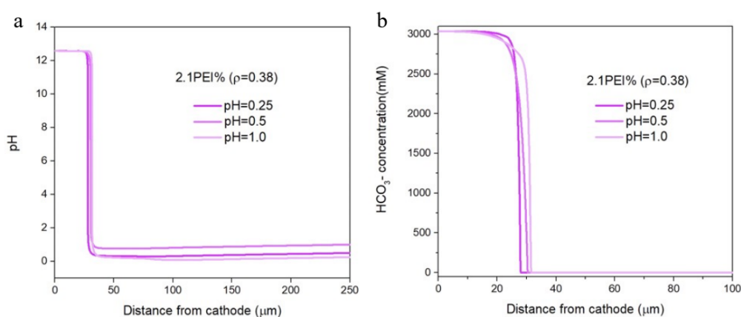

Figure S14. Finite-element numerical simulation results of 2.1% PEI- buffering layers in CEM-based MEA configuration with different 0.5 M K₂SO₄+ H₂SO₄ anolytes (pH=0.25, 0.5 and 1). (a) The pH profiles. (b) The bicarbonate concentration profiles.

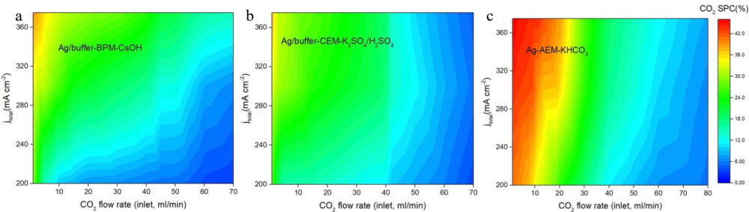

Figure S15. The relationships among flow rate, current density and CO₂ conversion efficiency in BPM-based MEA with an optimized Ag/buffer cathode(a), CEM-based MEA with an optimized Ag/buffer cathode (b) and AEM-based MEA electrolyzers with a pure Ag cathode (c)

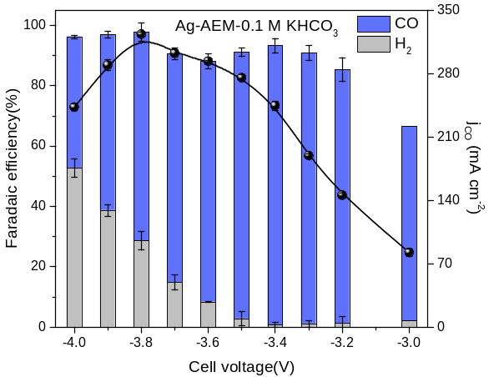

Figure S16. The FE and full cell voltage for neutral MEA with Ag catalyst.

Table S1. Comparison of the CO₂ Single-pass conversion rate (SPC, %), Single-pass utilization rate (SPU, %) in BPM/CEM-based MEA electrolyzers and this work.
Membranes | Catalysts | j_{total} (mA/cm²) | SPC (%) | SPU (%) | Note
BPM  (Reversed bias) | Ag | 200 | 9 | 58 | Ref 1
BPM  (Reversed bias) | Cu/K₂SO₄ buffering | 200 | / | 78 | Ref 2
BPM  (Reversed bias) | Ag/CsHCO₃ buffering | 375 | 20 | 80 | This work
CEM | Ni-N-C | 500 | / | 78 | Ref 3
CEM | Ag | 60 | / | 88 | Ref 4
CEM | Ag@C | 300 | 46 | / | Ref 5
CEM | Cu/PCRL | 100 | / | 85 | Ref 6
CEM | Ag/ CsHCO₃ buffering | 375 | 18 | 77 | This work

Table S2. The chemical reactions at the catholyte region and the corresponding forward k_{f} rate constants and reverse k_{r} rate constants used in simulation⁷.
Reaction | k_{f} | k_{r}
$$CO_{2}+H_{2}O=H^{+}+{HCO}_{3}^{-}$$ | 0.036 [s⁻¹] | 7.83×10⁴ [M⁻¹s⁻¹]
$$CO_{2}+OH^{-}={HCO}_{3}^{-}$$ | 2.23×10³ [M⁻¹s⁻¹] | 4.85×10⁻⁵ [M⁻¹s⁻¹]
$$HCO_{3}^{-}=H^{+}+{CO}_{3}^{2-}$$ | 2.5 [s⁻¹] | 5×10¹⁰ [M⁻¹s⁻¹]
$${HCO}_{3}^{-}+OH^{-}={CO}_{3}^{2-}+H_{2}O$$ | 6×10⁹ [M⁻¹s⁻¹] | 1.2 [s⁻¹]
$${HCO}_{3}^{-}+H^{+} =CO_{2}+H_{2}O$$ | 7.83×10⁴ [M⁻¹s⁻¹] | 0.036 [s⁻¹]
$$CsHCO_{3}={Cs}^{+}+HCO_{3}^{-}$$
$$K_{2}SO_{4}=2K^{+}+{SO}_{4}^{2-}$$ | 1×10⁷ [s⁻¹] | 7.96×10⁷ [M⁻²s⁻¹]
$$H_{2}O=H^{+}+ OH^{-}$$ | 10⁸ [s⁻¹] | 10¹⁹ [M⁻¹s⁻¹]

Table S3. The species diffusion coefficients used in simulation⁸⁻¹¹.
Species | ${Diffusion coefficients D}_{i}({{10}^{-9} m}^{2}s^{-1}$)
CO₂ | 1.91
H₂O | 2.57
K₂SO₄ | 1.39
KHCO₃ | 1.20
K⁺ | 1.98
H⁺ | 9.31
OH⁻ | 5.26
HCO₃⁻ | 1.185
CO₃²⁻ | 0.923
SO₄²⁻ | 1.07
Cs⁺ | 2.06
CsHCO₃ | 1.503

Table S4. The sechenov coefficients used in simulation ¹².
Species | Sechenov coefficients
h_{G,0,CO2} | -0.0172
h_{T,CO2} | -0.000338
h_{K} | 0.0922
h_{OH} | 0.0839
h_{HCO3} | 0.0967
h_{CO3} | 0.1423
h_{Cs} | 0.0759

References:
- Yang K, Li M, Subramanian S, et al. Cation-driven increases of CO₂ utilization in a bipolar membrane electrode assembly for CO₂ electrolysis[J]. ACS Energy Letters, 2021, 6(12): 4291-4298.
- Xie K, Miao R K, Ozden A, et al. Bipolar membrane electrolyzers enable high single-pass CO₂ electroreduction to multicarbon products[J]. Nature communications, 2022, 13(1): 3609.
- Li H, Li H, Wei P, et al. Tailoring acidic microenvironments for carbon-efficient CO₂ electrolysis over a Ni–N–C catalyst in a membrane electrode assembly electrolyzer[J]. Energy & Environmental Science, 2023, 16(4): 1502-1510.
- Pan B, Fan J, Zhang J, et al. Close to 90% single-pass conversion efficiency for CO₂ electroreduction in an acid-fed membrane electrode assembly[J]. ACS Energy Letters, 2022, 7(12): 4224-4231.
- Li X, Zhang P, Zhang L, et al. Confinement of an alkaline environment for electrocatalytic CO₂ reduction in acidic electrolytes[J]. Chemical Science, 2023, 14(21): 5602-5607.
- O’Brien C P, Miao R K, Liu S, et al. Single pass CO₂ conversion exceeding 85% in the electrosynthesis of multicarbon products via local CO₂ regeneration[J]. ACS Energy Letters, 2021, 6(8): 2952-2959.
- Chen, Y., Lewis, N.S., and Xiang, C. (2020). Modeling the Performance of A Flow-Through Gas Diffusion Electrode for Electrochemical Reduction of CO or CO₂. J. Electrochem. Soc. 167, 114503.
- Petr Vany ́sek (1996). ionic conductiVity and diffusion at infinite dilution. CRC Handb. Chem. Phys 96, 5–98.
- Aqion Table of Diffusion Coefficients. https://www.aqion.de/site/diffusion-coefficients.
- Applin, K.R., and Lasaga, A.C. (1984). The determination of SO₄²⁻, NaSO₄⁻, and MgSO₄⁰ tracer diffusion coefficients and their application to diagenetic flux calculations. Geochim. Cosmochim. Acta 48, 2151–2162.
- Sugisaki, M. (1975). Soret Coefficients and Heat of Transport of Polyvalent Electrolytes in an Aqueous Solution. Bull. Chem. Soc. Jpn., 2751.
- Weisenberger, S., and Schumpe, A. (1996). Estimation of Gas Solubilities in Salt Solutions at Temperatures from 273 K to 363 K. AIChE J. 42, 298–300.

