Wild rice GL12 regulated by GIF1 and WRKY53 synergistically improves grain length and salt tolerance in cultivated rice
Yanyan Wang^{1,2}, Wenxi Chen^{1,2}, Meng Xing^{1,2}, Jiaqiang Sun¹, Shizhuang Wang¹, Ziyi Yang¹, Jingfen Huang^{1,2}, Yamin Nie¹, Mingchao Zhao^{2,5}, Yapeng Li^{2,5}, Wenlong Guo^{1,2}, Yinting Wang¹, Ziyi Chen¹, Qiaoling Zhang^{1,2}, Jiang Hu^{2,4,5}, Yunhai Li⁶, Ke Huang⁶, Xiaoming Zheng^{1,2}, Leina Zhou¹, Lifang Zhang¹, Yunlian Cheng¹, Qian Qian^{1,3,4,*}, Qingwen Yang^{1,2*}, Weihua Qiao^{1,2*}

*Correspondence: Qian Qian (qianqian@caas.cn), Qingwen Yang (yangqingwen@caas.cn), Weihua Qiao (qiaoweihua@caas.cn),
¹State Key Laboratory of Crop Gene Resources and Breeding, Institute of Crop Sciences, Chinese Academy of Agricultural Sciences. Beijing, China, 100081
²National Nanfan Research Institute (Sanya), Chinese Academy of Agricultural Sciences, Sanya, China, 572024
³ China National Rice Research Institute, Hangzhou, 310006, China
⁴Yazhouwan National Laboratory, Sanya 572024, China
⁵Cereal Crop Institute, Hainan Agricultural Academy Sciences, Haikou, China, 571100
⁶Institute of Genetics and Developmental Biology, Chinese Academy of Sciences, Beijing 100101, China

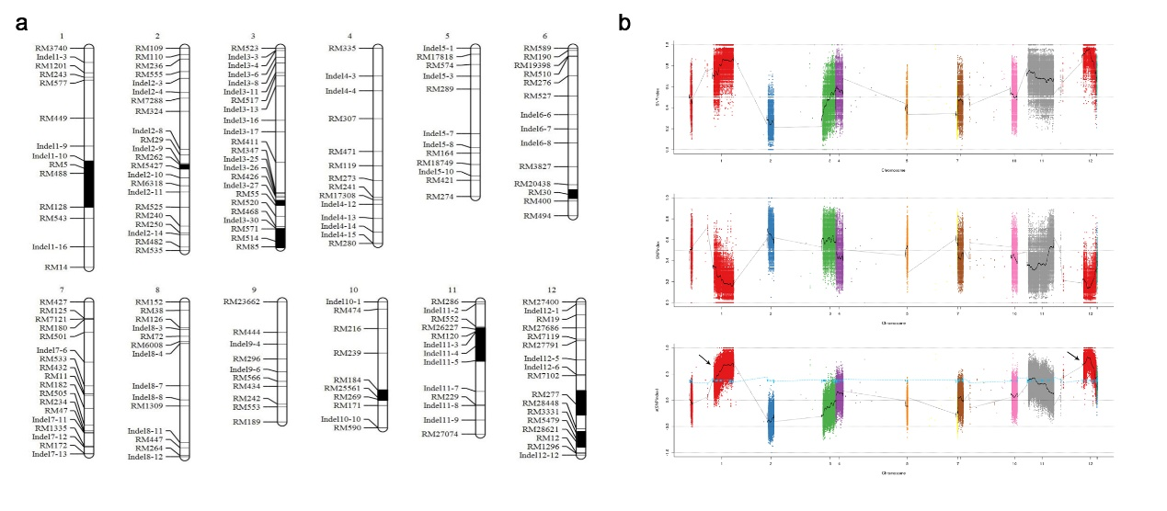
Supplementary Figure 1. Mapping of qGL12 using a wild rice CSSL population on 9311 genetic background.
(a) Genotypes of CSSL41, which have large grain length and harbor qGL12. The black bars represent the wild rice genotype in CSSL41, the SNP and InDel markers were shown on the left of corresponding chromosomes.
(b) Bulked segregant analysis (BSA) of the CSSL41/9311 F₂ population. SNP-index graphs of long-grain bulk pool (above), short-grain bulk pool (middle), and Δ(SNP-index) graph (bottom) from the BSA. The X-axis shows the position of 12 chromosomes and the Y-axis shows the SNP-index and ∆ (SNP-index). The blue line is the screening threshold at a 95% confidence level.

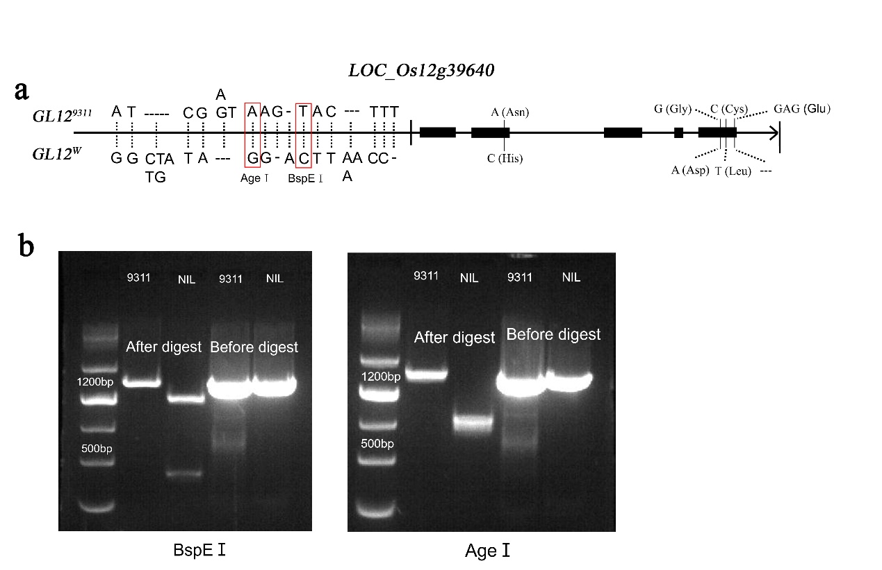
Supplementary Figure 2. Development of CAPS molecular markers for GL12/LOC_Os12g39640.
(a) Alignments of two alleles of GL12 in wild rice and 9311, the SNPs, InDels and enzyme digest sites for the CAPS markers were shown.
(b) Electrophoresis photo of the CAPS markers. The CAPS marker were developed for gene GL12 based on the A/G variation and T/C at site -476 and -824 of the promoter region between 9311 and NIL, and the restriction enzymes were BspEⅠ and Age I, respectively. The full length of the promoter was 1,536bp.

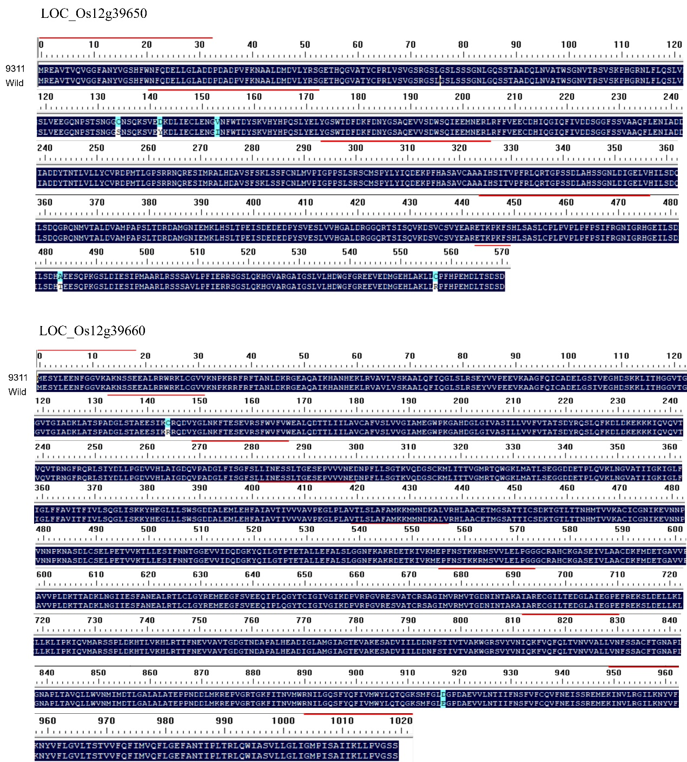

Supplementary Figure 3. Comparison of amino acid sequences of LOC_Os12g39650 and LOC_Os12g39660 genes in qGL12 interval between wild rice/NIL and 9311.

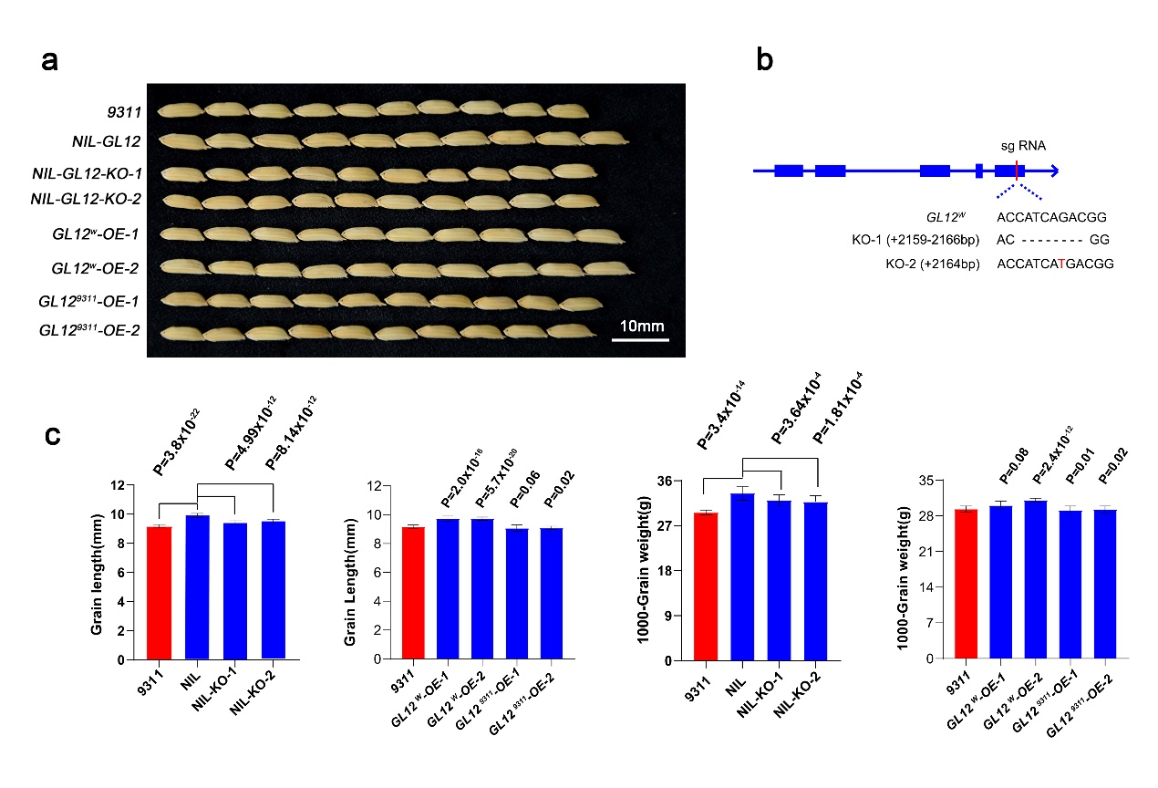

Supplementary Figure 4. Wild rice GL12/LOC_Os12g39640 gene increased the grain length in 9311 genetic background.

(a) Grains of NIL, GL12^{W} knockout (NIL-KO) lines, and GL12^{W} and GL12⁹³¹¹ overexpression (OE) lines.
(b) Mutation sites in the GL12^{W} gene in the NIL knockout lines (KO1 and KO2) generated by CRISPR/Cas9 editing.
(c) Statistical analysis of grain length (GL) and 1000-grain weight (TGW) of NIL, NIL-KO, GL12^{W} and GL12⁹³¹¹ overexpression lines. Data were given as means ± SD. Student’s t-test was used to generate the P values.

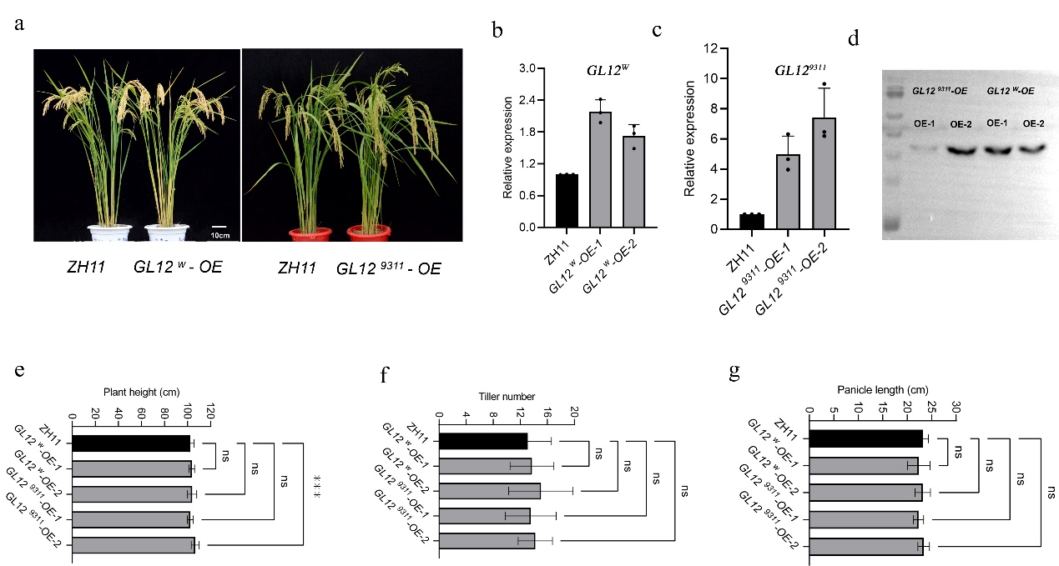
Supplementary Figure 5. Identification and investigation of the agronomic traits in GL12 overexpression lines in Zhonghua11 genetic background.

(a) GL12^{W} and GL12⁹³¹¹ overexpression transgenic lines (OE) and ZH11 wild type.
(b, c) Relative expression levels of GL12 in transgenic lines, detected by real-time PCR.
(d) Western blot of GL12 using GL12-OE transgenic lines, the anti-Flag was used as antibody.
(e-g) Statistical analysis of plant height (e), till number (f), and panicle length (g) of GL12^{W} and GL12⁹³¹¹-OE lines. Data were given as means ± SD. Student’s t-test was used to generate the P values.

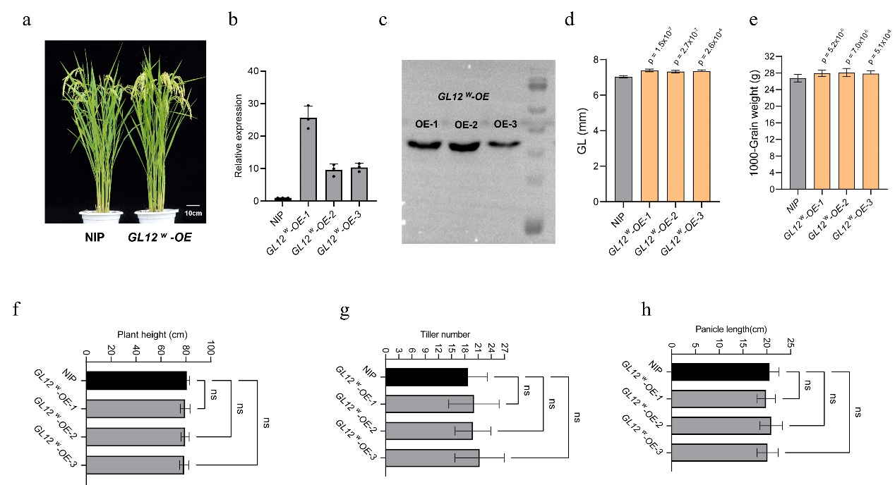
Supplementary Figure 6. Overexpression of GL12^{W} improve grain length and weight in Nipponbare background.
(a) Nipponbare (NIP) wild type and GL12^{W} -OE lines.
(b) Relative expression levels of GL12 in transgenic lines, detected by real-time PCR.
(c) Western blot of GL12 using GL12-OE transgenic lines, the anti-Flag was used as antibody.
(d-e) Statistical analysis of grain length (d) and 1000-grain weight (e) of GL12^{W}-OE lines and NIP. Data were given as means ± SD. Student’s t-test was used to generate the P values.
(f-h) Statistical analysis of plant height (f), till number (g), and panicle length (h) of GL12^{W} -OE lines. Data were given as means ± SD. Student’s t-test was used to generate the P values.

Supplementary Figure 7. Phylogenetic analysis of GL12.

Phylogenetic analysis of GL12/LOC_Os12g39640 homologs in cultivated rice, wild rice, wheat, barley, sorghum, maize, and other plants. GL12 is mainly clustered with homologous genes in cultivated rice japonica, and there are also homologous genes in Oryza meyeriana. The phylogenetic tree was generated by MEGA 7.0 using the neighbor-joining method.

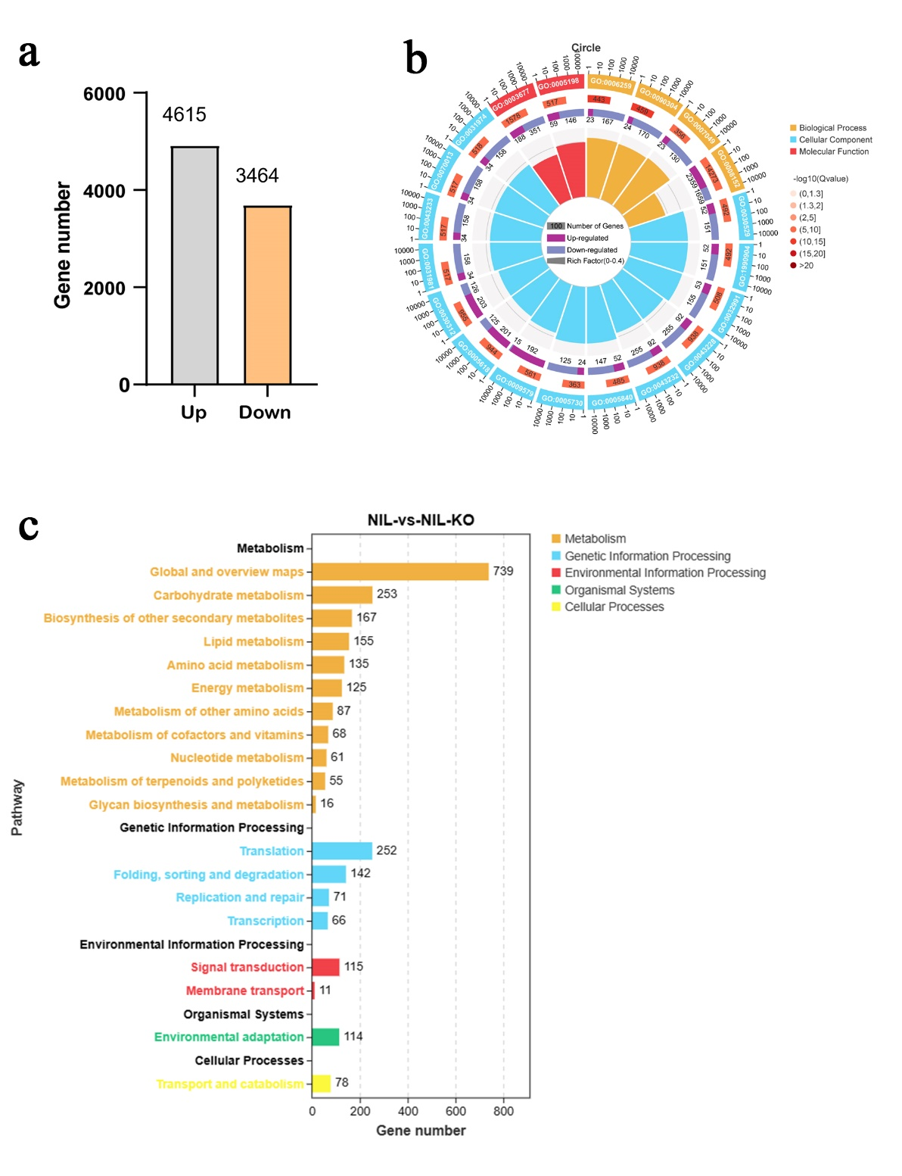

Supplementary Figure 8. Transcriptome analysis of NIL and NIL-KO lines. The young panicles of 8cm of NIL and NIL-KO lines were used for transcriptome analysis.
(a) The different expression genes (DEGs) of NIL vs NIL-KO.
(b) Gene Ontology (GO) terms enriched in the DEGs for NIL and NIL-KO lines.
(c) Statistic analysis of gene number of DEGs in KEGG pathway.

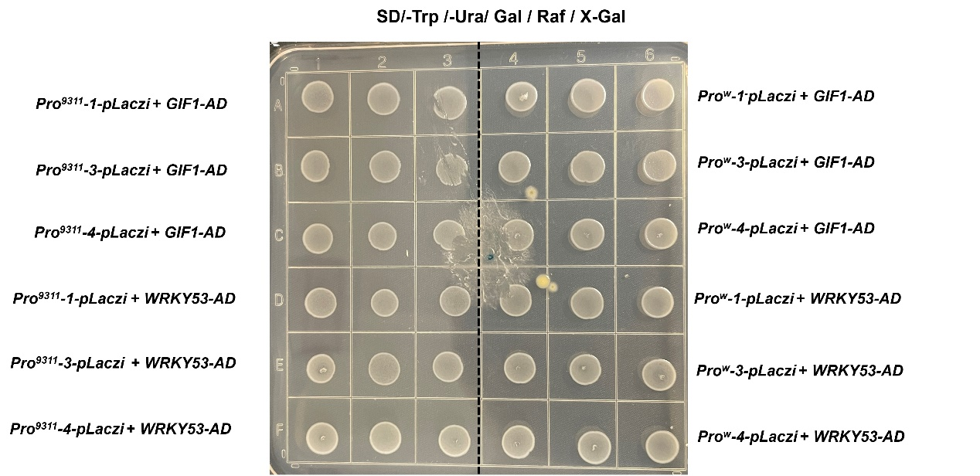

Supplementary Figure 9. Yeast one-hybrid of GIF1, WRKY53 binding to the promoter of GL12.
Four truncated promoter constructs of GL12 alleles from wild rice/NIL and 9311 (Pro^{W} and Pro⁹³¹¹) were generated respectively (shown in Fig. 4d in the main manuscript), named as Pro^{W}-1, -2, -3, -4 and Pro⁹³¹¹-1, -2, -3, -4, respectively. Yeast one-hybrid results demonstrated that both GIF1 and WRKY53 bound with Pro^{W}-2 truncation (Fig. 4d, Fig. 6b in the main manuscript). Pro-1, -3 and -4 did not bind to neither GIF1 nor WRKY53.

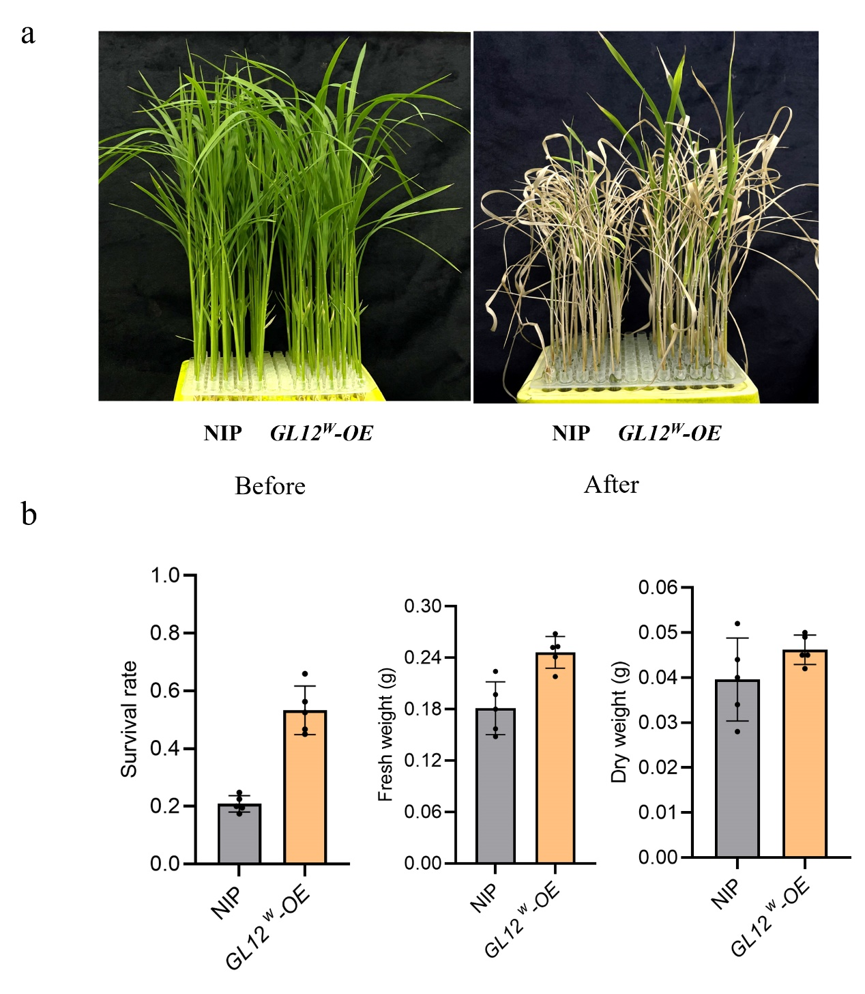
Supplementary Figure 10. GL12^{W} improved salt tolerance in Nipponbare background.
(a) Photos of GL12^{W} overexpression lines and Nipponbare wild type plants before and after salt treatments, 20-day-old seedlings were treated with 150mM NaCl for seven days.
(b) Statistical analysis of survival rate, fresh and dry weight of plants. Data were given as means ± SD.

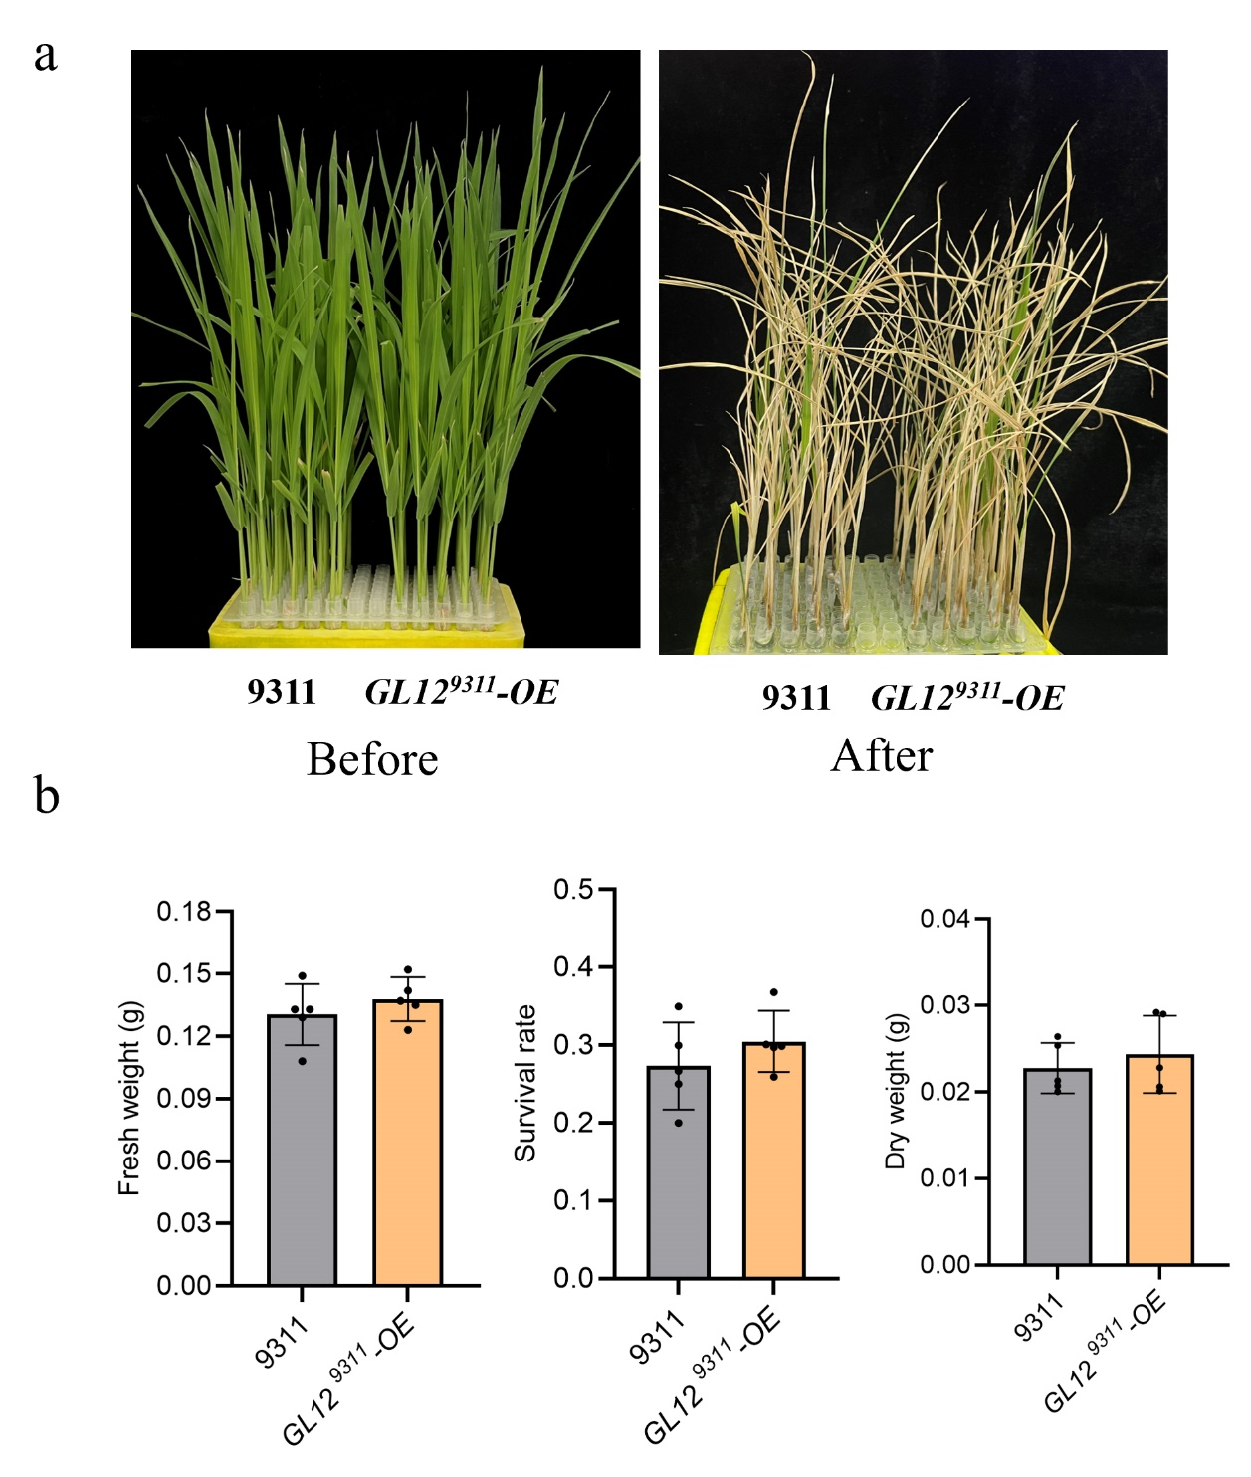

Supplementary Figure 11. Overexpression of GL12⁹³¹¹ did not improve 9311 salt tolerance.
(a) Photos of GL12⁹³¹¹ overexpression lines and 9311 wild type plants before and after salt treatments, 20-day-old seedlings were treated with 150mM NaCl for seven days.
(b) Statistical analysis of survival rate, fresh and dry weight of plants. Data were given as means ± SD.

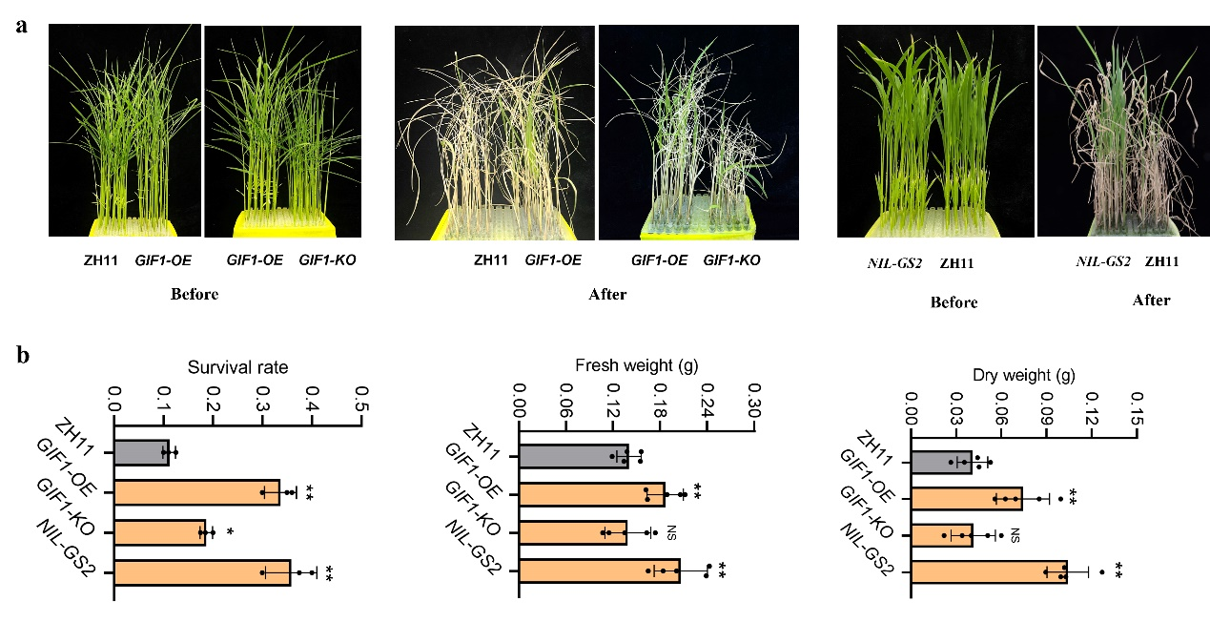

Supplementary Figure 12. GIF1 and GS2 positively regulated rice salt tolerance.
(a) Photos of GIF1-OE, GIF1-KO, GS2-NIL, and ZH11 wild type plants before and after salt treatments, 20-day-old seedlings were treated with 150mM NaCl for seven days.
(b) Statistical analysis of the survival rate, fresh and dry weight of plants. Data were given as means ± SD.

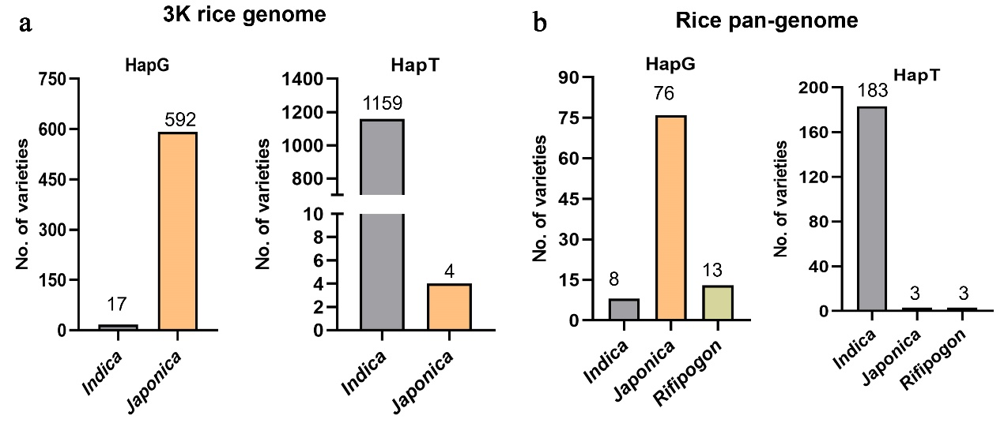

Supplementary Figure 13. Distribution of G/T variation in the GL12 promoter region is unbalanced between japonica and indica varieties.
(a) The distribution of G/T variation in 1,772 rice varieties from the 3K rice genomes project.
(b) The distribution of G/T variation in 286 rice varieties from the Rice Super Pan-genome Information Resource Database (RiceSuperPIRdb).

Supplementary Figure 14. Investigation on the effect of GL12^{W} on rice yield.
(a, b) Statistical analysis of the number of grains per panicle (a), and yield per plant (b) of 9311, NIL and GL12^{W}-OE lines. Data were given as means ± SD. Data were given as means ± SD. (n>30).
(c, d) statistical analysis of the number of grains per panicle of GL12^{W}-OE line in ZhongHua11 (c) and Nipponbare (d) genetic backgrounds.

