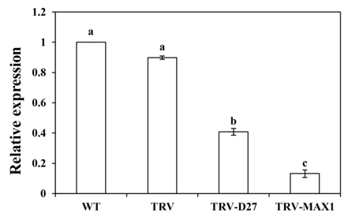
Supplementary Materials

Fig. S1. SlD27 and SlMAX1 Silence Efficiency Detection. Each value represents the mean ± standard deviation (SD). Different letters above the bars indicate significant differences among different treatments in the same line (p<0.05).
Supplementary Table 1 Primer sequence used for qRT-PCR analysis of the target gene
Gene | Accession No ^{A} | Primer Sequence (5’–3’ )
CCD7 | NM_001247504 | F: 5′-CCA TAC CAT CCG ATT TCC CTT CCG -3′
CCD7 | NM_001247504 | R: 5′-AAG TAG CCG TGT CCG TCT AGAGG-3′
CCD8 | NM_001279347 | F: 5′-CCA GTG GTT ACG GAC AGT GAG TTC -3′
CCD8 | NM_001279347 | R: 5′-TGG TGC TGG TCC TCC TCT ACAAC-3′
D27 | MH000338.1 | F: 5′-GGA GGC TGC AAG GGT TGT GTATG-3′
D27 | MH000338.1 | R: 5′-GGA ATC TAA GTG GGC GAG GGAGT-3′
D14 | XM_004253433 | F: 5′-TGG CAT CAT TGG TTG CAT TGCT-3′
D14 | XM_004253433 | R: 5′-TGG TAT GTT GAA ACC TCC CTCGT-3′
MAX1 | MH000337.1 | F: 5′-GGC AAG GGA GTC AGA GAA GTT AGC-3′
MAX1 | MH000337.1 | R: 5′-GCA GAA CCC GCC AGC AAG TG-3′
MAX2 | XM_004251758 | F: 5′-GTT CTC GTG GCT CGT TCA AGGAC-3′
MAX2 | XM_004251758 | R: 5′-CTA ACA TTA TCG CCG CCG TCTCC-3′
Actin | SGN-U580609 | F: 5′-AAT GAA CTT CGT GTG GCT CCA GAG -3′
Actin | SGN-U580609 | R: 5′-ATG GCA GGG GTG TTG AAG GTTTC-3′
^{A} NCBI database

