Supporting Information

Decylammonium sulfate post-treatment for efficient hole-conductor-free printable perovskite solar cells with reduced voltage loss

Zexiong Qiu,ª Jiale Liu,ª Chuanzhou Han,ª Chaoyang Wang,ª Junwei Xiang,ª Ziwei Zheng,ª Minhao Xia,ª Yang Zhou,ª Anyi Mei,*ª and Hongwei Han* ª
ªMichael Grätzel Center for Mesoscopic Solar Cells, Wuhan National Laboratory for Optoelectronics, Key Laboratory of Materials Chemistry for Energy Conversion and Storage of Ministry of Education, Huazhong University of Science and Technology, Wuhan, 430074 Hubei, PR China
* Correspondence to Hongwei Han, E-mail: hongwei.han@mail.hust.edu.cn
* Correspondence to Anyi Mei, E-mail: anyimei@hust.edu.cn

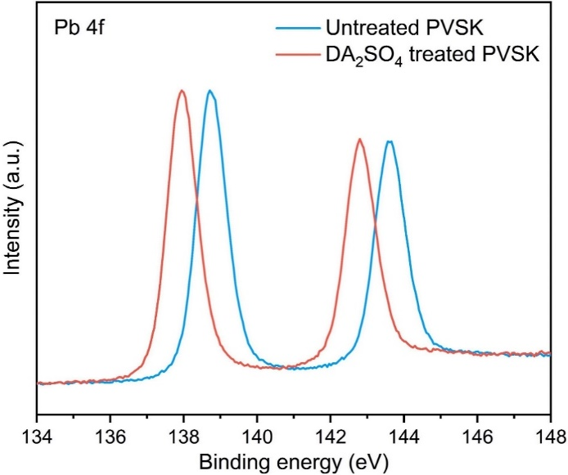
Supplementary Figure 1. XPS spectra of Pb 4f for the untreated and DA₂SO₄ treated perovskite films.

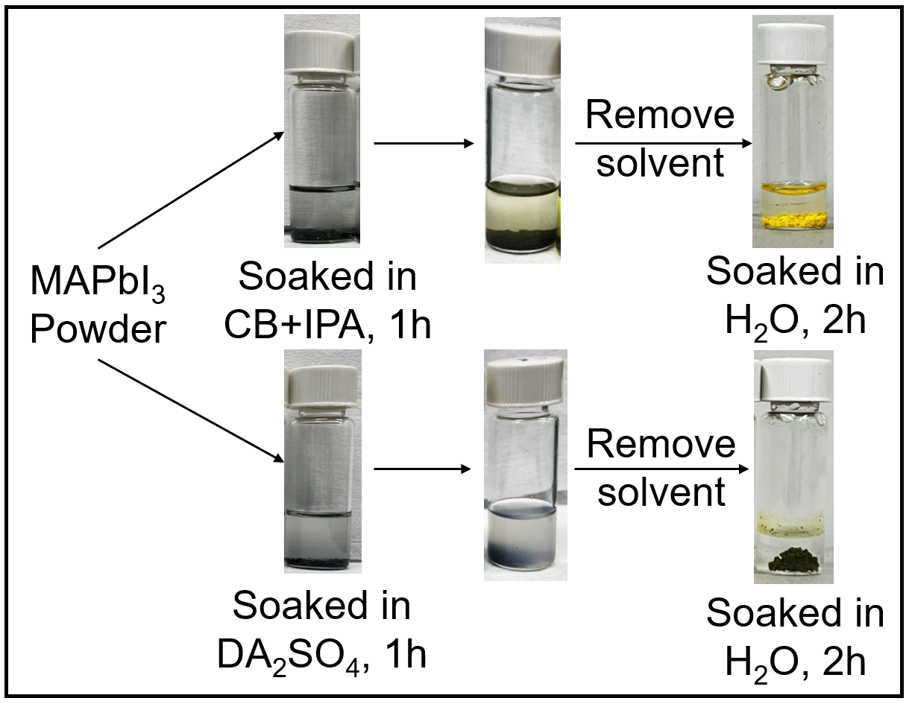
Supplementary Figure 2. Digital photographs of the water resistance test for the untreated and DA₂SO₄ treated MAPbI₃ crystal powders.

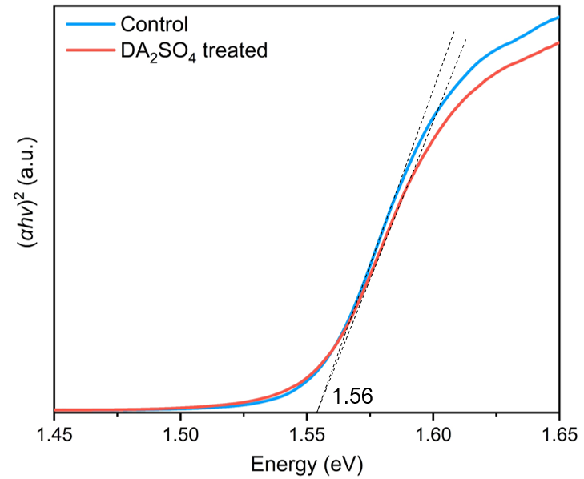
Supplementary Figure 3. Tauc plot of the untreated and DA₂SO₄ treated perovskite films in the low energy region.

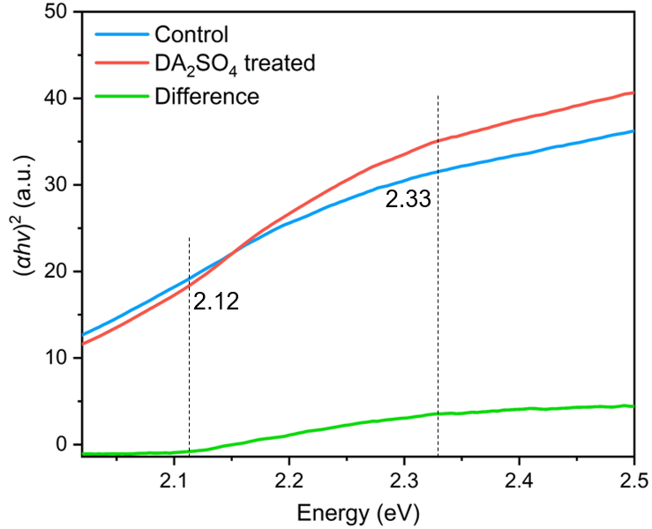
Supplementary Figure 4. Tauc plot of the untreated and DA₂SO₄ treated perovskite films in the high energy region.

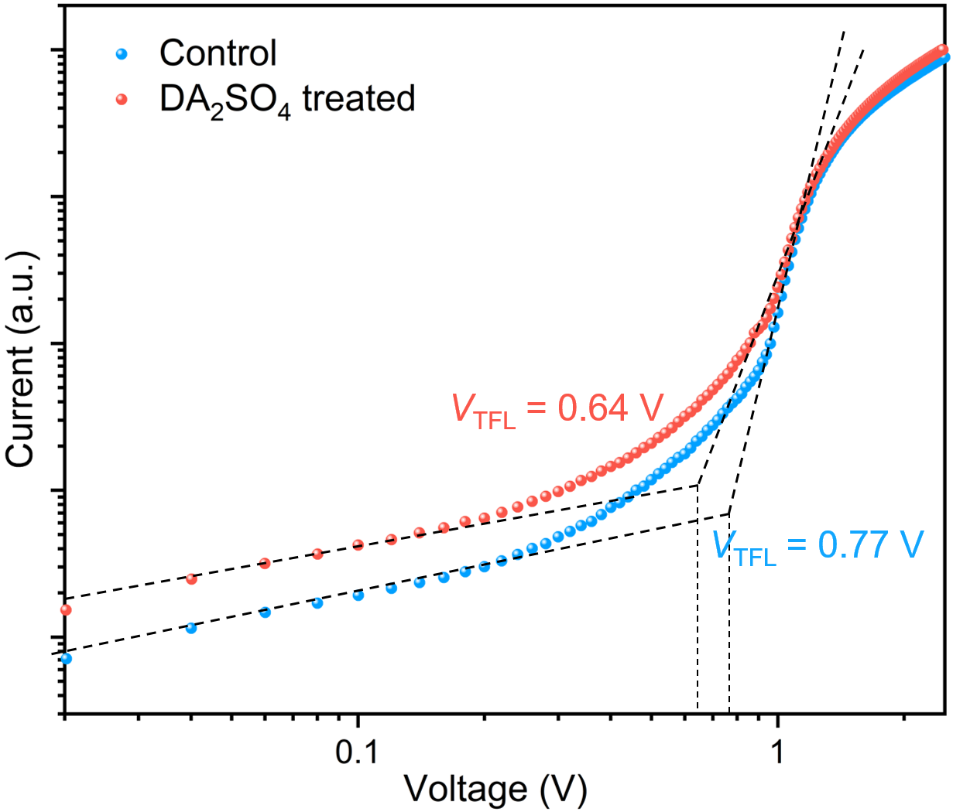
Supplementary Figure 5. Dark J-V curves of the untreated and DA₂SO₄ treated perovskites, based on an FTO/c-NiO_{x}/mp-ZrO₂/carbon structure.

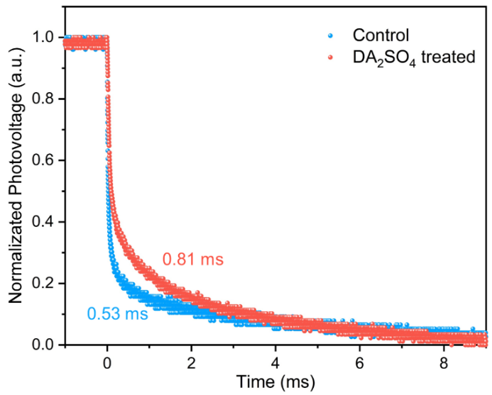
Supplementary Figure 6. TPV decay curves of the untreated and treated DA₂SO₄ devices.

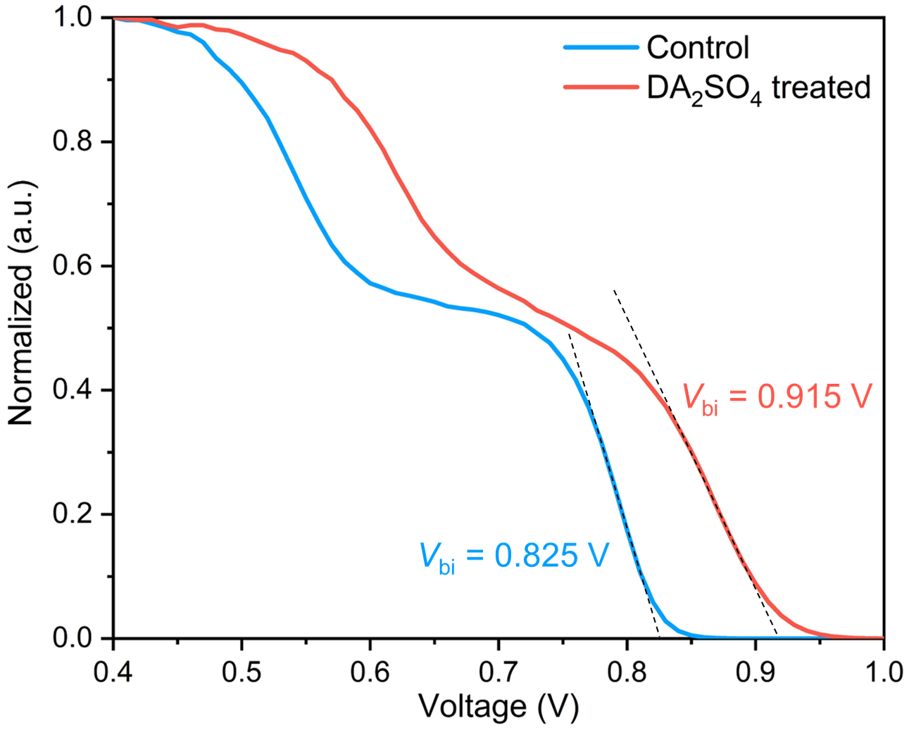
Supplementary Figure 7. Mott−Schottky diagrams of the untreated and DA₂SO₄ treated p-MPSCs.

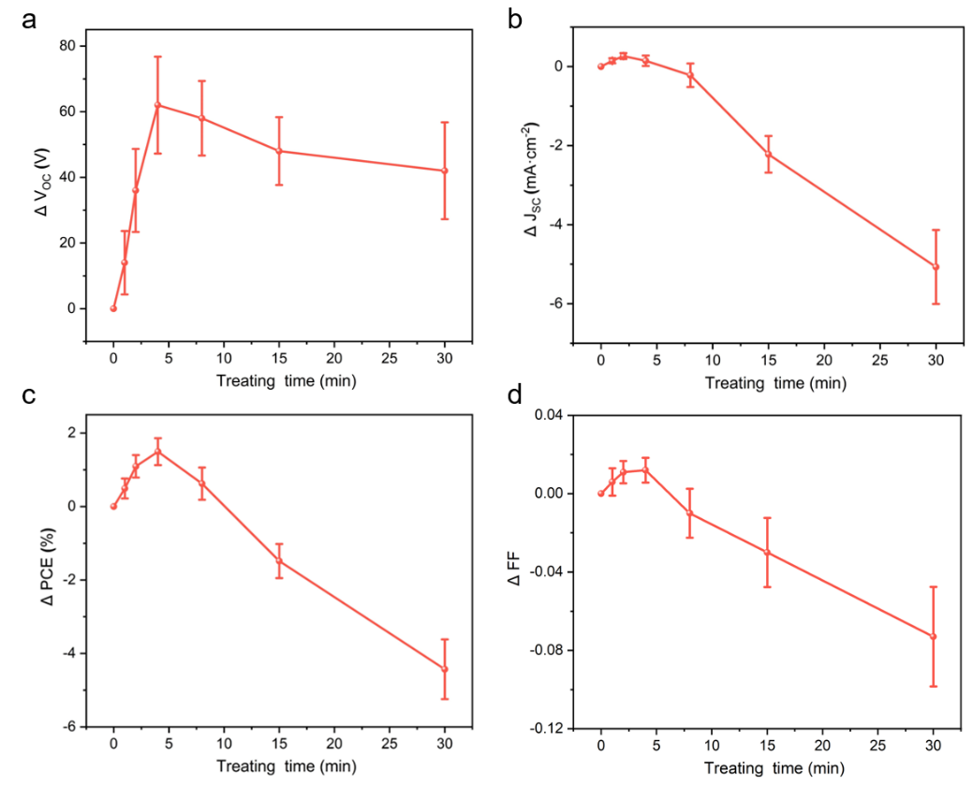
Supplementary Figure 8. Statistical distribution diagrams of the variation of photoelectric parameters under different DA₂SO₄ treating time (10 devices for each batch).
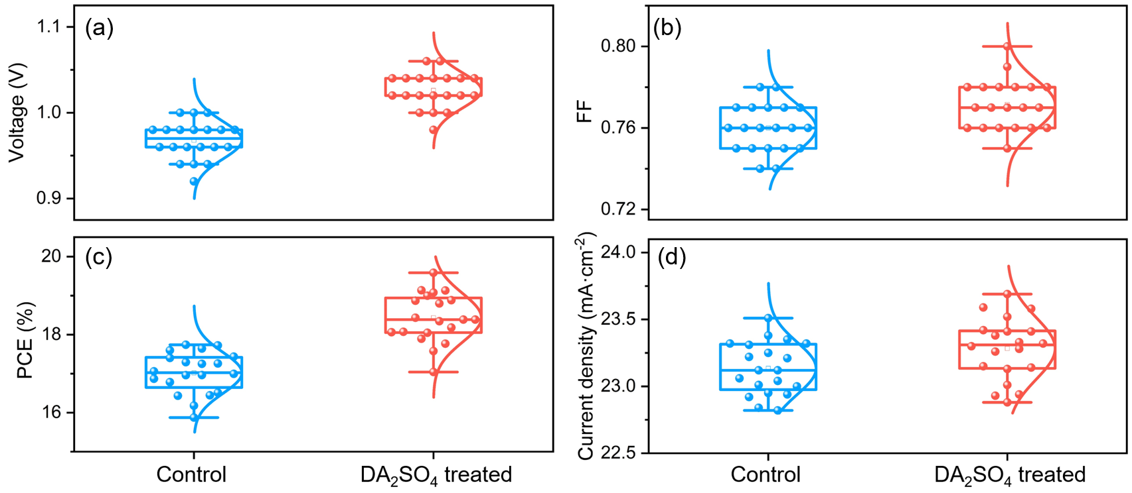
Supplementary Figure 9. Statistical distribution diagrams of the photoelectric parameters before and after DA₂SO₄ treatment (20 devices for each batch).

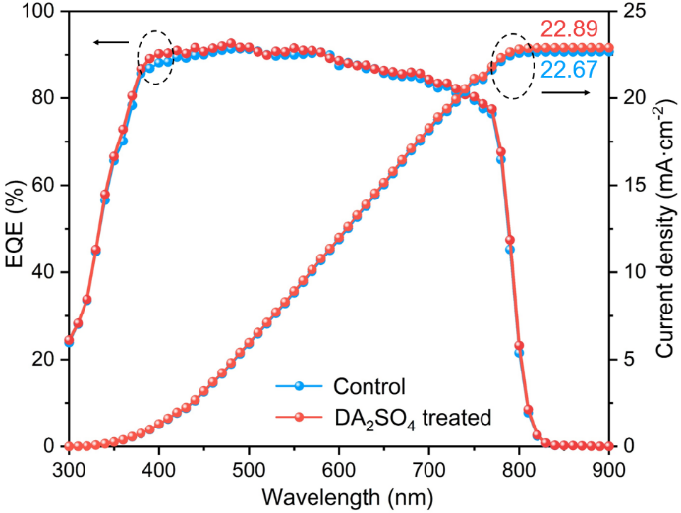
Supplementary Figure 10. EQE spectra and integrated current density curves of the pristine and champion DA₂SO₄ treated devices.

Supplementary Table 1. The fitted TRPL parameters of the untreated and DA₂SO₄ treated perovskites in mp-ZrO₂/glass structure.
 | $τ_{1}$ (ns) | $τ_{2}$ (ns) | $$B_{1}$$ | $$B_{2}$$ | $τ_{ave}$ (ns)
Control | 65.899 | 469.86 | 0.378 | 0.622 | 317.04
DA₂SO₄ treated | 103.01 | 1162.8 | 0.197 | 0.803 | 954.07

Supplementary Table 2. The variation of photoelectric parameters of the devices before and after DA₂SO₄ treatment (10 devices for each batch).
 | ΔV_{OC} (mV) | ΔJ_{SC} (mA·cm⁻²) | ΔFF | ΔPCE (%)
1 min | 14±9.66 | 0.148±0.064 | 0.006±0.0070 | 0.491±0.272
2 mins | 36±12.65 | 0.267±0.075 | 0.011±0.0057 | 1.093±0.306
4 mins | 62±14.76 | 0.148±0.133 | 0.012±0.0063 | 1.494±0.367
8 mins | 58±11.35 | -0.219±0.298 | -0.010±0.0125 | 0.623±0.438
15 mins | 48±10.33 | -2.22±0.464 | -0.030±0.0176 | -1.484±0.466
30 mins | 42±14.76 | -5.07±0.937 | -0.073±0.0254 | -4.432±0.812

Supplementary Table 3. Photoelectric parameters of the devices before and after DA₂SO₄ treatment (20 devices for each batch).
 | V_{OC} (V) | J_{SC} (mA·cm⁻²) | FF | PCE (%)
Control | 0.968±0.022 | 23.13±0.20 | 0.741±0.024 | 17.02±0.53
DA₂SO₄ treated | 1.026±0.021 | 23.28±0.23 | 0.761±0.022 | 18.43±0.63

