Supplementary Information for

Peripheral administration of sepiapterin replenishes brain tetrahydrobiopterin
Akiko Ohashi,^{1,2} Hiroshi Matsuoka,³ Eiko Nakamaru-Ogiso,^{4,5} Shin Aizawa,² and Hiroyuki Hasegawa^{2*}
¹ Department of Anatomy, Nihon University School of Dentistry, Chiyoda, Tokyo 101-8310, Japan
² Department of Functional Morphology, Nihon University School of Medicine, Itabashi, Tokyo 173-8610, Japan
³ Department of Life & Health Sciences, Teikyo University of Science, Adachi, Tokyo 120-0045, Japan
⁴ Mitochondrial Medicine Frontier Program, Division of Human Genetics, Department of Pediatrics, The Children’s Hospital of Philadelphia, Philadelphia, PA 19104, USA
⁵ Department of Pediatrics, University of Pennsylvania Perelman School of Medicine, Philadelphia, PA 19104, USA
* Corresponding author:
Hiroyuki Hasegawa
Email: hsgw-bh4@asahi-net.email.ne.jp

This file includes:
Supplementary Figure S1
Supplementary Figure S2

Supplementary Figure S1
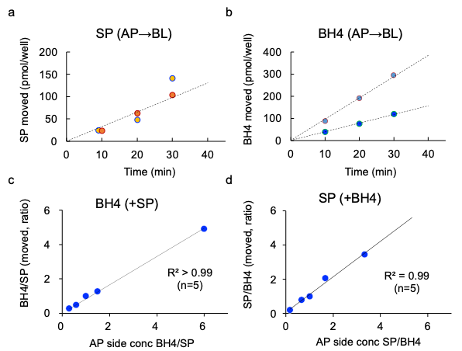
Figure S1. Linear time course of permeation and lack of interference between coexisting SP and 6RBH4 in the RBEC monolayer BBB model.
The in vitro model (BBB Kit® RBT-24™, 0.33 cm²) was used as described in Figure 4.
a) and b) Linearity of the time course of SP and 6RBH4: The linearity is a prerequisite for the estimation of the permeation coefficients of SP and 6RBH4 from the measured permeation at a fixed time. Permeation was initiated by adding 100 µM SP (a) or 6RBH4 (b) to the AP side of two wells each (indicated by two shades). After 10, 20, and 30 min of tracking, an aliquot (50 µL) was removed from the BL side of each well for measurement and 50 µL of HBSS solution was added for volume correction. In the graph, the change in concentration due to this withdrawal was corrected by calculation. a) SP permeation proceeded linearly at almost the same rate in the two wells. b) 6RBH4 permeation was linear over time in each well. However, the two wells showed different rates despite the same concentration of 6RBH4, due to well-to-well variation during long-term reconstitution incubation, which is inevitable with this model kit, as mentioned in the Materials and Methods section.
c) and d) Permeation of SP and 6RBH4 does not interfere when placed together in one well for comparison: With this model kit, some well-to-well variability is inevitable, as shown above. This error can be reduced by simultaneously measuring the compounds being compared in the same well. To determine whether SP and 6RBH4 interfere with each other's permeability, their permeation was examined at various ratios of the two compounds. Permeation was initiated by adding SP and 6RBH4 at the indicated concentration ratios to the AP side of each well. c) The ratio of BH4/SP that penetrated the BL side (y-axis) is plotted against the concentration ratio placed on the AP side (x-axis). The ratio of the amount of BH4/SP that permeated to the BL side (y-axis) was proportional to the ratio of the concentrations of 6RBH4/SP placed together on the AP side (R² > 0.99, n=5). All concentrations used for BH4/SP are in µM and are listed from left to right as follows: 0.3 = 30/100, 0.6 = 60/100, 1 = 50/50, 1.5 = 150/100, and 6 = 600/100. d) The ratio of SP/BH4 on the BL side (y-axis) is plotted against the concentration ratio SP/BH4 placed on the AP side (x-axis). The permeation ratio of SP/BH4 was proportional to the concentration ratio SP/BH4 when both SP and 6RBH4 were placed together on the AP side (R² = 0.99, n=5), irrespective of the concentration, as long as SP and 6RBH4 were placed in the same well. The concentration ratios of SP/BH4 on the AP side were 0.17 = 100/600, 0.67 = 100/150, 1 = 50/50, 1.7 = 100/60, and 3.3 = 100/30 in µM. From these data, we have confirmed that SP and 6RBH4 do not interfere with each other. This means that we can measure the permeation of SP in the presence of any concentration of 6RBH4 and vice versa. This saves on the number of wells required, which reduces errors due to inevitable well-to-well variation.
SP, sepiapterin; AP, apical side; BBB, blood–brain barrier; BL, basolateral side; BH4: tetrahydrobiopterin; RBEC: rat brain endothelial cells; 6RBH4: 6R-L-erythro-5,6,7,8-tetrahydrobiopterin

Supplementary Figure S2
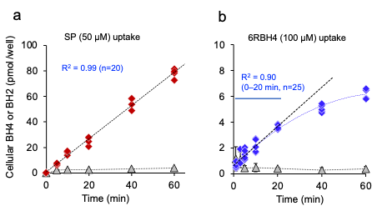

Figure S2. SP uptake proceeds linearly, while the linearity of 6RBH4 uptake is limited.
Linearity of uptake was verified as it is a prerequisite for calculating clearance from rate. The culture system was the same CTX TNA2 cells at 1 × 10⁵/well as used in Figure 5. The linear uptake kinetics of SP was evident, whereas those of 6RBH4 were limited, potentially affecting the validity of the 6RBH4 clearance calculation. a) A progressive increase in cellular BH4 (red) was observed upon exposure to 50 μM SP for 60 min (linearity, R² = 0.99, full range, n = 20). b) The accumulation of BH4 upon exposure to 100 µM 6RBH4 (blue) showed exponential kinetics, indicating a type of x = A·(1 – e^{–kt}), with a gradual slowing down with time. Therefore, based on regression analysis using uptake up to 20 min (R² = 0.90, 0-20 min, n = 25), we concluded that uptake during the first 20 min was acceptable as linear. In both (a) and (b), the metabolic intermediate BH2 (gray) appeared as a steady state, consistent with the characteristic mechanism of 6RBH4 uptake compared to SP uptake shown in Figure 5-b. In (a), BH2 is an intermediate in the salvage pathway that appears in SP uptake and conversion.¹ Alternatively, in (b), BH2 is an oxidation product of extracellularly supplied BH4 that is taken up preferentially to BH4 and subsequently converted to BH4.²
SP: sepiapterin; BH4: Tetrahydrobiopterin; BH2: dihydrobiopterin; 6RBH4: 6R-L-erythro-5,6,7,8-tetrahydrobiopterin

1. Sawabe, K. et al. Cellular uptake of sepiapterin and push-pull accumulation of tetrahydrobiopterin. Mol Genet Metab. 94, 410-416 (2008).
2. Sawabe, K., Suetake, Y., Nakanishi, N., Wakasugi, K. O. & Hasegawa, H. Cellular accumulation of tetrahydrobiopterin following its administration is mediated by two different processes; direct uptake and indirect uptake mediated by a methotrexate-sensitive process. Mol Genet Metab. 86 Suppl 1, S133-138 (2005).

