Using AI-Powered Mid-Infrared Spectroscopy for Malaria Screening Under Varying Parasite Densities and Anaemic Conditions
Issa H. Mshani^{1, 2}*, Frank M. Jackson¹, Rehema Y. Mwanga¹, Prisca A. Kweyamba^{1,3,4}, Emmanuel P. Mwanga^{1, 2} , Mgeni M. Tambwe¹, Lorenz M. Hofer^{1,3}, Doreen J. Siria^{1,2}, Mario González-Jiménez^{2, 5}, Klaas Wynne⁵, Sarah J. Moore^{1,3,4,6}, Fredros Okumu^{1, 2, 6, 7}*†, Simon A. Babayan²*† and Francesco Baldini^{1,2}*†
- Ifakara Health Institute, Environmental Health, and Ecological Sciences Department, Morogoro, United Republic of Tanzania.
- The University of Glasgow, School of Biodiversity, One Health and Veterinary Medicine, Glasgow, UK.
- Swiss Tropical and Public Health Institute, Kreuzstrasse , 4123 Allschwil, Switzerland
- University of Basel, Petersplatz , 4001 Basel, Switzerland
- The University of Glasgow, School of Chemistry, Glasgow G128QQ, UK.
- Nelson Mandela African Institution of Science and Technology, School of Life Sciences and Biotechnology, Arusha, United Republic of Tanzania.
- The University of the Witwatersrand, School of Public Health, Park Town, South Africa.

†Simon A. Babayan, Fredros Okumu and Francesco Baldini are equally co-supervised this work.
*Correspondence:
1. Issa H. Mshani: imshani@ihi.or.tz
2. Francesco Baldini: Francesco.Baldini@glasgow.ac.uk
3. Simon A. Babayan: Simon.Babayan@glasgow.ac.uk
4. Fredros Okumu: fredros@ihi.or.tz

Table S1: A two-way matrix of dried blood spots (DBS) generated in laboratory and used to train, test and validate machine-learning classifiers.
Hematocrit concentrations that mimic anemic condition
Malaria parasitemia (%) |  | Normal  (40-50%) | Moderate anemia  (25%) | Severe anemia (12.5%) | Total
Malaria parasitemia (%) | 6% | 335 | 335 | 335 | 1005
Malaria parasitemia (%) | 0.1% | 335 | 335 | 335 | 1005
Malaria parasitemia (%) | 0.002% | 335 | 335 | 335 | 1005
Malaria parasitemia (%) | 0.00003% | 335 | 335 | 335 | 1005
Malaria parasitemia (%) | 0% | 335 | 150 | 150 | 635
Total DBS |  | 1675 | 1490 | 1490 | 4655

Table S2: A summary of total spectra discarded due to either excessive water content, atmospheric water vapor and carbon dioxide interferences or bad intensity.
Hematocrit concentrations that mimic anemic condition
Malaria parasitemia (%) |  | Normal  (40-50%) | Moderate anemia  (25%) | Severe anemia (12.5%) | Total
Malaria parasitemia (%) | 6% | 4 | 5 | 11 | 20
Malaria parasitemia (%) | 0.1% | 2 | 10 | 8 | 20
Malaria parasitemia (%) | 0.002% | 1 | 6 | 16 | 23
Malaria parasitemia (%) | 0.00003% | 2 | 3 | 6 | 11
Malaria parasitemia (%) | 0% | 3 | 11 | 7 | 22
Total DBS |  | 12 | 35 | 49 | 96

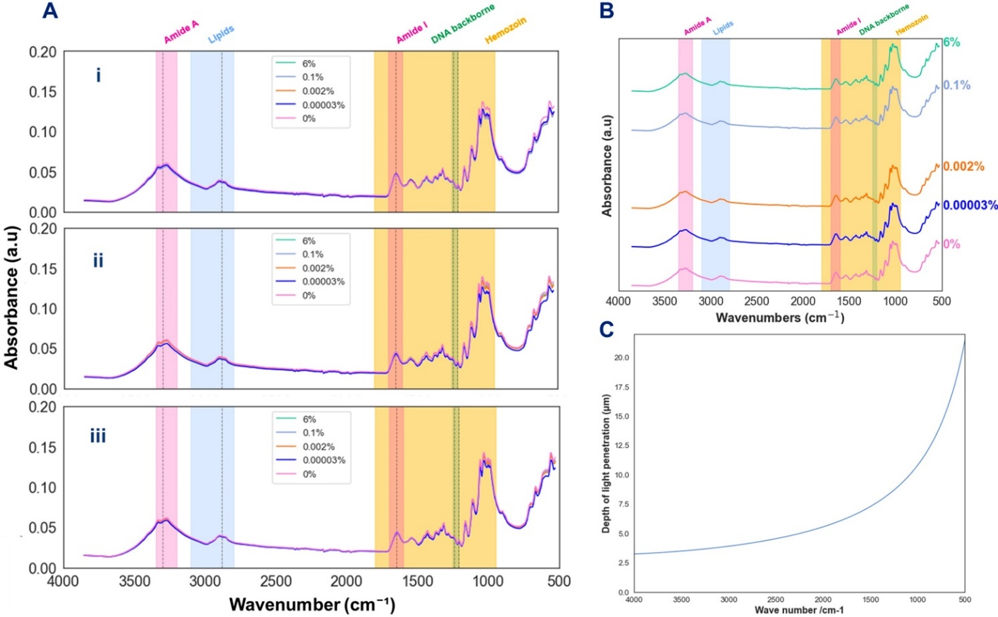
Figure S1: Average spectra of the generated anemic conditions, non-anemic (Ai), moderate (Aii), and severe anemia (Aiii) spectra. (B) Illustrates the magnified (Ai) for a better visualization of the average spectra of specific parasitemia in non-anemic samples. (C) Represent the estimated depth of light penetration to the DBS sample.

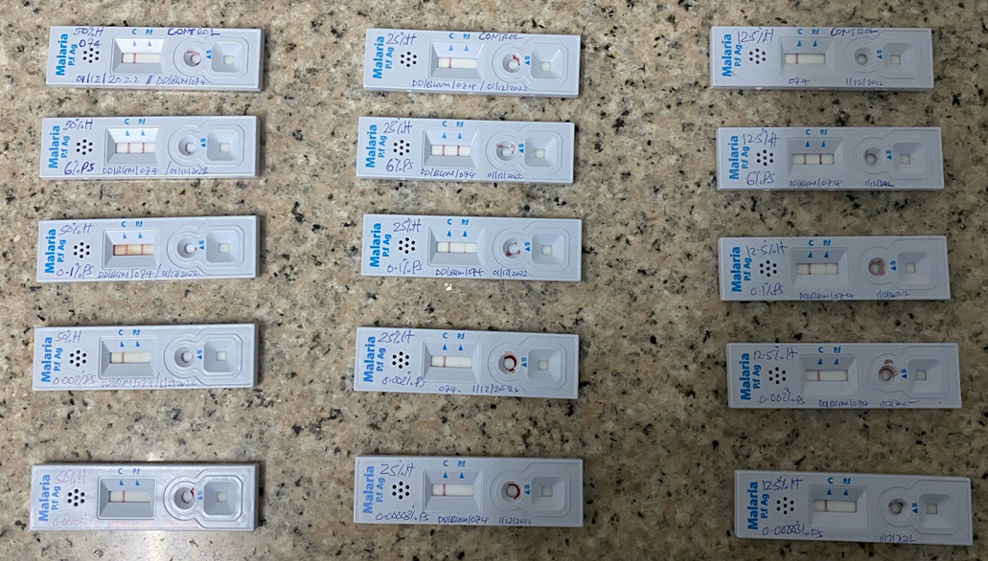
Figure S2: RDTS showing results when we tested the final dilutions sample as part of quality assurance processes
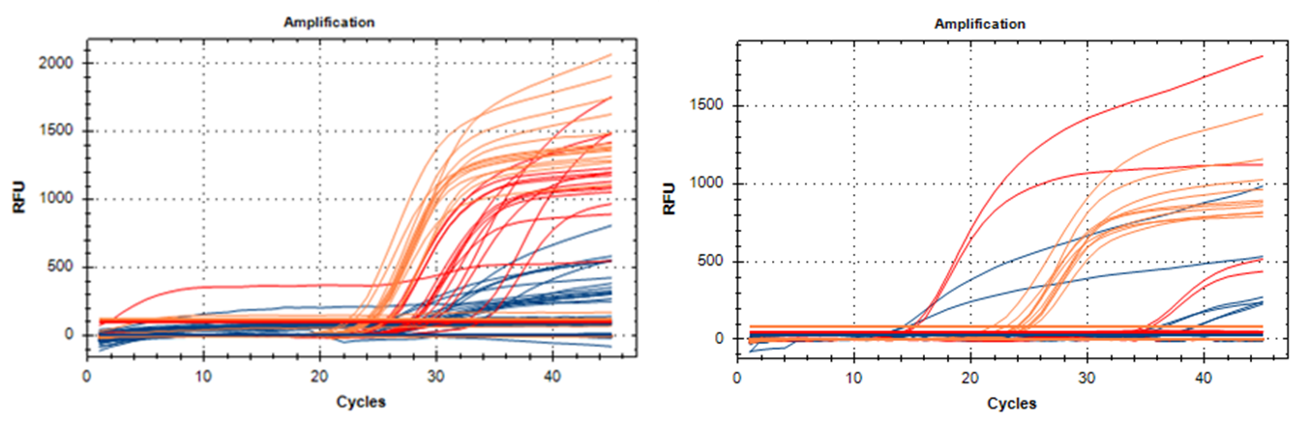
Figure S3: A representative PCR amplification cycles for the random samples generated in the laboratory as part of quality assurance processes

