Supplemental Materials
Supplementary Table S1. Comparisons between baseline and follow-up echocardiographic features according to ARNI dose stratified by BP profiles
Page 2
Supplementary Table S2. Comparisons in one-year interval changes in echocardiographic features between intermediate/high-dose and low-dose groups stratified by BP profiles
Page 4
Page 5
Supplementary Figure S1. Relationship between average ARNI dose and SBP
Page 6
Supplementary Figure S2. Spline curves for the clinical outcomes associated with ARNI dose according to BP profile
Page 7
Supplementary Figure S3. Spline curves for the clinical outcomes associated with systolic BP

Supplementary Table S1. Comparisons between baseline and follow-up echocardiographic features according to ARNI dose stratified by BP profiles
Total population | Intermediate- to High-dose |  |  | Low-dose
Total population | Baseline | Follow-up | p | Baseline | Follow-up | p
LVEDD, mm | 60 (55–65) | 55 (50–61) | <0.001 | 58 (53–63) | 54 (50–61) | <0.001
LVEDV, ml | 160 (127–200) | 127 (98–166) | <0.001 | 151 (115–189) | 126 (94–169) | <0.001
LVESV, ml | 110 (85–146) | 74 (53–110) | <0.001 | 104 (79–139) | 73 (51–109) | <0.001
LVEF, % | 30 (24–35) | 39 (33–49) | <0.001 | 31 (26–36) | 40 (32–50) | <0.001
LVMI, g/m² | 135.5 (113.1–158.9) | 118.1 (99.4–144.1) | <0.001 | 136.7 (108.6–162.6) | 118.4 (97.0–149.7) | <0.001
LAVI, ml/m² | 55 (43–72) | 43 (33–60) | <0.001 | 59 (41–80) | 51 (36–67) | <0.001
E/e' | 15 (11–22) | 12 (9–16) | <0.001 | 17 (12–26) | 13 (10–20) | <0.001
PASP, mmHg | 33 (26–44) | 28 (24–34) | <0.001 | 34 (28–48) | 31 (26–39) | <0.001
Echo interval, days | 399 (328–489) |  |  | 378 (300–466)
High-BP profiles | Intermediate- to High-dose |  |  | Low-dose
High-BP profiles | Baseline | Follow-up | p | Baseline | Follow-up | p
LVEDD, mm | 60 (55–65) | 55 (50–60) | <0.001 | 59 (54–63) | 54 (50–61) | <0.001
LVEDV, ml | 158 (126–197) | 125 (97–161) | <0.001 | 160 (125–193) | 127 (95–171) | <0.001
LVESV, ml | 107 (85–143) | 72 (51–102) | <0.001 | 109 (80–141) | 73 (52–110) | <0.001
LVEF, % | 31 (25–35) | 41 (33–50) | <0.001 | 31 (26–36) | 40 (31–50) | <0.001
LVMI, g/m² | 137.6 (115.4–160.3) | 120.3 (101.1–145.4) | <0.001 | 142.0 (118.8–164.8) | 128.4 (100.9–157.2) | <0.001
LAVI, ml/m² | 54 (42–69) | 42 (33–59) | <0.001 | 60 (46–80) | 51 (38–68) | 0.013
E/e' | 15 (11–21) | 12 (9–16) | <0.001 | 18 (12–26) | 14 (10–20) | <0.001
PASP, mmHg | 32 (26–43) | 28 (24–34) | <0.001 | 39 (30–49) | 32 (28–41) | 0.003
Echo interval, days | 391 (323–483) |  |  | 388 (306–486)
Low-BP profiles | Intermediate- to High-dose |  |  | Low-dose
Low-BP profiles | Baseline | Follow-up | p | Baseline | Follow-up | p
LVEDD, mm | 60 (56–65) | 56 (51–63) | <0.001 | 57 (52–63) | 55 (50–62) | <0.001
LVEDV, ml | 163 (130–206) | 135 (100–183) | <0.001 | 139 (112–186) | 126 (89–160) | <0.001
LVESV, ml | 117 (87–157) | 81 (57–124) | <0.001 | 97 (74–137) | 75 (51–108) | <0.001
LVEF, % | 28 (23–34) | 37 (29–47) | <0.001 | 31 (26–36) | 40 (32–48) | <0.001
LVMI, g/m² | 131.6 (109.2–154.5) | 113.1 (95.5–140.0) | <0.001 | 123.9 (100.4–157.5) | 108.9 (93.1–144.8) | <0.001
LAVI, ml/m² | 58 (45–80) | 46 (36–64) | <0.001 | 56 (40–80) | 50 (35–66) | 0.012
E/e' | 15 (11–25) | 12 (8–16) | <0.001 | 17 (12–25) | 13 (10–22) | 0.003
PASP, mmHg | 35 (27–46) | 28 (24–34) | <0.001 | 32 (26–45) | 30 (24–36) | 0.001
Echo interval, days | 408 (342–496) |  |  | 370 (287–450)
Abbreviations: BP, blood pressure; LAVI, left atrial volume index; LVEDD, left ventricular end-diastolic dimension; LVEDV, left ventricular end-diastolic volume; LVEF, left ventricular ejection fraction; LVESV, LV end-systolic volume; LVMI, left ventricular mass index; PASP, pulmonary artery systolic pressure
Supplementary Table S2. Comparisons in one-year interval changes in echocardiographic features between intermediate/high-dose and low-dose groups stratified by BP profiles
 | Total population
 | Intermediate/high dose | Low dose | p
∆ LVEDD, mm | 3.0 (0.0–7.0) | 2.0 (-1.0–5.5) | 0.002
∆ LVEDV, ml | 23.0 (3.0–56.0) | 15.0 (-4.0–47.3) | 0.028
∆ LVESV, ml | 26.0 (6.0–57.0) | 21.5 (1.0–52.0) | 0.072
∆ LVEF, % | 8.0 (1.0–19.0) | 6.0 (0.0–18.0) | 0.133
∆ LVMI, g/m² | 15.4 (-2.2–34.6) | 8.3 (-6.7–30.3) | 0.026
∆ LAVI, ml/m² | 9.0 (-1.0–21.0) | 5.0 (-8.4–20.2) | 0.031
∆ E/e' | 3.0 (0.0–7.0) | 3.0 (-2.0–8.0) | 0.176
∆ PASP, mmHg | 4.0 (-2.0–11.0) | 3.5 (-3.0–13.0) | 0.839
 | High-BP profiles
 | Intermediate/high dose | Low dose | p
∆ LVEDD, mm | 4.0 (0.0–8.0) | 2.0 (0.0–7.5) | 0.047
∆ LVEDV, ml | 25.0 (4.0–57.0) | 15.0 (-5.5–47.5) | 0.026
∆ LVESV, ml | 26.0 (7.0–59.0) | 21.0 (-1.0–55.0) | 0.060
∆ LVEF, % | 8.5 (1.0–20.0) | 5.0 (-1.0–17.5) | 0.040
∆ LVMI, g/m² | 15.8 (-1.8–34.9) | 5.9 (-8.8–24.8) | 0.028
∆ LAVI, ml/m² | 8.3 (-1.0–21.9) | 2.6 (-9.0–26.0) | 0.089
∆ E/e' | 3.0 (0.0–7.0) | 2.0 (-2.0–9.0) | 0.560
∆ PASP, mmHg | 4.0 (-2.0–10.0) | 3.0 (-3.5–13.0) | 0.957
 | Low-BP profiles
 | Intermediate/high dose | Low dose | p
∆ LVEDD, mm | 3.0 (0.0–7.0) | 2.0 (-1.0–5.0) | 0.070
∆ LVEDV, ml | 20.0 (-3.5–50.5) | 15.0 (-3.0–46.7) | 0.783
∆ LVESV, ml | 23.0 (2.5–51.5) | 23.0 (3.5–47.0) | 0.873
∆ LVEF, % | 6.0 (1.0–17.0) | 6.5 (1.0–18.0) | 0.662
∆ LVMI, g/m² | 15.1 (-2.4–33.0) | 14.0 (-6.2–31.9) | 0.378
∆ LAVI, ml/m² | 9.0 (-3.0–20.0) | 7.0 (-7.0–17.0) | 0.246
∆ E/e' | 3.0 (0.0–7.5) | 3.0 (-2.0–7.0) | 0.154
∆ PASP, mmHg | 5.0 (0.0–12.0) | 4.0 (-2.5–12.5) | 0.614
Abbreviations: BP, blood pressure; LAVI, left atrial volume index; LVEDD, left ventricular end-diastolic dimension; LVEDV, left ventricular end-diastolic volume; LVEF, left ventricular ejection fraction; LVESV, LV end-systolic volume; LVMI, left ventricular mass index; PASP, pulmonary artery systolic pressure
Supplementary Figure S1. Relationship between average ARNI dose and SBP. Correlation between average ARNI dose and on-treatment SBP was plotted. ARNI, angiotensin receptor-neprilysin inhibitor; SBP, systolic blood pressure
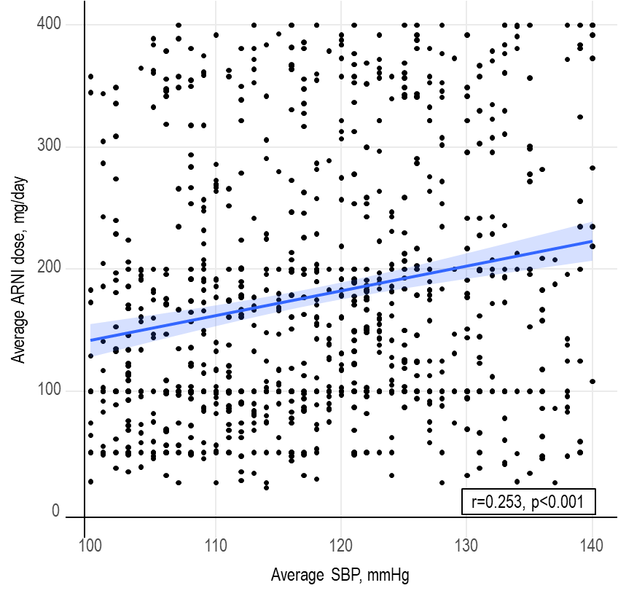
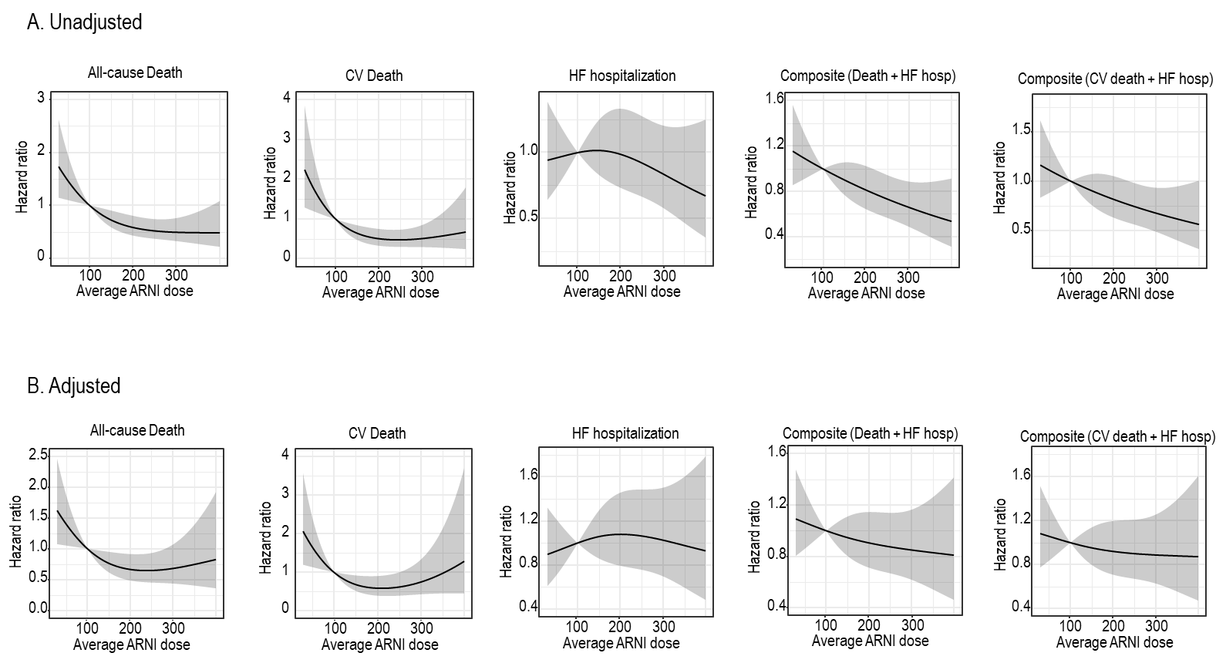
Supplementary Figure S2. Spline curves for the clinical outcomes associated with ARNI dose according to BP profile. Spline curves of clinical outcomes were plotted for average ARNI dose. Covariates (average SBP, age, sex, and baseline LVEF) were included for adjusted curves. ARNI, angiotensin receptor-neprilysin inhibitor; BP blood pressure; CV, cardiovascular; HF, heart failure
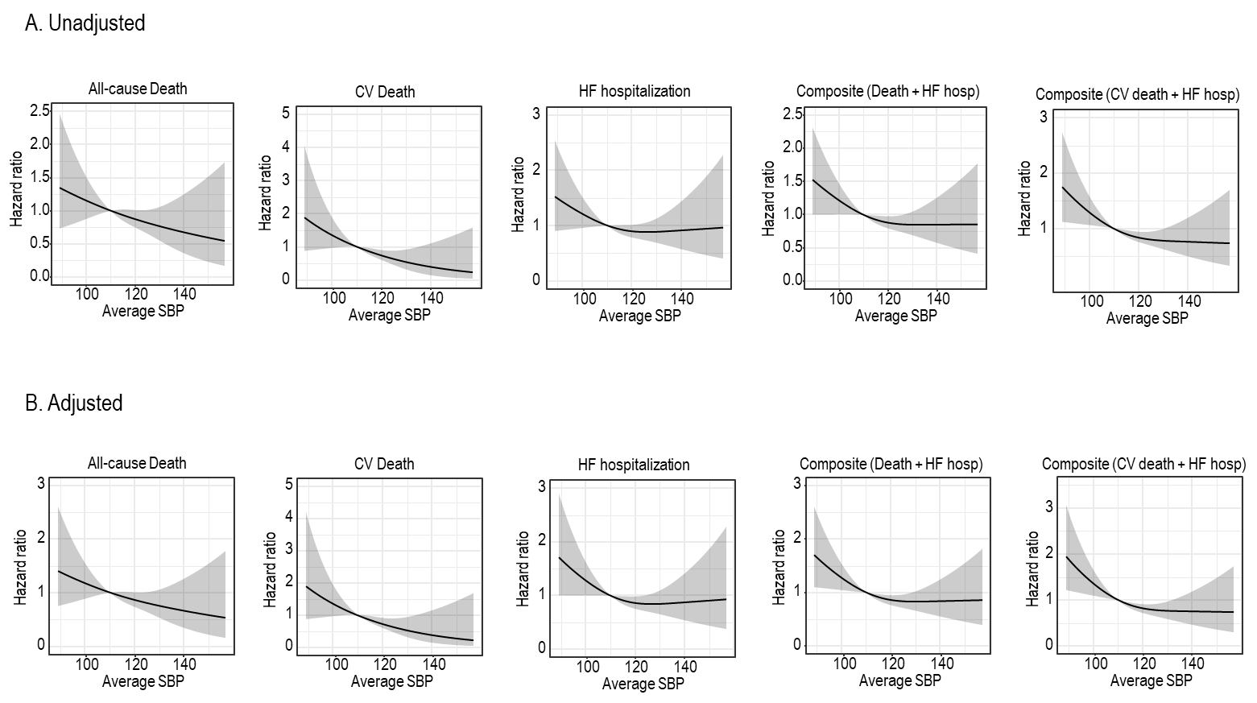
Supplementary Figure S3. Spline curves for the clinical outcomes associated with systolic BP. Spline curves of clinical outcomes were plotted for average SBP. Covariates (average SBP, age, sex, and baseline LVEF) were included for adjusted curves. CV, cardiovascular; HF, heart failure; SBP, systolic blood pressure

