Supplementary materials
Table S1 Baseline Characteristics of Patients with Hepatocellular Carcinoma by prognosis (survival or death)
 | Total (n = 87) | HCs (n = 55) | HCd (n = 32) | P_{value}
Age (year)ª | 50.84 (12.88) | 50.08 (12.83) | 57.02 (12.06) | 0.839
Median follow-up time (day) | 2513 | 2696 | 850 | <0.001
Sex, n (%) |  |  |  | 0.626
Men | 74 (85.1) | 46 (83.6) | 28 (87.5)
Women | 13 (14.9) | 9 (16.4) | 4 (12.5)
BMI (kg/m²)ª | 22.25 (3.29) | 22.57 (2.81) | 22.00 (2.36) | 0.767
Physical activity (MET-h/d)ª | 29.70  (26.10,38.25) | 29.56  (25.50,38.42) | 30.00  (27.28,38.86) | 0.395
Residence, n (%) |  |  |  | 0.652
Urban | 57 (65.5) | 37 (67.3) | 20 (62.5)
Rural | 30 (34.5) | 18 (32.7) | 12 (37.5)
Education level, n (%) |  |  |  | 0.460
Primary school or below | 20 (23.3) | 13 (24.1) | 7 (21.9)
Secondary or technical secondary school | 50 (58.1) | 29 (53.7) | 21 (65.6)
College or above | 16 (18.6) | 12 (22.2) | 4 (12.5)
Smoking status, n (%) |  |  |  | 0.038
Never smoker | 48 (55.2) | 35 (63.6) | 13 (40.6)
Former smoker | 16 (18.4) | 6 (10.9) | 10 (31.3)
Current smoker | 23 (26.4) | 14 (25.5) | 9 (28.1)
Alcohol drinking status, n (%) |  |  |  | 0.766
Never drinker | 62 (71.3) | 38 (69.1) | 24 (75.0)
Former drinker | 11 (12.6) | 8 (14.5) | 3 (9.4)
Current drinker | 14 (16.1) | 9 (16.4) | 5 (15.6)
Presence of chronic diseases, n (%)
FLD | 15 (17.2) | 12 (21.8) | 3 (9.4) | 0.138
Cirrhosis | 69 (79.3) | 42 (76.4) | 27 (84.4) | 0.374
With family history of PLC, n (%) | 18 (20.7) | 12 (21.8) | 6 (18.8) | 0.733
HBV infection^{b} | 82 (94.3) | 52 (94.5) | 30 (93.8) | 0.878
ALT (U/L)ª | 35.40  (26.00,43.50) | 35.40  (25.40,42.90) | 34.20  (26.83,44.15) | 0.650
AST (U/L)ª | 33.20  (26.80,42.60) | 31.80  (26.40,40.60) | 38.60  (28.13,58.63) | 0.017
AST/ALTª | 1.00 (0.75,1.28) | 0.95 (0.74,1.19) | 1.07 (0.80,1.38) | 0.020
TC (mmol/L)ª | 4.88 (4.34,5.50) | 4.95 (4.35,5.77) | 4.82 (4.33,5.29) | 0.223
TG (mmol/L)ª | 0.97 (0.67,1.30) | 1.06 (0.67,1.40) | 0.88 (0.67,1.12) | 0.908
LDLC (mmol/L)ª | 2.96 (2.53,3.67) | 3.00 (2.61,3.77) | 2.88 (2.37,3.48) | 0.242
HDLC (mmol/L)ª | 1.31 (1.07,1.51) | 1.31 (1.09,1.51) | 1.32 (1.02,1.51) | 0.313
AFP≥200 ng/L, n (%) | 43 (49.4) | 27 (49.1) | 16 (50.0) | 0.935
CRP≥3 mg/L, n (%) | 27 (31.0) | 10 (18.2) | 17 (53.1) | 0.001
TNM stage, n (%) |  |  |  | <0.001
Ⅰ | 41 (47.1) | 31 (56.4) | 10 (31.3)
Ⅱ | 26 (29.9) | 20 (36.4) | 6 (18.8)
Ⅲ | 16 (18.4) | 4 (7.3) | 12 (37.5)
Ⅳ | 4 (4.6) |  | 4 (12.5)
BCLC stage, n (%) |  |  |  | 0.010
0 | 5 (5.7) | 4 (7.3) | 1 (3.1)
A | 37 (42.5) | 28 (50.9) | 9 (28.1)
B | 8 (9.2) | 7 (12.7) | 1 (3.1)
C | 37 (42.5) | 16 (29.1) | 21 (65.6)
Treatment, n (%) |  |  |  | 0.480
Liver resection | 81 (93.1) | 51 (92.7) | 30 (93.8)
Radiofrequency ablation | 2 (2.3) | 2 (3.6)
Intervention | 4 (4.6) | 2 (3.6) | 2 (6.3)
Abbreviations: BMI, body mass index; MET, metabolic equivalent; FLD, fatty liver disease; HBV, hepatitis B virus; ALT, alanine amino transferase; AST, aspartate amino transferase; TC, total cholesterol; TG, triglyceride; LDLC, low density lipoprotein cholesterol; HDLC, high density lipoprotein cholesterol; AFP, alpha fetoprotein; CRP, C-reaction protein; TNM stage, tumor-node-metastasis stage; BCLC stage, Barcelona Clinic Liver Cancer stage.
ª Values are mean ± SD or medians (interquartile range [IQR]).
^{b} HBV infection was defined as seropositivity of HBV surface antigen.
Table S2 Diagnostic power of total amount of phospholipids classes for HCC tissue and tumor-adjacent normal hepatic tissue
 | Fold Change | log2(FC) | VIP | FDR | AUC
LPC | 1.070 | 0.097 | 0.338 | 5.19E-01 | 0.537
LPE | 0.751 | -0.413 | 0.905 | 3.08E-05 | 0.672
LPG | 0.425 | -1.236 | 2.034 | 1.06E-11 | 0.816
LPI | 0.546 | -0.872 | 1.130 | 8.51E-06 | 0.692
PC | 1.262 | 0.336 | 1.452 | 1.49E-06 | 0.759
PE | 1.268 | 0.342 | 1.215 | 3.44E-03 | 0.707
PG | 0.813 | -0.298 | 0.630 | 9.75E-03 | 0.609
PI | 1.247 | 0.319 | 0.862 | 1.35E-02 | 0.617
PS | 1.040 | 0.056 | 0.316 | 3.07E-01 | 0.567
SM | 0.986 | -0.021 | 0.043 | 7.59E-01 | 0.541

Table S3 Thirty-six differential metabolites between HCC tissue and tumor-adjacent normal hepatic tissue
Identificationª | P | FDR | VIP | AUC | Tendency^{b}
Lysophosphatidylcholine
LPC (20:1) | 1.68E-12 | 1.28E-11 | 1.465 | 0.818 | D
Lysophosphatidylethanolamine
LPE (16:0) | 3.11E-18 | 6.66E-17 | 1.768 | 0.884 | D
LPE (18:3) | 2.78E-10 | 1.27E-09 | 1.271 | 0.776 | D
LPE (20:2) | 1.92E-12 | 1.37E-11 | 1.402 | 0.816 | I
LPE (20:3) | 2.12E-14 | 2.29E-13 | 1.647 | 0.859 | I
LPE (22:4) | 1.82E-12 | 1.34E-11 | 1.409 | 0.819 | I
LPE (22:5) | 1.35E-08 | 4.26E-08 | 1.178 | 0.770 | I
Lysophosphatidylglycerol
LPG (18:1) | 4.09E-10 | 1.71E-09 | 1.281 | 0.760 | D
LPG (18:2) | 8.88E-12 | 5.43E-11 | 1.485 | 0.811 | D
Lysophosphatidylinositol
LPI (18:0) | 1.38E-10 | 6.89E-10 | 1.351 | 0.767 | D
LPI (18:2) | 1.68E-06 | 4.03E-06 | 1.18 | 0.744 | D
Phosphatidylcholine
PC (30:0) | 3.49E-25 | 2.49E-23 | 1.97 | 0.932 | I
PC (30:1) | 4.08E-20 | 9.69E-19 | 1.771 | 0.903 | I
PC (32:1) | 2.85E-14 | 2.91E-13 | 1.515 | 0.832 | I
PC (33:0) | 3.26E-21 | 9.96E-20 | 1.902 | 0.917 | I
PC (38:2) | 2.14E-23 | 1.14E-21 | 1.953 | 0.912 | I
PC (38:3) | 9.76E-16 | 1.39E-14 | 1.725 | 0.856 | I
PC (39:3) | 1.01E-22 | 4.33E-21 | 1.929 | 0.911 | D
PC (40:2) | 8.75E-17 | 1.56E-15 | 1.692 | 0.865 | D
PC (40:3) | 8.51E-29 | 1.82E-26 | 2.127 | 0.948 | D
PC (40:4) | 3.33E-16 | 5.09E-15 | 1.736 | 0.867 | I
PC (40:7) | 1.66E-14 | 1.97E-13 | 1.589 | 0.867 | I
PC (P-36:3) | 2.25E-13 | 1.79E-12 | 1.503 | 0.836 | I
PC (P-38:3) | 1.34E-14 | 1.69E-13 | 1.633 | 0.866 | I
PC (P-38:4) | 3.24E-11 | 1.78E-10 | 1.39 | 0.811 | I
PC (P-40:6) | 3.84E-12 | 2.57E-11 | 1.412 | 0.808 | D
PC (P-42:2) | 3.00E-09 | 1.07E-08 | 1.222 | 0.761 | D
PC (P-42:4) | 4.68E-14 | 4.36E-13 | 1.58 | 0.834 | D
PC (P-42:5) | 1.17E-16 | 1.92E-15 | 1.591 | 0.849 | D
PC (P-42:6) | 6.35E-17 | 1.23E-15 | 1.591 | 0.850 | D
Phosphatidylethanolamine
PE (32:1) | 2.44E-09 | 9.17E-09 | 1.245 | 0.762 | I
PE (41:7) | 1.54E-20 | 4.13E-19 | 1.774 | 0.889 | D
Phosphatidylinositol
PI (38:5) | 5.77E-10 | 2.37E-09 | 1.092 | 0.753 | I
PI (40:4) | 1.56E-10 | 7.60E-10 | 1.269 | 0.774 | I
Phosphatidylserine
PS (35:2) | 9.99E-07 | 2.43E-06 | 1.05 | 0.780 | D
PS (38:1) | 8.84E-26 | 9.46E-24 | 2.024 | 0.935 | D
ªSignificantly differential metabolites for comparison were selected based on FDR<0.05, VIP >1, FC>2 or <0.5.
^{b} “D” means downregulated and “I” means upregulated in HCC tissues when compared with NATs.

Table S4 Seventy-seven identified differential phospholipid species between HCC tissue and tumor-adjacent normal hepatic tissue in females
Phospholipid speciesª | P |  | AUC |  | FC |  | VIP |  | Tendency^{b}
Lysophosphatidylcholine
LPC (14:0) |  | 2.77E-03 |  | 0.793 |  | 1.806 |  | 1.331 |  | I
LPC (16:1) |  | 1.54E-03 |  | 0.828 |  | 1.711 |  | 1.515 |  | I
LPC (20:1) |  | 1.45E-02 |  | 0.781 |  | 0.425 |  | 1.051 |  | D
LPC (20:3) |  | 2.04E-02 |  | 0.763 |  | 1.944 |  | 1.186 |  | I
LPC (P-18:0) |  | 7.91E-03 |  | 0.822 |  | 1.654 |  | 1.442 |  | I
Lysophosphatidylethanolamine
LPE (16:0) |  | 7.05E-04 |  | 0.828 |  | 0.379 |  | 1.426 |  | D
LPE (16:1) |  | 1.97E-02 |  | 0.740 |  | 1.663 |  | 1.316 |  | I
LPE (20:1) |  | 1.61E-03 |  | 0.852 |  | 1.796 |  | 1.480 |  | I
LPE (20:2) |  | 1.81E-04 |  | 0.905 |  | 1.950 |  | 1.764 |  | I
LPE (20:3) |  | 4.73E-05 |  | 0.923 |  | 2.451 |  | 1.816 |  | I
LPE (20:4) |  | 3.30E-02 |  | 0.822 |  | 1.703 |  | 1.270 |  | I
LPE (22:4) |  | 2.00E-03 |  | 0.917 |  | 2.314 |  | 1.697 |  | I
LPE (22:5) |  | 1.81E-03 |  | 0.870 |  | 2.300 |  | 1.433 |  | I
Lysophosphatidylglycerol
LPG (18:1) |  | 1.25E-02 |  | 0.716 |  | 0.363 |  | 1.030 |  | D
LPG (18:2) |  | 2.02E-02 |  | 0.799 |  | 0.302 |  | 1.218 |  | D
Lysophosphatidylinositol
LPI (20:3) |  | 4.05E-02 |  | 0.716 |  | 1.416 |  | 1.032 |  | I
Phosphatidylcholine
PC (30:0) |  | 5.52E-04 |  | 0.905 |  | 4.314 |  | 1.748 |  | I
PC (30:1) |  | 2.75E-04 |  | 0.893 |  | 4.700 |  | 1.718 |  | I
PC (32:0) |  | 4.43E-02 |  | 0.775 |  | 1.440 |  | 1.232 |  | I
PC (32:1) |  | 2.83E-03 |  | 0.781 |  | 2.286 |  | 1.468 |  | I
PC (33:0) |  | 1.30E-04 |  | 0.947 |  | 2.894 |  | 1.884 |  | I
PC (33:1) |  | 3.55E-03 |  | 0.828 |  | 1.838 |  | 1.500 |  | I
PC (34:2) |  | 8.77E-03 |  | 0.828 |  | 0.870 |  | 1.301 |  | D
PC (35:2) |  | 2.27E-02 |  | 0.775 |  | 0.885 |  | 1.038 |  | D
PC (36:1) |  | 3.21E-02 |  | 0.817 |  | 1.467 |  | 1.144 |  | I
PC (38:2) |  | 3.89E-04 |  | 0.899 |  | 2.279 |  | 1.612 |  | I
PC (38:3) |  | 6.42E-03 |  | 0.805 |  | 2.267 |  | 1.375 |  | I
PC (38:4) |  | 3.32E-02 |  | 0.793 |  | 2.010 |  | 1.217 |  | I
PC (39:3) |  | 1.03E-04 |  | 0.876 |  | 0.159 |  | 1.552 |  | D
PC (40:1) |  | 2.74E-05 |  | 0.976 |  | 0.617 |  | 1.979 |  | D
PC (40:2) |  | 3.46E-06 |  | 0.994 |  | 0.383 |  | 1.926 |  | D
PC (40:3) |  | 1.30E-05 |  | 0.947 |  | 0.175 |  | 1.992 |  | D
PC (40:4) |  | 1.79E-03 |  | 0.893 |  | 2.247 |  | 1.673 |  | I
PC (40:7) |  | 3.42E-03 |  | 0.852 |  | 3.734 |  | 1.532 |  | I
PC (P-36:1) |  | 1.28E-02 |  | 0.781 |  | 0.868 |  | 1.105 |  | D
PC (P-36:2) |  | 3.10E-03 |  | 0.864 |  | 1.699 |  | 1.553 |  | I
PC (P-36:3) |  | 2.38E-03 |  | 0.923 |  | 2.443 |  | 1.731 |  | I
PC (P-38:2) |  | 8.02E-03 |  | 0.840 |  | 1.376 |  | 1.202 |  | I
PC (P-38:3) |  | 3.23E-03 |  | 0.929 |  | 2.253 |  | 1.723 |  | I
PC (P-38:4) |  | 4.29E-03 |  | 0.893 |  | 2.197 |  | 1.646 |  | I
PC (P-38:5) |  | 1.42E-02 |  | 0.757 |  | 0.809 |  | 1.158 |  | D
PC (P-40:6) |  | 2.51E-03 |  | 0.899 |  | 0.493 |  | 1.456 |  | D
PC (P-40:7) |  | 2.51E-04 |  | 0.893 |  | 0.757 |  | 1.651 |  | D
PC (P-42:2) |  | 6.88E-03 |  | 0.793 |  | 0.475 |  | 1.199 |  | D
PC (P-42:4) |  | 4.46E-03 |  | 0.799 |  | 0.401 |  | 1.251 |  | D
PC (P-42:5) |  | 1.64E-03 |  | 0.852 |  | 0.336 |  | 1.461 |  | D
PC (P-42:6) |  | 5.12E-03 |  | 0.864 |  | 0.417 |  | 1.598 |  | D
Phosphatidylethanolamine
PE (32:0) |  | 4.27E-02 |  | 0.751 |  | 1.777 |  | 1.253 |  | I
PE (33:1) |  | 3.65E-02 |  | 0.751 |  | 1.929 |  | 1.173 |  | I
PE (37:2) |  | 3.04E-03 |  | 0.888 |  | 0.578 |  | 1.350 |  | D
PE (37:4) |  | 5.09E-03 |  | 0.858 |  | 1.642 |  | 1.575 |  | I
PE (38:2) |  | 3.07E-02 |  | 0.740 |  | 1.951 |  | 1.176 |  | I
PE (39:6) |  | 4.23E-02 |  | 0.769 |  | 0.821 |  | 1.092 |  | D
PE (40:1) |  | 4.21E-02 |  | 0.799 |  | 0.735 |  | 1.196 |  | D
PE (40:2) |  | 1.66E-04 |  | 0.893 |  | 0.590 |  | 1.612 |  | D
PE (40:9) |  | 1.50E-03 |  | 0.959 |  | 0.566 |  | 1.655 |  | D
PE (41:5) |  | 4.27E-03 |  | 0.840 |  | 0.618 |  | 1.265 |  | D
PE (41:6) |  | 1.90E-03 |  | 0.923 |  | 0.606 |  | 1.591 |  | D
PE (41:7) |  | 5.34E-05 |  | 0.964 |  | 0.358 |  | 1.923 |  | D
PE (42:4) |  | 1.86E-03 |  | 0.846 |  | 0.551 |  | 1.420 |  | D
PE (42:9) |  | 3.25E-05 |  | 0.852 |  | 0.511 |  | 1.429 |  | D
Phosphatidylinositol
PI (36:3) |  | 4.65E-03 |  | 0.840 |  | 1.734 |  | 1.473 |  | I
PI (36:4) |  | 1.06E-02 |  | 0.834 |  | 1.700 |  | 1.305 |  | I
PI (38:3) |  | 1.20E-02 |  | 0.828 |  | 1.886 |  | 1.333 |  | I
PI (38:5) |  | 3.27E-03 |  | 0.876 |  | 1.971 |  | 1.545 |  | I
PI (38:6) |  | 3.99E-02 |  | 0.769 |  | 1.834 |  | 1.143 |  | I
PI (40:4) |  | 7.11E-03 |  | 0.870 |  | 2.330 |  | 1.493 |  | I
Phosphatidylserine
PS (38:1) |  | 1.74E-04 |  | 0.953 |  | 0.421 |  | 1.747 |  | D
PS (38:2) |  | 2.00E-02 |  | 0.722 |  | 0.671 |  | 1.068 |  | D
PS (38:3) |  | 3.33E-03 |  | 0.893 |  | 2.060 |  | 1.610 |  | I
Sphingomyelin
SM(d32:1) |  | 1.08E-02 |  | 0.704 |  | 1.337 |  | 1.061 |  | I
SM(d36:0) |  | 7.15E-03 |  | 0.799 |  | 0.625 |  | 1.343 |  | D
SM(d37:1) |  | 2.31E-03 |  | 0.746 |  | 0.674 |  | 1.107 |  | D
SM(d40:1) |  | 1.19E-02 |  | 0.716 |  | 0.617 |  | 1.056 |  | D
SM(d41:1) |  | 7.61E-03 |  | 0.781 |  | 0.642 |  | 1.216 |  | D
SM(d42:0) |  | 4.86E-02 |  | 0.704 |  | 0.660 |  | 1.060 |  | D
SM(d42:1) |  | 1.23E-02 |  | 0.781 |  | 0.690 |  | 1.176 |  | D
ª Significantly differential metabolites for comparison were selected based on P<0.05, VIP >1.
^{b} “D” means downregulated and “I” means upregulated in HCC tissues when compared with NATs.
Table S5 Eighty-eight identified differential phospholipid species between HCC tissue and tumor-adjacent normal hepatic tissue in males
Phospholipid speciesª | P |  | AUC |  | FC |  | VIP |  | Tendency^{b}
Lysophosphatidylcholine
LPC (16:0) |  | 1.29E-06 |  | 0.727 |  | 0.621 |  | 1.206 |  | D
LPC (18:0) |  | 2.05E-08 |  | 0.776 |  | 0.546 |  | 1.254 |  | D
LPC (20:0) |  | 6.53E-08 |  | 0.753 |  | 0.515 |  | 1.235 |  | D
LPC (20:1) |  | 3.42E-11 |  | 0.827 |  | 0.425 |  | 1.516 |  | D
Lysophosphatidylethanolamine
LPE (16:0) |  | 1.52E-15 |  | 0.893 |  | 0.379 |  | 1.793 |  | D
LPE (18:0) |  | 2.87E-08 |  | 0.770 |  | 0.550 |  | 1.223 |  | D
LPE (18:3) |  | 8.74E-11 |  | 0.803 |  | 0.437 |  | 1.393 |  | D
LPE (20:1) |  | 2.51E-09 |  | 0.803 |  | 1.796 |  | 1.198 |  | I
LPE (20:2) |  | 1.41E-09 |  | 0.800 |  | 1.950 |  | 1.322 |  | I
LPE (20:3) |  | 3.80E-11 |  | 0.843 |  | 2.451 |  | 1.593 |  | I
LPE (22:4) |  | 3.30E-10 |  | 0.806 |  | 2.314 |  | 1.349 |  | I
LPE (22:5) |  | 1.21E-06 |  | 0.751 |  | 2.300 |  | 1.121 |  | I
Lysophosphatidylglycerol
LPG (18:1) |  | 8.88E-09 |  | 0.767 |  | 0.363 |  | 1.288 |  | D
LPG (18:2) |  | 1.83E-10 |  | 0.818 |  | 0.302 |  | 1.493 |  | D
Lysophosphatidylinositol
LPI (18:0) |  | 9.43E-10 |  | 0.775 |  | 0.397 |  | 1.402 |  | D
LPI (18:2) |  | 1.23E-05 |  | 0.747 |  | 0.313 |  | 1.151 |  | D
Phosphatidylcholine
PC (30:0) |  | 2.55E-22 |  | 0.935 |  | 4.314 |  | 1.995 |  | I
PC (30:1) |  | 6.09E-17 |  | 0.909 |  | 4.700 |  | 1.780 |  | I
PC (32:0) |  | 1.06E-06 |  | 0.757 |  | 1.440 |  | 1.031 |  | I
PC (32:1) |  | 4.13E-12 |  | 0.841 |  | 2.286 |  | 1.524 |  | I
PC (32:2) |  | 8.10E-07 |  | 0.736 |  | 1.729 |  | 1.041 |  | I
PC (33:0) |  | 9.61E-18 |  | 0.913 |  | 2.894 |  | 1.874 |  | I
PC (33:1) |  | 9.69E-12 |  | 0.814 |  | 1.838 |  | 1.503 |  | I
PC (35:1) |  | 2.76E-07 |  | 0.732 |  | 1.456 |  | 1.124 |  | I
PC (36:1) |  | 2.86E-08 |  | 0.753 |  | 1.467 |  | 1.329 |  | I
PC (36:3) |  | 5.28E-08 |  | 0.768 |  | 1.529 |  | 1.200 |  | I
PC (38:2) |  | 2.54E-20 |  | 0.915 |  | 2.279 |  | 1.989 |  | I
PC (38:3) |  | 6.59E-14 |  | 0.863 |  | 2.267 |  | 1.760 |  | I
PC (38:4) |  | 1.18E-09 |  | 0.793 |  | 2.010 |  | 1.411 |  | I
PC (38:5) |  | 4.41E-08 |  | 0.770 |  | 1.984 |  | 1.234 |  | I
PC (39:3) |  | 2.87E-19 |  | 0.918 |  | 0.159 |  | 1.982 |  | D
PC (39:4) |  | 1.93E-06 |  | 0.753 |  | 0.563 |  | 1.110 |  | D
PC (39:5) |  | 4.50E-10 |  | 0.799 |  | 0.571 |  | 1.403 |  | D
PC (40:1) |  | 1.21E-10 |  | 0.812 |  | 0.617 |  | 1.409 |  | D
PC (40:2) |  | 8.54E-13 |  | 0.842 |  | 0.383 |  | 1.601 |  | D
PC (40:3) |  | 2.91E-24 |  | 0.949 |  | 0.175 |  | 2.132 |  | D
PC (40:4) |  | 7.80E-14 |  | 0.858 |  | 2.247 |  | 1.713 |  | I
PC (40:5) |  | 2.21E-07 |  | 0.744 |  | 1.847 |  | 1.254 |  | I
PC (40:6) |  | 6.46E-06 |  | 0.713 |  | 2.056 |  | 1.085 |  | I
PC (40:7) |  | 1.89E-12 |  | 0.873 |  | 3.734 |  | 1.593 |  | I
PC (P-36:2) |  | 3.55E-10 |  | 0.814 |  | 1.699 |  | 1.326 |  | I
PC (P-36:3) |  | 3.70E-11 |  | 0.825 |  | 2.443 |  | 1.448 |  | I
PC (P-38:3) |  | 1.89E-12 |  | 0.854 |  | 2.253 |  | 1.588 |  | I
PC (P-38:4) |  | 2.40E-09 |  | 0.801 |  | 2.197 |  | 1.346 |  | I
PC (P-38:6) |  | 4.11E-07 |  | 0.717 |  | 1.372 |  | 1.154 |  | I
PC (P-40:6) |  | 5.98E-10 |  | 0.791 |  | 0.493 |  | 1.364 |  | D
PC (P-40:7) |  | 1.17E-08 |  | 0.780 |  | 0.757 |  | 1.246 |  | D
PC (P-42:2) |  | 1.30E-07 |  | 0.754 |  | 0.475 |  | 1.186 |  | D
PC (P-42:4) |  | 4.08E-12 |  | 0.845 |  | 0.401 |  | 1.607 |  | D
PC (P-42:5) |  | 3.30E-14 |  | 0.851 |  | 0.336 |  | 1.580 |  | D
PC (P-42:6) |  | 4.10E-15 |  | 0.849 |  | 0.417 |  | 1.560 |  | D
Phosphatidylethanolamine
PE (32:0) |  | 3.08E-08 |  | 0.764 |  | 1.777 |  | 1.223 |  | I
PE (32:1) |  | 1.96E-08 |  | 0.775 |  | 2.338 |  | 1.281 |  | I
PE (33:1) |  | 3.85E-09 |  | 0.770 |  | 1.929 |  | 1.291 |  | I
PE (36:3) |  | 5.05E-06 |  | 0.724 |  | 1.630 |  | 1.005 |  | I
PE (37:2) |  | 5.09E-07 |  | 0.737 |  | 0.578 |  | 1.079 |  | D
PE (37:4) |  | 3.89E-10 |  | 0.795 |  | 1.642 |  | 1.370 |  | I
PE (38:2) |  | 1.30E-12 |  | 0.861 |  | 1.951 |  | 1.604 |  | I
PE (38:3) |  | 5.62E-11 |  | 0.841 |  | 2.042 |  | 1.539 |  | I
PE (38:5) |  | 1.14E-05 |  | 0.730 |  | 1.665 |  | 1.010 |  | I
PE (40:2) |  | 1.42E-07 |  | 0.774 |  | 0.590 |  | 1.211 |  | D
PE (40:7) |  | 8.18E-07 |  | 0.747 |  | 2.087 |  | 1.107 |  | I
PE (40:9) |  | 3.60E-13 |  | 0.848 |  | 0.566 |  | 1.509 |  | D
PE (41:5) |  | 1.38E-07 |  | 0.770 |  | 0.618 |  | 1.152 |  | D
PE (41:6) |  | 3.86E-08 |  | 0.738 |  | 0.606 |  | 1.133 |  | D
PE (41:7) |  | 4.02E-17 |  | 0.871 |  | 0.358 |  | 1.691 |  | D
PE (42:4) |  | 3.54E-08 |  | 0.777 |  | 0.551 |  | 1.211 |  | D
PE (42:9) |  | 4.90E-11 |  | 0.796 |  | 0.511 |  | 1.331 |  | D
Phosphatidylinositol
PI (32:0) |  | 1.72E-07 |  | 0.734 |  | 2.199 |  | 1.115 |  | I
PI (36:2) |  | 8.86E-07 |  | 0.727 |  | 0.590 |  | 1.118 |  | D
PI (38:3) |  | 5.26E-07 |  | 0.722 |  | 1.886 |  | 1.060 |  | I
PI (40:4) |  | 9.23E-09 |  | 0.762 |  | 2.330 |  | 1.207 |  | I
Phosphatidylserine
PS (35:2) |  | 1.85E-05 |  | 0.767 |  | 0.340 |  | 1.049 |  | D
PS (36:2) |  | 3.98E-07 |  | 0.775 |  | 1.328 |  | 1.159 |  | I
PS (36:4) |  | 1.00E-06 |  | 0.719 |  | 1.505 |  | 1.013 |  | I
PS (38:1) |  | 1.84E-22 |  | 0.937 |  | 0.421 |  | 2.071 |  | D
PS (38:2) |  | 3.95E-08 |  | 0.771 |  | 0.671 |  | 1.247 |  | D
PS (38:3) |  | 1.83E-20 |  | 0.938 |  | 2.060 |  | 1.964 |  | I
PS (38:4) |  | 2.06E-09 |  | 0.788 |  | 1.522 |  | 1.237 |  | I
PS (40:5) |  | 1.72E-08 |  | 0.784 |  | 1.703 |  | 1.328 |  | I
Sphingomyelin
SM (d36:0) |  | 3.20E-07 |  | 0.742 |  | 0.625 |  | 1.113 |  | D
SM (d37:1) |  | 2.06E-07 |  | 0.728 |  | 0.674 |  | 1.005 |  | D
SM (d40:0) |  | 2.67E-07 |  | 0.732 |  | 0.695 |  | 1.111 |  | D
SM (d40:1) |  | 7.03E-13 |  | 0.808 |  | 0.617 |  | 1.424 |  | D
SM (d41:1) |  | 2.09E-09 |  | 0.774 |  | 0.642 |  | 1.225 |  | D
SM (d42:0) |  | 3.24E-09 |  | 0.782 |  | 0.660 |  | 1.238 |  | D
SM (d42:1) |  | 3.41E-09 |  | 0.774 |  | 0.690 |  | 1.205 |  | D
SM (d43:2) |  | 2.93E-08 |  | 0.771 |  | 1.688 |  | 1.209 |  | I
ª Significantly differential metabolites for comparison were selected based on P<0.05, VIP >1.
^{b} “D” means downregulated and “I” means upregulated in HCC tissues when compared with NATs.
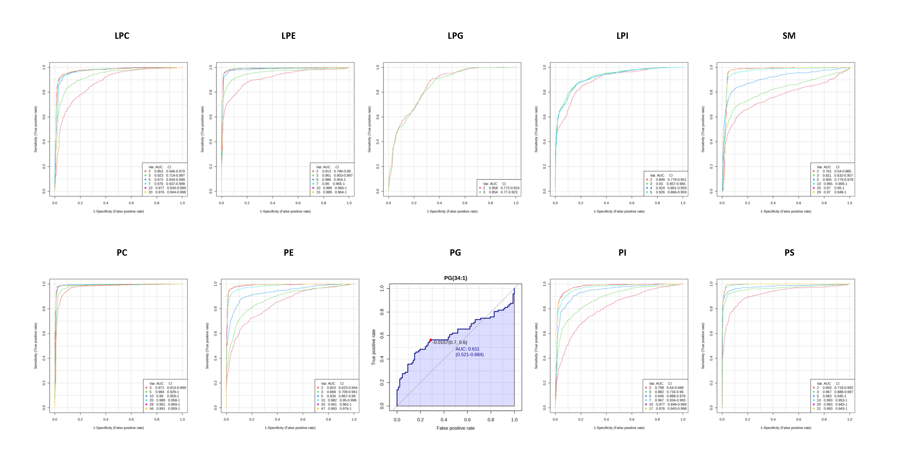
Figure S1 Multivariate exploratory ROC analysis for each phospholipid class distinguishing HCC and NAT based on support vector machines (SVM) algorithm.

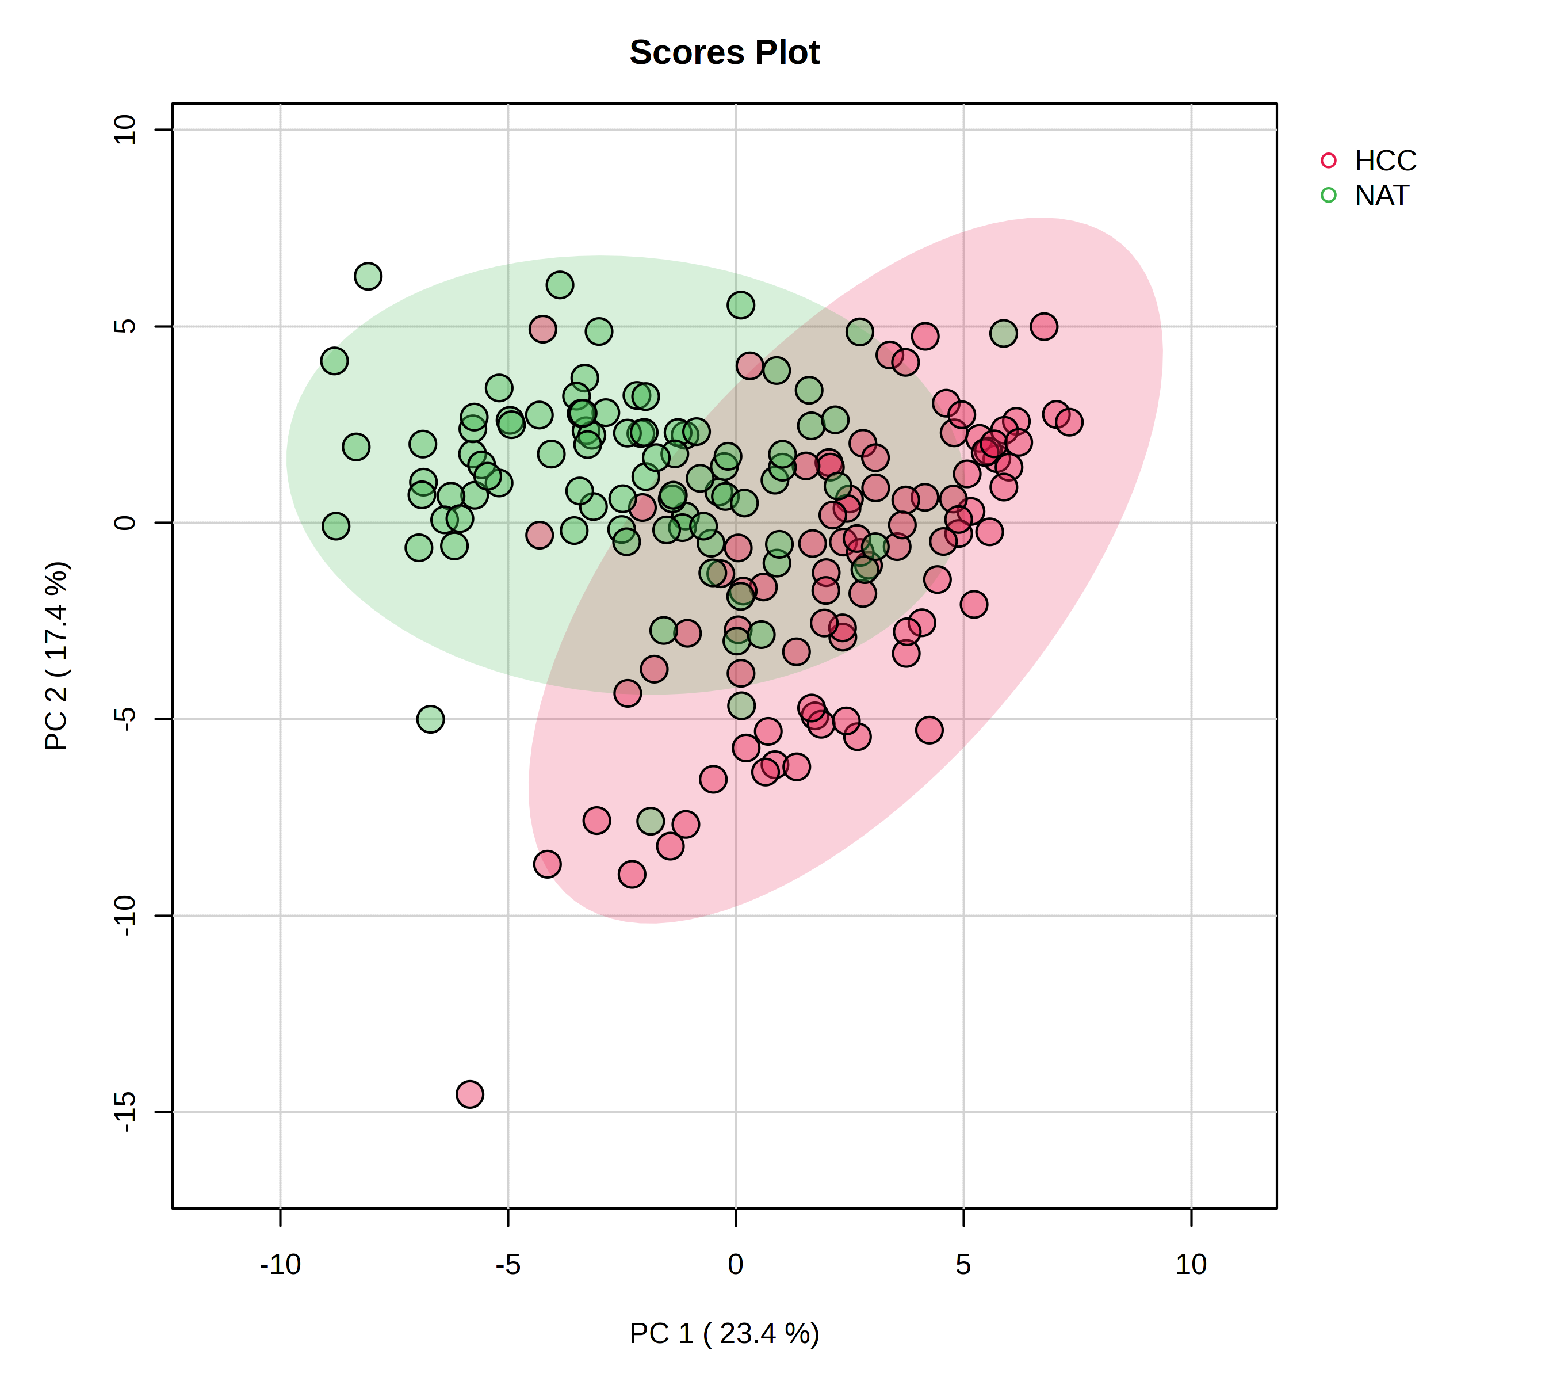
Figure S2 Principal Component Analysis (PCA) plot showing the discrimination between hepatocellular carcinoma tissue (HCC) and tumor-adjacent normal hepatic tissue (NAT).

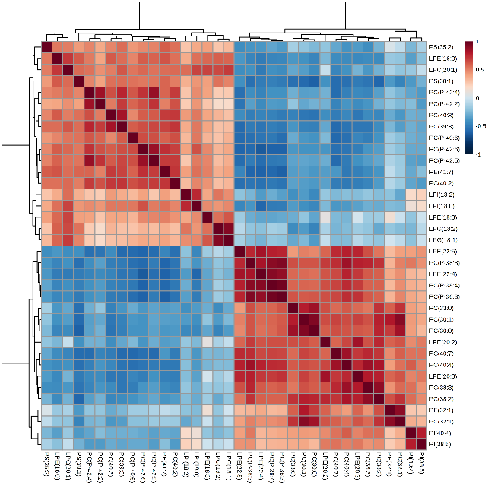
Figure S3 Hierarchical Clustering Heatmaps of 36 identified significant metabolites in HCC and NAT samples.

