Table 3. Molecular docking results of the CA1, CA2 and Azidothymidine comparison
Name |  | Product 3  (3R,4aS,8aR)-6,8a-dimethyl-3-(prop-1-en-2-yl)-3,4,4a,5,8,8a-hexahydronaphthalen-1(2H)-one |  | Product 4  (3R,4aR,8aS)-6,8a-dimethyl-3-vinyl-3,4,4a,5,8,8a-hexahydronaphthalen-1(2H)-one |  | AZT  Azidothymidine
2D Compound Structure
3D Compound Structure |  | 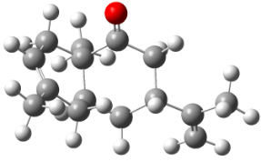 |  | 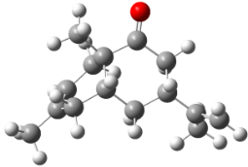 |  | 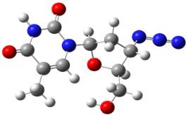
Binding energy | 5W4Q | -5.7 |  | -5.6 |  | -5.4
Binding energy | 1A8O | -5.5 |  | -5.5 |  | -5.7
Interaction  Residues-Bond distance (Å) | 5W4Q | ALA174 | 4.15 | ALA174 | 4.16 | PRO34 | 5.11
Interaction  Residues-Bond distance (Å) | 5W4Q | PRO34 | 4.72 | PRO34 | 4.70 | ILE37 | 4.94
Interaction  Residues-Bond distance (Å) | 5W4Q | PRO147 | 5.38  5.41 | PRO147 | 5.39  5.43 | ARG173 | 4.31
Interaction  Residues-Bond distance (Å) | 5W4Q | TYR145 | 4.35  4.82 | TYR145 | 4.38  4.85 | PRO38 | 3.53
Interaction  Residues-Bond distance (Å) | 5W4Q | ALA31 | 4.32 | ALA31 | 4.25 | ASN139 | 2.14
Interaction  Residues-Bond distance (Å) | 5W4Q |  |  |  |  | LYS182 | 2.08
Interaction  Residues-Bond distance (Å) | 1A8O | LYZ158 | 4.47 | LYZ158 | 4.50 | PHE161 | 2.32
Interaction  Residues-Bond distance (Å) | 1A8O | ASN195 | 2.07 | ASN195 | 2.04 | GLN155 | 2.40
Interaction  Residues-Bond distance (Å) | 1A8O | CYS198 | 4.09 | CYS198 | 4.09 | PRO157 | 2.42
Interaction  Residues-Bond distance (Å) | 1A8O | CYS218 | 3.73 | CYS218 | 3.72 | LYS158 | 2.40 3.29
Interaction  Residues-Bond distance (Å) | 1A8O | ILE201 | 4.84 | ILE201 | 5.50  4.84 | GLY220 | 3.44
Interaction  Residues-Bond distance (Å) | 1A8O |  |  |  |  | LYS158 | 3.29

