The Synergistic Impact of Probiotic Supplementation and High-intensity Interval Training on Dyslipidemia and the Liver Longevity Genes in Ovariectomized Rats

Supplementary file

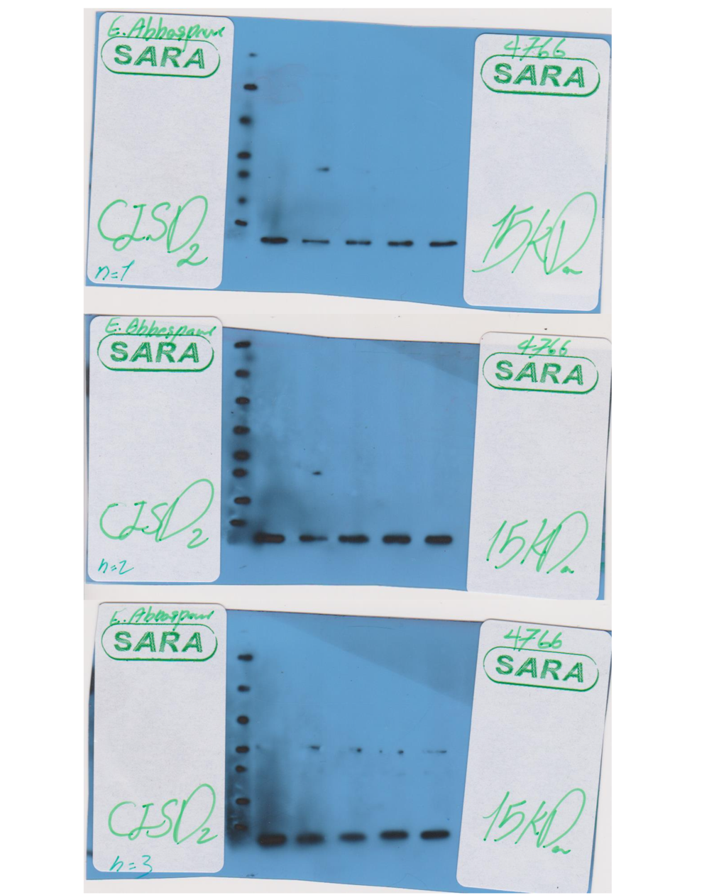

Figure S1| Full-length blots of CISD2 displaying the entire vertical length of the gel

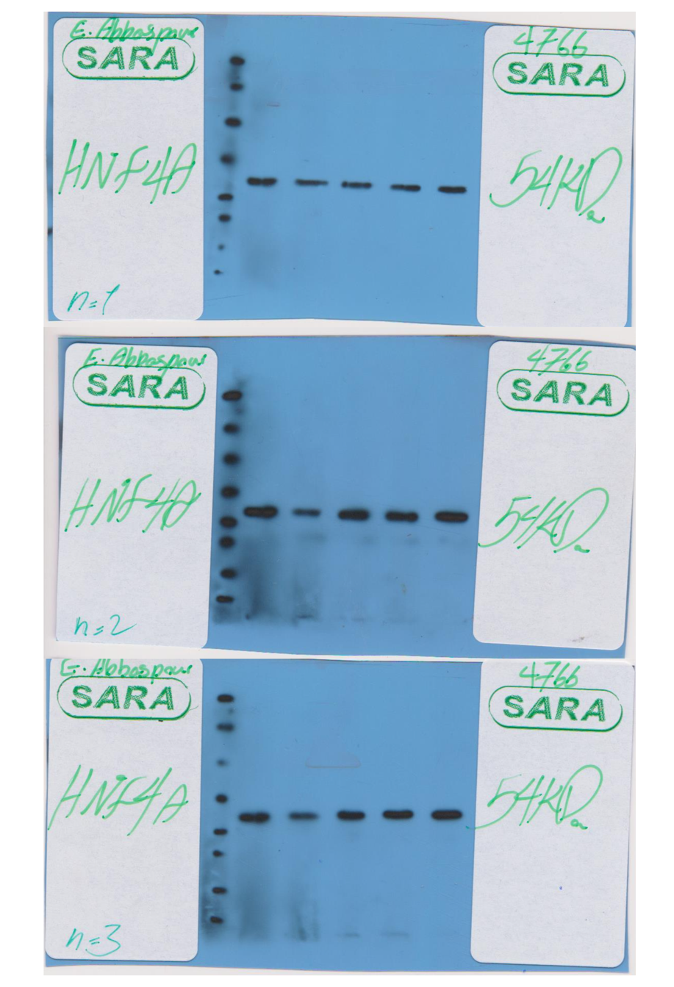

Figure S2| Full-length blots of HNF4A displaying the entire vertical length of the gel

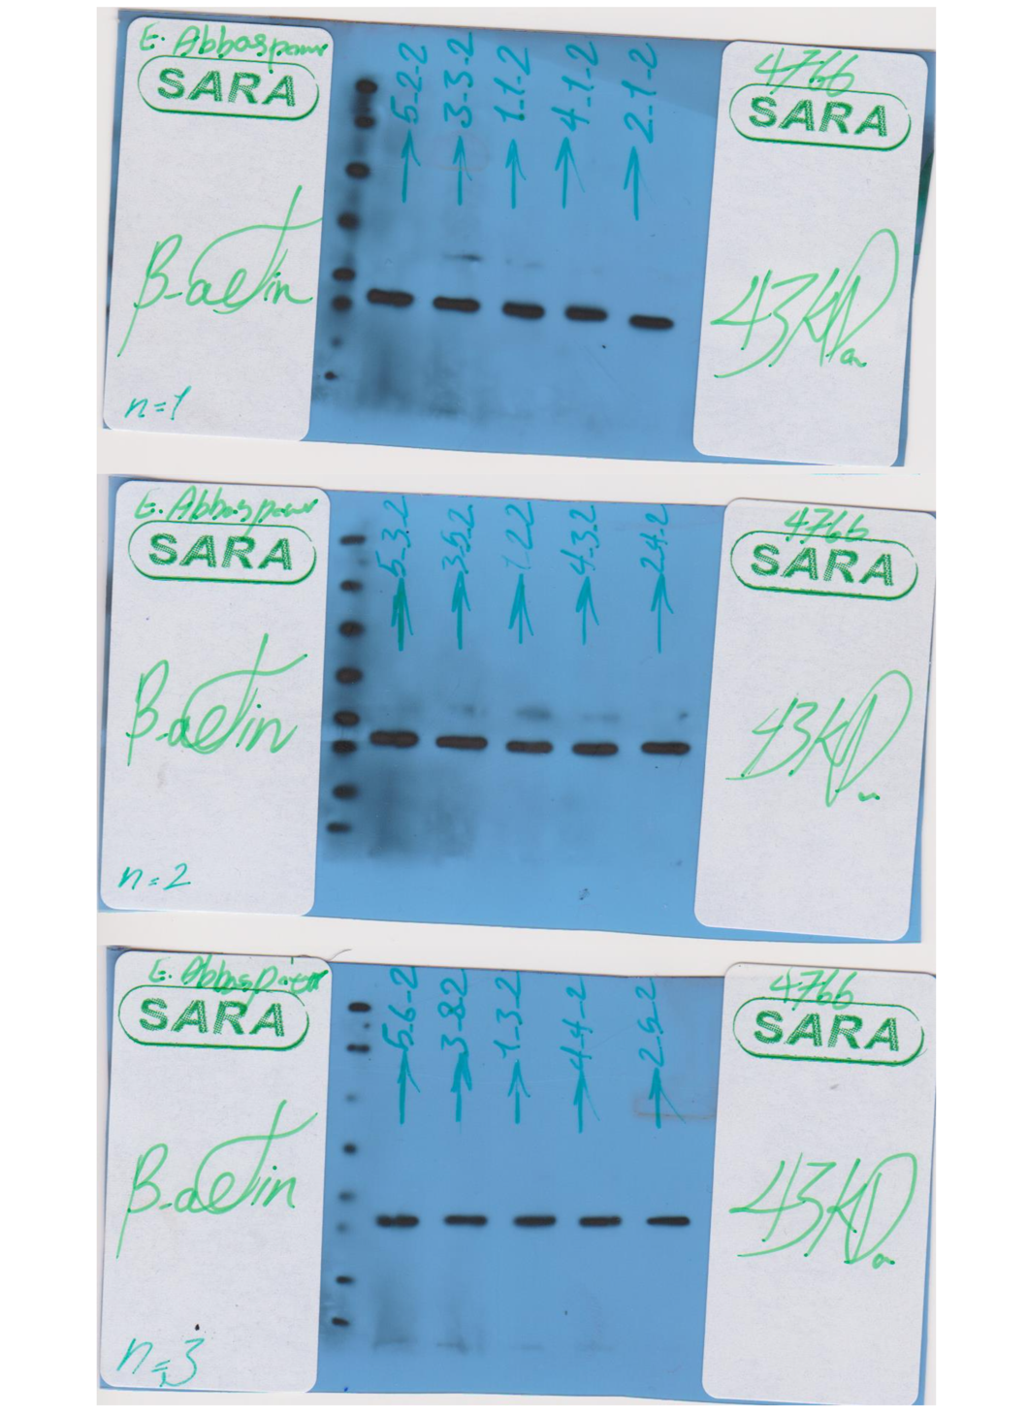

Figure S3| Full-length blots of β-actin displaying the entire vertical length of the gel

