Supplementary Material

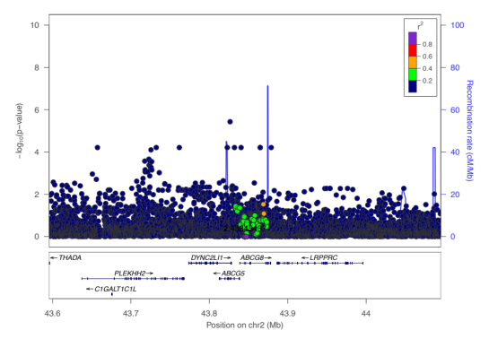
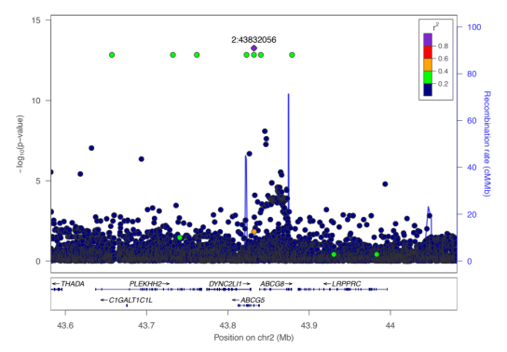
- (B)

(C)
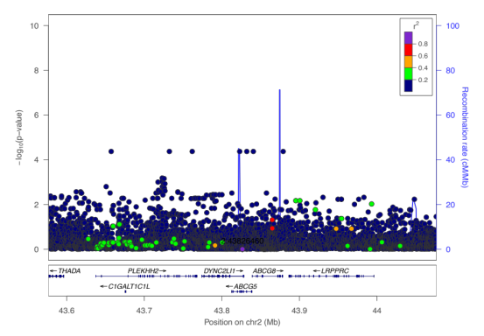

Figure S1: Conditional analysis of variants associated with β-sitosterol from chromosome 2 (A) Before conditional analysis, (B) after conditioning for rs145164937 and rs4299376, (C) after conditioning for rs145164937, rs4299376, and rs72796720.

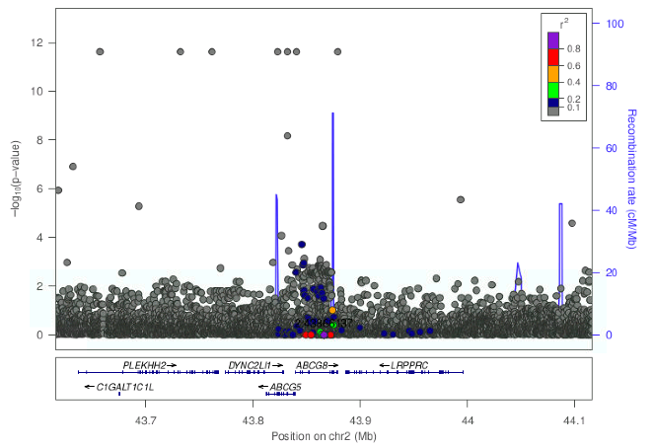
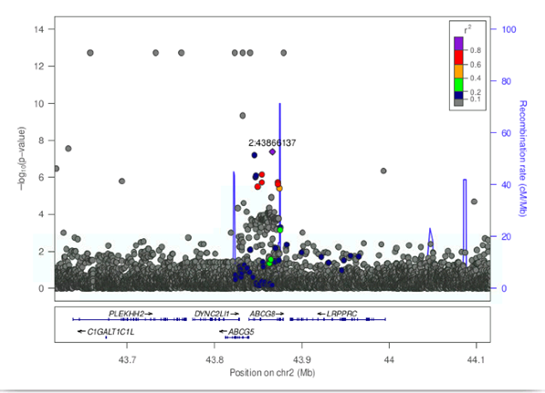
(B)
(A)
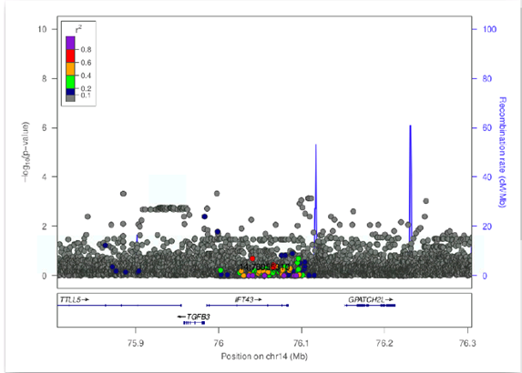
(C)
(D)
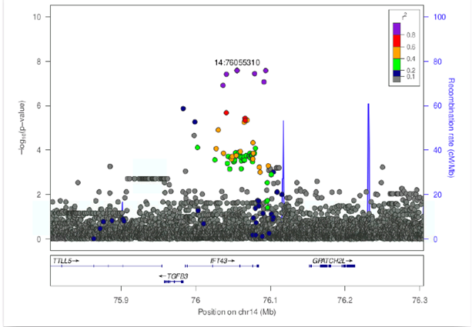
Figure S2: Conditional analysis of variants associated with campesterol from chromosome 2 (A) before condition analysis, (B) after conditioning for rs7598542, and chromosome14 (C) before conditional analysis and (D) after conditioning for rs75901165.

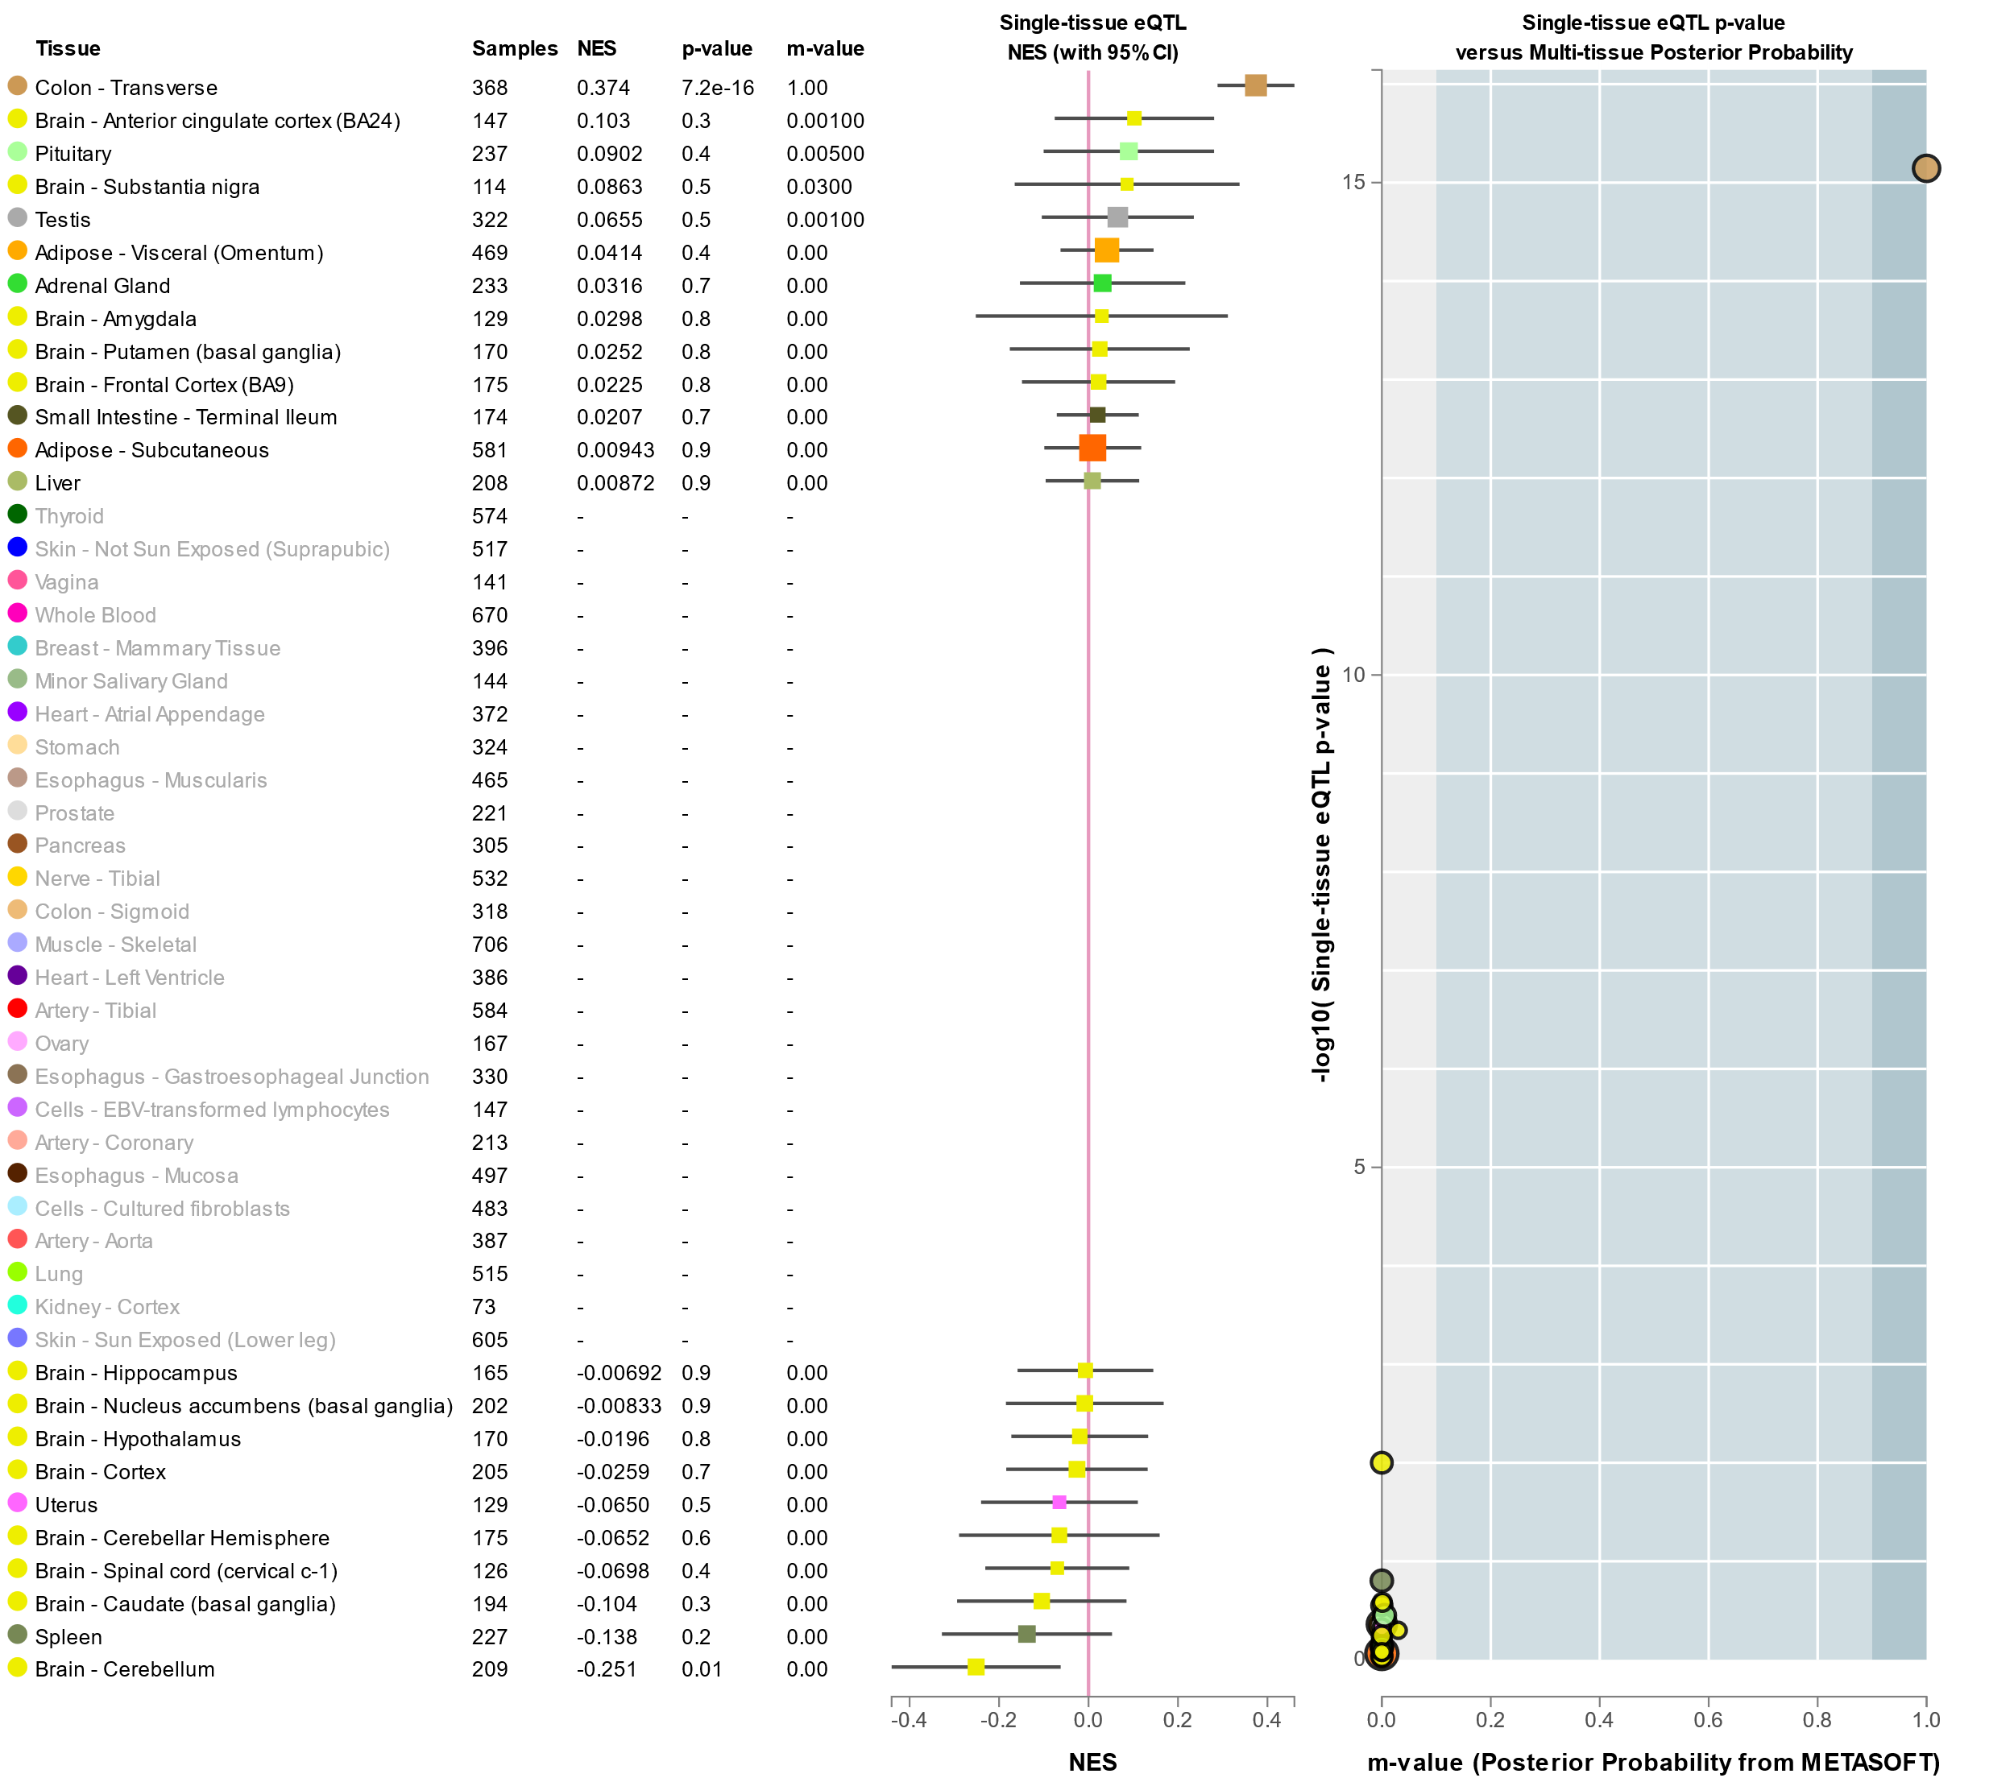
Figure S3: Genotype associated gene expression for GWAS significant SNPs
A. ABCG8 gene expression in various tissues in relation to rs6544713 genotypes associated with β- sitosterol.

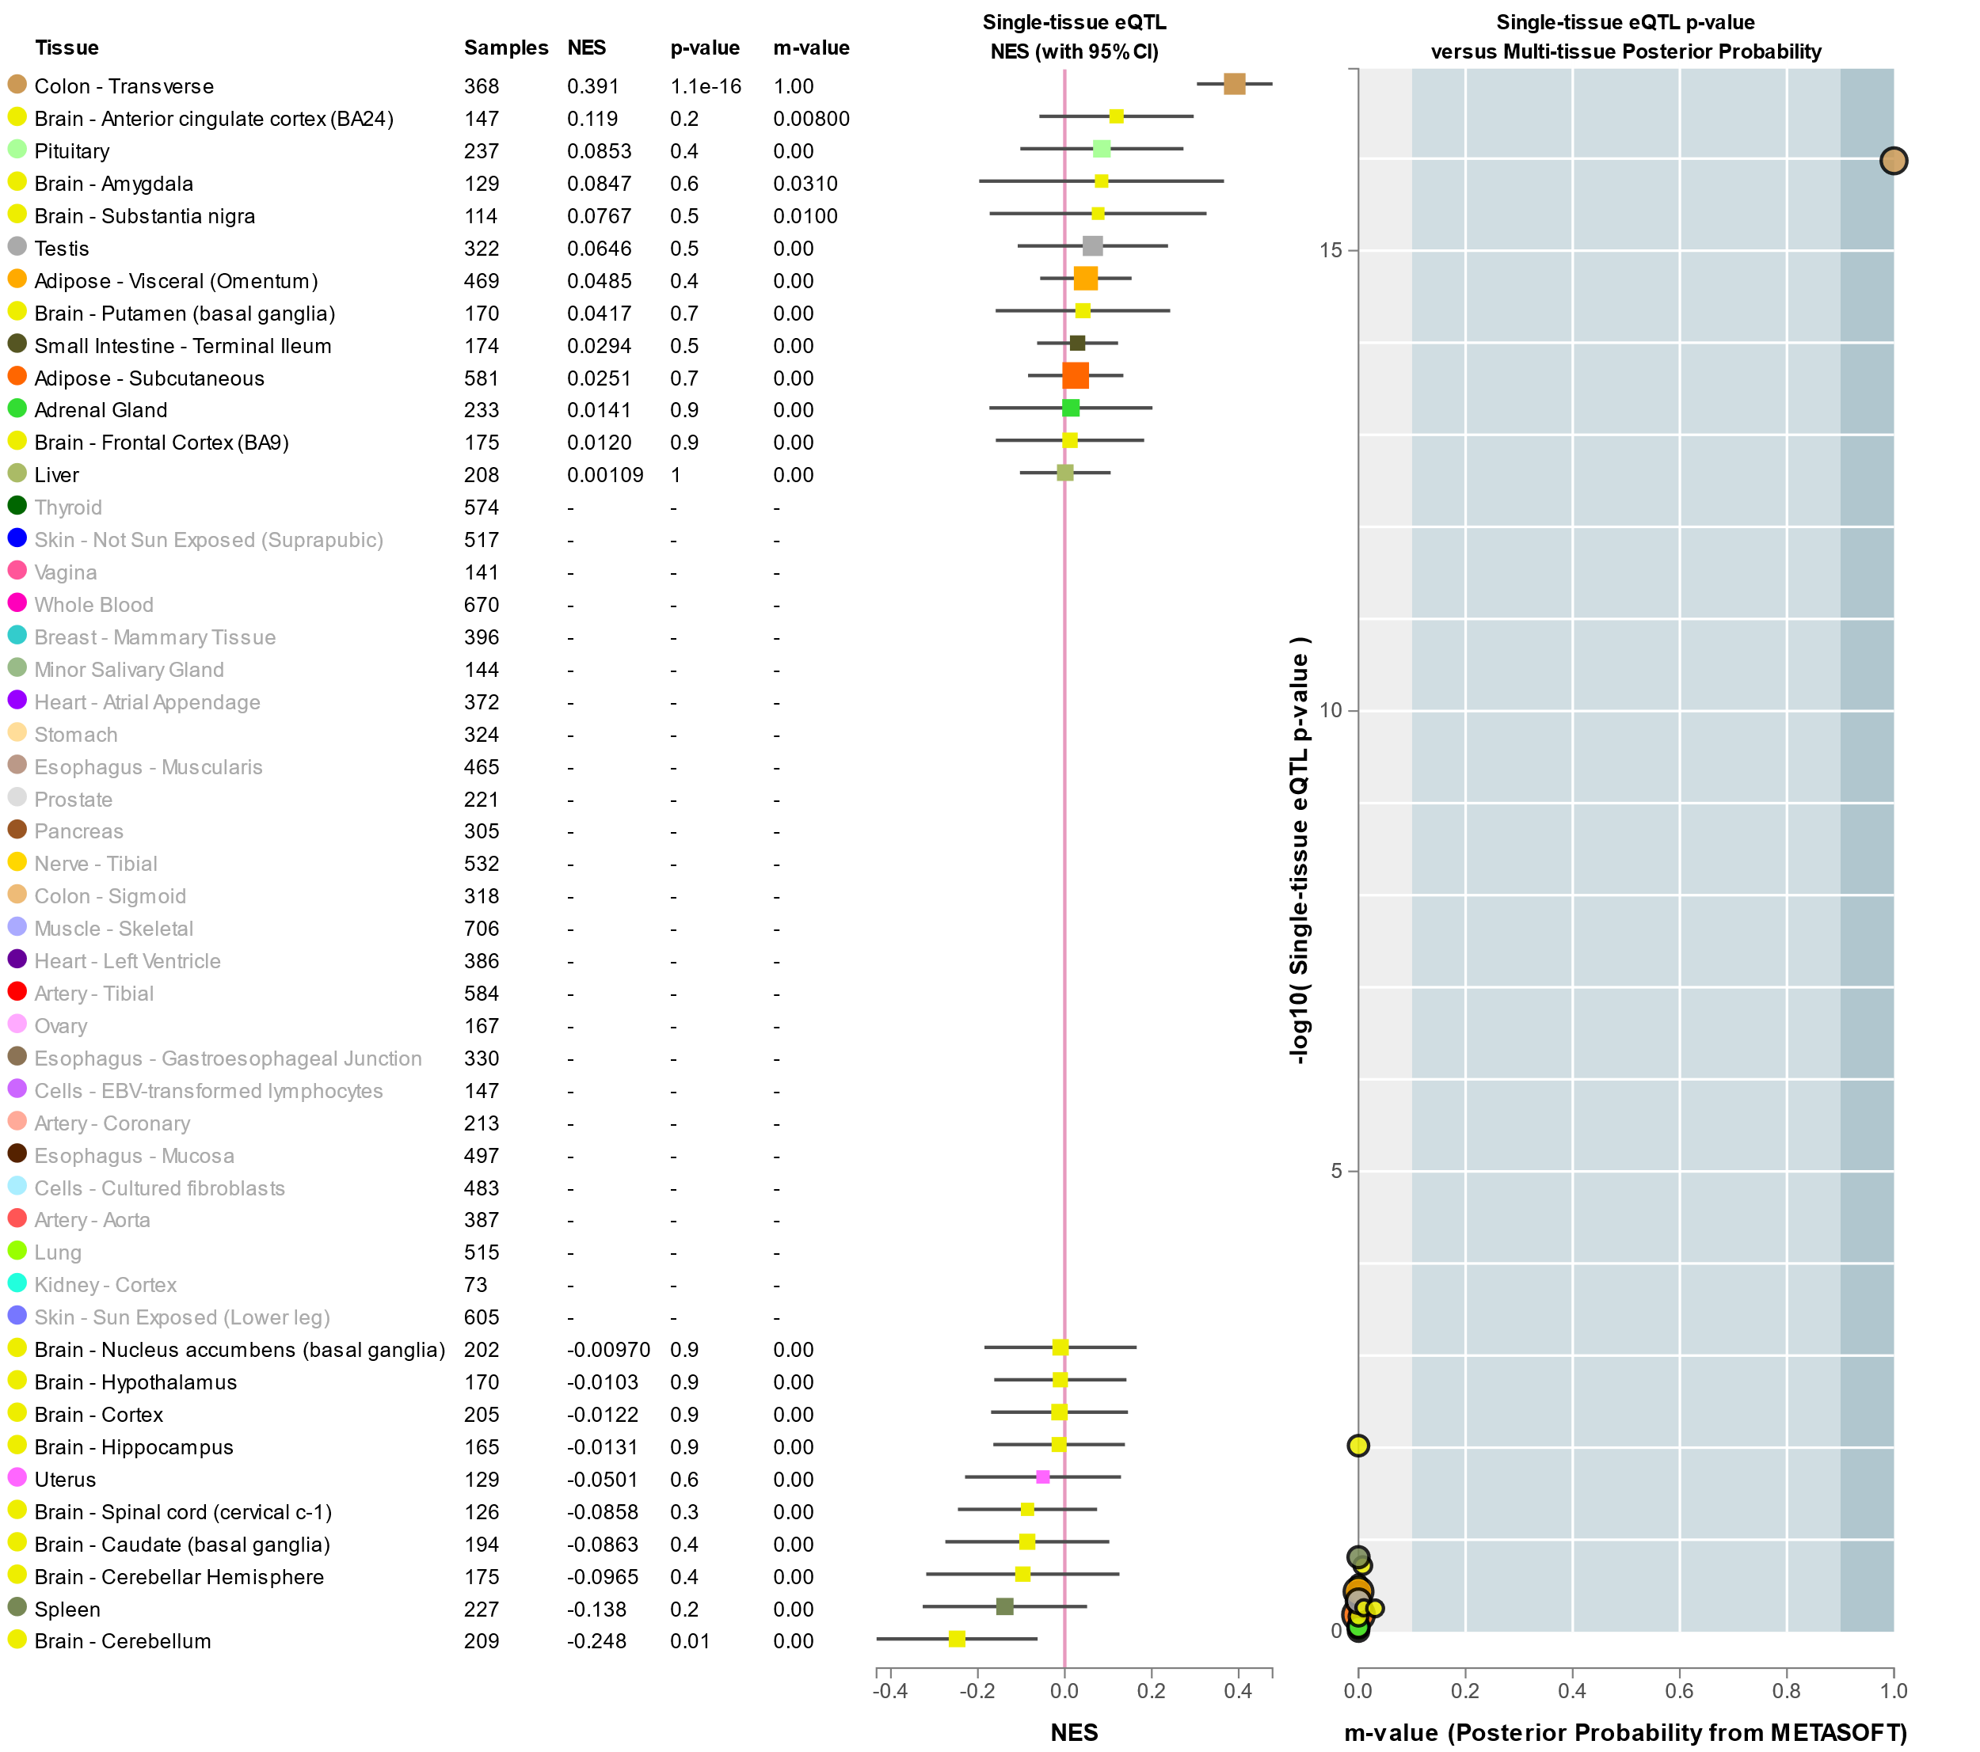
Figure S3: Genotype associated gene expression for GWAS significant SNPs
B. ABCG8 gene expression in various tissues in relation to rs4245791 genotypes associated with β- sitosterol.

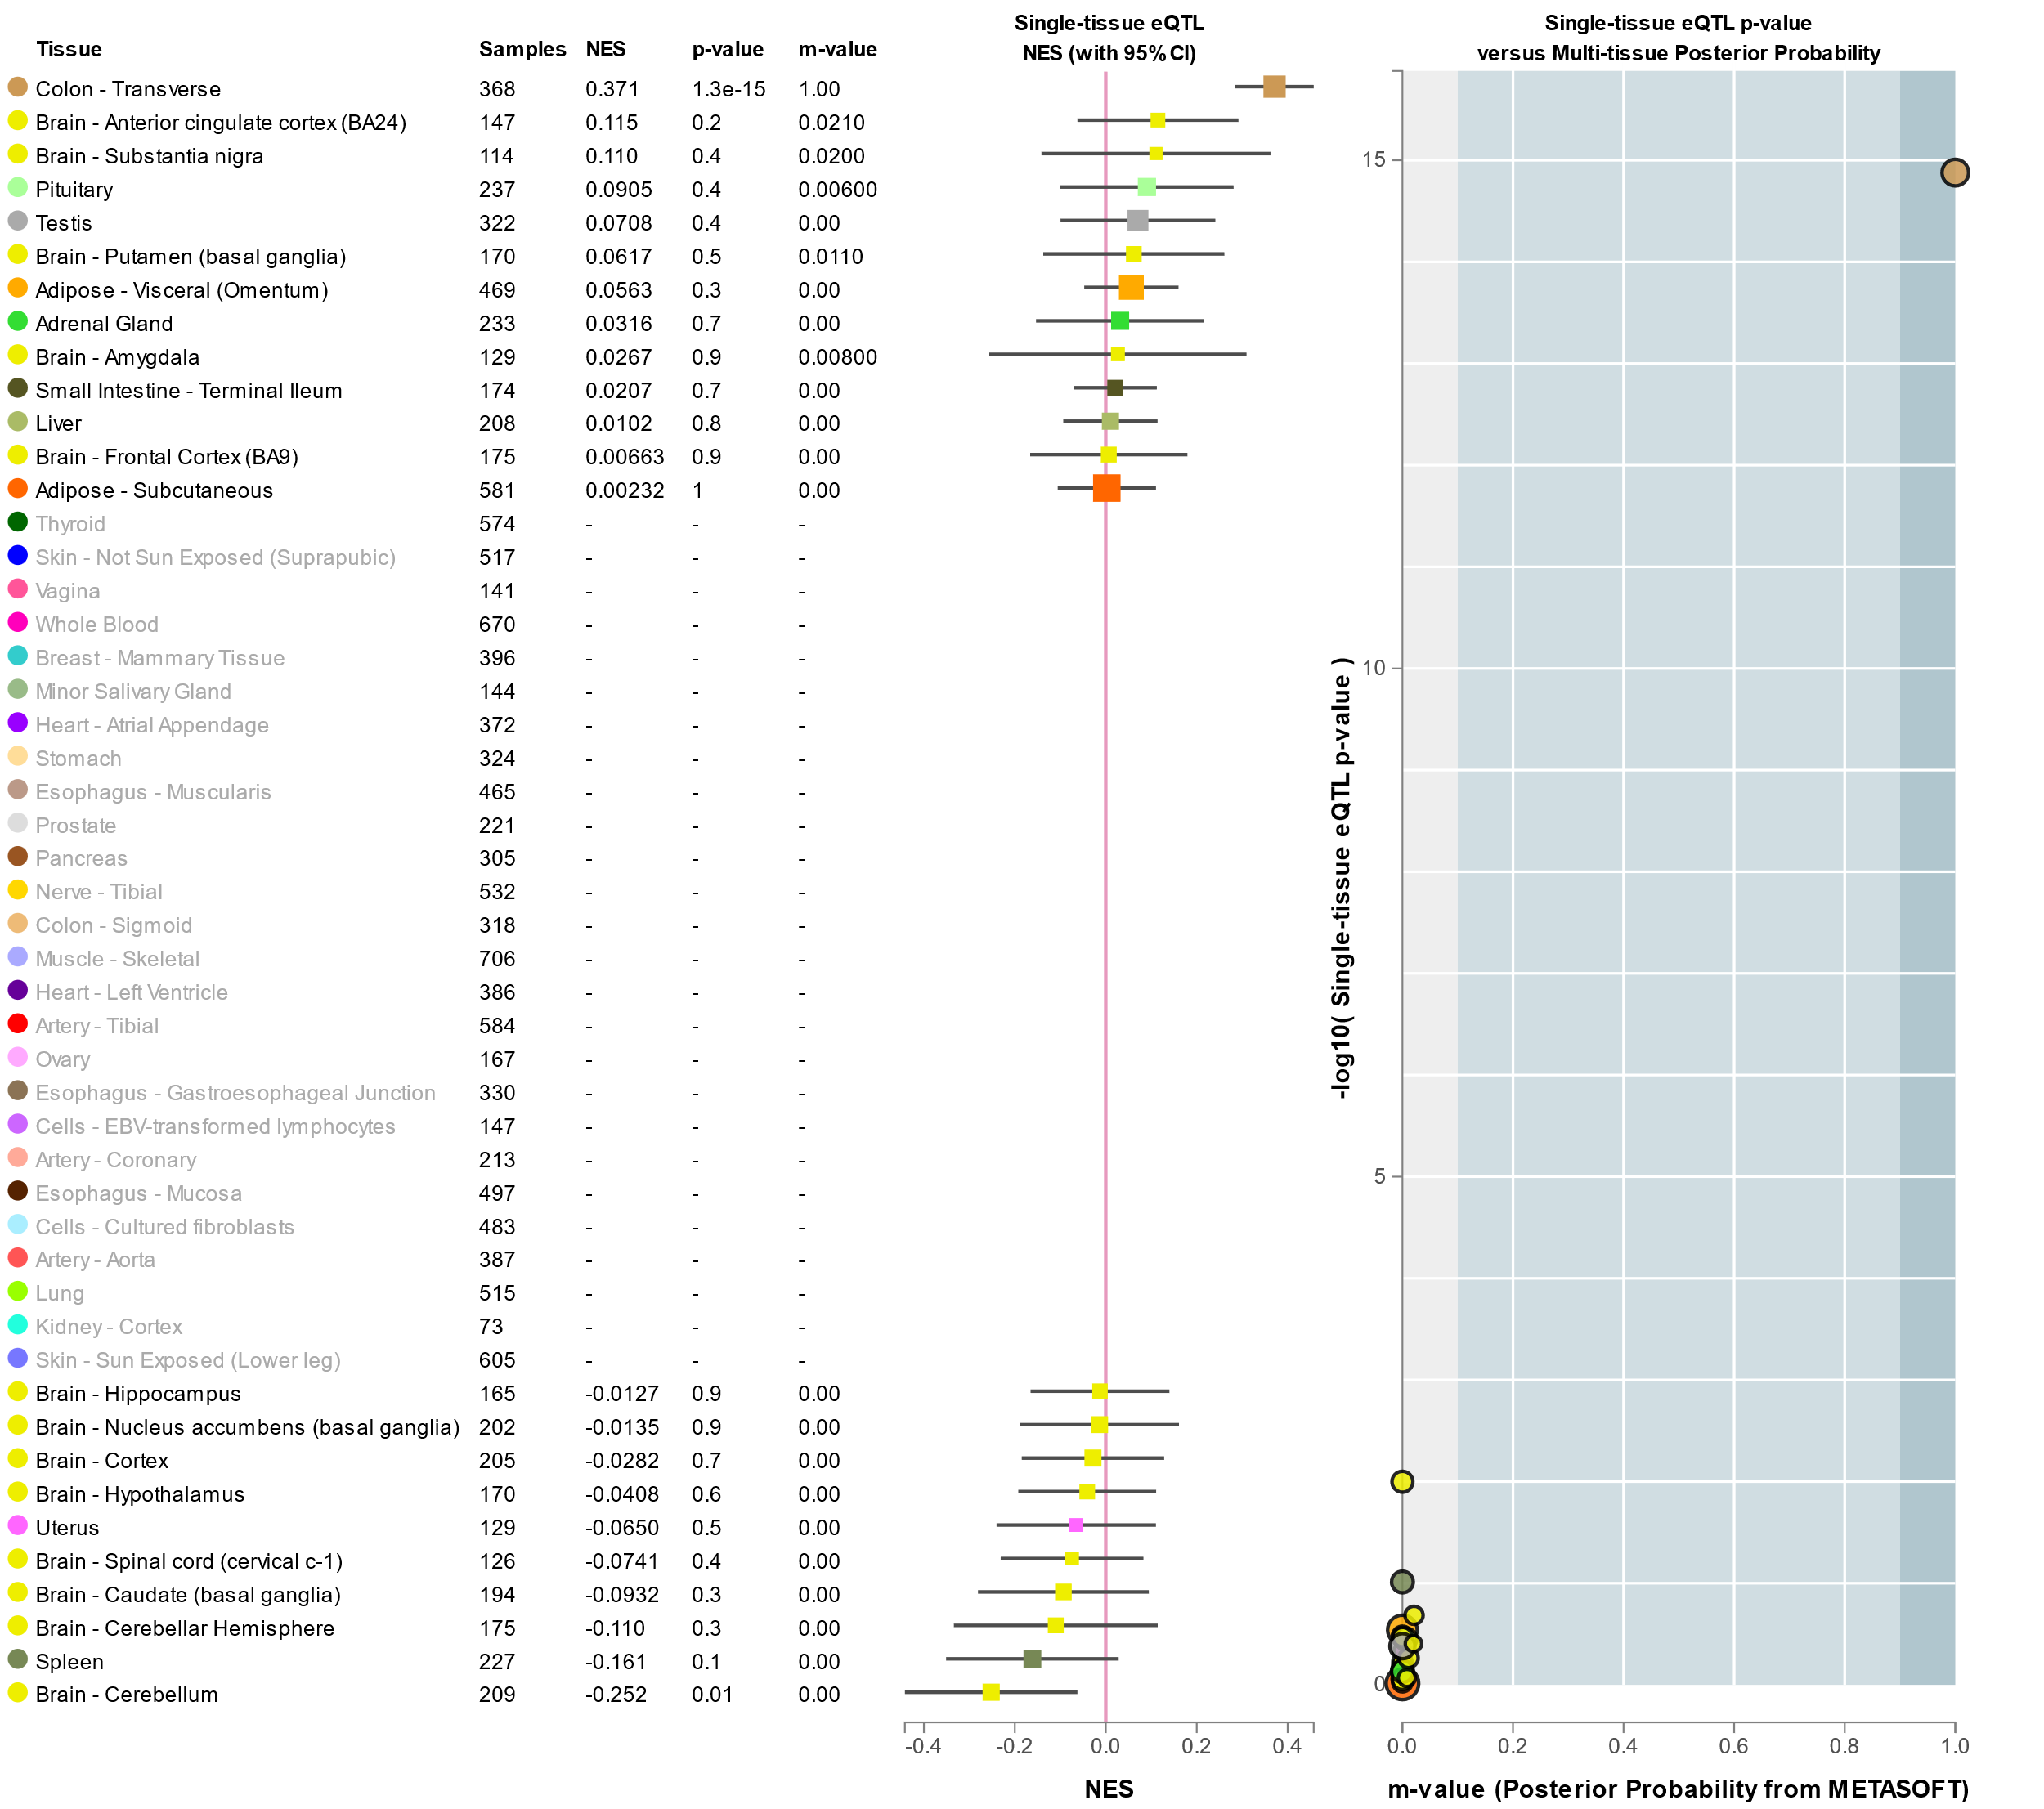

Figure S3: Genotype associated gene expression for GWAS significant SNPs
C. ABCG8 gene expression in various tissues in relation to rs4299376 genotypes associated with β- sitosterol.

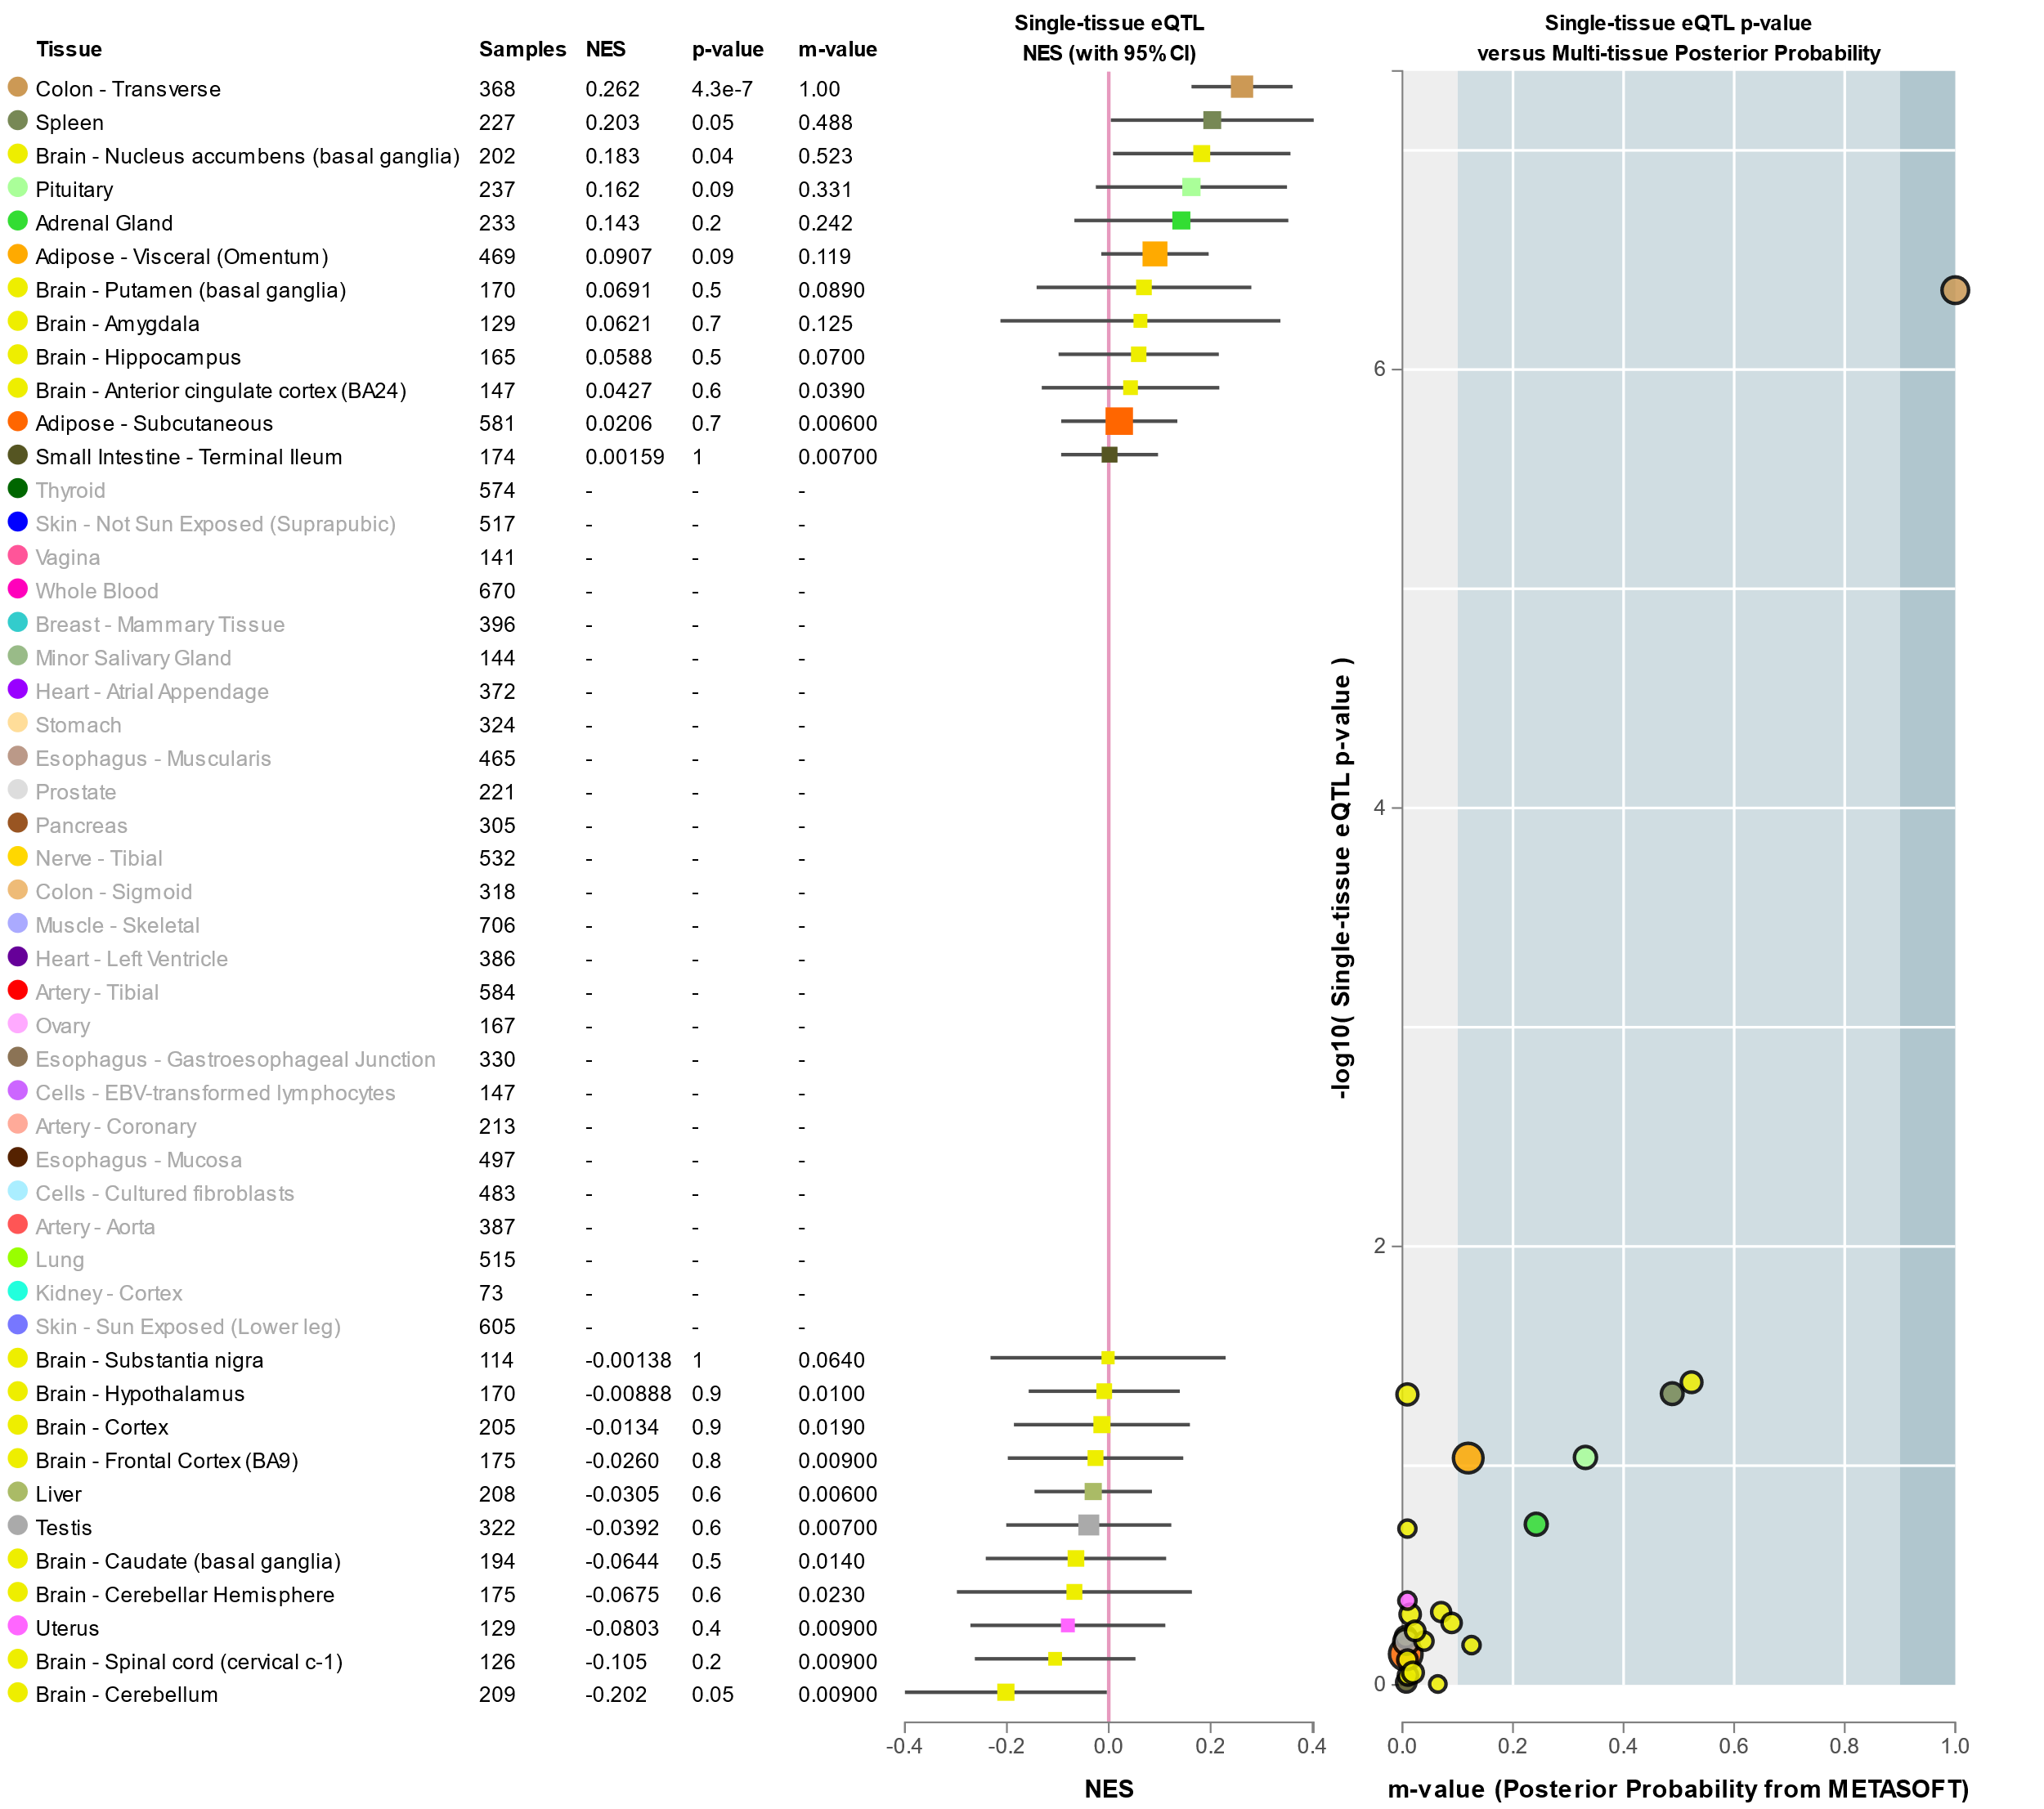

Figure S3: Genotype associated gene expression for GWAS significant SNPs
D. ABCG8 gene expression in various tissue in relation to rs7598542 genotypes associated with campesterol.

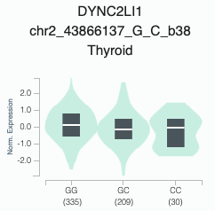

P=4.73x10⁻⁶

Figure S3: Genotype associated gene expression for GWAS significant SNPs
E. DYNC2LI1 Gene expression in thyroid tissue in relation to rs7598542 genotypes associated with campesterol.

(A)
(B)
Figure S4. Comparison of (A) Allele frequency and (B) effect size between QBB and Scholz et al data for loci associated with β-sitosterol at genome wide significant level from Scholz et al study and replicated at nominal level (P<0.05) from the QBB study. R is the correlation coefficient.
R= 0.9598
R= 0.7846
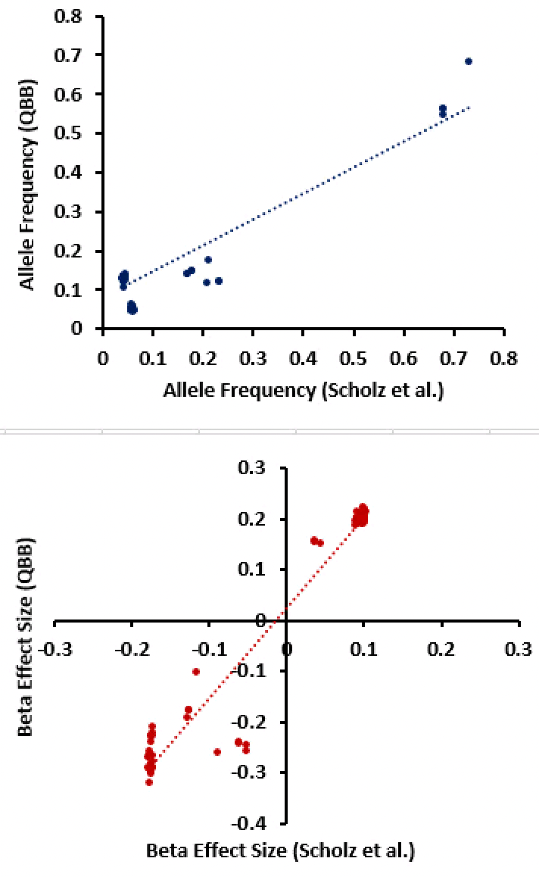
(A)
(B)
R= 0.8872

Figure S5. Comparison of (A) Allele frequency and (B) effect size between QBB and Scholz et al data for loci associated with campesterol at genome wide significant level from Scholz et al study and replicated at nominal level (P<0.05) from the QBB study. R is the correlation coefficient.
R=0.9799

Figure S6. Genome-wide SNP heritability (h²) estimates for β-sitosterol and campesterol. Error bars represent standard error.

SNP | Chr | POS | Allele1 | Allele2 | AF_Allele2 | BETA_Allele2 | SE | P | Gene Name | Trait
rs865922650 | 2 | 43632145 | A | C | 0.9972 | -1.8995197 | 0.341886 | 2.76E-08 | --- | Campesterol
rs939665343 | 2 | 43657289 | A | AT | 0.9941 | -1.7474949 | 0.237478 | 1.86E-13 | PLEKHH2 | Campesterol
chr2:43732320:G:A | 2 | 43732320 | A | G | 0.9941 | -1.7474949 | 0.237478 | 1.86E-13 | PLEKHH2 | Campesterol
rs565738564 | 2 | 43761739 | T | C | 0.9941 | -1.7474949 | 0.237478 | 1.86E-13 | PLEKHH2 | Campesterol
rs199689137 | 2 | 43822924 | A | G | 0.9941 | -1.7474949 | 0.237478 | 1.86E-13 | ABCG5 | Campesterol
rs145164937 | 2 | 43832056 | C | G | 0.9848 | -0.8820744 | 0.141531 | 4.59E-10 | ABCG5 | Campesterol
rs781194036 | 2 | 43832057 | A | C | 0.9941 | -1.7474949 | 0.237478 | 1.86E-13 | ABCG5 | Campesterol
rs146548006 | 2 | 43840519 | T | C | 0.9941 | -1.7474949 | 0.237478 | 1.86E-13 | ABCG8 | Campesterol
rs565241587 | 2 | 43878966 | T | C | 0.9941 | -1.7474949 | 0.237478 | 1.86E-13 | ABCG8 | Campesterol
chr2:44189852:C:A | 2 | 44189852 | A | C | 0.9941 | -1.7474949 | 0.237478 | 1.86E-13 | PPM1B | Campesterol
chr2:44247576:C:G | 2 | 44247576 | G | C | 0.9941 | -1.7474949 | 0.237478 | 1.86E-13 | --- | Campesterol
rs546195979 | 2 | 44264828 | T | C | 0.9928 | -1.5363919 | 0.213188 | 5.73E-13 | --- | Campesterol
rs1019875701 | 2 | 44514088 | T | C | 0.9941 | -1.7474949 | 0.237478 | 1.86E-13 | CAMKMT | Campesterol
chr2:44784331:T:TA | 2 | 44784331 | TA | T | 0.9941 | -1.7474949 | 0.237478 | 1.86E-13 | --- | Campesterol
rs374354612 | 2 | 44959530 | A | G | 0.9931 | -1.4330485 | 0.21854 | 5.48E-11 | --- | Campesterol
rs7598542 | 2 | 43866137 | C | G | 0.8267 | 0.2606919 | 0.047534 | 4.15E-08 | ABCG8 | Campesterol
rs17183866 | 14 | 76041116 | G | A | 0.8739 | 0.28452403 | 0.051764 | 3.87E-08 | IFT43 | Campesterol
rs75901165 | 14 | 76055310 | A | C | 0.8739 | 0.28885374 | 0.05192 | 2.64E-08 | IFT43 | Campesterol
rs17183963 | 14 | 76078917 | G | T | 0.8697 | 0.28149321 | 0.051107 | 3.63E-08 | IFT43 | Campesterol
rs142300998 | 14 | 76093642 | G | GC | 0.8732 | 0.28940493 | 0.051961 | 2.66E-08 | IFT43 | Campesterol
rs865922650 | 2 | 43632145 | A | C | 0.9973 | -1.7430536 | 0.326253 | 3.35E-13 | --- | β- sitosterol
rs939665343 | 2 | 43657289 | A | AT | 0.9945 | -1.7229869 | 0.233089 | 1.45E-13 | PLEKHH2 | β- sitosterol
chr2:43732320:G:A | 2 | 43732320 | A | G | 0.9945 | -1.7229869 | 0.233089 | 1.45E-13 | PLEKHH2 | β- sitosterol
rs565738564 | 2 | 43761739 | T | C | 0.9945 | -1.7229869 | 0.233089 | 1.45E-13 | PLEKHH2 | β- sitosterol
rs199689137 | 2 | 43822924 | A | G | 0.9945 | -1.7229869 | 0.233089 | 1.45E-13 | ABCG5 | β- sitosterol
rs145164937 | 2 | 43832056 | C | G | 0.9863 | -1.0646114 | 0.141598 | 5.54E-14 | ABCG5 | β- sitosterol
rs781194036 | 2 | 43832057 | A | C | 0.9945 | -1.7229869 | 0.233089 | 1.45E-13 | ABCG5 | β- sitosterol
rs146548006 | 2 | 43840519 | T | C | 0.9945 | -1.7229869 | 0.233089 | 1.45E-13 | ABCG8 | β- sitosterol
rs4299376 | 2 | 43845437 | G | T | 0.5525 | -0.1979033 | 0.034334 | 8.21E-09 | ABCG8 | β- sitosterol
rs6544713 | 2 | 43846742 | T | C | 0.5665 | -0.1879042 | 0.034561 | 5.42E-08 | ABCG8 | β- sitosterol
rs4245791 | 2 | 43847292 | C | T | 0.5656 | -0.1935582 | 0.034701 | 2.43E-08 | ABCG8 | β- sitosterol
rs565241587 | 2 | 43878966 | T | C | 0.9945 | -1.7229869 | 0.233089 | 1.45E-13 | ABCG8 | β- sitosterol
chr2:44189852:C:A | 2 | 44189852 | A | C | 0.9945 | -1.7229869 | 0.233089 | 1.45E-13 | PPM1B | β- sitosterol
chr2:44247576:C:G | 2 | 44247576 | G | C | 0.9945 | -1.7229869 | 0.233089 | 1.45E-13 | --- | β- sitosterol
rs546195979 | 2 | 44264828 | T | C | 0.9933 | -1.5364593 | 0.21053 | 2.92E-13 | --- | β- sitosterol
rs1019875701 | 2 | 44514088 | T | C | 0.9945 | -1.7229869 | 0.233089 | 1.45E-13 | CAMKMT | β- sitosterol
chr2:44784331:T:TA | 2 | 44784331 | TA | T | 0.9945 | -1.7229869 | 0.233089 | 1.45E-13 | --- | β- sitosterol
rs374354612 | 2 | 44959530 | A | G | 0.9939 | -1.5361083 | 0.220798 | 3.47E-12 | --- | β- sitosterol
Table S1: SNPs showing Genome wide significant (P-value of < 5 x10⁻⁸) associations for β-sitosterol and campesterol traits from the QBB cohort

SNP | Chr | POS | Allele 1 | Allele 2 | QGP AF_Allele 2 | gnomAD | BETA | SE | P  (Cond) | Gene Name | Type of Mutation | Trait
rs781194036 | 2 | 43832057 | A | C | 0.004 | 0.00002 | -1.723 | 0.233 | 4.02E-05 | ABCG5 | Missense | β-sitosterol
rs7296720 | 2 | 43826460 | A | G | 0.022 | 0.002 | -0.608 | 0.117 | 3.09E-06 | ABCG5 | Synonymous | β-sitosterol

Table S2: Description of the independent suggestive variants associated with β- sitosterol

CHR | BP | SNP | A1 | A2 | N | P | P(R) | BETA | BETA(R) | Q | I | F0 | F1
2 | 43845437 | rs4299376 | T | G | 2 | 3.29E-129 | 3.29E-129 | -0.201 | -0.201 | 0.9264 | 0 | -0.1979 | -0.2012
2 | 43847292 | rs4245791 | T | C | 2 | 2.47E-126 | 2.47E-126 | -0.1988 | -0.1988 | 0.8772 | 0 | -0.1936 | -0.1991
2 | 43846742 | rs6544713 | C | T | 2 | 1.07E-125 | 1.07E-125 | -0.1984 | -0.1984 | 0.7553 | 0 | -0.1879 | -0.199
2 | 43869000 | rs6740545 | A | G | 2 | 2.86E-92 | 1.36E-07 | -0.1804 | -0.1617 | 0.0867 | 65.92 | -0.1199 | -0.1842
2 | 43869631 | rs4952688 | A | T | 2 | 3.51E-92 | 1.53E-10 | -0.1803 | -0.1664 | 0.1332 | 55.66 | -0.1271 | -0.1836
2 | 43851714 | rs56132765 | G | A | 2 | 1.02E-60 | 3.16E-08 | 0.2704 | 0.2505 | 0.1977 | 39.74 | 0.1658 | 0.2747
2 | 43867513 | rs114818032 | A | G | 2 | 2.70E-19 | 2.70E-19 | -0.1659 | -0.1659 | 0.5496 | 0 | -0.1946 | -0.1616
2 | 43870249 | rs76492655 | A | C | 2 | 4.01E-19 | 4.01E-19 | -0.1654 | -0.1654 | 0.5141 | 0 | -0.1966 | -0.1607
2 | 43870189 | rs72798830 | C | T | 2 | 4.07E-19 | 4.07E-19 | -0.1655 | -0.1655 | 0.5151 | 0 | -0.1966 | -0.1608
2 | 43872495 | rs41281461 | G | A | 2 | 4.17E-19 | 4.17E-19 | -0.1652 | -0.1652 | 0.5117 | 0 | -0.1966 | -0.1605
2 | 43872687 | rs72798838 | C | G | 2 | 4.17E-19 | 4.17E-19 | -0.1652 | -0.1652 | 0.5117 | 0 | -0.1966 | -0.1605
2 | 43871918 | rs55741639 | A | G | 2 | 4.19E-19 | 4.19E-19 | -0.1652 | -0.1652 | 0.5115 | 0 | -0.1966 | -0.1605
2 | 43872924 | rs72798839 | C | T | 2 | 4.20E-19 | 4.20E-19 | -0.1651 | -0.1651 | 0.5099 | 0 | -0.1966 | -0.1603
2 | 43855988 | rs139145637 | T | C | 2 | 5.19E-19 | 5.19E-19 | -0.1631 | -0.1631 | 0.4712 | 0 | -0.1975 | -0.158
2 | 43851053 | rs72796745 | T | C | 2 | 5.37E-19 | 5.37E-19 | -0.1607 | -0.1607 | 0.449 | 0 | -0.1968 | -0.1555
2 | 43855755 | rs72796760 | C | T | 2 | 5.40E-19 | 5.40E-19 | -0.1629 | -0.1629 | 0.4746 | 0 | -0.1971 | -0.1579
2 | 43853828 | rs72796751 | G | A | 2 | 5.92E-19 | 5.92E-19 | -0.1616 | -0.1616 | 0.4921 | 0 | -0.1946 | -0.1569
2 | 43852532 | rs9282572 | C | T | 2 | 6.15E-19 | 6.15E-19 | -0.1605 | -0.1605 | 0.4704 | 0 | -0.195 | -0.1556
2 | 43869643 | rs72798828 | C | A | 2 | 6.20E-19 | 6.20E-19 | -0.1645 | -0.1645 | 0.5023 | 0 | -0.1966 | -0.1597
2 | 43870131 | rs72798829 | G | T | 2 | 6.20E-19 | 6.20E-19 | -0.1645 | -0.1645 | 0.5023 | 0 | -0.1966 | -0.1597
2 | 43868347 | rs72798818 | T | C | 2 | 6.34E-19 | 6.34E-19 | -0.1645 | -0.1645 | 0.5028 | 0 | -0.1966 | -0.1597
2 | 43870503 | rs76464523 | C | A | 2 | 6.36E-19 | 6.36E-19 | -0.1637 | -0.1637 | 0.5312 | 0 | -0.1937 | -0.1592
2 | 43854226 | rs56728462 | T | G | 2 | 6.40E-19 | 6.40E-19 | -0.1617 | -0.1617 | 0.4937 | 0 | -0.1946 | -0.157
2 | 43868611 | rs72798819 | G | A | 2 | 6.40E-19 | 6.40E-19 | -0.1645 | -0.1645 | 0.5026 | 0 | -0.1966 | -0.1597
2 | 43868725 | rs72798820 | C | T | 2 | 6.40E-19 | 6.40E-19 | -0.1645 | -0.1645 | 0.5026 | 0 | -0.1966 | -0.1597
2 | 43870398 | rs72798831 | G | T | 2 | 6.47E-19 | 6.47E-19 | -0.1641 | -0.1641 | 0.4973 | 0 | -0.1966 | -0.1593
2 | 43854111 | rs72796755 | A | G | 2 | 6.51E-19 | 6.51E-19 | -0.1616 | -0.1616 | 0.4925 | 0 | -0.1946 | -0.1569
2 | 43853748 | rs72796750 | T | C | 2 | 6.52E-19 | 6.52E-19 | -0.1612 | -0.1612 | 0.4877 | 0 | -0.1946 | -0.1565
2 | 43853576 | rs72796749 | C | T | 2 | 6.52E-19 | 6.52E-19 | -0.161 | -0.161 | 0.4846 | 0 | -0.1946 | -0.1562
2 | 43854287 | rs61145568 | T | A | 2 | 6.54E-19 | 6.54E-19 | -0.1618 | -0.1618 | 0.4942 | 0 | -0.1946 | -0.157
2 | 43854498 | rs57839994 | T | A | 2 | 6.55E-19 | 6.55E-19 | -0.1619 | -0.1619 | 0.4962 | 0 | -0.1946 | -0.1572
2 | 43855763 | rs72796762 | T | C | 2 | 6.55E-19 | 6.55E-19 | -0.1625 | -0.1625 | 0.5043 | 0 | -0.1946 | -0.1579
2 | 43856210 | rs72796765 | G | A | 2 | 6.55E-19 | 6.55E-19 | -0.1628 | -0.1628 | 0.5073 | 0 | -0.1946 | -0.1581
2 | 43855414 | rs72796759 | C | G | 2 | 6.59E-19 | 6.59E-19 | -0.1624 | -0.1624 | 0.5026 | 0 | -0.1946 | -0.1577
2 | 43855170 | rs72796758 | C | G | 2 | 6.61E-19 | 6.61E-19 | -0.1623 | -0.1623 | 0.501 | 0 | -0.1946 | -0.1576
2 | 43857351 | rs61710790 | A | C | 2 | 6.67E-19 | 6.67E-19 | -0.165 | -0.165 | 0.5665 | 0 | -0.1925 | -0.1609
2 | 43853200 | rs113441172 | T | A | 2 | 6.71E-19 | 6.71E-19 | -0.1604 | -0.1604 | 0.477 | 0 | -0.1946 | -0.1556
2 | 43854041 | rs72796754 | G | A | 2 | 6.73E-19 | 6.73E-19 | -0.1615 | -0.1615 | 0.4916 | 0 | -0.1946 | -0.1568
2 | 43856405 | rs72796766 | T | C | 2 | 6.78E-19 | 6.78E-19 | -0.1628 | -0.1628 | 0.5079 | 0 | -0.1946 | -0.1582
2 | 43854979 | rs58696060 | C | T | 2 | 6.79E-19 | 6.79E-19 | -0.1621 | -0.1621 | 0.5004 | 0 | -0.1944 | -0.1574
2 | 43853499 | rs79912906 | G | A | 2 | 6.81E-19 | 6.81E-19 | -0.1609 | -0.1609 | 0.4829 | 0 | -0.1946 | -0.1561
2 | 43853103 | rs72796747 | A | G | 2 | 6.82E-19 | 6.82E-19 | -0.1604 | -0.1604 | 0.4766 | 0 | -0.1946 | -0.1555
2 | 43855779 | rs79220359 | A | T | 2 | 6.93E-19 | 6.93E-19 | -0.1624 | -0.1624 | 0.5201 | 0 | -0.1932 | -0.1579
2 | 43867914 | rs72798813 | G | T | 2 | 6.94E-19 | 6.94E-19 | -0.1643 | -0.1643 | 0.5191 | 0 | -0.1952 | -0.1597
2 | 43854919 | rs60633742 | G | T | 2 | 7.19E-19 | 7.19E-19 | -0.162 | -0.162 | 0.5149 | 0 | -0.1933 | -0.1575
2 | 43860234 | rs72796779 | A | G | 2 | 7.30E-19 | 7.30E-19 | -0.1645 | -0.1645 | 0.4854 | 0 | -0.1984 | -0.1595
2 | 43857345 | rs60632368 | T | A | 2 | 7.33E-19 | 7.33E-19 | -0.1648 | -0.1648 | 0.5757 | 0 | -0.1916 | -0.1608
2 | 43857364 | rs59880010 | A | T | 2 | 7.33E-19 | 7.33E-19 | -0.1648 | -0.1648 | 0.5757 | 0 | -0.1916 | -0.1608
2 | 43858988 | rs72796776 | C | A | 2 | 7.34E-19 | 7.34E-19 | -0.164 | -0.164 | 0.4634 | 0 | -0.1996 | -0.1588
2 | 43857873 | rs72796773 | G | A | 2 | 7.61E-19 | 7.61E-19 | -0.1633 | -0.1633 | 0.5135 | 0 | -0.1946 | -0.1586
2 | 43858402 | rs57452597 | C | T | 2 | 7.64E-19 | 7.64E-19 | -0.1636 | -0.1636 | 0.4889 | 0 | -0.1971 | -0.1587
2 | 43857041 | rs60782591 | C | A | 2 | 7.81E-19 | 7.81E-19 | -0.1629 | -0.1629 | 0.5209 | 0 | -0.1938 | -0.1584
2 | 43870543 | rs72798833 | C | T | 2 | 7.89E-19 | 7.89E-19 | -0.1637 | -0.1637 | 0.5317 | 0 | -0.1937 | -0.1593
2 | 43861008 | rs72796783 | A | G | 2 | 8.02E-19 | 7.36E-15 | -0.1663 | -0.1683 | 0.2939 | 9.22 | -0.2167 | -0.1586
2 | 43861039 | rs72796785 | T | C | 2 | 8.02E-19 | 7.36E-15 | -0.1663 | -0.1683 | 0.2939 | 9.22 | -0.2167 | -0.1586
2 | 43856913 | rs113723868 | T | C | 2 | 8.10E-19 | 8.10E-19 | -0.1627 | -0.1627 | 0.5353 | 0 | -0.1925 | -0.1584
2 | 43865479 | rs114553753 | C | A | 2 | 8.15E-19 | 8.15E-19 | -0.164 | -0.164 | 0.5509 | 0 | -0.1926 | -0.1597
2 | 43856744 | rs72796769 | G | C | 2 | 8.24E-19 | 8.24E-19 | -0.1626 | -0.1626 | 0.5448 | 0 | -0.1916 | -0.1583
2 | 43856746 | rs72796770 | T | C | 2 | 8.24E-19 | 8.24E-19 | -0.1626 | -0.1626 | 0.5448 | 0 | -0.1916 | -0.1583
2 | 43870574 | rs72798835 | G | T | 2 | 8.58E-19 | 8.58E-19 | -0.1635 | -0.1635 | 0.5293 | 0 | -0.1937 | -0.1591
2 | 43870571 | rs72798834 | G | A | 2 | 8.59E-19 | 8.59E-19 | -0.1635 | -0.1635 | 0.5293 | 0 | -0.1937 | -0.1591
2 | 43859082 | rs72796777 | C | A | 2 | 8.78E-19 | 8.78E-19 | -0.1634 | -0.1634 | 0.5158 | 0 | -0.1946 | -0.1588
2 | 43870875 | rs78579904 | A | G | 2 | 8.84E-19 | 8.84E-19 | -0.1632 | -0.1632 | 0.4851 | 0 | -0.1966 | -0.1582
2 | 43865487 | rs72798806 | C | G | 2 | 8.95E-19 | 8.95E-19 | -0.1639 | -0.1639 | 0.5599 | 0 | -0.1919 | -0.1597
2 | 43869420 | rs72798826 | T | A | 2 | 9.05E-19 | 9.05E-19 | -0.1638 | -0.1638 | 0.5332 | 0 | -0.1937 | -0.1594
2 | 43858105 | rs60206887 | A | G | 2 | 9.43E-19 | 9.43E-19 | -0.1629 | -0.1629 | 0.5496 | 0 | -0.1916 | -0.1587
2 | 43858567 | rs58245941 | C | A | 2 | 1.01E-18 | 1.01E-18 | -0.163 | -0.163 | 0.5506 | 0 | -0.1916 | -0.1588
2 | 43859084 | rs72796778 | G | C | 2 | 1.03E-18 | 1.03E-18 | -0.163 | -0.163 | 0.5096 | 0 | -0.1946 | -0.1583
2 | 43868337 | rs72798817 | G | A | 2 | 1.05E-18 | 1.05E-18 | -0.1642 | -0.1642 | 0.523 | 0 | -0.1958 | -0.1597
2 | 43861739 | rs59481186 | A | C | 2 | 1.05E-18 | 4.69E-17 | -0.166 | -0.1667 | 0.309 | 3.37 | -0.2149 | -0.1585
2 | 43861712 | rs56708646 | C | T | 2 | 1.06E-18 | 4.93E-17 | -0.166 | -0.1667 | 0.3089 | 3.42 | -0.2149 | -0.1585
2 | 43860721 | rs57167155 | G | A | 2 | 1.10E-18 | 1.10E-18 | -0.1649 | -0.1649 | 0.5068 | 0 | -0.1985 | -0.1603
2 | 43852467 | rs9282575 | G | A | 2 | 1.11E-18 | 1.11E-18 | -0.1597 | -0.1597 | 0.5378 | 0 | -0.1898 | -0.1555
2 | 43859584 | rs58318775 | G | A | 2 | 1.22E-18 | 1.22E-18 | -0.1628 | -0.1628 | 0.5303 | 0 | -0.1928 | -0.1583
2 | 43853171 | rs72796748 | C | T | 2 | 1.22E-18 | 1.22E-18 | -0.1596 | -0.1596 | 0.5447 | 0 | -0.1893 | -0.1555
2 | 43855576 | rs115300411 | A | G | 2 | 1.27E-18 | 1.27E-18 | -0.1621 | -0.1621 | 0.4982 | 0 | -0.1946 | -0.1573
2 | 43862478 | rs115668039 | T | C | 2 | 1.27E-18 | 1.40E-13 | -0.166 | -0.1688 | 0.2843 | 12.78 | -0.2175 | -0.1581
2 | 43855564 | rs114596503 | C | T | 2 | 1.28E-18 | 1.28E-18 | -0.1621 | -0.1621 | 0.4981 | 0 | -0.1946 | -0.1573
2 | 43855568 | rs115253168 | C | A | 2 | 1.28E-18 | 1.28E-18 | -0.1621 | -0.1621 | 0.4981 | 0 | -0.1946 | -0.1573
2 | 43855572 | rs114358996 | A | G | 2 | 1.28E-18 | 1.28E-18 | -0.1621 | -0.1621 | 0.4981 | 0 | -0.1946 | -0.1573
2 | 43863958 | rs79758672 | G | C | 2 | 1.29E-18 | 1.29E-18 | -0.164 | -0.164 | 0.4241 | 0 | -0.2023 | -0.1582
2 | 43861251 | rs72796786 | T | C | 2 | 1.36E-18 | 1.36E-18 | -0.1652 | -0.1652 | 0.3319 | 0 | -0.212 | -0.1581
2 | 43863916 | rs72796797 | G | A | 2 | 1.37E-18 | 1.37E-18 | -0.1638 | -0.1638 | 0.3983 | 0 | -0.2039 | -0.1576
2 | 43862913 | rs72796790 | T | C | 2 | 1.39E-18 | 2.71E-16 | -0.1656 | -0.1666 | 0.3052 | 4.9 | -0.2149 | -0.158
2 | 43868193 | rs72798815 | A | G | 2 | 1.44E-18 | 1.44E-18 | -0.1637 | -0.1637 | 0.6323 | 0 | -0.1875 | -0.1604
2 | 43863944 | rs72796798 | A | G | 2 | 1.47E-18 | 1.47E-18 | -0.1638 | -0.1638 | 0.4442 | 0 | -0.2004 | -0.1582
2 | 43861942 | rs58004649 | C | T | 2 | 1.54E-18 | 1.54E-18 | -0.1653 | -0.1653 | 0.3504 | 0 | -0.2104 | -0.1584
2 | 43864367 | rs72796802 | T | C | 2 | 1.54E-18 | 1.54E-18 | -0.1636 | -0.1636 | 0.4643 | 0 | -0.1984 | -0.1582
2 | 43864283 | rs72796800 | T | C | 2 | 1.54E-18 | 1.54E-18 | -0.1636 | -0.1636 | 0.4642 | 0 | -0.1984 | -0.1582
2 | 43864499 | rs72798803 | A | G | 2 | 1.54E-18 | 1.54E-18 | -0.1636 | -0.1636 | 0.4642 | 0 | -0.1984 | -0.1582
2 | 43863131 | rs147322283 | C | G | 2 | 1.73E-18 | 1.73E-18 | -0.1652 | -0.1652 | 0.3225 | 0 | -0.2128 | -0.1579
2 | 43855550 | rs114330461 | G | C | 2 | 1.77E-18 | 1.77E-18 | -0.1611 | -0.1611 | 0.4853 | 0 | -0.1946 | -0.1562
2 | 43864140 | rs72796799 | T | C | 2 | 1.82E-18 | 1.82E-18 | -0.1633 | -0.1633 | 0.486 | 0 | -0.1966 | -0.1582
2 | 43849105 | rs67734975 | C | G | 2 | 1.86E-18 | 1.86E-18 | -0.1582 | -0.1582 | 0.5727 | 0 | -0.1856 | -0.1544
2 | 43862795 | rs72796789 | G | A | 2 | 2.16E-18 | 2.16E-18 | -0.1647 | -0.1647 | 0.366 | 0 | -0.2083 | -0.1581
2 | 43863762 | rs72796795 | C | G | 2 | 2.30E-18 | 8.64E-12 | -0.1646 | -0.1688 | 0.2674 | 18.72 | -0.2182 | -0.1564
2 | 43861014 | rs72796784 | T | A | 2 | 2.59E-18 | 2.74E-18 | -0.1689 | -0.1689 | 0.3172 | 0.05 | -0.2167 | -0.1611
2 | 43863067 | rs72796793 | C | T | 2 | 2.79E-18 | 2.79E-18 | -0.1643 | -0.1643 | 0.3668 | 0 | -0.2078 | -0.1576
2 | 43867560 | rs114912290 | C | T | 2 | 3.15E-18 | 3.15E-18 | -0.1617 | -0.1617 | 0.7766 | 0 | -0.1756 | -0.1597
2 | 43863798 | rs72796796 | G | A | 2 | 3.29E-18 | 3.29E-18 | -0.1637 | -0.1637 | 0.3251 | 0 | -0.211 | -0.1564
2 | 43863047 | rs115651311 | G | A | 2 | 3.40E-18 | 3.40E-18 | -0.1654 | -0.1654 | 0.3238 | 0 | -0.2128 | -0.158
2 | 43863045 | rs72796792 | G | A | 2 | 3.85E-18 | 1.34E-17 | -0.1644 | -0.1647 | 0.3146 | 1.1 | -0.2128 | -0.1569
2 | 43855840 | rs72796763 | G | A | 2 | 4.20E-18 | 4.20E-18 | -0.1583 | -0.1583 | 0.4702 | 0 | -0.193 | -0.1533
2 | 43862676 | rs72796787 | T | C | 2 | 4.35E-18 | 4.35E-18 | -0.1658 | -0.1658 | 0.3436 | 0 | -0.2115 | -0.1586
2 | 43861909 | rs58955887 | T | C | 2 | 4.63E-18 | 4.63E-18 | -0.1634 | -0.1634 | 0.4822 | 0 | -0.1984 | -0.1584
2 | 43867477 | rs149082381 | A | G | 2 | 7.22E-18 | 7.22E-18 | -0.1568 | -0.1568 | 0.4325 | 0 | -0.1945 | -0.1514
2 | 43871195 | rs115879565 | G | A | 2 | 7.51E-18 | 7.51E-18 | -0.1626 | -0.1626 | 0.7133 | 0 | -0.1817 | -0.1601
2 | 43871129 | rs141102169 | T | C | 2 | 1.30E-17 | 1.30E-17 | -0.1611 | -0.1611 | 0.7966 | 0 | -0.1742 | -0.1593
2 | 43841837 | rs61226753 | C | A | 2 | 1.74E-17 | 1.74E-17 | -0.1532 | -0.1532 | 0.4789 | 0 | -0.1875 | -0.1485
2 | 43845748 | rs58613498 | A | G | 2 | 1.78E-17 | 1.78E-17 | -0.1527 | -0.1527 | 0.5291 | 0 | -0.1831 | -0.1485
2 | 43871140 | rs145185864 | C | T | 2 | 2.04E-17 | 2.04E-17 | -0.1601 | -0.1601 | 0.901 | 0 | -0.1665 | -0.1593
2 | 43854052 | rs4148216 | C | T | 2 | 2.63E-17 | 0.029 | 0.0915 | 0.142 | 0.01 | 84.93 | 0.2166 | 0.0853
2 | 43853953 | rs4148215 | C | A | 2 | 3.37E-17 | 0.02857 | 0.091 | 0.1407 | 0.0103 | 84.82 | 0.2146 | 0.0848
2 | 43847413 | rs72796744 | A | G | 2 | 3.71E-17 | 3.71E-17 | -0.1539 | -0.1539 | 0.4652 | 0 | -0.19 | -0.149
2 | 43836592 | rs72796734 | C | T | 2 | 3.98E-17 | 3.98E-17 | -0.1532 | -0.1532 | 0.4353 | 0 | -0.1907 | -0.1479
2 | 43870529 | rs72798832 | T | C | 2 | 6.06E-17 | 6.06E-17 | -0.1531 | -0.1531 | 0.3875 | 0 | -0.1945 | -0.147
2 | 43841202 | rs66900043 | C | G | 2 | 7.07E-17 | 7.07E-17 | -0.1497 | -0.1497 | 0.6215 | 0 | -0.1731 | -0.1464
2 | 43861028 | rs62136452 | A | G | 2 | 2.73E-16 | 2.73E-16 | 0.0662 | 0.0662 | 0.6368 | 0 | 0.083 | 0.0653
2 | 43859656 | rs4507143 | G | T | 2 | 1.81E-15 | 1.81E-15 | 0.0642 | 0.0642 | 0.5585 | 0 | 0.0852 | 0.0631
2 | 43854349 | rs4076835 | C | T | 2 | 1.50E-14 | 1.50E-14 | 0.0618 | 0.0618 | 0.8065 | 0 | 0.0703 | 0.0613
2 | 43855880 | rs28429480 | C | A | 2 | 4.45E-14 | 4.45E-14 | 0.0606 | 0.0606 | 0.6042 | 0 | 0.0786 | 0.0596
2 | 43851023 | rs13390041 | A | G | 2 | 1.08E-13 | 1.08E-13 | 0.0597 | 0.0597 | 0.632 | 0 | 0.0762 | 0.0588
2 | 43847954 | rs13430143 | A | G | 2 | 2.26E-13 | 2.26E-13 | 0.0592 | 0.0592 | 0.7389 | 0 | 0.0706 | 0.0585
2 | 43861808 | rs7580380 | C | T | 2 | 2.55E-13 | 2.55E-13 | 0.0586 | 0.0586 | 0.7252 | 0 | 0.071 | 0.058
2 | 43847534 | rs10182672 | C | T | 2 | 2.78E-13 | 2.78E-13 | 0.0592 | 0.0592 | 0.4148 | 0 | 0.0876 | 0.0577
2 | 43863194 | rs7601130 | T | C | 2 | 2.80E-13 | 2.80E-13 | 0.0585 | 0.0585 | 0.617 | 0 | 0.0759 | 0.0575
2 | 43865820 | rs4245793 | G | C | 2 | 2.87E-13 | 2.87E-13 | 0.0584 | 0.0584 | 0.7029 | 0 | 0.0717 | 0.0577
2 | 43868871 | rs6752551 | T | A | 2 | 3.68E-13 | 3.68E-13 | 0.0582 | 0.0582 | 0.6934 | 0 | 0.0719 | 0.0575
2 | 43871716 | rs3795860 | T | C | 2 | 4.69E-13 | 4.69E-13 | 0.0579 | 0.0579 | 0.6932 | 0 | 0.0716 | 0.0572
2 | 43868482 | rs13395859 | A | G | 2 | 4.91E-13 | 4.91E-13 | 0.058 | 0.058 | 0.7152 | 0 | 0.0707 | 0.0574
2 | 43872938 | rs6756778 | G | A | 2 | 5.26E-13 | 5.26E-13 | 0.0581 | 0.0581 | 0.5485 | 0 | 0.0792 | 0.057
2 | 43873218 | rs6714800 | T | C | 2 | 7.39E-13 | 7.39E-13 | 0.0581 | 0.0581 | 0.6452 | 0 | 0.0741 | 0.0572
2 | 43847503 | rs10182584 | C | G | 2 | 1.06E-12 | 1.06E-12 | 0.0577 | 0.0577 | 0.6202 | 0 | 0.0748 | 0.0568
2 | 43839035 | rs3806471 | T | G | 2 | 5.03E-11 | 0.004563 | 0.0563 | 0.0681 | 0.1625 | 48.74 | 0.1075 | 0.0535
2 | 43840030 | rs3806470 | G | A | 2 | 6.50E-11 | 0.02924 | 0.0556 | 0.0808 | 0.0551 | 72.83 | 0.1285 | 0.052
10 | 116638373 | rs4751995 | G | A | 2 | 1.22E-10 | 4.31E-05 | 0.0515 | 0.0546 | 0.2703 | 17.69 | 0.0889 | 0.0494
2 | 43833090 | rs150144845 | G | A | 2 | 1.34E-10 | 0.0001962 | -0.1394 | -0.1557 | 0.1365 | 54.9 | -0.213 | -0.1252
10 | 116635040 | rs2286779 | C | G | 2 | 1.43E-10 | 4.15E-09 | 0.0514 | 0.0518 | 0.3117 | 2.28 | 0.0857 | 0.0495
10 | 116638535 | rs7910135 | A | C | 2 | 1.49E-10 | 1.49E-10 | 0.0513 | 0.0513 | 0.329 | 0 | 0.0843 | 0.0494
10 | 116638383 | rs4751996 | G | A | 2 | 1.60E-10 | 1.60E-10 | 0.0512 | 0.0512 | 0.3523 | 0 | 0.0828 | 0.0494
2 | 43853185 | rs6709904 | A | G | 2 | 2.44E-10 | 0.9514 | 0.0789 | 0.0057 | 0 | 93.98 | -0.092 | 0.094
2 | 43835757 | rs4953020 | G | T | 2 | 4.55E-10 | 0.008695 | 0.0533 | 0.0665 | 0.1461 | 52.67 | 0.1064 | 0.0504
12 | 124827879 | rs10846744 | G | C | 2 | 4.78E-10 | 0.01692 | -0.0661 | -0.0903 | 0.0488 | 74.25 | -0.1374 | -0.06
2 | 43833710 | rs6729865 | A | C | 2 | 4.82E-10 | 0.0008619 | 0.0533 | 0.0593 | 0.2354 | 28.98 | 0.0972 | 0.051
12 | 124831509 | rs11057840 | A | C | 2 | 6.03E-10 | 0.001624 | -0.067 | -0.0777 | 0.1789 | 44.66 | -0.1189 | -0.0629
2 | 43817700 | rs13427362 | A | G | 2 | 6.08E-10 | 0.8135 | 0.0949 | -0.0361 | 0 | 94.37 | -0.1969 | 0.1092
12 | 124831485 | rs11057839 | G | T | 2 | 6.71E-10 | 0.000928 | -0.0665 | -0.0756 | 0.1948 | 40.5 | -0.1154 | -0.0625
12 | 124822507 | rs11057830 | G | A | 2 | 7.89E-10 | 0.008349 | -0.0675 | -0.0858 | 0.1007 | 62.88 | -0.131 | -0.0624
12 | 124818708 | rs112403212 | C | T | 2 | 1.26E-09 | 0.008098 | -0.0667 | -0.0844 | 0.1054 | 61.86 | -0.129 | -0.0616
12 | 124831101 | rs7485656 | A | G | 2 | 1.37E-09 | 0.03563 | -0.0646 | -0.0968 | 0.0185 | 81.98 | -0.1504 | -0.0572
2 | 43833693 | rs6716451 | T | C | 2 | 2.31E-09 | 0.005363 | 0.0513 | 0.0609 | 0.1886 | 42.14 | 0.0999 | 0.0486
2 | 43852262 | rs56260466 | G | A | 2 | 2.57E-09 | 0.1501 | 0.1062 | 0.2393 | 0.0215 | 81.09 | 0.4394 | 0.1012
2 | 43795452 | rs72794897 | C | T | 2 | 2.72E-09 | 0.9299 | 0.0899 | -0.0107 | 0.0006 | 91.51 | -0.1415 | 0.1015
2 | 43785261 | rs10206087 | T | C | 2 | 3.30E-09 | 0.914 | 0.0893 | -0.0133 | 0.0005 | 91.74 | -0.1461 | 0.101
10 | 116645109 | rs2301179 | G | A | 2 | 4.55E-09 | 4.55E-09 | 0.0467 | 0.0467 | 0.3843 | 0 | 0.076 | 0.045
2 | 43875352 | rs4148221 | C | T | 2 | 5.22E-09 | 0.0483 | 0.0667 | 0.1037 | 0.0386 | 76.64 | 0.1687 | 0.0613
2 | 43784591 | rs10190622 | C | T | 2 | 6.95E-09 | 0.8625 | 0.0882 | -0.0229 | 0.0002 | 92.68 | -0.164 | 0.1007
12 | 124824136 | rs10846742 | A | G | 2 | 9.39E-09 | 0.02336 | -0.061 | -0.0849 | 0.0453 | 75.05 | -0.1311 | -0.0545
2 | 43777721 | rs3792026 | G | A | 2 | 9.87E-09 | 0.8904 | 0.0872 | -0.0173 | 0.0005 | 91.84 | -0.1521 | 0.099
2 | 43821207 | rs10439467 | C | T | 2 | 1.32E-08 | 0.8293 | 0.0913 | -0.0313 | 0.0001 | 93.63 | -0.1853 | 0.1059
2 | 43800809 | rs3792013 | G | A | 2 | 2.05E-08 | 0.8818 | 0.0854 | -0.0186 | 0.0004 | 91.9 | -0.1529 | 0.0974
2 | 43797429 | rs7370253 | G | T | 2 | 2.08E-08 | 0.8817 | 0.0854 | -0.0186 | 0.0004 | 91.89 | -0.1529 | 0.0974
2 | 43781426 | rs55770011 | A | G | 2 | 2.08E-08 | 0.9134 | 0.0853 | -0.0129 | 0.0007 | 91.22 | -0.1416 | 0.0969
2 | 43780254 | rs13395550 | C | G | 2 | 2.28E-08 | 0.8884 | 0.0851 | -0.0173 | 0.0005 | 91.68 | -0.1501 | 0.0969
2 | 43781106 | rs13424280 | A | G | 2 | 2.60E-08 | 0.87 | 0.0847 | -0.0207 | 0.0004 | 92.05 | -0.1563 | 0.0968
2 | 43770312 | rs13429716 | G | A | 2 | 3.18E-08 | 0.8652 | 0.0845 | -0.0216 | 0.0003 | 92.2 | -0.158 | 0.0969

Table S3: Genome-wide significance SNPs (n=166) from the meta-analysis of the β-sitosterol trait

CHR | BP | SNP | A1 | A2 | N | P | P(R) | BETA | BETA(R) | Q | I | F0 | F1
2 | 43845437 | rs4299376 | G | T | 2 | 1.25E-102 | 3.14E-06 | 0.1285 | 0.1510 | 0.0638 | 70.89 | -0.8237 | -0.8811
2 | 43847292 | rs4245791 | C | T | 2 | 2.02E-99 | 1.35E-08 | 0.1263 | 0.1404 | 0.1378 | 54.58 | -0.8356 | -0.8827
2 | 43846742 | rs6544713 | T | C | 2 | 4.65E-99 | 3.83E-09 | 0.1262 | 0.1392 | 0.1494 | 51.9 | -0.8371 | -0.8827
2 | 43869000 | rs6740545 | G | A | 2 | 1.37E-74 | 1.37E-74 | 0.1159 | 0.1159 | 0.7514 | 0 | -0.9013 | -0.8903
2 | 43839108 | rs11887534 | C | G | 2 | 5.27E-55 | 7.65E-16 | -0.1805 | -0.1849 | 0.2919 | 9.99 | -1.3118 | -1.1958
2 | 43842633 | rs75331444 | A | G | 2 | 2.05E-54 | 0.001097 | -0.1783 | -0.2233 | 0.0962 | 63.85 | -1.3795 | -1.1922
2 | 43835959 | rs115445558 | C | G | 2 | 6.58E-54 | 8.22E-05 | -0.1784 | -0.2073 | 0.1576 | 49.94 | -1.345 | -1.1927
2 | 43848344 | rs76866386 | C | T | 2 | 8.62E-54 | 8.62E-54 | -0.1770 | -0.1770 | 0.32 | 0 | -1.294 | -1.1917
2 | 43837951 | rs6756629 | A | G | 2 | 1.46E-53 | 1.63E-05 | -0.1797 | -0.2026 | 0.1886 | 42.15 | -1.3374 | -1.1943
2 | 43846517 | rs41360247 | C | T | 2 | 4.32E-53 | 0.000328 | -0.1771 | -0.2125 | 0.1301 | 56.36 | -1.3568 | -1.1909
2 | 43846861 | rs4953023 | A | G | 2 | 9.06E-53 | 0.000228 | -0.1764 | -0.2083 | 0.1505 | 51.63 | -1.3526 | -1.1903
2 | 43854488 | rs4076834 | G | T | 2 | 1.29E-50 | 1.29E-50 | -0.1727 | -0.1727 | 0.5191 | 0 | -1.2495 | -1.1872
2 | 43851714 | rs56132765 | A | G | 2 | 2.06E-50 | 7.94E-06 | -0.1764 | -0.1964 | 0.2046 | 37.86 | -1.3284 | -1.1904
2 | 43852171 | rs72875462 | A | C | 2 | 1.42E-49 | 1.42E-49 | -0.1733 | -0.1733 | 0.6033 | 0 | -1.2357 | -1.1881
2 | 43830431 | rs3923912 | C | A | 2 | 3.42E-49 | 5.91E-13 | -0.1771 | -0.1829 | 0.2825 | 13.43 | -1.3052 | -1.1915
2 | 43857461 | rs9753033 | T | A | 2 | 1.03E-48 | 7.07E-06 | -0.1738 | -0.1925 | 0.2135 | 35.38 | -1.3249 | -1.1875
2 | 43831062 | rs77725792 | A | G | 2 | 1.08E-48 | 1.08E-48 | -0.1761 | -0.1761 | 0.5207 | 0 | -1.2569 | -1.1912
2 | 43829009 | rs79835740 | T | A | 2 | 1.11E-48 | 1.11E-48 | -0.1760 | -0.1760 | 0.5203 | 0 | -1.2569 | -1.1911
2 | 43859885 | rs4614977 | G | C | 2 | 1.19E-48 | 0.000119 | -0.1742 | -0.2023 | 0.1643 | 48.29 | -1.3406 | -1.1875
2 | 43859452 | rs4507142 | A | G | 2 | 1.19E-48 | 0.000119 | -0.1742 | -0.2023 | 0.1643 | 48.29 | -1.3406 | -1.1875
2 | 43828783 | rs111617668 | T | C | 2 | 2.91E-48 | 2.91E-48 | -0.1758 | -0.1758 | 0.4192 | 0 | -1.2713 | -1.1904
2 | 43828371 | rs114938914 | T | C | 2 | 5.54E-47 | 5.54E-47 | -0.1736 | -0.1736 | 0.5008 | 0 | -1.2569 | -1.1881
2 | 43827852 | rs56266464 | A | G | 2 | 2.38E-46 | 6.52E-09 | -0.1737 | -0.1835 | 0.2603 | 21.07 | -1.308 | -1.1873
2 | 43866137 | rs7598542 | C | G | 2 | 2.12E-38 | 0.05239 | -0.0912 | -0.1677 | 0.0003 | 92.31 | -1.2978 | -1.0913
2 | 43872443 | rs4148218 | A | G | 2 | 4.73E-18 | 0.1083 | -0.0647 | -0.1434 | 0.0005 | 91.76 | -1.2712 | -1.0628
2 | 43872294 | rs4148217 | A | C | 2 | 6.25E-18 | 0.1113 | -0.0645 | -0.1448 | 0.0004 | 92.03 | -1.2749 | -1.0624
2 | 43867513 | rs114818032 | G | A | 2 | 2.57E-16 | 0.003109 | 0.1088 | 0.1375 | 0.0789 | 67.61 | -0.8189 | -0.9023
2 | 43868337 | rs72798817 | A | G | 2 | 4.99E-16 | 0.009836 | 0.1083 | 0.1478 | 0.0396 | 76.39 | -0.8037 | -0.9035
2 | 43870503 | rs76464523 | A | C | 2 | 5.09E-16 | 0.003662 | 0.1074 | 0.1368 | 0.0752 | 68.42 | -0.8193 | -0.9036
2 | 43870189 | rs72798830 | T | C | 2 | 5.68E-16 | 0.003759 | 0.1079 | 0.1377 | 0.0728 | 68.94 | -0.8183 | -0.9033
2 | 43870398 | rs72798831 | T | G | 2 | 6.46E-16 | 0.004026 | 0.1074 | 0.1375 | 0.0712 | 69.27 | -0.8183 | -0.9037
2 | 43867914 | rs72798813 | T | G | 2 | 6.52E-16 | 0.003904 | 0.1076 | 0.1376 | 0.0719 | 69.12 | -0.8183 | -0.9035
2 | 43868347 | rs72798818 | C | T | 2 | 6.52E-16 | 0.003904 | 0.1076 | 0.1376 | 0.0719 | 69.12 | -0.8183 | -0.9035
2 | 43868611 | rs72798819 | A | G | 2 | 6.57E-16 | 0.003911 | 0.1076 | 0.1376 | 0.0719 | 69.12 | -0.8183 | -0.9035
2 | 43868725 | rs72798820 | T | C | 2 | 6.57E-16 | 0.003911 | 0.1076 | 0.1376 | 0.0719 | 69.12 | -0.8183 | -0.9035
2 | 43871918 | rs55741639 | G | A | 2 | 6.75E-16 | 0.00399 | 0.1075 | 0.1375 | 0.0715 | 69.22 | -0.8183 | -0.9037
2 | 43872495 | rs41281461 | A | G | 2 | 6.75E-16 | 0.00399 | 0.1075 | 0.1375 | 0.0715 | 69.22 | -0.8183 | -0.9037
2 | 43872687 | rs72798838 | G | C | 2 | 6.75E-16 | 0.00399 | 0.1075 | 0.1375 | 0.0715 | 69.22 | -0.8183 | -0.9037
2 | 43870543 | rs72798833 | T | C | 2 | 6.86E-16 | 0.003731 | 0.1073 | 0.1367 | 0.0748 | 68.49 | -0.8193 | -0.9037
2 | 43870131 | rs72798829 | T | G | 2 | 6.87E-16 | 0.003981 | 0.1075 | 0.1375 | 0.0715 | 69.21 | -0.8183 | -0.9037
2 | 43869643 | rs72798828 | A | C | 2 | 6.92E-16 | 0.003987 | 0.1075 | 0.1375 | 0.0715 | 69.22 | -0.8183 | -0.9037
2 | 43870249 | rs76492655 | C | A | 2 | 7.36E-16 | 0.002743 | 0.1074 | 0.1345 | 0.087 | 65.85 | -0.8223 | -0.9035
2 | 43865487 | rs72798806 | G | C | 2 | 7.62E-16 | 0.003136 | 0.1074 | 0.1355 | 0.0828 | 66.76 | -0.8209 | -0.9035
2 | 43870574 | rs72798835 | T | G | 2 | 7.65E-16 | 0.003827 | 0.1071 | 0.1367 | 0.0743 | 68.61 | -0.8193 | -0.9039
2 | 43870875 | rs78579904 | G | A | 2 | 7.70E-16 | 0.004313 | 0.1069 | 0.1373 | 0.0697 | 69.61 | -0.8183 | -0.9042
2 | 43870571 | rs72798834 | A | G | 2 | 7.86E-16 | 0.00385 | 0.1071 | 0.1366 | 0.0741 | 68.64 | -0.8193 | -0.904
2 | 43869420 | rs72798826 | A | T | 2 | 7.98E-16 | 0.003724 | 0.1074 | 0.1367 | 0.0749 | 68.47 | -0.8193 | -0.9037
2 | 43865479 | rs114553753 | A | C | 2 | 8.06E-16 | 0.00259 | 0.1073 | 0.1339 | 0.0901 | 65.19 | -0.823 | -0.9035
2 | 43872924 | rs72798839 | T | C | 2 | 8.72E-16 | 0.004304 | 0.1069 | 0.1373 | 0.0698 | 69.59 | -0.8183 | -0.9042
2 | 43868193 | rs72798815 | G | A | 2 | 9.30E-16 | 0.003871 | 0.1074 | 0.1367 | 0.0814 | 67.07 | -0.8183 | -0.9034
2 | 43867560 | rs114912290 | T | C | 2 | 1.18E-15 | 0.002025 | 0.1068 | 0.1312 | 0.1086 | 61.15 | -0.8253 | -0.9035
2 | 43855988 | rs139145637 | C | T | 2 | 1.25E-15 | 0.00701 | 0.1058 | 0.1403 | 0.0515 | 73.62 | -0.8137 | -0.9056
2 | 43871195 | rs115879565 | A | G | 2 | 1.32E-15 | 0.008787 | 0.1084 | 0.1456 | 0.0548 | 72.89 | -0.8052 | -0.9029
2 | 43855755 | rs72796760 | T | C | 2 | 1.34E-15 | 0.006288 | 0.1056 | 0.1389 | 0.0567 | 72.47 | -0.8155 | -0.9056
2 | 43859584 | rs58318775 | A | G | 2 | 1.54E-15 | 0.005216 | 0.1062 | 0.1379 | 0.0638 | 70.89 | -0.8171 | -0.905
2 | 43852532 | rs9282572 | T | C | 2 | 1.55E-15 | 0.007897 | 0.1042 | 0.1393 | 0.0495 | 74.09 | -0.8143 | -0.9069
2 | 43855576 | rs115300411 | G | A | 2 | 1.56E-15 | 0.004514 | 0.1060 | 0.1363 | 0.0705 | 69.44 | -0.8191 | -0.905
2 | 43855564 | rs114596503 | T | C | 2 | 1.58E-15 | 0.004523 | 0.1060 | 0.1363 | 0.0704 | 69.45 | -0.8191 | -0.905
2 | 43855568 | rs115253168 | A | C | 2 | 1.58E-15 | 0.004523 | 0.1060 | 0.1363 | 0.0704 | 69.45 | -0.8191 | -0.905
2 | 43855572 | rs114358996 | G | A | 2 | 1.58E-15 | 0.004523 | 0.1060 | 0.1363 | 0.0704 | 69.45 | -0.8191 | -0.905
2 | 43855763 | rs72796762 | C | T | 2 | 1.61E-15 | 0.004926 | 0.1053 | 0.1361 | 0.0684 | 69.89 | -0.8191 | -0.9056
2 | 43859084 | rs72796778 | C | G | 2 | 1.64E-15 | 0.004524 | 0.1060 | 0.1363 | 0.0704 | 69.45 | -0.8191 | -0.905
2 | 43855779 | rs79220359 | T | A | 2 | 1.66E-15 | 0.004934 | 0.1053 | 0.1361 | 0.0684 | 69.9 | -0.8191 | -0.9056
2 | 43856210 | rs72796765 | A | G | 2 | 1.67E-15 | 0.004872 | 0.1054 | 0.1361 | 0.0687 | 69.83 | -0.8191 | -0.9055
2 | 43856405 | rs72796766 | C | T | 2 | 1.69E-15 | 0.004841 | 0.1055 | 0.1361 | 0.0688 | 69.8 | -0.8191 | -0.9055
2 | 43853828 | rs72796751 | A | G | 2 | 1.72E-15 | 0.005337 | 0.1046 | 0.1358 | 0.0665 | 70.3 | -0.8191 | -0.9062
2 | 43853103 | rs72796747 | G | A | 2 | 1.72E-15 | 0.007376 | 0.1042 | 0.1384 | 0.0536 | 73.16 | -0.8154 | -0.9069
2 | 43857873 | rs72796773 | A | G | 2 | 1.73E-15 | 0.004666 | 0.1058 | 0.1362 | 0.0697 | 69.6 | -0.8191 | -0.9052
2 | 43861014 | rs72796784 | A | T | 2 | 1.74E-15 | 0.005757 | 0.1106 | 0.1449 | 0.0517 | 73.59 | -0.8097 | -0.9019
2 | 43856913 | rs113723868 | C | T | 2 | 1.75E-15 | 0.004555 | 0.1055 | 0.1357 | 0.0715 | 69.21 | -0.8198 | -0.9054
2 | 43854979 | rs58696060 | T | C | 2 | 1.76E-15 | 0.005261 | 0.1050 | 0.1362 | 0.0665 | 70.31 | -0.8188 | -0.9059
2 | 43856744 | rs72796769 | C | G | 2 | 1.79E-15 | 0.004461 | 0.1055 | 0.1354 | 0.0726 | 68.98 | -0.8201 | -0.9054
2 | 43856746 | rs72796770 | C | T | 2 | 1.79E-15 | 0.004461 | 0.1055 | 0.1354 | 0.0726 | 68.98 | -0.8201 | -0.9054
2 | 43855414 | rs72796759 | G | C | 2 | 1.81E-15 | 0.005051 | 0.1051 | 0.1360 | 0.0678 | 70.01 | -0.8191 | -0.9058
2 | 43854226 | rs56728462 | G | T | 2 | 1.82E-15 | 0.005299 | 0.1047 | 0.1358 | 0.0667 | 70.26 | -0.8191 | -0.9061
2 | 43855170 | rs72796758 | G | C | 2 | 1.82E-15 | 0.005102 | 0.1050 | 0.1360 | 0.0676 | 70.06 | -0.8191 | -0.9059
2 | 43854111 | rs72796755 | G | A | 2 | 1.83E-15 | 0.00533 | 0.1046 | 0.1358 | 0.0666 | 70.29 | -0.8191 | -0.9062
2 | 43854498 | rs57839994 | A | T | 2 | 1.83E-15 | 0.005231 | 0.1048 | 0.1359 | 0.067 | 70.19 | -0.8191 | -0.9061
2 | 43851053 | rs72796745 | C | T | 2 | 1.84E-15 | 0.005955 | 0.1039 | 0.1359 | 0.0617 | 71.36 | -0.8189 | -0.9069
2 | 43857041 | rs60782591 | A | C | 2 | 1.85E-15 | 0.004486 | 0.1055 | 0.1354 | 0.073 | 68.88 | -0.82 | -0.9054
2 | 43853576 | rs72796749 | T | C | 2 | 1.86E-15 | 0.00556 | 0.1043 | 0.1357 | 0.0656 | 70.51 | -0.8191 | -0.9065
2 | 43858567 | rs58245941 | A | C | 2 | 1.87E-15 | 0.004275 | 0.1058 | 0.1355 | 0.0736 | 68.75 | -0.8201 | -0.9051
2 | 43854287 | rs61145568 | A | T | 2 | 1.87E-15 | 0.005304 | 0.1047 | 0.1358 | 0.0667 | 70.26 | -0.8191 | -0.9062
2 | 43858105 | rs60206887 | G | A | 2 | 1.87E-15 | 0.00432 | 0.1057 | 0.1355 | 0.0734 | 68.81 | -0.8201 | -0.9052
2 | 43854041 | rs72796754 | A | G | 2 | 1.88E-15 | 0.00536 | 0.1046 | 0.1358 | 0.0664 | 70.31 | -0.8191 | -0.9062
2 | 43859082 | rs72796777 | A | C | 2 | 1.90E-15 | 0.0046 | 0.1059 | 0.1363 | 0.0701 | 69.52 | -0.8191 | -0.9051
2 | 43853748 | rs72796750 | C | T | 2 | 1.91E-15 | 0.005483 | 0.1044 | 0.1357 | 0.0659 | 70.43 | -0.8191 | -0.9064
2 | 43855550 | rs114330461 | C | G | 2 | 1.93E-15 | 0.004804 | 0.1056 | 0.1361 | 0.069 | 69.75 | -0.8191 | -0.9054
2 | 43858988 | rs72796776 | A | C | 2 | 1.94E-15 | 0.005298 | 0.1059 | 0.1374 | 0.0666 | 70.29 | -0.8173 | -0.9051
2 | 43857351 | rs61710790 | C | A | 2 | 1.98E-15 | 0.004103 | 0.1064 | 0.1360 | 0.0741 | 68.66 | -0.8198 | -0.9047
2 | 43853200 | rs113441172 | A | T | 2 | 1.98E-15 | 0.005796 | 0.1039 | 0.1355 | 0.0646 | 70.72 | -0.8191 | -0.9068
2 | 43853499 | rs79912906 | A | G | 2 | 1.98E-15 | 0.005632 | 0.1042 | 0.1356 | 0.0653 | 70.57 | -0.8191 | -0.9066
2 | 43854919 | rs60633742 | T | G | 2 | 2.00E-15 | 0.004505 | 0.1048 | 0.1345 | 0.074 | 68.67 | -0.821 | -0.9059
2 | 43857364 | rs59880010 | T | A | 2 | 2.00E-15 | 0.003983 | 0.1064 | 0.1357 | 0.0753 | 68.38 | -0.8201 | -0.9046
2 | 43857345 | rs60632368 | A | T | 2 | 2.01E-15 | 0.00399 | 0.1064 | 0.1357 | 0.0753 | 68.39 | -0.8201 | -0.9047
2 | 43858402 | rs57452597 | T | C | 2 | 2.12E-15 | 0.003863 | 0.1056 | 0.1343 | 0.0795 | 67.47 | -0.8215 | -0.9052
2 | 43861008 | rs72796783 | G | A | 2 | 2.15E-15 | 0.007893 | 0.1074 | 0.1437 | 0.0451 | 75.09 | -0.8097 | -0.9046
2 | 43861039 | rs72796785 | C | T | 2 | 2.15E-15 | 0.007893 | 0.1074 | 0.1437 | 0.0451 | 75.09 | -0.8097 | -0.9046
2 | 43861712 | rs56708646 | T | C | 2 | 2.36E-15 | 0.007976 | 0.1073 | 0.1436 | 0.0456 | 74.98 | -0.8096 | -0.9046
2 | 43861739 | rs59481186 | C | A | 2 | 2.38E-15 | 0.007986 | 0.1073 | 0.1436 | 0.0456 | 74.99 | -0.8096 | -0.9046
2 | 43863958 | rs79758672 | C | G | 2 | 2.39E-15 | 0.006712 | 0.1063 | 0.1403 | 0.0535 | 73.18 | -0.8138 | -0.9053
2 | 43860721 | rs57167155 | A | G | 2 | 2.41E-15 | 0.005942 | 0.1063 | 0.1385 | 0.0708 | 69.37 | -0.8147 | -0.9045
2 | 43863944 | rs72796798 | G | A | 2 | 2.42E-15 | 0.006685 | 0.1063 | 0.1402 | 0.0538 | 73.11 | -0.8139 | -0.9053
2 | 43861251 | rs72796786 | C | T | 2 | 2.51E-15 | 0.007663 | 0.1071 | 0.1428 | 0.0478 | 74.47 | -0.8106 | -0.9047
2 | 43863916 | rs72796797 | A | G | 2 | 2.53E-15 | 0.008327 | 0.1061 | 0.1425 | 0.0441 | 75.33 | -0.8108 | -0.9056
2 | 43860234 | rs72796779 | G | A | 2 | 2.57E-15 | 0.001973 | 0.1057 | 0.1294 | 0.1112 | 60.58 | -0.8274 | -0.9046
2 | 43861942 | rs58004649 | T | C | 2 | 2.73E-15 | 0.007285 | 0.1071 | 0.1422 | 0.0507 | 73.8 | -0.8113 | -0.9046
2 | 43849105 | rs67734975 | G | C | 2 | 2.78E-15 | 0.006085 | 0.1032 | 0.1347 | 0.0665 | 70.3 | -0.8196 | -0.9074
2 | 43852467 | rs9282575 | A | G | 2 | 2.78E-15 | 0.004438 | 0.1034 | 0.1321 | 0.0815 | 67.06 | -0.823 | -0.9069
2 | 43862913 | rs72796790 | C | T | 2 | 2.86E-15 | 0.008144 | 0.1071 | 0.1435 | 0.0452 | 75.07 | -0.8096 | -0.9048
2 | 43864283 | rs72796800 | C | T | 2 | 2.90E-15 | 0.004984 | 0.1060 | 0.1370 | 0.0658 | 70.46 | -0.8183 | -0.9053
2 | 43864499 | rs72798803 | G | A | 2 | 2.90E-15 | 0.004984 | 0.1060 | 0.1370 | 0.0658 | 70.46 | -0.8183 | -0.9053
2 | 43864140 | rs72796799 | C | T | 2 | 2.91E-15 | 0.004984 | 0.1059 | 0.1369 | 0.0667 | 70.26 | -0.8183 | -0.9053
2 | 43864367 | rs72796802 | C | T | 2 | 2.92E-15 | 0.004993 | 0.1059 | 0.1370 | 0.0658 | 70.47 | -0.8183 | -0.9053
2 | 43863131 | rs147322283 | G | C | 2 | 3.01E-15 | 0.007895 | 0.1071 | 0.1430 | 0.0468 | 74.7 | -0.8102 | -0.9048
2 | 43862478 | rs115668039 | C | T | 2 | 3.04E-15 | 0.01195 | 0.1073 | 0.1485 | 0.0309 | 78.54 | -0.8026 | -0.9052
2 | 43867477 | rs149082381 | G | A | 2 | 3.05E-15 | 0.005189 | 0.1033 | 0.1336 | 0.0712 | 69.28 | -0.8215 | -0.9072
2 | 43862795 | rs72796789 | A | G | 2 | 3.35E-15 | 0.006388 | 0.1068 | 0.1404 | 0.0565 | 72.51 | -0.8137 | -0.9048
2 | 43853171 | rs72796748 | T | C | 2 | 3.58E-15 | 0.002771 | 0.1031 | 0.1279 | 0.1045 | 62.05 | -0.8282 | -0.9069
2 | 43863762 | rs72796795 | G | C | 2 | 4.55E-15 | 0.0089 | 0.1063 | 0.1432 | 0.0434 | 75.48 | -0.8096 | -0.9056
2 | 43871129 | rs141102169 | C | T | 2 | 4.64E-15 | 0.003307 | 0.1063 | 0.1329 | 0.1033 | 62.31 | -0.8212 | -0.904
2 | 43863798 | rs72796796 | A | G | 2 | 4.66E-15 | 0.009036 | 0.1063 | 0.1434 | 0.0427 | 75.65 | -0.8094 | -0.9057
2 | 43871140 | rs145185864 | T | C | 2 | 5.00E-15 | 0.002922 | 0.1062 | 0.1317 | 0.11 | 60.86 | -0.8225 | -0.904
2 | 43863067 | rs72796793 | T | C | 2 | 5.16E-15 | 0.007176 | 0.1062 | 0.1406 | 0.0529 | 73.32 | -0.8131 | -0.9054
2 | 43855840 | rs72796763 | A | G | 2 | 5.85E-15 | 0.006325 | 0.1029 | 0.1347 | 0.0641 | 70.82 | -0.8197 | -0.9078
2 | 43861909 | rs58955887 | C | T | 2 | 6.63E-15 | 0.002439 | 0.1058 | 0.1304 | 0.1083 | 61.22 | -0.8255 | -0.9046
2 | 43863047 | rs115651311 | A | G | 2 | 7.89E-15 | 0.008552 | 0.1064 | 0.1427 | 0.0454 | 75.03 | -0.8102 | -0.9056
2 | 43863045 | rs72796792 | A | G | 2 | 1.14E-14 | 0.009433 | 0.1054 | 0.1423 | 0.0434 | 75.5 | -0.8102 | -0.9065
2 | 43862676 | rs72796787 | C | T | 2 | 1.23E-14 | 0.007544 | 0.1065 | 0.1413 | 0.0516 | 73.6 | -0.8122 | -0.9054
2 | 43841837 | rs61226753 | A | C | 2 | 3.20E-14 | 0.01055 | 0.0988 | 0.1337 | 0.0511 | 73.71 | -0.8188 | -0.9117
2 | 43845748 | rs58613498 | G | A | 2 | 3.54E-14 | 0.009472 | 0.0983 | 0.1316 | 0.0577 | 72.24 | -0.8214 | -0.912
2 | 43836592 | rs72796734 | T | C | 2 | 4.57E-14 | 0.01682 | 0.0993 | 0.1408 | 0.0296 | 78.87 | -0.8091 | -0.9121
2 | 43870529 | rs72798832 | C | T | 2 | 5.06E-14 | 0.01019 | 0.0992 | 0.1338 | 0.0518 | 73.57 | -0.8189 | -0.9115
2 | 43841202 | rs66900043 | G | C | 2 | 8.73E-14 | 0.006048 | 0.0968 | 0.1249 | 0.0791 | 67.56 | -0.8303 | -0.913
2 | 43847413 | rs72796744 | G | A | 2 | 2.90E-13 | 0.01107 | 0.0964 | 0.1298 | 0.0611 | 71.48 | -0.8222 | -0.9137
2 | 43854052 | rs4148216 | T | C | 2 | 6.82E-13 | 0.1537 | -0.0553 | -0.1489 | 0.0001 | 93.59 | -1.2968 | -1.0521
2 | 43853953 | rs4148215 | A | C | 2 | 8.06E-13 | 0.147 | -0.0550 | -0.1425 | 0.0002 | 92.88 | -1.2811 | -1.052
9 | 1.33E+08 | rs635634 | T | C | 2 | 3.76E-11 | 0.1018 | 0.0462 | 0.0837 | 0.0535 | 73.18 | -0.8603 | -0.9565
9 | 1.33E+08 | rs495828 | T | G | 2 | 7.96E-09 | 0.1475 | 0.0386 | 0.0840 | 0.0289 | 79.06 | -0.8562 | -0.9639
9 | 1.33E+08 | rs600038 | C | T | 2 | 8.25E-09 | 0.1477 | 0.0386 | 0.0840 | 0.0288 | 79.08 | -0.8562 | -0.9639
9 | 1.33E+08 | rs579459 | C | T | 2 | 8.34E-09 | 0.1449 | 0.0386 | 0.0821 | 0.0336 | 77.85 | -0.8589 | -0.9639
9 | 1.33E+08 | rs651007 | T | C | 2 | 8.55E-09 | 0.148 | 0.0386 | 0.0840 | 0.0287 | 79.09 | -0.8562 | -0.964

Table S4: Genome-wide significance SNPs (n=142) from the meta-analysis of the campesterol trait

Variant ID | Gene | Chr | Position | Type of Mutation | A1 | A2 | QGP_GWAS _Discovery |  |  | QGP_GWAS_Replication |  |  | Meta-Analysis
 |  |  |  |  |  |  | MAF | P value | BETA | MAF | P value | BETA | P | BETA
rs10846742 | SCARB1 | 12 | 124824136 | Intronic | G | A | 0.302 | 3.39E-04 | 0.131 | 0.173 | 8.78E-07 | 0.055 | 9.39E-09 | 0.061
rs7485656 | SCARB1 | 12 | 124831101 | Intronic | G | A | 0.272 | 7.44E-05 | 0.150 | 0.167 | 2.46E-07 | 0.057 | 1.37E-09 | 0.065
rs4148221 | ABCG8 | 2 | 43875352 | synonymous | T | C | 0.13 | 8.53E-04 | -0.169 | 0.167 | 1.77E-07 | -0.061 | 5.22E-09 | -0.067
rs150144845 | ABCG5 | 2 | 43833090 | Intronic | A | G | 0.11 | 8.00E-05 | 0.213 | 0.032 | 1.23E-07 | 0.125 | 1.34E-10 | 0.139
rs112403212 | SCARB1 | 12 | 124818708 | Intronic | T | C | 0.237 | 1.26E-03 | 0.129 | 0.158 | 6.73E-08 | 0.062 | 1.26E-09 | 0.067

Table S5: Novel genome-wide significant SNPs post β-sitosterol meta-analysis

Variant ID | Gene | Chr | Position | Type of Mutation | A1 | A2 | QGP_GWAS _Discovery |  |  | QGP_GWAS_Replication |  |  | Meta-Analysis
 |  |  |  |  |  |  | MAF | P value | BETA | MAF | P value | BETA | P | BETA
rs600038 | ABO | 9 | 136151806 | Intronic | T | C | 0.12 | 3.89E-03 | 0.845 | 0.235 | 5.07E-08 | -0.037 | 8.25E-09 | 0.039
rs651007 | ABO | 9 | 136153875 | Intronic | C | T | 0.12 | 3.89E-03 | 0.845 | 0.235 | 5.25E-08 | -0.037 | 8.55E-09 | 0.039

Table S6: Novel genome-wide significance SNPs post campesterol meta-analysis

Trait | SNP | A1 | A2 | Gene | MAF in QBB | MAF in Scholz | MAF in 1KGP_{EUR} 30X | MAF gnomAD EUR
BETA-SITOSTEROL | rs7485656 | A | G | SCARB1 | 0.2723 | 0.117 | 0.1738 | 0.1556
BETA-SITOSTEROL | rs112403212 | C | T | SCARB1 | 0.2366 | 0.1575 | 0.1643 | 0.242
BETA-SITOSTEROL | rs145164937 | G | C | ABCG5/8 | 0.0137 | NA | 0.0016 | 0.002
BETA-SITOSTEROL | rs150144845 | G | A | ABCG5/8 | 0.1099 | 0.0316 | 0.0221 | 0.0298
BETA-SITOSTEROL | rs4148221 | C | T | ABCG5/8 | 0.1296 | 0.167 | 0.1738 | 0.1697
CAMPESTEROL | rs7598542 | G | C | ABCG5/8 | 0.1733 | 0.2144 | 0.2417 | 0.2206
CAMPESTEROL | rs75901165 | C | A | IFT43 | 0.1261 | 0.1217 | 0.1201 | 0.1273
CAMPESTEROL | rs600038 | T | C | ABO | 0.1199 | 0.235 | 0.2109 | 0.2237
CAMPESTEROL | rs651007 | C | T | ABO | 0.1199 | 0.2345 | 0.2093 | 0.2237

* The table lists the abbreviation and definition for each variable, including SNP (single nucleotide polymorphism), A1 (reference allele), A2 (alternative allele), MAF (minor allele frequency), AF: Allele Frequency of A2, 1KGP: 1000 Genomes Project, gnomAD: The Genome Aggregation Database, EUR: European. SNPs contributing independently to the trait are in red.

Table S7: Allele frequency comparison between novel SNPs identified in QBB GWAS and Scholz’s GWAS, 1KGP (EUR) and gnomAD (EUR)

