Instructions for Coding
CDR-syntra: A living systematic map for carbon dioxide removal technologies
The project step by step
The literature on CDR is large and fast-growing (Minx et al., 2017). The main aim for this project is to identify what research exists on Carbon Dioxide Removal (CDR) technologies in the scientific community. Technologies, in scope of this project, are defined broadly as means to an end, and include devices, practices and behaviours. The main challenge is that this literature is spread across multiple disciplines, having large corpora, using diverse terminology.
We address this problem by operationalising and developing inclusion criteria - that serve as system boundaries - and definitions used for categorizations of the records.
In order to deal with the large corpora, machine learning is used to scale-up the repetitive task of analysing abstracts and categorising the articles accordingly thereby staying within resource boundaries. We use Machine learning to both filter out relevant literature and to identify different categories. The whole process can be roughly divided into three steps:
- Develop a search query. This query tries to find articles that are about Carbon Dioxide Removal and specific known CDR Technologies; however, it uses broad search terms for all its components by design. In essence, we are trying to gather as many documents as seems feasible and then use the subsequent step to filter out the irrelevant articles. For each CDR technology we created a separated query which are listed here: link

- Train machine learning algorithms. We will mostly make use of so-called “supervised machine learning”. This means that a computer tries to mimic human decisions based on a training set. The training set consists of documents that are hand-coded by researchers.

- Analyse results. Once the relevant documents are selected and categorised by the machine learning algorithm, we can use additional data science methods and unsupervised machine learning to explore the data and compare it to assumptions and draw the living map of the research landscape. The map will be living in the sense that it will automatically search for and categorise new relevant research.
This document is focussed on step 2. It contains the instructions for coding—in essence, the decisions researchers are trying to teach to a computer algorithm. Machine learning algorithms can only perform well if their training data is consistent; however, in practice, scientific publishing on CDR is heterogeneous and includes grey areas and edge-cases. This means that coders will have to continuously talk to each other to ensure that we get as close as possible to consistent coding.

Platform Instructions
The coding for this project will take place on the NACSOS platform. The platform is hosted by the MCC in Berlin, but all elements of it are also provided publicly.
Coders should all have received login details for this platform. Once inside, you should be able to click on “scoping”, which takes you to the overview of projects you are a part of. This project has the ID 309 which can be accessed by the the project overview page.
At the top, you should see your username. Clicking this takes you to the review overview page.
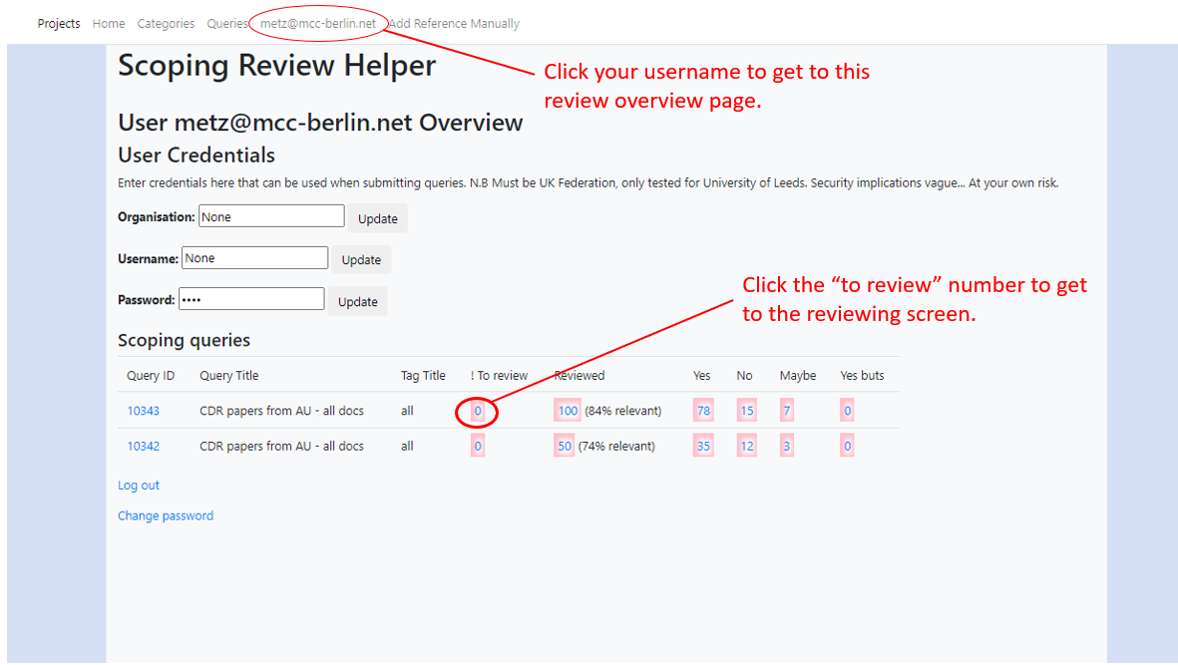

Once you are in the review page, you see an overview of all documents that are assigned to you for review. The column “to review” shows the number of documents that have not been coded yet. Click this to start the coding. If for any reason you need to go back, you can also click the numbers in the other columns to see documents that you have already coded.
The review screen presents you with a screen that is divided into four major areas:
- At the top, there is a progress bar. This shows you how many documents you have already rated. You can also click the blocks in this progress bar to move between documents, for example if you want to revise a rating.

- Below the progress bar on the left, you will see all the information of the current document. In most cases, this will be a title at the top, followed by an abstract, where certain keywords are highlighted to help you find relevant passages. Below that is bibliography information, including the authors, keywords, and publication year.

- Below this is a notes section. This may be especially helpful for double-coded documents or documents you wish to discuss with the rest of the team. Remember to click the “Add note” button to save your note before moving on.

- Finally, the actual coding categories are presented on the right. You should first decide whether an exclusion criterion applies to the record, rendering it not relevant. (see picture on the next page). If an article does not deal with a CDR -related topic you only click “Non-CDR” and immediately “No” for relevance. In all other cases you should click all categories that apply to your document. Hovering over a category option will show additional info on what is meant by the category. You should assign relevance last, as this will save your choices and move you to the next document automatically. 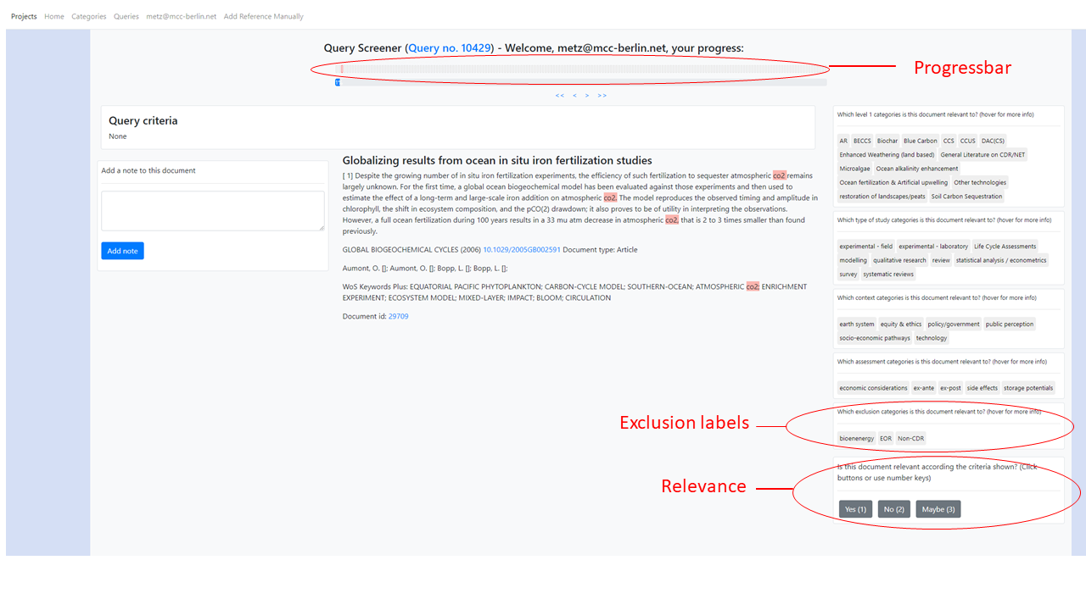

Inclusion and Exclusion
The first choice for all documents is whether it is relevant or not. In essence, a document is relevant if it discusses Carbon Dioxide Removal (CDR) Technology in any way. This includes discussing the application of a CDR - Technology, its side-effects or societal implications, such as governance or public perception. Note that the technology is not always mentioned explicitly, sometimes rather a process is described that amounts to removing CO₂ from the atmosphere and storing it, e.g. Pyrolysis of Biomass resulting in the sequestration of CO₂. Long-term storage (at least 5 years is important in this context. We are not interested in technology pathways that re-release the carbon after short periods of time. Within this definition, CO₂ from direct air capture used in sparkling water or used for the production of synthetic car fuels are not considered as CDR. Although some of the technologies are not regarded as CDR, such as CCS, algae farming or CCUS we include them anyway. We might want to analyse them later..
More detailed inclusion/exclusion criteria are given in the table below. If a document meets all of the inclusion criteria, you click “Yes” on the question for relevance . If it does not meet one or more of the below criteria, click “No” to move to the next document. If you are unsure, click “Maybe”. Articles rated as “Maybe” will be discussed with your colleagues. (Note again that the assignment of relevance should be the last step in coding the record as it immediately saves changes and presents the next record.)

Inclusion | Exclusion
Any study where CO₂ Storage by active and conscious human intervention is discussed and is (potentially) accomplished over a longer period (more than 1 year). This includes any direct discussion of CDR Technologies (explicitly and implicitly) or of concrete implications for the application of CDR Technologies. Furthermore, it includes any process of C-fixation, where the end-use is framed in the context of CCS or remains open.  Edge cases to include:  - biochar is produced but it is not clear what happens to the biochar | Explicitly excluded are  - studies discussing CCS in the production of biofuels and other short-lived products (e.g. cosmetics etc.) where no net-negative emissions are achieved.  - studies where biochar is burned  - studies not dealing with a CDR Technology  - natural processes where there is no human influence or the data can not be used to influence human actions, such as Example1, Example2
The abstract must be available in English. (If no abstract is presented see point 2 below) | The abstract is only available in languages other than English.

General Remarks on Coding Conventions
- We code very inclusively, meaning:
All records where the abstract mentions a CDR technology are included unless it is only mentioned in the context of concluding remarks for further research, as a rhetorical figure OR a pathway only involves short-term CO₂ storage. Furthermore, if we cannot exclude a paper on the abstract base, we include that record.

- We use the title, abstract and - if available - the author keywords to judge the study. If an abstract is not available, judge from the title if possible. If the information does not suffice for an inclusion click “maybe”. And add the note “No abstract”. A title clearly mentioning Carbon Dioxide Removal, a CDR technology or CDR technologies in general is sufficient for inclusion.

- We code what has been stated in the abstract and can be regarded as primary research and the objective of the study. If the title/abstract deals with more than one technologies/scientific methods all are coded.

- Since we want to use machine learning methods to judge the remaining articles, please do not use information besides the title/abstract/keywords to come to an inclusion judgement, rather use the “Maybe” label. You should infer as little as possible to come to a judgement.

- You may and should refer to author keywords.

- We do not use the Web of Science Keywords for judgements, as they apparently automatically generated and often misleading.

- It is not sufficient to include a study if only one vague reference to CDR or a CDR Technology is mentioned. Include the record if multiple references are given.

Categories
For all relevant articles we further sort them into 4 different categories, namely CDR technology, research method, main focus of study, side-effects. Please click all categories that apply. This can mean tha categories are not mutually exclusive. We try to fix coding boundaries in the tables below.
It is possible that none of the options in one or multiple of the categories apply. If the information in the abstract itself is not sufficient to decide what option within a category applies, please do not make a selection. But becuase all the documents are research articles on CDR we expect for each article that it deals with a CDR technology and uses a research method. Those two categories must be filled for each included article. Do not use outside sources or make speculative inferences.
The tables below present all categories, their labels and label descriptions, furthermore the third column on rules/application provides for some cases additional information on how a given label is applied and edge cases are treated.

0 Technology (CDR Technologies)
Every included study has to be assigned to a technology. Not mentioning a specific technology gets a “General literature on CDR” label, a technology which cannot be assigned to another technology a “Other/New technology” label.
Label | Description/Definition | Rule / Application
Bioenergy with Carbon Capture and Storage (BECCS) | The application of Carbon Dioxide Capture and Storage (CCS) technology to bioenergy conversion processes. | This label includes carbon negative Biofuel production  If BECCS is applied, we do not code CCS separately. Unless BECCS and CCS are also discussed separately.  BECCS usually refers to Energy or Heat production in a power plant , where the flue-gases are filtered and stored using CCS.  If co-firing (using Biomass and fossils together) is discussed, we code both CCS and BECCS  Mentioning bioenergy alone in the context of mitigation does not suffice for an inclusion.
Afforestation and reforestation (AR) | Planting of new forests on lands that historically have not contained forests and replanting of forests that have been cleared. Planting forests per se reduces CO2. Studies mentioning AR are therefore included very inclusively.
Agroforestry | Agroforestry is a land use management system in which trees or shrubs are grown around or among crops or pastureland. Agroforestry is one of the CDR technologies mentioned in the latest IPCC report and as such it is always included.
Forest management | Every aspect of management which leads to a sustained carbon dioxide removal. Forest management per se does not increase carbon storage, the already existing storage is rather maintained. Because of that the study must refer to carbon sequestration, e.g. soil carbon, biomass in the forest etc, to be included into the map.
Direct Air Carbon Capture and Storage (DACCS) | Chemical process by which CO₂ is captured directly from the ambient air, with subsequent storage. Also known as direct air capture and storage (DACS). | If DACCS is applied, we do not code CCS separately. Unless DACCS and CCS are also discussed separately.  We also include DAC-only papers here that focus on the process of dissection C from ambient air.  Included are also research on DACCS indoors although their capacity is small.
Enhanced Weathering (terrestrial) | Enhancing the removal of carbon dioxide (CO₂) from the atmosphere through dissolution of silicate and carbonate rocks by grinding these minerals to small particles and actively applying them to soils. | Examples of silicate and carbonate rocks are basalt and feldspar and lime and dolostone. Sometimes components of limestone are mentioned as well e.g. CaCo3.  Liming is explicitly included.  We are interested in active human mediated weathering. Excluded are:  Descriptive analyses of natural weathering processes  - Non active anthropogenic effects:  - Analyses of aerosol effects  If it is unclear whether the EW process is applied on land or in the ocean use Enhanced Weathering as default.  If both usages (on land and in the ocean) are described use both labels.  Liming in agriculture seems to have controversially effects on CO2, it might sequester CO2 or increase CO2 emissions. Because we are not sure about the overall outcome we will include papers on liming in agriculture.  Ocean liming is a one way to in enhance ocean alkalinity and is included as “Ocean alkalinity enhancement”.
Ocean alkalinity enhancement (enhanced ocean weathering) | Enhancing the removal of carbon dioxide from the atmosphere through dissolution of silicate and carbonate rocks by grinding these minerals to small particles and actively applying them to coasts and oceans. | Is the opposite of acidification.  We are interested in active human mediated weathering. Excluded are:  - Descriptive analyses of natural weathering processes  - No active anthropogenic effects:  - Analyses of aerosol effects
Ocean fertilization & Artificial upwelling | Deliberate increase of nutrient supply to the near-surface ocean in order to enhance biological production through which additional carbon dioxide from the atmosphere is sequestered. This can be achieved by the addition of micro-nutrients or macro-nutrients.  Upwelling refers to the use of pipes or other methods to pump nutrient-rich deep ocean water to the surface where it has a fertilizing effect.
Biochar | Stable, carbon-rich material produced by heating biomass in an oxygen-limited environment (pyrolysis) . | Studies examining the production, usage and features of biochar (e.g. Sorption etc.) and studies discussing the co-production of biochar and biofuel are included.  We include Hydrochar under this label.  Uses of Biochar as fuel (where it is burned and CO₂ released) are excluded:  - E.g. Direct fuel cell applications
Soil Carbon Sequestration (SCS) | Land management changes which increase the soil organic carbon content, resulting in a net removal of CO₂ from the atmosphere. | Applications of biochar as soil amendment are included if the effects on the C content of the soil is discussed.  “crop residue retention” is practice used for SCS  We include records dealing with cover crops only if their application is framed in a CDR context.  It seems cultivation of biofuel crops is beneficial for long term storage of soil carbon. We include those cases and label them with SCS and bioenergy. Example1, Example2  Sediment carbon, i.e. carbon stored in materila which sank to the ground in water, is no soil carbon. We do not code SCS here.  Carbon Farming is a practice where farming serves to sequester carbon in soil. We will code it as SCS but it can include other technologies, such as biochar.
Blue carbon | Blue carbon is the carbon captured by living organisms in coastal (e.g., mangroves, salt marshes, seagrass beds, macro algae and seaweed) and marine ecosystems, and stored in biomass and sediments. | We include all discussion of restoration efforts of Blue Carbon (often dealing with mangrove forests and seagrass beds), either before restoration or evaluation of already existing restored forests/beds, Example.  Included is conservation of marine ecosystems (mangroves etc.) if it is done with a focus on carbon sequestration. Example  Coral reefs are not a clear Blue carbon technology as their potential of sequestering carbon is low. If they are discussed with a focus on Blue Carbon we follow the restoration/conservation rules.  Mentioning “management” without mentioning carbon sequestration or looking at the sequestered carbon will not be included, cp. forest management.  Blue carbon often manifests in sediment carbon. Sediment consists of material which sank to the ground. It is no soil carbon.
Restoration of landscapes and peats | A process by which formerly destroyed landscapes that sequester CO₂ are restored to their natural conditions. | Is only applied to land-based activities.  Mere rewetting for peats is not sufficient, a record needs to state that CO2 is sequestered.  Should only be double coded with AR and SCS if either AR or SCS are discussed additionally.
Carbon dioxide Capture Utilization and Storage (CCUS) | A process in which CO₂ is captured and then used to produce a new product. Only if the CO₂ is stored in a product for a climate-relevant time horizon, this is referred to as carbon dioxide capture, utilisation, and storage. Only then, and only combined with CO₂ recently removed from the atmosphere, can CCUS lead to carbon dioxide removal. Examples would be usage for furniture, as building material, | Included are in general products which are solid, excluded are products which are highly flammable. More detailed inclusion/exclusion list: link  Enhanced oil recovery (EOR) is excluded as study and does not count as CCUS. Exceptions are if EOR is discussed as part of BECCS/DACCS etc.  We observe that many studies talk about CCUS but actually mean CCS. We code here CCS, eg. 1826959.  If several long lived and short lived products are discussed we include the study
Other/New Technology | Any technology that removes CO₂ from the Atmosphere and is not listed in this overview. | Applied to any new technology that comes up. Be reminded of the wide definition technology employed here.  example
General Literature on CDR and CDR Technologies. | Any literature that discusses the process or impact of CDR- Technologies, without a limited focus on one or multiple explicit technologies. | If a record compares multiple specific CDR Technologies all single labels are applied plus “General literature”.  If a record deals with a class of multiple technologies - e.g. terrestrial or marine CDR – use general literature. Also, if a record deals with a (partly) unknown portfolio of CDR technologies, use the labels for the known technologies and “general literature” additionally.  Included are papers that explicitly deal with scenarios excluding CDR Technologies and discussing that exclusion.

Additional Technology
Additional technology labels are applied to either further qualify a CDR Technology or to distinguish literature that deals with key technology components of a CDR Technology. On NACSOS we do not differentiate Technology from Additional Technology.
Label | Description/Definition | Rule / Application
Algae Farming | Any managed processes that fixate C in macro or micro algae, in tanks or in the sea, to be harvested later. | Applied if C is stored in algae. If they discuss harvesting or growing algae in general, there need to be a framing in CO2 storage (ex1)  Some papers discussing algae will be relevant:  - Algae Farming to gather Biomass for BECCS  - as material for mid/long term stable products  Others will be irrelevant:  - Algae farmed for biofuel production.  - Algae farmed as fodder for livestock
Carbon Capture and Storage (CCS) | A process in which a relatively pure stream of carbon dioxide (CO2) from industrial and energy-related sources is separated (captured), conditioned, compressed and transported to a storage location for long term isolation from the atmosphere | This is a partial technology for BECCS and DACCS and EOR. If only BECCS/DACCS, EOR are discussed in an article we do not apply an additional CSS label.  Only if the technologies are discussed separately apply multiple labels.  If a paper focuses on the capture process also code CCS if it is capture from a highly concentrated CO2 stream.  Wastewater from mining can be treated with CO2 to detoxify it. We include this as CCS, example , exampel2  We code CCS where an emulsion of CO2 and water using CaCO3 is generated, example

Scientific Method
Please assign to each included article a scientific method. If you are unsure what method is used in the article use “Unknown method”.
Label / Subgroup | Description | Rule / Application
Life Cycle Assessments (LCA) | Analysis of all environmental impacts of a product or service over its lifetime. By quantifying all inputs and outputs of material flows and assessing how these material flows affect the environment. In the context of CDR often assessments of C storage with regard to material flows. | - Is related to both statistical analysis/accounting and modelling  - If the LCA label is applied do not double code statistical analysis or modelling
Modelling | (Mathematical) simulation of socio-economic systems, energy systems, technological systems, human processes | We also code modelling if there are concrete quantified predictions of the future mentioned in the abstract.  Aspen Plus is a software for simulating industrial processes and an indicator for “modelling”.  Other words which indicate modelling:  - techno-economic assessment  - IAM, integrative assessment modelling  - scenario
Experiment | The manipulation of variables to establish cause and effect relationships. | For all experiments we do not label data analysis additionally if they do some basic calculations, e.g. mean, stdv etc.  More complex analysis asks for an additional label in data analysis, e.g. an example with spatial correlation
Experiment - Field study | Testing a hypothesis outside of artificial and highly controlled settings. The idea is to include natural variation into the experimental setting. | Includes observational studies.  Mesocosm experiment, e.g. a tank in the ocean, are labelled as field study.
Experiment - Laboratory experiments | Testing a hypothesis in an artificial and highly controlled setting of a laboratory. | Microcosm studies where an ecosystem is simulated are labelled as laboratory experiments.  Includes pot experiments in greenhouses.
Review | Any study that relies on a literature review as scientific basis for its claims. | This is understood very broad in the context of this research and includes:  - Overview pieces (e.g.in book chapters)  - Perspective pieces that rely limited and sometimes skewed literature bases (often these do not provide methods and give an introduction into a topic/ overview of what research needs to be done)  - Introductions to journal volumes  - Proceedings paper are no reviews automatically but preliminary research papers, if possible identify a method of all available methods, including review  - commentary are included as reviews, example
Systematic review | A type of evidence synthesis, using repeatable analytical methods to collect secondary data and analyse it (quantitatively and qualitatively). It is often mentioned as method in the abstract. | Mentioning numbers of reviewed /synthesised articles in the abstract is an indication for a systematic review.  Meta-analysis, i.e. the comparison and evaluation of several data sets, can be a part of a systematic review. But if the study only conducts a meta-analysis we code it as “data analysis”
Survey | Using any physical or digital tool to gather answers to a predefined set of questions. | also included here are interviews, e.g. with experts
Data analysis / Statistical analysis / Econometric | Data analysis, remote sensing analysis,, statistical models, e.g. panel analysis and accounting studies | Meta-analysis, i.e. the comparison and evaluation of several data sets, can be a part of a systematic review. But if the study only conducts a meta-analysis we code it as “data analysis”.  Included here are:  - machine learning approaches  - multi-criteria analysis, ex (included in the author keywords)  - statistical linear-mixed effect models, ex
Qualitative research | This label is attributed to any qualitative design not caught by other labels. This might include focus groups, case studies, developing frameworks for assessments etc. | Double check if the article does not qualify as perspective (review category) before applying this label.
Unknown method | It is the default label if none of the other labels are applicable. | Double check if the article does not qualify as perspective (review category) before applying this label.

Main focus
This category aims at catching the wider context in which a technology or its application are discussed in an article.

Label | Description | Rule / Application
Public perception & acceptance | Developments of opinions/stances in a given population and media coverage.
Policy, politics and governance | Legislation, enforcement and their effects.
Earth system/ Climate Systems | Global ocean-, land- and air-systems or their interactions and respective outcomes with regard to Climate Change. This includes management, intervention through deploying CDR technologies and their estimated outcomes. | This category is limited to:  Quantitative assessments e.g. in the form of climate (consequences) modelling  This label usually co-occurs with modelling as method.  Hints are usage of following scenario models:  MAgPIE, LPJ, LPJmL, JSBACH, the name carbon cycle-climate model (see http://climatemodels.uchicago.edu/)
Socio-economic pathways | Societal- and market decisions and trajectories. They elicit options for actions. A classical example would be to investigate with a model deployment strategies for different technologies under economic constraints. Here, we do not include optimal deployment of one technology, this would be labelled as technology specific. | This includes:  - Market modelling  - Emission pathways  - modelling of scenarios  - Energy system portfolios  - Integrated assessments  - Government investments  - Land-use depending on the context it is discussed  This label usually co-occurs with modelling as method.  Not included are optimal solutions for one technology, e.g. best suitable land for planting. 4377360. We code such documents as technology.  Often these documents are framed in a way that they want to guide policies, e.g. If they just mention policy in an outlook, we do not code the policy label here.
Technology | Features, processes, and the application of the technology. | This is the most vague/catch-all label in this category. As many articles revolve around technicalities of a given CDR Technology and do not contextualise further.  If another context category (e.g. Earth Systems) is applied only code this label if, the record discusses variables of/ variations to the process of the CDR technology additionally.
Equity & Ethics | Analysis or discussions of the ethical/ normative dimension of CDR technologies and their application. | This might include, risk assessments, assessments of burden-sharing and the like. An example

Assessment
The “Assessment” category is used if an article analyses the application of CDR Technologies.
For that purpose, different assessment criteria are distinguished.
Label | Description | Rule / Application
Economic considerations | Information about the economic viability of the Technology and its cost. | Only apply this label if considerations are either given quantitatively OR a result of a quantitative method, i.e.. model, statistical analysis, experimental measurement.
Storage/sequestration potentials | Information about the global and local CO₂ – storage/capturing potentials of CDR Technologies. | Only apply this label if the storage potentials are either given quantitatively OR a result of a quantitative method, , i.e.. model, statistical ananylsis, experimental measurement.  Storage potentials are only assessed for CO2/carbon.  The capturing process involves ad/absorption of the CO2 to a filtering material and the desorption process from this material. We include in this label all quantified stages of this process.
Environmental side effects | Anything caused by deploying or introducing a CDR Technology on the (Ecological/Physical) environment which does not relate to carbon storage/removal. We want to code very inclusive on side-effects to capture as much as possible. | This is a vague label to also capture qualitative effects that are mentioned in the abstracts.  Apply this label (or the other side effect label) if results are not directly caused by the CDR technology, e.g. looking at algae in ocean fertilisation experiments are no side effects.
Non-environmental side effects | Anything caused by deploying or introducing a CDR Technology on the social/economic surroundings which does not relate to carbon storage/removal. We want to code very inclusive on side-effects to capture as much as possible. | This is a vague label to also capture qualitative effects that are mentioned in the abstracts.  This includes potential economic trade-offs/ positive/negative externalities. (Quantified and non-quantified) For example fertilisation effects on crop / farm land or increased crop yield in general.  No implicit double coding with the Economic considerations.  Apply this label (or the other side effect label) if results are not directly caused by the CDR technology, e.g. looking at algae in ocean fertilisation experiments are no side effects.
Ex-post | Ex-post analysis looks at results after they have occurred | Is given in the context of policy and model evaluations. Explicitly not used for any experimental or observational study
Ex-ante | Ex-ante analysis looks at predictions | Is given in the context of policy and model evaluations. Explicitly not used for any experimental study

Exclusion
If this category is applied, the record is judged as not relevant, based on the inclusion criteria.
It is used to catch some topics that might later be included or relevant for further investigation.
This allows us to set the limits to our living map more flexibly. Please apply an exclusion label if the study is excluded.
Variable | Description | Rule / Application
Bioenergy | Energy derived from any form of biomass or its metabolic by-products. | This includes all uses of biological material for heat or energy production including biofuel and burning biochar.
Enhanced Oil Recovery (EOR) | The practice of pumping CO₂ into oil reservoirs (effectively sequestering it) to increase the oil yield.
Short-lived CCUS | A process in which CO2 is captured and then used to produce a new product, which stores CO2 only for a short period of time. | This includes usages of CO2 produce cosmetics via algae or to produce fodder for livestock.
Solar Radiation Modification (SRM) | Sunlight would be reflected back to space to limit or reverse human-caused climate change. | Please also apply if the record is relevant based on the other technology labels applied.
Non-CDR | The paper clearly deals with a non-related topic | This is our “Catch all”- label, used if no other exclusion category applies. Meaning that the paper does not address CDR Technologies at all.  If it is applied no other category needs to be applied.  Fuel cells are included here if there is no relation to CDR.

Current working definition: At least one accounting period: one year.

