Supplementary material
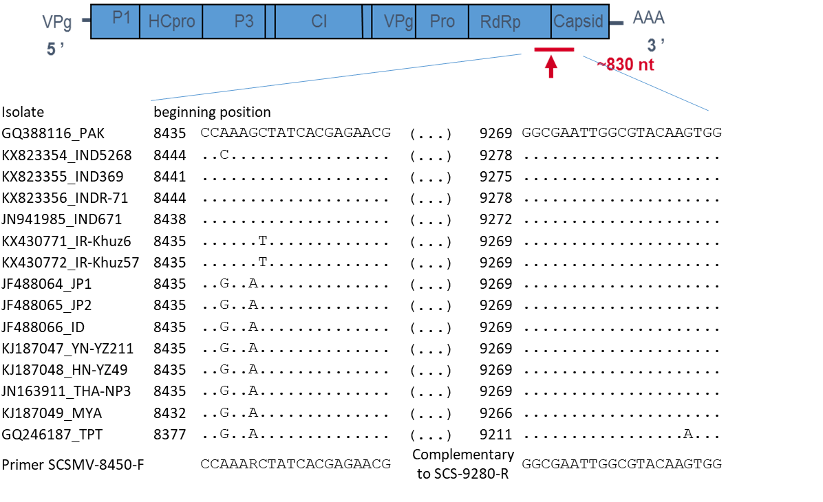

Fig S1. Polypeptide structure of SCSMV showing the site of choice of the specific primer pair at the N-terminal part of the protein capsid
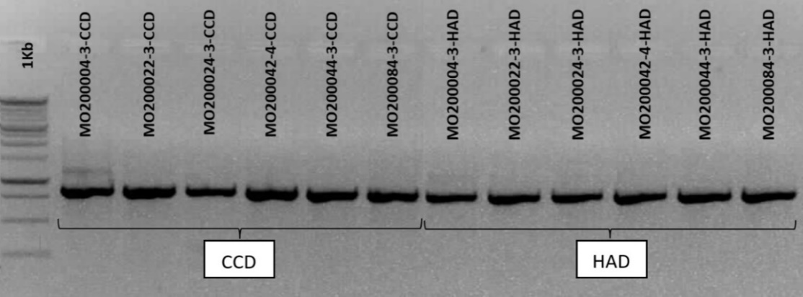

Fig S2. Amplification of SCSMV from samples stored after calcium chloride dehydration (CCD) and hot-air dehydration (HAD)

