Supporting Information for
A dual growth mode unique for organic crystals relies on mesoscopic liquid precursors
Manasa Yerragunta, Akash Tiwari, Rajshree Chakrabarti, Jeffrey D. Rimer, Bart Kahr,
Peter G. Vekilov

Methods
Materials. Etioporphyrin I was purchased from Frontier Specialty Chemicals. 1-Octanol (anhydrous, ≥99 %) was purchased from Sigma Aldrich. Deionized (DI) water was produced by Smart2Pure 6 water purification system from Thermo Scientific.
Bulk Crystallization: Supersaturated solutions of Etioporphyrin I (0.5 mM) were prepared at 70⁰C using octanol as solvent. Solutions were filtered using 0.22 μm PTFE membrane filter and the concentrations were measured using UV-vis spectroscopy. 20 ml glass vials were cleaned with DI water and ethanol. 15 mm glass disks were scratched and placed in the vials. Solutions of 0.5 mM concentration were then transferred into the vials with glass disks and placed in incubator at 70⁰C for 1 hour. Then the temperature was reduced slowly to room temperature and left overnight for crystals to grow.
Growth solutions of desired concentrations for microfluidics and in-situ AFM studies were prepared by diluting the supersaturated solutions.
UV-Vis Spectroscopy: UV-Vis absorbance spectra were recorded with DU Spectrometer 800 (Beckman) in the wavelength range 200 – 800 nm. Etioporphyrin I has a Soret band and four Q-bands ^{1,2}. The linear correlation between optical density at a wavelength 492 nm, at which the absorbance is at a of maximum, was used to measure the concentrations of etioporphyrin I solutions.
For determination of the solubility, three identical compositions of etioporphyrin I solutions were kept in three vials and maintained at constant temperature of 29⁰C. The solution was filtered and concentrations were measured spectrophotometrically using the known extinction coefficient ². All the measurements were carried out in triplicates independently for experimental statistics. This process was repeated multiple times until the concentrations did not change for at least three consecutive measurements.
Scanning Electron Microscopy. Crystals of Etioporphyrin I in octanol were prepared by slow cooling as described above. The glass coverslips were carefully taken out from the glass vials and rinsed thoroughly with solvent to remove loose crystals. Coverslips were then air-dried and mounted on metal stubs with carbon tape and coated with 10-20 nm gold. SEM images were collected at a system vacuum of 2×10⁻⁵ mbar pressure and EHT 3 kV.
Microfluidics measurement of crystal growth rates. Semiautomatic inverted light microscope (Leica DMi8 equipped with PL Fluotar 5×, 10×, 20× and N Plan 50× objectives) ³ was used to examine the growth of etioporphyrin I crystals. For this study, etioporphyrin I crystals were prepared on glass disks and a glass disk was placed inside a polydimethylsiloxane (PDMS) channel. Growth solutions of different concentrations (0.25 – 0.5 mM) were prepared and each solution was pumped inside the channel continuously at a rate of 0.1 ml/min using a syringe pump (Chemyx, Fusion 4000). Images were captured every 5 min at multiple positions along the channel. Optical micrographs of crystals were analyzed using ImageJ for the average length. The growth rate was measured by linear regression of 20 crystal lengths measured from 5-10 crystals.
Time-resolved in situ AFM monitoring of etioporphyrin I crystal surfaces. Multimode atomic force microscopy (Nanoscope VIII) from Bruker was used for all AFM experiments. AFM images were collected in tapping mode using SNL-10 “C” probes (Sharp nitride lever probes, silicon nitride cantilever, silicon tip, 0.24 N/m spring constant) with a tapping frequency of 32 kHz. Images size ranges from nm to 20 μm. Scan rates were between 1-3 lines/s. Images were captured in three imaging modes: height, amplitude, and phase. Standard captured image consists of 256 scan lines, or 128 scan lines based on the aspect ratio. The temperature in the fluid cell was measured to be 29 ± 0.1⁰C within 15 min of imaging which is higher than the room temperature (ca. 22⁰C). This shows that the fluid cell is heated by the AFM scanner and the laser.
Etioporphyrin I crystals were grown on scratched glass disks. The glass disks were glued onto the AFM sample disks (Ted Pella Inc.) and the sample disks were placed on the stage. Different concentrations of etioporphyrin I solutions in 1-octanol were prepared by dilution before an hour and solutions were placed in an incubator at 70⁰C to maintain the concentrations. A solution sample was loaded into an AFM liquid cell using 1 ml disposable polypropylene syringe (Millipore Sigma- Sigma Aldrich), which are tolerant to organic solvents. The system was left for 10 min to thermally equilibrate. A (010) face was identified visually from the edges and morphology of the crystals. AFM probe cantilever was then adjusted and set to the preferred region. Scan direction was set along the length of the crystal. Surface features of etioporphyrin I changed quickly because of the fast growth dynamics. Fresh solutions were loaded every 15 min to maintain the concentrations.
Etioporphyrin I crystal surface has spiral steps originate at the outcrop points of screw dislocations. The displacements of 15-20 individual steps with a measured height h = 0.99 ± 0.10 nm were monitored, and the velocities of growing steps were calculated.
Step height and the separation between each step for 15-18 steps were measured for single and double steps and the velocities of these steps were calculated. Comparison of these step velocities with step separation was used to find the pathway of solute molecules from the solution to the crystal surface. There are two possible pathways where solute molecules can incorporate into the crystal. (1) Surface diffusion. In this pathway, solute molecules first adsorb onto the terrace and diffuse along steps to reach kink. (2) Direct incorporation. In this pathway, solute molecules directly attach to the kinks. ^{3–6}
The step velocity was approximately 20 nm/s for both single and double step (Fig. S6). This independence indicates that there is no competition between the steps when they are even 200 nm close, and the step velocities are independent of step separation. From this we can conclude that the pathway is direct incorporation of solute molecules directly onto the kinks.
For the characterization of particles landed on the crystal surface at 0.39 mM, the length along the axial direction was measured to monitor the growth of these particles. The height of the particles was measured using AFM image analysis software (Nanoscope Analysis 1.8) by drawing a line along the axial direction. The growth velocity of the flattop generated from the landed particles was calculated using the change in the size of the flattop in axial direction. The growth velocities of steps were measured as described above.
Oblique Illumination Microscopy (OIM). Etioporphyrin I clusters were monitored using Nanosight LM10-HS microscope (Malvern Panalytical Inc) with OIM, also known as Brownian microscopy or particle tracking ⁴⁻⁶ ⁷. In this technique, thin sample solution layer was illuminated by a green laser at an oblique angle to avoid the lens of microscope positioned above the sample. With this technique, objects at the nano and microscale can be identified using light scattered at wave vectors of order mm⁻¹. Larger particles dominate in the scattering signal in a solution comprising objects of varied sizes because the scattered intensity is proportional to the sixth power of the scatterer’s sizes. Thus, the technique is especially well-suited to characterize the particle’s size and number distribution that show up in OIM micrographs as brilliant cyan dots. A custom-made package from Nanosight counts the spots. The number of spots in a frame and the volume V = 120 × 80 × 5 μm³ ref. ^{6,7} were used to calculate the concentration of the seen particles. Each particle’s Brownian motion in the picture plane was captured by OIM, which uses the correlation the mean squared displacement $d_{n}^{2}$ and the lag time Δt. $d_{n}^{2}=4D∆t$, where D is the diffusion coefficient of the observed particle.
Solution of desired concentration was loaded into the sample cuvette of volume ca. 0.3 ml using polypropylene syringe (Millipore Sigma- Sigma Aldrich). The green laser used has a wavelength of 532 nm. The temperature was set to 29⁰C for the experiment. Five movies were obtained from different solution volumes in each loaded sample solution. The number of clusters in each range of sizes were averaged.
Transmission Mueller polarimetry. The method relies on optical instruments that measure the light polarization evolution through a sample to recover the sixteen elements of the so-called Mueller matrix $M$, more descriptively the polarization transfer matrix. Such a device is a complete polarimeter. A home-built Mueller matrix microscope was used based on dual continuously rotating retarders ⁸⁻¹⁰. This concept was first described by Azzam ¹¹. An incident light beam is directed through a linear polarizer ($P$₁) coupled to a continuously rotating retarder or waveplate ($M$ _{R1}). Together, P₁ and $M$_{R1} define the polarization state generator (PSG). They are each of a form of a 4x4 Mueller matrix and operate successively by multiplication. After the beam is transmitted through the sample ($M_{s}$) the light is gathered by an objective lens and passed onto the polarization state analyzer (PSA), composed of a continuously rotating waveplate, $M$_{R2}, followed by a fixed linear polarizer, P₂. Continuous rotation of the waveplates creates a time-dependent signal ($I\left(t\right))$ at the detector that encodes the elements of $M$. By sampling the characteristic periodic signal $I\left(t\right)$, $M$_{s} can be recovered. The signal function $I\left(t\right)$ can be derived using the Stokes-Mueller formalism since the Mueller matrix of the polarization modulation elements are known. The elements of $M$ encoded by $I\left(t\right)$ and can be extracted through digital demodulation.
The imaging polarimeter used for the experiments described in this work was constructed by adapting the accessory slots of a commercial light microscope (Zeiss Z1 Observer). Two custom polarization modulators, each composed of a manually adjustable polarizer and motorized retarder (quarter waveplate film), were designed for the transmission illumination and detection illumination pathways using rapid-prototyping techniques ^{12,13}. The modulators operate to produce and subsequently analyze the polarization state of light. A minimum number of elements, limited to a strain-free condenser and objective lens, are installed between the polarization modulators to reduce the introduction of parasitic optical effects.
Transmission measurements are made with a spectroscopic light source constructed from a plasma-arc lamp coupled to a monochromator with adjustable grating. The beam is directed to the microscope via a light guide (Figs. S9, S10).
The instrument calibration process determines the initial phase offset ($ϕ_{j})$and retardance (δ_{j} ) of each quarter waveplate. In the absence of optical anisotropies, the off-diagonal elements vanish and M_{s} takes the form of the identity matrix. Calibration is conducted in a straight through configuration, without a sample on the stage.
The etioporphyrin crystals were examined under the octanol mother liquor in which they were grown. The extraction of relevant optical parameters from an experimental M has been described previously ¹⁴.

Supporting Figures
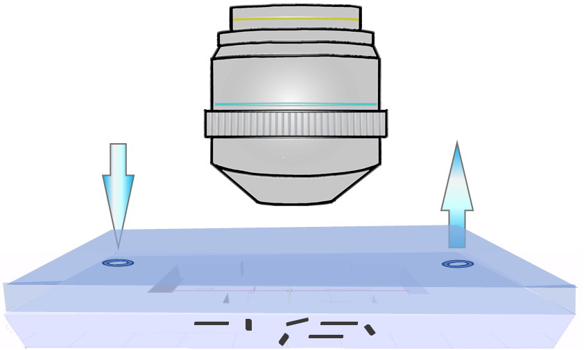

Fig. S1. Schematic of a microfluidic device to measure the crystal growth rate. Crystal seeds are introduced to microfluidic channels. Growth solution is supplied to the device (arrows) by a syringe pump at a constant flow rate to maintain steady supersaturation.

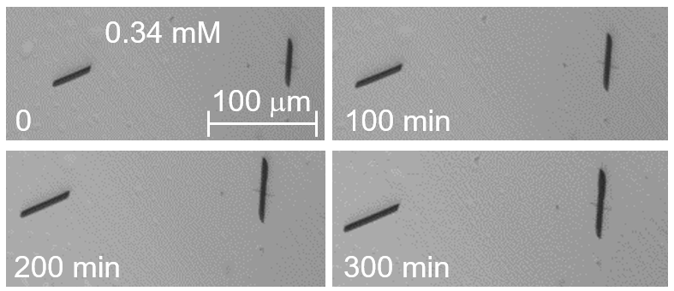

Figs. S2 The evolutions of two etioporphyrin I crystals. The crystals grew in a microfluidic device at steady solute concentration C = 0.34 mM. Time-resolved images are shown over 300 min of seeded growth.
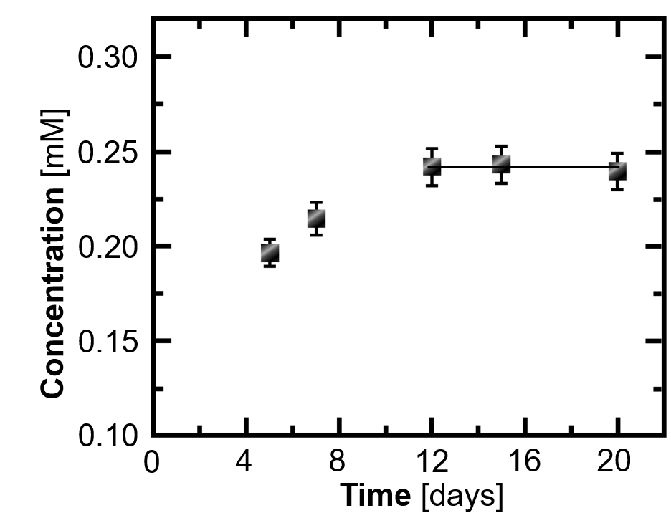

Fig. S3. Solubility of etioporphyrin I in neat 1-ocatanol at 29ºC, equal to the temperature of the AFM liquid cell. The temperature in the AFM liquid cell is elevated above that in the room, ca. 23ºC, owing to heating by the piezo scanner, on which the sample rests, and the red laser used to detect the deflection of the AFM cantilever. The solubility measurement was carried in three independent experiments, run in parallel. In each of these experiments, a solvent sample was kept in a vial stationed in a thermostat at 29ºC. Crystals of etioporphyrin I were added periodically and left to dissolve. After some of the crystals we found not to dissolve, a sample of the supernatant was decanted with precautions not to include crystals in it. The etioporphyrin I concentration in that solution sample was measured spectrophotometrically. The measured concentration was averaged between the three experiments. Three consecutive measurements that yielded concentrations equal within the error limit of the determination were viewed as evidence that the concentration has reached a steady state. The steady concentration values were averaged over the last three time points and the average was taken as the solubility at 29ºC. The standard deviation from that averages was evaluated from the same nine concentration data points.

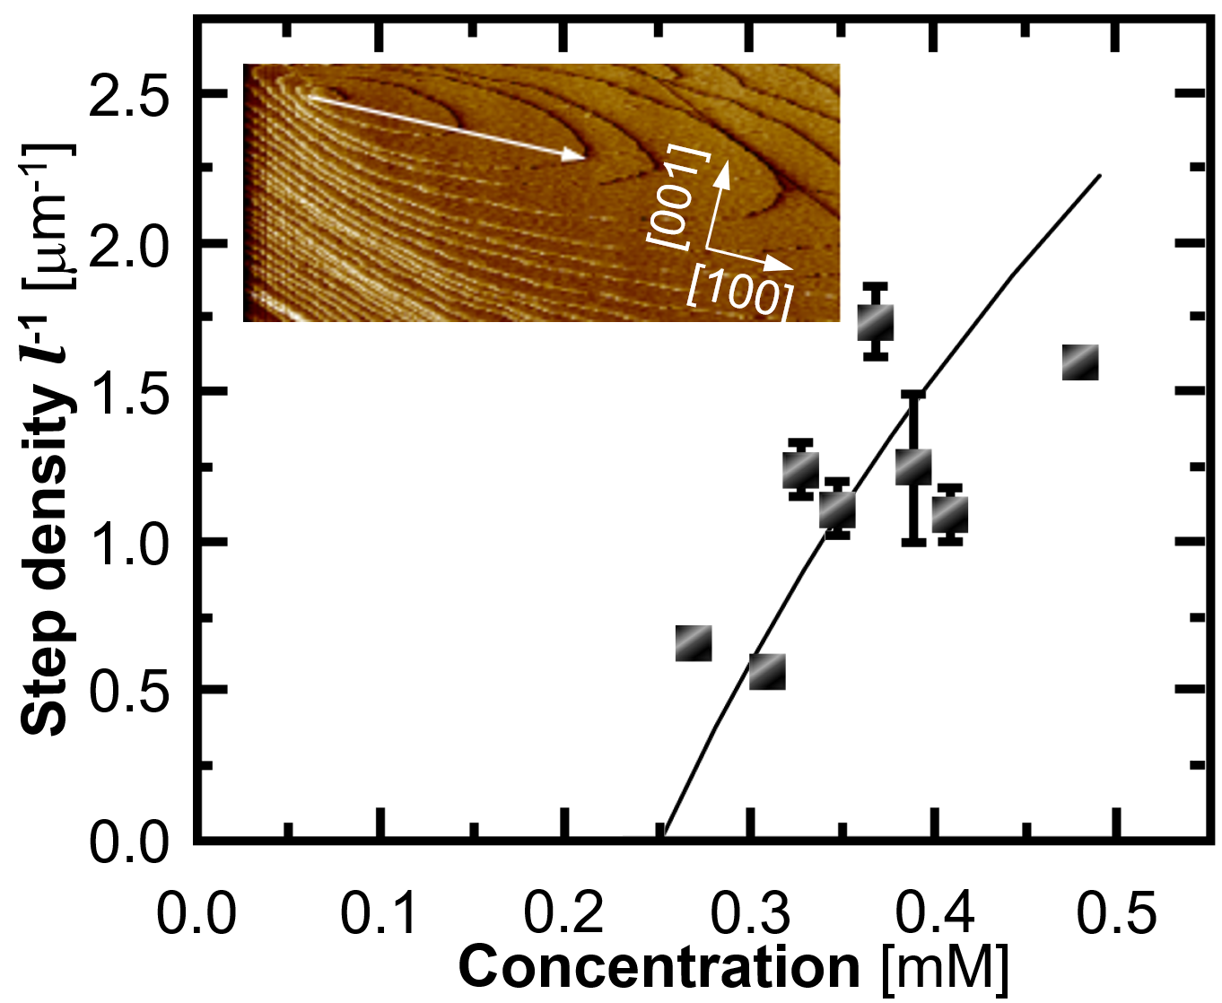
Fig. S4. The correlation between step density l⁻¹ and etioporphyrin I concentration C. Inset: steps growing on the (010) face of etioporphyrin I crystal. Growth in the [100] direction, in which step growth is fastest and l, longest, is highlighted with an arrow. 20 step separations l in the [100] direction were measured at each C. The error bars represent the standard deviations from the averages of these measurements. The deviations from the best-fit curve are likely due to step shape fluctuations and to interactions between steps coming from different sources, including crystal growth precursors. Solid line, fit with the correlation between l and supersaturation $Δμ$ for layers generated by single dislocation, as in inset and Fig. 1i, $l_{\left[100\right]}=19r_{crit}B_{\left[100\right]}^{*}=19ΩγB_{\left[100\right]}^{*}Δμ^{-1}=19ΩγB_{\left[100\right]}^{*}{\left[k_{B}T\ln\left(\frac{C}{C_{e}}\right)\right]}^{-1}$, where $r_{crit}$ is the radius of the critical two-dimensional nucleus, $Ω$ = 0.678 nm³ ref. ¹⁵ is the contribution of one etioporphyrin molecule to the crystal volume, $γ$ is the surface free energy of the step edge, $Δμ=k_{B}T\ln\left(\frac{C}{C_{e}}\right)$ is the difference in etioporphyrin I chemical potential in the solution and the crystal, C_{e} = 0.25 mM is the solubility, $k_{B}$ is the Boltzmann constant, $T$ is temperature ¹⁶⁻¹⁸, and $B_{\left[100\right]}^{*}=\frac{1}{4}\left[1+\frac{β_{\left[100\right]}}{β_{\left[001\right]}}+\frac{β_{\left[100\right]}}{β_{\left[\overline{1}00\right]}}+\frac{β_{\left[100\right]}}{β_{\left[00\overline{1}\right]}}\right]$ is an anisotropy factor which accounts for distinct step velocities in the different directions on the (010) face ¹⁸. $β_{i}$ is the step kinetic coefficients in the i direction (i = [$100$], [$001$], [$\overline{1}00$], and [$00\overline{1}$]) From images as in the inset $B_{\left[100\right]}^{*}≅0.25\left[1+9+7+6\right]=5.75$. The best-fit value for $γ$ = 17.8 mJ m⁻². This estimate of $γ$ is close to an estimate using the Turnbull empirical rule ¹⁹⁻²¹ and the crystallization enthalpy $ΔH_{cryst}^{o}= -27$ kJ mol⁻¹ ref. ², $γ=\frac{0.3\left|ΔH_{cryst}^{o}\right|}{Ω^{2/3}N_{A}}$ = 17 mJ m⁻².
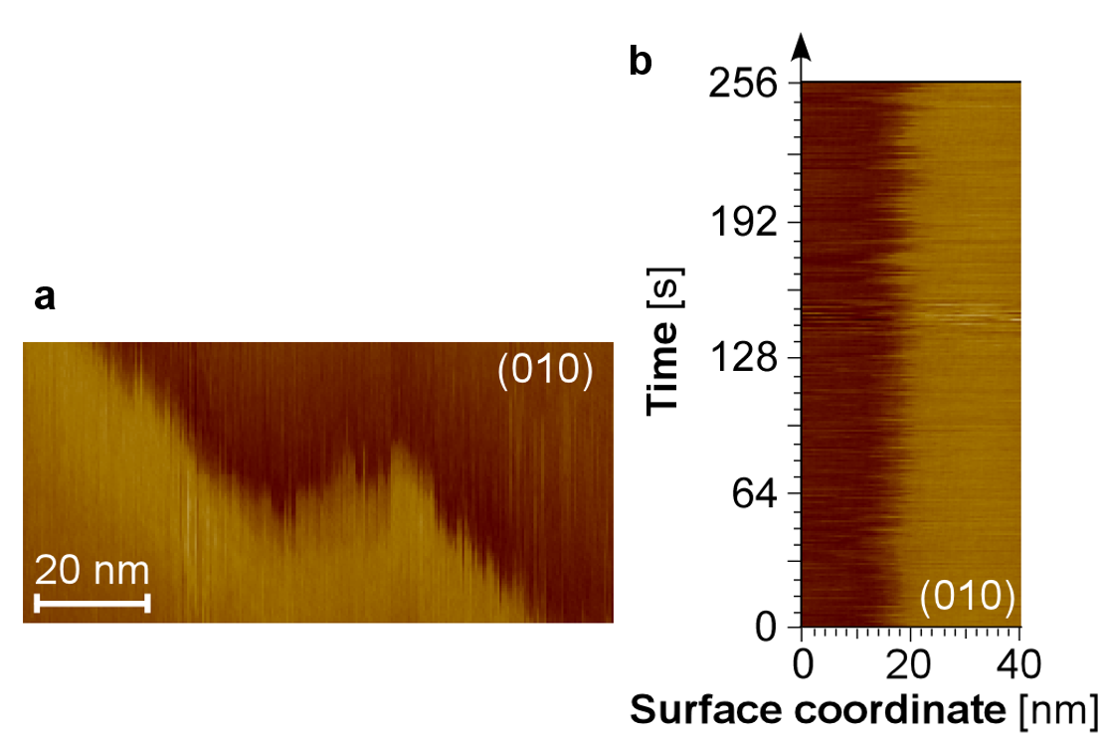

Fig. S5 High-resolution view of molecular incorporation into kinks. a. An AFM image of a short step segment on the (010) face of an etioporphyrin I crystal at C ≅ C_{e} shows rough step edges with abundant kinks, whose density close is to the thermodynamic limit of 0.3. b. Image of one location at a step on a (010) face of an etioporphyrin I crystal at C ≅ C_{e}. Image collected with disabled y-axis. In this imaging mode, the vertical axis represents time, determined from the scanning frequency and the scan line number. The image shows dynamics of step edge owing to exchange of molecules with the solvent.

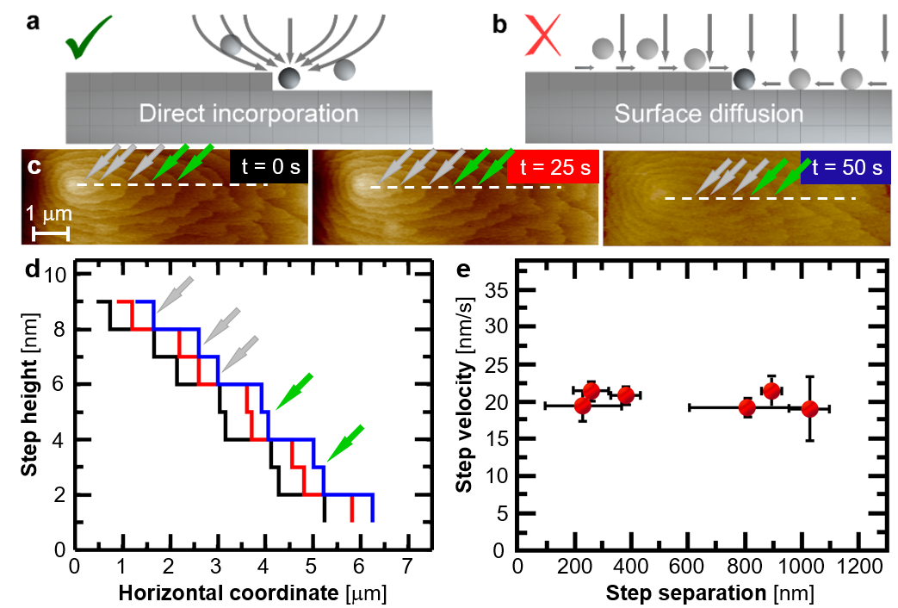

Fig. S6. The pathway of a solute molecule into a kink. a, b. Schematic representations of two pathways from solution to steps. a. Solute molecules reach the steps directly from the solution. b. Solute molecules adsorb on the crystal surface and diffuse towards the steps. c. Time-resolved in situ AFM images of the growth of steps with height $h=2\left|\vec{b}\right|$ ($\vec{b,}$ lattice parameter in [010] direction) (green arrows) and steps of height $h=\left|\vec{b}\right|$ (silver arrows) at C = 0.38 mM. d. The surface profiles along the dotted lines in c. Colors correspond to colors of time tags in c. Single height steps (silver arrows) advance over lengths similar to those of double-height steps (green arrows). e. The step velocity does not correlate with the step separation $l$. C = 0.38 mM. The averages of 15 measurements for each$l$ interval, represented by horizontal bars, are shown. Vertical bars represent the standard deviations of the groups of measurements. These observations affirm that etioporphyrin I molecules prefer the direct incorporation pathway. Indeed, if solute reaches the steps via the crystal surface, the step supply field is constrained to two dimensions, which stunts the growth of closely spaced steps or steps of double height. Concurrently, analytical models of step growth mediated by surface diffusion predict that $v$ scales with $h^{-1}$ and sharply slows down at short l ^{22,23}. Experimental observations reveal that double-height steps that feed via the surface grow slower than single-height steps ^{20,24}. By contrast, if the steps feed directly from the solution, the supply field is three-dimensional and abundant for closely spaced or twinned steps. Closed-form expressions for this growth mode predict negligible $v(h)$ and weak $v(l)$ correlations ^{23,25,26}.

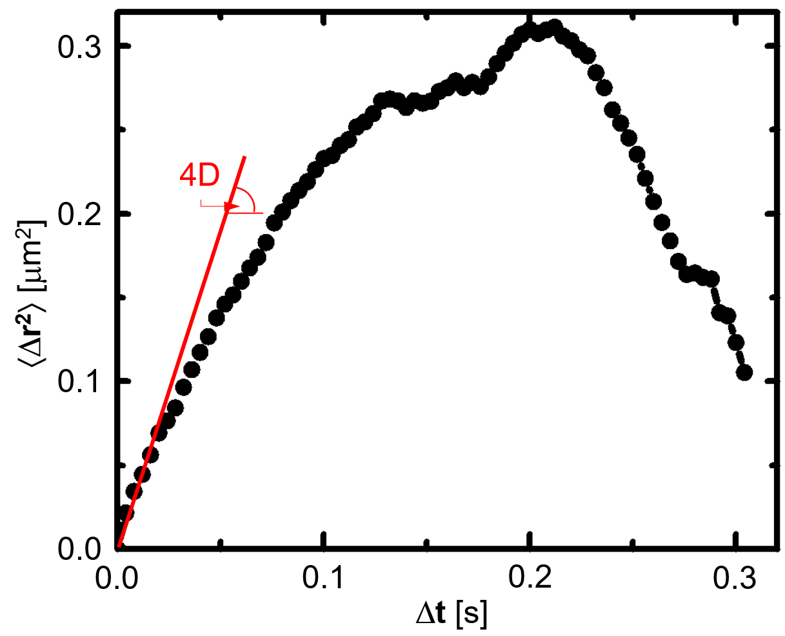
Fig. S7. Mean squared displacement as a function of the lag time Δt. The mean squared displacement, $〈Δr^{2}〉$, was calculated from the trajectory in Fig. 3c Since the trajectory was recorded at two dimensions, $〈Δr^{2}〉=4DΔt$. The correlation deviates from strict linearity at longer lag times Δt owing to the paucity of data collected from a single cluster. The slope of the initial linear correlation is used to evaluate the diffusion coefficient D ref. ²⁷, from which we evaluate the particle radius R_{c} using the Stokes-Einstein relation, $D=k_{B}T{\left(6πηR_{c}\right)}^{-1}$, where $k_{b}$ is the Boltzmann constant, $T$ is temperature, and $η$ is the solvent, octanol, viscosity.

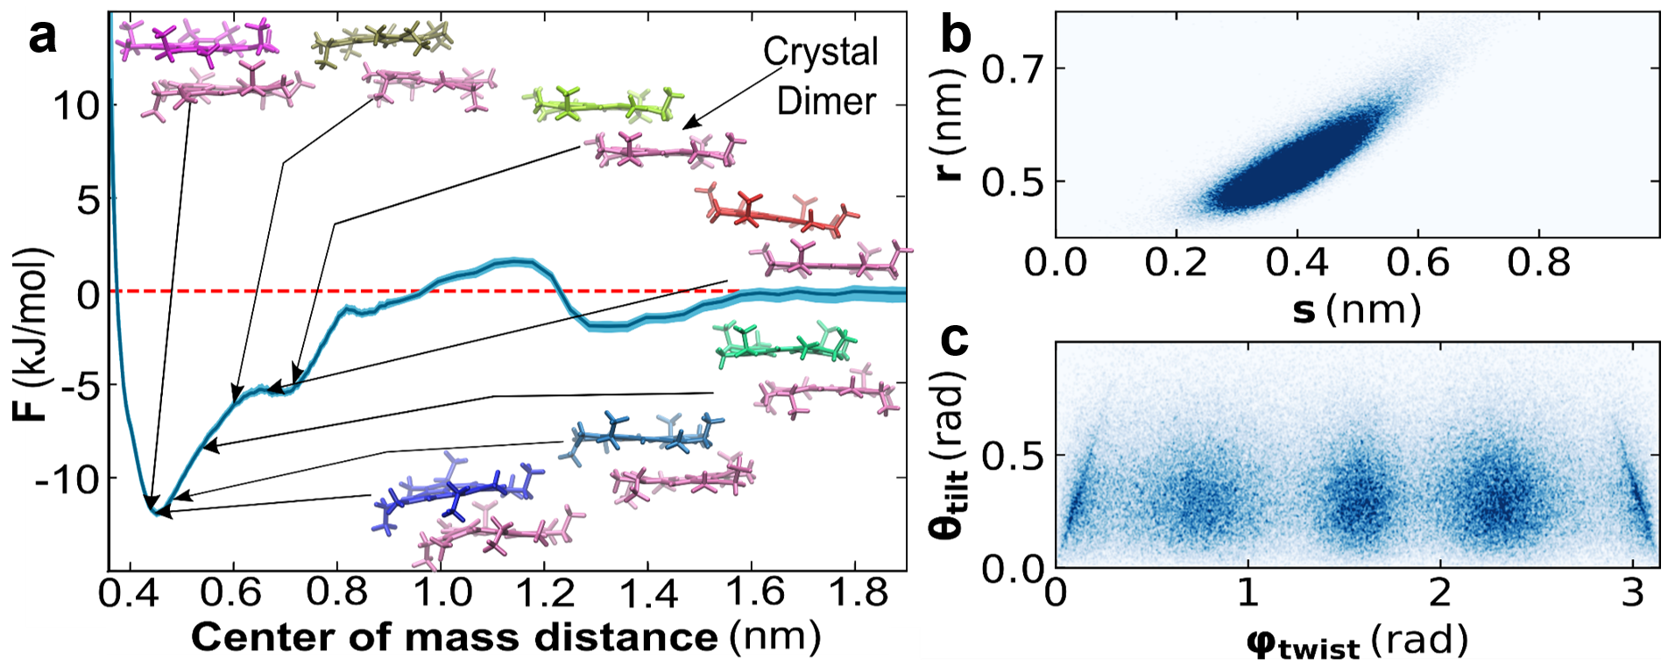

Fig. S8. The dimerization equilibrium of etioporphyrin I in 1-octanol. a. All-atom molecular dynamics (MD) computation of the potential of mean force F between two etioporphyrin I monomers in 1-octanol. Insets: configurations of the two monomers, the configuration that mimics that in the crystal lattice is highlighted. The dimer in the deep F minimum deviates from the one in the crystal by closer separation, and relative twist and tilts of the monomers. The strength of the bonds between two monomers in a dimer, ca.$4k_{B}T$, where $k_{b}$ is the Boltzmann constant, $T$ is temperature, is within the range of several $k_{B}T$ units required for formation of mesoscopic solute-rich clusters ²⁸. Data from Verma et al. ²⁹ b. The distribution of the probability of the separations between the centers of mass of the monomers in a dimer. r, along the normal to the porphyrin plane, s, along the axis connecting the two hydrogenated N atoms in the porphyrin plane. High color density indicates high probability. As the monomers pull closer together, their shift diminishes to ensure better π-π staking. Perfect fit is hindered by the ethyl and methyl sidechains. c. Distribution of the orientations of the two monomers in a dimer characterized in terms of the angle between their porphyrin planes, θ_{tilt}, and the angle between the axes passing through the two hydrogenated N atoms (Fig. 1a). High color density indicates high probability. Low tilt angles are preferred. Perfectly parallel configurations (θ_{tilt} = 0) are hindered by the methyl and ethyl side chains. The distribution of the twist angles reflects the quasi-fourfold molecular symmetry.

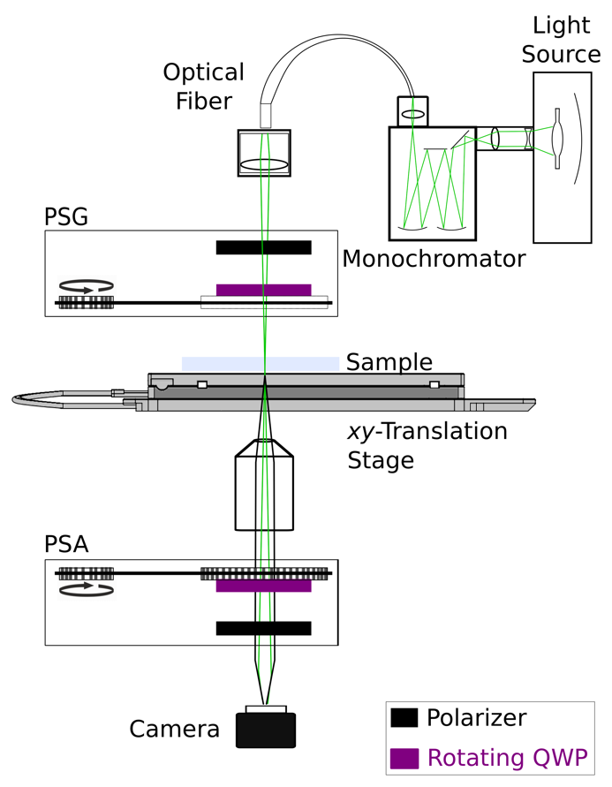

Fig. S9. Schematic of Mueller matrix imaging polarimeter. The device employs dual continuously rotating retarders. The polarization state generator (PSG) and polarization state analyzer (PSA) are composed of a stationary polarizer and mechanized retarder (quarter waveplate) that are inserted before and after the sample plane, respectively (Fig. S10) ^{12,13}.

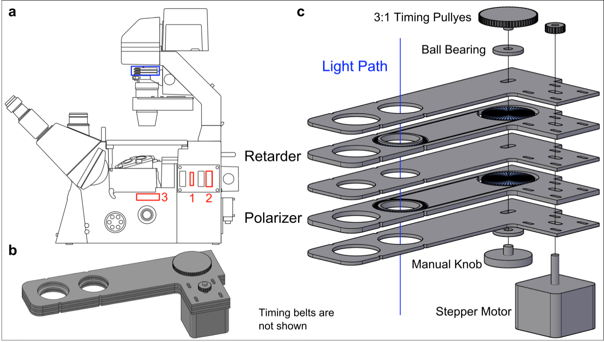

Fig. S10. Mechanical drawings of components of light modulators. In our case, in transmission, the PSG is at the top below the light source and the PSA is in slot 3 before the camera port ¹². Quarter wave films are rotated with respect to fixed crossed linear polarizers.

Supporting Movies
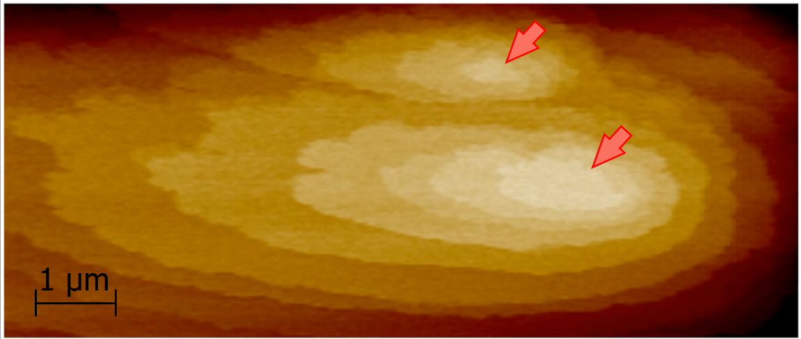
Movie S1. Time-resolved in situ AFM images of a growing etioporphyrin I (010) face. Arrows indicate the outcrop points of two screw dislocations, which generate spiral-shaped steps. Steps grow fastest is the horizontal [100] direction.

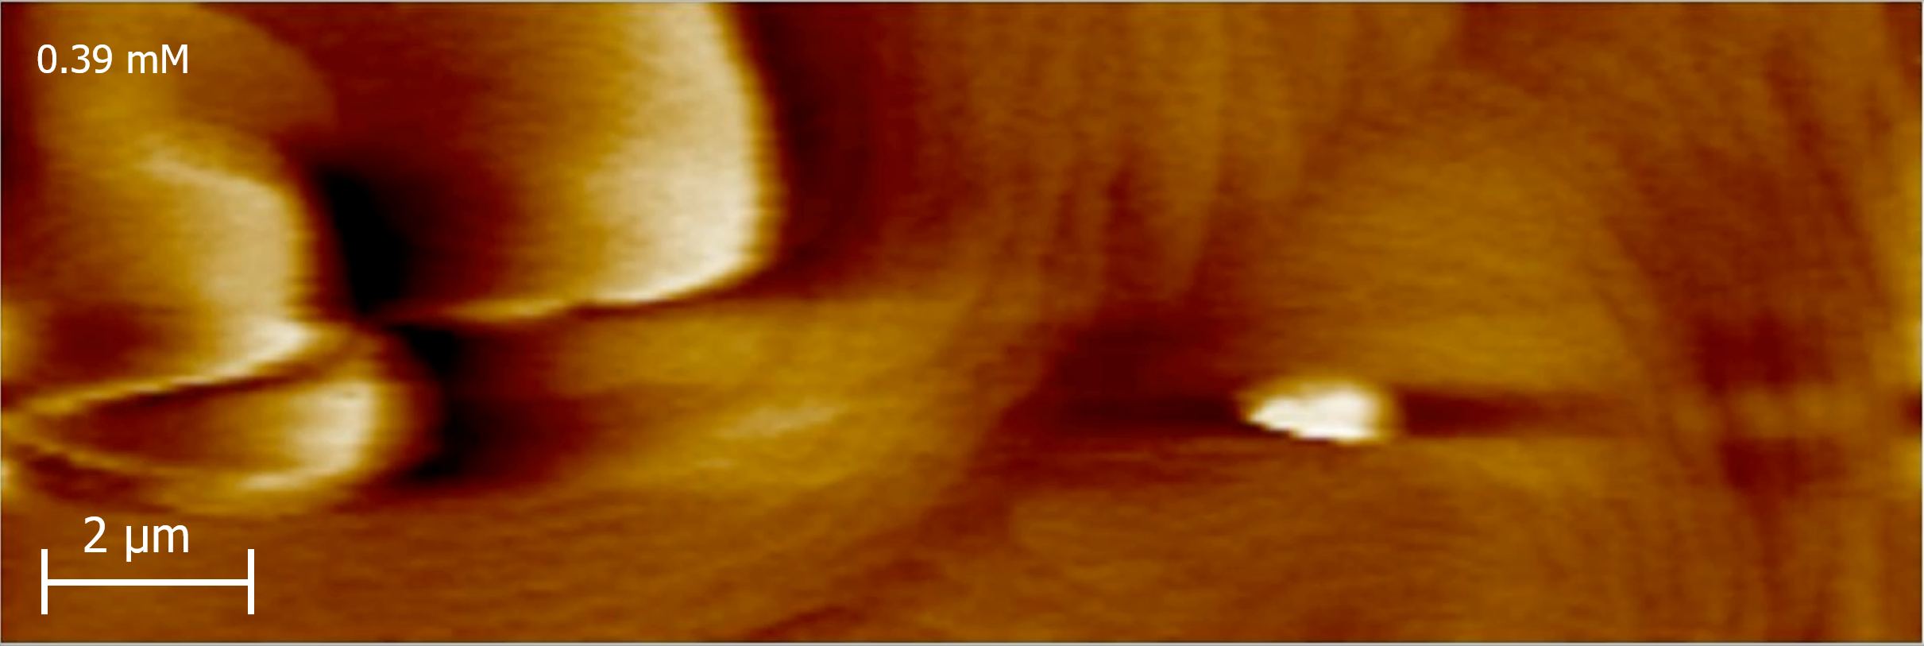
Movie S2. Time-resolved in situ AFM images of the evolution of two precursors, indicated with red and blue arrows, on a crystal face growing at C = 0.39 mM. Select frames of this movie are presented as Fig. 2a.
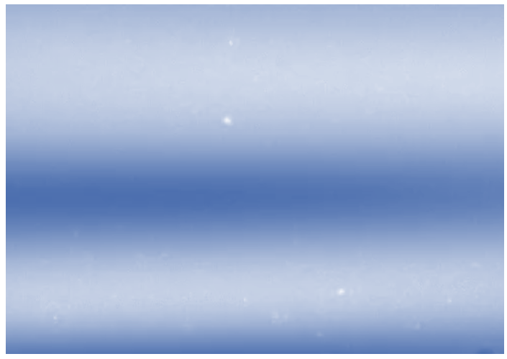
Movie S3. Brownian dynamics of the mesoscopic etioporphyrin-I-rich clusters captured by oblique illumination microscopy. C = 0.058 mM, T = 29ºC. The cluster trajectories, as in Fig. 3d, were extracted from movies like this and used to evaluate the clusters size.

Supporting references
1 Chakrabarti, R., Verma, L., Hadjiev, V. G., Palmer, J. C. & Vekilov, P. G. The elementary reactions for incorporation into crystals. Proceedings of the National Academy of Sciences 121, e2320201121, (2024).
2 Chakrabarti, R. G. & Vekilov, P. G. Attraction between Permanent Dipoles and London Dispersion Forces Dominate the Thermodynamics of Organic Crystallization. Crystal Growth & Design 20, 7429-7438, (2020).
3 Kim, D., Moore, J., McCoy, C. P., Irwin, N. J. & Rimer, J. D. Engaging a Battle on Two Fronts: Dual Role of Polyphosphates as Potent Inhibitors of Struvite Nucleation and Crystal Growth. Chemistry of Materials, (2020).
4 Vorontsova, M. A., Chan, H. Y., Lubchenko, V. & Vekilov, P G. Lack of Dependence of the Sizes of the Mesoscopic Protein Clusters on Electrostatics. Biophysical Journal 109, 1959-1968, (2015).
5 Filipe, V., Hawe, A. & Jiskoot, W. Critical Evaluation of Nanoparticle Tracking Analysis (NTA) by NanoSight for the Measurement of Nanoparticles and Protein Aggregates. Pharmaceutical Research 27, 796-810, (2010).
6 Maes, D. et al. Do protein crystals nucleate within dense liquid clusters? Acta Crystallographica Section F 71, 815-822, (2015).
7 Li, Y., Lubchenko, V. & Vekilov, P. G. The Use of Dynamic Light Scattering and Brownian Microscopy to Characterize Protein Aggregation. Rev. Sci. Instrum. 82, 053106 (2011).
8 Chipman, R., Lam, W. S. T. & Young, G. Polarized Light and Optical Systems (1st ed.). (CRC Press., 2018).
9 Chen, C. et al. Multichannel Mueller matrix ellipsometer based on the dual rotating compensator principle. Thin Solid Films 455-456, 14-23, (2004).
10 Arteaga, O. et al. Mueller matrix microscope with a dual continuous rotating compensator setup and digital demodulation. Applied Optics 53, 2236-2245, (2014).
11 Azzam, R. M. A. Photopolarimetric measurement of the Mueller matrix by Fourier analysis of a single detected signal. Optics Letters 2, 148-150, (1978).
12 Nichols, S. M. Coherence in polarimetry, PhD dissertation. New York University, (2018).
13 Tan, M. S. The chiroptics of imperfect crystals, PhD Dissertation. (New York University, 2020).
14 Arteaga, O. & Kahr, B. Mueller matrix polarimetry of bianisotropic materials [Invited]. Journal of the Optical Society of America B 36, F72-F83, (2019).
15 Che, C.-M. et al. A High-Performance Organic Field-Effect Transistor Based on Platinum(II) Porphyrin: Peripheral Substituents on Porphyrin Ligand Significantly Affect Film Structure and Charge Mobility. Chemistry – An Asian Journal 3, 1092-1103, (2008).
16 Burton, W. K., Cabrera, N. &. Frank, F.C. The growth of crystals and equilibrium structure of their surfaces. Phil. Trans. Roy. Soc. London Ser. A 243, 299- 360, (1951).
17 Chernov, A. A., Rashkovich, L. N. & Mkrtchan, A. A. Solution growth kinetics and mechanism: primatic face of KDP. J. Crystal Growth 74, 101-112, (1986).
18 Vekilov, P. G., Kuznetsov, Y. G. & Chernov, A. A. Interstep interaction in solution growth; (101) ADP face. J. Crystal Growth 121, 643-655, (1992).
19 Turnbull, D. Formation of crystal nuclei in liquid metals. Journal of Applied Physics 21, 1022-1028, (1950).
20 Olafson, K. N., Ketchum, M. A., Rimer, J. D. & Vekilov, P. G. Mechanisms of hematin crystallization and inhibition by the antimalarial drug chloroquine. Proceedings of the National Academy of Sciences 112, 4946-4951, (2015).
21 Ma, W., Lutsko, J. F., Rimer, J. D. & Vekilov, P. G. Antagonistic cooperativity between crystal growth modifiers. Nature 577, 497-501, (2020).
22 Gilmer, G. H., Ghez, R. & Cabrera, N. An analysis of combined volume and surface diffusion processes in crystal growth. J. Crystal Growth 8, 79-93, (1971).
23 Vekilov, P. G., Verma, L., Palmer, J. C., Chakrabarti, R. & Warzecha, M. The pathway from the solution to the steps. Journal of Crystal Growth 599, 126870, (2022).
24 Land, T. A., DeYoreo, J. J. & Lee, J. D. An in-situ AFM investigation of canavalin crystallization kinetics. Surf. Sci. 384, 136-155, (1997).
25 Chernov, A. A. The spiral growth of crystals. Sov. Phys. Uspekhi 4, 116-148, (1961).
26 Chernov, A. A. Modern Crystallography III, Crystal Growth,. (Springer, 1984).
27 Vorontsova, M. A., Vekilov, P. G. & Maes, D. Characterization of the diffusive dynamics of particles with time-dependent asymmetric microscopy intensity profiles. Soft Matter 12, 6926-6936, (2016).
28 Chan, Ho Y., Lankevich, V., Vekilov, Peter G. & Lubchenko, V. Anisotropy of the Coulomb Interaction between Folded Proteins: Consequences for Mesoscopic Aggregation of Lysozyme. Biophysical Journal 102, 1934-1943, (2012).
29 Verma, L. et al. How to Identify the Crystal Growth Unit. Israel Journal of Chemistry 61, 1 -11, (2021).

