Supplementary Information

Spatiotemporal Coupling Dual-photocatalytic Integration in Atomic- hybridized Co_{0.5}Fe_{0.5}In₂S₄ Nanosheets for High Efficiency Nitrogen Reduction
Qifan Wu^{1,†}, Gang Zhou^{1,2,†,*}, Hao Li², Junhong Guo³, Lizhe Liu^{1,*}
¹ Key Laboratory of Modern Acoustics, MOE, Institute of Acoustics and Collaborative Innovation Center of Advanced Microstructures, National Laboratory of Solid State Microstructures, Nanjing University, Nanjing 210093, People’s Republic of China
² Key Laboratory of Integrated Regulation and Resources Development on Shallow Lakes, Ministry of Education, College of Environment, Hohai University, Nanjing 210098, People’s Republic of China
³School of Optoelectronic Engineering and Grüenberg Research Centre, Nanjing University of Posts and Telecommunications, Nanjing 210023, People’s Republic of China
*e-mail: gangzhou@hhu.edu.cn(G.Z.); lzliu@nju.edu.cn (L.Z.L)

Characterization.
The morphology and microstructure were characterized by field-emission scanning electron microscopy (ZEISS, G500) equipped with X-ray energy dispersive spectrum (EDS), high-resolution transmission electron microscopy (JEOL2100), tapping-mode atomic force microscope (Nanoscope IIIA) and X-ray diffractometer (Bruker, D8) with Cu Kα radiation (λ=0.154 nm). In situ Raman spectra were recorded on a Raman microscope (NR-1800, JASCO) using a 514.5 nm argon ion laser with a probe station. The ¹H NMR spectra were collected on a superconducting-magnet NMR spectrometer (Bruker AVANCE III HD 600 MHz). The transient absorption spectroscopic measurements were measured by a femtosecond pump-probe system using a regeneratively amplified titanium sapphire laser (Spectra-Physics, Spitfire Pro F, 1 kHz) pumped by a Nd:YLF laser. The X-ray absorption fine structure spectroscopy (XAFS) was performed at the 1W2B beamline of Beijing Synchrotron Radiation Facility. The Co K-edge and Fe K-edge XAS spectra were collected on the beamline BL01C1 in NSRRC. The collected EXAFS data were analyzed using the ATHENA program as implemented in the IFEFFIT software packages according to the standard procedures. The k²-weighted EXAFS spectra were achieved by pre-edge background deduction and then normalized relative to the edge-jump step, and the plotting k-weight was 2.

Determination of the produced ammonia.
The quantiﬁcation of ammonia was determined by the indophenol blue method (1,2). At an interval of 20 min, 4 mL of reaction solution was extracted and removed catalyst by using centrifugation, and then 50 μL of oxidizing solution (NaClO (ρ_{Cl} =~ 4-4.9) and 0.75 M NaOH) was added into this solution. Subsequently, 500 µL of coloring solution (0.4 M C₇H₅O₃Na and 0.32 M NaOH) and 50 µL of catalyst solution (0.1 g Na₂[Fe(CN)₅NO]₂H₂O diluted to 10 mL with deionized water) were added into the above solution. After standing for 60 min at room temperature to reach a steady color, the UV-vis absorption spectra with the characteristic peaks at 698 nm denoting the ammonia concentrations were recorded using a spectrometer. The concentration-absorbance curves were calibrated using standard ammonia nitrogen solution. The calibration curve below was used to calculate the NH₃ concentration. The fitting curve (y=0.92238x+0.01377, R²=0.998) showed good linear relation of absorbance value with NH₃ concentration by three times independent calibrations (Supplementary Fig. 7). The quantiﬁcation of ammonia was further determined via a reported colorimetric method using Nessler’s reagent (3-5). Typically, 16 g of sodium hydroxide was dissolved in 50 mL of deionized water. After cooling down to room temperature, 7 g of potassium iodide and mercury iodide were dissolved in deionized water subsequently, and sluggishly added above solution. Finally, the mixed solution was diluted to 100 mL to obtain Nessler's reagent. During the illumination process, about 3 mL of the aqueous solution was taken out at intervals of 20 min. Subsequently, 60 μL of potassium sodium tartrate solution (KNaC4H4O6, chelating soluble metal ion, saturated) and 90 μL of Nessler's reagent were added into above solution. After standing for 60 min at room temperature to reach a steady color, the UV-Vis absorption spectra were performed. The concentration of indophenol blue was determined using the absorbance at a wavelength of 425 nm. A series of reference solutions with suitable ammonia nitrogen concentration was created to plot a calibration curve. The calibration curve below was used to calculate the NH₃ concentration. The fitting curve (y=0.18568x+0.02857, R²=0.999) showed good linear relation of absorbance value with NH₃ concentration by three times independent calibrations (Supplementary Fig. 9).

Detection of hydrazine.
The amount of N₂H₄ present in 0.1 M Na₂SO₄ was estimated by the method of Watt and Chrisp (6). The color reagent was prepared by using 5.99 g C₉H₁₁NO, 30 mL HCl and 300 mL ethanol. Calibration curve was plotted as follow: ﬁrst, preparing a series of standard solutions; second, 5 mL standard solution was mixed with 5 mL above prepared color reagent and stirring 20 min at room temperature; ﬁnally, the absorbance of the resulting solution was measured at 458 nm, and the yields of N₂H₄ were estimated from a standard curve using 5 mL reaction solution after centrifugation and 5 mL color reagent. Absolute calibration of this method was achieved using N₂H₄ solutions of known concentration as standards, and the ﬁtting curve shows good linear relation of absorbance with N₂H₄ concentration in 0.1 M Na₂SO₄ (Supplementary Fig. 15, y=0.99304x +0.04306, R² = 0.995) by three times independent calibrations.

¹⁵N isotopic labeling experiment.
In the labeling experiment, ¹⁵N₂ (99 atom%¹⁵N, Newradar Special Gas Co. Ltd., Wuhan, China) was applied as the feeding gas. The catalyst suspension was stirred and vacuumed to remove the dissolved nitrogen in the solution prior to photocatalytic experiments, then the ¹⁵N₂ was bubbled through the suspension at a flow rate of 10 mL/min for 15 min under dark environment to obtain a ¹⁵N₂-saturated aqueous suspension. The photochemical nitrogen fixation process is carried out under a sluggish gas flow (10 mL/min) to ensure the sufficient participation of ¹⁵N₂ during the photoreduction reaction. Next, the reaction solution without catalyst under uniform irradiation for 5 h was extracted and added 0.1 M muriatic acid to ensure that the pH of solution was adjusted to 3. After concentration to 2 mL, 0.9 mL solution was taken out and 0.1 mL D₂O was added in as an internal standard. ¹⁵NH₄Cl was used as the benchmark. The quantiﬁcation of the produced NH₃ was performed by ¹H nuclear magnetic resonance measurement (Bruker AVANCE III HD 600 MHz) (4,7).

Gas purification.
The adsorption purification process was essentially employed to improve the purity of all the gases (Ar, ¹⁴N₂, ¹⁵N₂) for avoiding the contribution of contaminants such as NO_{x} and other labile nitrogen compounds. To remove these contaminants, all the gases need to be passed through our collector vials to trap the impurities in the gas stream, which composed of adequate Cu-based oxide catalyst in a U-shaped glass tube.

Supplementary Fig. 1. EDS spectrum of the Co_{0.5}Fe_{0.5}In₂S₄ layers. No noticeable impurities are introduced unintentionally in the preparation process. The detected C and Si elements is derived from the substrate. The as-prepared nanostructures are mainly composed of Co, Fe, In and S elements at approximate ratio of 0.5:0.5:2.1:3.9.

Supplementary Fig. 2. (a) The Fe and Co valance state as a function of alloy composition. Compared to the pristine FeIn₂S₄ (Fe/Co=1.0), the Fe valance state is linearly increased as increasing Co concentration. On the contrary, the alloying design makes their Co valance state decrease slowly from CoIn₂S₄ (Fe/Co=0.0). The changes in Co and Fe valance state indicates that some electrons are redistributed between Fe and Co 3d orbitals by alloying strategy. (b) Radial charge distribution 4πr²ρ(r) for the Fe-3d and Co-3d atomic orbitals. They have a similar spatial distribution, whereas the Co-3d orbital is more localized. This is the reason why some electrons in the Fe atom are easily transferred to the neighboring S atom than Co atom. Asymmetric charge transfer leads to a local distortion due to the orbital hybridization between Fe-S and Co-S bond.

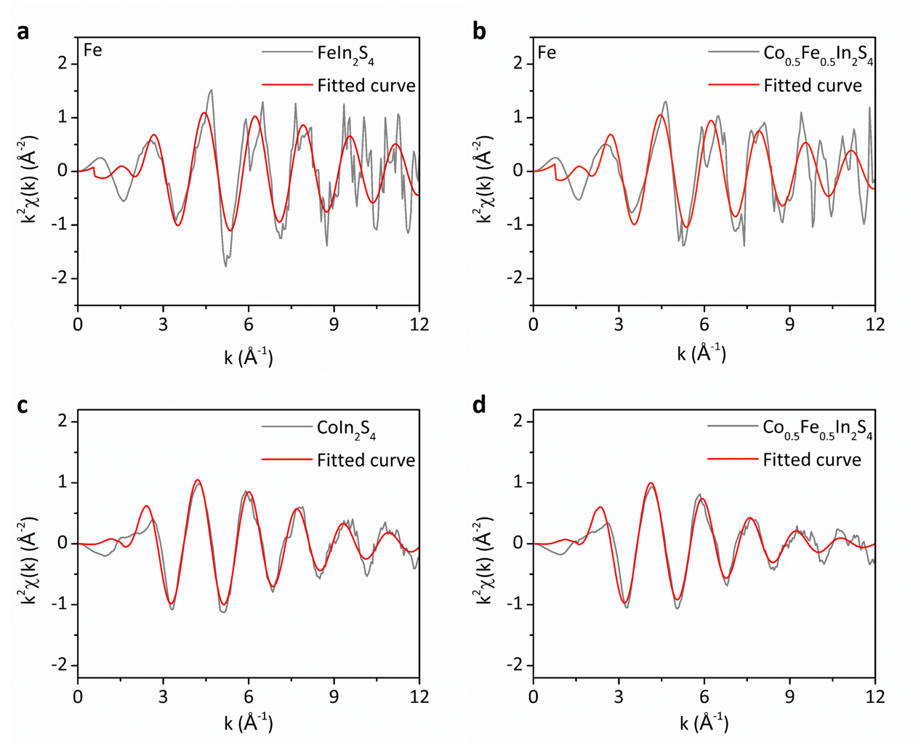
Supplementary Fig. 3. (a, b) k²-weighted Fe K-edge EXAFS oscillations for the FeIn₂S₄ and Co_{0.5}Fe_{0.5}In₂S₄ nanoflowers, respectively. (c, d) k²-weighted Co K-edge EXAFS oscillations for the CoIn₂S₄ and Co_{0.5}Fe_{0.5}In₂S₄ nanoflowers, respectively. EXAFS in k space for spectral data, the overlap between the fitted curve and the experimental value at the low k value is very good, indicating that the fitted result is reliable, which is consistent with the R-factor. Fitted curves: red; fitted ranges: 3-10 Å⁻¹ for ∆k and 1.3-2.5 Å for ∆R.

Supplementary Fig. 4. High-resolution XPS spectra in (a) Fe 2p and (b) Co 2p regions of FeIn₂S₄, CoIn₂S₄ and Co_{0.5}Fe_{0.5}In₂S₄ nanoflowers. As shown in Supplementary Fig. 4a, the high resolution XPS spectra of FeIn₂S₄ sample in Fe 2p region discloses that the dominant peaks of Fe 2p_{3/2} and Fe 2p_{1/2} are located at 703.61 and 725.05 eV, respectively, which corresponds to chemical coordination of S and Fe ions. Compared with FeIn₂S₄, the peaks of Fe 2p_{3/2} and Fe 2p_{1/2} of Co_{0.5}Fe_{0.5}In₂S₄ have obvious positive shifts of 0.35 eV and 0.4 eV, respectively. This is due to the electronic coupling between Co and Fe in Co_{0.5}Fe_{0.5}In₂S₄, which is explained in detail in the theory section (Supplementary Fig. 2). For the Co 2p spectrum, the spin-orbit splitting value of Co 2p_{3/2} and Co 2p_{1/2} of 15.55 eV in CoIn₂S₄ can be observed as well as two strong satellites. Interestingly, the characteristic peaks from Co 2p shift toward lower binding energies, indicative of miscible bond Co-S-Fe. The binding energy shifts can be attributed to the electron transfer from Fe to Co, indicating the charge exchange induced by the coordination bonds of Fe, Co and S atoms, which agrees well with the internal charge kinetic change analysis in Fig. 3.
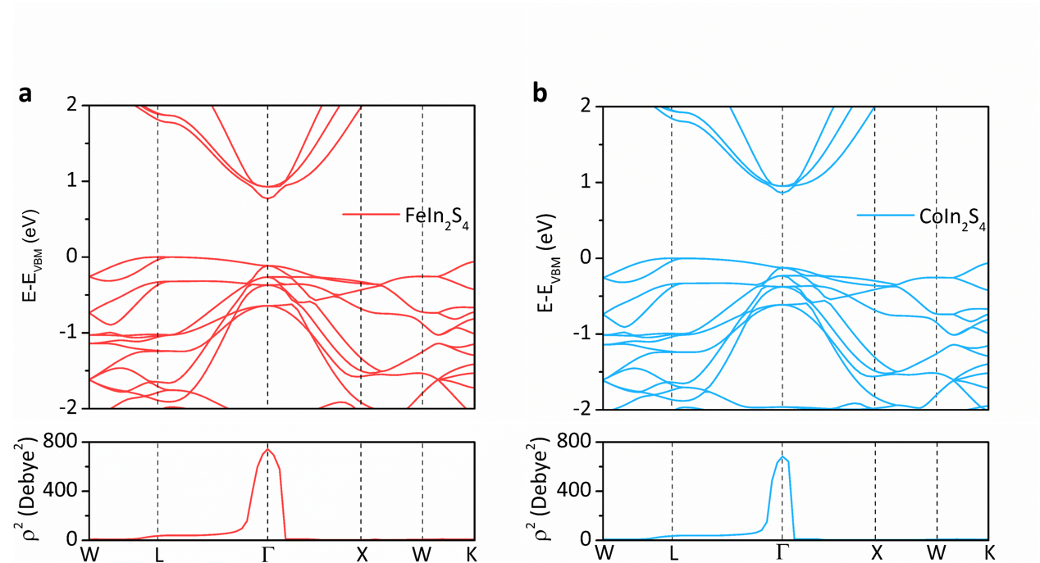
Supplementary Fig. 5. The band structure of FeIn₂S₄ (a) and CoIn₂S₄ (b) and corresponding transition dipole moment ρ² from valence band to conduction band. For a single, nonrelativistic particle of mass m, in zero magnetic field, the transition dipole moment can alternatively be written in terms of the momentum operator, using the relationship,
$$\left(P_{a→b}\right)=〈ψ_{a}|r|ψ_{b}〉=\frac{iℏ}{\left(E_{b}-E_{a}\right)m}〈ψ_{a}|p|ψ_{b}〉=\frac{iℏ}{\left(E_{b}-E_{a}\right)m}\sum_{i}{C_{ai}C_{bi}G_{i}}$$
where ψ_{a} and ψ_{b} are energy eigenstates with energy E_{a} and E_{b}. C_{ai}, C_{bi} and G_{i} are plane-wave coefficients and reciprocal space vector with the same k vector, respectively, summed over the number of plane-wave. The transition probabilities between the valence and the conduction band are revealed by the calculated sum of the squares of transition dipole moment (in unit of Debye).

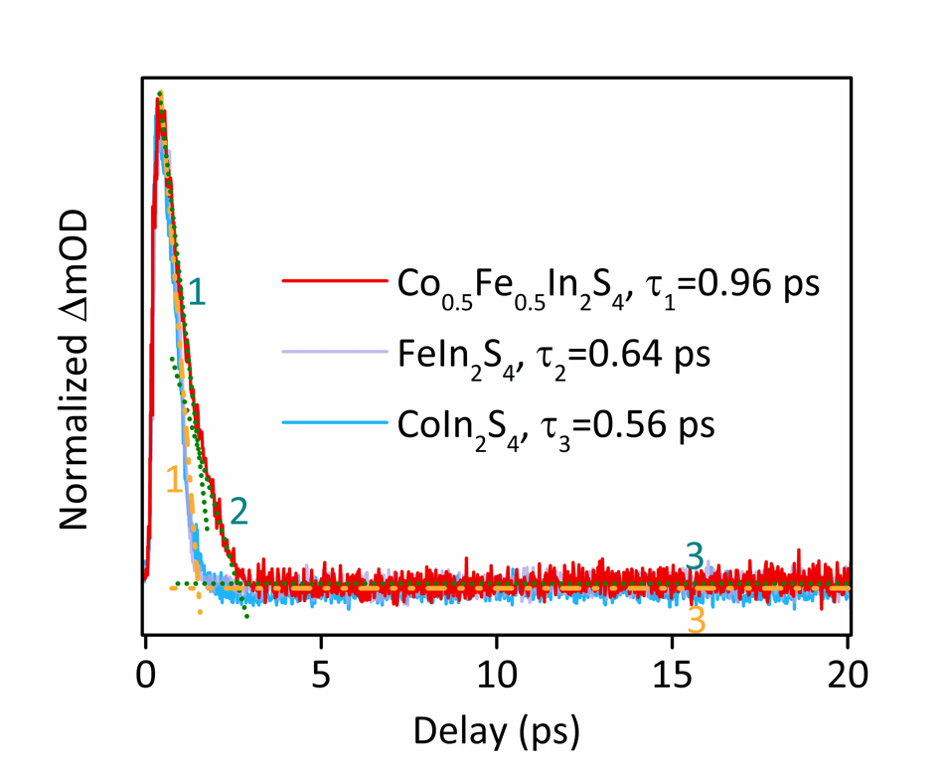
Supplementary Fig. 6. We display the TA dynamics of FeIn₂S₄, CoIn₂S₄ and Co_{0.5}Fe_{0.5}In₂S₄ for a delay time from 0.00 to 20.00 ps as a comparison. The Co_{0.5}Fe_{0.5}In₂S₄ sample display a typical three-stage evolution dynamic behavior. Nevertheless, only the fast 2PA and the long-lived slow exciton absorption can be discovered for CoIn₂S₄ and FeIn₂S₄ (marked by 1 and 3). Associate with energy-level diagram in Fig. 4D, we conclude that higher-lying metastable state E₁ cannot be observed in CoIn₂S₄ and FeIn₂S₄, which is responsible for the intermediate TA stage of Co_{0.5}Fe_{0.5}In₂S₄. More importantly, the slow dynamic lives longer in Co_{0.5}Fe_{0.5}In₂S₄ than that of CoIn₂S₄ and FeIn₂S₄, as shown in the inset, indicating photo-excited carrier lifetime is efficiently extended by atomic-hybridized-induced higher-lying metastable state.

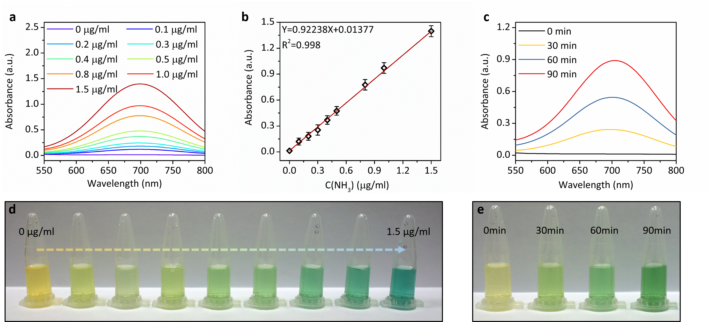
Supplementary Fig. 7. (a) UV-Vis absorption spectra of indophenol assays with NH₃ after incubated for 60 min at room temperature. (b) Calibration curve used for estimation of NH₃. (c) According to the standard curve, quantitatively detect the NH₃ production of Co_{0.5}Fe_{0.5}In₂S₄ nanoflowers under different irradiation time. (d, e) Digital photographs showing the chromogenic reaction using the different standard NH₃ concentration liquids and test sample centrifugal liquids, respectively. The line showed a linear fit (y = 0.92238x + 0.01377) of N = 3 independent calibration curves. Quantification of ammonia by indophenol assays method, photocatalytic test performed using for Co_{0.5}Fe_{0.5}In₂S₄ nanoflowers yielded ammonia production rates of 85.8 µmol g⁻¹ h⁻¹.

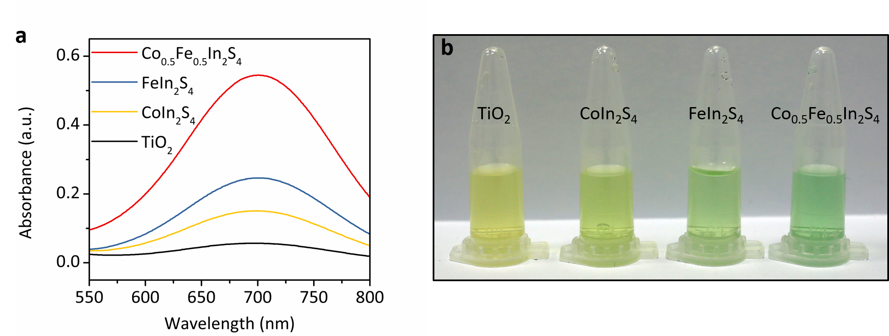
Supplementary Fig. 8. (a) Variations in absorption spectra and (b) corresponding digital photographs of the chromogenic reaction using the indophenol blue method with different photocatalysts under 1 h irradiation. Quantification of ammonia by indophenol assays method, the catalytic performance of Co_{0.5}Fe_{0.5}In₂S₄ nanoflowers is the most excellent.

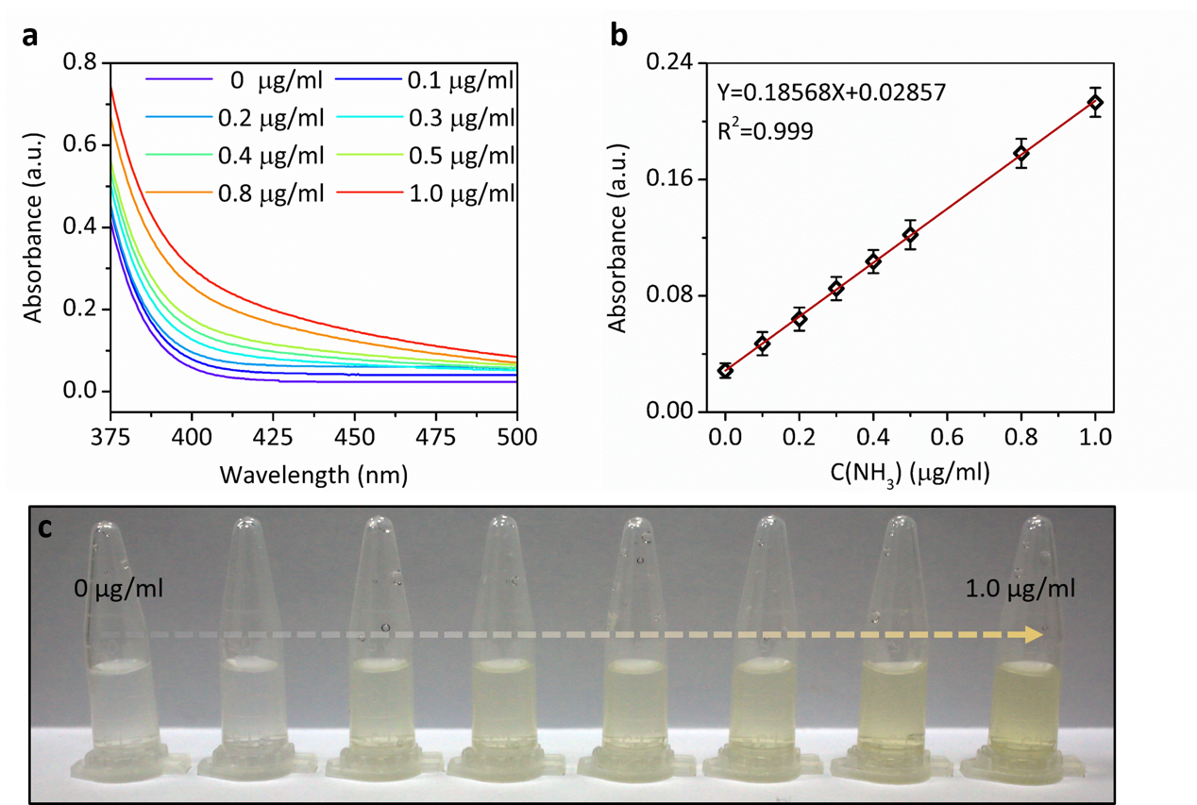
Supplementary Fig. 9. (a) UV-Vis absorption spectra for mixed solution containing different standard concentration liquids and Nessler's reagents after incubated for 60 min at room temperature. (b) Calibration curve used for estimation of NH₃. (c) The corresponding digital photographs of the chromogenic reaction with different standard NH₃ concentration liquids. The line showed a linear fit (y = 0.18568x + 0.02857) of N = 3 independent calibration curves. It shows that the calibration results are reliable.

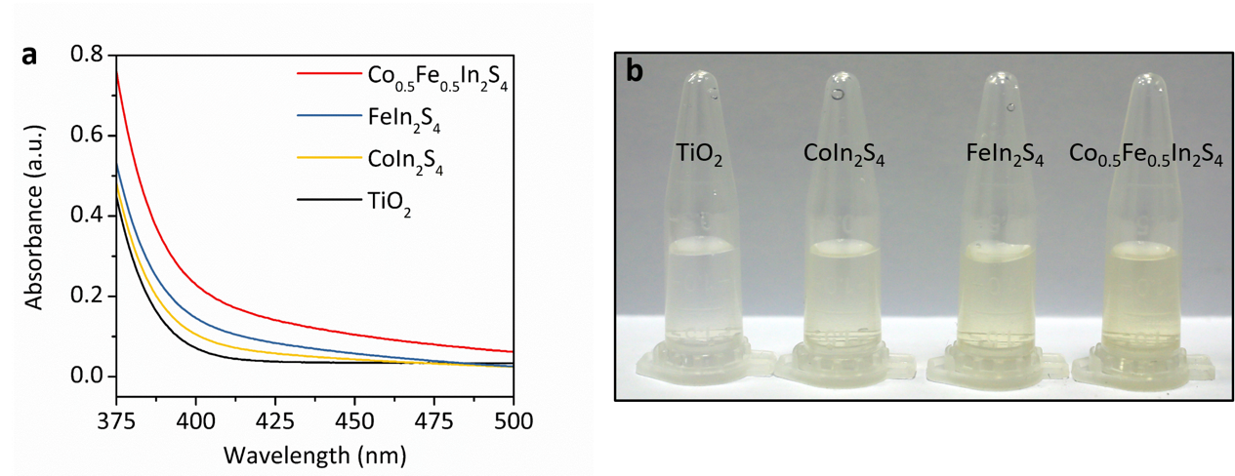
Supplementary Fig. 10. (a) Absorption spectra and (b) corresponding photographs for the detection of the NH₃ production using colorimetric method extracted from the centrifugal solution using different photocatalysts under 1 h irradiation and Nessler’s reagent. Quantification of ammonia by Nessler's reagent method and indophenol assays yielded very similar results. The catalytic performance of Co_{0.5}Fe_{0.5}In₂S₄ nanoflowers is the most excellent.

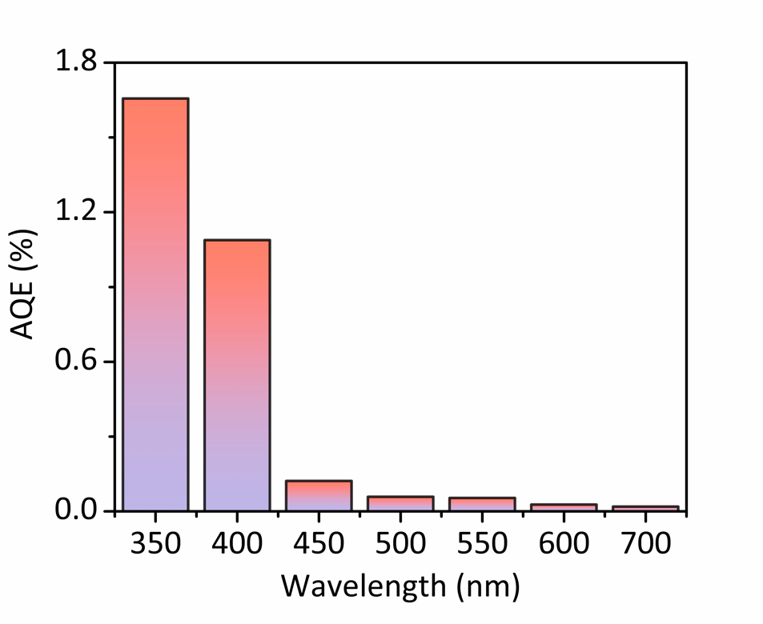
Supplementary Fig. 11. Wavelength-dependent apparent quantum efficiency of the as-prepared Co_{0.5}Fe_{0.5}In₂S₄ nanoflowers under monochromatic light irradiation. The apparent quantum efficiency (AQE) was measured using a 300 W Xe lamp with 350, 400, 450, 500, 550, 600 and 700 nm (±5 nm) band-pass filters and an irradiatometer. The AQE was calculated through the following equation:
$$AQE\left(\%\right)=\frac{number of reacted electrons}{number of incident photons}×100\%$$
$$=\frac{number of generated {NH}_{3}×6}{number of incident photons}×100\%$$
$$=\frac{M×N_{A}×6}{\frac{I×A×t}{h×ν}}×100\%$$
where M represents the amount of NH3 generation, NA represents Avogadro’s constant, I is the light intensity, A is the light incident area, t is light incident time, h is the Planck constant and ν is the incident light frequency.

Supplementary Fig. 12. Multicycle N2 fixation of the as-prepared ultrafine Co_{0.5}Fe_{0.5}In₂S₄ nanoflowers. The Co_{0.5}Fe_{0.5}In₂S₄ nanoflowers displayed excellent photocatalytic stability, with no obvious decrease in activity evidenced after four successive photocatalytic cycles. And it can be explained that NRR was derived from photocatalysis, because ammonia production hardly increased under dark conditions.

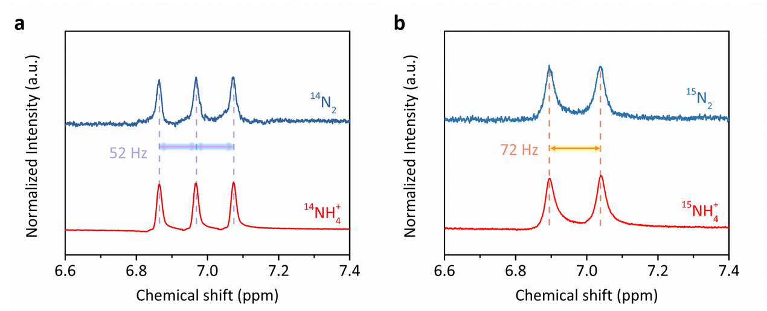
Supplementary Fig. 13. ¹H NMR analyses of the solution fed by (a) ¹⁴N₂ and (b) ¹⁵N₂ after the photocatalytic NRR reaction. The 1H-NMR spectrum of solution in ¹⁴N₂ atmosphere shows a nearly 1:1:1 triplet pattern with the coupling constant of J_{N-H} = 52 Hz, which agrees with that of ¹⁴NH₄Cl standard solution. When we employ isotopic ¹⁵N₂ as a nitrogen source to perform the photocatalytic reaction, a doublet pattern with the coupling constant of J_{N-H} = 72 Hz can be detected, corresponding to ¹⁵NH₄Cl standard solution. This confirms that the generated ammonia indeed originates from N₂ fixation.

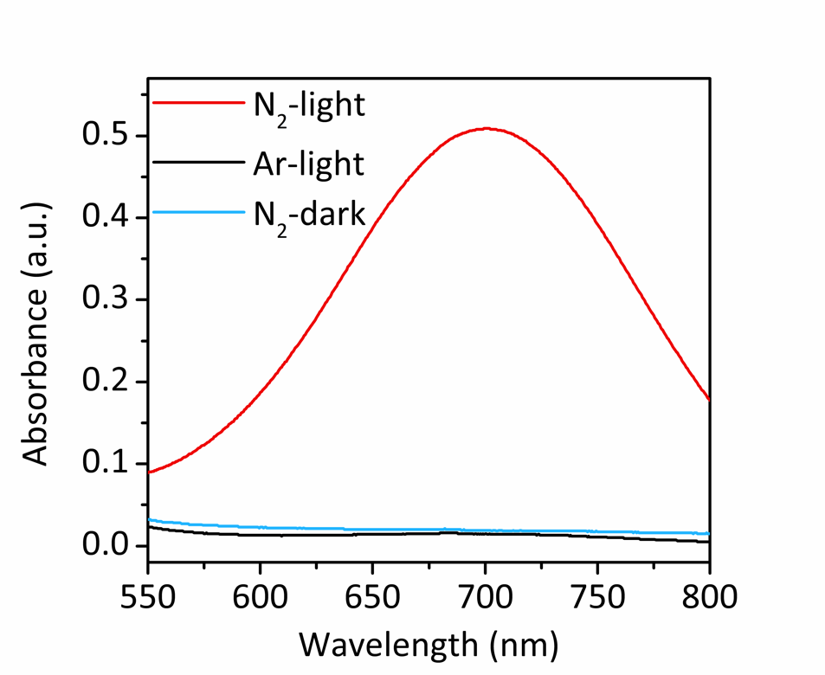
Supplementary Fig. 14. UV-Vis absorption spectra of the solution stained with indophenol indicator after 1 h reaction using Ar and N₂ under light irradiation or under dark. Under light irradiation, no NH₃ was observed in the absence of N₂, whereas the concentration of NH₃ increased linearly under N₂ flow with irradiation time (Fig.5A). Similarly, no ammonia was formed under dark environment, which was consistent with the conclusion of Supplementary Fig. 12.

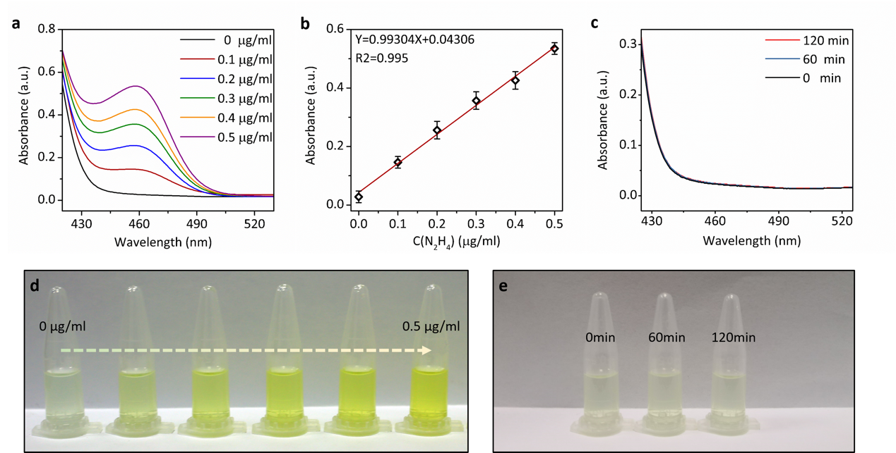
Supplementary Fig. 15. (a) UV-Vis absorption spectra of various N₂H₄ concentration after incubated for 20 min at room temperature. (b) Calibration curve used for calculation of N₂H₄ concentration. (c) According to the standard curve, quantitatively detect the N₂H₄ production of Co_{0.5}Fe_{0.5}In₂S₄ nanoflowers under different irradiation time. (d, e) Digital photographs showing the chromogenic reaction of standard N₂H₄ concentration solution and centrifugal test sample solution, respectively. The line showed a linear fit (y = 0.92238x + 0.01377) of N = 3 independent calibration curves. According to the standard curve, after 2 hours of stable NRR with Co_{0.5}Fe_{0.5}In₂S₄ nanoflowers, there is no indication that the reduction process produced N₂H₄.

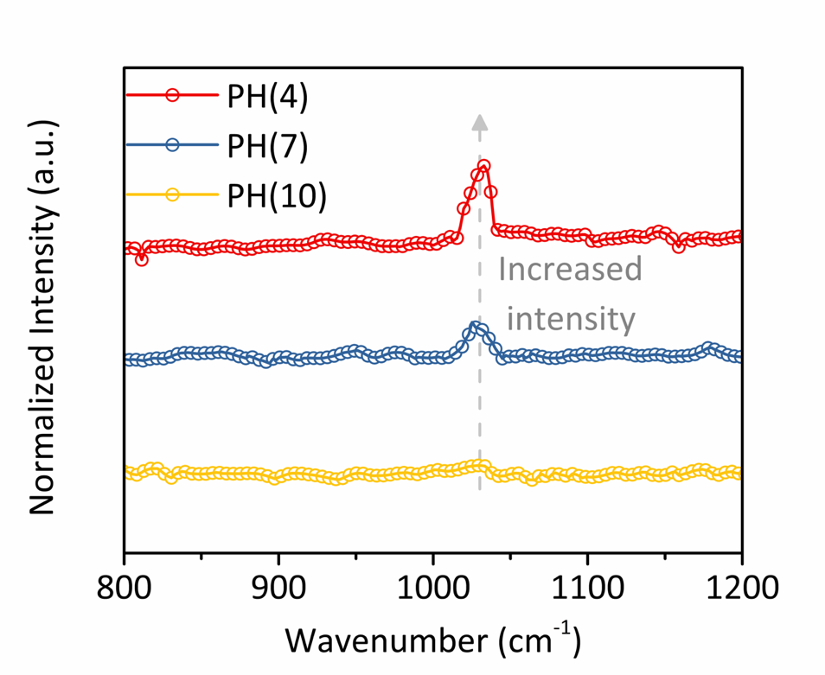
Supplementary Fig. 16. In-situ Raman spectroscopy of Co_{0.5}Fe_{0.5}In₂S₄ at different pH values. It is found that the Raman peak at 1028.53 cm⁻¹ is decreased as increasing pH value, which implies that the Raman mode is strongly related with passivated H* group on Co_{0.5}Fe_{0.5}In₂S₄ surface.

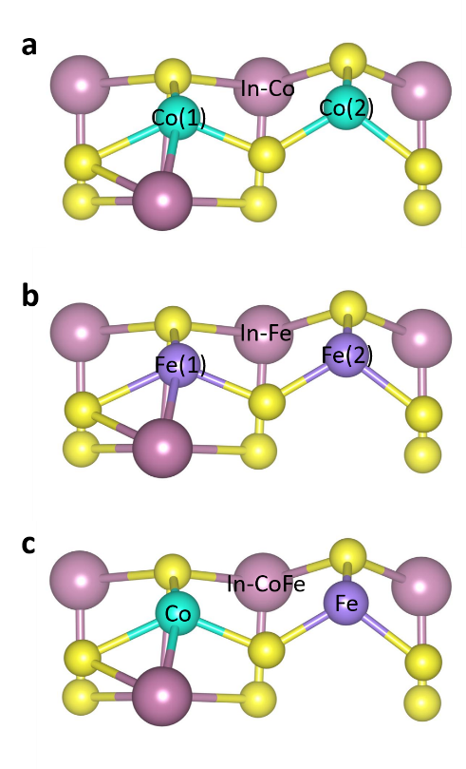
Supplementary Fig. 17. The HER and NRR occur at different reactive site on CoIn₂S₄ (a), FeIn₂S₄ (b) and Co_{0.5}Fe_{0.5}In₂S₄ (c) surface. When HER occur at Co(1), Co(2) and In site on CoIn₂S₄ surface, as shown in Supplementary Fig. 17a, the calculated ΔG_{H} value is indicated as gray Co(1), Co(2) and In-Co in Fig. 5c. The corresponding NRR simultaneously occurs at Co(1) and Co(2) site on CoIn₂S₄ surface, which is indicated as red Co(1&2).
When HER occur at Fe(1), Fe(2) and In site on FeIn₂S₄ surface, as shown in Supplementary Fig. 17b, the calculated ΔG_{H} value is indicated as gray Fe(1), Fe(2) and In-Fe in Fig. 5c. The corresponding NRR simultaneously occurs at Fe(1) and Fe(2) site on FeIn₂S₄ surface, which is indicated as red Fe(1&2).
When HER occur at Co, Fe and In site on Co_{0.5}Fe_{0.5}In₂S₄ surface, as shown in Supplementary Fig. 17c, the calculated ΔG_{H} value is indicated as gray Co, Fe and In-CoFe in Fig. 5c. The corresponding NRR simultaneously occurs at Co and Fe site on Co_{0.5}Fe_{0.5}In₂S₄ surface, which is indicated as red CoFe.
Supplementary Fig. 18. H₂ yield curves using Co_{0.5}Fe_{0.5}In₂S₄ nanoflowers as photocatalysts under Ar or N₂ environment during 60 min reaction. The H₂ yield in Ar atmosphere is obviously higher than that in N₂ atmosphere, indicating the passivated H* groups are converted into *N₂H₂ intermediates, instead of H₂.

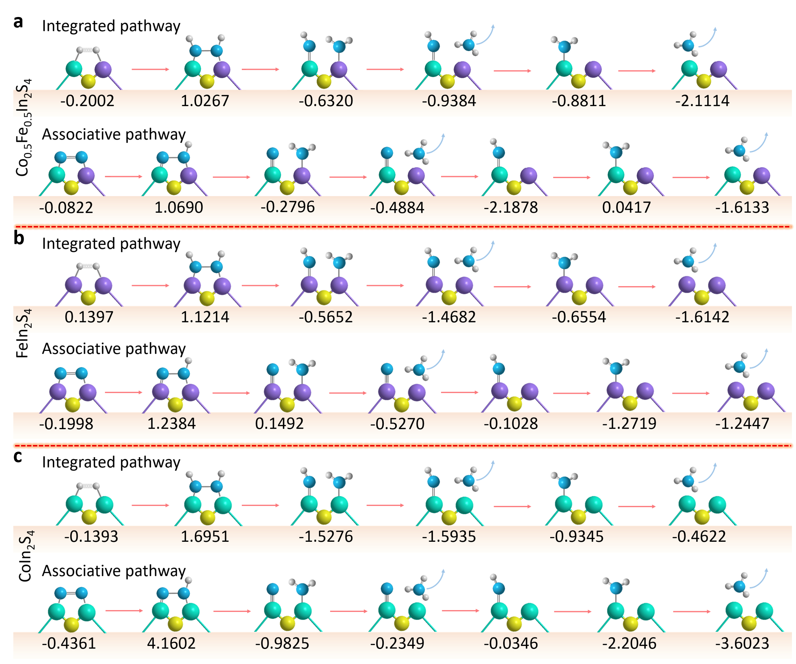
Supplementary Fig. 19. Free energies of N₂ reduction along different reaction pathway in Co_{0.5}Fe_{0.5}In₂S₄ (a), CoIn₂S₄ (b) and FeIn₂S₄ (c), respectively. The adsorption configuration of N₂ molecule on the catalyst surface can directly determine the activity of N≡N triplet bond and reaction pathway selectivity. We systematically compare correlated energetics of N₂ reduction along conventional distal pathway and integrated pathway. As a general feature, the rate-limiting potential barrier along conventional distal pathway is obviously larger than that of integrated pathway. The best catalytic activity appears at Co_{0.5}Fe_{0.5}In₂S₄ along integrated pathway.

Supplementary Table S1. EXAFS data fitting results from Co_{0.5}Fe_{0.5}In₂S₄, FeIn₂S₄ and CoIn₂S₄. (S₀²=0.73)
Sample | Scattering  pair | CN | R(Å) | σ²×10³(Å⁻²) | ∆E₀ (eV) | R-Factor
FeIn₂S₄ | Fe-S | 3.7±0.5 | 2.26±0.01 | 1.6±1.4 | 0.6±1.2 | 0.007
Co_{0.5}Fe_{0.5}In₂S₄ | Fe-S | 3.6±0.7 | 2.28±0.01 | 2.4±1.1 | 0.8±1.8 | 0.005
CoIn₂S₄ | Co-S | 4.6±0.7 | 2.31±0.01 | 5.6±1.0 | -3.1±1.5 | 0.010
Co_{0.5}Fe_{0.5}In₂S₄ | Co-S | 4.1±0.5 | 2.29±0.01 | 9.0±1.5 | -2.0±1.3 | 0.014
CN is the coordination number; R is interatomic distance; σ² is Debye-Waller factor; ΔE₀ is edge-energy shift. R factor is used to value the goodness of the fitting.

Supplementary Table S2. Comparison of various photocatalysts for N₂ reduction to NH₃.
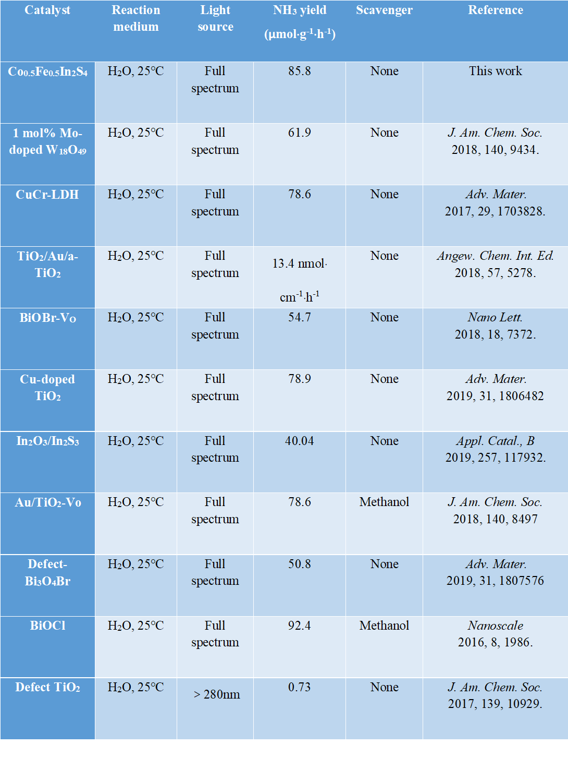

REFERENCES AND NOTES
- M. Wang, S. Liu, T. Qian, J. Liu, J. Zhou, H. Ji, J. Xiong, J. Zhong, C. Yan, Over 56.55% Faradaic efficiency of ambient ammonia synthesis enabled by positively shifting the reaction potential. Nat. Commun. 10, 1-8 (2019).
- L. Zhang, X. Ji, X. Ren, Y. Ma, X. Shi, Z. Tian, A. M. Asiri, L. Chen, B. Tang, X. Sun, Electrochemical ammonia synthesis via nitrogen reduction reaction on a MoS2 catalyst: theoretical and experimental studies. Adv. Mater. 30, 1800191 (2018).
- H. Li, J. Shang, Z. Ai, L. Zhang, Efficient visible light nitrogen fixation with BiOBr nanosheets of oxygen vacancies on the exposed {001} facets. J. Am. Chem. Soc. 137, 6393-6399 (2015).
- Y. X. Lin, S. N. Zhang, Z. H. Xue, J. J. Zhang, H. Su, T. J. Zhao, G. Y. Zhai, X. H. Li, M. Antonietti, J. S. Chen, Boosting selective nitrogen reduction to ammonia on electron-deficient copper nanoparticles. Nat. Commun. 10, 1-7 (2019).
- Y. C. Hao, Y. Guo, L. W. Chen, M. Shu, X. Y. Wang, T. A. Bu, W. Y. Gao, N. Zhang, X. Su, X. Feng, Promoting nitrogen electroreduction to ammonia with bismuth nanocrystals and potassium cations in water. Nat. Catal. 2, 448-456 (2019).
- S. Liu, M. Wang, T. Qian, H. Ji, J. Liu, C. Yan, Facilitating nitrogen accessibility to boron-rich covalent organic frameworks via electrochemical excitation for efficient nitrogen fixation. Nat. Commun. 10, 1-9 (2019).
- S. Z. Andersen, V. Čolić, S. Yang, J. A. Schwalbe, A. C. Nielander, J. M. McEnaney, K. Enemark-Rasmussen, J. G. Baker, A. R. Singh, B. A. Rohr, A rigorous electrochemical ammonia synthesis protocol with quantitative isotope measurements. Nature 570, 504-508 (2019).

