Table S1. Search Strategy
Database | Date of search | Search Strategy | Initial returns
PubMed | 2023/9/11 | ((("Parkinson Disease"[Mesh]) OR (((((((((((Idiopathic Parkinson's Disease[Title/Abstract]) OR (Lewy Body Parkinson's Disease[Title/Abstract])) OR (Parkinson's Disease, Idiopathic[Title/Abstract])) OR (Parkinson's Disease, Lewy Body[Title/Abstract])) OR (Parkinson Disease, Idiopathic[Title/Abstract])) OR (Parkinson's Disease[Title/Abstract])) OR (Idiopathic Parkinson Disease[Title/Abstract])) OR (Lewy Body Parkinson Disease[Title/Abstract])) OR (Primary Parkinsonism[Title/Abstract])) OR (Parkinsonism, Primary[Title/Abstract])) OR (Paralysis Agitans[Title/Abstract]))) AND (("Tai Ji"[Mesh]) OR ((((((((((Tai-ji[Title/Abstract]) OR (Tai Chi[Title/Abstract])) OR (Chi, Tai[Title/Abstract])) OR (Tai Ji Quan[Title/Abstract])) OR (Ji Quan, Tai[Title/Abstract])) OR (Quan, Tai Ji[Title/Abstract])) OR (Taiji[Title/Abstract])) OR (Taijiquan[Title/Abstract])) OR (T'ai Chi[Title/Abstract])) OR (Tai Chi Chuan[Title/Abstract])))) AND (randomized controlled trial[Publication Type] OR randomized[Title/Abstract] OR placebo[Title/Abstract]) | 29
Embase | 2023/9/11 | ('Parkinson disease'/exp OR 'Idiopathic Parkinson's Disease':ti,ab OR 'Lewy Body Parkinson's Disease':ti,ab OR 'Parkinson's Disease, Idiopathic':ti,ab OR 'Parkinson's Disease, Lewy Body':ti,ab OR 'Parkinson Disease, Idiopathic':ti,ab OR 'Parkinson's Disease':ti,ab OR 'Idiopathic Parkinson Disease':ti,ab OR 'Lewy Body Parkinson Disease':ti,ab OR 'Primary Parkinsonism':ti,ab OR 'Parkinsonism, Primary':ti,ab OR 'Paralysis Agitans':ti,ab) AND ('Tai Ji'/exp OR 'Tai-ji':ti,ab OR 'Tai Chi':ti,ab OR 'Chi, Tai':ti,ab OR 'Tai Ji Quan':ti,ab OR 'Ji Quan, Tai':ti,ab OR 'Quan, Tai Ji':ti,ab OR 'Taiji':ti,ab OR 'Taijiquan':ti,ab OR 'T'ai Chi':ti,ab OR 'Tai Chi Chuan':ti,ab) AND ("random":ab,ti OR "placebo":ab,ti OR "double-blind":ab,ti) | 33
Web of Science | 2023/9/11 | TS=(Parkinson Disease OR Idiopathic Parkinson's Disease OR Lewy Body Parkinson's Disease OR Parkinson's Disease, Idiopathic OR Parkinson's Disease, Lewy Body OR Parkinson Disease, Idiopathic OR Parkinson's Disease OR Idiopathic Parkinson Disease OR Lewy Body Parkinson Disease OR Primary Parkinsonism OR Parkinsonism, Primary OR Paralysis Agitans) AND TS=(Tai Ji OR Tai-ji OR Tai Chi OR Chi, Tai OR Tai Ji Quan OR Ji Quan, Tai OR Quan, Tai Ji OR Taiji OR Taijiquan OR T'ai Chi OR Tai Chi Chuan) AND TS=(random* controlled trial OR random* OR placebo) | 133
Cochrane Library | 2023/9/11 | (MeSH descriptor: [Parkinson Disease] explode all trees) OR (Idiopathic Parkinson's Disease):ti,ab,kw OR (Lewy Body Parkinson's Disease):ti,ab,kw OR (Parkinson's Disease, Idiopathic):ti,ab,kw OR (Parkinson's Disease, Lewy Body):ti,ab,kw OR (Parkinson Disease, Idiopathic):ti,ab,kw OR (Parkinson's Disease):ti,ab,kw OR (Idiopathic Parkinson Disease):ti,ab,kw OR (Lewy Body Parkinson Disease):ti,ab,kw OR (Primary Parkinsonism):ti,ab,kw OR (Parkinsonism, Primary):ti,ab,kw OR (Paralysis Agitans):ti,ab,kw AND (MeSH descriptor: [Tai Ji] explode all trees) OR (Tai-ji):ti,ab,kw OR (Tai Chi):ti,ab,kw OR (Chi, Tai):ti,ab,kw OR (Tai Ji Quan):ti,ab,kw OR (Ji Quan, Tai):ti,ab,kw OR (Quan, Tai Ji):ti,ab,kw OR (Taiji):ti,ab,kw OR (Taijiquan):ti,ab,kw OR (T'ai Chi):ti,ab,kw OR (Tai Chi Chuan):ti,ab,kw | 73
Scopus | 2023/9/11 | ( ( TITLE-ABS-KEY ( parkinson AND disease ) OR TITLE-ABS-KEY ( idiopathic AND parkinson's AND disease ) OR TITLE-ABS-KEY ( lewy AND body AND parkinson's AND disease ) OR TITLE-ABS-KEY ( parkinson's AND disease, AND idiopathic ) OR TITLE-ABS-KEY ( parkinson's AND disease, AND lewy AND body ) OR TITLE-ABS-KEY ( parkinson AND disease, AND idiopathic ) OR TITLE-ABS-KEY ( parkinson's AND disease ) OR TITLE-ABS-KEY ( idiopathic AND parkinson AND disease ) OR TITLE-ABS-KEY ( lewy AND body AND parkinson AND disease ) OR TITLE-ABS-KEY ( primary AND parkinsonism ) OR TITLE-ABS-KEY ( parkinsonism, AND primary ) OR TITLE-ABS-KEY ( paralysis AND agitans ) ) ) AND ( ( TITLE-ABS-KEY ( tai AND ji ) OR TITLE-ABS-KEY ( tai-ji ) OR TITLE-ABS-KEY ( tai AND chi ) OR TITLE-ABS-KEY ( chi, AND tai ) OR TITLE-ABS-KEY ( tai AND ji AND quan ) OR TITLE-ABS-KEY ( ji AND quan, AND tai ) OR TITLE-ABS-KEY ( quan, AND tai AND ji ) OR TITLE-ABS-KEY ( taiji ) OR TITLE-ABS-KEY ( taijiquan ) OR TITLE-ABS-KEY ( t'ai AND chi ) OR TITLE-ABS-KEY ( tai AND chi AND chuan ) ) ) AND ( ( TITLE-ABS-KEY ( randomized AND controlled AND trial ) OR TITLE-ABS-KEY ( randomized ) OR TITLE-ABS-KEY ( placebo ) OR TITLE-ABS-KEY ( double-blind ) OR TITLE-ABS-KEY ( random ) ) ) | 219
EBSCO | 2023/9/11 | (TX Parkinson Disease OR TX Idiopathic Parkinson's Disease OR TX Lewy Body Parkinson's Disease OR TX Parkinson's Disease, Idiopathic OR TX Parkinson's Disease, Lewy Body OR TX Parkinson Disease, Idiopathic OR TX Parkinson's Disease OR TX Idiopathic Parkinson Disease OR TX Lewy Body Parkinson Disease OR TX Primary Parkinsonism OR TX Parkinsonism, Primary OR TX Paralysis Agitans) AND (TX Tai Ji OR TX Tai-ji OR TX Tai Chi OR TX Chi, Tai OR TX Tai Ji Quan OR TX Ji Quan, Tai OR TX Quan, Tai Ji OR TX Taiji OR TX Taijiquan OR TX T'ai Chi OR TX Tai Chi Chuan) AND (TX randomized controlled trial OR TX randomized OR TX placebo OR TX random OR TX double-blind) | 46
CNKI | 2023/9/11 | (TI=帕金森病+帕金森氏病+帕金森综合症+帕金森氏综合症+帕金森症+帕金森氏综合征+震颤麻痹+帕金森综合征+帕金森氏症+帕金森) and (TI=太极拳+大成拳+意拳) and随机 | 25
CMB | 2023/9/11 | "帕金森病"[常用字段:智能] OR "帕金森氏病"[常用字段:智能] OR "帕金森综合症"[常用字段:智能] OR "帕金森氏综合症"[常用字段:智能] OR "帕金森症"[常用字段:智能] OR "帕金森氏综合征"[常用字段:智能] OR "震颤麻痹"[常用字段:智能] OR "帕金森综合征"[常用字段:智能] OR "帕金森氏症"[常用字段:智能] OR "帕金森"[常用字段:智能] AND "太极拳"[常用字段:智能] OR "大成拳"[常用字段:智能] OR "意拳"[常用字段:智能] AND "随机分配"[常用字段:智能] OR "随机化"[常用字段:智能] | 26
Wanfang | 2023/9/11 | 主题:(帕金森病OR帕金森氏病OR帕金森综合症OR帕金森氏综合症OR帕金森症OR帕金森氏综合征OR震颤麻痹OR帕金森综合征OR帕金森氏症OR帕金森) AND 主题:(太极拳OR大成拳OR意拳) AND 主题:(随机对照+随机分组+随机) | 30
Weipu | 2023/9/11 | 题名与关键词:(帕金森病+帕金森氏病+帕金森综合症+帕金森氏综合症+帕金森症+帕金森氏综合征+震颤麻痹+帕金森综合征+帕金森氏症+帕金森) AND 题名与关键词:(太极拳+大成拳+意拳) AND 摘要:(随机对照+随机分组+随机) | 19
Baidu Scholar | 2023/9/11 | 帕金森病,帕金森氏病,帕金森综合症,帕金森氏综合症,帕金森症,帕金森氏综合征,震颤麻痹,帕金森综合征,帕金森氏症,帕金森, 太极拳,大成拳,意拳,随机 | 84
CTR | 2023/9/11 | Keywords:太极拳(Manual inspection of relevant literature on Parkinson Disease) | 15
NLM | 2023/9/11 | Condition/disease: Parkinson Disease (All studies)  Intervention/treatment: Tai Ji (All studies) | 11
Note: CNKI, China National Knowledge Infrastructure; CMB, China Biology Medicine database; CTR, China Clinical Trial Registry; NLM, National Library of Medicine

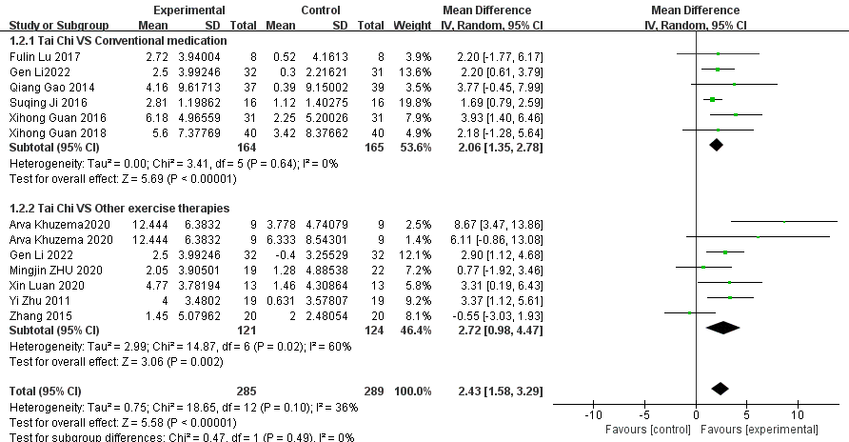
Figure S1. Effect of Tai Chi on lower limb balance function in patients with Parkinson's disease (random-effects model).

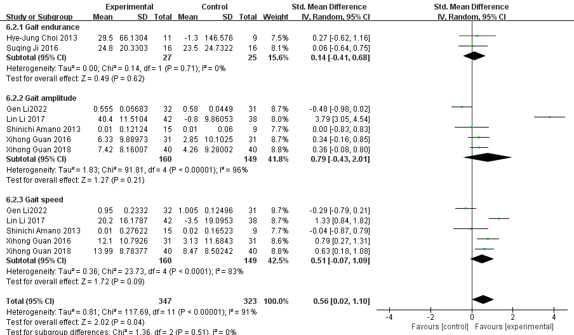
Figure S2. Effect of Tai Chi on gait function in patients with Parkinson's disease compared with conventional medication. (random-effects model).

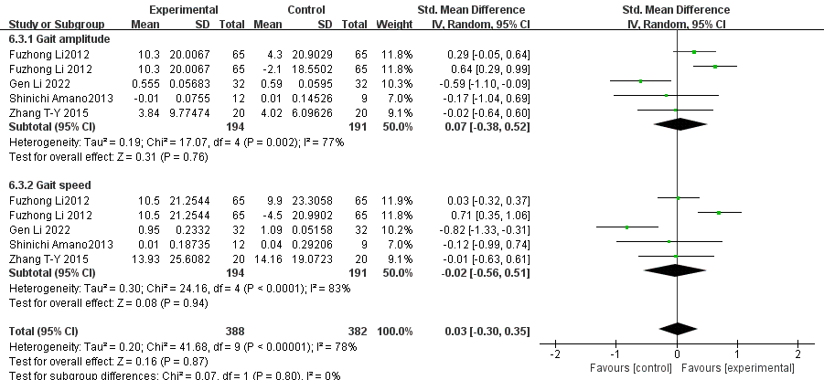
Figure S3. Effect of Tai Chi on gait function in patients with Parkinson's disease compared with other exercise therapies (random-effects model).

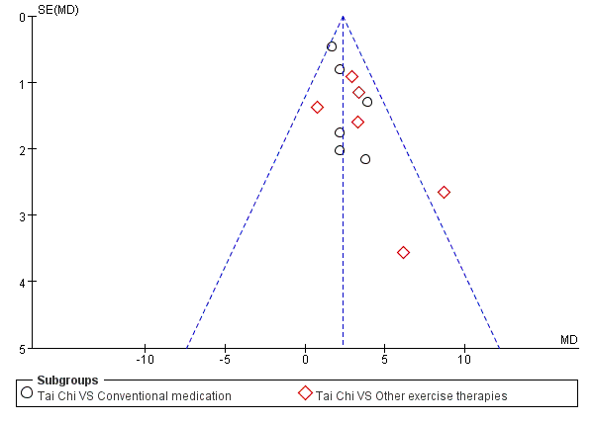
A
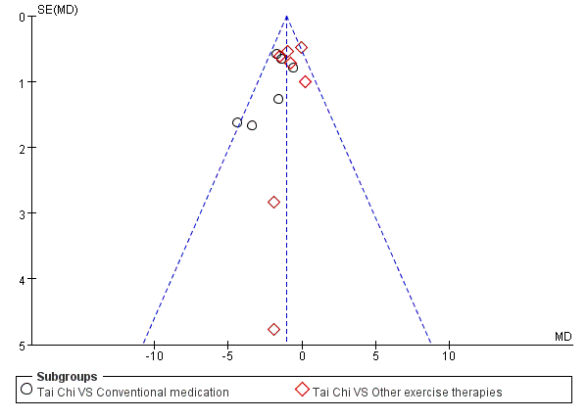
B

D

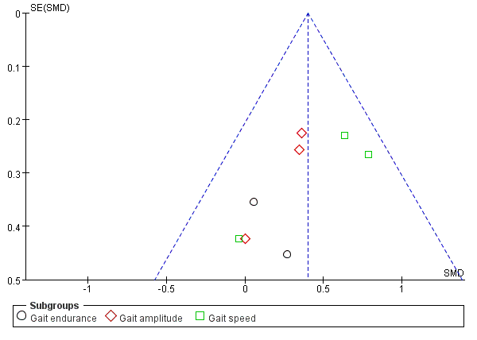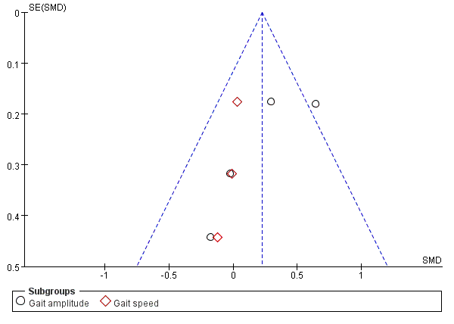
C
Figure S4. Funnel plot of subgroup analysis on the influence of Tai Chi on lower limb motor function in patients with Parkinson's disease.
(A) Funnel plot of subgroup analysis on the impact of different treatment groups on the Berg Balance Scale (BBS) in patients with Parkinson's disease.
(B) Funnel plot of subgroup analysis on the impact of different treatment groups on the Timed Up and Go Test (TUGT) in patients with Parkinson's disease.
(C) Funnel plot of subgroup analysis on the influence of Tai Chi on gait function in patients with Parkinson's disease compared to conventional medication.
(D) Funnel plot of subgroup analysis on the influence of Tai Chi on gait function in patients with Parkinson's disease compared to other exercise therapies.

