An aid diagnostic platform to detect the transition of mild cognitive impairment to Alzheimer's disease based on 48,116 individuals AD and MCI patients
Jing Li^{1,2}, Siwen Li¹, Yat-fung Shea³, Ming Yue¹, Pengfei Zhu⁴, Quan Zou^{5,6}, Shuofeng Yuan², Leung-Wing Chu³, You-Qiang Song^{1#}
- School of Biomedical Sciences, University of Hong Kong, Hong Kong, China.
- Department of Microbiology, University of Hong Kong, Hong Kong, China.
- Department of Medicine, School of Clinical Medicine, University of Hong Kong, Hong Kong, China.
- College of Intelligence and Computing, Tianjin University, Tianjin, China.
- Institute of Fundamental and Frontier Sciences, University of Electronic Science and Technology of China, Chengdu, China.
- Yangtze Delta Region Institute (Quzhou), University of Electronic Science and Technology of China, Quzhou, Zhejiang China.
Correspondence to: You-Qiang Song
School of Biomedical Sciences, University of Hong Kong, Hong Kong, China
E-mail: songy@hku.hk

Data processing supplement
In fact, during the data processing procedure, the patients with less than 2 (including 2) missing values of the 31 biomarkers were retained. Initially, patients containing more than 2 missing values were removed, resulting in 1,501 patients in Female 65 ~ 74 (MCI, 216; AD, 1,285), 1,289 patients in Male 65 ~ 74 (MCI, 249; AD, 1,040), 7,460 patients in Female 75 ~ 89 (MCI, 420; AD, 7,040), and 3,758 patients in Male 75 ~ 89 (MCI, 420; AD, 3,338). The samples were then subject to balancing and splitting into training sets and independent test sets. However, the performances of the models using data from these samples were not stable, showing a sensitivity close to 0.90 and a specificity close to 0.50 (data not shown). We thus next excluded patients with more than 1 missing value and kept those with only 1 or no missing value, obtaining 1,235 patients in Female 65 ~ 74 (MCI, 179; AD, 1,056), 1,048 patients in Male 65 ~ 74 (MCI, 206; AD, 842), 6,064 patients in Female 75 ~ 89 (MCI, 356; AD, 5,708), and 2,984 patients in Male 75 ~ 89 (MCI, 334; AD, 2,650). Again, these samples were balanced and split into training sets and independent test sets for further analysis. Results revealed that the models trained with data from patients containing less than 1 missing value exhibited poor stability, like those with less than 2 missing values. Therefore, we finally excluded all patients containing missing values of the 31 biomarkers, leaving 777 patients in Female 65 ~ 74 (MCI, n = 131; AD, n = 646), 642 patients in Male 65 ~ 74 (MCI, n = 147; AD, n = 495), 3,821 patients in Female 75 ~ 89 (MCI, n = 249; AD, n = 3,572), and 1,919 patients in Male 75 ~ 89 (MCI, n = 222; AD, n = 1,697). The details for data processing are listed in Figure S1.
Relevant algorithms
Tabular Attention-based Network (TabNet)
TabNet¹ is a deep learning model that combines Attention mechanisms and decision tree. The core idea of TabNet is to gradually select the important biomarkers through the self-attention mechanism, which are used for model training and prediction. TabNet calculates an attention score for each biomarker. The higher the attention score, the more important the biomarker. Biomarkers with high attention scores are selected to better capture information. The prediction of TabNet is made step by step, using a decision tree structure that starts at root node and branches either left or right in the decision tree based on the attention score of the current feature. TabNet uses a loss function to motivate the attention mechanism to select important biomarkers and gradually bring the model closer to patient label (MCI or AD). The combination of attention mechanism and decision tree structure realizes feature selection and model prediction. This combination allows the model to remain interpretive while efficiently analyzing the data to improve the performance of models.
Feature selection algorithm
Maximum-Relevance-Maximum-Distance (MRMD)
MRMD² is a feature selection algorithm based on PageRank, which obtains the graph by calculating the correlation distance matrix (CDM) and Euclidean matrix (EDM), with the eigenvalues as the nodes of the graph and the EDM as the edge weights. The weighted PageRank (WPR)³ is used to calculate the PageRank value of each function, and the result is used to sort in descanting order. The feature subset with the highest score is the result of MRMD.
Forward Feature Step (FFS)
Forward Feature Step (FFS)⁴ is a feature selection method used to select the best feature subset to train a machine learning model. On the training set of Female 75 ~ 89, starting from a feature vector, features are gradually added, and only one feature is added each time. The training stops when the AUC of CV test is greater than 0.65.
Performance evaluation
Cross validation⁵ is one of the most popular techniques in machine learning and has the advantage that all the data can be used to train the model. In 5-fold cross validation, the computer extracts 4/5 of all the training set as the true training set and 1/5 as the test set. This process occurs 5 times to train 5 models. The performance in cross validation is the mean of the 5 models.
TPs are the actual AD patients that are classified as AD, TNs are the AD patients that are categorized as MCI, FPs are the MCI subjects that are categorized as AD and FNs are the AD patients that are classified as MCI. These variables are included in Eq. (1) ~ Eq. (4). Precision represents how many of the patients predicted as AD by the model are always AD patients. Sensitivity (SN, Eq. (1)) represents the proportion of patients that are predicted to be AD among always AD patients. Specificity (SP, also known as recall. Eq. (2)) aims to calculate the proportion of patients that are predicted as MCI to the always MCI patients. Accuracy (ACC, Eq. (3)) is a credible indicator in balanced data. ACC refers to the percentage of the total patients for which the classifier predicts correctly. The F-score is a comprehensive evaluation indicator of precision and recall. The F-score (Eq. (4)) can be a good measure of the relationship between precision and recall making a better judgment for the classifier. AUC refers to the area under the ROC curve. The larger the AUC, the better the performance of the model.
$$\begin{aligned}SN=\frac{TPs}{TPs+FNs}\#Eq. \left(1\right)\end{aligned}$$
$$\begin{aligned}SP=\frac{TNs}{TNs+FPs}\#Eq. \left(2\right)\end{aligned}$$
$$\begin{aligned}ACC=\frac{TPs+TNs}{TPs+TNs+FPs+FNs}\#Eq. \left(3\right)\end{aligned}$$
$$\begin{aligned}F-score=\frac{2*TP}{2TP+FP+FN}\#Eq. \left(4\right)\end{aligned}$$

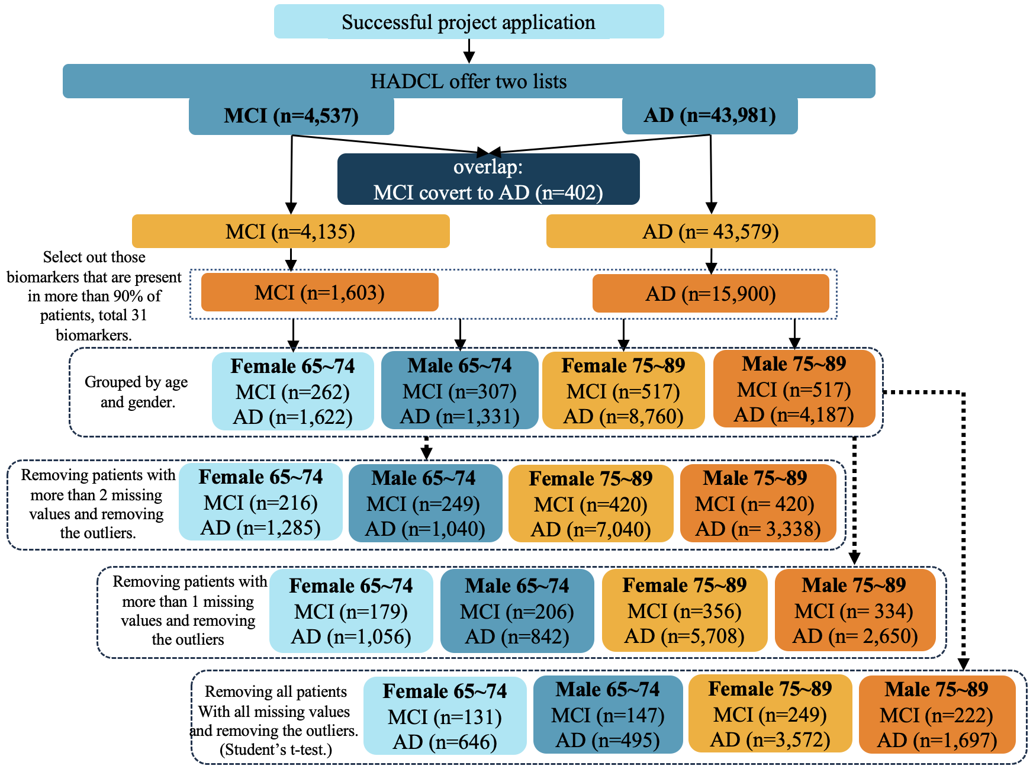
Figure S1. Data processing supplement. Abbreviations: HADCL, Hospital Authority Data Collaboration Lab; MCI, Mild Cognitive Impairment; AD, Alzheimers’ Disease; Female 65 ~ 74, Female 65 ~ 74 years old; Male 65 ~ 74, Male 65 ~ 74 years old; Female 75 ~ 89, Female 75 ~ 89 years old; Male 75 ~ 89, Male 75 ~ 89 years old; Train, data distribution of training set; Test, independent test set to verify model performance.

References
1. Shah C, Du Q, Xu Y. Enhanced TabNet: Attentive Interpretable Tabular Learning for Hyperspectral Image Classification. Remote Sensing. 2022;14(3):716.
2. He S, Guo F, Zou Q. MRMD2. 0: a python tool for machine learning with feature ranking and reduction. Current Bioinformatics. 2020;15(10):1213-1221.
3. Xing W, Ghorbani A. Weighted pagerank algorithm. Paper presented at: Proceedings. Second Annual Conference on Communication Networks and Services Research, 2004.2004.
4. Ververidis D, Kotropoulos C. Fast and accurate sequential floating forward feature selection with the Bayes classifier applied to speech emotion recognition. Signal processing. 2008;88(12):2956-2970.
5. Browne MW. Cross-validation methods. Journal of mathematical psychology. 2000;44(1):108-132.

