On the Utility of Large Language Model Embeddings for Revolutionizing Semantic Data Harmonization in Alzheimer's and Parkinson’s Disease
Yasamin Salimi^{1⁑}, Tim Adams^{1⁑}, Mehmet Can Ay¹, Helena Balabin^{2,3}, Marc Jacobs^{1*}, Martin Hofmann-Apitius^{1,4}, for the Alzheimer's Disease Neuroimaging Initiative^{φ}, the Japanese Alzheimer’s Disease Neuroimaging Initiative†, for the Aging Brain: Vasculature, Ischemia, and Behavior Study‡, the Alzheimer's Disease Repository Without Borders Investigators§
- Department of Bioinformatics, Fraunhofer Institute for Algorithms and Scientific Computing (SCAI), Sankt Augustin 53757, Germany
- Laboratory for Cognitive Neurology, Department of Neurosciences, KU Leuven, Leuven 3000, Belgium
- Language Intelligence and Information Retrieval Lab, Department of Computer Science, KU Leuven, Leuven 3000, Belgium
- Bonn-Aachen International Center for IT, Rheinische Friedrich-Wilhelms-Universität Bonn, Bonn 53115, Germany
*Corresponding author: Dr. Marc Jacobs, Fraunhofer-Institute for Algorithms and Scientific Computing (SCAI), Schloss Birlinghoven 1, 53757 Sankt Augustin, marc.jacobs@scai.fraunhofer.de, +49 - 2241 - 14 - 4013
⁑ The authors contributed equally to this work.
φ Data used in preparation of this article were obtained from the Alzheimer’s Disease Neuroimaging Initiative (ADNI) database (adni.loni.usc.edu). As such, the investigators within the ADNI contributed to the design and implementation of ADNI and/or provided data but did not participate in analysis or writing of this report. A complete listing of ADNI investigators can be found at: http://adni.loni.usc.edu/wp-content/uploads/how_to_apply/ADNI_Acknowledgement_List.pdf
† Japanese Alzheimer’s Disease Neuroimaging Initiative: Data used in preparation of this article were obtained from the Japanese Alzheimer’s Disease Neuroimaging Initiative (J-ADNI) database deposited in the National Bioscience Database Center Human Database, Japan (Research ID: hum0043.v1, 2016). As such, the investigators within J-ADNI contributed to the design and implementation of J-ADNI and/or provided data but did not participate in analysis or writing of this report. A complete listing of J-ADNI investigators can be found at: https://humandbs.biosciencedbc.jp/en/hum0043-j-adni-authors.
‡ Data used in preparation of this article were obtained from the Aging Brain: Vasculature, Ischemia, and Behavior Study (ABVIB). As such, the key investigators within the ABVIB contributed to the design and implementation of ABVIB and/or provided data but did not participate in analysis or writing of this report: Helena C. Chui M.D. (Principal Investigator), Charles C. DeCarli, M.D., William G. Ellis, M.D., William J. Jagust, M.D., Joel H. Kramer, Ph.D., Meng Law, M.D., Dan Mungas Ph,D. Bruce R. Reed, Ph.D., Nerses Sanossian, M.D., Michael W. Weiner, M.D. Wendy J. Mack, Ph.D., Harry V. Vinters, M.D., Chris Zarow, Ph.D., Ling Zheng, Ph.D.
§ Data used in preparation of this article were obtained from the Alzheimer's Disease Repository Without Borders (ARWiBo) database (www.arwibo.it). As such, the researchers within the ARWiBo contributed to the design and implementation of ARWiBo and/or provided data but did not participate in analysis or writing of this report. A complete listing of
ARWiBo researchers can be found at:https://www.arwibo.it/acknowledgments.pdf

Variable Source |  | # Included variables
Cohort | BIOFIND[15] | 147
Cohort | LCC[16] | 240
Cohort | LuxPARK[17] | 510
Cohort | OPDC[18] | 46
Cohort | PPMI[19] | 338
Cohort | PRoBaND[20] | 88
CDM | OMOP[21] | 201
PASSIONATE CDM | Reference Term | 741
PASSIONATE CDM | Ontology[22] | 256
Table S1: Total number of included variables in PASSIONATE from each source.

Mapping from / mapping to | Method | A4  (n=89) | ABVIB  (n=12) | ADNI  (n=486) | AIBL  (n=60) | ARWIBO  (n=212) | DOD-  ADNI  (n=218) | EDSD  (n=159) | EMIF  (n=32) | I-ADNI  (n=160) | JADNI  (n=222) | PharmaCog  (n=164) | PREVENT-AD  (n=39) | VITA  (n=150) | AD-Mapper  (n=340)
A4 | Fuzzy | - | 43% | 29% | 36% | 12% | 27% | 12% | 29% | 14% | 50% | 11% | 26% | 12% | 26%
ABVIB | Fuzzy | 29% | - | 27% | 0% | 0% | 0% | 0% | 33% | 50% | 12% | 0% | 17% | 0% | 0%
ADNI | Fuzzy | 28% | 64% | - | 34% | 12% | 41% | 16% | 27% | 9% | 74% | 14% | 33% | 10% | 13%
AIBL | Fuzzy | 55% | 17% | 48% | - | 36% | 33% | 32% | 33% | 29% | 35% | 42% | 65% | 39% | 19%
ARWIBO | Fuzzy | 15% | 60% | 15% | 24% | - | 9% | 86% | 21% | 14% | 12% | 89% | 15% | 90% | 15%
DOD-  ADNI | Fuzzy | 27% | 40% | 41% | 38% | 14% | - | 11% | 26% | 12% | 70% | 10% | 32% | 9% | 26%
EDSD | Fuzzy | 14% | 57% | 6% | 26% | 94% | 3% | - | 23% | 23% | 29% | 99% | 24% | 98% | 10%
EMIF | Fuzzy | 38% | 67% | 21% | 43% | 37% | 5% | 29% | - | 57% | 25% | 33% | 21% | 29% | 0%
I-ADNI | Fuzzy | 40% | 0% | 20% | 57% | 44% | 44% | 75% | 80% | - | 44% | 50% | 0% | 50% | 0%
JADNI | Fuzzy | 85% | 62% | 82% | 37% | 50% | 84% | 42% | 55% | 25% | - | 46% | 35% | 57% | 38%
PharmaCog | Fuzzy | 14% | 57% | 6% | 29% | 98% | 3% | 100% | 31% | 19% | 30% | - | 22% | 99% | 17%
PREVENT-AD | Fuzzy | 38% | 17% | 38% | 52% | 25% | 37% | 25% | 19% | 10% | 41% | 25% | - | 25% | 12%
VITA | Fuzzy | 15% | 57% | 5% | 33% | 99% | 3% | 100% | 25% | 19% | 19% | 100% | 19% | - | 13%
Table S2: Calculated accuracy of the closest match using fuzzy string matching for all applicable cohorts in the AD CDM. The n describes the number of variables that have a corresponding mapping in the AD CDM.

Mapping from / mapping to | Method | A4  (n=89) | ABVIB  (n=12) | ADNI  (n=486) | AIBL  (n=60) | ARWIBO  (n=212) | DOD-  ADNI  (n=218) | EDSD  (n=159) | EMIF  (n=32) | I-ADNI  (n=160) | JADNI  (n=222) | PharmaCog  (n=164) | PREVENT-AD  (n=39) | VITA  (n=150) | AD-Mapper  (n=340)
A4 | MPNet | 97% | 86% | 55% | 52% | 42% | 55% | 43% | 33% | 21% | 64% | 42% | 63% | 42% | 57%
ABVIB | MPNet | 86% | - | 71% | 62% | 27% | 80% | 43% | 100% | 100% | 88% | 43% | 83% | 43% | 80%
ADNI | MPNet | 54% | 86% | - | 44% | 50% | 67% | 53% | 73% | 50% | 53% | 50% | 47% | 56% | 60%
AIBL | MPNet | 73% | 83% | 52% | - | 64% | 61% | 61% | 62% | 29% | 56% | 58% | 65% | 61% | 58%
ARWIBO | MPNet | 39% | 60% | 70% | 47% | - | 36% | 91% | 28% | 19% | 32% | 93% | 67% | 99% | 29%
DOD-  ADNI | MPNet | 43% | 80% | 58% | 55% | 36% | 99% | 27% | 34% | 25% | 74% | 23% | 58% | 26% | 47%
EDSD | MPNet | 36% | 71% | 63% | 61% | 95% | 35% | - | 30% | 45% | 38% | 99% | 45% | 97% | 41%
EMIF | MPNet | 62% | 100% | 77% | 67% | 68% | 50% | 71% | - | 57% | 65% | 67% | 57% | 65% | 73%
I-ADNI | MPNet | 40% | 100% | 25% | 71% | 89% | 33% | 75% | 80% | - | 44% | 100% | 50% | 100% | 67%
JADNI | MPNet | 77% | 100% | 42% | 59% | 62% | 84% | 81% | 50% | 50% | 95% | 67% | 70% | 71% | 50%
PharmaCog | MPNet | 36% | 71% | 67% | 59% | 98% | 34% | 100% | 38% | 38% | 37% | - | 52% | 98% | 46%
PREVENT-AD | MPNet | 75% | 83% | 32% | 72% | 79% | 63% | 70% | 50% | 30% | 64% | 75% | - | 75% | 50%
VITA | MPNet | 45% | 71% | 63% | 52% | 100% | 35% | 93% | 36% | 31% | 37% | 93% | 52% | - | 39%
Table S3: Calculated accuracy of the closest cosine similarity of MPNet embeddings for all applicable cohorts in the AD CDM. The n describes the number of variables that have a corresponding mapping in the AD CDM.

Mapping from / mapping to | Method | A4  (n=89) | ABVIB  (n=12) | ADNI  (n=486) | AIBL  (n=60) | ARWIBO  (n=212) | DOD-  ADNI  (n=218) | EDSD  (n=159) | EMIF  (n=32) | I-ADNI  (n=160) | JADNI  (n=222) | PharmaCog  (n=164) | PREVENT-AD  (n=39) | VITA  (n=150) | AD-Mapper  (n=340)
A4 | OpenAI embeddings | - | 86% | 86% | 48% | 43% | 83% | 47% | 33% | 29% | 64% | 43% | 68% | 44% | 52%
ABVIB | OpenAI embeddings | 86% | - | 82% | 62% | 45% | 80% | 57% | 100% | 100% | 75% | 57% | 83% | 57% | 60%
ADNI | OpenAI embeddings | 73% | 91% | - | 52% | 42% | 92% | 44% | 56% | 25% | 79% | 41% | 58% | 31% | 57%
AIBL | OpenAI embeddings | 68% | 83% | 45% | - | 64% | 54% | 50% | 62% | 29% | 49% | 58% | 73% | 61% | 68%
ARWIBO | OpenAI embeddings | 56% | 80% | 58% | 50% | - | 61% | 97% | 40% | 14% | 43% | 99% | 50% | 99% | 38%
DOD-  ADNI | OpenAI embeddings | 84% | 80% | 79% | 54% | 49% | - | 49% | 51% | 25% | 80% | 46% | 63% | 42% | 62%
EDSD | OpenAI embeddings | 57% | 71% | 59% | 50% | 97% | 65% | - | 53% | 36% | 53% | 99% | 66% | 99% | 66%
EMIF | OpenAI embeddings | 69% | 100% | 67% | 67% | 74% | 73% | 65% | - | 57% | 65% | 72% | 71% | 71% | 67%
I-ADNI | OpenAI embeddings | 60% | 100% | 60% | 57% | 78% | 56% | 100% | 100% | - | 67% | 75% | 75% | 75% | 83%
JADNI | OpenAI embeddings | 88% | 88% | 91% | 56% | 71% | 88% | 77% | 68% | 44% | - | 71% | 74% | 76% | 62%
PharmaCog | OpenAI embeddings | 57% | 71% | 56% | 50% | 100% | 65% | 100% | 55% | 19% | 53% | - | 63% | 100% | 71%
PREVENT-AD | OpenAI embeddings | 69% | 67% | 67% | 76% | 79% | 59% | 75% | 50% | 30% | 59% | 80% | - | 80% | 50%
VITA | OpenAI embeddings | 67% | 71% | 62% | 52% | 100% | 68% | 100% | 54% | 19% | 48% | 100% | 63% | - | 65%
Table S4: Calculated accuracy of the closest cosine similarity of OpenAI embeddings for all applicable cohorts in the AD CDM. The n describes the number of variables that have a corresponding mapping in the AD CDM.

Mapping from / mapping to | A4 | ABVIB | ADNI | AIBL | ARWIBO | DOD-ADNI | EDSD | EMIF | I-ADNI | JADNI | PharmaCog | PREVENT-AD | VITA | AD-Mapper
A4 | - | MPNet, OpenAI embeddings | OpenAI embeddings | MPNet | OpenAI embeddings | OpenAI embeddings | OpenAI embeddings | MPNet, OpenAI embeddings | OpenAI embeddings | MPNet, OpenAI embeddings | OpenAI embeddings | OpenAI embeddings | OpenAI embeddings | MPNet
ABVIB | MPNet, OpenAI embeddings | - | OpenAI embeddings | MPNet, OpenAI embeddings | OpenAI embeddings | MPNet, OpenAI embeddings | OpenAI embeddings | MPNet, OpenAI embeddings | MPNet, OpenAI embeddings | MPNet | OpenAI embeddings | MPNet, OpenAI embeddings | OpenAI embeddings | MPNet
ADNI | OpenAI embeddings | OpenAI embeddings | - | OpenAI embeddings | MPNet | OpenAI embeddings | MPNet | MPNet | MPNet | OpenAI embeddings | MPNet | OpenAI embeddings | MPNet | MPNet
AIBL | MPNet | MPNet, OpenAI embeddings | MPNet | - | MPNet, OpenAI embeddings | MPNet | MPNet | MPNet, OpenAI embeddings | 0 | MPNet | MPNet, OpenAI embeddings | OpenAI embeddings | MPNet, OpenAI embeddings | OpenAI embeddings
ARWIBO | OpenAI embeddings | OpenAI embeddings | MPNet | OpenAI embeddings | - | OpenAI embeddings | OpenAI embeddings | OpenAI embeddings | MPNet | OpenAI embeddings | OpenAI embeddings | MPNet | MPNet, OpenAI embeddings | OpenAI embeddings
DOD-ADNI | OpenAI embeddings | MPNet, OpenAI embeddings | OpenAI embeddings | MPNet | OpenAI embeddings | - | OpenAI embeddings | OpenAI embeddings | MPNet, OpenAI embeddings | OpenAI embeddings | OpenAI embeddings | OpenAI embeddings | OpenAI embeddings | OpenAI embeddings
EDSD | OpenAI embeddings | MPNet, OpenAI embeddings | MPNet | MPNet | OpenAI embeddings | OpenAI embeddings | - | OpenAI embeddings | MPNet | OpenAI embeddings | 0 | OpenAI embeddings | OpenAI embeddings | OpenAI embeddings
EMIF | OpenAI embeddings | MPNet, OpenAI embeddings | MPNet | MPNet, OpenAI embeddings | OpenAI embeddings | OpenAI embeddings | MPNet | - | 0 | MPNet, OpenAI embeddings | OpenAI embeddings | OpenAI embeddings | OpenAI embeddings | MPNet
I-ADNI | OpenAI embeddings | MPNet, OpenAI embeddings | OpenAI embeddings | MPNet | MPNet | OpenAI embeddings | OpenAI embeddings | OpenAI embeddings | - | OpenAI embeddings | MPNet | OpenAI embeddings | MPNet | OpenAI embeddings
JADNI | OpenAI embeddings | MPNet | OpenAI embeddings | MPNet | OpenAI embeddings | OpenAI embeddings | MPNet | OpenAI embeddings | MPNet | - | OpenAI embeddings | OpenAI embeddings | OpenAI embeddings | OpenAI embeddings
PharmaCog | OpenAI embeddings | MPNet, OpenAI embeddings | MPNet | MPNet | OpenAI embeddings | OpenAI embeddings | 0 | OpenAI embeddings | MPNet | OpenAI embeddings | - | OpenAI embeddings | OpenAI embeddings | OpenAI embeddings
PREVENT-AD | MPNet | MPNet | OpenAI embeddings | OpenAI embeddings | MPNet, OpenAI embeddings | MPNet | OpenAI embeddings | MPNet, OpenAI embeddings | MPNet, OpenAI embeddings | MPNet | OpenAI embeddings | - | OpenAI embeddings | MPNet, OpenAI embeddings
VITA | OpenAI embeddings | MPNet, OpenAI embeddings | MPNet | MPNet, OpenAI embeddings | MPNet, OpenAI embeddings | OpenAI embeddings | Fuzzy, OpenAI embeddings | OpenAI embeddings | MPNet | OpenAI embeddings | Fuzzy, OpenAI embeddings | OpenAI embeddings | - | OpenAI embeddings
Table S5: Comparison of the accuracies achieved using all three approaches. 0 indicates equal accuracy across all methods.
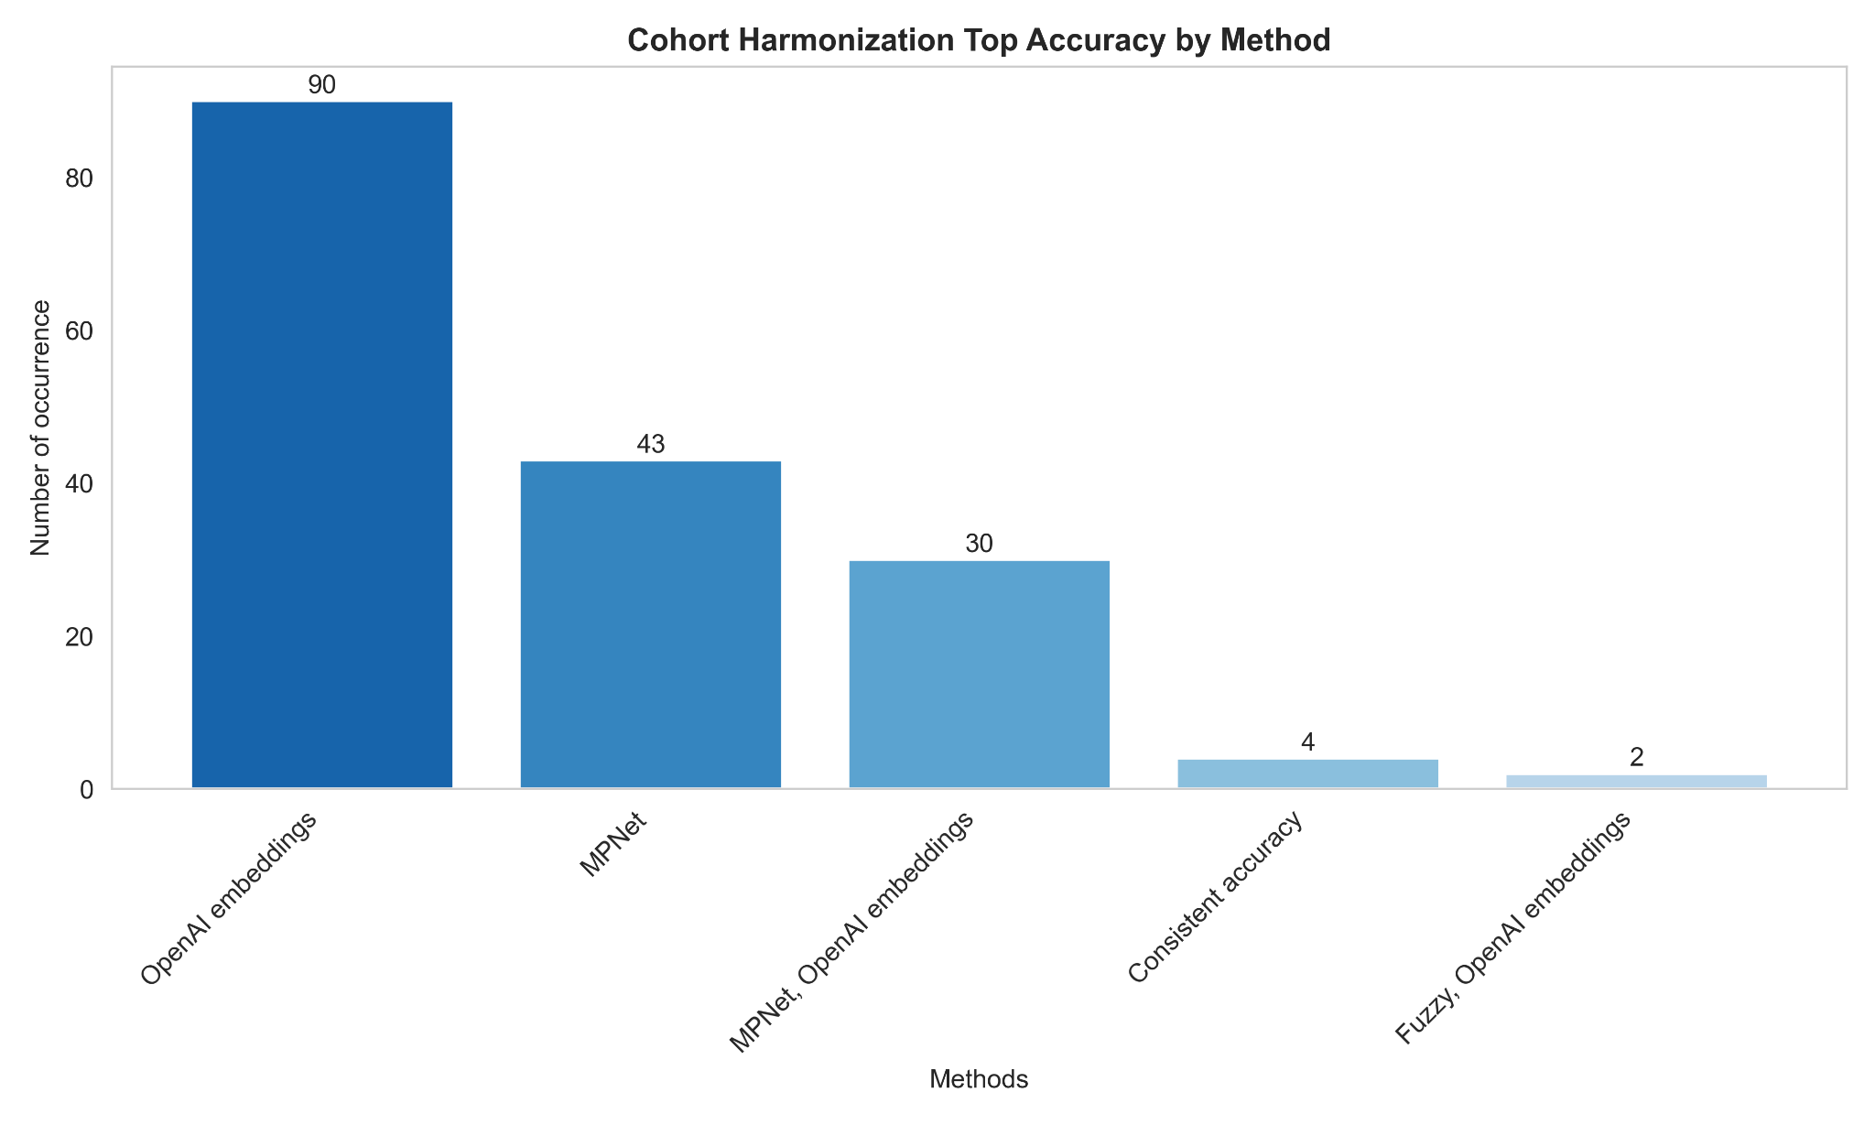
Figure S1: Total occurrences of highest accuracy achieved via different methods for AD cohort harmonization. Note: when two methods are mentioned together, it indicates that both methods achieved the same accuracy, which was superior to the accuracy of the last method mentioned.

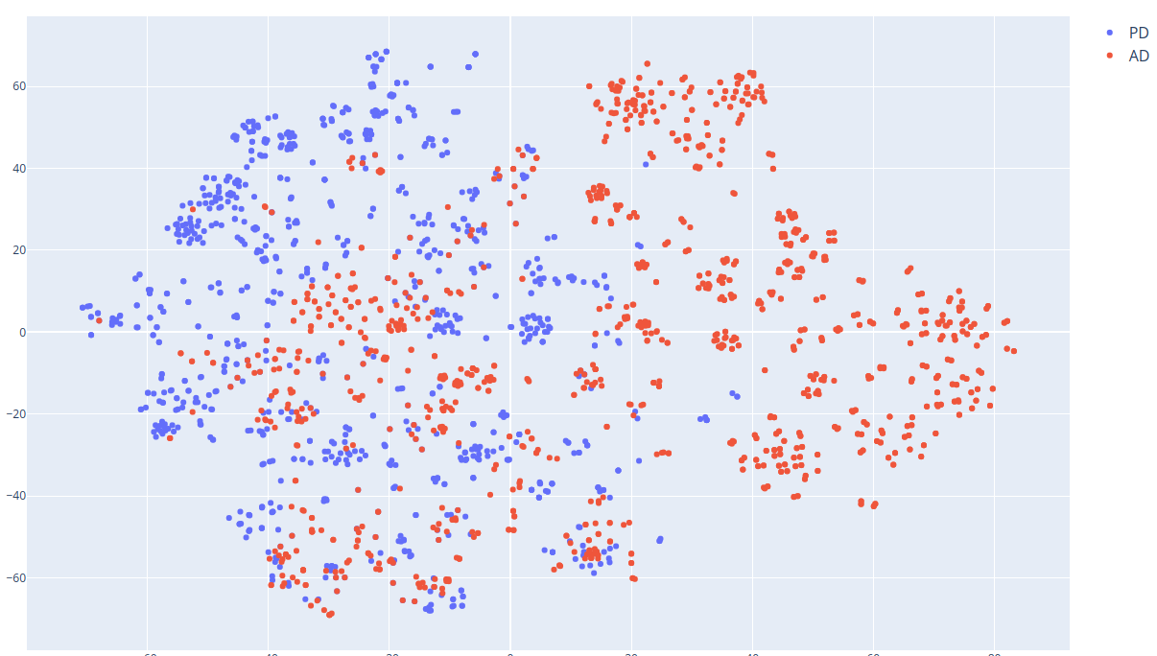
(a)

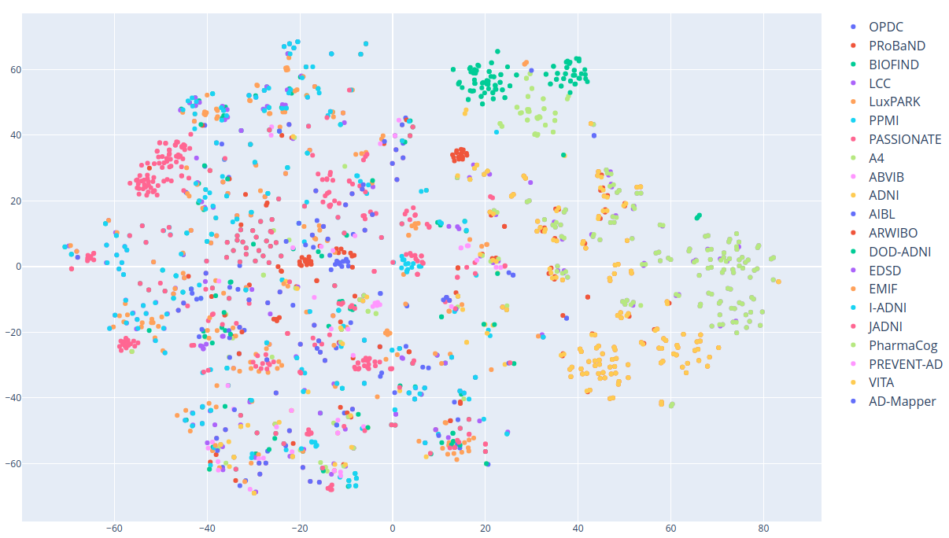
(b)
Figure S2: Two-dimensional t-SNE distribution plot of all computed AD and PD variable description embeddings using MPNet. The first plot (a) shows the distribution between AD and PD variable descriptions, and the second plot (b) the distribution of each cohort.

Variable origin |  | Consortium | # Mapped variables
Cohort | A4[1] | Anti-Amyloid Treatment in Asymptomatic Alzheimer’s Disease | 73
Cohort | ABVIB[2] | Aging Brain: Vasculature, Ischemia, and Behavior | 12
Cohort | ADNI[3] | The Alzheimer’s Disease Neuroimaging Initiative | 340
Cohort | AIBL[4] | The Australian Imaging, Biomarker & Lifestyle Flagship Study of Ageing | 54
Cohort | ARWIBO[5] | Alzheimer’s Disease Repository Without Borders | 1104
Cohort | DOD-ADNI[6] | Effects of TBI & PTSD on Alzheimer’s Disease in Vietnam Vets | 322
Cohort | EDSD[7] | The European DTI Study on Dementia | 1061
Cohort | EMIF[8] | European Medical Information Framework | 30
Cohort | I-ADNI[9] | The Italian Alzheimer’s Disease  Neuroimaging Initiative | 1064
Cohort | JADNI[10] | Japanese Alzheimer’s Disease Neuroimaging Initiative | 647
Cohort | PharmaCog[11] | Prediction of Cognitive Properties of New Drug Candidates for Neurodegenerative Diseases in Early Clinical Development | 1067
Cohort | PREVENT-AD[12] | Pre-symptomatic Evaluation of Experimental or Novel Treatments for Alzheimer’s Disease | 34
Cohort | VITA[13] | Vienna Transdanube Aging | 1054
Table S6: Investigated AD cohort studies and their total number of variables that were included in AD-Mapper CDM.[14] Note: we excluded cohorts that had no description provided in their data dictionaries or contained encodings that were not compatible with our mapping procedure.
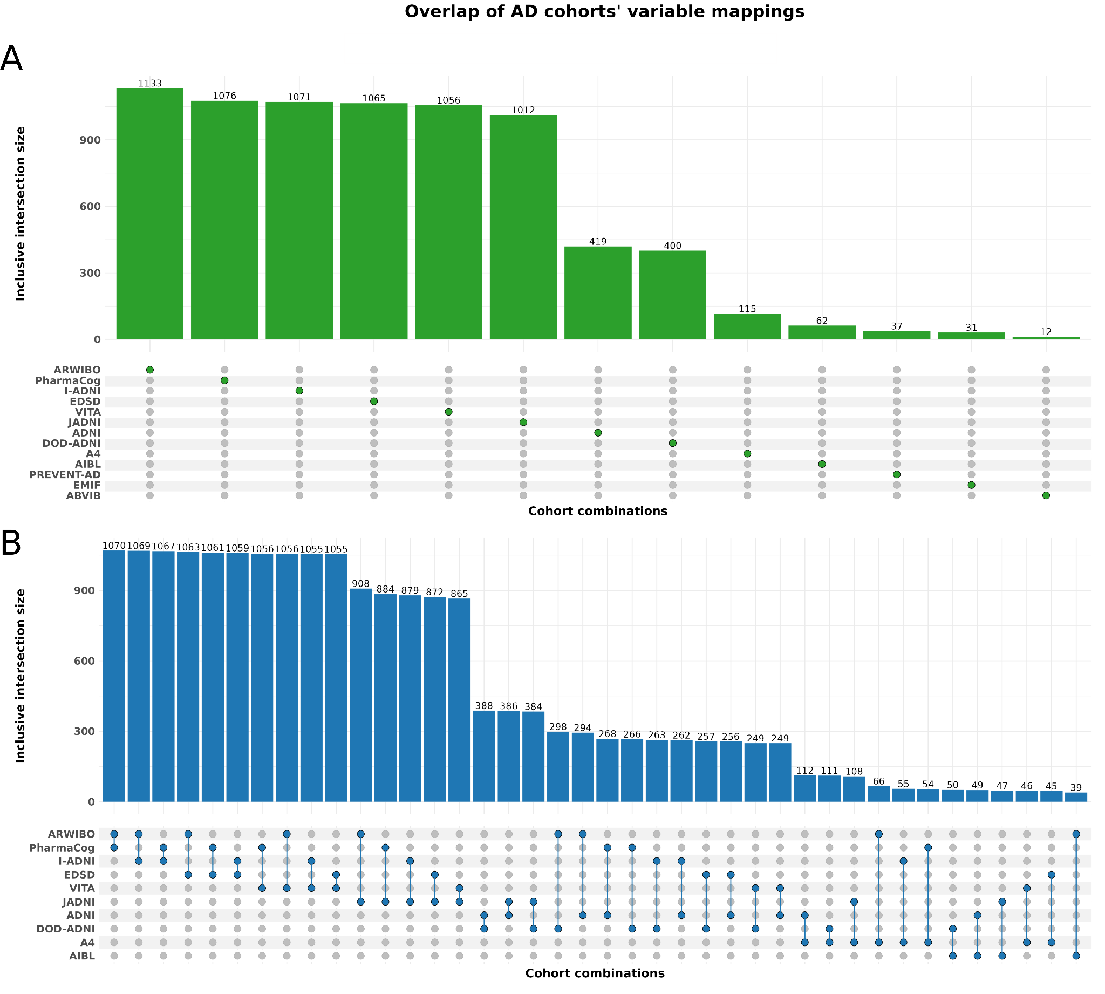
Figure S3: The total number of variable mappings from each cohort (panel A), as well as the variable overlap within two cohorts (panel B). Note: we deliberately excluded the empty sets and certain cohort combinations with variable overlap lower than 30.

Accuracy: A to B vs. B to A
By comparing the harmonization results of one cohort to another and rearranging the PD cohorts (e.g., harmonizing PPMI to PRoBaND and PRoBaND to PPMI), we observed that the accuracy remained unchanged or changed marginally in most cases. While harmonizing PRoBaND to OPDC, BIOFIND to OPDC, and PPMI to LuxPARK using OpenAI embeddings, had the same accuracy. The unchanged results could potentially be due to similarities between the cohorts’ descriptions. Similarly within AD cohorts, only in 10 cohort-to-cohort harmonization, the accuracy remained the same when the order of cohorts to be harmonized to another was switched.
When harmonizing LCC to LuxPARK, OpenAI embeddings achieved an accuracy of 89%, and harmonizing LuxPARK to LCC resulted in an accuracy of 88%. In a few instances, there was a moderate variation in accuracy, with the maximum change being 15%. Similarly, string matching accuracies differed when the order of cohort that was used for harmonization was switched. However, unlike the OpenAI embedding-based accuracies, the changes within the extracted result varied substantially for half of the cases (i.e., string matching results). One extreme case was observed for the harmonization of OPDC to PPMI with 7% accuracy whereas the harmonization of PPMI to OPDC had an accuracy of 57%.

REFERENCES

1. Sperling RA, Rentz DM, Johnson KA, et al. The A4 study: stopping AD before symptoms begin? Sci Transl Med 2014;6(228):228fs13. doi:10.1126/scitranslmed.3007941
2. Rodriguez FS, Zheng L, Chui HC. Psychometric Characteristics of Cognitive Reserve: How High Education Might Improve Certain Cognitive Abilities in Aging. Dement Geriatr Cogn Disord 2019;47(4-6):335-344. doi:10.1159/000501150
3. Mueller SG, Weiner MW, Thal LJ, et al. Ways toward an early diagnosis in Alzheimer’s disease: the Alzheimer’s Disease Neuroimaging Initiative (ADNI). Alzheimers Dement J Alzheimers Assoc 2005;1(1):55-66. doi:10.1016/j.jalz.2005.06.003
4. Ellis KA, Bush AI, Darby D, et al. The Australian Imaging, Biomarkers and Lifestyle (AIBL) study of aging: methodology and baseline characteristics of 1112 individuals recruited for a longitudinal study of Alzheimer’s disease. Int Psychogeriatr 2009;21(4):672-687. doi:10.1017/S1041610209009405
5. Frisoni GB, Prestia A, Zanetti O, et al. Markers of Alzheimer’s disease in a population attending a memory clinic. Alzheimers Dement J Alzheimers Assoc 2009;5(4):307-317. doi:10.1016/j.jalz.2009.04.1235
6. Weiner MW, Veitch DP, Hayes J, et al. Effects of traumatic brain injury and posttraumatic stress disorder on Alzheimer’s disease in veterans, using the Alzheimer’s Disease Neuroimaging Initiative. Alzheimers Dement J Alzheimers Assoc 2014;10(3 Suppl):S226-235. doi:10.1016/j.jalz.2014.04.005
7. Brueggen K, Grothe MJ, Dyrba M, et al. The European DTI Study on Dementia - A multicenter DTI and MRI study on Alzheimer’s disease and Mild Cognitive Impairment. NeuroImage 2017;144(Pt B):305-308. doi:10.1016/j.neuroimage.2016.03.067
8. Bos I, Vos S, Vandenberghe R, et al. The EMIF-AD Multimodal Biomarker Discovery study: design, methods and cohort characteristics. Alzheimers Res Ther 2018;10(1):64. doi:10.1186/s13195-018-0396-5
9. Cavedo E, Redolfi A, Angeloni F, et al. The Italian Alzheimer’s Disease Neuroimaging Initiative (I-ADNI): validation of structural MR imaging. J Alzheimers Dis JAD 2014;40(4):941-952. doi:10.3233/JAD-132666
10. Iwatsubo T. Japanese Alzheimer’s Disease Neuroimaging Initiative: present status and future. Alzheimers Dement J Alzheimers Assoc 2010;6(3):297-299. doi:10.1016/j.jalz.2010.03.011
11. Galluzzi S, Marizzoni M, Babiloni C, et al. Clinical and biomarker profiling of prodromal Alzheimer’s disease in workpackage 5 of the Innovative Medicines Initiative PharmaCog project: a “European ADNI study”. J Intern Med 2016;279(6):576-591. doi:10.1111/joim.12482
12. Breitner JCS, Poirier J, Etienne PE, et al. Rationale and Structure for a New Center for Studies on Prevention of Alzheimer’s Disease (StoP-AD). J Prev Alzheimers Dis 2016;3(4):236-242. doi:10.14283/jpad.2016.121
13. Fischer P, Jungwirth S, Krampla W, et al. Vienna Transdanube Aging “VITA”: study design, recruitment strategies and level of participation. J Neural Transm Suppl 2002;(62):105-116. doi:10.1007/978-3-7091-6139-5_11
14. Wegner P, Balabin H, Ay MC, et al. Semantic harmonization of Alzheimer’s disease datasets using AD-Mapper. Published online October 30, 2023. doi:10.1101/2023.10.26.564134
15. Kang UJ, Goldman JG, Alcalay RN, et al. The BioFIND study: Characteristics of a clinically typical Parkinson’s disease biomarker cohort. Mov Disord 2016;31(6):924-932. doi:10.1002/mds.26613
16. Pont-Sunyer C, Tolosa E, Caspell-Garcia C, et al. The prodromal phase of leucine-rich repeat kinase 2-associated Parkinson disease: Clinical and imaging Studies. Mov Disord Off J Mov Disord Soc 2017;32(5):726-738. doi:10.1002/mds.26964
17. Hipp G, Vaillant M, Diederich NJ, et al. The Luxembourg Parkinson’s Study: A Comprehensive Approach for Stratification and Early Diagnosis. Front Aging Neurosci 2018;10:326. doi:10.3389/fnagi.2018.00326
18. Hu M. Oxford Parkinson’s Disease Centre Discovery CohortOPDC Discovery. Published online 2017. doi:10.48532/036000
19. Verdi S, Marquand AF, Schott JM, et al. Beyond the average patient: how neuroimaging models can address heterogeneity in dementia. Brain J Neurol 2021;144(10):2946-2953. doi:10.1093/brain/awab165
20. Malek N, Swallow DMA, Grosset KA, et al. Tracking Parkinson’s: Study Design and Baseline Patient Data. J Park Dis 2015;5(4):947-959. doi:10.3233/JPD-150662
21. Data Standardization – OHDSI. Accessed November 28, 2023. https://www.ohdsi.org/data-standardization/
22. Institute EB. EMBL-EBI homepage. Accessed November 28, 2023. https://www.ebi.ac.uk/

