Table 2 Protein ligand interaction of corneal proteins in Endothelial region
 | Protein | Structure 1 | Structure 2 | Structure 3
1 | Collagen alpha-1(VIII) chain | 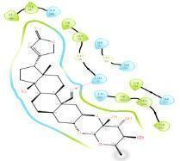 Calotropin | 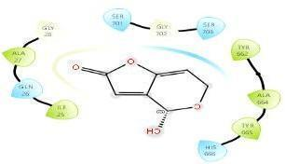Gigantin | 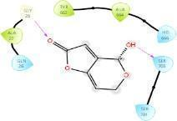  Gigantin
2 | Collagen alpha-2(VIII) chain: | 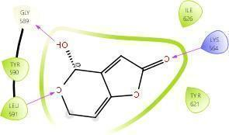  Gigantin | 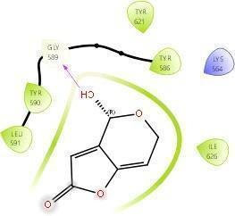  Gigantin
3 | Collagen alpha-3(IV) chain | 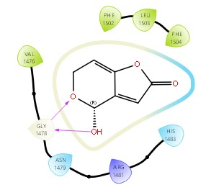  Gigantin | 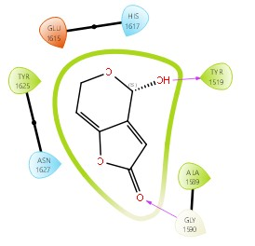  Gigantin | 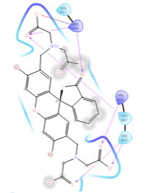  Calotoxin
4 | Collagen alpha- 4(IV) chain: | 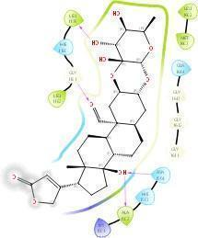  Calotropin | 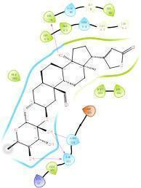Calotropin | 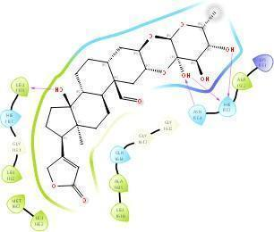  Calotropin
5 | Collagen alpha- 5(IV) chain: | 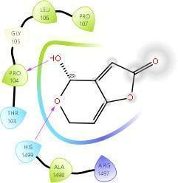Gigantin | 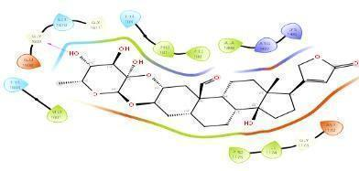  Calotropin | 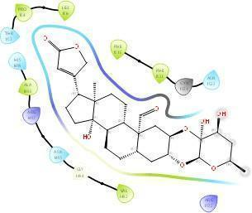Calotropin
6 | Fibulin-5: | 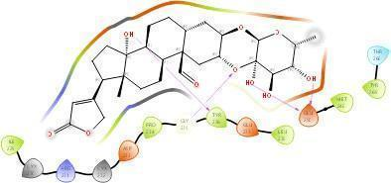  Calotropin | 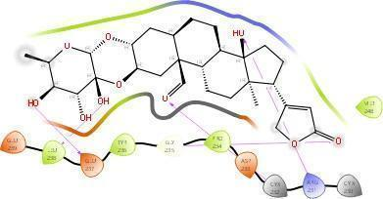  Calotoxin | 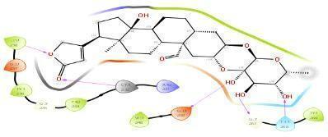  Calotoxin
7 | Ig lambda-2 chain C regions | 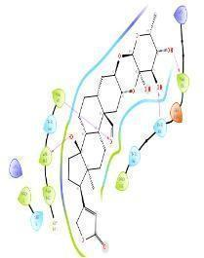  Calotropin | 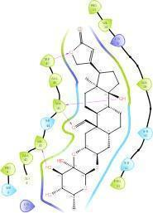  Calotoxin | 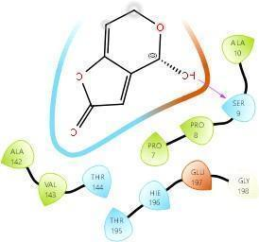  Gigantin
8 | Immunoglobulin lambda-like polypeptide 5 | 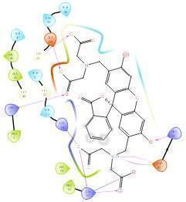Calotoxin | 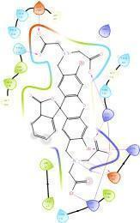Calotoxin | 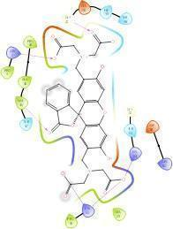Calotropin
9 | Myocilin | 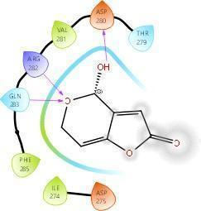Gigantin | 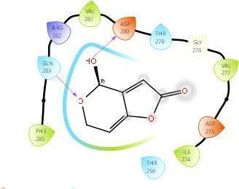  Gigantin | 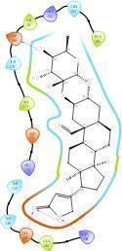  Calotropin
10 | Serine protease HTRA1 | 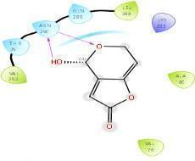Gigantin | 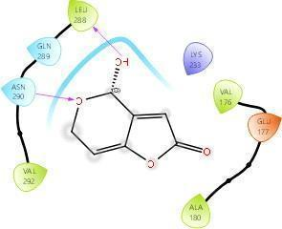Gigantin | 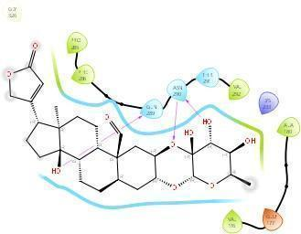  Calotoxin
11 | Thrombospondi n-4 | 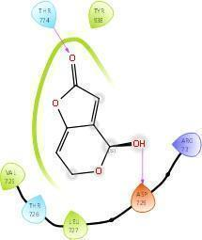  Gigantin | 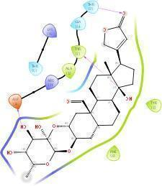  Calotoxin | 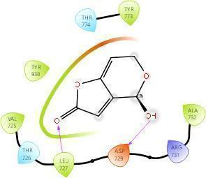Gigantin

Table 3 Protein ligand interaction of corneal protein in Epithelial region:

 | Protein | Structure1 | Structure 2 | Structure 3
1 | Actin, cytoplasmic 1 | 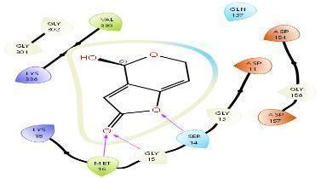  Giantin | 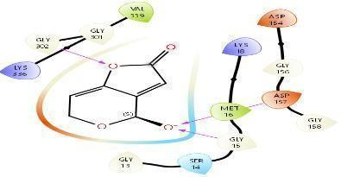  Giantin | 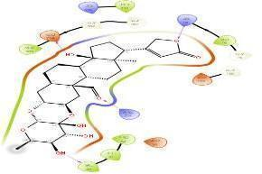  Calotropin
2 | Aldehyde dehydrogenase, dimeric NADP- preferring | 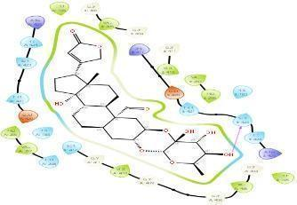Calotropin | 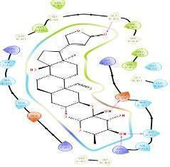Calotropin | 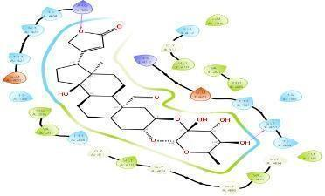Calotoxin
3 | Annexin A2 | 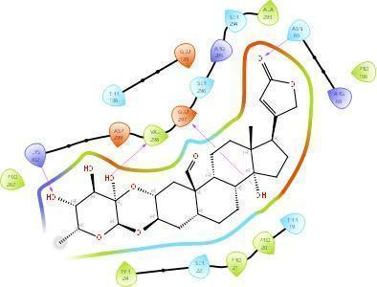Calotropin | 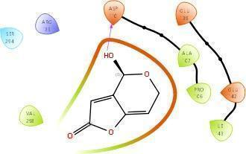Gigantin | 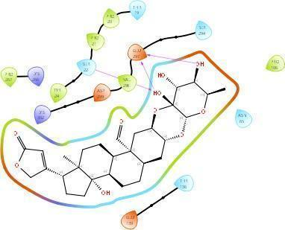Calotoxin
4 | Elongation factor 1-alpha 1 | 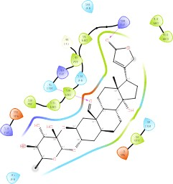Calotoxin | 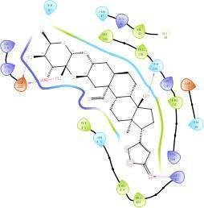Calotoxin
5 | Ferritin heavy chain: | 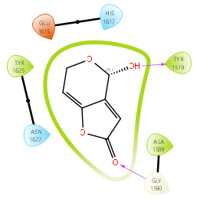Gigantin
6 | Glyceraldehyde- 3-phosphate dehydrogenase: | 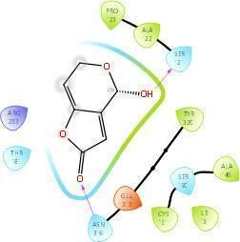Gigantin | 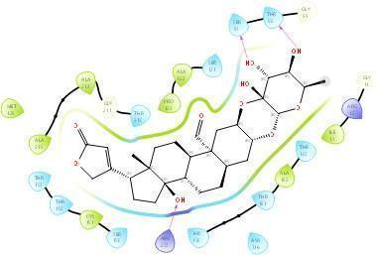Calotoxin | 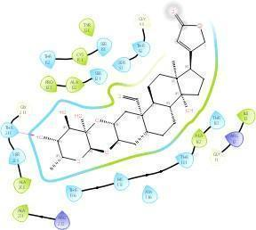Calotropin
7 | Heat shock protein beta-1 | 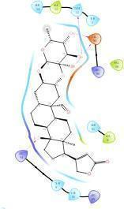Calotoxin | 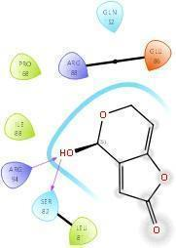Gigantin | 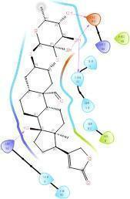Calotoxin
8 | Histone H2B type 1-B | 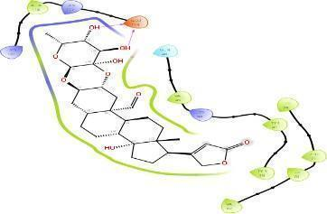Calotoxin | 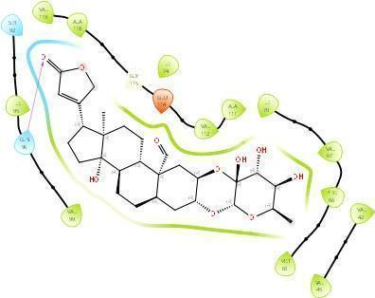Calotxin | 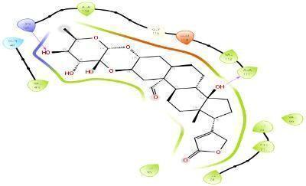Calotoxin
9 | Histone H2B type 1-CEF GI | 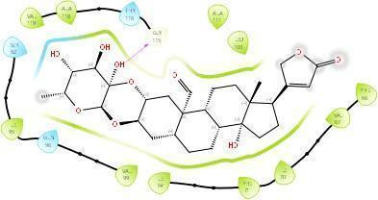Calotoxin | 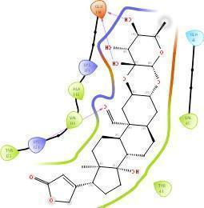  Calotropin | 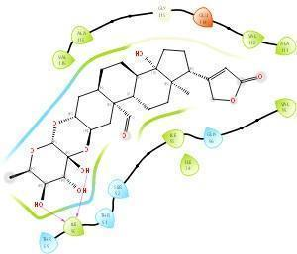  Calotropin
10 | Histone H4 | 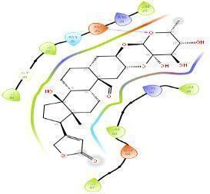Calotoxin | 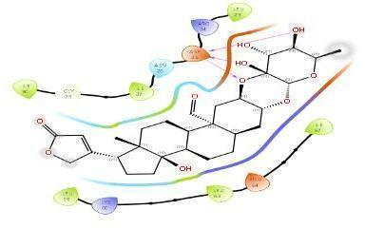Calotoxin | 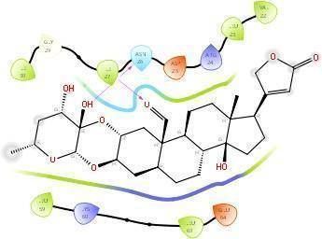  Calotropin
11 | Keratin, type I cytoskeletal 12 | 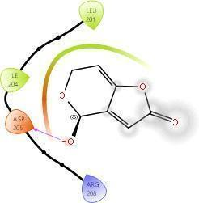  Gigantin | 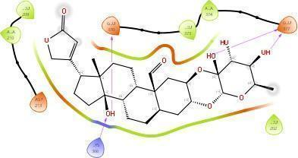  Calotoxin | 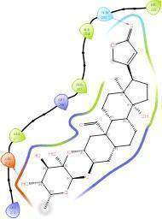  Calotoxin

12 | Keratin, type I cytoskeletal 13 | 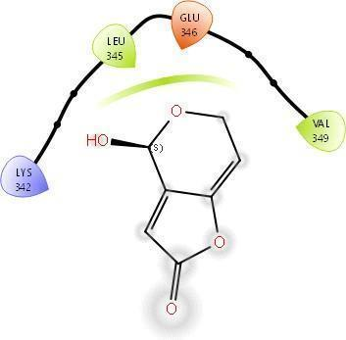Gigantin | 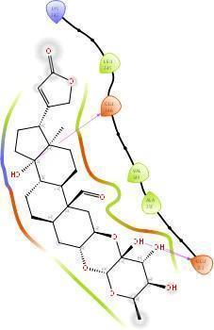  Calotoxin | 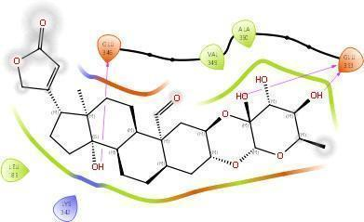  Calotoxin
13 | Keratin, type I cytoskeletal 14 | 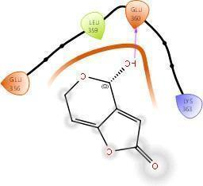Gigantin | 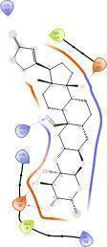  Calotropin | 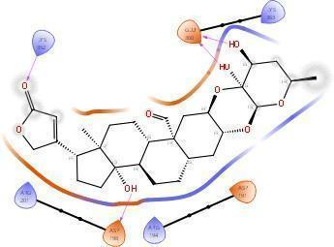  Calotoxin
14 | Keratin, type I cytoskeletal 15 | 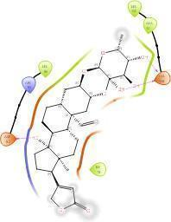  Calotropin | 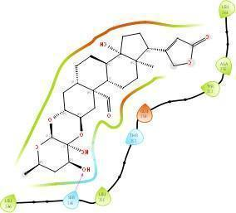  Calotoxin | 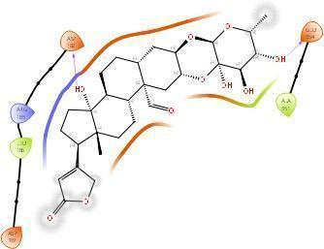  Calotoxin
15 | Keratin, type I cytoskeletal 19 | 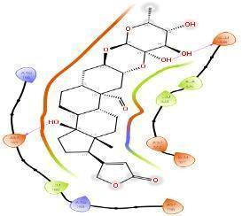  Calotropin | 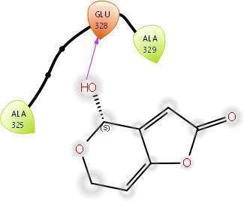Gigantin | 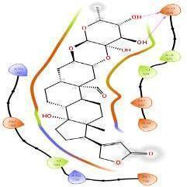  Calotoxin
16 | Keratin, type II cytoskeletal 2 oral | 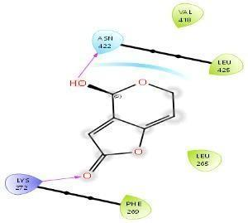  Calcin | 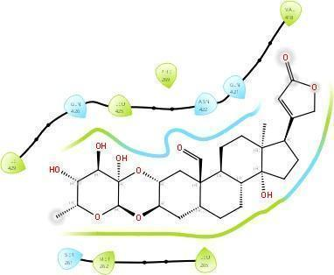  Calotoxin | 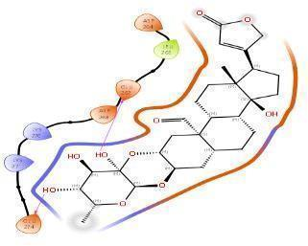  Calotoxin
17 | Keratin, type II cytoskeletal 3 | 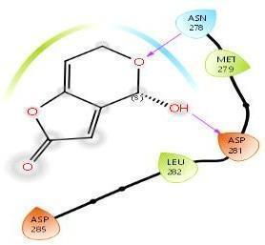  Calcin | 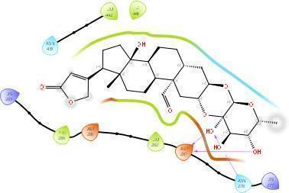  Calotoxin | 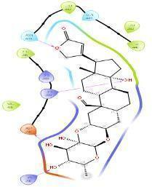  Calotoxin

18 | Keratin, type II cytoskeletal 4: |  | NO DOCKING
19 | Keratin, type II cytoskeletal 5 |  | 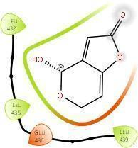  Calcin | 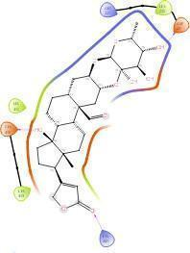Calotoxin | 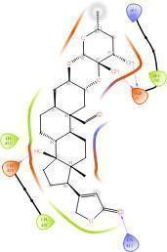  Calotoxin
20 | Keratin, type II cytoskeletal 6A |  | 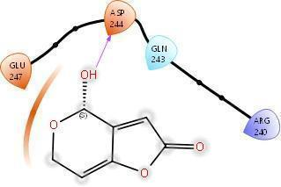  Gigantin | 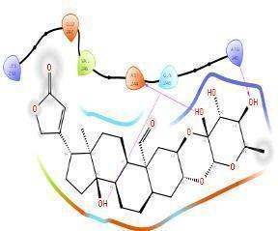  Calotropin | 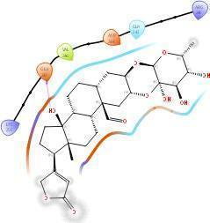  Calotoxin
21 | Keratin, type II cytoskeletal 8 |  | 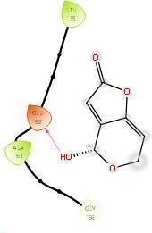Gigantin | 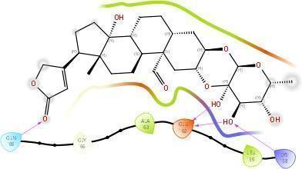Calotoxin | 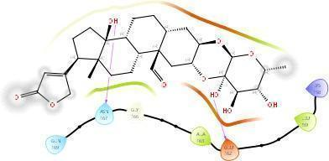Calotoxin
22 | L-lactate dehydrogenase A chain |  | NO DOCKING
23 | Protein S100- A4 |  | 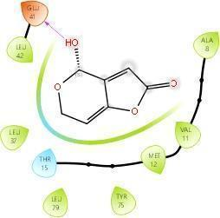  Gigantin | 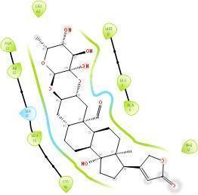Calotoxin | 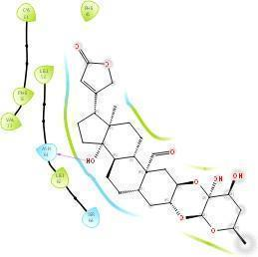Calotoxin
24 | Pyruvate kinase isozymes M1/M2 | NO DOCKING
25 | Retinal dehydrogenase 1 | 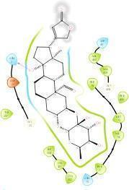Calotoxin |  | 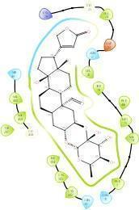Calotoxin | 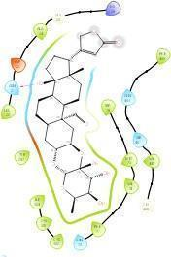Calotoxin

Table 4 Protein ligand interaction of corneal protein Stroma region:
 | Proteins | Structure 1 | Structure 2 | Structure 3
1 | Alpha-1- antichymotryp sin | 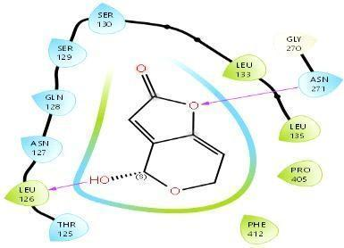  Gigantin | 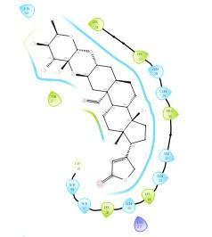Calotoxin
2 | Alpha-1-antitrypsin | 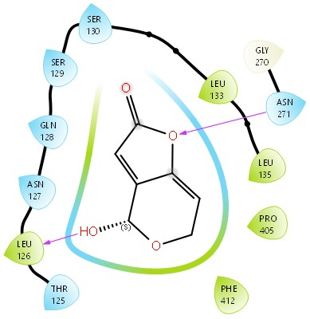Gigantin
3 | Alpha-enolase | NO DOCKING
4 | Apolipoprotein D | 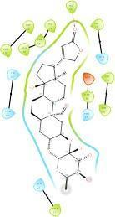Calcin | 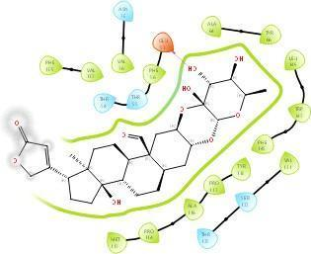Calotoxin | 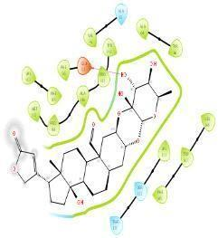Calotoxin
5 | Biglycan | 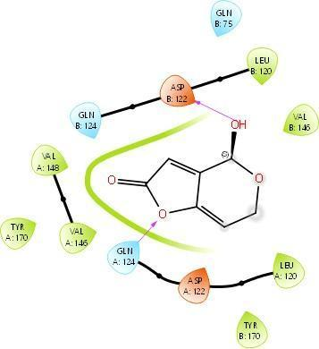Gigantin | 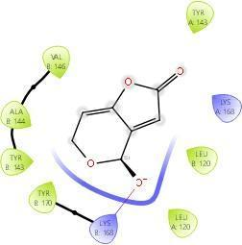  Gigantin | 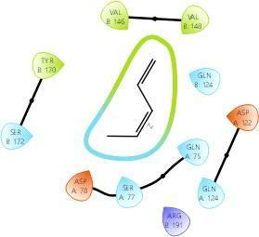  Calcin
6 | Clusterin | 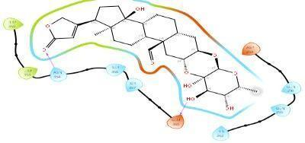Calotoxin | 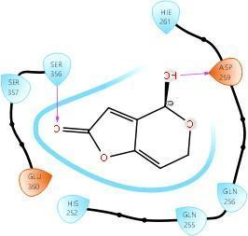Gigantin | 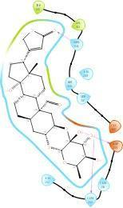 Calotropin
7 | Collagen alpha 1(VI) chain | NO DOCKING
8 | Collagen alpha 2(VI) chain | 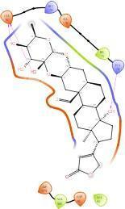  Calotropin | 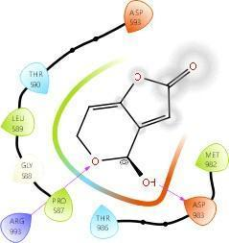  Gigantin | 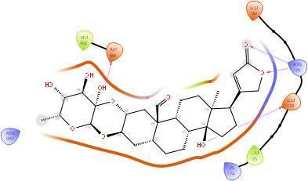  Calotoxin
9 | Collagen alpha 3(VI) chain | NO DOCKING
10 | Collagen alpha-1(I) chain | 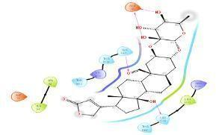Calotropin | 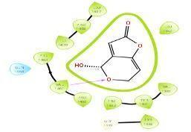Gigantin | 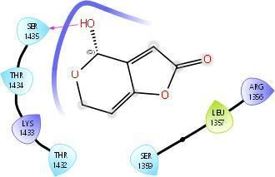Gigantin

11 | Collagen alpha-1(III) chain | 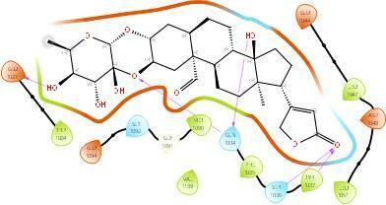Calotoxin | 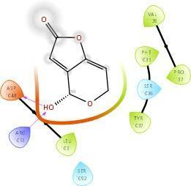  Gigantin | 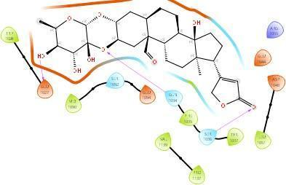Calotoxin
12 | Collagen alpha-1(V) chain | 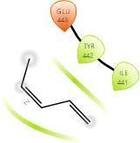Calcin
13 | Collagen alpha-1(XII) chain | 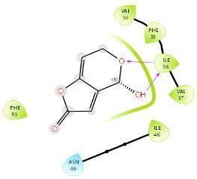Gigantin | 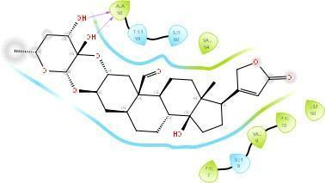Calotropin | 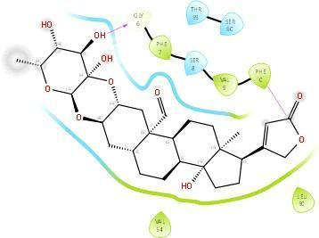Calotoxin
14 | Collagen alpha2(I) chain | 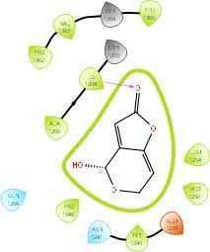Gigantin | 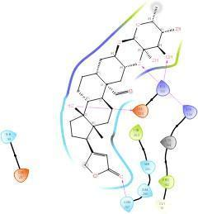Calotropin | 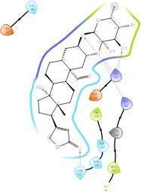  Calotoxin
15 | Collagen alpha-2(V) chain | 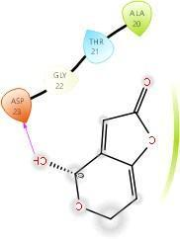Gigantin | 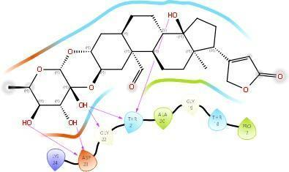Calotoxin | 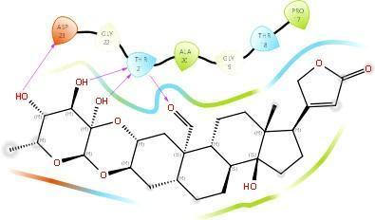Calotoxin
16 | Decorin | 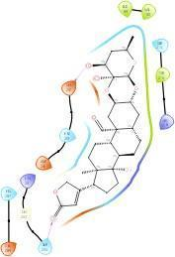  Calotoxin | 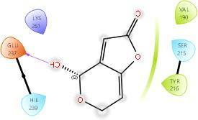  Gigantin | 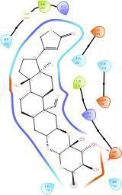  Calotropin
17 | Ig alpha-1 chain C region | 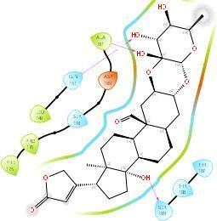Calotoxin | 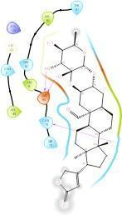  Calotoxin | 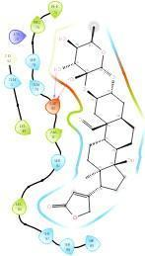Calotoxin

18 | Ig gamma1 chain C region | 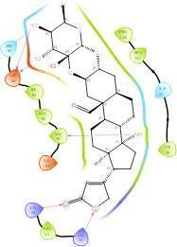  Calotoxin | 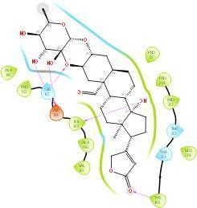  Calotoxin | 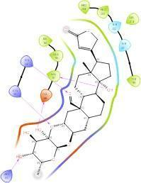  Calotoxin
19 | Ig gamma-2 chain C region | 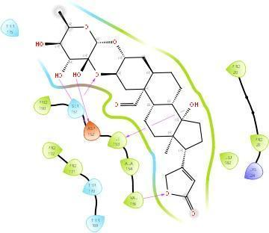  Calotoxin | 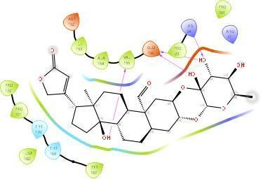  Calotoxin | 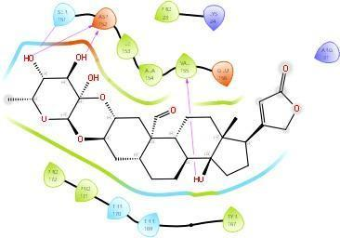Calotoxin
20 | ig gamma-3 chain C region | 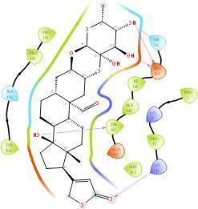  Calotropin | 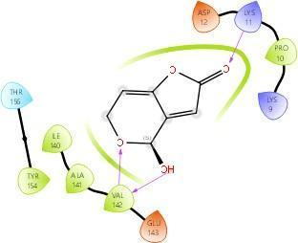  Calcin | 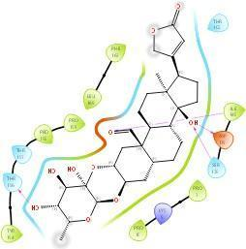  Calotoxin
21 | Ig gamma-4 chain C region | 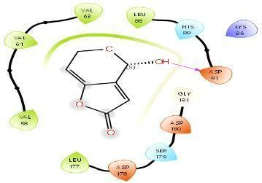  Calcin | 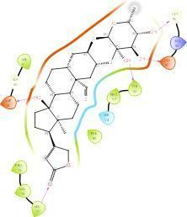  Calotoxin | 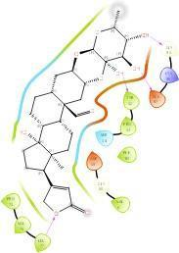  Calotoxin
22 | Ig kappa chain C region | 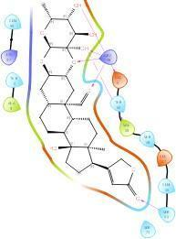  Calotoxin | 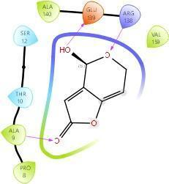  Calcin | 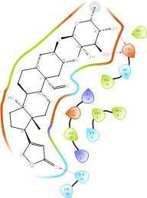Calotropin
23 | Keratocan | 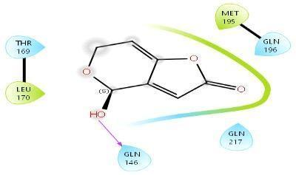  Calcin | 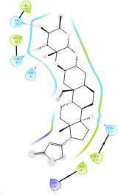  Calotoxin | 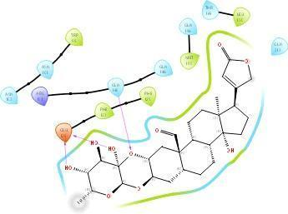  Calotoxin

24 | Lumican | 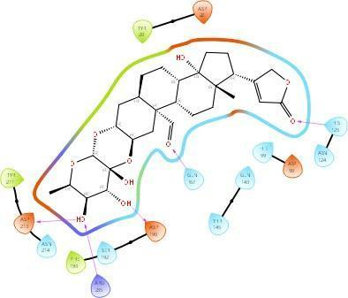Calotoxin | 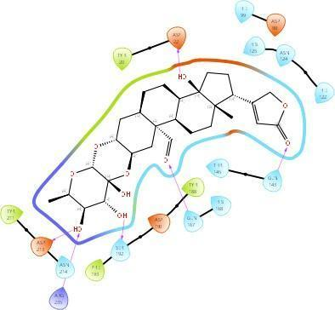Calotoxin | 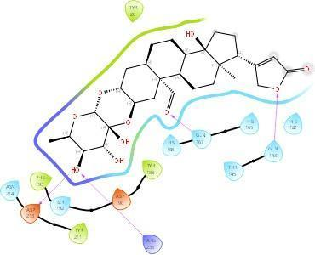Calotoxin
25 | MAM domain- containing protein 2 | 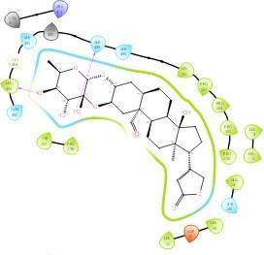Calotoxin | 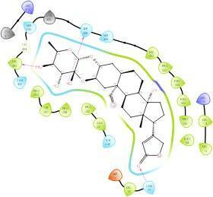Calotoxin | 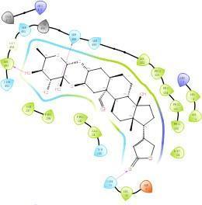  Calotoxin
26 | Prolargin | NO DOCKING
27 | Serum albumin | 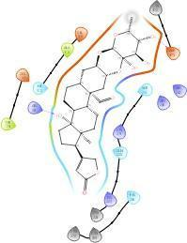  Calotoxin | 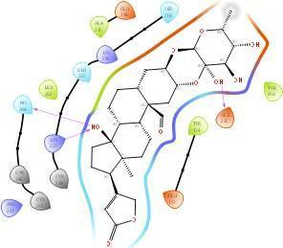  Calotoxin | 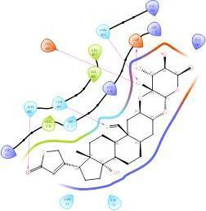  Calotoxin
28 | Transforming growth factor beta induced protein ig-h3 | 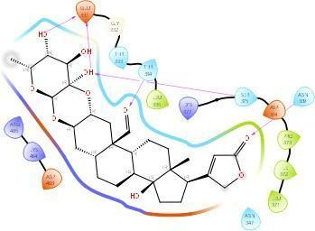 Calotoxin | 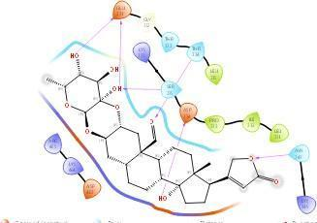  Calotoxin | 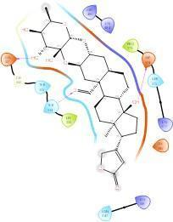  Calotoxin
29 | Vimentin | 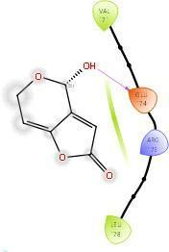 Calcin | 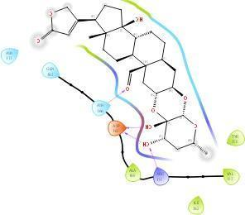Calotoxin | 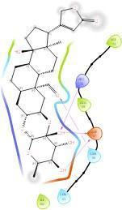Calotoxin

Halogen bond Metal coordination

Hvdrophobic
Polar
Unspecified Residues
Water
Distance
Charged (Negative) Charged (positive) Glycine Metal

Table 5 Represents the two hits from each Protein- ligand Docking out of 32 hits for the different types of corneal proteins.
Proteins | SMILES | Ligand | Docking_status | r_i_docking_score | r_i_glide_gscore | r_i_glide_hbond
Endothelial
Collagen alpha-1(VIII) chain | O=C1C=C2C(=CCO[C@@H]2O)O1 | Gigantin | Done | -4.47824 | -4.51654 | 0
 | O=C1C=C2C(=CCO[C@H]2O)O1 | Gigantin | Done | -4.39781 | -4.43611 | -0.0442711
Collagen alpha-2(VIII) chain | O=C1C=C2C(=CCO[C@@H]2O)O1 | Gigantin | Done | -4.44581 | -4.48411 | -0.416812
 | O=C1C=C2C(=CCO[C@H]2O)O1 | Gigantin | Done | -3.53208 | -3.57038 | 0
Collagen alpha-3(IV) chain | O=C1C=C2C(=CCO[C@H]2O)O1 | Gigantin | Done | -5.04178 | -5.08008 | 0
 | O=C1C=C2C(=CCO[C@@H]2O)O1 | Gigantin | Done | -4.15775 | -4.19605 | -0.287438
Collagen alpha-4(IV) chain | O=C([O-])CN(CC(=O)[O-])Cc1cc2c(cc1O)Oc1cc([O-])c(C[NH+](CC(=O)[O-])CC(=O)[O-])cc1[C@]21OC(=O)c2ccccc21 | Calcin | Done | -5.53016 | -5.63386 | -0.740695
 | C[C@H]1O[C@@H]2O[C@@H]3C[C@H]4CC[C@H]5[C@@H](CC[C@@]6(C)[C@@H](C7=CC(=O)OC7)CC[C@@]56O)[C@@]4(C=O)C[C@H]3O[C@]2(O)[C@H](O)[C@H]1O | Calotoxin | Done | -5.4282 | -5.4282 | -0.510117
Collagen alpha-5(IV) chain | O=C1C=C2C(=CCO[C@@H]2O)O1 | Gigantin | Done | -5.13741 | -5.17571 | 0
 | C[C@H]1O[C@@H]2O[C@@H]3C[C@H]4CC[C@@H]5[C@@H](CC[C@]6(C)[C@@H](C7=CC(=O)OC7)CC[C@]56O)[C@@]4(C=O)C[C@H]3O[C@]2(O)[C@H](O)[C@H]1O | Calotoxin | Done | -4.02442 | -4.02442 | 0
Fibulin-5 | C[C@H]1O[C@@H]2O[C@@H]3C[C@H]4CC[C@H]5[C@H](CC[C@]6(C)[C@@H](C7=CC(=O)OC7)CC[C@@]56O)[C@@]4(C=O)C[C@H]3O[C@]2(O)[C@H](O)[C@H]1O | Calotoxin | Done | -4.29765 | -4.29765 | -0.555426
 | C[C@H]1O[C@@H]2O[C@@H]3C[C@H]4CC[C@@H]5[C@H](CC[C@]6(C)[C@@H](C7=CC(=O)OC7)CC[C@@]56O)[C@]4(C=O)C[C@H]3O[C@]2(O)[C@H](O)[C@H]1O | Calotoxin | Done | -4.23422 | -4.23422 | -0.548149
Ig lambda-2 chain C regions | C[C@H]1O[C@@H]2O[C@@H]3C[C@H]4CC[C@@H]5[C@@H](CC[C@@]6(C)[C@@H](C7=CC(=O)OC7)CC[C@]56O)[C@@]4(C=O)C[C@H]3O[C@]2(O)[C@H](O)[C@H]1O | Calotoxin | Done | -5.41448 | -5.41448 | -0.64149
 | C[C@H]1O[C@@H]2O[C@@H]3C[C@H]4CC[C@@H]5[C@H](CC[C@@]6(C)[C@@H](C7=CC(=O)OC7)CC[C@]56O)[C@@]4(C=O)C[C@H]3O[C@]2(O)[C@H](O)[C@H]1O | Calotoxin | Done | -5.33323 | -5.33323 | -0.415501
Immunoglobulin lambda-like  polypeptide 5 | O=C([O-])C[NH+](CC(=O)[O-])Cc1cc2c(cc1O)Oc1cc(O)c(C[NH+](CC(=O)[O-])CC(=O)[O-])cc1C21OC(=O)c2ccccc21 | Calcin | Done | -7.09896 | -8.31106 | -1.02557
 | O=C1C=C2C(=CCO[C@H]2O)O1 | Gigantin | Done | -5.98751 | -6.02581 | -0.517264
Myocilin | O=C1C=C2C(=CCO[C@@H]2O)O1 | Gigantin | Done | -5.37941 | -5.41771 | -0.555268
 | C[C@H]1O[C@@H]2O[C@@H]3C[C@H]4CC[C@H]5[C@H](CC[C@@]6(C)[C@@H](C7=CC(=O)OC7)CC[C@@]56O)[C@@]4(C=O)C[C@H]3O[C@]2(O)[C@H](O)[C@H]1O | Calotoxin | Done | -4.28501 | -4.28501 | -0.51441
Serine protease HTRA1 | O=C1C=C2C(=CCO[C@H]2O)O1 | Gigantin | Done | -4.62866 | -4.66696 | -0.304
 | O=C1C=C2C(=CCO[C@@H]2O)O1 | Gigantin | Done | -4.15671 | -4.19501 | -0.16464
Thrombospondin-4 | O=C1C=C2C(=CCO[C@@H]2O)O1 | Gigantin | Done | -5.26325 | -5.30155 | -0.31138
 | O=C1C=C2C(=CCO[C@H]2O)O1 | Gigantin | Done | -4.9546 | -4.9929 | -0.17125
Epithelial
Actin, cytoplasmic 1 | O=C1C=C2C(=CCO[C@@H]2O)O1 | Gigantin | Done | -5.1567 | -5.195 | -0.427386
 | O=C1C=C2C(=CCO[C@@H]2[O-])O1 | Gigantin | Done | -5.08232 | -6.72362 | -0.367528
Aldehyde dehydrogenase,  dimeric NADP-preferring, | C[C@H]1O[C@@H]2O[C@@H]3C[C@H]4CC[C@H]5[C@@H](CC[C@@]6(C)[C@@H](C7=CC(=O)OC7)CC[C@]56O)[C@@]4(C=O)C[C@H]3O[C@]2(O)[C@H](O)[C@H]1O | Calotoxin | Done | -7.19692 | -7.19692 | -0.0943172
 | C[C@H]1O[C@@H]2O[C@@H]3C[C@H]4CC[C@@H]5[C@@H](CC[C@@]6(C)[C@@H](C7=CC(=O)OC7)CC[C@@]56O)[C@@]4(C=O)C[C@H]3O[C@]2(O)[C@H](O)[C@H]1O | Calotoxin | Done | -7.11238 | -7.11238 | -0.126559
Annexin A2 | C[C@H]1O[C@@H]2O[C@@H]3C[C@H]4CC[C@@H]5[C@@H](CC[C@]6(C)[C@@H](C7=CC(=O)OC7)CC[C@@]56O)[C@@]4(C=O)C[C@H]3O[C@]2(O)[C@H](O)[C@H]1O | Calotoxin | Done | -4.96771 | -4.96771 | 0
 | O=C1C=C2C(=CCO[C@@H]2O)O1 | Gigantin | Done | -4.3787 | -4.417 | 0
Elongation factor 1-alpha 1 | O=C1C=C2C(=CCO[C@@H]2O)O1 | Gigantin | Done | -5.41354 | -5.45184 | -0.162918
 | C[C@H]1O[C@@H]2O[C@@H]3C[C@H]4CC[C@H]5[C@H](CC[C@@]6(C)[C@@H](C7=CC(=O)OC7)CC[C@]56O)[C@]4(C=O)C[C@H]3O[C@]2(O)[C@H](O)[C@H]1O | Calotoxin | Done | -5.16294 | -5.16294 | -0.235487
Ferritin heavy chain | O=C1C=C2C(=CCO[C@@H]2O)O1 | Gigantin | Done | -4.57031 | -4.60861 | 0
 | C[C@H]1O[C@@H]2O[C@@H]3C[C@H]4CC[C@H]5[C@H](CC[C@@]6(C)[C@@H](C7=CC(=O)OC7)CC[C@@]56O)[C@]4(C=O)C[C@H]3O[C@]2(O)[C@H](O)[C@H]1O | Calotoxin | Done | -3.50907 | -3.50907 | 0
Glyceraldehyde-3-phosphate dehydrogenase | O=C1C=C2C(=CCO[C@@H]2O)O1 | Gigantin | Done | -6.01074 | -6.04904 | -0.301499
 | C[C@H]1O[C@@H]2O[C@@H]3C[C@H]4CC[C@H]5[C@@H](CC[C@@]6(C)[C@@H](C7=CC(=O)OC7)CC[C@@]56O)[C@@]4(C=O)C[C@H]3O[C@]2(O)[C@H](O)[C@H]1O | Calotoxin | Done | -5.61378 | -5.61378 | -0.252625
Heat shock protein beta-1 | O=C1C=C2C(=CCO[C@@H]2O)O1 | Gigantin | Done | -3.69431 | -3.73261 | 0
 | C[C@H]1O[C@@H]2O[C@@H]3C[C@H]4CC[C@H]5[C@@H](CC[C@@]6(C)[C@@H](C7=CC(=O)OC7)CC[C@]56O)[C@]4(C=O)C[C@H]3O[C@]2(O)[C@H](O)[C@H]1O | Calotoxin | Done | -3.41469 | -3.41469 | -0.0703146
Histone H2B type 1-B | C[C@H]1O[C@@H]2O[C@@H]3C[C@H]4CC[C@@H]5[C@H](CC[C@]6(C)[C@@H](C7=CC(=O)OC7)CC[C@@]56O)[C@]4(C=O)C[C@H]3O[C@]2(O)[C@H](O)[C@H]1O | Calotoxin | Done | -4.42827 | -4.42827 | 0
 | C[C@H]1O[C@@H]2O[C@@H]3C[C@H]4CC[C@@H]5[C@H](CC[C@]6(C)[C@@H](C7=CC(=O)OC7)CC[C@]56O)[C@@]4(C=O)C[C@H]3O[C@]2(O)[C@H](O)[C@H]1O | Calotoxin | Done | -4.37172 | -4.37172 | -0.294601
Histone H2B type 1-CEF GI | C[C@H]1O[C@@H]2O[C@@H]3C[C@H]4CC[C@@H]5[C@@H](CC[C@]6(C)[C@@H](C7=CC(=O)OC7)CC[C@@]56O)[C@]4(C=O)C[C@H]3O[C@]2(O)[C@H](O)[C@H]1O | Calotoxin | Done | -4.48504 | -4.48504 | 0
 | C[C@H]1O[C@@H]2O[C@@H]3C[C@H]4CC[C@H]5[C@@H](CC[C@]6(C)[C@@H](C7=CC(=O)OC7)CC[C@]56O)[C@@]4(C=O)C[C@H]3O[C@]2(O)[C@H](O)[C@H]1O | Calotoxin | Done | -4.34084 | -4.34084 | -0.133224
Histone H4 | C[C@H]1O[C@@H]2O[C@@H]3C[C@H]4CC[C@@H]5[C@@H](CC[C@]6(C)[C@@H](C7=CC(=O)OC7)CC[C@]56O)[C@@]4(C=O)C[C@H]3O[C@]2(O)[C@H](O)[C@H]1O | Calotoxin | Done | -4.27529 | -4.27529 | -0.0747594
 | C[C@H]1O[C@@H]2O[C@@H]3C[C@H]4CC[C@@H]5[C@@H](CC[C@@]6(C)[C@@H](C7=CC(=O)OC7)CC[C@@]56O)[C@@]4(C=O)C[C@H]3O[C@]2(O)[C@H](O)[C@H]1O | Calotoxin | Done | -4.12974 | -4.12974 | 0
Keratin, type I cytoskeletal 12 | O=C1C=C2C(=CCO[C@@H]2O)O1 | Gigantin | Done | -4.18185 | -4.22015 | 0
 | C[C@H]1O[C@@H]2O[C@@H]3C[C@H]4CC[C@H]5[C@H](CC[C@@]6(C)[C@@H](C7=CC(=O)OC7)CC[C@@]56O)[C@]4(C=O)C[C@H]3O[C@]2(O)[C@H](O)[C@H]1O | Calotoxin | Done | -4.12894 | -4.12894 | -0.284637
Keratin, type I cytoskeletal 13 | O=C1C=C2C(=CCO[C@@H]2O)O1 | Gigantin | Done | -3.75446 | -3.79276 | 0
 | C[C@H]1O[C@@H]2O[C@@H]3C[C@H]4CC[C@H]5[C@@H](CC[C@]6(C)[C@@H](C7=CC(=O)OC7)CC[C@]56O)[C@]4(C=O)C[C@H]3O[C@]2(O)[C@H](O)[C@H]1O | Calotoxin | Done | -3.67064 | -3.67064 | 0
Keratin, type I cytoskeletal 14 | O=C1C=C2C(=CCO[C@@H]2O)O1 | Gigantin | Done | -4.06272 | -4.10102 | 0
 | C[C@H]1O[C@@H]2O[C@@H]3C[C@H]4CC[C@@H]5[C@@H](CC[C@]6(C)[C@@H](C7=CC(=O)OC7)CC[C@]56O)[C@@]4(C=O)C[C@H]3O[C@]2(O)[C@H](O)[C@H]1O | Calotoxin | Done | -3.16403 | -3.16403 | -0.279001
Keratin, type I cytoskeletal 15 | C[C@H]1O[C@@H]2O[C@@H]3C[C@H]4CC[C@H]5[C@@H](CC[C@@]6(C)[C@@H](C7=CC(=O)OC7)CC[C@@]56O)[C@]4(C=O)C[C@H]3O[C@]2(O)[C@H](O)[C@H]1O | Calotoxin | Done | -3.38377 | -3.38377 | -0.272453
 | C[C@@H]1C[C@H](O)[C@]2(O)O[C@@H]3C[C@@]4(C=O)[C@@H](CC[C@@H]5[C@@H]4CC[C@]4(C)[C@@H](C6=CC(=O)OC6)CC[C@]54O)C[C@H]3O[C@@H]2O1 | Calotropin | Done | -3.2321 | -3.2321 | 0
Keratin, type I cytoskeletal 19 | C[C@H]1O[C@@H]2O[C@@H]3C[C@H]4CC[C@H]5[C@@H](CC[C@]6(C)[C@@H](C7=CC(=O)OC7)CC[C@]56O)[C@]4(C=O)C[C@H]3O[C@]2(O)[C@H](O)[C@H]1O | Calotoxin | Done | -3.51471 | -3.51471 | -0.144
 | O=C1C=C2C(=CCO[C@@H]2O)O1 | Gigantin | Done | -3.5041 | -3.5424 | 0
Keratin, type II cytoskeletal 2 oral | O=C1C=C2C(=CCO[C@@H]2O)O1 | Gigantin | Done | -4.26143 | -4.29973 | -0.16
 | C[C@H]1O[C@@H]2O[C@@H]3C[C@H]4CC[C@@H]5[C@H](CC[C@@]6(C)[C@@H](C7=CC(=O)OC7)CC[C@@]56O)[C@@]4(C=O)C[C@H]3O[C@]2(O)[C@H](O)[C@H]1O | Calotoxin | Done | -3.57343 | -3.57343 | 0
Keratin, type II cytoskeletal 3 | O=C1C=C2C(=CCO[C@@H]2O)O1 | Gigantin | Done | -4.13037 | -4.16867 | 0
 | C[C@H]1O[C@@H]2O[C@@H]3C[C@H]4CC[C@H]5[C@H](CC[C@]6(C)[C@@H](C7=CC(=O)OC7)CC[C@]56O)[C@]4(C=O)C[C@H]3O[C@]2(O)[C@H](O)[C@H]1O | Calotoxin | Done | -3.67856 | -3.67856 | 0
Keratin, type II cytoskeletal 4 |  |  | NO DOCKING
Keratin, type II cytoskeletal 5 | C[C@H]1O[C@@H]2O[C@@H]3C[C@H]4CC[C@H]5[C@@H](CC[C@]6(C)[C@@H](C7=CC(=O)OC7)CC[C@@]56O)[C@@]4(C=O)C[C@H]3O[C@]2(O)[C@H](O)[C@H]1O | Calotoxin | Done | -3.68356 | -3.68356 | 0
 | C[C@H]1O[C@@H]2O[C@@H]3C[C@H]4CC[C@@H]5[C@H](CC[C@]6(C)[C@@H](C7=CC(=O)OC7)CC[C@]56O)[C@@]4(C=O)C[C@H]3O[C@]2(O)[C@H](O)[C@H]1O | Calotoxin | Done | -3.58024 | -3.58024 | -0.313878
Keratin, type II cytoskeletal 6A | O=C1C=C2C(=CCO[C@@H]2O)O1 | Gigantin | Done | -3.80779 | -3.84609 | 0
 | C[C@H]1O[C@@H]2O[C@@H]3C[C@H]4CC[C@@H]5[C@@H](CC[C@]6(C)[C@@H](C7=CC(=O)OC7)CC[C@@]56O)[C@@]4(C=O)C[C@H]3O[C@]2(O)[C@H](O)[C@H]1O | Calotoxin | Done | -3.13178 | -3.13178 | 0
Keratin, type II cytoskeletal 8 | O=C1C=C2C(=CCO[C@@H]2O)O1 | Gigantin | Done | -3.81733 | -3.85563 | 0
 | C[C@H]1O[C@@H]2O[C@@H]3C[C@H]4CC[C@@H]5[C@H](CC[C@]6(C)[C@@H](C7=CC(=O)OC7)CC[C@@]56O)[C@]4(C=O)C[C@H]3O[C@]2(O)[C@H](O)[C@H]1O | Calotoxin | Done | -3.41668 | -3.41668 | -0.202718
L-lactate dehydrogenase A chain |  |  | NO DOCKING
Protein S100-A4 | O=C1C=C2C(=CCO[C@@H]2O)O1 | Gigantin | Done | -5.0774 | -5.1157 | 0
 | C[C@H]1O[C@@H]2O[C@@H]3C[C@H]4CC[C@H]5[C@H](CC[C@@]6(C)[C@@H](C7=CC(=O)OC7)CC[C@@]56O)[C@]4(C=O)C[C@H]3O[C@]2(O)[C@H](O)[C@H]1O | Calotoxin | Done | -3.62512 | -3.62512 | 0
pyruvate kinase isozymes M1/M2 |  |  | NO DOCKING
Retinal dehydrogenase 1 | C[C@H]1O[C@@H]2O[C@@H]3C[C@H]4CC[C@@H]5[C@H](CC[C@]6(C)[C@@H](C7=CC(=O)OC7)CC[C@]56O)[C@@]4(C=O)C[C@H]3O[C@]2(O)[C@H](O)[C@H]1O | Calotoxin | Done | -6.87483 | -6.87483 | -0.213296
 | C[C@H]1O[C@@H]2O[C@@H]3C[C@H]4CC[C@@H]5[C@H](CC[C@@]6(C)[C@@H](C7=CC(=O)OC7)CC[C@@]56O)[C@@]4(C=O)C[C@H]3O[C@]2(O)[C@H](O)[C@H]1O | Calotoxin | Done | -6.87269 | -6.87269 | 0
Stroma
Alpha-1-antichymotrypsin | O=C1C=C2C(=CCO[C@@H]2O)O1 | Gigantin | Done | -6.50356 | -6.54186 | -0.144759
Alpha-1-antitrypsin | O=C1C=C2C(=CCO[C@@H]2O)O1 | Gigantin | Done | -4.67399 | -4.71229 | -0.251797
 | C[C@H]1O[C@@H]2O[C@@H]3C[C@H]4CC[C@H]5[C@H](CC[C@@]6(C)[C@@H](C7=CC(=O)OC7)CC[C@@]56O)[C@@]4(C=O)C[C@H]3O[C@]2(O)[C@H](O)[C@H]1O | Calotoxin | Done | -3.58213 | -3.58213 | -0.0512355
Alpha-enolase |  |  | NO DOCKING
Apolipoprotein D | C[C@H]1O[C@@H]2O[C@@H]3C[C@H]4CC[C@@H]5[C@H](CC[C@]6(C)[C@@H](C7=CC(=O)OC7)CC[C@@]56O)[C@@]4(C=O)C[C@H]3O[C@]2(O)[C@H](O)[C@H]1O | Calotoxin | Done | -6.29806 | -6.29806 | -0.106609
 | C[C@H]1O[C@@H]2O[C@@H]3C[C@H]4CC[C@H]5[C@@H](CC[C@]6(C)[C@@H](C7=CC(=O)OC7)CC[C@@]56O)[C@]4(C=O)C[C@H]3O[C@]2(O)[C@H](O)[C@H]1O | Calotoxin | Done | -6.26416 | -6.26416 | 0
Biglycan | O=C1C=C2C(=CCO[C@@H]2O)O1 | Gigantin | Done | -4.69264 | -4.73094 | -0.0982457
 | O=C1C=C2C(=CCO[C@@H]2[O-])O1 | Gigantin | Done | -3.04112 | -4.68242 | -0.0161045
Clusterin | O=C1C=C2C(=CCO[C@@H]2O)O1 | Gigantin | Done | -4.7858 | -4.8241 | -0.263094
 | C[C@H]1O[C@@H]2O[C@@H]3C[C@H]4CC[C@H]5[C@H](CC[C@@]6(C)[C@@H](C7=CC(=O)OC7)CC[C@]56O)[C@@]4(C=O)C[C@H]3O[C@]2(O)[C@H](O)[C@H]1O | Calotoxin | Done | -4.77645 | -4.77645 | -0.293548
Collagen alpha 1(VI) chain |  |  | NO DOCKING
Collagen alpha 2(VI) chain | C[C@H]1O[C@@H]2O[C@@H]3C[C@H]4CC[C@@H]5[C@@H](CC[C@]6(C)[C@@H](C7=CC(=O)OC7)CC[C@]56O)[C@]4(C=O)C[C@H]3O[C@]2(O)[C@H](O)[C@H]1O | Calotoxin | Done | -4.1603 | -4.1603 | -0.0830623
 | O=C1C=C2C(=CCO[C@@H]2O)O1 | Gigantin | Done | -4.1093 | -4.1476 | -0.16
Collagen alpha 3(VI) chain |  |  | NO DOCKING
Collagen alpha-1(I) chain | C[C@H]1O[C@@H]2O[C@@H]3C[C@H]4CC[C@H]5[C@H](CC[C@@]6(C)[C@@H](C7=CC(=O)OC7)CC[C@@]56O)[C@]4(C=O)C[C@H]3O[C@]2(O)[C@H](O)[C@H]1O | Calotoxin | Done | -4.8879 | -4.8879 | -0.297963
 | O=C1C=C2C(=CCO[C@@H]2O)O1 | Gigantin | Done | -4.87559 | -4.91389 | 0
Collagen alpha-1(III) chain | C[C@H]1O[C@@H]2O[C@@H]3C[C@H]4CC[C@H]5[C@@H](CC[C@]6(C)[C@@H](C7=CC(=O)OC7)CC[C@@]56O)[C@@]4(C=O)C[C@H]3O[C@]2(O)[C@H](O)[C@H]1O | Calotoxin | Done | -5.10493 | -5.10493 | -0.989362
 | O=C1C=C2C(=CCO[C@@H]2O)O1 | Gigantin | Done | -4.65285 | -4.69115 | 0
Collagen alpha-1(V) chain | C=C/C=C\C | Calcin | Done | -0.696713 | -0.696713 | 0
Collagen alpha-1(XII) chain | O=C1C=C2C(=CCO[C@@H]2O)O1 | Gigantin | Done | -4.93891 | -4.97721 | -0.304
 | C[C@@H]1C[C@H](O)[C@]2(O)O[C@@H]3C[C@@]4(C=O)[C@@H](CC[C@@H]5[C@@H]4CC[C@]4(C)[C@@H](C6=CC(=O)OC6)CC[C@]54O)C[C@H]3O[C@@H]2O1 | Calotropin | Done | -4.39786 | -4.39786 | 0
Collagen alpha2(I) chain | O=C1C=C2C(=CCO[C@@H]2O)O1 | Gigantin | Done | -4.8298 | -4.8681 | -0.0385486
 | C[C@H]1O[C@@H]2O[C@@H]3C[C@H]4CC[C@H]5[C@H](CC[C@]6(C)[C@@H](C7=CC(=O)OC7)CC[C@@]56O)[C@]4(C=O)C[C@H]3O[C@]2(O)[C@H](O)[C@H]1O | Calotoxin | Done | -3.57664 | -3.57664 | -0.320074
Collagen alpha-2(V) chain | O=C1C=C2C(=CCO[C@@H]2O)O1 | Gigantin | Done | -3.4125 | -3.4508 | 0
 | C[C@H]1O[C@@H]2O[C@@H]3C[C@H]4CC[C@H]5[C@@H](CC[C@]6(C)[C@@H](C7=CC(=O)OC7)CC[C@@]56O)[C@@]4(C=O)C[C@H]3O[C@]2(O)[C@H](O)[C@H]1O | Calotoxin | Done | -3.12779 | -3.12779 | -0.441878
Decorin | C[C@@H]1C[C@H](O)[C@]2(O)O[C@@H]3C[C@@]4(C=O)[C@@H](CC[C@@H]5[C@@H]4CC[C@]4(C)[C@@H](C6=CC(=O)OC6)CC[C@]54O)C[C@H]3O[C@@H]2O1 | Calotropin | Done | -4.19863 | -4.19863 | -0.211256
 | O=C1C=C2C(=CCO[C@@H]2O)O1 | Gigantin | Done | -4.11287 | -4.15117 | 0
Ig alpha-1 chain C region | C[C@H]1O[C@@H]2O[C@@H]3C[C@H]4CC[C@@H]5[C@@H](CC[C@]6(C)[C@@H](C7=CC(=O)OC7)CC[C@]56O)[C@]4(C=O)C[C@H]3O[C@]2(O)[C@H](O)[C@H]1O | Calotoxin | Done | -4.23097 | -4.23097 | -0.138503
 | C[C@H]1O[C@@H]2O[C@@H]3C[C@H]4CC[C@H]5[C@@H](CC[C@]6(C)[C@@H](C7=CC(=O)OC7)CC[C@@]56O)[C@@]4(C=O)C[C@H]3O[C@]2(O)[C@H](O)[C@H]1O | Calotoxin | Done | -4.12691 | -4.12691 | -0.288
Ig gamma1 chain C region | C[C@H]1O[C@@H]2O[C@@H]3C[C@H]4CC[C@H]5[C@@H](CC[C@]6(C)[C@@H](C7=CC(=O)OC7)CC[C@]56O)[C@]4(C=O)C[C@H]3O[C@]2(O)[C@H](O)[C@H]1O | Calotoxin | Done | -5.74585 | -5.74585 | -0.721031
 | C[C@H]1O[C@@H]2O[C@@H]3C[C@H]4CC[C@H]5[C@@H](CC[C@]6(C)[C@@H](C7=CC(=O)OC7)CC[C@@]56O)[C@@]4(C=O)C[C@H]3O[C@]2(O)[C@H](O)[C@H]1O | Calotoxin | Done | -5.41082 | -5.41082 | -0.887784
Ig gamma-2 chain C region | C[C@H]1O[C@@H]2O[C@@H]3C[C@H]4CC[C@H]5[C@@H](CC[C@]6(C)[C@@H](C7=CC(=O)OC7)CC[C@@]56O)[C@@]4(C=O)C[C@H]3O[C@]2(O)[C@H](O)[C@H]1O | Calotoxin | Done | -5.34073 | -5.34073 | -0.56116
 | C[C@H]1O[C@@H]2O[C@@H]3C[C@H]4CC[C@H]5[C@@H](CC[C@]6(C)[C@@H](C7=CC(=O)OC7)CC[C@]56O)[C@]4(C=O)C[C@H]3O[C@]2(O)[C@H](O)[C@H]1O | Calotoxin | Done | -5.2848 | -5.2848 | -0.623901
ig gamma-3 chain C region | C[C@H]1O[C@@H]2O[C@@H]3C[C@H]4CC[C@H]5[C@@H](CC[C@]6(C)[C@@H](C7=CC(=O)OC7)CC[C@]56O)[C@]4(C=O)C[C@H]3O[C@]2(O)[C@H](O)[C@H]1O | Calotoxin | Done | -5.63255 | -5.63255 | -0.717565
 | O=C1C=C2C(=CCO[C@@H]2O)O1 | Gigantin | Done | -5.5997 | -5.638 | -0.461436
Ig gamma-4 chain C region | O=C1C=C2C(=CCO[C@@H]2O)O1 | Gigantin | Done | -5.15359 | -5.19189 | 0
 | C[C@H]1O[C@@H]2O[C@@H]3C[C@H]4CC[C@@H]5[C@@H](CC[C@@]6(C)[C@@H](C7=CC(=O)OC7)CC[C@@]56O)[C@@]4(C=O)C[C@H]3O[C@]2(O)[C@H](O)[C@H]1O | Calotoxin | Done | -4.50018 | -4.50018 | -0.172603
Ig kappa chain C region | C[C@H]1O[C@@H]2O[C@@H]3C[C@H]4CC[C@H]5[C@@H](CC[C@]6(C)[C@@H](C7=CC(=O)OC7)CC[C@@]56O)[C@]4(C=O)C[C@H]3O[C@]2(O)[C@H](O)[C@H]1O | Calotoxin | Done | -4.46246 | -4.46246 | -0.289381
 | C[C@H]1O[C@@H]2O[C@@H]3C[C@H]4CC[C@H]5[C@@H](CC[C@@]6(C)[C@@H](C7=CC(=O)OC7)CC[C@@]56O)[C@@]4(C=O)C[C@H]3O[C@]2(O)[C@H](O)[C@H]1O | Calotoxin | Done | -4.40358 | -4.40358 | -0.198782
Keratocan | O=C1C=C2C(=CCO[C@@H]2O)O1 | Gigantin | Done | -4.54226 | -4.58056 | 0
Lumican | C[C@H]1O[C@@H]2O[C@@H]3C[C@H]4CC[C@H]5[C@H](CC[C@@]6(C)[C@@H](C7=CC(=O)OC7)CC[C@]56O)[C@@]4(C=O)C[C@H]3O[C@]2(O)[C@H](O)[C@H]1O | Calotoxin | Done | -4.58748 | -4.58748 | -0.423966
 | O=C1C=C2C(=CCO[C@@H]2O)O1 | Gigantin | Done | -4.25883 | -4.29713 | -0.19034
MAM domain-containing protein 2 | C[C@H]1O[C@@H]2O[C@@H]3C[C@H]4CC[C@@H]5[C@@H](CC[C@@]6(C)[C@@H](C7=CC(=O)OC7)CC[C@]56O)[C@@]4(C=O)C[C@H]3O[C@]2(O)[C@H](O)[C@H]1O | Calotoxin | Done | -6.78223 | -6.78223 | -0.29319
 | C[C@H]1O[C@@H]2O[C@@H]3C[C@H]4CC[C@@H]5[C@@H](CC[C@]6(C)[C@@H](C7=CC(=O)OC7)CC[C@@]56O)[C@@]4(C=O)C[C@H]3O[C@]2(O)[C@H](O)[C@H]1O | Calotoxin | Done | -6.79546 | -6.79546 | 0
Prolargin |  |  | NO DOCKING
Serum albumin | C[C@H]1O[C@@H]2O[C@@H]3C[C@H]4CC[C@H]5[C@@H](CC[C@@]6(C)[C@@H](C7=CC(=O)OC7)CC[C@@]56O)[C@]4(C=O)C[C@H]3O[C@]2(O)[C@H](O)[C@H]1O | Calotoxin | Done | -5.26539 | -5.26539 | -0.166672
 | C[C@H]1O[C@@H]2O[C@@H]3C[C@H]4CC[C@@H]5[C@@H](CC[C@@]6(C)[C@@H](C7=CC(=O)OC7)CC[C@]56O)[C@@]4(C=O)C[C@H]3O[C@]2(O)[C@H](O)[C@H]1O | Calotoxin | Done | -5.14168 | -5.14168 | -0.371454
 | C[C@H]1O[C@@H]2O[C@@H]3C[C@H]4CC[C@H]5[C@@H](CC[C@@]6(C)[C@@H](C7=CC(=O)OC7)CC[C@@]56O)[C@@]4(C=O)C[C@H]3O[C@]2(O)[C@H](O)[C@H]1 | Calotoxin | Done | -4.48338 | -4.48338 | -0.429936
Vimentin | O=C1C=C2C(=CCO[C@@H]2O)O1 | Gigantin | Done | -4.38012 | -4.41842 | 0
 | O=C1C=C2C(=CCO[C@@H]2[O-])O1 | Gigantin | Done | -2.41208 | -4.05338 | -0.184495

