Supplementary Information
Habitat selection and foraging segregation between two geographically proximate colonies of a tropical seabird

Content
Fig. S1 Frequency histogram of the difference between observed and expected GPS points in all trips.
Fig. S2 Trip metrics data distribution before and after log transformation.
Table S1 Akaike Information Criteria results of the two- and three-state Hidden Markov Model.
Fig. S3 Proportion of time spent in a foraging, transiting, or resting state.
Fig. S4 Correlation plots for trip metrics.
Fig. S5 Trip metrics by individual by sex from Danger Island.
Fig. S6 Frequency densities of three-state HMM
Fig. S7 Deconstructed tracks for both colonies.
Fig. S8 Example individual from Danger Island with deconstructed track.
Table S2 Model selection for resource selection function
Table S3 Model validatoin for resource selection function

Figure S1. Frequency histogram of the difference between observed and expected GPS points in all trips used in the analyses (n = 74). Negative values on the x axis indicate the number of points missing in the trip, and positive values those where the observed value was higher than the expected. For example, -5 indicates 25 minutes of failed GPS recordings with a five-minute duty cycle.

Figure S2. Trip metrics data distribution before (above) and after (below) log transformation. Distributions showing a more normal distribution following log transformation suggested the use of log transformed data.

Table S1. Akaike Information Criteria (AIC) results of the two- and three-state Hidden Markov Model. Lower value indicates a better model. A significantly lower value in the three-state model indicated that it was a more parsimonious representation of the data and better suited for analysing behavioural states.

Model | AIC
Two-state HMM | 13058.65
Three-state HMM | 12315.84

Figure S3. Proportion of time spent in a foraging, transiting, or resting state (coloured bars) associated to trips (black line, N = 74) in descending order of maximum distance from colony. When deconstructing tracks by behaviour, foraging was the only state to be observed in all trips. Foraging behaviour was disproportionately greater in shorter trips than longer ones (r_{s} = -0.415, P < 0.001), and there was also a strong correlation between maximum trip distance and transiting behaviour (r_{s} = 0.426, P < 0.001). There was no significant correlation between maximum distance and resting behaviour (r_{s} = 0.192, P = 0.1). Higher proportions of foraging behaviour in shorter trips may have resulted from transiting times not having been captured by the 5-minute duty cycle of the loggers when foraging occurred at shorter distances from the colony.

Figure S4. Correlation plots and coefficients for the following trip metrics; trip duration, total distance and maximum distance from colonies. Trip metrics are presented for both colonies combined as trip metrics were not significantly different.

Figure S5. Box-and-whisker plots of trip metrics (trip duration, maximum distance from colony, and total distance) by individual by sex from Danger Island (where both males and females were tracked). Starting letter of Bird ID on x axis indicates if individual was male or female. Graphs illustrate that there is high individual variability in trip metrics.
Figure S6. Three-state HMM showing frequency densities of step length (left) and turning angle (right) and frequency distributions for each behavioural state.

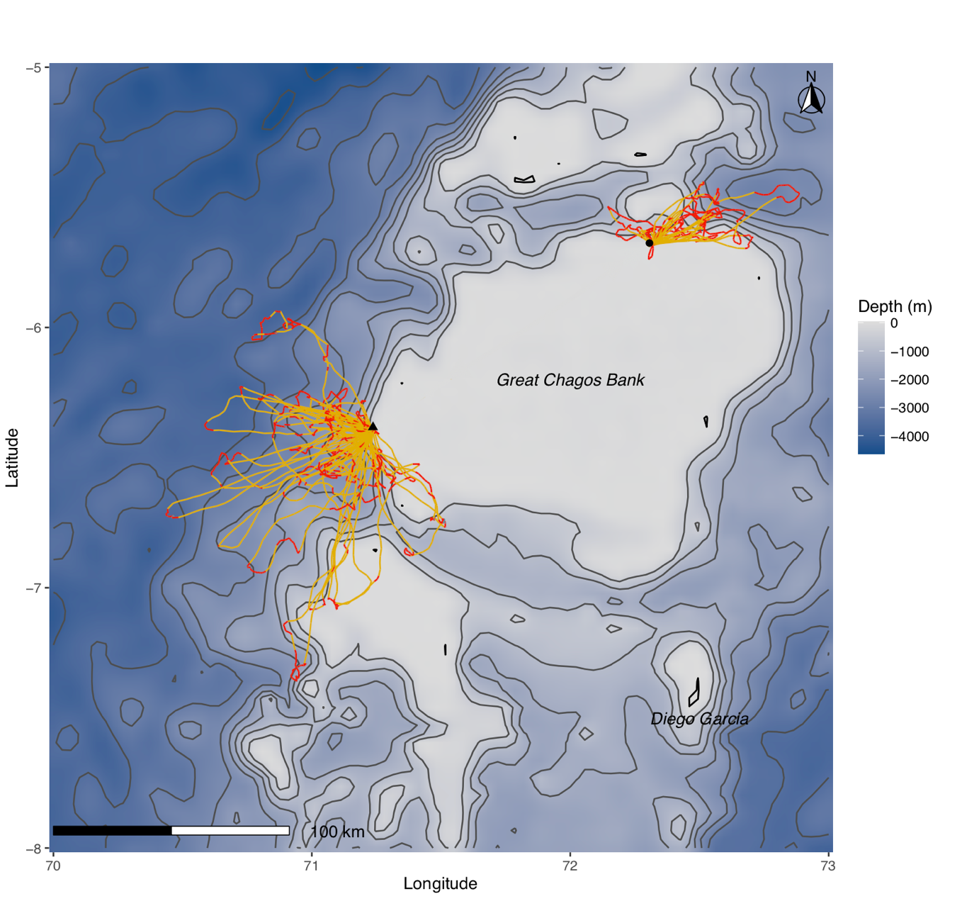

Fig. S7. Tracks from both colonies deconstructed by behaviour as identified by the HMM (foraging = red, transiting = yellow, resting = blue) with bathymetric data overlaid onto map. Black triangle and circle respectively indicate Danger Island and Nelson’s Island.

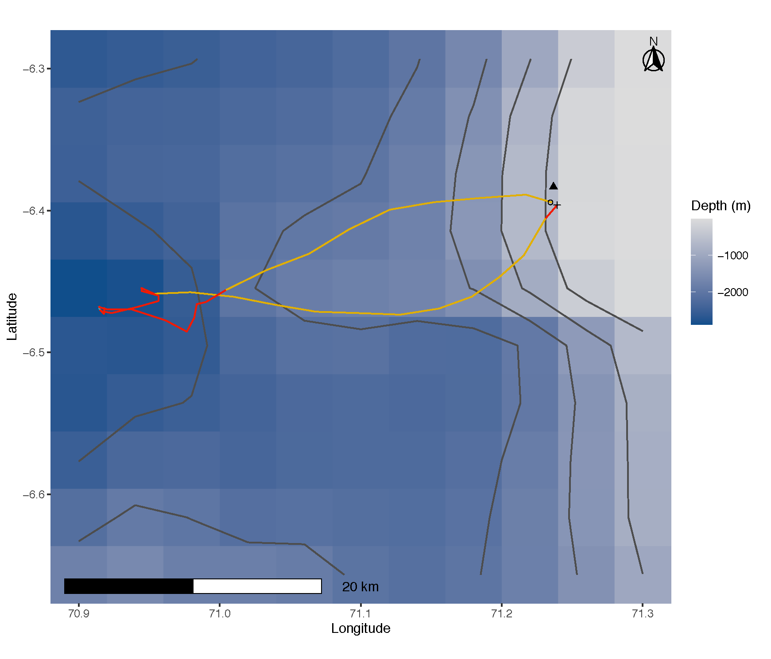
Figure S8. An example individual from Danger Island with behaviours highlighted as identified by the HMM (foraging = red, transiting = yellow, resting = blue) with bathymetric data overlaid onto map. Cross (+) indicates start of trip and circle (o) end of trip. Black triangle indicates location of Danger Island.

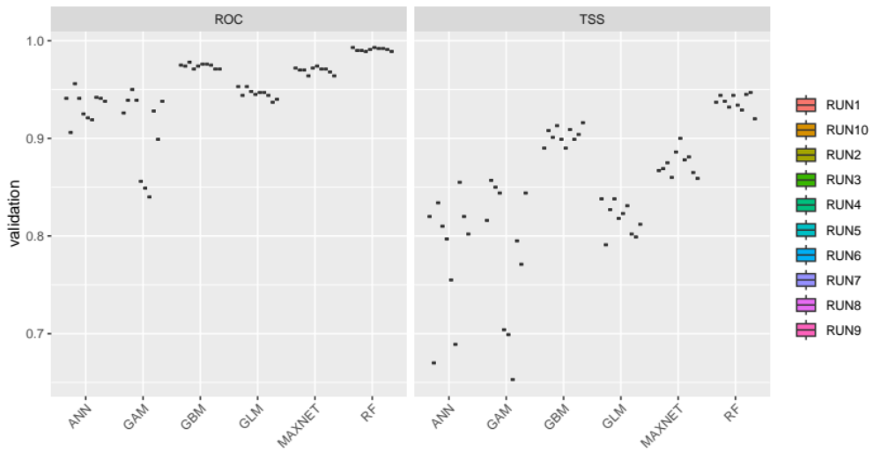
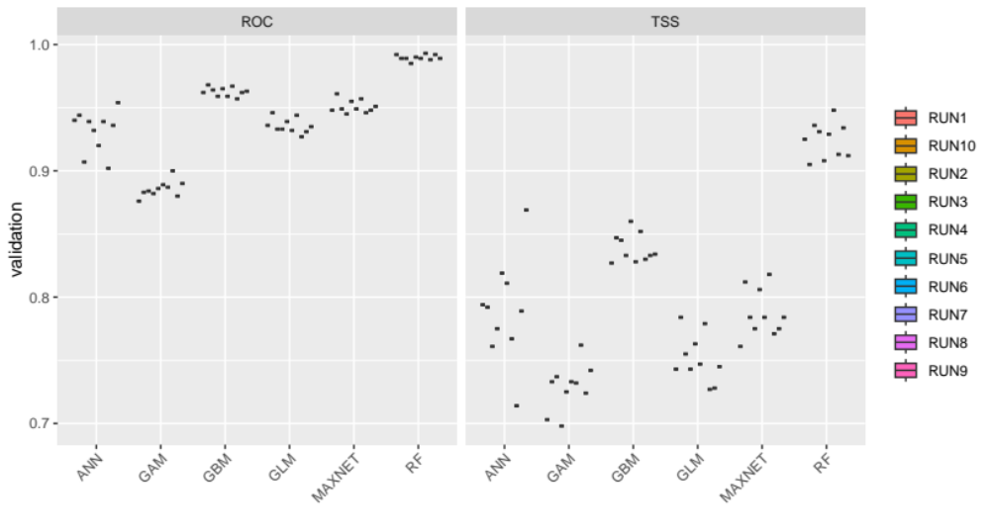
- Danger Island
- Nelson’s Island
Figure S9. Model performance for each component of ensemble models, for each run of the 10-fold spatially blocked validation, for models at Danger Island (top) and Nelson’s Island (bottom). Performance scores were high for both reciever operator curves (ROC, left) and true skills statistic (TSS, right), the latter of which was used to weight models in ensemble predictions.

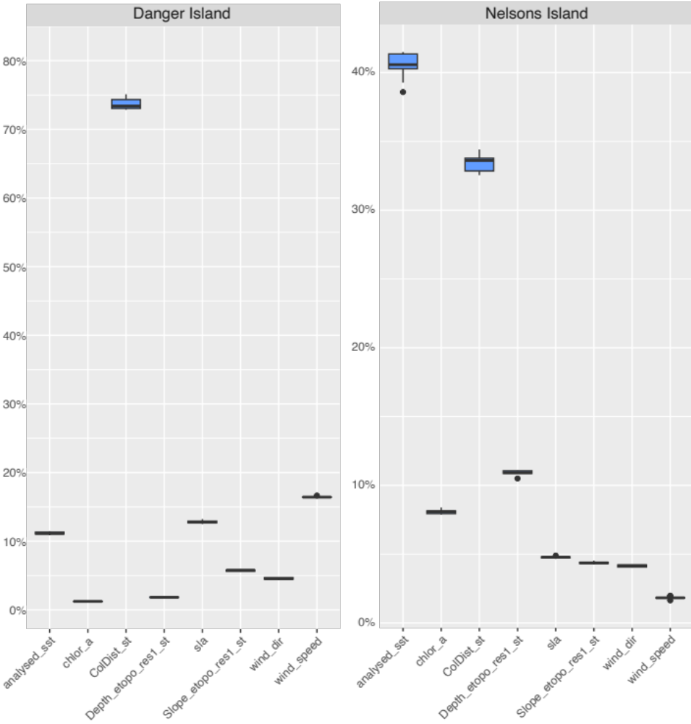
Figure S10. Variable importance based on ensemble predictions using the weighted sum of probabilities (EMwmeanByTSS).

