Supplementary Information
Near-infrared light controlled self-healing ability of epoxy vitrimer nanocomposites containing bio-based curing agents and carbon nanotubes for corrosion protection

Table S1 Chemical composition of steel plate
Element | Fe | C | Cr | Si | Cu | As | Ni | Mn | Other metals
wt% | 99.523 | 0.169 | 0.053 | 0.039 | 0.051 | 0.013 | 0.016 | 0.106 | 0.030

Table S2 Formulation of epoxy/CNSL/CA vitrimer matrix.
R | Epoxy (g) | CA (g)
0 | 5.607 | 0
0.15 | 5.338 | 0.289
0.35 | 5.016 | 0.633
0.55 | 4.730 | 0.939
CNSL content is 7 wt% of epoxy for each formula.

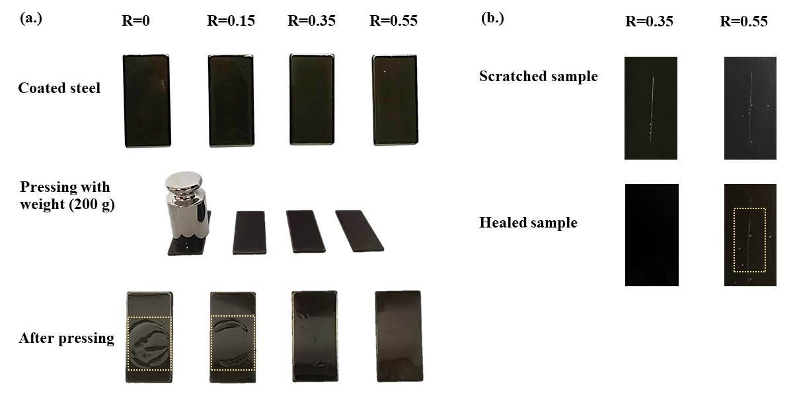
Figure S1 Coated steel with epoxy/CNSL/CA at various R ratios: (a) film forming ability and (b) self-healing ability.
Figure S1(a) shows the film forming ability of samples. It is clearly seen that epoxy/CNSL/CA at R= 0.35 and R= 0.55 exhibited good solid films without any wrinkle after removed the weight. The wrinkles on films were observed in epoxy/CNSL/CA at R= 0 and 0.5. It is due to insufficient curing agents for polymerization of solid films. Hence, the epoxy/CNSL/CA at R= 0.35 and R= 0.55 were conducted to test the self-healing ability as depicted in Figure S1(b). The coated steel samples were heated at 150 ºC for 5 min. The epoxy/CNSL/CA at R= 0.35 had a complete self-healing surface without any scratch whereas the sample with R= 0.55 showed the scratch on surface. Based on this primary results, it could be suggested that R= 0.35 was the suitable ratio for self-healing coating. Mo et al ^{[1]} observed the self-healing ability of epoxy vitrimer crosslinked polyimine. The self-healing ability of samples depended on two main factors i.e. amount of curing agents and degree of crosslink density. No self-healing behavior occurred, when high crosslink density was produced at amount of curing agent at 50% and 70%.

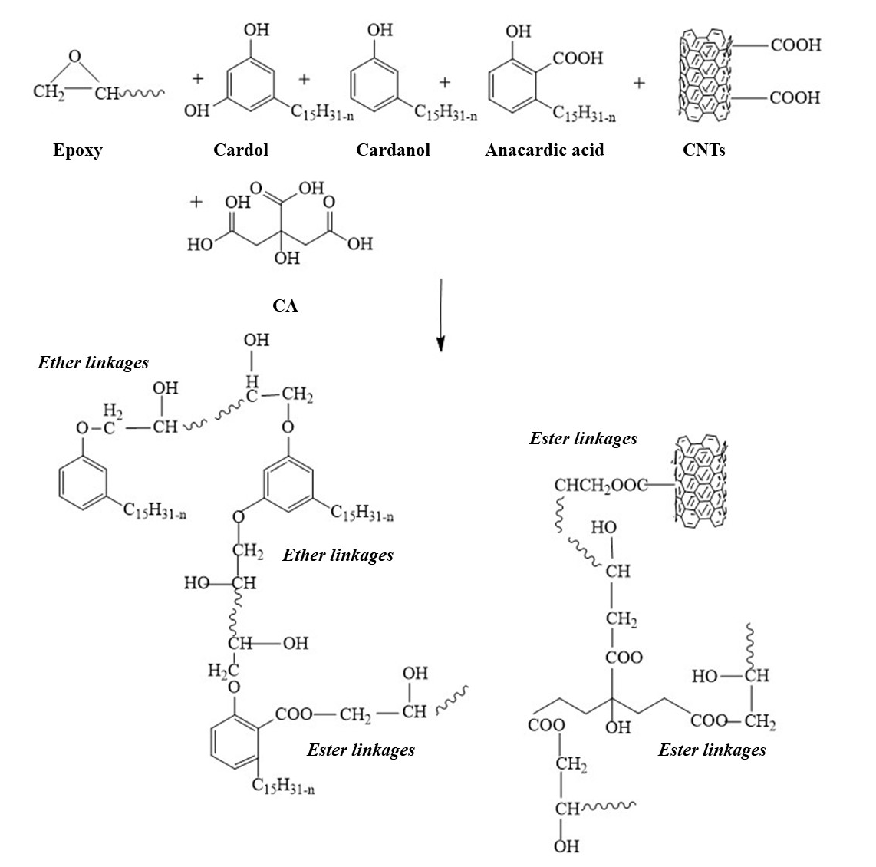
Scheme S1 Possible reactions between epoxy, CNSL, CA and CNTs.

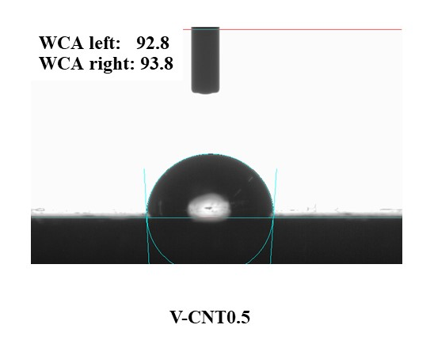
Figure S2 Water contact angles (WCA) of coated steels with V-CNT0.5.
The WCA of sample in Figure S2 was characterized using an optical contact angle meter (OCA 15EC) with 5 μL deionized water droplet at ambient temperature. The WCA values of coated steel with V-CNT0.5 was 93.8º. The WCA of 90–150° is considered as a hydrophobic surface ^{[2]}.

References
[1] R. Mo, J. Hu, H. Huang, X. Sheng, X. Zhang, J. Mater. Chem. A. 2019, 7, 3031.
[2] N. Lorwanishpaisarn, P. Kasemsiri, N. Srikhao, K. Jetsrisuparb, J.T.N. Knijnenburg, S. Hiziroglu, U. Pongsa, P. Chindaprasirt, Surf. Coatings Technol. 2019, 366, 106.

