SUPPLEMENTARY RESULTS

Benchmarking multi-omics integrative clustering methods for subtype identification in colorectal cancer
Zhang et al.

Supplementary Figures

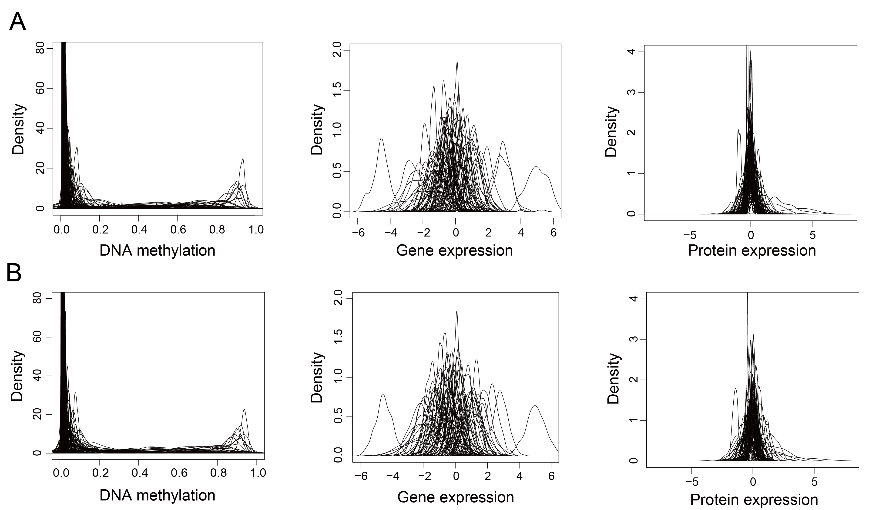

Fig. S1 Probability density distribution plot of 182 methylated sites, 81 genes, and 93 proteins. (A) original data. (B) simulated data ($δ$ = 0). We retained the $β$-values of DNA methylation data and scaled gene expression and protein expression data.

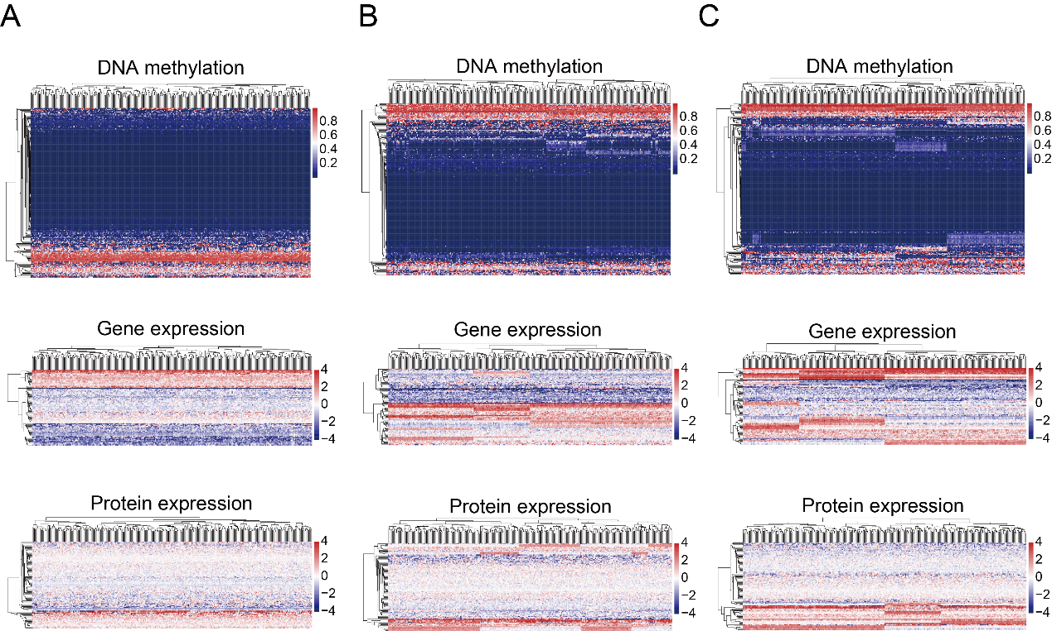
Fig. S2 Heatmap of simulated data in different shift among subgroups. (A) $δ$ = 0. (B) $δ$ = 2. (C) $δ$ = 2.5. Other simulated parameters are $n$ = 150, $k$ = 3, $p$ = 10%, $σ$ = 1, and $c$ = (0.2, 0.3, 0.5). We retained the $β$-values of DNA methylation data and scaled gene expression and protein expression data.

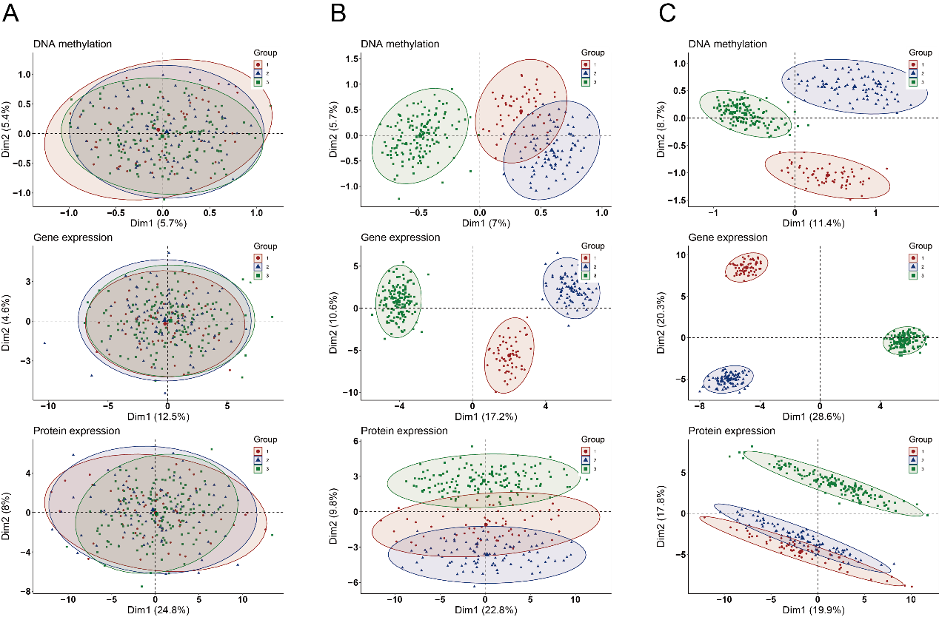
Fig. S3 PCA plots of simulated data in different shift among subgroups. (A) $δ$ = 0. (B) $δ$ = 2. (C) $δ$ = 2.5. Other simulated parameters are $n$ = 150, $k$ = 3, $p$ = 10%, $σ$ = 1, and $c$ = (0.2, 0.3, 0.5). We scaled all multi-omics data.

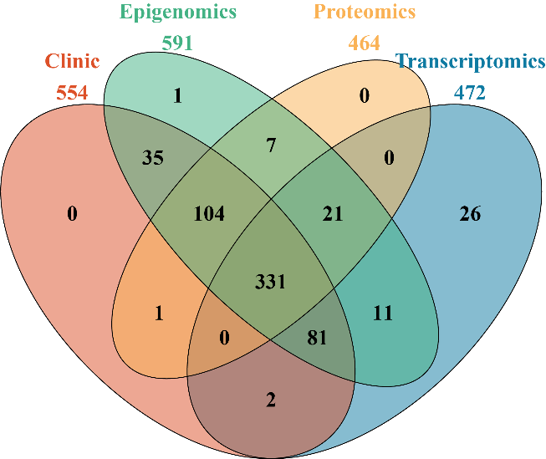
Fig. S4 Venn diagram of colorectal cancer patients with epigenomics, transcriptomics, proteomics, and clinical data in TCGA, a total of 331 patients were included to conduct multi-omics integrative clustering analysis.

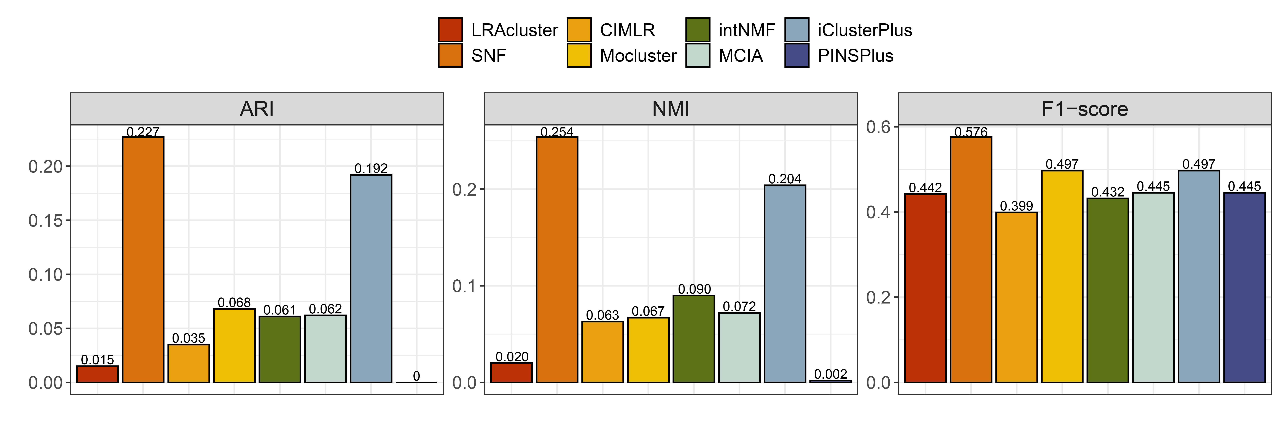
Fig. S5 Bar charts of the corresponding ARI, NMI, and F1-score between the clusters identified by each method and the CMS subgroups on preprocessed colorectal cancer multi-omics data, we take the optimal clustering number determined by each method as the number of integrative subtypes.

Fig. S6 t-SNE dimension-reduction plots in different multi-omics data of 5 SNF subgroups. The color and shape of points represents different SNF clusters.

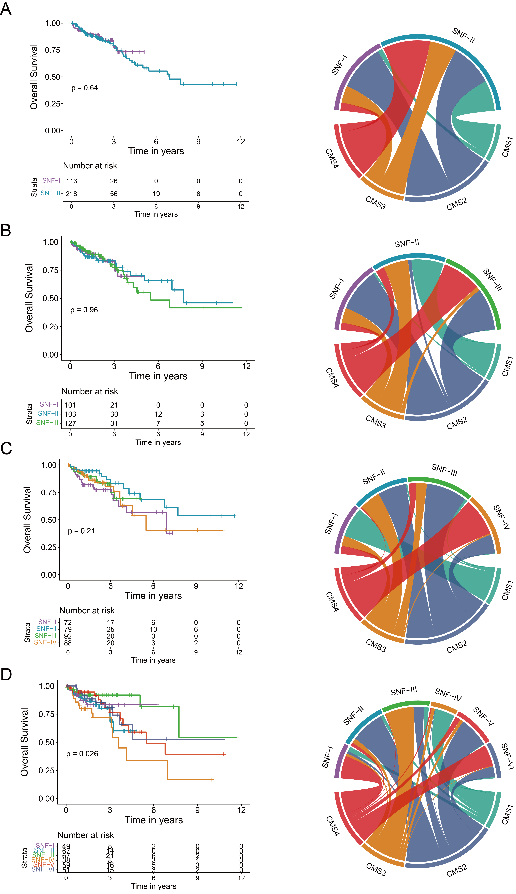
Fig. S7 The associations among SNF subtypes with various clustering numbers, overall survival, and CMS subtypes (A) $k$ = 2. (B) $k$ = 3. (C) $k$ = 4. (D) $k$ = 6.
Fig. S8 Upset plot of differentially expressed genes among SNF subgroups based on differential expression testing (log2 Fold change > 1.5 and FDR in edgeR < 0.05). The height of the vertical bars indicates the number of differentially expressed genes in this set overlap, as indicated by the colored dots and connecting lines in the bottom panel. The height of the horizontal bars indicates the total number of differentially expressed genes per set.

Supplementary Tables

Table. S1 The corresponding relationship and Pearson correlation coefficients between methylation sites and genes in simulated data.
Methylation sites | Genes | Correlation coefficients | Methylation sites | Genes | Correlation coefficients
cg20139214 | ACACA | -0.093 | cg14155397 | MAP2K1 | -0.027
cg23640701 | ACVRL1 | -0.018 | cg20484306 | MAP2K1 | -0.027
cg02956093 | AKT1 | 0.002 | cg11265916 | MAPK1 | -0.003
cg08711674 | AKT1S1 | -0.087 | cg21169285 | MAPK9 | 0.139
cg09842540 | AKT1S1 | -0.087 | cg20815063 | MRE11A | -0.009
cg11739626 | AKT1S1 | -0.087 | cg23759214 | MRE11A | -0.009
cg19073614 | AKT1S1 | -0.087 | cg15488251 | MYH11 | 0.017
cg01086868 | AR | -0.003 | cg17880199 | MYH11 | 0.017
cg04755662 | AR | -0.003 | cg07477160 | NDRG1 | 0.221
cg05019001 | AR | -0.003 | cg09102409 | NDRG1 | 0.221
cg05786601 | AR | -0.003 | cg13671831 | NF2 | 0.083
cg07780118 | AR | -0.003 | cg16293088 | NF2 | 0.083
cg12589433 | AR | -0.003 | cg16829154 | NOTCH1 | 0.111
cg14807303 | AR | -0.003 | cg20042228 | NOTCH1 | 0.111
cg16679837 | AR | -0.003 | cg17457560 | NRG1 | 0.052
cg20878850 | AR | -0.003 | cg19162158 | NRG1 | 0.052
cg21966410 | AR | -0.003 | cg02689825 | PCNA | 0.012
cg27271368 | AR | -0.003 | cg04562739 | PCNA | 0.012
cg01245656 | ASNS | -0.076 | cg25984124 | PCNA | 0.012
cg14785449 | ASNS | -0.076 | cg16385933 | PDCD4 | -0.041
cg01800843 | ATM | 0.121 | cg24371157 | PDCD4 | -0.041
cg03165700 | ATM | 0.121 | cg05702952 | PDK1 | -0.111
cg18457775 | ATM | 0.121 | cg17679246 | PDK1 | -0.111
cg22477592 | ATM | 0.121 | cg07566050 | PEA15 | -0.037
cg07588779 | BAD | -0.017 | cg18177682 | PEA15 | -0.037
cg13620770 | BAD | -0.017 | cg23641145 | PGR | -0.115
cg07679836 | BAK1 | 0.001 | cg02631906 | PRDX1 | 0.005
cg14666892 | BAK1 | 0.001 | cg21319693 | PRDX1 | 0.005
cg15951107 | BAX | 0.143 | cg24364574 | PREX1 | 0.027
cg16225441 | BECN1 | -0.043 | cg26206598 | PREX1 | 0.027
cg05566965 | BID | -0.100 | cg01228636 | PTEN | -0.030
cg12836863 | BRCA2 | 0.066 | cg04738091 | PTEN | -0.030
cg27253386 | BRCA2 | 0.066 | cg08859916 | PTEN | -0.030
cg01306510 | CDKN1A | -0.050 | cg16687447 | PTEN | -0.030
cg05759269 | CDKN1A | -0.050 | cg17489897 | PTEN | -0.030
cg08179530 | CDKN1A | -0.050 | cg20849549 | PTEN | -0.030
cg10936763 | CDKN1A | -0.050 | cg21573601 | PTEN | -0.030
cg21222430 | CDKN1A | -0.050 | cg16785344 | PXN | 0.099
cg01745510 | CDKN1B | -0.085 | cg17026456 | PXN | 0.099
cg04875709 | CDKN1B | -0.085 | cg24974130 | RAD50 | -0.140
cg00554702 | CHEK1 | 0.153 | cg04662451 | RAD51 | -0.079
cg03474731 | CHEK1 | 0.153 | cg21465754 | RAD51 | -0.079
cg01875775 | CHEK2 | -0.048 | cg05368942 | RBM15 | 0.002
cg16189954 | CHEK2 | -0.048 | cg25416363 | RBM15 | 0.002
cg22585269 | CHEK2 | -0.048 | cg02942159 | RPS6 | -0.170
cg01663570 | DVL3 | 0.121 | cg16925486 | RPS6 | -0.170
cg16142977 | EEF2 | 0.086 | cg01031251 | RPS6KA1 | 0.138
cg18064655 | EEF2 | 0.086 | cg19259146 | RPS6KA1 | 0.138
cg09186685 | EEF2K | -0.054 | cg00547829 | RPS6KB1 | 0.071
cg03860890 | EGFR | -0.056 | cg10444350 | SFRS1 | 0.056
cg14094960 | EGFR | -0.056 | cg24269276 | SFRS1 | 0.056
cg14972143 | EIF4E | -0.088 | cg00915289 | SHC1 | 0.111
cg04531710 | EIF4G1 | 0.087 | cg06418219 | SHC1 | 0.111
cg09875273 | ERBB2 | 0.153 | cg17891149 | SHC1 | 0.111
cg10394385 | ERBB2 | 0.153 | cg01803059 | SMAD1 | -0.050
cg11993754 | ERBB2 | 0.153 | cg06440646 | SMAD1 | -0.050
cg13263114 | ERBB2 | 0.153 | cg14556189 | SMAD3 | 0.177
cg16065186 | ERBB2 | 0.153 | cg10315128 | SMAD4 | -0.082
cg22778981 | ERBB2 | 0.153 | cg26909431 | SMAD4 | -0.082
cg23906291 | ERBB2 | 0.153 | cg18112163 | STAT3 | 0.057
cg24649641 | ERBB2 | 0.153 | cg20716209 | STAT3 | 0.057
cg26111030 | ERBB2 | 0.153 | cg14009312 | STK11 | 0.093
cg27005179 | ERBB2 | 0.153 | cg21547976 | STK11 | 0.093
cg03437318 | ERBB3 | 0.057 | cg04471507 | STMN1 | 0.101
cg19258882 | ERBB3 | 0.057 | cg06453691 | STMN1 | 0.101
cg03386722 | FASN | 0.075 | cg23323671 | STMN1 | 0.101
cg10692870 | FN1 | 0.071 | cg02608019 | SYK | 0.166
cg22511947 | FN1 | 0.071 | cg05801648 | SYK | 0.166
cg09976774 | FOXM1 | 0.160 | cg07160163 | SYK | 0.166
cg02060698 | FOXO3 | 0.072 | cg10025443 | SYK | 0.166
cg14310890 | FOXO3 | 0.072 | cg14304761 | SYK | 0.166
cg12536534 | G6PD | -0.168 | cg16896647 | SYK | 0.166
cg18780751 | G6PD | -0.168 | cg23447996 | SYK | 0.166
cg06023257 | GAB2 | 0.074 | cg06587969 | TP53 | 0.049
cg23109191 | GAB2 | 0.074 | cg15206330 | TP53 | 0.049
cg00241355 | GAPDH | 0.119 | cg22175811 | TP53 | 0.049
cg20917484 | GAPDH | 0.119 | cg04648087 | TSC1 | -0.049
cg06230736 | GATA3 | -0.062 | cg19393006 | TSC1 | -0.049
cg04497885 | GSK3A | -0.030 | cg02198582 | TSC2 | 0.022
cg18333807 | GSK3A | -0.030 | cg05243909 | TSC2 | 0.022
cg00929855 | HSPA1A | 0.064 | cg19837824 | TSC2 | 0.022
cg05920090 | HSPA1A | 0.064 | cg20253700 | TSC2 | 0.022
cg18424091 | HSPA1A | 0.064 | cg24078828 | WWTR1 | -0.046
cg25854162 | IGFBP2 | 0.079 | cg14013300 | XBP1 | -0.016
cg26187237 | IGFBP2 | 0.079 | cg18940763 | XBP1 | -0.016
cg11620807 | IRS1 | -0.030 | cg01880404 | XRCC1 | -0.032
cg09759260 | ITGA2 | -0.010 | cg15167433 | XRCC1 | -0.032
cg15676241 | ITGA2 | -0.010 | cg16579354 | XRCC5 | -0.087
cg14323109 | KDR | 0.055 | cg21404906 | XRCC5 | -0.087
cg01525376 | LCK | -0.085 | cg01442799 | YAP1 | 0.135
cg17078393 | LCK | -0.085 | cg26369667 | YAP1 | 0.135

Table. S2 The corresponding relationship and Pearson correlation coefficients between genes and proteins in simulated data.
Genes | Proteins |  | Correlation coefficients | Genes |  | Proteins | Correlation coefficients
ACACA | ACC_PS79 |  | 0.293 | STK11 |  | LKB1 | 0.176
ACACA | ACC1 |  | 0.292 | MAP2K1 |  | MEK1 | 0.372
ACVRL1 | ACVRL1 |  | 0.072 | MRE11A |  | MRE11 | -0.156
AKT1 | AKT_PS473 |  | 0.238 | MYH11 |  | MYH11 | -0.077
AR | AR |  | 0.301 | NDRG1 |  | NDRG1_PT346 | 0.358
ASNS | ASNS |  | 0.637 | NF2 |  | NF2 | -0.010
ATM | ATM |  | 0.107 | NOTCH1 |  | NOTCH1 | 0.243
BAD | BAD_PS112 |  | 0.190 | CDKN1A |  | P21 | 0.148
BAK1 | BAK |  | 0.145 | CDKN1B |  | P27 | 0.388
BAX | BAX |  | 0.123 | CDKN1B |  | P27_PT157 | -0.051
BECN1 | BECLIN |  | 0.089 | CDKN1B |  | P27_PT198 | 0.066
BID | BID |  | 0.183 | TP53 |  | P53 | 0.349
BRCA2 | BRCA2 |  | 0.318 | RPS6KB1 |  | P70S6K_PT389 | -0.028
ITGA2 | CD49B |  | 0.326 | RPS6KA1 |  | P90RSK | 0.298
CHEK1 | CHK1 |  | 0.078 | PXN |  | PAXILLIN | 0.039
CHEK1 | CHK1_PS345 |  | 0.211 | PCNA |  | PCNA | 0.374
CHEK2 | CHK2 |  | 0.447 | PDCD4 |  | PDCD4 | 0.285
CHEK2 | CHK2_PT68 |  | 0.326 | PDK1 |  | PDK1 | -0.138
DVL3 | DVL3 |  | 0.037 | PDK1 |  | PDK1_PS241 | -0.120
EEF2 | EEF2 |  | -0.068 | PEA15 |  | PEA15_PS116 | 0.158
EEF2K | EEF2K |  | 0.069 | PGR |  | PR | 0.081
EGFR | EGFR |  | 0.334 | AKT1S1 |  | PRAS40_PT246 | -0.172
EGFR | EGFR_PY1068 |  | 0.182 | PRDX1 |  | PRDX1 | 0.242
EGFR | EGFR_PY1173 |  | 0.086 | PREX1 |  | PREX1 | 0.349
EIF4E | EIF4E |  | 0.180 | PTEN |  | PTEN | 0.132
EIF4G1 | EIF4G |  | 0.002 | RAD50 |  | RAD50 | 0.215
MAPK1 | ERK2 |  | 0.456 | RAD51 |  | RAD51 | 0.459
FASN | FASN |  | 0.437 | RBM15 |  | RBM15 | 0.027
FN1 | FIBRONECTIN |  | 0.396 | RPS6 |  | S6 | 0.095
FOXM1 | FOXM1 |  | 0.291 | SFRS1 |  | SF2 | 0.041
FOXO3 | FOXO3A |  | 0.300 | SHC1 |  | SHC_PY317 | 0.243
G6PD | G6PD |  | 0.239 | SMAD1 |  | SMAD1 | 0.289
GAB2 | GAB2 | 0.281 |  | SMAD3 | SMAD3 |  |  | 0.128
GAPDH | GAPDH | 0.442 |  | SMAD4 | SMAD4 |  |  | 0.310
GATA3 | GATA3 | -0.215 |  | STAT3 | STAT3_PY705 |  |  | 0.201
GSK3A | GSK3_PS9 | -0.174 |  | STMN1 | STATHMIN |  |  | 0.180
ERBB2 | HER2 | 0.203 |  | SYK | SYK |  |  | 0.304
ERBB2 | HER2_PY1248 | 0.549 |  | WWTR1 | TAZ |  |  | 0.199
ERBB3 | HER3 | 0.257 |  | TSC1 | TSC1 |  |  | 0.180
ERBB3 | HER3_PY1289 | 0.026 |  | TSC2 | TUBERIN |  |  | 0.037
NRG1 | HEREGULIN | -0.018 |  | TSC2 | TUBERIN_PT1462 |  |  | 0.034
HSPA1A | HSP70 | 0.086 |  | KDR | VEGFR2 |  |  | 0.042
IGFBP2 | IGFBP2 | 0.622 |  | XBP1 | XBP1 |  |  | 0.051
IRS1 | IRS1 | 0.371 |  | XRCC1 | XRCC1 |  |  | 0.030
MAPK9 | JNK2 | 0.373 |  | YAP1 | YAP |  |  | 0.084
XRCC5 | KU80 | 0.190 |  | YAP1 | YAP_PS127 |  |  | 0.361
LCK | LCK | 0.540

Table. S3 The results of classification accuracy results of multi-omics integrative clustering methods with different sample sizes.
Index | Sample size | LRAcluster | SNF | CIMLR | Mocluster | intNMF | MCIA | iClusterPlus | PINSPlus
ARI | 50 | 1.000 | 1.000 | 0.677 | 0.994 | 0.628 | 1.000 | 0.985 | 0.617
ARI | 100 | 1.000 | 1.000 | 0.931 | 0.998 | 0.542 | 1.000 | 0.963 | 0.532
ARI | 150 | 1.000 | 1.000 | 0.990 | 1.000 | 0.586 | 1.000 | 0.969 | 0.531
ARI | 200 | 1.000 | 1.000 | 0.999 | 1.000 | 0.555 | 1.000 | 0.953 | 0.535
ARI | 250 | 1.000 | 1.000 | 0.999 | 0.986 | 0.548 | 1.000 | 0.982 | 0.582
ARI | 300 | 1.000 | 1.000 | 1.000 | 1.000 | 0.554 | 1.000 | 0.944 | 0.541
ARI | 350 | 1.000 | 1.000 | 1.000 | 1.000 | 0.542 | 1.000 | 0.939 | 0.545
ARI | 400 | 1.000 | 1.000 | 1.000 | 1.000 | 0.557 | 1.000 | 0.923 | 0.575
ARI | 450 | 1.000 | 1.000 | 1.000 | 1.000 | 0.544 | 1.000 | 0.923 | 0.524
ARI | 500 | 1.000 | 1.000 | 1.000 | 1.000 | 0.539 | 1.000 | 0.893 | 0.521
NMI | 50 | 1.000 | 1.000 | 0.727 | 0.993 | 0.637 | 1.000 | 0.987 | 0.687
NMI | 100 | 1.000 | 1.000 | 0.941 | 0.997 | 0.551 | 1.000 | 0.968 | 0.617
NMI | 150 | 1.000 | 1.000 | 0.989 | 1.000 | 0.573 | 1.000 | 0.977 | 0.625
NMI | 200 | 1.000 | 1.000 | 0.997 | 1.000 | 0.548 | 1.000 | 0.958 | 0.623
NMI | 250 | 1.000 | 1.000 | 0.998 | 0.990 | 0.541 | 1.000 | 0.977 | 0.647
NMI | 300 | 1.000 | 1.000 | 0.999 | 1.000 | 0.540 | 1.000 | 0.945 | 0.621
NMI | 350 | 1.000 | 1.000 | 0.999 | 1.000 | 0.536 | 1.000 | 0.947 | 0.633
NMI | 400 | 1.000 | 1.000 | 1.000 | 1.000 | 0.546 | 1.000 | 0.939 | 0.644
NMI | 450 | 1.000 | 1.000 | 1.000 | 1.000 | 0.537 | 1.000 | 0.936 | 0.605
NMI | 500 | 1.000 | 1.000 | 1.000 | 1.000 | 0.535 | 1.000 | 0.907 | 0.602
F1-score | 50 | 1.000 | 1.000 | 0.843 | 0.998 | 0.802 | 1.000 | 0.991 | 0.812
F1-score | 100 | 1.000 | 1.000 | 0.967 | 0.999 | 0.741 | 1.000 | 0.982 | 0.758
F1-score | 150 | 1.000 | 1.000 | 0.996 | 1.000 | 0.758 | 1.000 | 0.985 | 0.768
F1-score | 200 | 1.000 | 1.000 | 1.000 | 1.000 | 0.743 | 1.000 | 0.974 | 0.765
F1-score | 250 | 1.000 | 1.000 | 1.000 | 0.993 | 0.735 | 1.000 | 0.986 | 0.784
F1-score | 300 | 1.000 | 1.000 | 1.000 | 1.000 | 0.745 | 1.000 | 0.965 | 0.764
F1-score | 350 | 1.000 | 1.000 | 1.000 | 1.000 | 0.728 | 1.000 | 0.969 | 0.769
F1-score | 400 | 1.000 | 1.000 | 1.000 | 1.000 | 0.737 | 1.000 | 0.956 | 0.794
F1-score | 450 | 1.000 | 1.000 | 1.000 | 1.000 | 0.723 | 1.000 | 0.956 | 0.759
F1-score | 500 | 1.000 | 1.000 | 1.000 | 1.000 | 0.728 | 1.000 | 0.940 | 0.758
Table. S4 The results of classification accuracy results of multi-omics integrative clustering methods with different numbers of subgroups.
Index | Number of  subgroups | LRAcluster | SNF | CIMLR | Mocluster | intNMF | MCIA | iClusterPlus | PINSPlus
ARI | 2 | 1.000 | 1.000 | 0.987 | 1.000 | 0.852 | 0.994 | 0.894 | 0.605
ARI | 3 | 1.000 | 1.000 | 0.993 | 1.000 | 0.573 | 1.000 | 0.983 | 0.583
ARI | 4 | 1.000 | 1.000 | 0.850 | 0.750 | 0.685 | 0.981 | 0.940 | 0.559
ARI | 5 | 0.995 | 1.000 | 0.825 | 0.684 | 0.669 | 0.934 | 0.936 | 0.528
ARI | 6 | 0.992 | 1.000 | 0.828 | 0.673 | 0.718 | 0.865 | 0.942 | 0.552
NMI | 2 | 1.000 | 1.000 | 0.979 | 1.000 | 0.833 | 0.993 | 0.890 | 0.655
NMI | 3 | 1.000 | 1.000 | 0.989 | 1.000 | 0.558 | 1.000 | 0.985 | 0.653
NMI | 4 | 1.000 | 1.000 | 0.894 | 0.818 | 0.679 | 0.983 | 0.956 | 0.615
NMI | 5 | 0.997 | 1.000 | 0.875 | 0.770 | 0.677 | 0.946 | 0.956 | 0.635
NMI | 6 | 0.995 | 1.000 | 0.884 | 0.765 | 0.726 | 0.901 | 0.967 | 0.641
F1-score | 2 | 1.000 | 1.000 | 0.997 | 1.000 | 0.948 | 0.998 | 0.958 | 0.871
F1-score | 3 | 1.000 | 1.000 | 0.997 | 1.000 | 0.753 | 1.000 | 0.993 | 0.784
F1-score | 4 | 1.000 | 1.000 | 0.915 | 0.854 | 0.796 | 0.989 | 0.965 | 0.722
F1-score | 5 | 0.996 | 1.000 | 0.885 | 0.782 | 0.767 | 0.952 | 0.959 | 0.679
F1-score | 6 | 0.994 | 1.000 | 0.879 | 0.754 | 0.785 | 0.899 | 0.961 | 0.684

Table. S5 The results of classification accuracy results of multi-omics integrative clustering methods with different shifts among subgroups.
Index | Shift among  subgroups | LRAcluster | SNF | CIMLR | Mocluster | intNMF | MCIA | iClusterPlus | PINSPlus
ARI | 0 | 0.001 | 0.001 | 0.001 | 0.000 | 0.000 | 0.001 | -0.004 | -0.001
ARI | 0.5 | 0.004 | 0.113 | 0.004 | 0.002 | 0.003 | 0.010 | 0.004 | 0.003
ARI | 1 | 0.574 | 0.998 | 0.022 | 0.680 | 0.022 | 0.581 | 0.483 | 0.404
ARI | 1.5 | 1.000 | 1.000 | 0.584 | 0.985 | 0.476 | 0.997 | 0.863 | 0.591
ARI | 2 | 1.000 | 1.000 | 0.985 | 1.000 | 0.569 | 1.000 | 0.950 | 0.530
ARI | 2.5 | 1.000 | 1.000 | 1.000 | 1.000 | 0.846 | 1.000 | 0.976 | 0.986
ARI | 3 | 1.000 | 1.000 | 1.000 | 1.000 | 1.000 | 1.000 | 1.000 | 1.000
NMI | 0 | 0.013 | 0.013 | 0.014 | 0.012 | 0.013 | 0.014 | 0.010 | 0.013
NMI | 0.5 | 0.016 | 0.123 | 0.016 | 0.015 | 0.015 | 0.023 | 0.018 | 0.020
NMI | 1 | 0.616 | 0.996 | 0.037 | 0.709 | 0.036 | 0.603 | 0.527 | 0.431
NMI | 1.5 | 1.000 | 1.000 | 0.637 | 0.986 | 0.466 | 0.995 | 0.890 | 0.650
NMI | 2 | 1.000 | 1.000 | 0.986 | 0.999 | 0.555 | 1.000 | 0.959 | 0.604
NMI | 2.5 | 1.000 | 1.000 | 1.000 | 1.000 | 0.838 | 1.000 | 0.980 | 0.989
NMI | 3 | 1.000 | 1.000 | 1.000 | 1.000 | 1.000 | 1.000 | 1.000 | 1.000
F1-score | 0 | 0.434 | 0.415 | 0.423 | 0.425 | 0.426 | 0.440 | 0.426 | 0.449
F1-score | 0.5 | 0.440 | 0.525 | 0.426 | 0.430 | 0.427 | 0.446 | 0.435 | 0.453
F1-score | 1 | 0.763 | 0.999 | 0.448 | 0.833 | 0.449 | 0.781 | 0.716 | 0.689
F1-score | 1.5 | 1.000 | 1.000 | 0.778 | 0.993 | 0.695 | 0.998 | 0.928 | 0.782
F1-score | 2 | 1.000 | 1.000 | 0.993 | 1.000 | 0.750 | 1.000 | 0.972 | 0.758
F1-score | 2.5 | 1.000 | 1.000 | 1.000 | 1.000 | 0.917 | 1.000 | 0.988 | 0.993
F1-score | 3 | 1.000 | 1.000 | 1.000 | 1.000 | 1.000 | 1.000 | 1.000 | 1.000

Table. S6 The results of classification accuracy results of multi-omics integrative clustering methods with different proportions of differentially expressed variables.
Index | Proportion of differentially  expressed variables | LRAcluster | SNF | CIMLR | Mocluster | intNMF | MCIA | iClusterPlus | PINSPlus
ARI | 1% | 0.246 | 0.631 | 0.023 | 0.512 | 0.020 | 0.269 | 0.033 | 0.177
ARI | 5% | 0.999 | 1.000 | 0.634 | 1.000 | 0.470 | 0.986 | 0.744 | 0.570
ARI | 10% | 1.000 | 1.000 | 0.998 | 0.997 | 0.576 | 1.000 | 0.957 | 0.598
ARI | 15% | 1.000 | 1.000 | 0.999 | 0.986 | 0.656 | 1.000 | 0.995 | 0.793
ARI | 20% | 1.000 | 1.000 | 1.000 | 0.967 | 0.775 | 1.000 | 1.000 | 0.982
ARI | 25% | 1.000 | 1.000 | 1.000 | 0.972 | 0.952 | 1.000 | 1.000 | 1.000
NMI | 1% | 0.292 | 0.636 | 0.038 | 0.550 | 0.032 | 0.298 | 0.049 | 0.201
NMI | 5% | 0.999 | 1.000 | 0.675 | 1.000 | 0.472 | 0.984 | 0.778 | 0.627
NMI | 10% | 1.000 | 1.000 | 0.996 | 0.995 | 0.572 | 1.000 | 0.965 | 0.668
NMI | 15% | 1.000 | 1.000 | 0.999 | 0.988 | 0.646 | 1.000 | 0.993 | 0.829
NMI | 20% | 1.000 | 1.000 | 1.000 | 0.974 | 0.766 | 1.000 | 1.000 | 0.980
NMI | 25% | 1.000 | 1.000 | 1.000 | 0.975 | 0.947 | 1.000 | 1.000 | 1.000
F1-score | 1% | 0.582 | 0.808 | 0.440 | 0.744 | 0.443 | 0.613 | 0.454 | 0.569
F1-score | 5% | 1.000 | 1.000 | 0.814 | 1.000 | 0.700 | 0.993 | 0.857 | 0.766
F1-score | 10% | 1.000 | 1.000 | 0.999 | 0.998 | 0.758 | 1.000 | 0.976 | 0.798
F1-score | 15% | 1.000 | 1.000 | 1.000 | 0.993 | 0.808 | 1.000 | 0.995 | 0.897
F1-score | 20% | 1.000 | 1.000 | 1.000 | 0.984 | 0.873 | 1.000 | 1.000 | 0.990
F1-score | 25% | 1.000 | 1.000 | 1.000 | 0.987 | 0.975 | 1.000 | 1.000 | 1.000

Table. S7 The results of classification accuracy results of multi-omics integrative clustering methods with different noises.
Index | Noise | LRAcluster | SNF | CIMLR | Mocluster | intNMF | MCIA | iClusterPlus | PINSPlus
ARI | 0.5 | 1.000 | 1.000 | 1.000 | 1.000 | 0.998 | 1.000 | 1.000 | 0.953
ARI | 1 | 1.000 | 1.000 | 1.000 | 1.000 | 0.984 | 1.000 | 1.000 | 0.968
ARI | 2 | 0.904 | 1.000 | 0.976 | 0.959 | 0.828 | 0.917 | 1.000 | 0.489
ARI | 3 | 0.238 | 1.000 | 0.738 | 0.650 | 0.579 | 0.647 | 0.998 | 0.577
NMI | 0.5 | 1.000 | 1.000 | 0.999 | 1.000 | 0.997 | 1.000 | 1.000 | 0.952
NMI | 1 | 1.000 | 1.000 | 1.000 | 1.000 | 0.978 | 1.000 | 1.000 | 0.963
NMI | 2 | 0.920 | 1.000 | 0.966 | 0.962 | 0.801 | 0.921 | 1.000 | 0.604
NMI | 3 | 0.298 | 0.999 | 0.729 | 0.671 | 0.553 | 0.680 | 0.996 | 0.638
F1-score | 0.5 | 1.000 | 1.000 | 1.000 | 1.000 | 0.999 | 1.000 | 1.000 | 0.977
F1-score | 1 | 1.000 | 1.000 | 1.000 | 1.000 | 0.993 | 1.000 | 1.000 | 0.986
F1-score | 2 | 0.948 | 1.000 | 0.989 | 0.977 | 0.920 | 0.957 | 1.000 | 0.739
F1-score | 3 | 0.585 | 1.000 | 0.875 | 0.805 | 0.794 | 0.822 | 0.999 | 0.779

Table. S8 The results of classification accuracy results of multi-omics integrative clustering methods with different ratios of sample size among subgroups.
Index | Number of  Subgroups | Sample size  per subgroups | LRAcluster | SNF | CIMLR | Mocluster | intNMF | MCIA | iClusterPlus | PINSPlus
ARI | 3 | extreme imbalanced | 1.000 | 1.000 | 0.901 | 0.984 | 0.568 | 0.999 | 0.896 | 0.536
ARI | 3 | moderate imbalanced | 1.000 | 1.000 | 0.999 | 1.000 | 0.539 | 1.000 | 0.933 | 0.520
ARI | 3 | balanced | 1.000 | 1.000 | 0.999 | 1.000 | 0.570 | 1.000 | 0.938 | 0.678
ARI | 4 | extreme imbalanced | 0.966 | 1.000 | 0.664 | 0.630 | 0.542 | 0.971 | 0.852 | 0.483
ARI | 4 | moderate imbalanced | 1.000 | 1.000 | 0.930 | 0.839 | 0.734 | 0.995 | 0.959 | 0.554
ARI | 4 | balanced | 1.000 | 1.000 | 0.987 | 0.998 | 0.637 | 0.986 | 0.940 | 0.616
NMI | 3 | extreme imbalanced | 1.000 | 1.000 | 0.910 | 0.985 | 0.532 | 0.998 | 0.908 | 0.587
NMI | 3 | moderate imbalanced | 1.000 | 1.000 | 0.997 | 0.999 | 0.544 | 1.000 | 0.946 | 0.613
NMI | 3 | balanced | 1.000 | 1.000 | 0.998 | 1.000 | 0.597 | 1.000 | 0.945 | 0.719
NMI | 4 | extreme imbalanced | 0.976 | 1.000 | 0.760 | 0.722 | 0.555 | 0.975 | 0.891 | 0.562
NMI | 4 | moderate imbalanced | 1.000 | 1.000 | 0.940 | 0.869 | 0.717 | 0.992 | 0.967 | 0.637
NMI | 4 | balanced | 1.000 | 1.000 | 0.987 | 0.998 | 0.688 | 0.989 | 0.953 | 0.701
F1-score | 3 | extreme imbalanced | 1.000 | 1.000 | 0.947 | 0.992 | 0.756 | 0.999 | 0.945 | 0.750
F1-score | 3 | moderate imbalanced | 1.000 | 1.000 | 0.999 | 1.000 | 0.735 | 1.000 | 0.965 | 0.758
F1-score | 3 | balanced | 1.000 | 1.000 | 1.000 | 1.000 | 0.782 | 1.000 | 0.969 | 0.867
F1-score | 4 | extreme imbalanced | 0.979 | 1.000 | 0.802 | 0.776 | 0.710 | 0.982 | 0.920 | 0.678
F1-score | 4 | moderate imbalanced | 1.000 | 1.000 | 0.957 | 0.892 | 0.825 | 0.996 | 0.973 | 0.732
F1-score | 4 | balanced | 1.000 | 1.000 | 0.994 | 0.999 | 0.790 | 0.994 | 0.964 | 0.808

Table. S9 Characteristics of colorectal cancer patients from TCGA.
Characteristics | Sample Information Statistics
Cancer types, n(%)
COAD | 277 (83.7)
READ | 54 (16.3)
Age, years | 66.56 (12.56)
Sex, n(%)
Female | 159 (48.0)
Male | 172 (52.0)
Stage, n(%)
Stage I | 57 (17.2)
Stage II | 130 (39.3)
Stage III | 97 (29.3)
Stage IV | 47 (14.2)
CMS subgroups, n(%)
CMS1 | 52 (15.7)
CMS2 | 132 (39.9)
CMS3 | 65 (19.6)
CMS4 | 82 (24.8)
SNF clusters, n(%)
SNF-I | 70 (21.1)
SNF-II | 72 (21.8)
SNF-III | 71 (21.5)
SNF-IV | 66 (19.9)
SNF-V | 52 (15.7)
Data are mean (sd), or n (%)
Abbreviations: COAD, colon adenocarcinoma; READ, rectal adenocarcinoma; SNF, similarity network fusion; CMS, consensus molecular subtypes.

Table. S10 Univariate and multivariable Cox analysis for overall survival of SNF and CMS subgroups.
Subgroup | Variable | Univariate Analysis |  |  | Multivariate Analysis
Subgroup | Variable | HR (95% CI) | P value |  | HR (95% CI) | P value
SNF | SNF-V | Reference | - |  | Reference | -
SNF | SNF-I | 0.49 (0.24-0.98) | 0.044 |  | 0.40 (0.20-0.82) | 0.013
SNF | SNF-II | 0.39 (0.19-0.80) | 0.010 |  | 0.30 (0.15-0.63) | 0.001
SNF | SNF-III | 0.27 (0.12-0.60) | 0.001 |  | 0.35 (0.16-0.79) | 0.012
SNF | SNF-IV | 0.39 (0.17-0.87) | 0.021 |  | 0.33 (0.14-0.74) | 0.007
CMS | CMS4 | Reference | - |  | Reference | -
CMS | CMS1 | 1.21 (0.59-2.45) | 0.603 |  | 1.30 (0.61-2.77) | 0.503
CMS | CMS2 | 0.95 (0.52-1.76) | 0.874 |  | 1.00 (0.54-1.85) | 0.992
CMS | CMS3 | 0.35 (0.14-0.85) | 0.020 |  | 0.53 (0.21-1.31) | 0.170
Multivariable Cox models were adjusted age and pathological stages based on univariate Cox models. Abbreviations: HR, hazard ratio; CI, confidence interval; SNF, similarity network fusion; CMS, consensus molecular subtypes.

