Figure S1: Experimental study flow chart
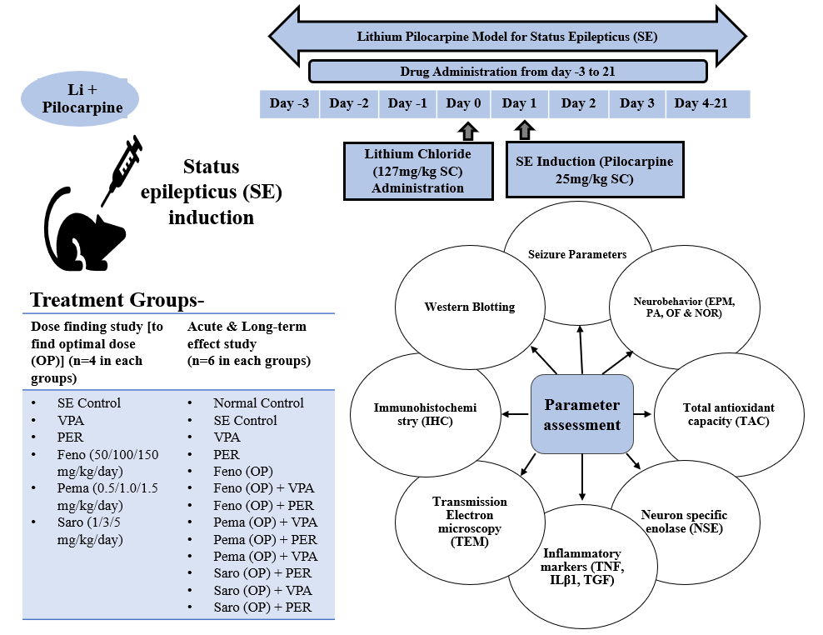
Table S1: Dose, route, and strength of stock solutions of drugs administered to the rats
S. No. | Drugs (API) | Dose & Route | Stock Solution Strength | Vehicle Used
1 | Lithium chloride | 127 mg/kg, SC | 127 mg/ml | Normal saline
2 | Pilocarpine HCl | 25 mg/kg, SC | 25 mg/ml | Normal saline
3 | Glycopyrrolate | 0.02 mg/kg, SC | 0.02 mg/ml | Normal saline
4 | Lorazepam | 10 mg/kg, IP | 2 mg/ml | -
5 | Valproate (VPA) | 370 mg/kg, Oral | 185 mg/ml | 10% DMSO
6 | Perampanel (PER) | 2 mg/kg, Oral | 1 mg/kg | 10% DMSO
7 | Fenofibrate (Feno) | 50 mg/kg, Oral | 50 mg/ml | 10% DMSO
8 | Fenofibrate (Feno) | 100 mg/kg, Oral | 50 mg/ml | 10% DMSO
9 | Fenofibrate (Feno) | 200 mg/kg, Oral | 50 mg/ml | 10% DMSO
10 | Pemafibrate (Pema) | 0.5 mg/kg, Oral | 0.5 mg/ml | 10% DMSO
11 | Pemafibrate (Pema) | 1.0 mg/kg, Oral | 0.5 mg/ml | 10% DMSO
12 | Pemafibrate (Pema) | 1.5 mg/kg, Oral | 0.5 mg/ml | 10% DMSO
13 | Saroglitazar (Saro) | 1.0 mg/kg, Oral | 1 mg/ml | 10% DMSO
14 | Saroglitazar (Saro) | 3.0 mg/kg, Oral | 1 mg/ml | 10% DMSO
15 | Saroglitazar (Saro) | 5.0 mg/kg, Oral | 1 mg/ml | 10% DMSO

Table S2: Effect of PPAR-m and ASMs on seizure parameters in the SE model
S. No. | Groups | Parameters
S. No. | Groups | Latency to stage-3/4 seizure (min) [mean±SD] | No. of stage 3-4 seizure [median (range)] |  | % with stage 3-4 seizure (no. of rats)
S. No. | Groups | Latency to stage-3/4 seizure (min) [mean±SD] | Day 1 to 3 | Day 4 to 21 | Day 1 to 3 | Day 4 to 21
1 | SE control | 54.3±17.6 | 9.5 (8-14) | 4 (3-6) | 100% (6/6) | 100% (4/4)
2 | VPA | 152.5±35.1* | 1.5 (0-4) * | 0 (0-0) * | 50% (3/6) | 0% (0/4)
3 | PER | 175.7±10.6* | 0 (0-3) * | 0 (0-0) * | 16.6% (1/6) | 0% (0/6)
4 | Feno | 149.5±37.1* | 2 (0-5) * | 0 (0-4) | 33.3% (2/6) | 40% (2/5)
5 | Feno+VPA | 174.3±13.9* | 0 (0-3) * | 0 (0-1) * | 16.6% (1/6) | 16.6% (1/6)
6 | Feno+PER | 180.0±0.0* | 0 (0-0) * | 0 (0-0) * | 0% (0/6) | 0% (0/6)
7 | Pema | 157.5±24.7* | 2 (0-5) * | 0 (0-2) | 50.0% (3/6) | 25% (1/4)
8 | Pema+VPA | 157.8±28.5* | 1 (0-3) * | 0 (0-1) * | 50.0% (3/6) | 20% (1/5)
9 | Pema+PER | 180.0±0.0* | 0 (0-0) * | 0 (0-0) * | 0% (0/6) | 0% (0/6)
10 | Saro | 141.3±43.9* | 1.5 (0-5) * | 0 (0-2) | 50% (3/6) | 25% (1/4)
11 | Saro+VPA | 152.2±30.9* | 1 (0-3) * | 0 (0-1) * | 50% (3/6) | 20% (1/5)
12 | Saro+PER | 180.0±0.0* | 0 (0-0) * | 0 (0-0) * | 0% (0/6) | 0% (0/6)

Latency is presented as mean±SD, and numbers with stage 3-4 seizures are presented as median (range), statistical comparisons were carried out by using One-way ANOVA followed by Bonferroni’s post-hoc test, and Kruskal-Wallis test respectively. Symbol (*) denotes the significance compared to the SE control group.

Figure S2: Open field test (Time spent in the central area; peripheral area; immobility time)
Time spent in central & and peripheral areas, and immobility time are presented as mean±SD, statistical comparisons were carried out by using One-way ANOVA followed by Bonferroni’s post-hoc test. Symbol (*) denotes the significance compared to the SE control group, and Symbol (#) denotes the significance compared to the Valproate (VPA) group.

Table S3: Correlation of seizure severity with other investigational parameters (day 21)
Parameters |  | Pearson’s Correlation | p Value
Neurobehavior Parameters
1 | EPM | +0.536 | <0.001
2 | PA | - 0.603 | <0.001
3 | NOR | -0.278 | 0.064
4 | OF | -0.667 | <0.001
Inflammatory/Antioxidative Markers
1 | NSE | +0.294 | 0.043
2 | TNF-α | +0.380 | 0.010
3 | IL-β1 | +0.417 | 0.004
4 | TGF | -0.024 | 0.178
5 | TAC | -0.132 | 0.372

