Supplementary Data.
- Genetic Analyses
The genetic analyses were performed by given steps.
- Allele-Specific PCR
- Gel Electrophoresis
- Visualization of Gel
- Genotyping
Table 1. Allele-specific primer for CITED2 gene (rs375393125).
Gene | Exon | Forward Primer | Reverse Primer | Size
CITED 2 | 2 | GGGGGTAGGGGTGATGGT  GGGGTAGGGGTGATGGC | CGCCTTCAACGCCCTAAT | 254
FW: Forward wild primer, FM: Forward mutant primer, RC: Reverse common primer

- Allele-Specific PCR
The allele-specific PCR was performed for the amplification of the target SNP. The following optimized reaction mixture was used for allele-specific PCR.
Table.2.13. PCR reaction mixture for allele-specific primers.
Reagents | 1X | 50X
Green master mix | 10μl | 500μl
FW | 0.5μl | 25μl
FM | 0.5μl | 25μl
RC | 0.5μl | 25μl
Template DNA | 2μl | 100μl
Nuclease free water | 2μl | 100μl
Total volume | 15μl | 750μl
1X: Reaction mixture of PCR for one sample, 50X: Reaction mixture for fifty samples
- Thermal Cycle Conditions
The amplification of the CITED2 gene was processed through a Bio-Rad thermal cycler. The optimized conditions that were applied for proper amplification are given below.

Table.2.14. Thermal cycle conditions for allele-specific primers.
S.NO | Temperature | Time
1 | 94 ⁰C | 5 m
2 | 94 ⁰C | 30 s
3 | 59 ⁰C | 30 s
4 | 72 ⁰C | 45 s
Repeat from step 2 - 4 for 40 cycles
5 | 72 ⁰C | 5 m
6 | 4 ⁰C (Room Temperature) | Infinity
m: minute, s: second

- Gel Electrophoresis
The bands (amplified product) were visualized by the routine gel electrophoresis technique. The gel electrophoresis was carried out by taking 2.5% agarose gel. For that, 2.5gm agarose was mixed with 100ml of 1X TBE buffer in a 500 ml flask. The flask was shaken thoroughly to mix agarose properly and kept in a microwave-oven for 2 minutes to melt agarose. After a short time when the flask cooled down, 6ul visual-Ana were added. Then, mix it again thoroughly and pour it into the casting tray. The 15 teeth comb was arranged in the casting tray for the formation of the well. After solidification, the gel was transferred into electrophoresis assembly. The gel electrophoresis assembly was filled with fresh 1X TBE buffer until the cover agarose gel. The 100bp ladder was loaded into the first well then, the remaining wells were loaded with 15μl PCR product. The samples were run at 100v for 45 minutes.
- Visualization of Gel
The gel was taken out from assembly after 45min then kept in the gel documentation system (MoleQule-ON) for the visualization of bands under UV light. The gel image was captured for evaluation.
- Genotyping
All the samples were genotyped after the visualization of gels. The IDs were used for genotyping as T/T for homozygous (wild type) alleles, T/C for heterozygous alleles, and C/C for homozygous (mutant) alleles. Then, the collected data were analyzed through statistical software.
Statistical Analysis
The experimental data were interpreted through statistical software (SPSS and Excel) then chi-square and odd-ratio association tests were applied.

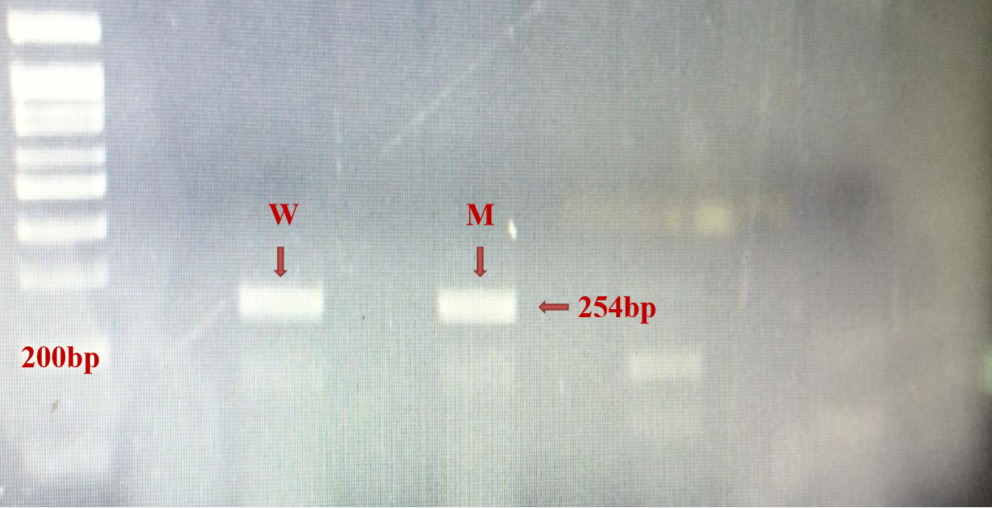
Figure 1. The primers were optimized through a series of variations in concentration and temperature. A molecular marker of 100 bp size was used to indicate to measure the actual size of the target DNA band product. An amplified wild-type allele (W) product and a mutant allele (M) with equal-sized bands measuring 254 bp are shown in the lower lane.

- Gel electrophoresis images.

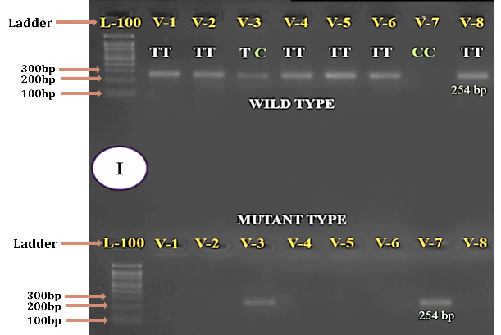
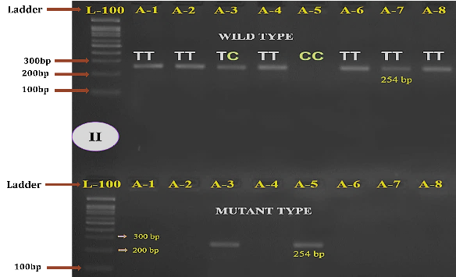
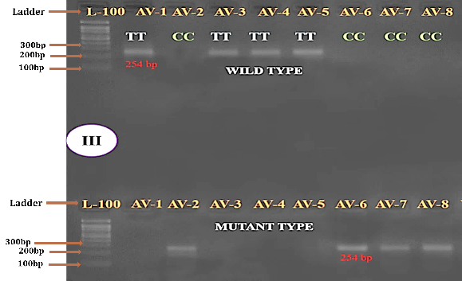

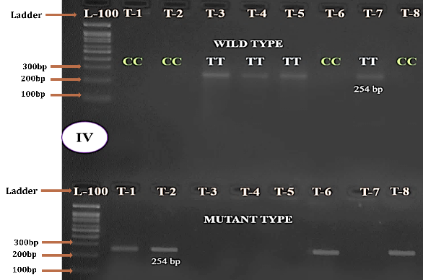
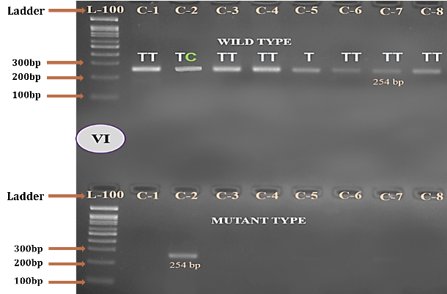
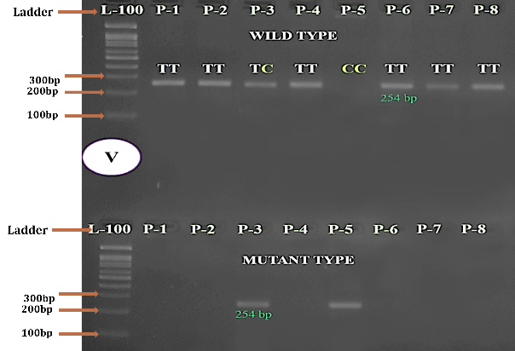
Figure 2. The CHD and control sample genotyping. Initials I: V=VSD, II: A=ASD, III: AV= AVSD, IV: T= TOP, V: P= PDA, and VI: C for controls stand for each form of CHD. L, which represents a size of 100 bp, was used to indicate the ladder marker. An amplified wild-type allele product is shown in the upper lane of the gel, whereas a mutant allele with equal-sized bands measuring 254 bp is shown in the lower lane.
- Ethical approval and consideration
- Approval Certificate of Ethical Review Committee (NICVD).
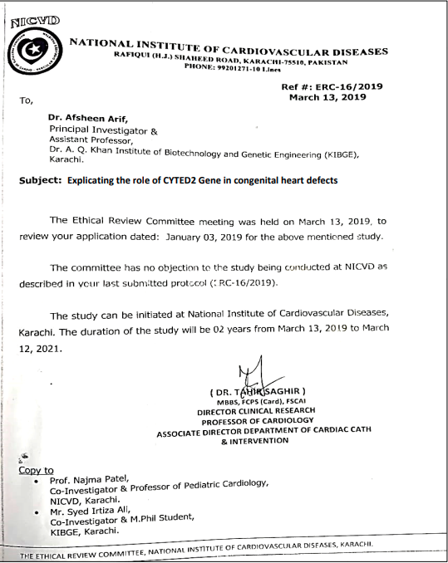

- Questionnaire used for Data Collection.
General Biodata
Date of Collection:
Sample ID:
OPD/Hospital ID:
Name:
Ethnicity:
Age:
Gender: | Male Female
Birthplace:
Address/Area:
Ph./Cell no:
Guardian Name:

Family History

Septal Defect Type
ASD
VSD
AVSD

Other:
Syndromic/Familial: Yes No
Surgery/Treatment:

Diagnosis/Symptoms
X-rays Chest Cardiac catheterization
Electrocardiogram (ECG) Cardiac murmur
Echocardiogram (echo)
Other findings:

Informed Consent:
I am donating my blood sample for research purpose only and not for commercial use.
میں اپناخون صرف تحقیقی مقاصد کے ليےعطيہ کر رہا / رہی ہوں۔

Signature/Thumb Impression:

- Statistical Analysis
Chi-square tables (Statistical analysis of data through chi-square test)
O | E | O-E | (O-E) ^2 | (O-E) ^2/E
39 | 39.1 | -0.142857143 | 0.020408163 | 0.00052
5 | 1.7 | 3.285714286 | 10.79591837 | 6.297619048
6 | 9.1 | -3.142857143 | 9.87755102 | 1.080357143
40 | 39.1 | 0.8571429 | 0.734693951 | 0.018769554
4 | 1.7 | 2.285714286 | 5.224489797 | 3.047619049
6 | 9.1 | -3.1428571 | 9.877551021 | 1.0803571
32 | 39.1 | -7.1428571 | 51.02040755 | 1.30344107
0 | 1.7 | -1.714285714 | 2.938775509 | 1.714285714
18 | 9.1 | 8.857142857 | 78.44897959 | 8.580357142
23 | 39.1 | -16.1428571 | 260.5918354 | 6.657455655
1 | 1.7 | -0.714285714 | 0.510204081 | 0.297619047
26 | 9.1 | 16.85714286 | 284.1632653 | 31.08035714
40 | 39.1 | 0.8571429 | 0.734693951 | 0.018769554
2 | 1.7 | 0.285714286 | 0.081632653 | 0.047619048
8 | 9.1 | -1.142857143 | 1.306122449 | 0.142857143
100 | 78.3 | 21.71428571 | 471.5102041 | 6.022940563
0 | 18.3 | -18.28571 | 334.3673469 | 18.28571
0 | 18.3 | -18.285 | 334.3673469 | 18.2857
Sum |  |  |  | 103.962374

Genotypic frequency of CHD types and controls
Diseases | TT | TC | CC | Total
VSD | 78 | 10 | 12 | 50
ASD | 80 | 8 | 12 | 50
AVSD | 64 | 0 | 36 | 50
TOF | 46 | 2 | 52 | 50
PDA | 80 | 4 | 16 | 50
Controls | 100 | 0 | 0 | 100
Total | 274 | 12 | 64 | 350

Observation of general factors
Samples | Gender |  | Consanguinity |  | Addiction
Samples | Male | Female | Yes | No | Yes | No
VSD | 28 | 22 | 27 | 23 | 15 | 35
ASD | 22 | 28 | 25 | 25 | 17 | 33
AVSD | 26 | 24 | 31 | 19 | 28 | 22
TOF | 36 | 14 | 38 | 12 | 6 | 44
PDA | 20 | 30 | 38 | 12 | 0 | 50
Control | 60 | 40 | 77 | 23 | 53 | 47

