Supplementary Information
High responsivity all-fiber-integrated perovskite photodetector based on FA_{0.4}MA_{0.6}PbI₃
Yuchen Zhang¹, Jie Liu², Chenghong Ma², Yanqi Fan², Yinping Miao^{1,*} and Xiaolan Li^{1,*}.
¹Tianjin Key Laboratory of Film Electronic and Communication Device, School of Integrated Circuit Science and Engineering, Tianjin University of Technology, Tianjin 300384, China.
²Key Laboratory of Quantum Optics and Intelligent Photonics, School of Science, Tianjin University of Technology, Tianjin 300384, China.
*Corresponding author E-mail addresses:
kikosi@126.com (Yinping Miao); lxl6788@163.com (Xiaolan Li).
- The define and details of $p_{3}$ , $κ_{4}$ , $p_{2}$ , and $κ_{1}$
In the slab waveguide model depicted in Fig. 3(a) of the manuscript, the equations governing the $E_{x}$ component field of the TE mode in different layers follow the following system of equations:
In air layer:
$\frac{d^{2}}{{dy}^{2}}E_{x}- p_{3}^{2}E_{X}=0$ (1)
$p_{3}=k_{0}\sqrt{N^{2}-n_{3}^{2}}$ (2)
$y>h_{1}+h_{2}+h_{4}$ (3)
In FA_{0.4}MA_{0.6}PbI₃ layer：
$\frac{d^{2}}{{dy}^{2}}E_{x}+ κ_{4}^{2}E_{X}=0$ (4)
$κ_{4}=k_{0}\sqrt{n_{4}^{2}-N^{2}}$ (5)
$h_{1}+h_{2}<y≤h_{1}+h_{2}+h_{4}$ (6)
In remaining cladding layer：
$\frac{d^{2}}{{dy}^{2}}E_{x}- p_{2}^{2}E_{X}=0$ (7)
$p_{2}=k_{0}\sqrt{N^{2}-n_{2}^{2}}$ (8)
$h_{1}<y≤h_{1}+h_{2}$ (9)

In core layer：
$\frac{d^{2}}{{dy}^{2}}E_{x}+ k_{1}^{2}E_{X}=0$ (10)
$κ_{1}=k_{0}\sqrt{n_{1}^{2}-N^{2}}$ (11)
$0<y≤h_{1}$ (12)

- The influence of 1nm deviation of $h_{4}$ to resonance intensity
As depicted in Fig. S1, we investigate the impact of incrementally adjusting $h_{4}$ by 1 nm, relative to the resonant thickness, on the intensity of the mode field within the active layer. The Deviation from the resonant thickness condition of $h_{4}$ results a rapid decrease in mode field intensity within the active layer. In Fig. S1 (g), the maximum resonant intensity corresponding to 649 nm and 650 nm is observed at the positions marked by the red dashed lines in Fig. S1 (e) and (f), respectively.
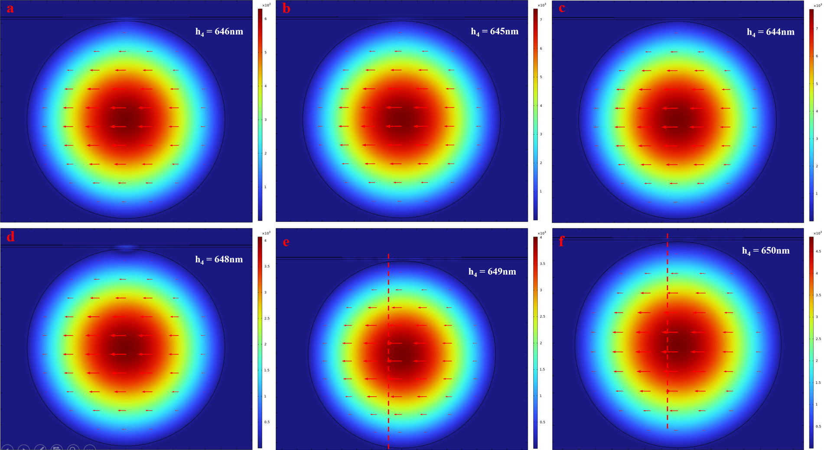
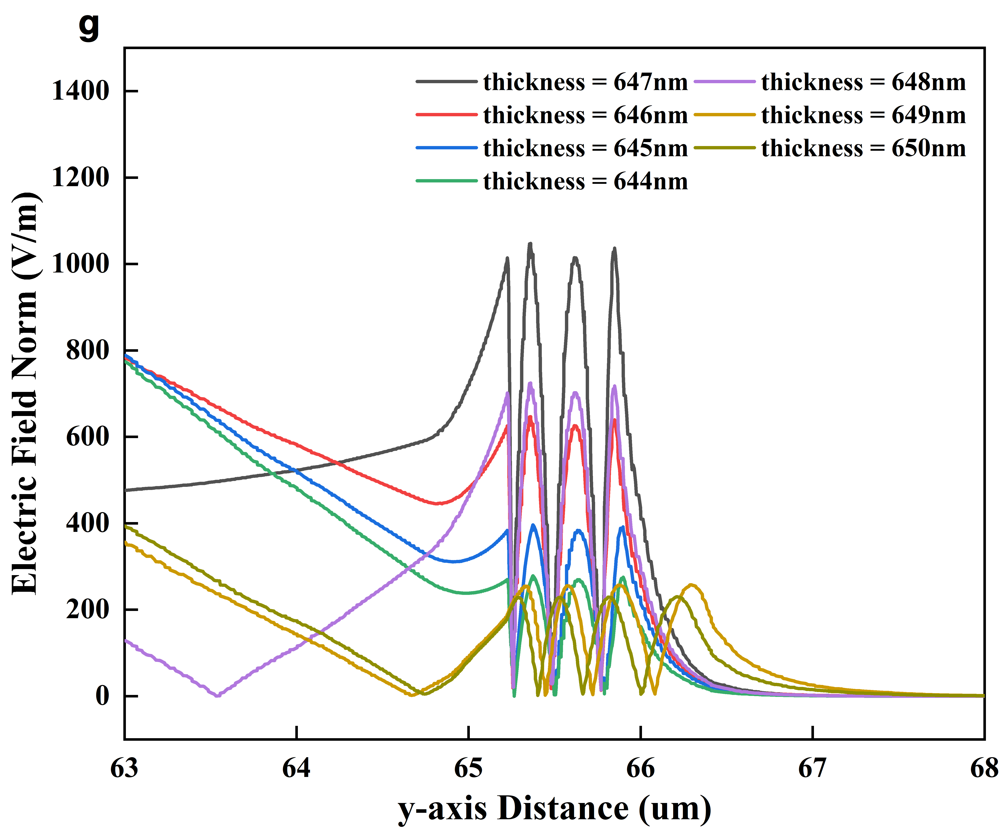
Fig. S1 Influence of the deviation of $h_{4}$ from the resonant thickness condition on the mode field intensity within the active layer.
As depicted in Fig. S2, simulation results suggest the correlation between the position of maximum resonance within the active layer and the presence of the Ag electrode. In Fig. S2 (a), in the absence of the Ag electrode, the mode field intensity peaks at the center of the active layer. However, in Fig. S2 (b), with the Ag electrode present, the maximum mode field intensity within the active layer exhibits a symmetric distribution along the central axis. The comparison of lateral distribution between the mode field within the active layer in Fig. S2 (a) and (b) implies that the Ag electrode effectively confines the mode field between two electrode fingers in the active layer. Furthermore, the maximum resonant intensity within the active layer is 208 V/m in Fig. S2 (a), whereas it increases to 240 V/m in Fig. S2 (b), indicating that the Ag electrode, as part of the waveguide structure, enhances the resonant intensity.
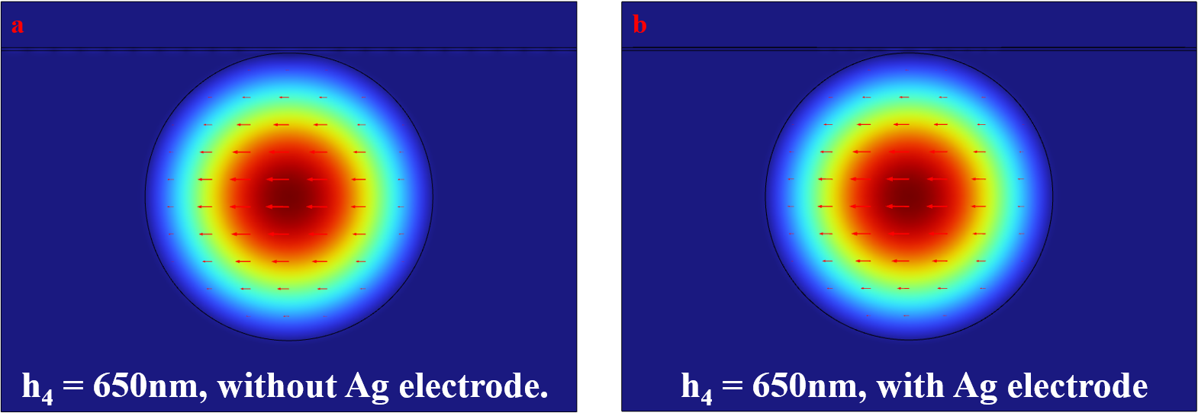
Fig. S2 Influence of Ag electrode on the distribution and intensity of mode field in the active layer
- Microscope images of the polished surface of SP-MMF
The microscope images of the polished surface of SP-MMF at different magnification are shown in Fig. S3. SP-MMF was prepared by unilaterally polishing MMF with a 3000-mesh grinding wheel. As shown in Fig. S3 (b), under a 250-magnification microscope, a rough surface of SP-MMF was observed, which leads to the increase of defects in the subsequent perovskite film prepared by blade-coating method. The roughness can be improved by utilizing chemical-mechanical polishing process, surface arc annealing and other methods.
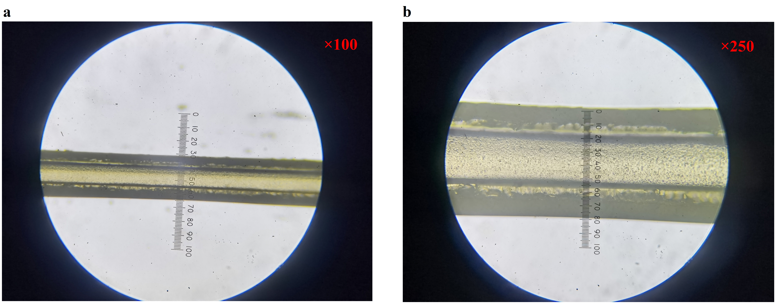
Fig. S3 Microscope images of the polished surface of SP-MMF.

