Supporting Informations
Table S1 Biochemical and physiological properties of Pseudoxanthomonas mexicana strain GTZY isolated from biological wastewater system
Parameter tests | Observations
Isolation source | Wastewater bioreactor
Gram stain | Gram negative
Motility test | Highly motile
Morphology | Small curved or rod shaped
O₂ requirement | Strictly aerobic
Optimum temperature | 34-37ºC
Colony morphology | Pale yellow color, circular, convex and mucoid
Optimum pH | 7-7.5
NaCl tolerance (%, w/v) | up to 8
H₂S production | Positive
Glucose fermentation | Positive
Sucrose fermentation | Negative
Lactose fermentation | Negative
Manitol fermentation | Positive
Gelatin hydrolysis | Positive
Casein hydrolysis | Positive
Tween 80 | Positive
Starch hydrolysis | Negative
Catalase enzyme | Positive
Oxidase test | Negative
Indole production | Negative
Nitrate reductase | Negative
Urease test | Negative
MR test | Positive
VP test | Negative

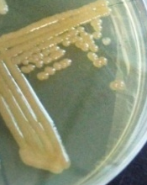

Fig. S1 The colony morphology of Pseudoxanthomonas mexicana GTZY grown overnight (37ºC) on the nutrient agar medium.


Fig. S2 The X-ray film was showed the mercury volatilization from Hg (II) to Hg (0) by the isolate, Pseudoxanthomonas mexicana GTZY (2). The foggy area (dark circle) represents the reaction between Hg (0) and Ag emulsion on the X-ray film (24h incubation at 35ºC). A similar solution mixture without bacterial cells (1) and bacterial suspension without HgCl₂ (2) were utilized as control and it shown no foggy area.
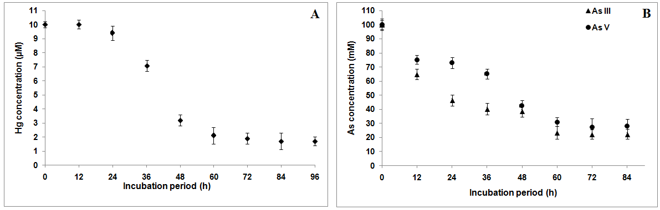
Fig. S3 Actual concentration of heavy metals during the incubation period with strain GTZY. A. Mercury (Hg) B. Arsenic (As)

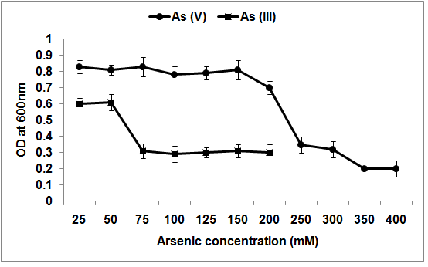
Fig. S4 The effect of different concentrations of Arsenic metals (As (V) and As (III)) on the microbial growth of isolate, P. mexicana strain GTZY.
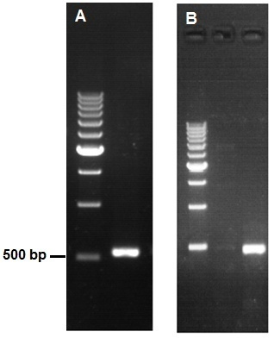
Fig. S5 1.2 % of agarose gel was showed the PCR amplification of partial merA (550 bp) (A) and arsC (495 bp) gene (B). In the lane 1, 500 bp sized DNA marker was used.

