Supplementary Information
Nanocomposite Hydrogels Enhanced by Cellulose Nanocrystals Stabilized Pickering Emulsions with Self-healing Performance in Subzero Environment
Qichao Fan,ª Bencai Lin,^{b} Yu Nie,ª Qing Sun,ª Wenxiang Wang,ª Liangjiu Bai,^{a,} * Hou Chen,^{a,} * Lixia Yang,ª Huawei Yang,ª Donglei Weiª
ª School of Chemistry and Materials Science, Ludong University; Key Laboratory of High Performance and Functional Polymer in the Universities of Shandong Province; Collaborative Innovation Center of Shandong Province for High Performance Fibers and Their Composites, Yantai 264025, China.
^{b} Changzhou University; Jiangsu Province Cultivation base for State Key Laboratory of Photovoltaic Science and Technology, Changzhou 213164, China.
*Corresponding authors E-mail: bailiangjiu@ldu.edu.cn (L. J. Bai), chenhou@ldu.edu.cn. (H. Chen)

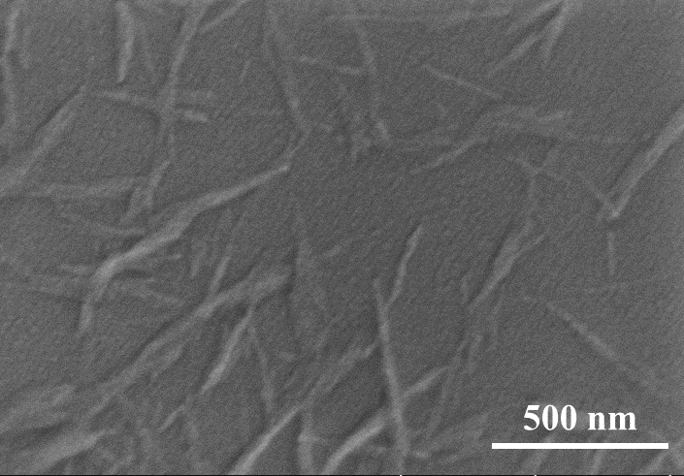
Fig. S1 SEM image of CNCs (accelerating voltage was 2.0 KV)

Fig. S2 FT-IR spectra of cellulose and CNCs

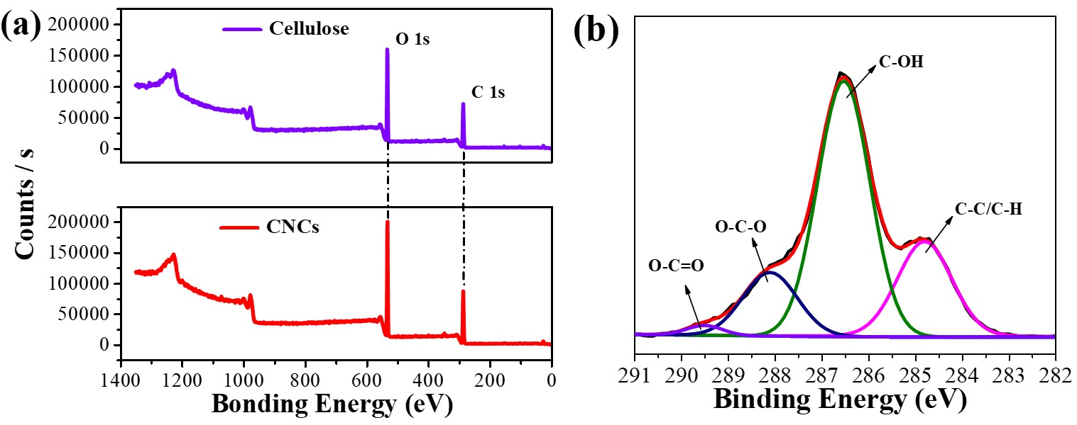
Fig. S3 (a) XPS wide scan of cellulose and CNCs. (b) C 1s of CNCs

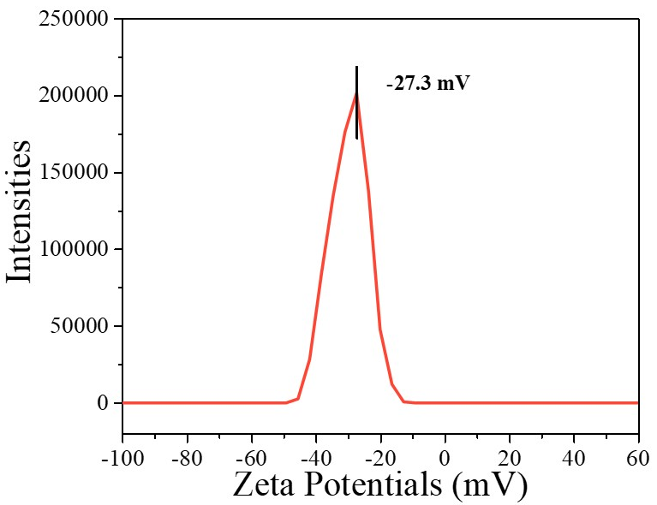
Fig. S4 Zeta potentials of CNCs

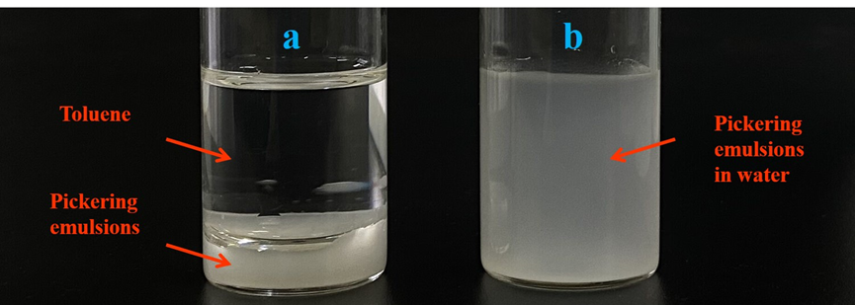
Fig. S5 Photographs of the Pickering emulsions were diluted ten times by (a) toluene and (b) water, respectively
To verify the types of emulsions, the fresh Pickering emulsions were diluted ten times by toluene and water, respectively. As shown in Fig S5, stratification was discovered with toluene, whereas Pickering emulsions were well dispersed in water. These results proved O/W emulsions with water as continuous phase and LO as dispersed phase.

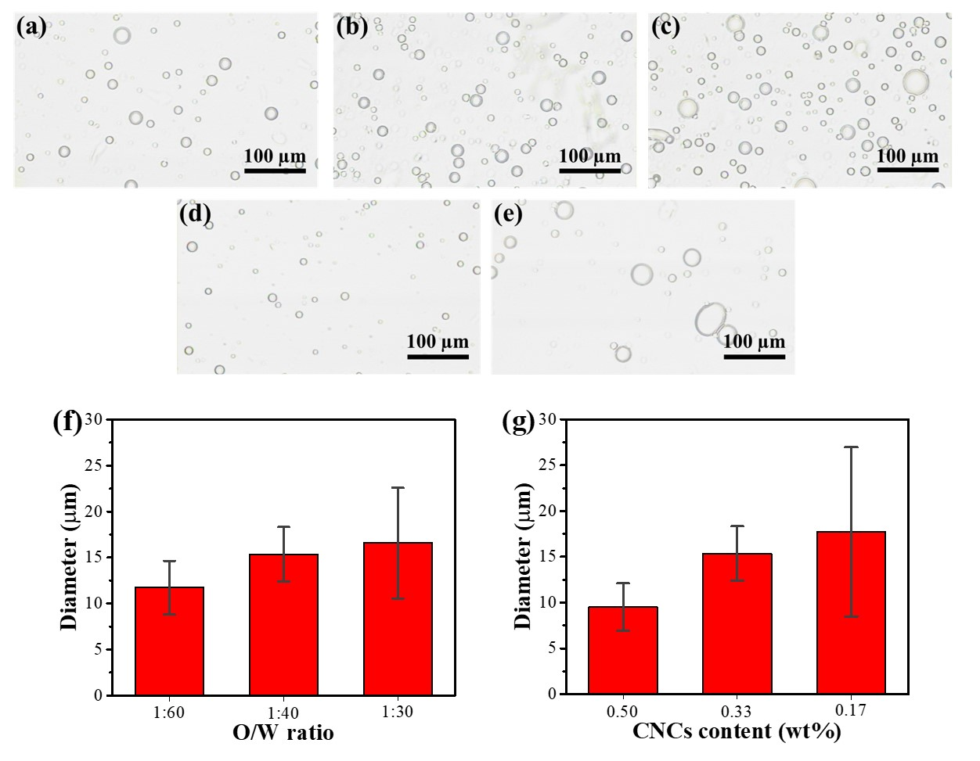
Fig. S6 Optical microscopy images of Pickering emulsions with (a) O/W = 1:60, 0.33 wt% CNCs; (b) O/W =1:40, 0.33 wt% CNCs; (c) O/W =1:30, 0.33 wt% CNCs; (d) O/W = 1:40, 0.50 wt% CNCs; (e) O/W = 1:40, 0.17 wt% CNCs. (f) The changes in the average oil droplet sizes effected by (e) O/W ratio and (g) CNCs content

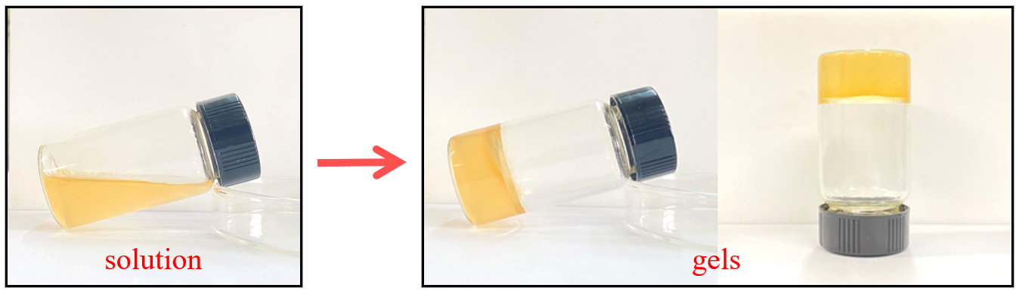
Fig. S7 The transformation from solution to gels during the preparation of hydrogels

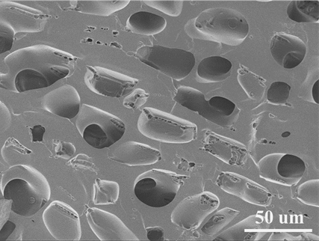
Fig. S8 SEM images of cross-sectional morphology of HG-P_{1.0}G₀

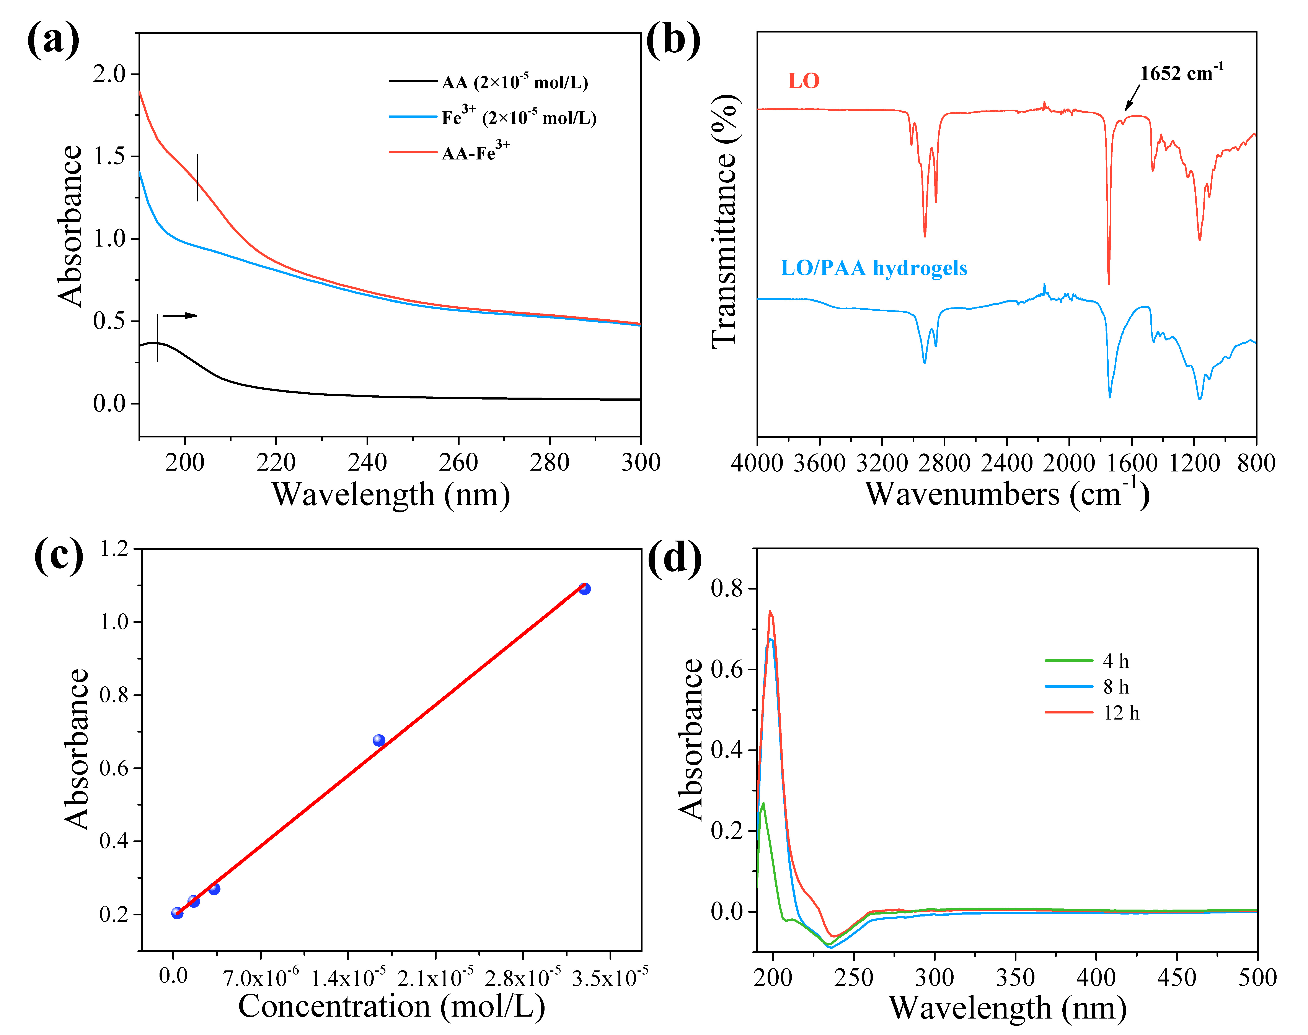
Fig. S9 (a) UV-vis spectra of AA (2×10⁻⁴ mol/L), Fe³⁺ (2×10⁻⁴ mol/L) and AA- Fe³⁺ (2×10⁻⁴ mol/L) solutions. (b) FT-IR spectra of LO and LO/PAA hydrogels. (c) Absorbance versus concentration graph for LO in petroleum ether. (d) UV-vis spectra of LO released from Pickering droplets in hydrogels at different time
In order to calibrate the release of LO in hydrogels, calibration curve was obtained by measuring the intensity of the absorption of a series of concentration of LO in petroleum ether (Fig. S10c). LO concentrations of 3.3×10⁻⁷, 1.65×10⁻⁶, 3.3×10⁻⁶, 1.65×10⁻⁵ and 3.3×10⁻⁵ were prepared in petroleum ether for calibration curves. The absorption coefficient was calculated using Beer-Lambert’s equation (Demissie et al. 2016; Waschewsky et al. 1996): A = kc, where A was absorbance, k was the absorption coefficient and c was the concentration of LO in petroleum ether. The good linear calibration curve (R²=0.99738) was obtained which could be further used to determine the release amount of LO in hydrogels. The HG-P_{1.0}G_{1.0} was immersed in 20 mL of petroleum ether for 4 h, 8 h and 12 h. LO released from Pickering droplets in hydrogels entered petroleum ether as exchange solvent and measured by UV-vis. Based on calibration curve, the concentrations of LO were calculated at a given intensity of optical absorption.

Fig. S10 Self-healing efficiency of HG-P₀G_{1.0} and HG-P_{1.0}G_{1.0} at 25 ℃ for 12h

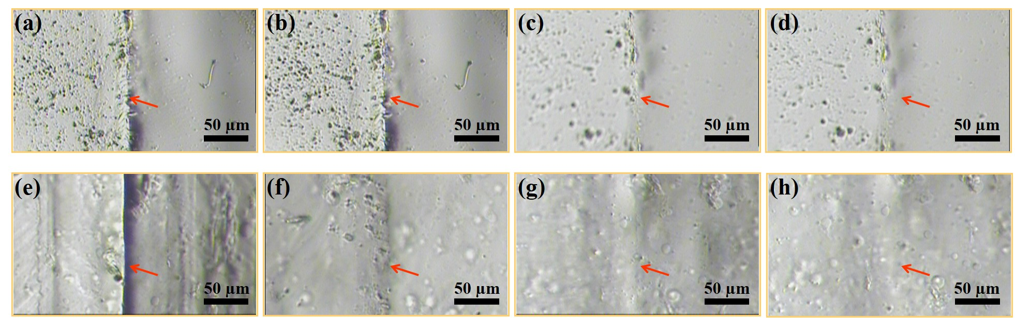
Fig. S11 Optical microscope images of self-healing process of HG-P₀G_{1.0} at -20 ℃ with different healing time for (a) 0 h; (b) 1 h; (c) 4 h; (d) 8 h, and HG-P_{1.0}G_{1.0} for (e) t = 0 h;(f) 1 h; (g) 4 h; (h) 8 h

Demissie EG, Woyessa GW, Abebe A (2016) UV/Vis spectrometer determination of caffeine in green coffee beans from hararghe, ethiopia, using beer-lambert's law and integrated absorption coefficient techniques. St Cerc St CICBIA 17:109-123.
Waschewsky GCG, Horansky R, Vaida V (1996) Effect of dimers on the temperature-dependent absorption cross section of methyl iodide, J Phys Chem 100:11559-11565. https://doi.org/10.1021/jp960809r

