SUPPLEMENTARY FILE
Supplementary Table 1. Summary of studies estimating doping prevalence in sport using indirect estimation models.
Author(s) | Document | Model | Sample |  |  |  |  |  | Data |  |  |  | Prevalence (95 CI), ± SE % | Non-compliance, % | Definition | Time frame | Validation | Response rate, %
Author(s) | Document | Model | N | Country | Sport | Competition level | Age: range, M±SD |  | Collection | Year | Sport event | WADA code
Abdulrazzaq and Tareq [73] | Peer-reviewed article | Crosswise | 500 male | Iraq | Bodybuilding | Local | 24.2±3.2 |  | Paper-and-pencil survey | 2021 | No | No | 80 | Not considered | AAS use | Current | None
Anti-Doping Agency of Serbia [49] | Report | Single Sample Count | 323 | Serbia | Multi-sport | National, elite |  |  | Online survey | 2013 | ✓ | Yes | 3.15 ± 7.86 | Deliberate: 1.78;  Innocent: 30.67 | Knowingly using prohibited performance enhancing substances | Past year | ✓
Backhouse et al. [74] | ✓ | ✓ | 591 male | UK | Rugby and other sports§ | Schoolboy | 16–19, 16.88±0.75 |  | ✓ | 2015–16 | ✓ | No | 9.2 (0–18.6) | 2.93 ± 6.88 § | AAS use | Past 3 months | ✓
Balk et al. [34] | Peer-reviewed article | Kuk’s Design | 249 (male: 100) | Netherlands | Multi-sport | International, elite |  |  | ✓ | 2020 | ✓ | Yes | 12.5 (3.0–24.7) | Assessed | AAS use, blood manipulation, stimulating agents, other prohibited substances/methods | Past year | ✓ | 32.7
Boardley et al. [41] | ✓ | Unrelated Question | 822 (female: 290, male: 532) | Australia, UK,  USA | ✓ | Regional, national, international | 22.04±5.23 |  | Paper-and-pencil survey |  | ✓ | ✓ | 13.9 (9.3–18.5) | Not considered | Knowingly using substances [eg, anabolic steroids, erythropoietin, banned stimulants, growth hormones] or methods [eg, blood infusions] that are banned by the WADA and the IOC and therefore would not be permitted in professional sport | ✓ | ✓
Breuer and Hallmann [50] | Report | Unrelated Question, Cheater Detection | 1154 (male: 49.4%) | Germany | ✓ | National, elite | 12–64, 22.4± |  | Online survey | 2012 | ✓ | No | 5.9 | Honest no: 53.4, no answer: 40.7 | Use of doping substances | Lifetime | ✓
Cruyff et al. [40] | Manuscript (pre-print) | Extended Crosswise | 354 (male: 153, female: 200) | National (country not specified) | ✓ | All competitive | 16+ |  | ✓ | 2020 | ✓ | Yes | 13.0 (3.9–22.2) | Considered and adjusted for where needed | Use of prohibited substances and/or method without TUE | Past year | Control questions
Cruyff et al. [40] | ✓ | ✓ | 325 (male: 157, female: 161) | ✓ | Not specified (single sport) | ✓ | ✓ |  | Online and tablet computer | 2021 | Yes | ✓ | 35.7 (22.5–48.5) | ✓ | ✓ | ✓ | ✓
Cruyff et al. [40] | ✓ | ✓ | 915 (male: 430, female: 483) | International | Multi-sport | International | ✓ |  | ✓ | 2022 | ✓ | ✓ | 21.3 (15.2–27.3) | ✓ | ✓ | ✓ | ✓
Cruyff et al. [40] | ✓ | ✓ | 813 (male: 251, female: 560) | National (country not specified) | ✓ | Competitive | ✓ |  | Online survey | ✓ | No | ✓ | 12.9 (6.9–18.9) | ✓ | ✓ | ✓ | ✓
Cruyff et al. [40] | ✓ | ✓ | 297 (male: 129, female: 168) | International | Not specified (single sport) | ✓ | 18+ |  | Online and tablet computer | ✓ | ✓ | ✓ | 18.8 (9.2–28.3) | ✓ | ✓ | ✓ | ✓
Dietz et al. [42] | Peer-reviewed article | Unrelated Question | 2987 (male: 2576) | ✓ | Triathlon | Regional, international, national | 18–79, 39.5±69.2 |  | Paper-and-pencil survey |  | ✓ | No | 13.0 (10.5–15.4) | Not considered | Physical enhancement: Use of substances which can only be prescribed by a doctor, are available in a pharmacy, or can be bought on the black market (e.g. anabolic steroids, erythropoietin, stimulants, growth hormones) to enhance physical performance | ✓ | None | 90.5
Dietz et al. [42] | ✓ | ✓ | 2987 (male: 2576) | ✓ | ✓ | ✓ | 18–79, 39.5±69.2 |  | ✓ |  | ✓ | ✓ | 15.1 (12.7–17.6) | ✓ | Cognitive enhancement: ✓ cognitive performance | ✓ | ✓ | 91.6
Duiven and de Hon [32] | Report | Kuk’s Design§ | 740 | Netherlands | Multi-sport | National, elite |  |  | Online survey | 2014–15 | ✓ | Yes | 4.2 (1.8–8.5) | ✓ | Use of anabolic agents, blood manipulation, stimulants,  other prohibited substances/methods | Lifetime, past year | ✓
Elbe and Pitsch [44] | Peer-reviewed article (editorial) | Forced Response | 771 (male: 56.5%) | Denmark | ✓ | National | 13–29: 86.7% |  | ✓ | 2016–17 | ✓ | ✓ | Last season: 0, lifetime: 3.1 (0–8.9) | “no”-cheater: last season - 30.6, lifetime - 22.9; “honest no”: last season - 69.4, lifetime: 74.0 | Intentional use of forbidden substances and/or for-bidden methods in order to enhance sporting performance in competitions | Lifetime, last season | ✓ | 57
Fincoeur and Pitsch [51] | ✓ | ✓ | 767 | Belgium | Cycling | Amateur competitive |  |  | ✓ | 2013 | ✓ | ✓ | Lifetime: 5.3 (0–13.5), past year: 0.4 (0–8.9) | Cheaters/dishonest no:  lifetime - 34.4, past year - 26.3 | Knowingly using a prohibited product or method to improve sports performance | Lifetime, past year | ✓ | 27.6
Franke et al. [75] | ✓ (letter) | Unrelated Question | 2420 | Germany | Chess | National  club | 47.5±17.0 |  | Online, paper-and-pencil | 2012–13 | ✓ | No | 8.9 (6.4–11.4) | Not considered | Cognitive enhancement through use of prescription or illicit drugs | Lifetime | ✓ | 37.5
Frenger et al. [76] | Peer-reviewed article | Forced Response | Lifetime: 786; last season/year: 616 | ✓ | Multi-sport | Regional, amateur, and recreational |  |  | Online survey |  | ✓ | Yes | Lifetime: 3.6, last season/year: 4.1 | Lifetime: honest “no” (88.4), cheater (8), last season: honest “no” (70.2), cheater (25.8) | Use of prohibited substances/or methods with the aim of enhancing sorts performance | Lifetime, last season/year | ✓ | <20
Heyes [45] | Thesis | Unrelated Question | 732 (female: 403) | UK | ✓ | University student athletes | 18–33, 20.08±1.56 |  | Paper-and-pencil survey |  | ✓ | ✓ | 14.02 (11.60–16.45) | Not considered | Use of performance-enhancing drugs or methods prohibited in sport (e.g., EPO, testosterone, HGH) | Past year | ✓
Heyes [45] | Thesis | Single Sample Count | 732 (female: 403) | ✓ | ✓ | University student athletes | 18–33, 20.08±1.56 |  | ✓ |  | ✓ | ✓ | 7.83 (0–16.54) | ✓ | ✓ | ✓ | ✓
Hilkens et al. [78] | Peer-reviewed article | Kuk’s design | 2269 male | Netherlands | ✓ | Recreational | 24±6 |  | Online survey | 2020 | ✓ | No | AAS - lifetime: 9.0 (6.4–11.6); last year - 3.6 (1.2–6.1), SARM - lifetime: 2.7 (0.3–5.1) | ✓ | AAS and SARM use | Lifetime, past year | ✓
James et al. [43] | ✓ | Unrelated Question, Single Sample Count | 513 (male: 58.7%) | UK,  Ireland | ✓ | National,  club | 24.18±3.87 |  | ✓ |  | ✓ | Yes | UQ: 58.42 (52.72–64.12),  SSC: 19.88 (10.57–29.20) | ✓, discussed | Taking prohibited performance enhancing drug | Past year | ✓
Musch and Plessner [30] | Manuscript | Forced Response | 365 | Germany | ✓ | Regional, state, national, international |  |  | ✓ |  | ✓ | No | 42.5 | Considered | Use of illicit performance-enhancing drugs | Lifetime | ✓
Nakhaee et al. [79] | Peer-reviewed article | Crosswise | 298 male | Iran | Bodybuilding | Recreational club, competitive, elite | 25.9±8.4 |  | Paper-and-pencil survey | 2013 | ✓ | ✓ | 56.8 | Not considered | AAS use | ✓ | ✓
Nilaweera et al. [80] | Conference abstract | Forced response§ | 347 | Sri Lanka | Multi-sport | National | <25 (44.7%)§ |  | ✓§ | 2018–19 | ✓ | Yes | 8.4 |  | Use of doping drugs | ✓ |  | 96§
Petróczi et al. [36]# | Peer-reviewed article | Single Sample Count | 1203# | International (WCA) | Track and field | International, elite |  |  | Digital (iPad) survey | 2011 | Yes | ✓ | 21.2±8.7# | 31.90 (26.28–37.52)# | Knowingly violating anti-doping regulations by using a prohibited substance or method | Past year | ✓ | 65.3#
Petróczi et al. [36] | ✓ | ✓ | 954 | International, regional (PAG) | Multi-sport | ✓ |  |  | ✓ | ✓ | ✓ | ✓ | 10.6±5.6 | 9.85 (4.01–15.69) | ✓ | ✓ | ✓ | 28.2
Pitsch [81] | Book chapter | Forced Response | 2949 | USA | Cycling | Recreational club, competitive, elite |  |  | Online survey | 2014 | No | ✓ | 3.15 | Considered | Use of forbidden substances or methods in order to enhance cycling performance (TUE excluded) | Last season | ✓ | 6.7
Pitsch [38] | Peer-reviewed article | ✓ | 210 | Norway, Denmark, the United Kingdom, Germany, Spain, Italy, Greece and Cyprus | Multi-sport | International |  |  | ✓ | 2019 | ✓ | ✓ | 0 | 9.2 (0–40.6) | Willingly using prohibited substances or methods to enhance performance | Past year (2019) | ✓
Pitsch [38] | ✓ | ✓ | 743 | ✓ | ✓ | National |  |  | ✓ | ✓ | ✓ | ✓ | 5.9 (0–15.1) | 59.5 (46.1–72.7) | ✓ | ✓ | ✓
Pitsch [38] | ✓ | ✓ | 911 | ✓ | ✓ | Regional |  |  | ✓ | ✓ | ✓ | ✓ | 1.3 (0–9.6) | 11.2 (0–38.4) | ✓ | ✓ | ✓
Pitsch [38] | ✓ | ✓ | 998 | ✓ | ✓ | Local |  |  | ✓ | ✓ | ✓ | ✓ | 0 | 24.3 (2.9–36.7) | ✓ | ✓ | ✓
Pitsch and Emrich [] (2011) | ✓ | ✓ | 863 | Germany | ✓ | Elite |  |  | Paper-and-pencil survey | 2008 | ✓ | No | 10.2 (10.2–34.9) | Cheaters: 24.7 | Knowingly using illicit drugs or methods in order to enhance performance | Lifetime | ✓ | 31.9
Pitsch et al. [29] | ✓ | ✓ | 448 (male: 66.1%) | ✓ | ✓ | ✓ |  |  | Online survey | 2005 | ✓ | Yes | Lifetime (25.8–48.1); current season (20.4–38.7) |  | Use of banned doping substances or methods in order to enhance performance | Lifetime, current season | ✓
Pitsch et al. [29] | ✓ | ✓ | 249 | ✓ | Multi-sport (CGS sports) | ✓ |  |  | ✓ | ✓ | ✓ | ✓ | Lifetime (38.1), current season (35.1) | Lifetime cheater (24.9), current season cheater (27.1) | ✓ | ✓ | ✓
Sayed et al. [46] | ✓ | Extended Crosswise | 2072§ | UK | Multi-sport | Recreational | 31.0±9.0§ |  | ✓ | 2020 | ✓ | ✓ | 9.2§ | Considered | Use of controlled sport drugs without medical need to enhance athletic performance (e.g., anabolic steroids, hormone) | Lifetime | ✓
Sayed et al. [46] | ✓ | ✓ | 269§ | ✓ | ✓ | Competitive | 27.7±8.3 |  | ✓ | 2020 | ✓ | ✓ | 15.6§ | Considered | ✓ | ✓ | ✓
Schröter et al. [48] | ✓ | Cheater Detection | 1001 (male: 884) | Germany | Triathlon | Local - Frankfurt, recreational | 23–63, 40.88±8.15 |  | Paper-and-pencil survey | 2014 | Yes | No | 11.9 (6.5–17.3) | 64.9 (59.6–70.3) | Physical doping: Taking substances to increase physical performance that are only available at a pharmacy, at the doctor’s office or on the black market (e.g. anabolic steroids, EPO, growth hormones, stimulants) | Past year | ✓ | Overall: 74.45
Schröter et al. [48] | ✓ | ✓ | 1001 (male: 884) | ✓ | ✓ | ✓ | 23–63, 40.88±8.15 |  | ✓ | ✓ | ✓ | ✓ | 9.4 (4.0–14.8 | 59.1 (53.7–64.5) | Cognitive doping: ✓ mental performance (e.g. caffeine pills, stimulants, Cocaine, Methylphenidate / Ritalin®, beta blocker, Modafinil) | ✓ | ✓ | Overall: 74.45
Schröter et al. [48] | ✓ | ✓ | 482 (male: 416) | ✓ | ✓ | Local – Wiesbaden, recreational | 19–69, 38.37±9.31 |  | ✓ | ✓ | ✓ | ✓ | 4.2 (-3.3–11.6) | 53.9 (46.5–61.4) | Physical doping: ✓ | ✓ | ✓ | Overall: 74.45
Schröter et al. [48] | ✓ | ✓ | 482 (male: 416) | ✓ | ✓ | ✓ | 19–69, 38.37±9.31 |  | ✓ | ✓ | ✓ | ✓ | 0.7 (-6.6–8.0) | 44.5 (37.2–51.7) | Cognitive doping: ✓ | ✓ | ✓ | Overall: 74.45
Schröter et al. [48] | ✓ | Unrelated Question | 534 (male: 481) | ✓ | ✓ | ✓ | 19–68, 39.11±9.22 |  | ✓ | ✓ | ✓ | ✓ | 3.9 (-1.1–8.9) | Not considered | Physical doping: ✓ | ✓ | ✓ | Overall: 74.45
Schröter et al. [48] | ✓ | ✓ | 534 (male: 481) | ✓ | ✓ | ✓ | 19–68, 39.11±9.22 |  | ✓ | ✓ | ✓ | ✓ | 8.4 (3.1–13.6) | ✓ | Cognitive doping: ✓ | ✓ | ✓ | Overall: 74.45
Seifarth et al. [47] | ✓ | ✓ | 1989 (male: 1491) | ✓ | ✓ | Competitive, recreational | 18–80, 39.6±10.7 |  | ✓ | 2017 | ✓ | ✓ | 7.0 (4.2–9.8) | ✓ | Physical doping: Taking substances that increase physical performance that are only available at a pharmacy, at the doctor’s office, or on the black market (with examples) | ✓ | None | 63.5
Seifarth et al. [47] | ✓ | ✓ | 1989 (male: 1491) | ✓ | ✓ | Competitive, recreational | ✓ |  | ✓ | ✓ | ✓ | ✓ | 9.4 (6.6–12.3) | ✓ | Cognitive doping: ‘✓ mental performance (with examples) | ✓ | ✓ | 63.5
Simon et al. [56] | ✓ | ✓ | 500 (male: 347) | ✓ | Recreational/gym goers | National | 32.0±11.0 |  | In-person interview | 2003–05 | No | No | 12.5 (8.2–17.4) | ✓ | Use of doping substances | Lifetime | Yes: larger sample questionnaire – 13.5% | 99.8
Striegel et al. [52] | ✓ | ✓ | 480 (male: 301) | ✓ | Multi-sport | National, elite | 15–18, Median: 16 |  | Paper-and-pencil survey | ✓ | ✓ | ✓ | 6.8 (2.7–10.9) | ✓ | ✓ | ✓ | None | 100
Stubbe et al. [85] | ✓ | Forced Response | 718 (female: 64.0%) | Netherlands | Recreational/gym goers | National | 43.4±13.6 |  | Online survey |  | ✓ | ✓ | 8.2 | Considered | PED use classified into: anabolic steroids, prohormones, substances to counteract  side-effects (such as clomiphene and tamoxifen), growth  hormone and/or insulin, stimulants (to reduce weight), and miscellaneous substances (such as diuretics and thyroid  hormones) | Past year | ✓
Ulrich et al. [35]# | ✓ | Unrelated Question | 1203# | International (WCA) | Track and field | International, elite |  |  | Digital (tablet computer) survey | 2011 | Yes | Yes | 43.6 (39.4–47.9)# | Not considered | Knowingly violating anti-doping regulations by using a prohibited substance or method | ✓ | ✓ | 93.3#
Ulrich et al. [35] | ✓ | ✓ | 965 | International (PAG) | Multi-sport | Regional, international, elite |  |  | ✓ | ✓ | ✓ | ✓ | 57.1 (52.4–61.8) | ✓ | ✓ | ✓ | ✓ | 93.4
WADA [13] | Internal report | Single Sample Count | 1357 | International | Multi-sport | International | 16+ |  | ✓ | 2018 | ✓ | ✓ | 9.2 (2.2–16.1) | Not detected | Use of prohibited substances and/or method without TUE | ✓ | Indirect control question (doping control)
WADA [13] | ✓ | ✓ | 707 | ✓ | ✓ | ✓ | 16+ |  | ✓ | 2019 | ✓ | ✓ | 39.0 (28.5–49.5) | Detected but not corrected for | ✓ | ✓ | ✓
WADA [13] | ✓ | Extended Crosswise | 686 | ✓ | ✓ | ✓ | 16+ |  | ✓ | ✓ | ✓ | ✓ | 44.4 (39.5–49.4) | ✓ | ✓ | ✓ | ✓
WADA [13] | ✓ | Single Sample Count | 344 | ✓ | ✓ | ✓ | 16+ |  | Paper-and-pencil survey | ✓ | ✓ | ✓ | 25.2 (8.7–41.7) | ✓ | ✓ | ✓ | ✓
WADA [13] | ✓ | Extended Crosswise | 299 | ✓ | ✓ | ✓ | 16+ |  | ✓ | ✓ | ✓ | ✓ | 38.6 (31.3–46.3) | ✓ | ✓ | ✓ | ✓
WADA [13] | ✓ | ✓ | 616 | ✓ | ✓ | ✓ | 16+ |  | ✓ | ✓ | ✓ | ✓ | 6.4 (2.8–14.2) | ✓ | ✓ | ✓ | ✓
WADA [13] | ✓ | ✓ | 620 | ✓ | ✓ | ✓ | 16+ |  | ✓ | ✓ | ✓ | ✓ | 18.0 (13.3–23.9) | Not detected | ✓ | ✓ | ✓
✓: As above. §: Personal communication. #Sample overlap. AAS: Anabolic-androgenic steroid(s). CDM: Cheater Detection Model. CGS: Sports where performance is measured in physical units like centimetres, grams or seconds (Pitsch et al., 2007). IOC: International Olympic Committee. PAG: Pan-Arab Games. PED: Performance-enhancing drug. UQM: Unrelated Question Model. SARM: Selective Androgen Receptor Modulator(s). Single Sample Count (SSC) model. TUE: Therapeutic use exemption. WADA: World Anti-Doping Agency. WCA: World Championships in Athletics.

Supplementary Table 2. Risk of bias/methodological quality of included studies.
Study | 1. Representation | 2. Sampling frame | 3. Random selection | 4. Response rate | 5. Primary data | 6. Definition | 7. Instrument | 8. Consistency | 9. Period | 10. Estimation | 11. Justification | 12. Target clear | 13. Target fact | 14. Innocuous clear | 15. Power | 16. Noncompliance | 17. Protection | 18. Estimate(s) reliable | 19. Parameter | 20. Innocuous modelled | Score | Category
Abdulrazzaq and Tareq [73] | 1 | 0 | 1 | 1 | 0 | 1 | 1 | 0 | 0 | 0 | 0 | 1 | 1 | 1 | 0.5 | 1 | 1 | 1 | 1 | 1 | 13.5 | LQ/HR
Anti-Doping Agency of Serbia [49] | NA | NA | NA | NA | NA | NA | NA | NA | NA | NA | NA | NA | NA | NA | NA | NA | NA | NA | NA | NA | NA | NA
Backhouse et al. [74] | 1 | 0 | 0 | 1 | 0 | 1 | 1 | 0 | 0 | 0 | 0 | 1 | 1 | 1 | 0.5 | 0 | 1 | 0 | 1 | 1 | 10.5 | LQ/HR
Balk et al. [34] | 1 | 1 | 1 | 1 | 0 | 0 | 1 | 0 | 0 | 0 | 0 | 1 | 1 | 0 | 1 | 1 | 0 | 1 | 1 | 0 | 11 | LQ/HR
Boardley et al. [41] | 1 | 1 | 1 | 1 | 0 | 0 | 1 | 0 | 0 | 0 | 0 | 0 | 0 | 0 | 1 | 1 | 0 | 0 | 1 | 0.5 | 8.5 | MQ/R
Breuer and Hallmann [50] | NA | NA | NA | NA | NA | NA | NA | NA | NA | NA | NA | NA | NA | NA | NA | NA | NA | NA | NA | NA | NA | NA
Cruyff et al. [40] | 1 | 1 | 1 | 0 | 0 | 0 | 1 | 0 | 0 | 0 | 0 | 0 | 0 | 0 | 0 | 0 | 0 | 0 | 0 | 0 | 4 | HQ/LR
Dietz et al. [42] | 0 | 0 | 0 | 0 | 0 | 1 | 1 | 0 | 0 | 0 | 0 | 1 | 0 | 0 | 0 | 1 | 0 | 0 | 0 | 0.5 | 4.5 | HQ/LR
Duiven and de Hon [32] | 1 | 1 | 1 | 1 | 0 | 0 | 1 | 0 | 1 | 0 | 0 | 0 | 0 | 1 | 1 | 1 | 1 | 0 | 1 | 0 | 11 | LQ/HR
Elbe and Pitsch [44] | 1 | 0 | 0 | 1 | 0 | 0 | 1 | 0 | 0.5 | 0 | 0 | 0 | 0 | 0 | 0 | 0 | 0 | 0 | 1 | 0.5 | 5 | MQ/R
Fincoeur and Pitsch [51] | NA | NA | NA | NA | NA | NA | NA | NA | NA | NA | NA | NA | NA | NA | NA | NA | NA | NA | NA | NA | NA | NA
Franke et al. [75] | 0 | 0 | 0 | 1 | 0 | 0 | 1 | 0 | 1 | 0 | 0 | 1 | 1 | 0 | 0.5 | 1 | 0 | 0 | 0 | 0.5 | 7 | MQ/R
Frenger et al. [76] | 1 | 1 | 1 | 1 | 0 | 0 | 1 | 0 | 0.5 | 0 | 0 | 0 | 0 | 0 | 1 | 0 | 0 | 1 | 1 | 0 | 8.5 | MQ/R
Heyes [45] ( | 1 | 1 | 1 | 1 | 0 | 0 | 1 | 0 | 0 | 0 | 0 | 0 | 0 | 0 | 0 | 1 | 0 | 0 | 0.5 | 0.5 | 7 | MQ/R
Hilkens et al. [78] | 1 | 1 | 1 | 1 | 0 | 0 | 1 | 0 | 0.5 | 0 | 0 | 0 | 0 | 0 | 0.5 | 1 | 0 | 0 | 0 | 0 | 7 | MQ/R
James et al. [43] | 1 | 1 | 1 | 1 | 0 | 0 | 1 | 0 | 0 | 0 | 0 | 0 | 0 | 0 | 1 | 0.5 | 1 | 0 | 1 | 0.5 | 9 | MQ/R
Musch and Plessner [30] | 1 | 1 | 1 | 1 | 0 | 0 | 1 | 0 | 1 | 0 | 0 | 0 | 1 | 0 | 1 | 1 | 1 | 1 | 1 | 0.5 | 12.5 | LQ/HR
Nakhaee et al. [79] | 1 | 0 | 0 | 1 | 0 | 0 | 0 | 0 | 1 | 0 | 1 | 1 | 1 | 0 | 1 | 1 | 0 | 1 | 1 | 0.5 | 10.5 | LQ/HR
Nilaweera et al. [80] | 1 | 1 | 0 | 1 | 0 | 1 | 1 | 0 | 1 | 0 | 0 | 1 | 1 | 1 | 1 | 1 | 1 | 1 | 1 | 1 | 15 | LQ/HR
Petróczi et al. [36] | 0 | 0 | 0 | 0 | 0 | 0 | 1 | 0 | 0 | 0 | 0 | 0 | 0 | 0 | 0.5 | 0 | 0 | 0 | 1 | 0 | 2.5 | HQ/LR
Pitsch [81] | 1 | 1 | 1 | 1 | 0 | 0 | 1 | 0 | 0 | 0 | 0 | 0 | 0 | 0 | 0.5 | 0 | 0 | 0 | 1 | 0 | 6.5 | MQ/R
Pitsch [38] | 1 | 1 | 1 | 1 | 0 | 0 | 1 | 0 | 0 | 0 | 0 | 0 | 0 | 0 | 1 | 0 | 0 | 0 | 1 | 0 | 7 | MQ/R
Pitsch and Emrich [27] | 0 | 0 | 0 | 1 | 0 | 0 | 1 | 0 | 1 | 0 | 0 | 0 | 0 | 0 | 1 | 0 | 0 | 0 | 1 | 0.5 | 5.5 | MQ/R
Pitsch et al. [29] | 1 | 1 | 1 | 1 | 0 | 0 | 1 | 0 | 0.5 | 0.5 | 0 | 0 | 0 | 0 | 1 | 0.5 | 0 | 0 | 1 | 0.5 | 9 | MQ/R
Sayed et al. [46] | 1 | 1 | 1 | 1 | 0 | 0 | 1 | 0 | 1 | 0 | 0 | 0 | 0 | 0 | 0 | 0 | 0 | 0 | 1 | 0 | 7 | MQ/R
Schröter et al. [48] | 0 | 0 | 0 | 1 | 0 | 1 | 1 | 0 | 0 | 0 | 0 | 1 | 1 | 0 | 1 | 0 | 0 | 0 | 1 | 0.5 | 7.5 | MQ/R
Seifarth et al. [47] | 0 | 0 | 0 | 1 | 0 | 1 | 1 | 0 | 0 | 0 | 0 | 1 | 1 | 0 | 0 | 1 | 0 | 0 | 1 | 0.5 | 7.5 | MQ/R
Simon et al. [56] | 0 | 0 | 0 | 0 | 0 | 0 | 1 | 0 | 1 | 0 | 0 | 0 | 0 | 0 | 1 | 1 | 0 | 0 | 1 | 0.5 | 5.5 | MQ/R
Striegel et al. [52] | 0 | 0 | 0 | 0 | 0 | 0 | 1 | 0 | 1 | 0 | 0 | 0 | 0 | 0 | 1 | 1 | 0 | 0 | 1 | 0.5 | 5.5 | MQ/R
Stubbe et al. [85] | 0 | 0 | 0 | 1 | 0 | 0 | 1 | 0 | 0 | 0 | 0 | 0 | 0 | 0 | 1 | 0 | 0 | 1 | 1 | 0 | 5 | MQ/R
Ulrich et al. [35] | 0 | 0 | 0 | 0 | 0 | 0 | 1 | 0 | 0 | 0 | 0 | 0 | 0 | 0 | 0.5 | 1 | 0 | 0 | 0.5 | 0.5 | 3.5 | HQ/LR
WADA [13] | NA | NA | NA | NA | NA | NA | NA | NA | NA | NA | NA | NA | NA | NA | NA | NA | NA | NA | NA | NA | NA | NA
Item score: 0: low risk, 0.5: moderate risk, 1: high risk.
HQ/LR: High quality/low risk. LQ/HR: Low quality/high risk. MQR: Moderate quality/risk. NA: Not applicable.
Supplementary Table 3. Distribution of the selected papers by journals.
Journal | Best JIF quartile | Frequency
PLOS One | Q1 | 4
Sports Medicine-Open | Q1 | 3
Addiction | Q1 | 1
Drug & Alcohol Dependence | Q1 | 1
Drug Testing and Analysis | Q2 | 1
Epidemiology | Q1 | 1
European Journal for Sport and Society | Q1 | 1
Frontiers in Psychology | Q1 | 1
Frontiers in Sports and Active Living | Q1 | 1
International Review for the Sociology of Sport | Q2 | 1
Journal of Risk and Financial Management | NA | 1
Journal of Sports Sciences | Q2 | 1
Journal of the Royal Statistical Society: Series A | Q1 | 1
Psychology of Sport and Exercise | Q1 | 1
Scandinavian Journal of Medicine & Science in Sports | Q1 | 1
Sports | NA | 1
Sports Medicine | Q1 | 1

Supplementary Table 4. Distribution of the selected papers by research field.
Web of Science subject category | Frequency
Sport sciences | 9
Multidisciplinary sciences | 5
Hospitality, leisure, sport and tourism | 3
Psychiatry | 2
Substance abuse | 2
Biochemical research methods | 1
Business, finance | 1
Chemistry, analytical | 1
Nutrition and dietetics | 1
Pharmacology and pharmacy | 1
Psychology | 1
Psychology, applied | 1
Psychology, multidisciplinary | 1
Public, environmental and occupational health | 1
Sociology | 1

Supplementary Table 5. List of authors involved in IEM application to doping prevalence estimation.
 | 2001 | 2002 | 2003 | 2004 | 2005 | 2006 | 2007 | 2008 | 2009 | 2010 | 2011 | 2012 | 2013 | 2014 | 2015 | 2016 | 2017 | 2018 | 2019 | 2020 | 2021 | 2022 | 2023 | 2024 | Sum
Abdulrazzaq, Z |  |  |  |  |  |  |  |  |  |  |  |  |  |  |  |  |  |  |  |  |  |  | 1 |  | 1
Aust, F |  |  |  |  |  | 1 |  |  |  |  |  |  |  |  |  |  |  |  |  |  |  |  |  |  | 1
Backhouse, S |  |  |  |  |  |  |  |  |  |  |  |  |  |  |  | 1 |  |  |  |  |  |  |  |  | 1
Balk, L |  |  |  |  |  |  |  |  |  |  |  |  |  |  |  |  |  |  |  |  | 1 |  | 1 |  | 2
Balló, H |  |  |  |  |  |  |  |  |  |  |  |  |  |  |  |  | 1 |  |  |  |  |  |  |  | 1
Beggs, C |  |  |  |  |  |  |  |  |  |  |  |  |  |  |  | 1 |  |  |  |  |  |  |  |  | 1
Benjamins, J |  |  |  |  |  |  |  |  |  |  |  |  |  |  |  |  |  |  |  |  | 1 |  |  |  | 1
Boardley, I |  |  |  |  |  |  |  |  |  |  |  |  |  |  |  |  |  |  | 1 |  |  |  |  |  | 1
Breuer, C |  |  |  |  |  |  |  |  |  |  |  |  | 1 |  |  |  |  |  |  |  |  |  |  |  | 1
Chirico, A |  |  |  |  |  |  |  |  |  |  |  |  |  |  |  |  |  |  |  |  |  |  | 1 |  | 1
Chorus, A |  |  |  |  |  |  |  |  |  |  |  |  |  | 1 |  |  |  |  |  |  |  |  |  |  | 1
Christiansen, A |  |  |  |  |  |  |  |  |  |  |  |  |  |  |  |  |  |  |  |  |  |  | 1 |  | 1
Cléret, L |  |  |  |  |  |  |  |  |  |  |  |  |  |  |  |  |  | 1 |  |  |  |  | 1 |  | 2
Comstock, R |  |  |  |  |  |  |  |  |  |  |  |  |  |  |  |  |  | 1 |  |  |  |  | 1 |  | 2
Cruyff, M |  |  |  |  |  |  |  |  |  |  |  |  |  |  |  |  |  |  |  |  | 1 | 2 | 2 | 1 | 6
Dalaker, R |  |  |  |  |  |  |  |  |  |  |  |  | 1 |  |  | 1 |  |  |  |  |  |  |  |  | 2
De Hon, O |  |  |  |  |  |  |  |  |  |  |  |  |  | 1 | 1 |  |  |  |  |  |  | 2 | 1 |  | 5
Dietz, P |  |  |  |  |  | 1 |  |  |  |  |  |  | 1 |  |  | 2 | 1 |  | 1 | 1 |  |  |  |  | 7
Disch, A |  |  |  |  |  |  |  |  |  |  |  |  |  |  |  |  |  |  | 1 |  |  |  |  |  | 1
Dopheide, M |  |  |  |  |  |  |  |  |  |  |  |  |  |  |  |  |  |  |  |  | 1 |  | 1 |  | 2
Duiven, E |  |  |  |  |  |  |  |  |  |  |  |  |  |  | 1 |  |  |  |  |  |  |  | 1 |  | 2
Elbe, A-M |  |  |  |  |  |  |  |  |  |  |  |  |  |  |  |  |  | 1 |  |  |  |  |  |  | 1
Emrich, E |  |  |  |  | 1 |  | 1 |  | 2 |  |  | 1 | 1 |  |  | 1 |  |  |  |  |  |  |  |  | 7
Engelhardt, M |  |  |  |  |  |  |  |  |  |  |  |  |  |  |  |  |  |  | 1 |  |  |  |  |  | 1
Evers, C |  |  |  |  |  |  |  |  |  |  |  |  |  |  |  |  |  |  |  |  | 1 |  |  |  | 1
Fincoeur, B |  |  |  |  |  |  |  |  |  |  |  |  |  |  |  |  | 1 |  |  |  |  |  |  |  | 1
Frank, L |  |  |  |  |  |  |  |  |  |  |  |  |  | 1 |  |  |  |  |  |  |  |  |  |  | 1
Franke, A |  |  |  |  |  |  |  |  |  |  |  |  | 1 |  |  |  | 1 |  |  |  |  |  |  |  | 2
Frenger, M |  |  |  |  |  |  |  |  |  |  |  |  | 1 |  |  | 1 |  |  |  |  |  |  | 1 |  | 3
Gebert, A |  |  |  |  |  |  |  |  |  |  | 1 |  |  |  |  |  |  |  |  |  |  |  |  |  | 1
Geyer, H | 1 |  |  |  |  |  |  |  |  |  |  |  |  |  |  |  |  |  |  |  |  |  |  |  | 1
Gleaves, J |  |  |  |  |  |  |  |  |  |  |  |  |  |  |  |  |  |  |  |  |  | 1 |  |  | 1
Gucciardi, D |  |  |  |  |  |  |  |  |  |  |  |  |  |  |  |  |  |  | 1 |  |  |  |  |  | 1
Hallmann, K |  |  |  |  |  |  |  |  |  |  |  |  | 1 |  |  |  |  |  |  |  |  |  |  |  | 1
Harris, T |  |  |  |  |  |  |  |  |  |  |  |  |  |  |  |  |  |  | 1 |  |  |  |  |  | 1
Heller, S |  |  |  |  |  |  |  |  |  |  |  |  |  |  |  |  |  |  |  | 1 |  |  |  |  | 1
Heyes, A |  |  |  |  |  |  |  |  |  |  |  |  |  |  |  |  |  |  |  |  |  | 1 |  |  | 1
Hilkens, L |  |  |  |  |  |  |  |  |  |  |  |  |  |  |  |  |  |  |  |  | 1 |  |  |  | 1
James, R |  |  |  |  |  |  |  |  |  |  |  |  | 1 |  |  |  |  |  |  |  |  |  |  |  | 1
Kamber, M |  |  |  |  |  |  |  |  |  |  | 1 |  |  |  |  |  |  |  |  |  |  |  |  |  | 1
Kanayama, G |  |  |  |  |  |  |  |  |  |  |  |  |  |  |  |  |  | 1 |  |  |  |  | 1 |  | 2
Klein, M |  |  |  |  | 1 |  | 1 |  |  |  |  |  |  |  |  |  |  |  |  |  |  |  |  |  | 2
Lamprecht, M |  |  |  |  |  |  |  |  |  |  | 1 |  |  |  |  |  |  |  |  |  |  |  |  |  | 1
Letzel, S |  |  |  |  |  |  |  |  |  |  |  |  |  |  |  | 1 |  |  |  |  |  |  |  |  | 1
Lieb, K |  |  |  |  |  |  |  |  |  |  |  |  | 1 |  |  |  | 1 |  |  |  |  |  |  |  | 2
Maats, P |  |  |  |  |  |  |  |  | 2 |  |  |  |  |  |  |  |  |  |  |  |  |  |  |  | 2
Mareck-Engelke, U | 1 |  |  |  |  |  |  |  |  |  |  |  |  |  |  |  |  |  |  |  |  |  |  |  | 1
McKenna, J |  |  |  |  |  |  |  |  |  |  |  |  |  |  |  | 1 |  |  |  |  |  |  |  |  | 1
Musch, J |  | 2 |  |  |  |  |  |  |  |  |  |  |  |  |  |  |  |  |  |  |  |  |  |  | 2
Nadishani, U |  |  |  |  |  |  |  |  |  |  |  |  |  |  |  |  |  |  |  | 1 |  |  |  |  | 1
Nakhaee, M |  |  |  |  |  |  |  |  |  |  |  |  | 1 |  |  |  |  |  |  |  |  |  |  |  | 1
Nakhaee, N |  |  |  |  |  |  |  |  |  |  |  |  | 1 |  |  |  |  |  |  |  |  |  |  |  | 1
Naughton, D |  |  |  |  |  |  |  |  |  |  |  |  | 1 |  |  |  |  |  |  |  |  |  |  |  | 1
Nepusz, T |  |  |  |  |  |  |  |  |  |  |  |  | 1 |  |  |  |  | 1 |  |  |  |  |  |  | 2
Nilaweera, A |  |  |  |  |  |  |  |  |  |  |  |  |  |  |  |  |  |  |  | 1 |  |  |  |  | 1
Nipunya, G |  |  |  |  |  |  |  |  |  |  |  |  |  |  |  |  |  |  |  | 1 |  |  |  |  | 1
Ntoumanis, N |  |  |  |  |  |  |  |  |  |  |  |  |  |  |  |  |  |  | 1 |  |  |  |  |  | 1
Nunn, R |  |  |  |  |  |  |  |  |  |  |  |  |  |  |  | 1 |  |  |  |  |  |  |  |  | 1
Pakravan, F |  |  |  |  |  |  |  |  |  |  |  |  | 1 |  |  |  |  |  |  |  |  |  |  |  | 1
Petróczi, A |  |  |  |  |  |  |  |  |  |  |  |  | 1 |  |  | 1 |  | 1 |  |  |  | 3 | 1 | 1 | 8
Pitsch, W |  |  |  |  | 1 |  | 1 |  | 2 |  |  | 1 | 1 |  |  | 1 | 1 | 2 |  |  |  | 1 | 1 |  | 12
Plessner, H |  | 2 |  |  |  |  |  |  |  |  |  |  |  |  |  |  |  |  |  |  |  |  |  |  | 2
Pope, H |  |  |  |  |  |  |  |  |  |  |  |  |  |  |  |  |  | 1 |  |  |  |  | 1 |  | 2
Ranft, K |  |  |  |  |  |  |  |  |  |  |  |  |  |  |  |  | 1 |  |  |  |  |  |  |  | 1
Sagoe, D |  |  |  |  |  |  |  |  |  |  |  |  |  |  |  |  |  |  |  |  |  | 2 |  |  | 2
Saugy, M |  |  |  |  |  |  |  |  |  |  |  |  |  |  |  |  |  |  |  |  |  | 2 |  |  | 2
Sayed, K |  |  |  |  |  |  |  |  |  |  |  |  |  |  |  |  |  |  |  |  |  | 1 | 1 | 1 | 3
Schaffer, J |  |  |  |  |  |  |  |  |  |  |  |  |  |  |  |  |  | 1 |  |  |  |  |  |  | 1
Schröter, H |  |  |  |  |  |  |  |  |  |  |  |  |  |  |  | 1 |  |  |  |  |  |  |  |  | 1
Schweiz, A |  |  |  |  |  |  |  |  |  |  | 1 |  |  |  |  |  |  |  |  |  |  |  |  |  | 1
Seifarth, S |  |  |  |  |  |  |  |  |  |  |  |  |  |  |  |  |  |  | 1 |  |  |  |  |  | 1
Simon, P |  |  |  |  |  | 1 |  |  |  | 1 |  |  | 1 |  |  | 2 | 1 | 1 |  | 1 |  |  | 1 |  | 9
Smith, A |  |  |  |  |  |  |  |  |  |  |  |  |  |  |  |  |  |  | 1 |  |  |  |  |  | 1
Stahlberger, M |  |  |  |  |  |  |  |  |  |  | 1 |  |  |  |  |  |  |  |  |  |  |  |  |  | 1
Stamm, H |  |  |  |  |  |  |  |  |  |  | 1 |  |  |  |  |  |  |  |  |  |  |  |  |  | 1
Striegel, H |  |  |  |  |  | 1 |  |  |  | 1 |  | 1 | 1 |  |  | 1 |  |  |  |  |  |  |  |  | 5
Stubbe, J |  |  |  |  |  |  |  |  |  |  |  |  |  | 1 |  |  |  |  |  |  |  |  |  |  | 1
Studzinski, B |  |  |  |  |  |  |  |  |  |  |  |  |  |  |  | 1 |  |  |  |  |  |  |  |  | 1
Tareq, A |  |  |  |  |  |  |  |  |  |  |  |  |  |  |  |  |  |  |  |  |  |  | 1 |  | 1
Ulrich, R |  |  |  |  |  | 1 |  |  |  | 1 |  |  | 1 |  |  | 1 |  | 1 |  | 1 |  |  | 1 |  | 7
Van der Heijden, P |  |  |  |  |  |  |  |  |  |  |  |  |  | 1 |  |  |  |  |  |  |  | 1 | 1 | 1 | 4
Watkins, S |  |  |  |  |  |  |  |  |  |  |  |  |  |  |  | 1 |  |  |  |  |  |  |  |  | 1
Whitaker, L |  |  |  |  |  |  |  |  |  |  |  |  |  |  |  | 1 |  |  |  |  |  |  |  |  | 1
Wijekoon, N |  |  |  |  |  |  |  |  |  |  |  |  |  |  |  |  |  |  |  | 1 |  |  |  |  | 1
Woertman, L |  |  |  |  |  |  |  |  |  |  |  |  |  |  |  |  |  |  |  |  | 1 |  |  |  | 1
Zwingenberger, S |  |  |  |  |  |  |  |  |  |  |  |  |  |  |  |  |  |  | 1 |  |  |  |  |  | 1

Supplementary Table 6. Comparison of the IEM used in doping prevalence studies
 | Crosswise Model [9] | Forced Response Technique [5] | Kuk’s design [6] | Single Sample Count [86] | Unrelated Question Model [7]
Short description | The model combines two questions (one sensitive target question and one innocuous question with known probability). Respondents are instructed to answer the two questions together by only revealing if they have two of the same answers (yes-yes or no-no) or two different answers (yes-no or no-yes) without specifying which one exactly. | The model uses a randomizer to instruct participants which one of the three options to follow: one option is to answer the sensitive target question, one option forces respondent to say ‘yes’/’true’ and one option forces respondents to say ‘no’/’false’. In some variants, forced ‘yes’ and forced ‘no’ is replaced by statements that are obviously ‘true’ or ‘false’. | In Warner’s model the respondent answers one of two complementary statements, e.g. “I have/do not have the sensitive attribute“) based on the outcome of the randomizer. In contrast to Warner’s model, the answers “true/false” are replaced by innocuous answers, like a colour or a geometric figure. | The model embeds the sensitive target question into k (= 2, 3, 4, etc.) number of innocuous unrelated questions, each with 0.5 probability). Respondents are instructed to reveal only the total number of ‘yes’ responses without revealing which ones. For protection, response | The model combines to questions (one sensitive target question and one innocuous question with known probability) and uses a randomizer to instruct participants which question to answer.
Protection | Combined response options | Randomized which question to answer | Randomized which question to answer | Combined responses | Randomized which question to answer
Face validity | All respondents answer the target question | A pre-determined proportion of the sample forced to say ‘yes’ or ‘no’, or instructed to answer one of the two unrelated questions | A pre-determined proportion of the sample answers the unrelated question only | All respondents answer the target question | A pre-determined proportion of the sample answers the unrelated question only
Forced ‘yes’ | No | Yes | No | No | No

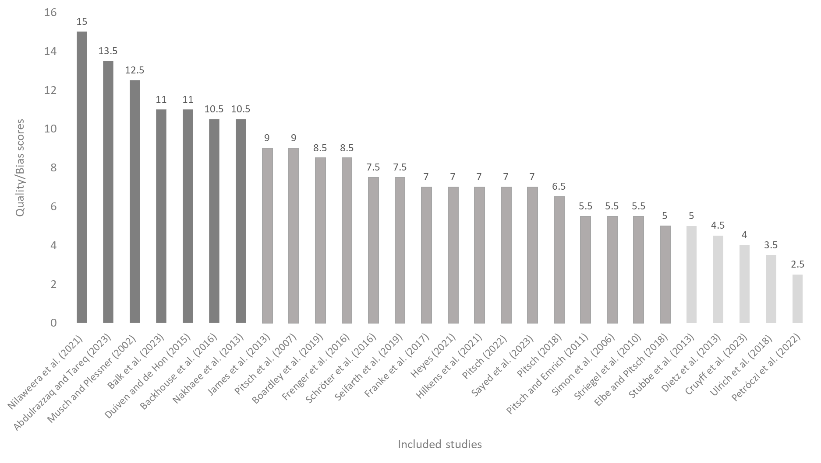
Supplementary Figure 1. Quality assessment score (dark grey: low quality/high risk; medium grey: medium quality/moderate risk; light grey: high quality/low risk).

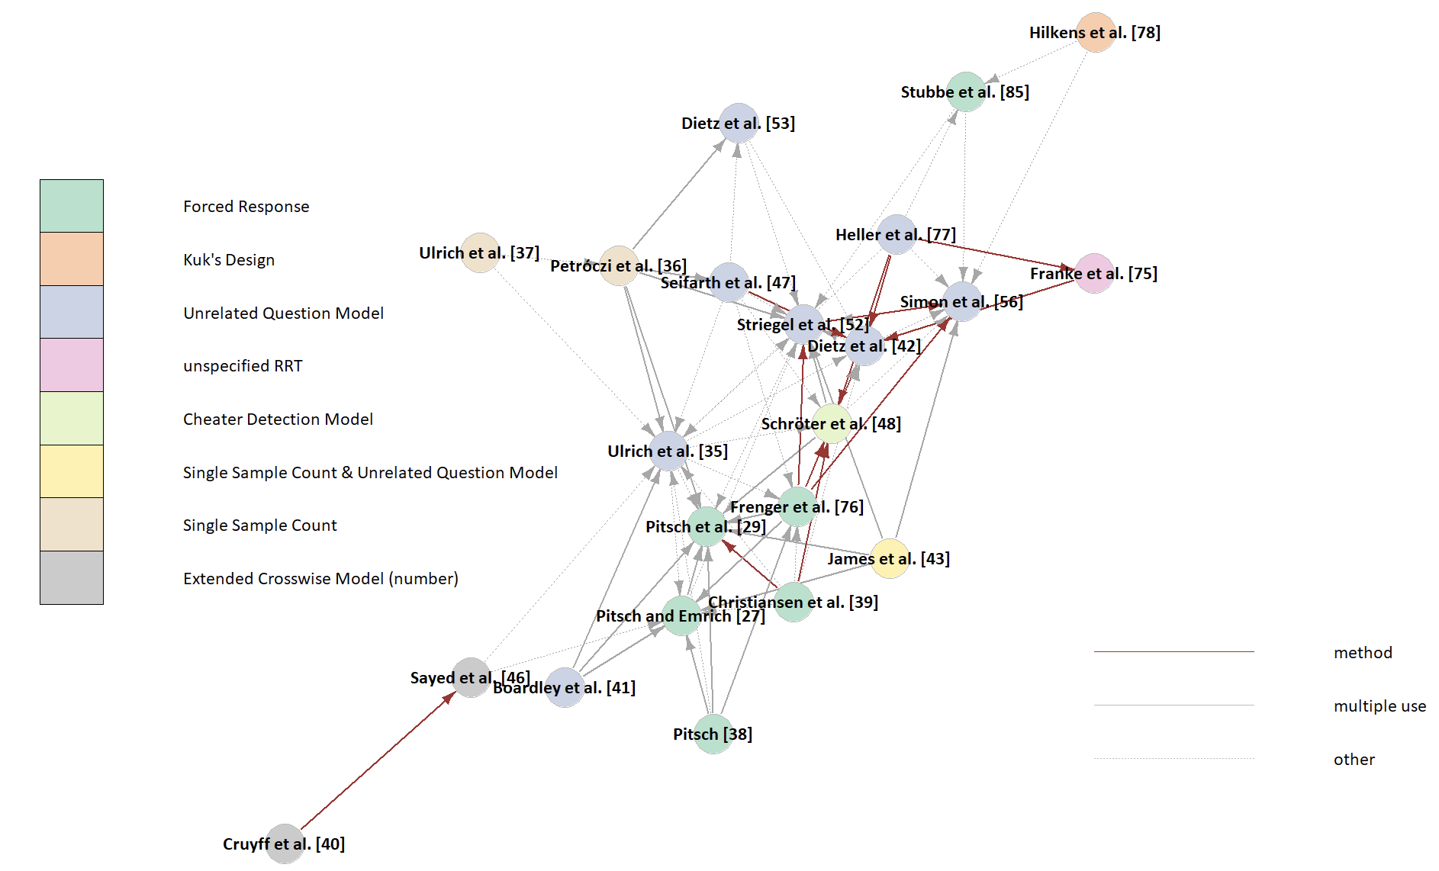
Supplementary Figure 2a. The local citation network of papers in the sample. Node colouring refers to the model employed in the paper, edge colouring indicates the type of citation statement(s). The layout represents the community structure of the citation network.

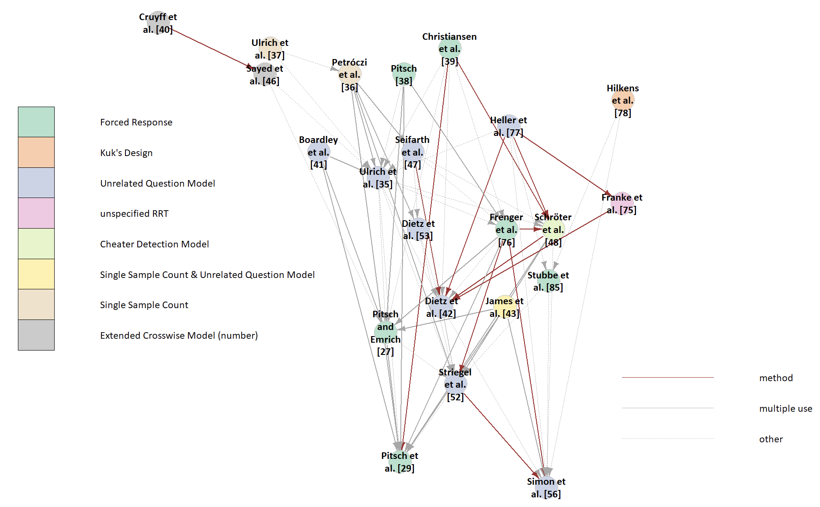
Supplementary Figure 2b. The local citation network of papers in the sample. Node colouring refers to the model employed in the paper, edge colouring indicates the type of citation statement(s). The layout represents the development of the citation network in time as the vertical axis.

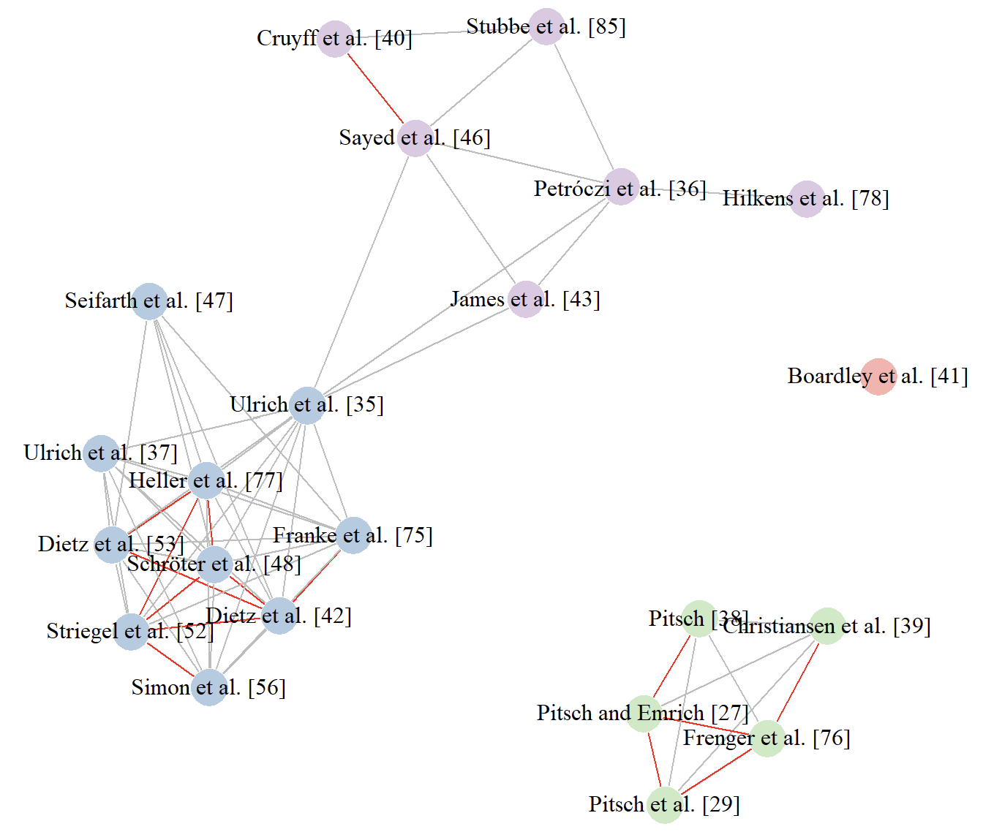
Supplementary Figure 3. Co-document network based on authorship. Colours denote clusters.

Section and Topic | Item # | Checklist item | Location where item is reported
TITLE
Title | 1 | Identify the report as a systematic review. | p. 1
ABSTRACT
Abstract | 2 | See the PRISMA 2020 for Abstracts checklist. | pp. 3–4
INTRODUCTION
Rationale | 3 | Describe the rationale for the review in the context of existing knowledge. | pp. 6–7
Objectives | 4 | Provide an explicit statement of the objective(s) or question(s) the review addresses. | pp. 6–7
METHODS
Eligibility criteria | 5 | Specify the inclusion and exclusion criteria for the review and how studies were grouped for the syntheses. | p. 8
Information sources | 6 | Specify all databases, registers, websites, organisations, reference lists and other sources searched or consulted to identify studies. Specify the date when each source was last searched or consulted. | pp. 7–8
Search strategy | 7 | Present the full search strategies for all databases, registers and websites, including any filters and limits used. | pp. 7–8
Selection process | 8 | Specify the methods used to decide whether a study met the inclusion criteria of the review, including how many reviewers screened each record and each report retrieved, whether they worked independently, and if applicable, details of automation tools used in the process. | pp. 8–9
Data collection process | 9 | Specify the methods used to collect data from reports, including how many reviewers collected data from each report, whether they worked independently, any processes for obtaining or confirming data from study investigators, and if applicable, details of automation tools used in the process. | pp. 8–9
Data items | 10a | List and define all outcomes for which data were sought. Specify whether all results that were compatible with each outcome domain in each study were sought (e.g. for all measures, time points, analyses), and if not, the methods used to decide which results to collect. | pp. 8, 54–70
Data items | 10b | List and define all other variables for which data were sought (e.g. participant and intervention characteristics, funding sources). Describe any assumptions made about any missing or unclear information. | pp. 8, 54–70
Study risk of bias assessment | 11 | Specify the methods used to assess risk of bias in the included studies, including details of the tool(s) used, how many reviewers assessed each study and whether they worked independently, and if applicable, details of automation tools used in the process. | pp. 8–9
Effect measures | 12 | Specify for each outcome the effect measure(s) (e.g. risk ratio, mean difference) used in the synthesis or presentation of results. | pp. 9–11
Synthesis methods | 13a | Describe the processes used to decide which studies were eligible for each synthesis (e.g. tabulating the study intervention characteristics and comparing against the planned groups for each synthesis (item #5)). | pp. 9–11
Synthesis methods | 13b | Describe any methods required to prepare the data for presentation or synthesis, such as handling of missing summary statistics, or data conversions. | pp. 9–11
Synthesis methods | 13c | Describe any methods used to tabulate or visually display results of individual studies and syntheses. | pp. 9–11
Synthesis methods | 13d | Describe any methods used to synthesize results and provide a rationale for the choice(s). If meta-analysis was performed, describe the model(s), method(s) to identify the presence and extent of statistical heterogeneity, and software package(s) used. | pp. 9–11
Synthesis methods | 13e | Describe any methods used to explore possible causes of heterogeneity among study results (e.g. subgroup analysis, meta-regression). | pp. 9–11
Synthesis methods | 13f | Describe any sensitivity analyses conducted to assess robustness of the synthesized results. | pp. 9–11
Reporting bias assessment | 14 | Describe any methods used to assess risk of bias due to missing results in a synthesis (arising from reporting biases). | pp. 8–9
Certainty assessment | 15 | Describe any methods used to assess certainty (or confidence) in the body of evidence for an outcome. | pp. 8–9
RESULTS
Study selection | 16a | Describe the results of the search and selection process, from the number of records identified in the search to the number of studies included in the review, ideally using a flow diagram. | pp. 11–14, 48
Study selection | 16b | Cite studies that might appear to meet the inclusion criteria, but which were excluded, and explain why they were excluded. | pp. 12–13, 44
Study characteristics | 17 | Cite each included study and present its characteristics. | pp. 44, 54–70
Risk of bias in studies | 18 | Present assessments of risk of bias for each included study. | pp. 16, 47, 71–72
Results of individual studies | 19 | For all outcomes, present, for each study: (a) summary statistics for each group (where appropriate) and (b) an effect estimate and its precision (e.g. confidence/credible interval), ideally using structured tables or plots. | pp. 52–72, 75–78, 80–83
Results of syntheses | 20a | For each synthesis, briefly summarise the characteristics and risk of bias among contributing studies. | pp. 16, 46, 71–72, 80
Results of syntheses | 20b | Present results of all statistical syntheses conducted. If meta-analysis was done, present for each the summary estimate and its precision (e.g. confidence/credible interval) and measures of statistical heterogeneity. If comparing groups, describe the direction of the effect. | pp. 11–22, 46–47, 49–53, 71–75, 80–83
Results of syntheses | 20c | Present results of all investigations of possible causes of heterogeneity among study results. | p. 17
Results of syntheses | 20d | Present results of all sensitivity analyses conducted to assess the robustness of the synthesized results. | p. 17
Reporting biases | 21 | Present assessments of risk of bias due to missing results (arising from reporting biases) for each synthesis assessed. | pp. 16, 46, 71–72, 80
Certainty of evidence | 22 | Present assessments of certainty (or confidence) in the body of evidence for each outcome assessed. | pp. 17–18, 52
DISCUSSION
Discussion | 23a | Provide a general interpretation of the results in the context of other evidence. | pp. 22–33
Discussion | 23b | Discuss any limitations of the evidence included in the review. | pp. 30–32
Discussion | 23c | Discuss any limitations of the review processes used. | pp. 30–32
Discussion | 23d | Discuss implications of the results for practice, policy, and future research. | pp. 31–32
OTHER INFORMATION
Registration and protocol | 24a | Provide registration information for the review, including register name and registration number, or state that the review was not registered. | pp. 7
Registration and protocol | 24b | Indicate where the review protocol can be accessed, or state that a protocol was not prepared. | pp. 7
Registration and protocol | 24c | Describe and explain any amendments to information provided at registration or in the protocol. | pp. 7
Support | 25 | Describe sources of financial or non-financial support for the review, and the role of the funders or sponsors in the review. | p. 34
Competing interests | 26 | Declare any competing interests of review authors. | p. 33–34
Availability of data, code and other materials | 27 | Report which of the following are publicly available and where they can be found: template data collection forms; data extracted from included studies; data used for all analyses; analytic code; any other materials used in the review. | Supplementary file: pp. 54–84

From: Page MJ, McKenzie JE, Bossuyt PM, Boutron I, Hoffmann TC, Mulrow CD, et al. The PRISMA 2020 statement: an updated guideline for reporting systematic reviews. BMJ 2021;372:n71. doi: 10.1136/bmj.n71
For more information, visit: http://www.prisma-statement.org/

