Supplementary Figures

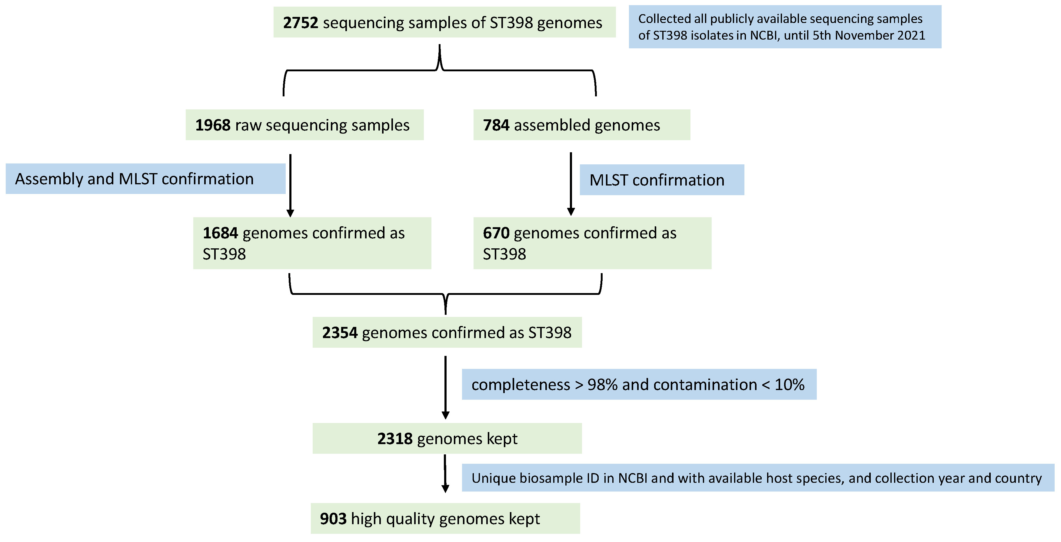
Fig. S1 Workflow of collection and processing of publicly available ST398 genomes in this study.
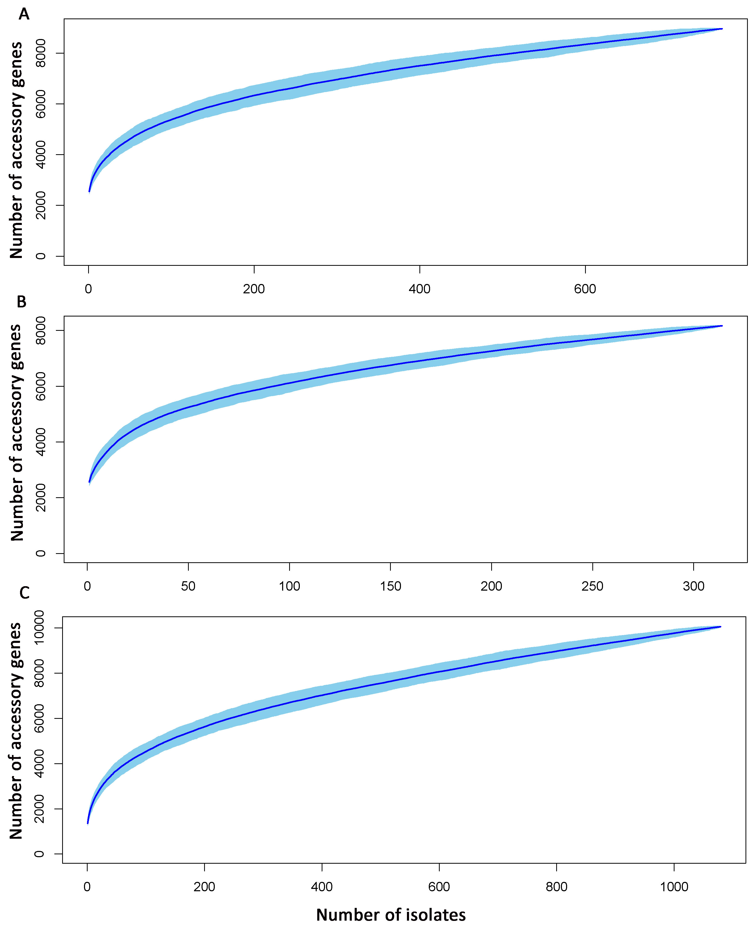
Fig. S2 Accumulative curves of accessory genes among human-isolates (A), animal-isolates (B) and all-isolates (C) of ST398.

Fig. S3 Null-model based normalized stochasticity ratio (NST) shows the importance of stochastic processes in the changes of accessory genomes across individuals within specific periods (A) and between periods (B). P values are in comparison between adjacent boxes by using Wilcoxon test.

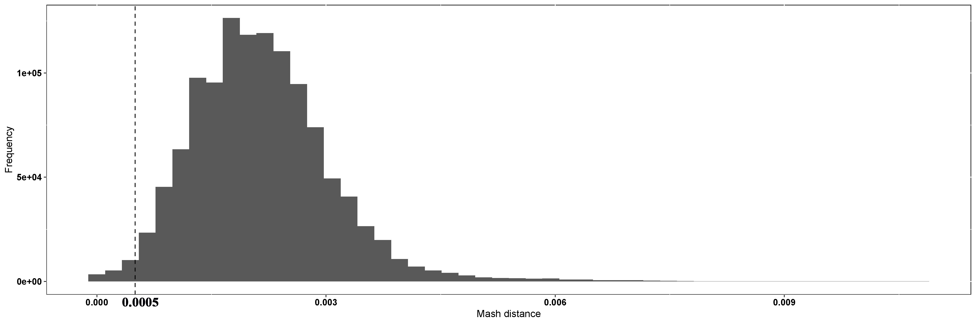
Fig. S4 Frequency of pairwise Mash distances among all 1079 isolates.

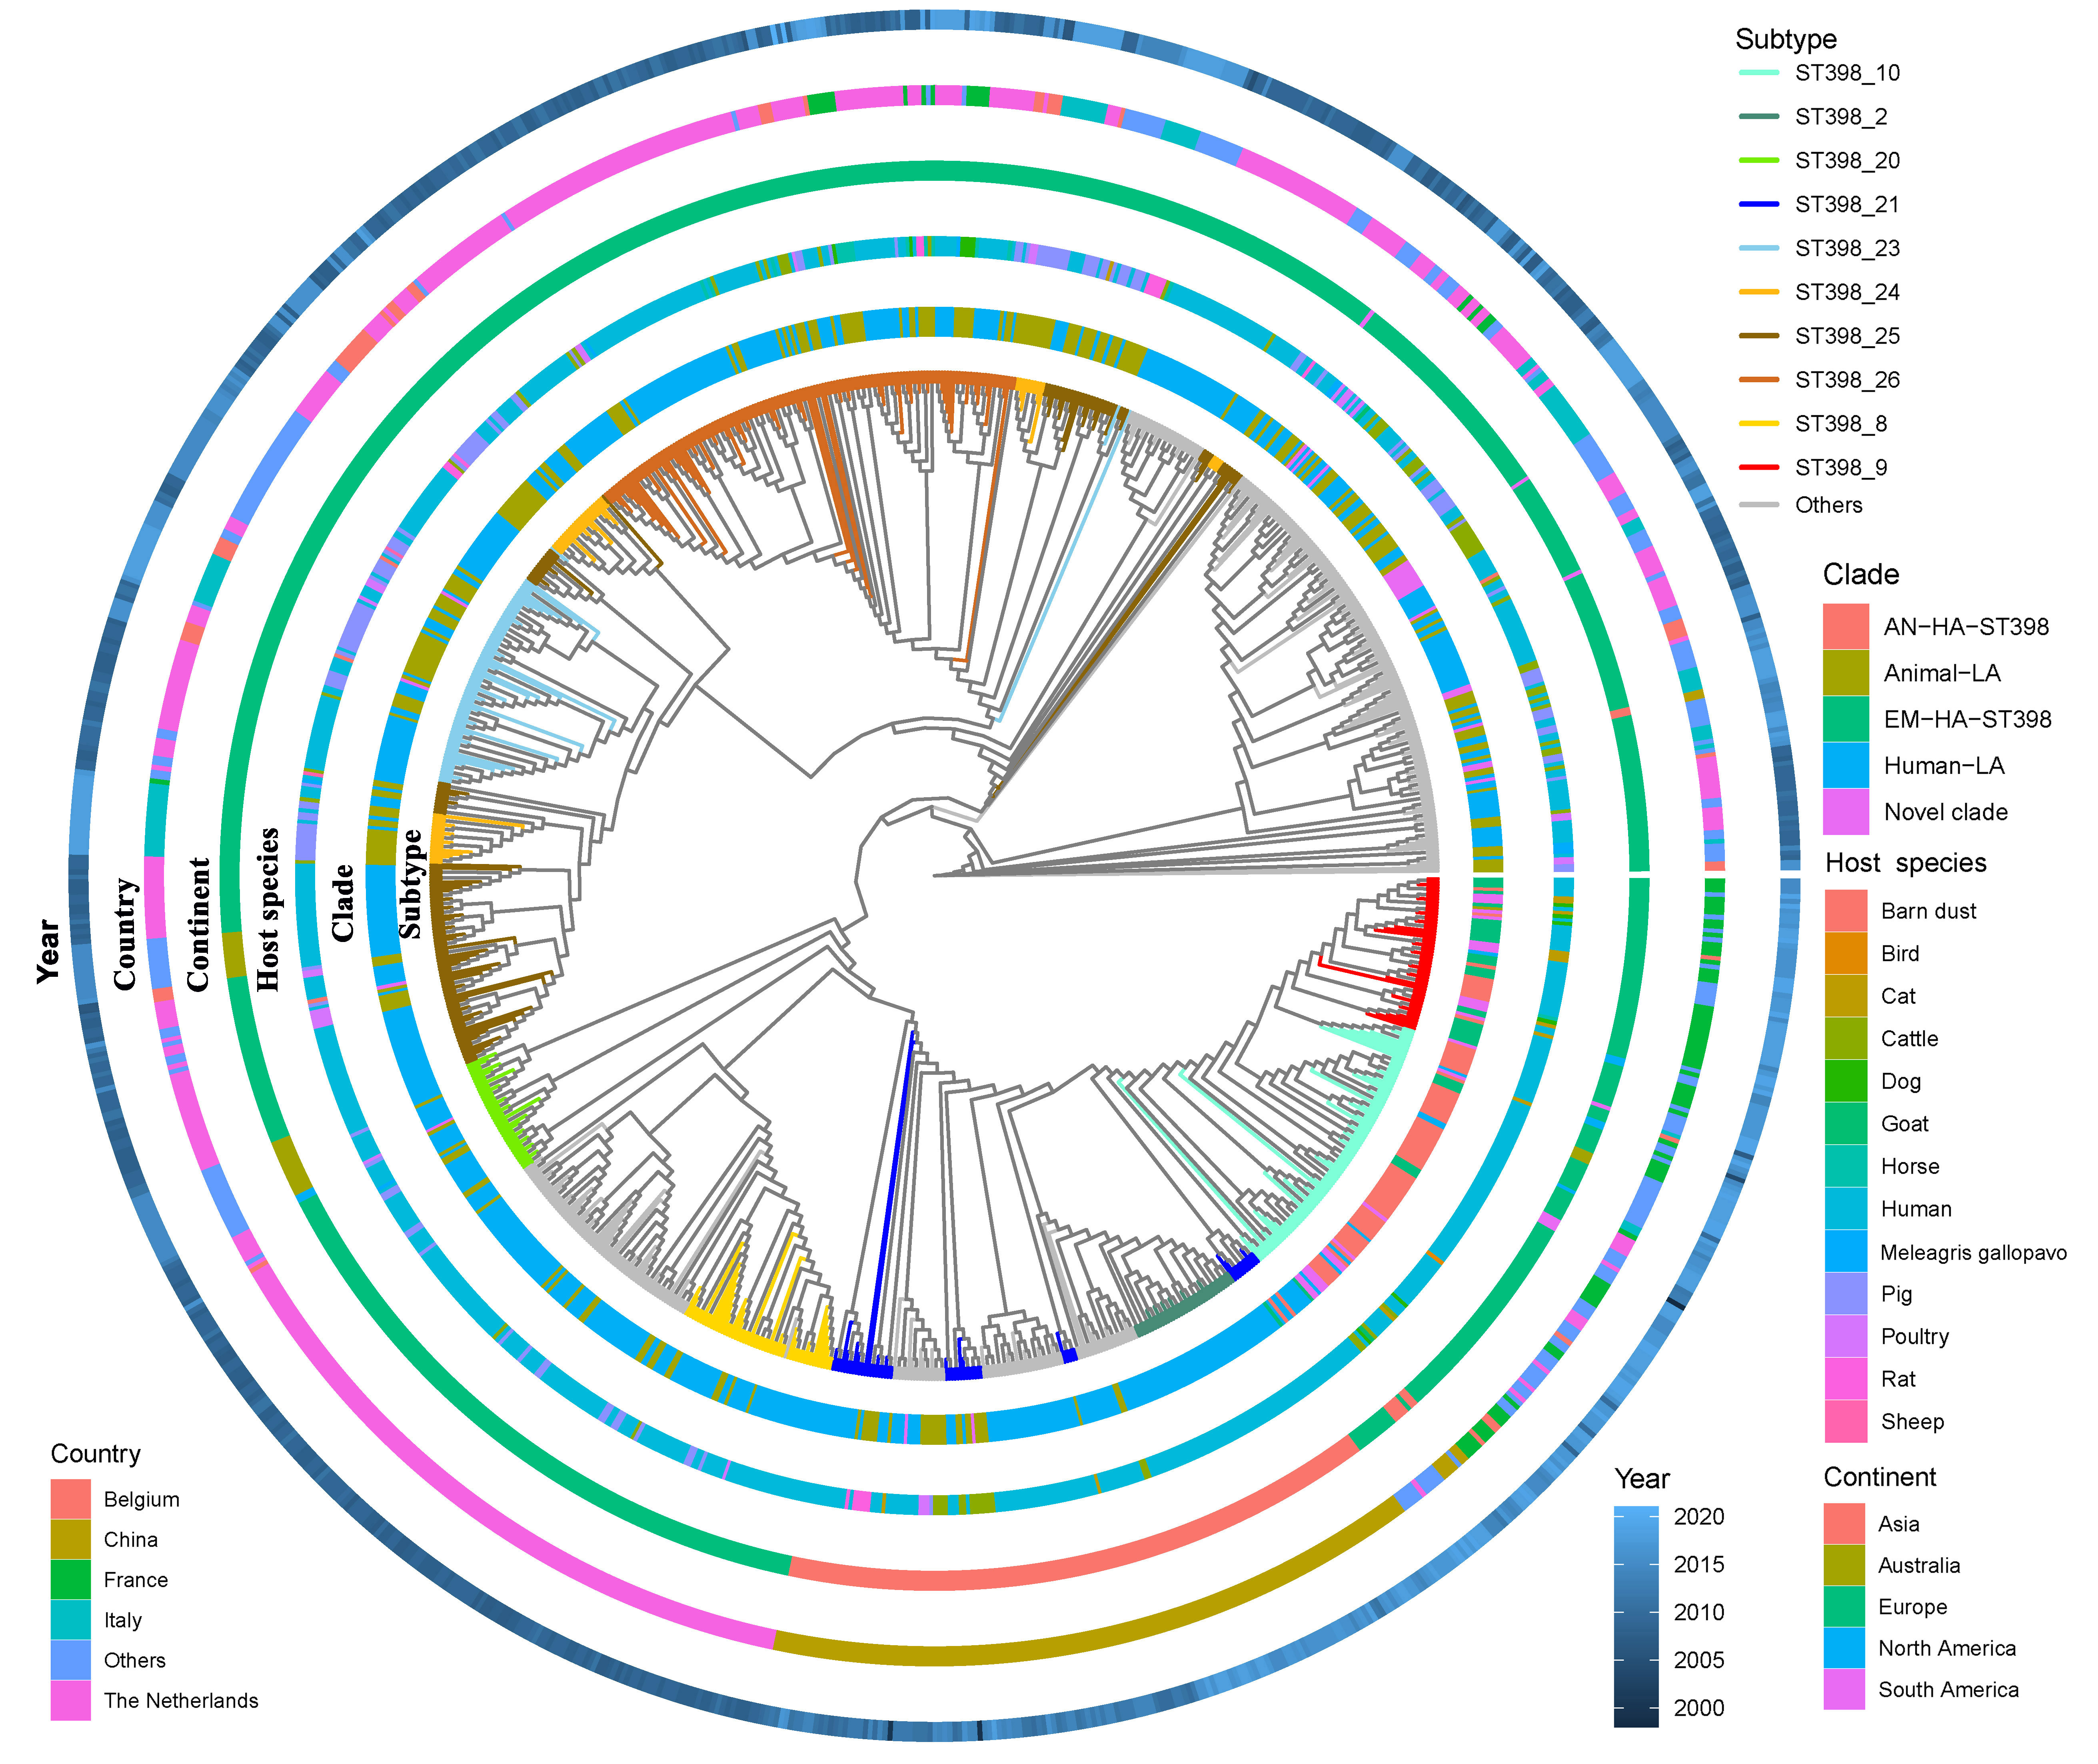
Fig. S5 Maximum likelihood phylogeny based on core genome of global ST398 isolates. For the collection country, only top five are colored.

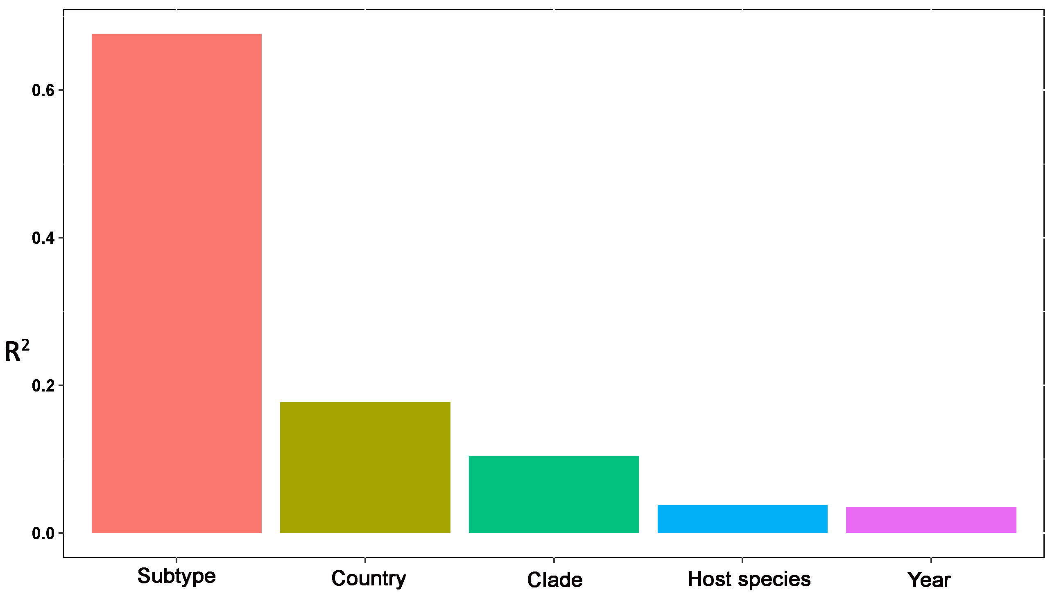
Fig. S6 The variable explanation for core genome phylogeny, evaluated by distance-based redundancy analysis.

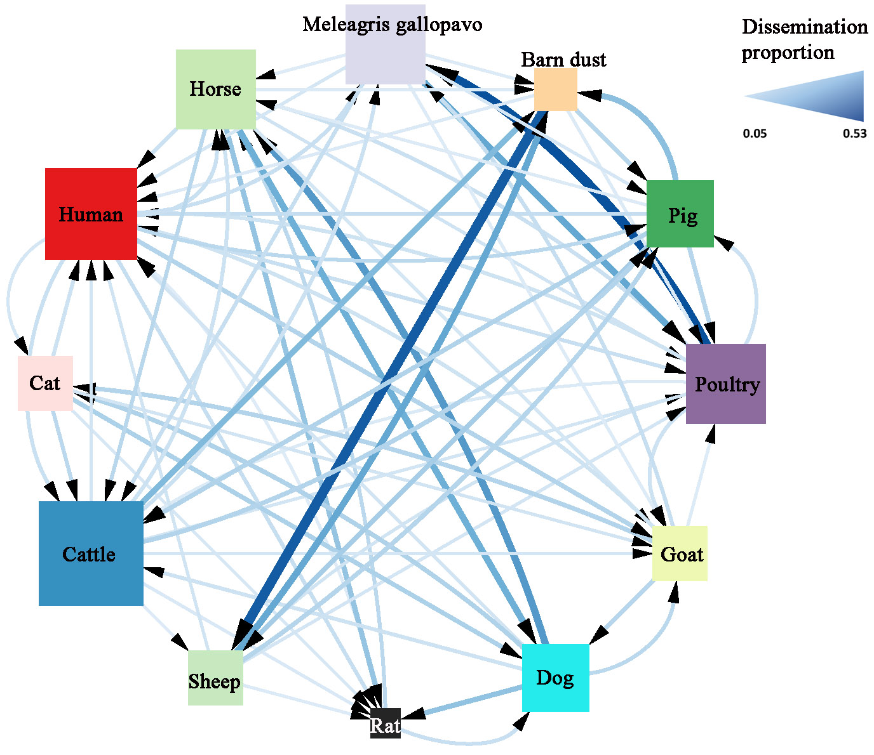
Fig. S7 The Bayesian source-tracker analysis quantifies the potential dissemination of ST398 across different host species, based on their accessory genomes. Lines are sized and colored by the estimated dissemination proportion of accessory genomes from the sourced host to the targeted host. Only lines with dissemination proportions > 5% are shown. The squares represent host species and are sized by the numbers of outward arrows.

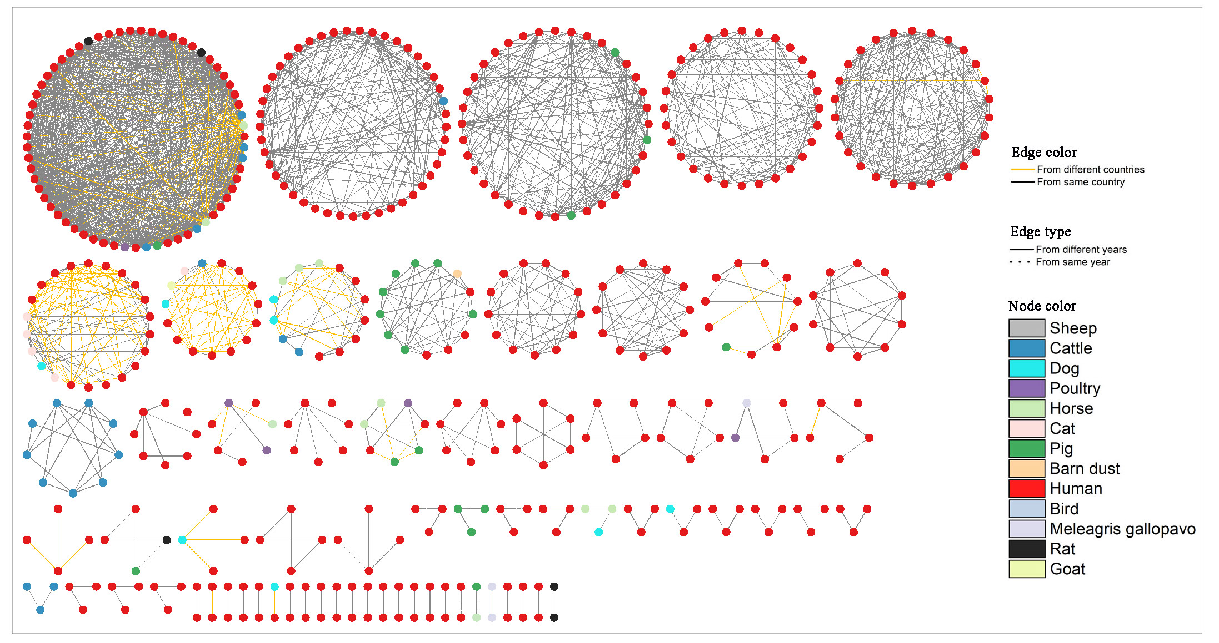
Fig. S8 Network analysis showing potential transmission of accessory genomes of ST398 across host species. Nodes represent ST398 isolates, and are sized by node degree (i.e., number of edges connected to the nodes). Edges represent that the accessory genomes of two isolates are similar. Only edges with Jaccard dissimilarity < 0.005 are shown.

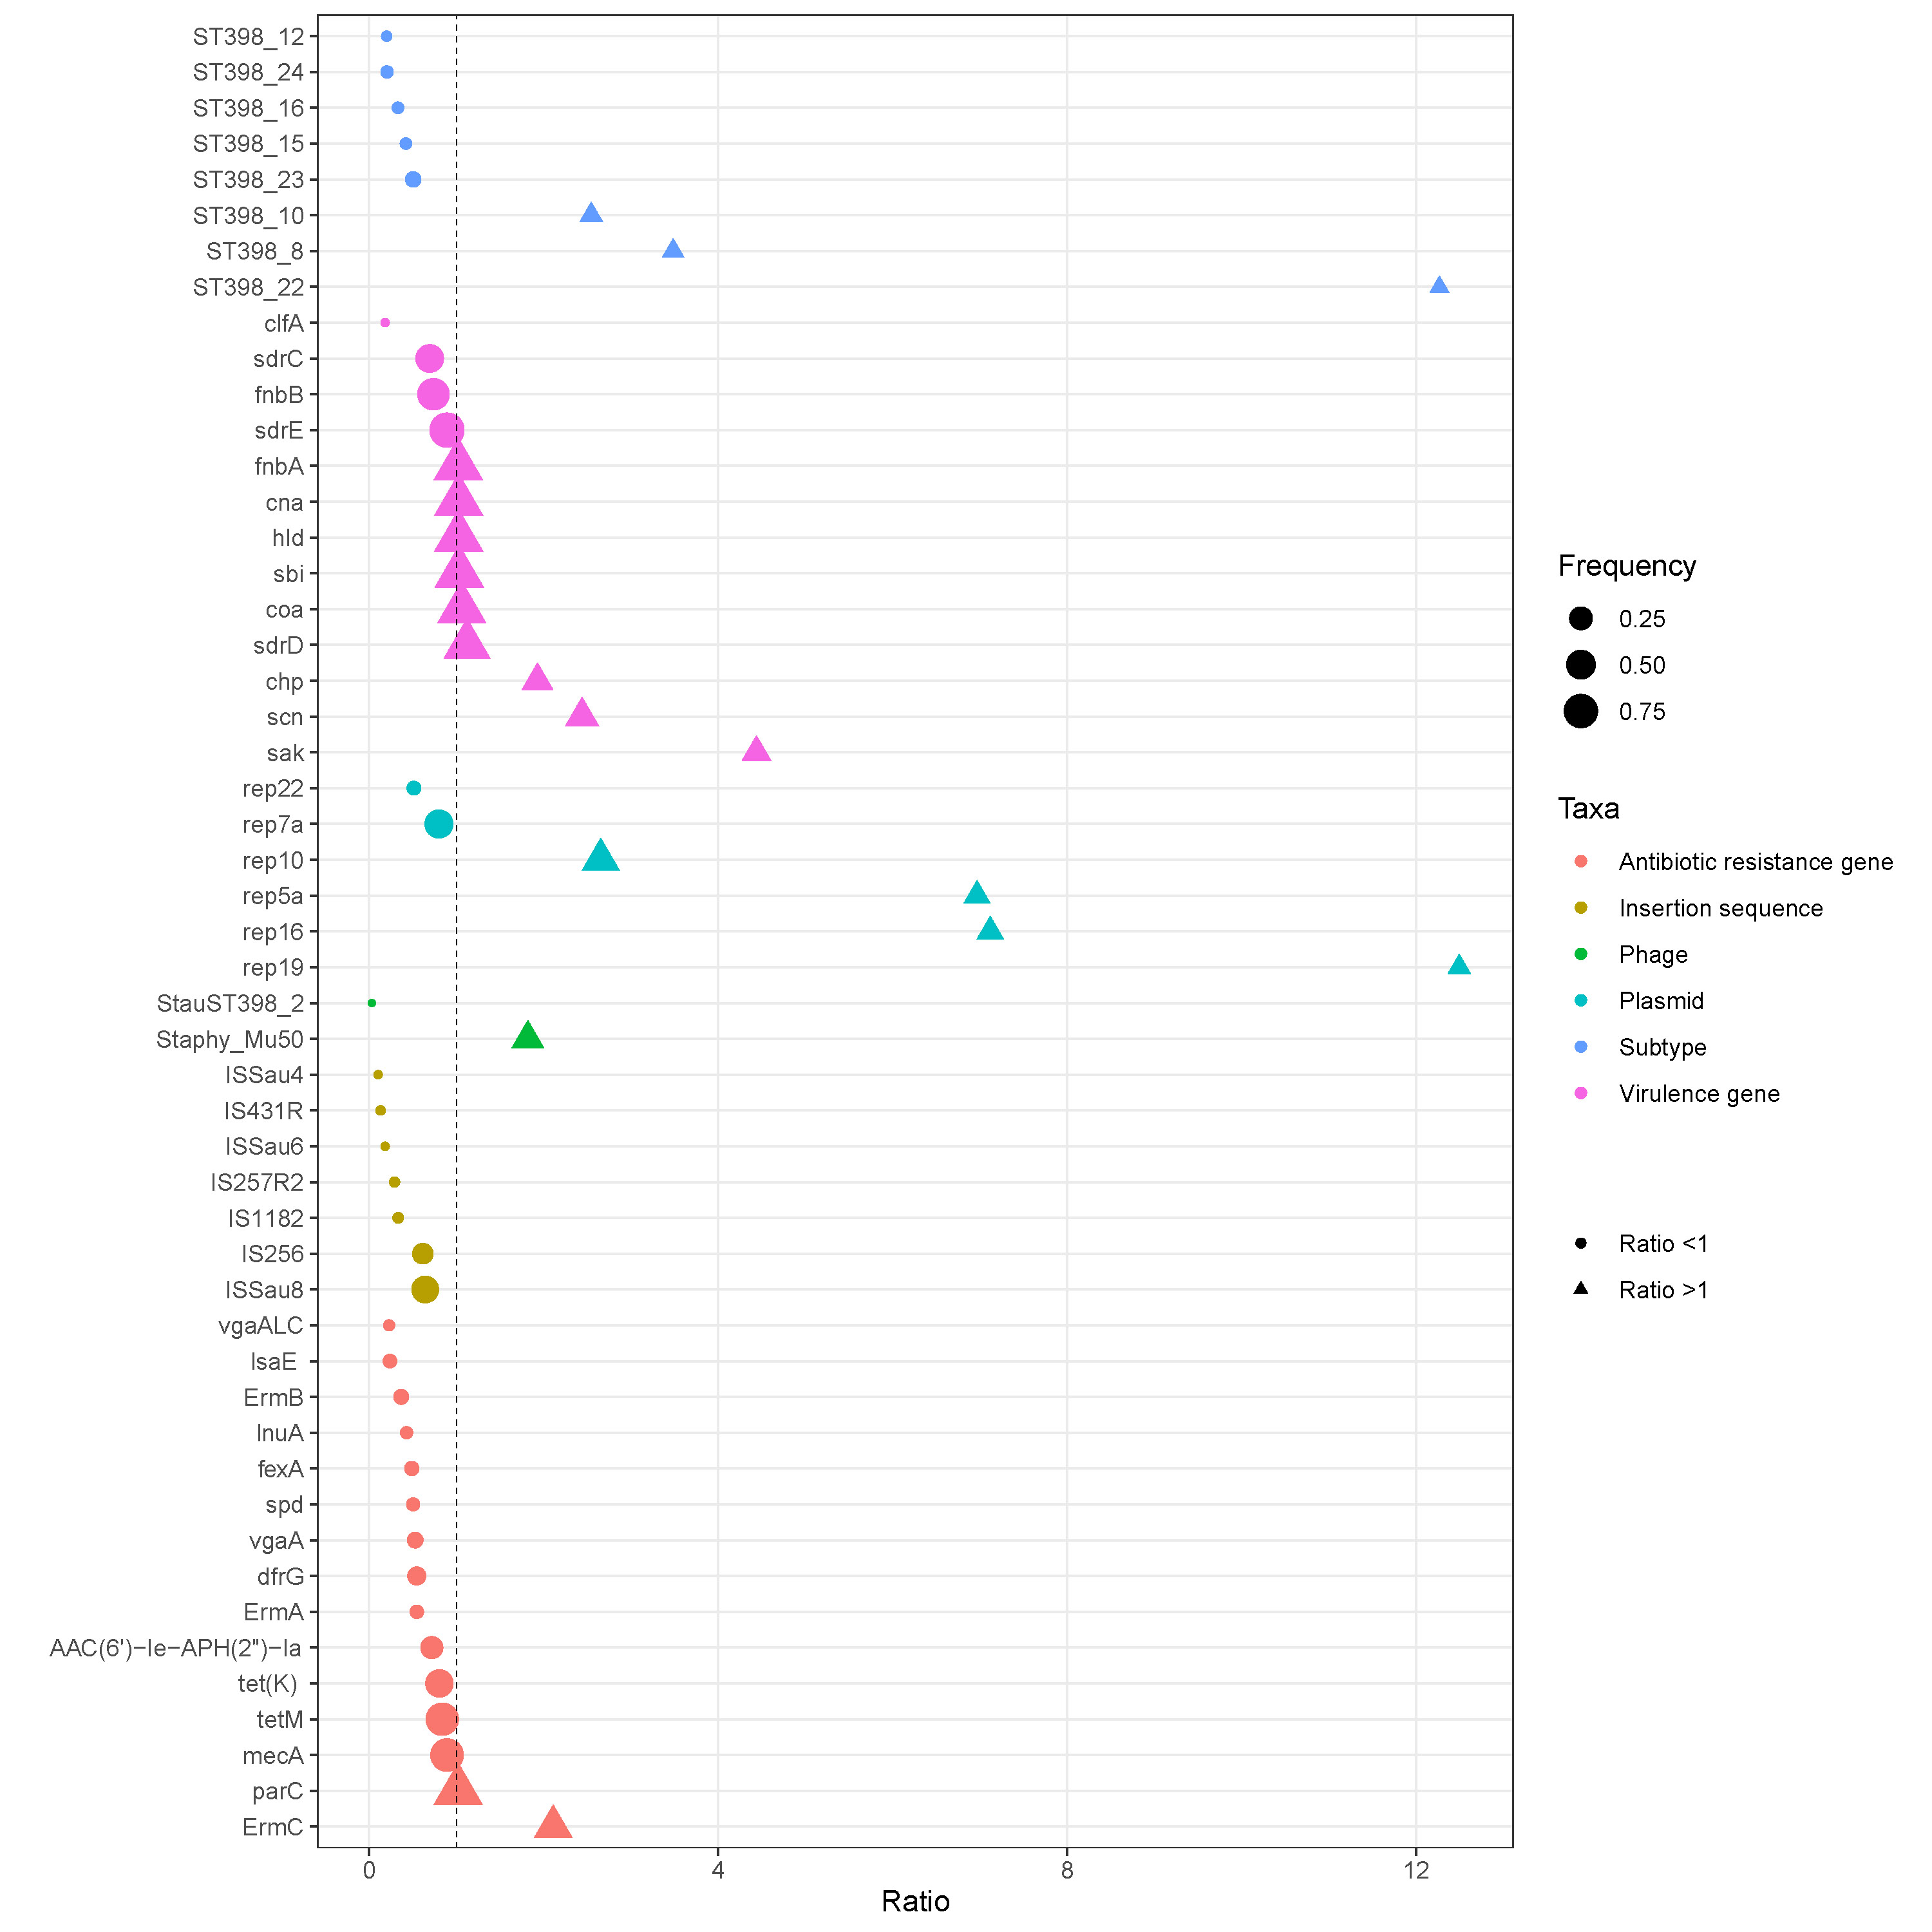
Fig. S9 Taxa significantly (P < 0.05) associated with human-isolates (ratio>1) or animal-isolates (ratio < 1). Points represent taxa and are sized by their frequencies among human-isolates. The dash line represents the ration = 1.

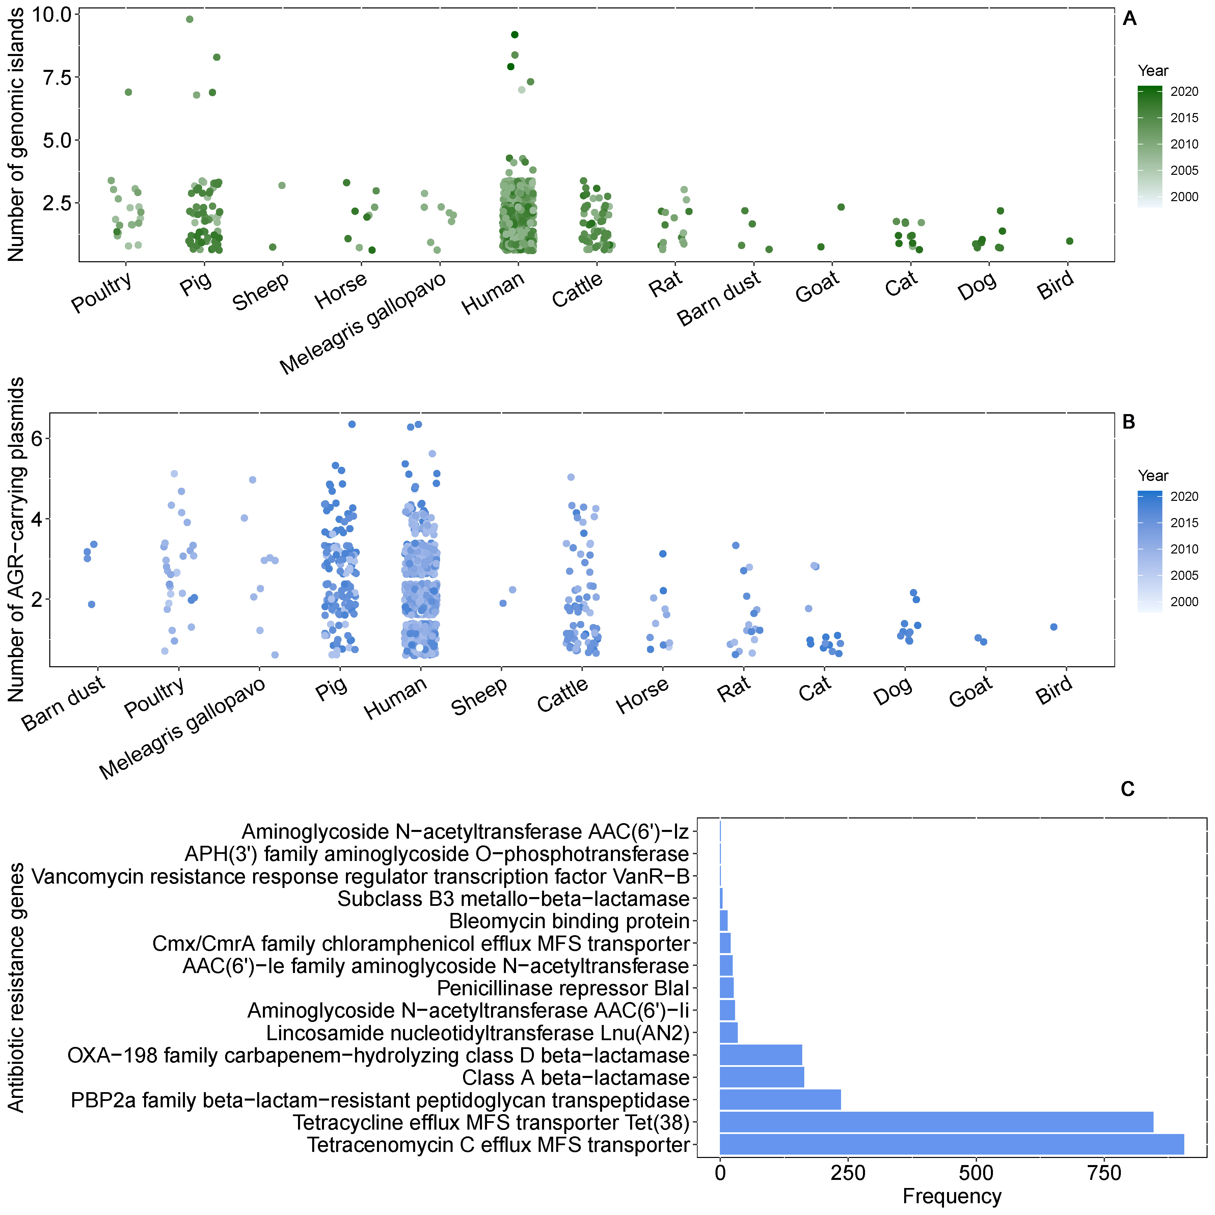
Fig. S10 Genomic islands and plasmids in ST398 isolates. The numbers of genomic islands (A) and antibiotic resistance gene (ARG)-carrying plasmids (B). The x-axis from left is ranked by decreasing means. The frequencies (C) of different ARGs in plasmids of ST398 isolates.

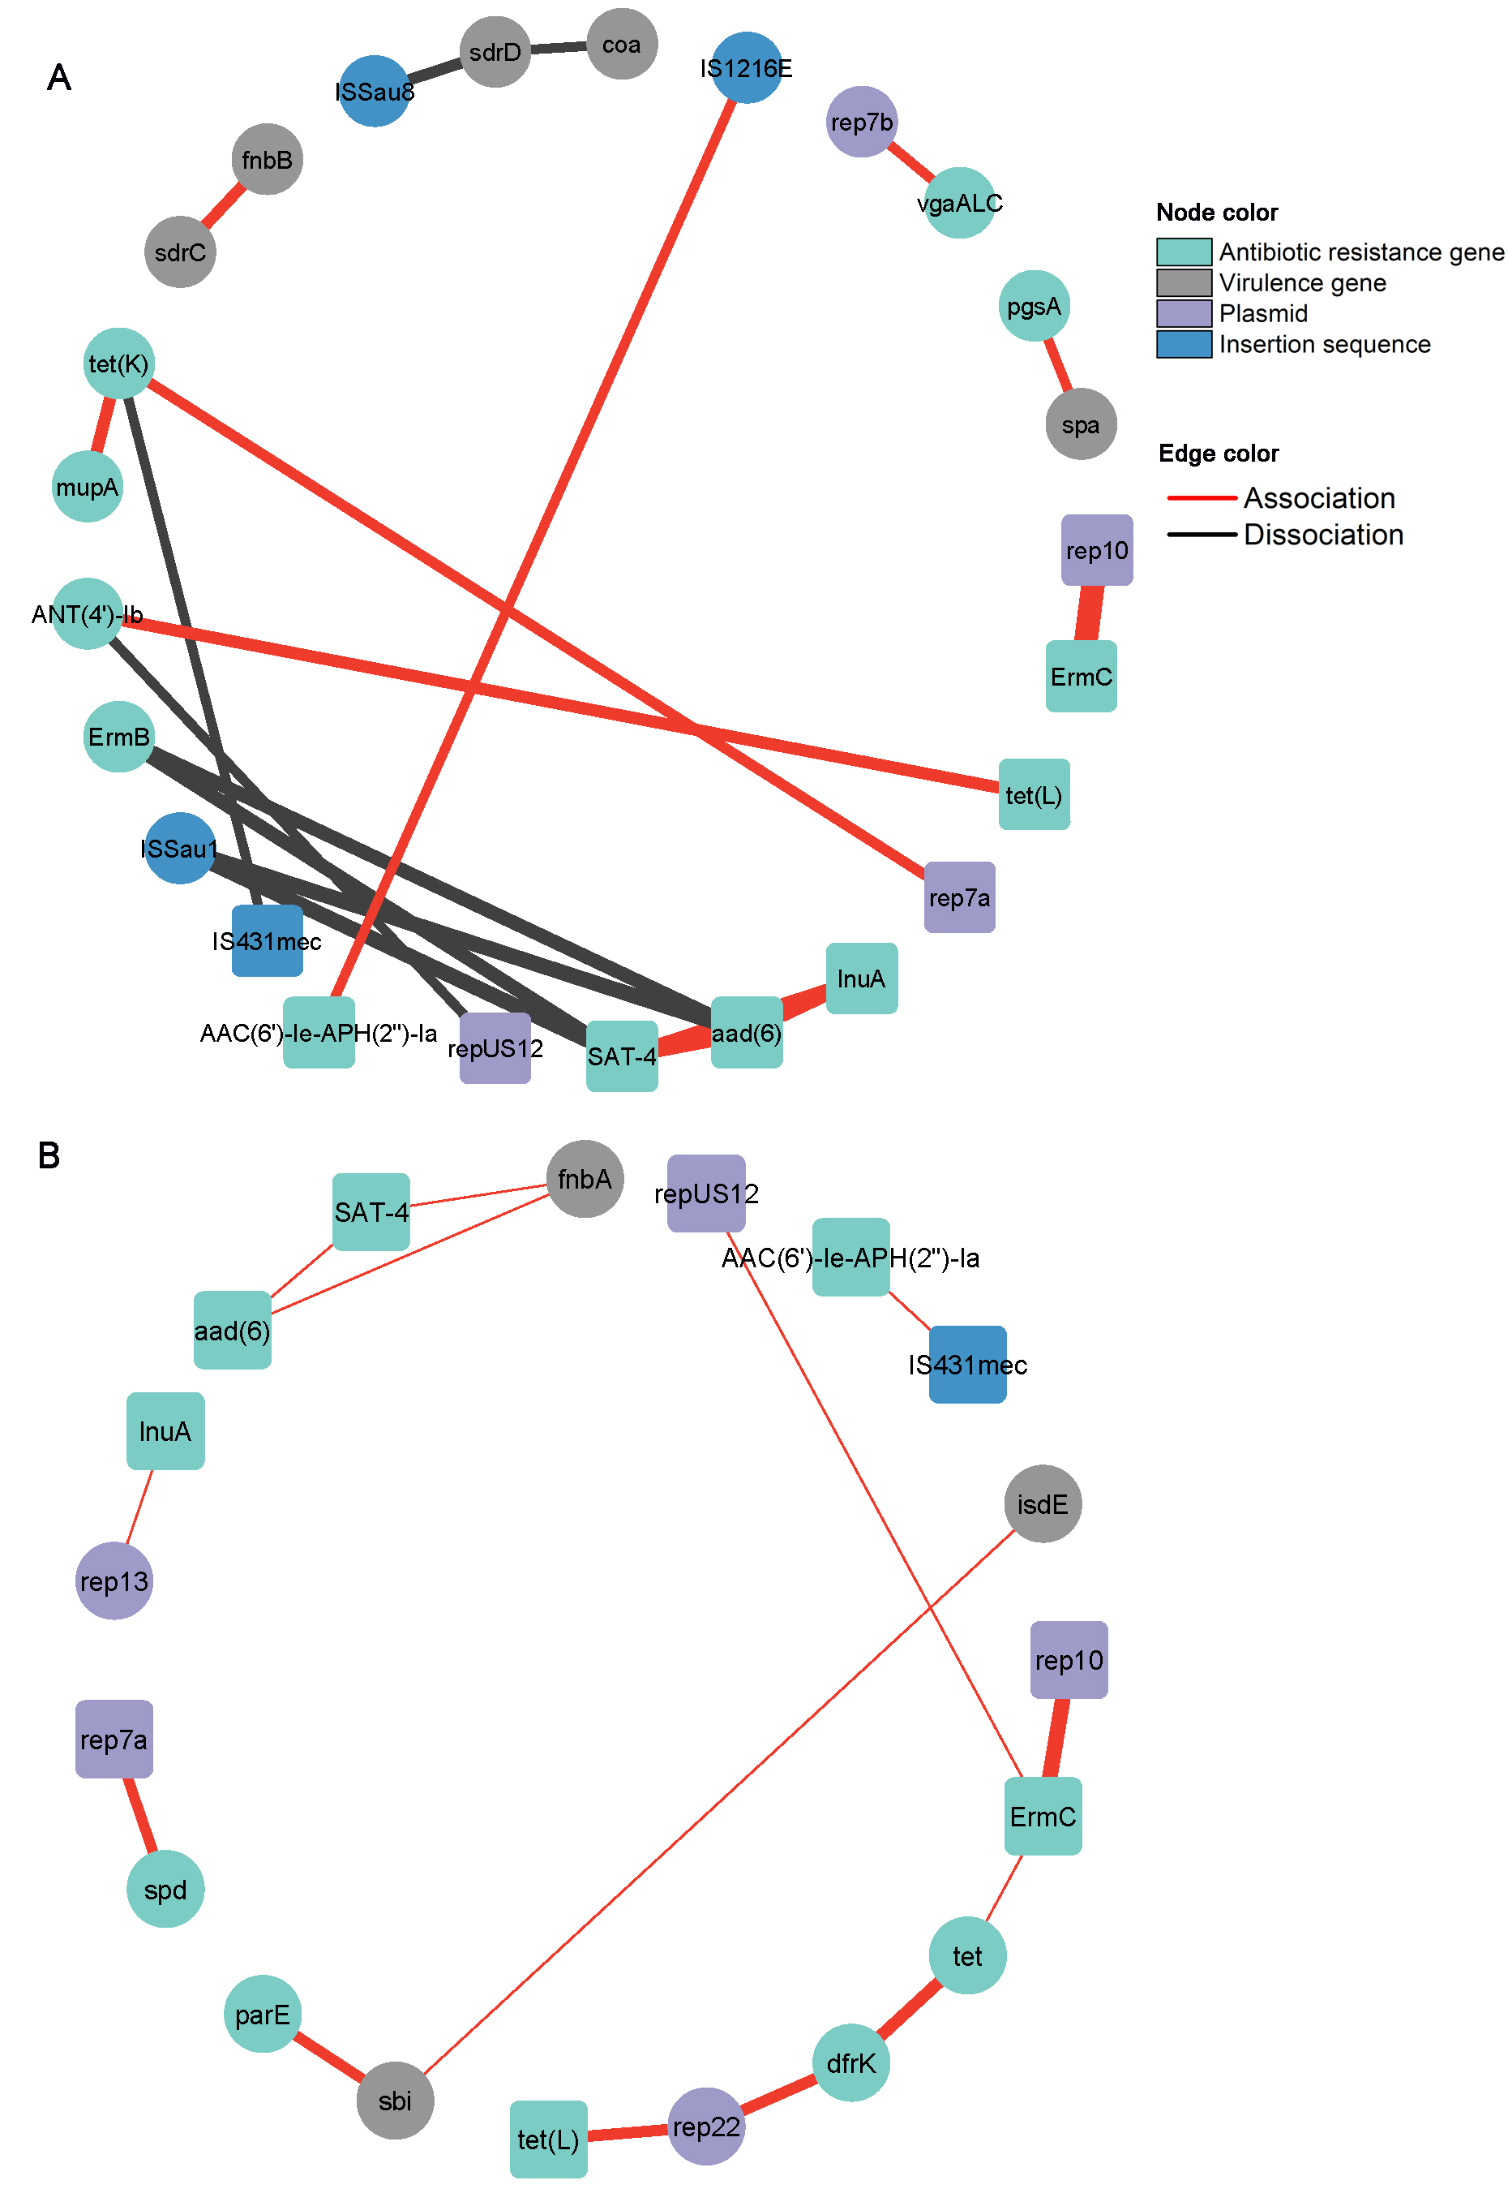
Fig. S11 Co-evolution networks of accessory genomes in human-isolates (A) and animal-isolates (B) of ST398. The width of edge is scaled by co-evolution score. Square nodes indicate the common taxa between the two networks. Among the top 100 edges (ranked by co-evolution score), only the edges among resistance genes, virulence genes, plasmids and insertion sequences are shown.

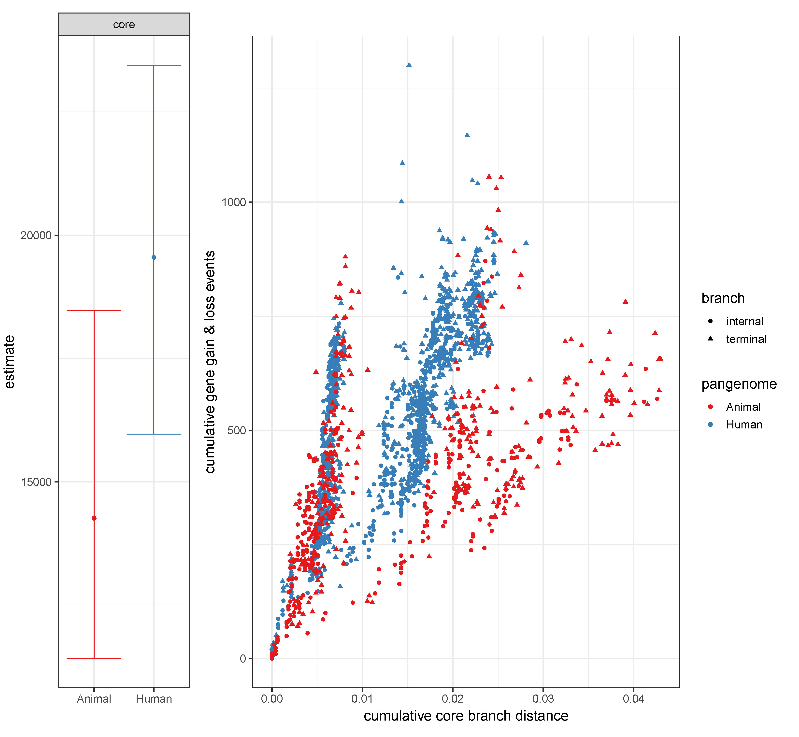
Fig. S12 The relationship between the cumulative number of gene gain and loss events and the cumulative branch length, separately in human-isolates and animal-isolates. P < 0.0001 in the core term indicates that the human-isolates have a significantly higher rate of gene gain and loss than animal-isolates.

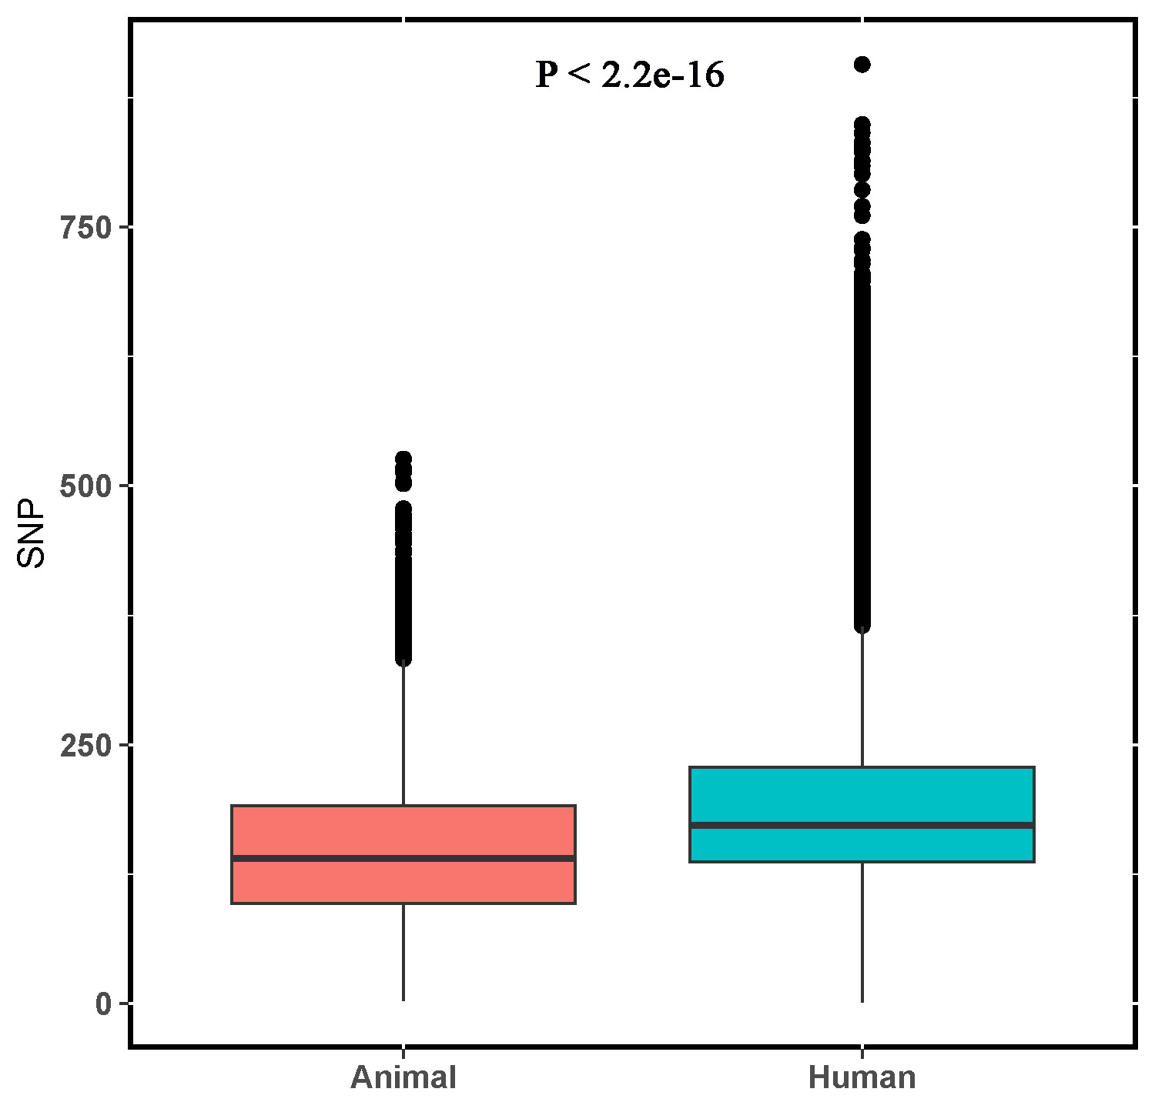
Fig. S13 SNP (Single-Nucleotide Polymorphisms) dissimilarity among human-isolates, and among animal-isolates.

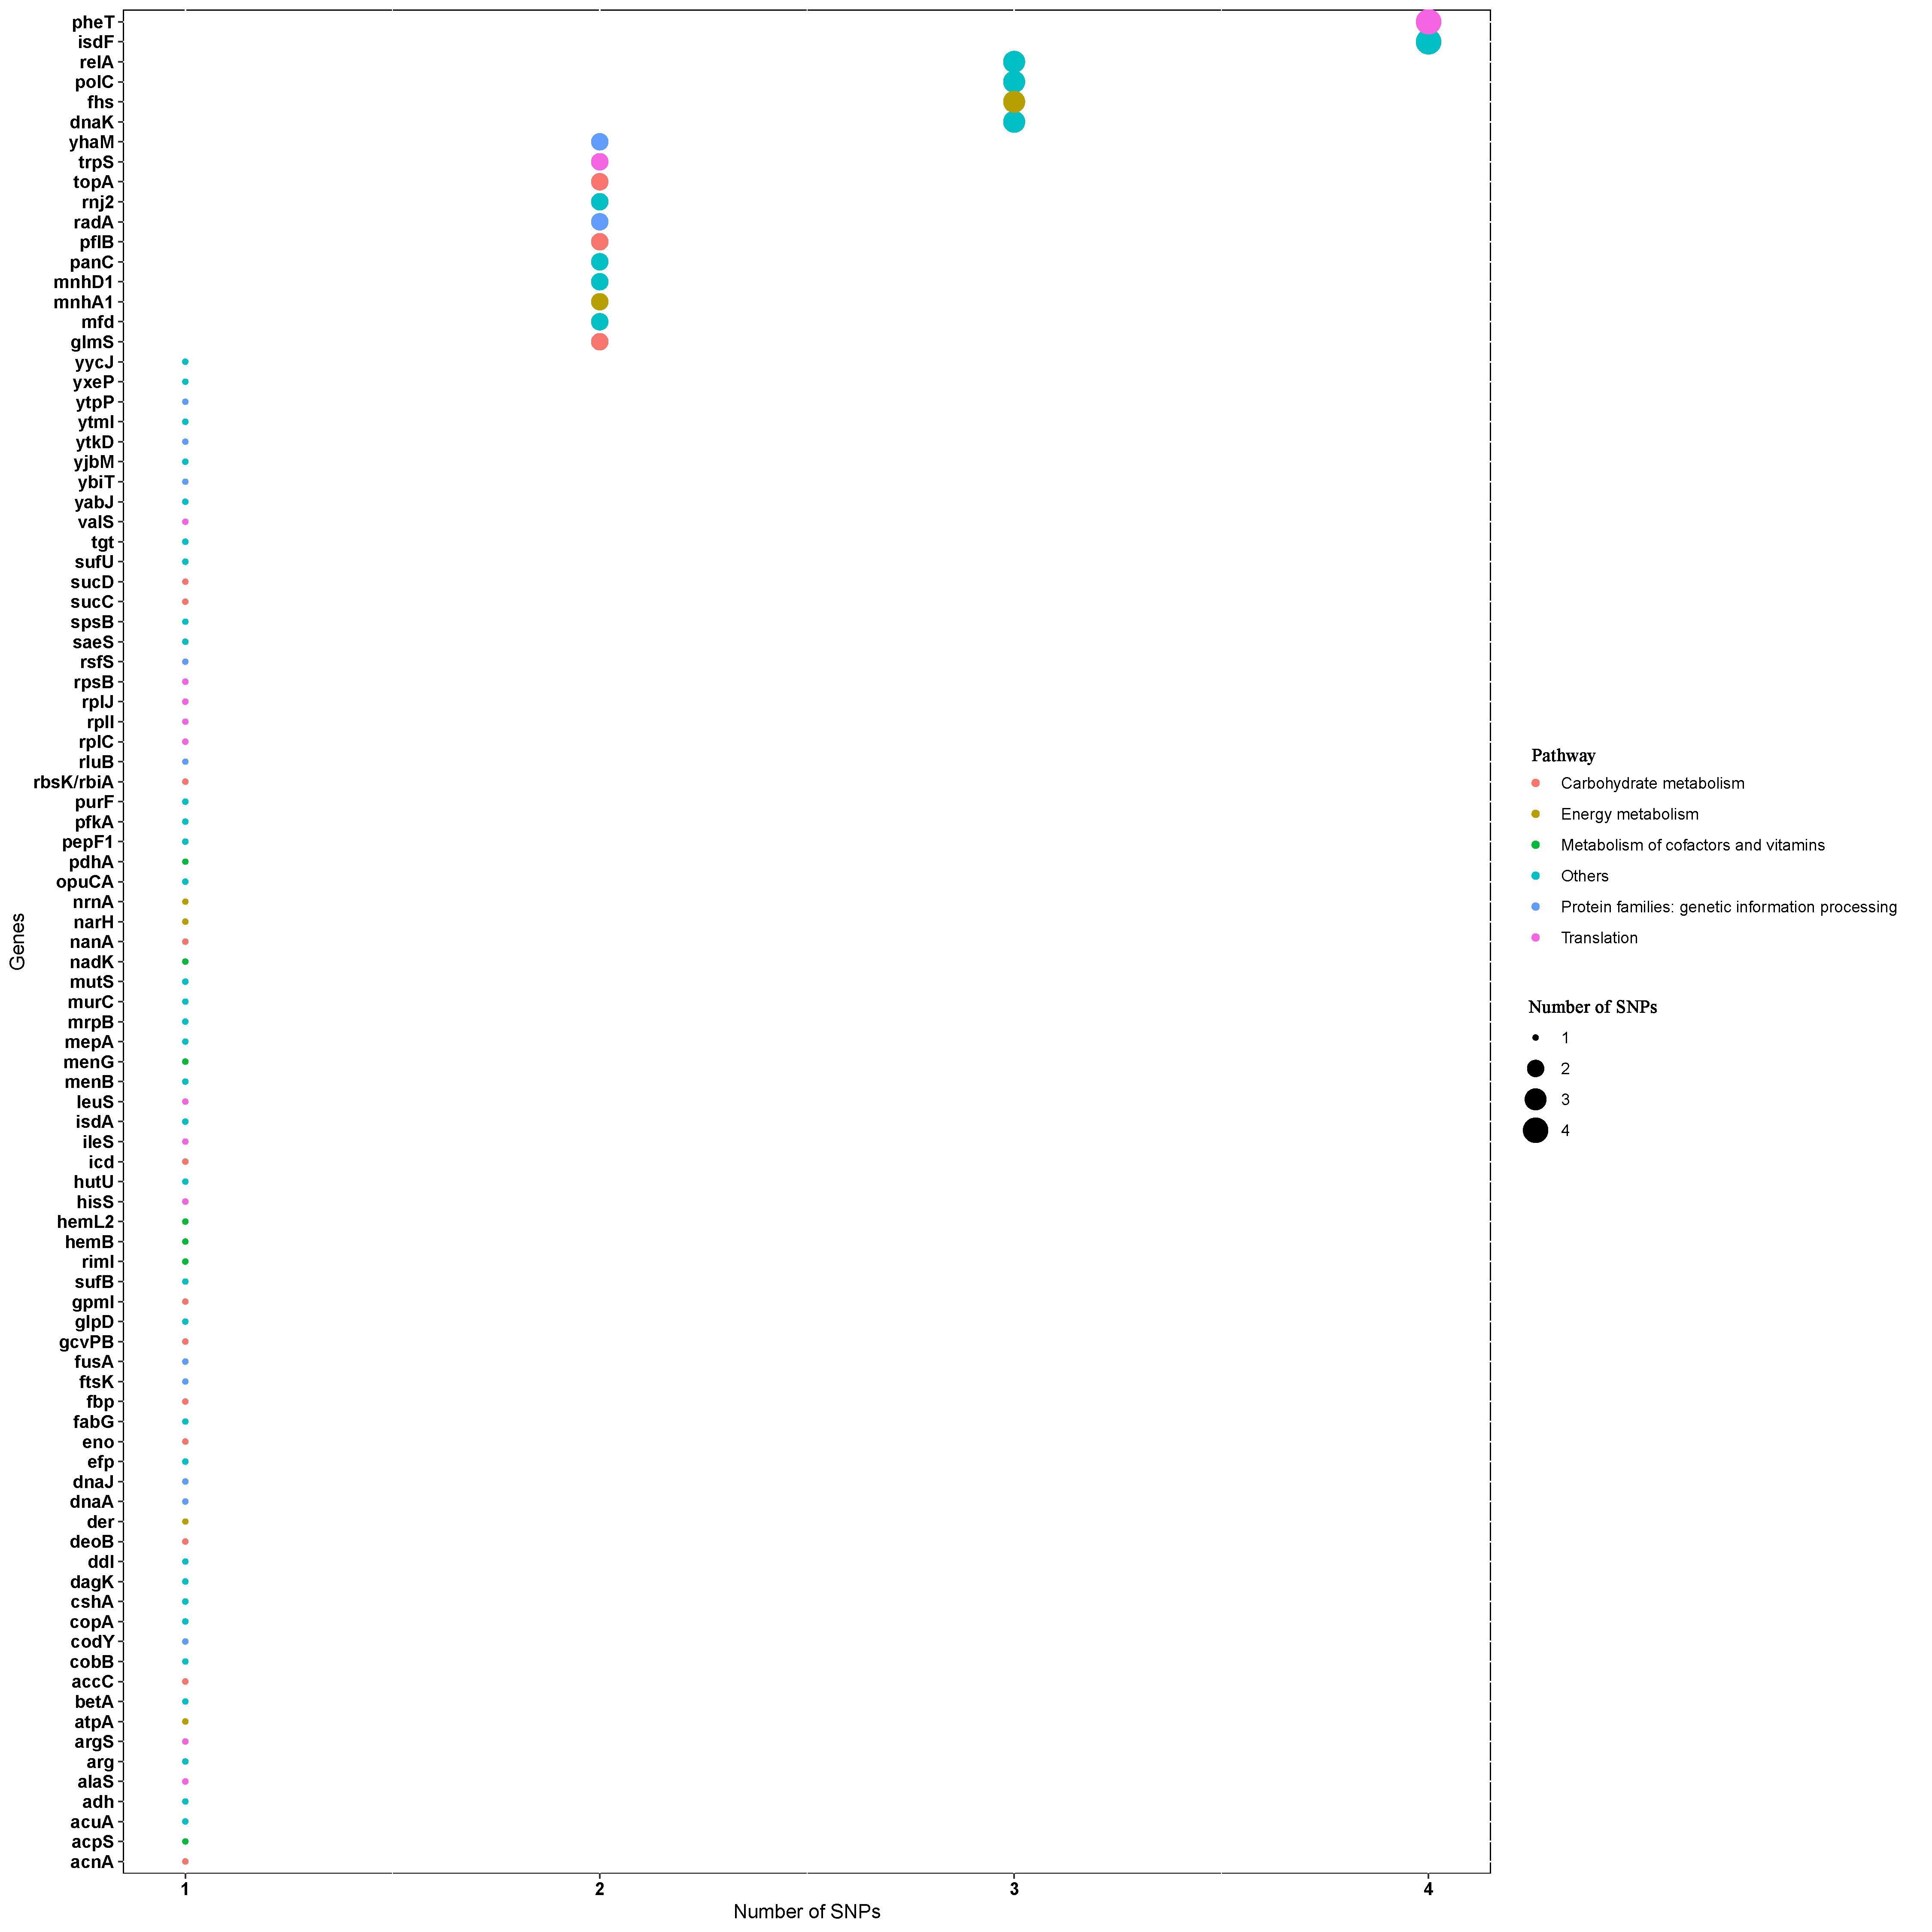
Fig. S14 Number of SNPs (Single-Nucleotide Polymorphisms) within genes. In total, 177 SNPs are identified to distinguish the dominant 10 subtypes of global ST398 isolates. Only the top 5 KEGG pathways are shown.

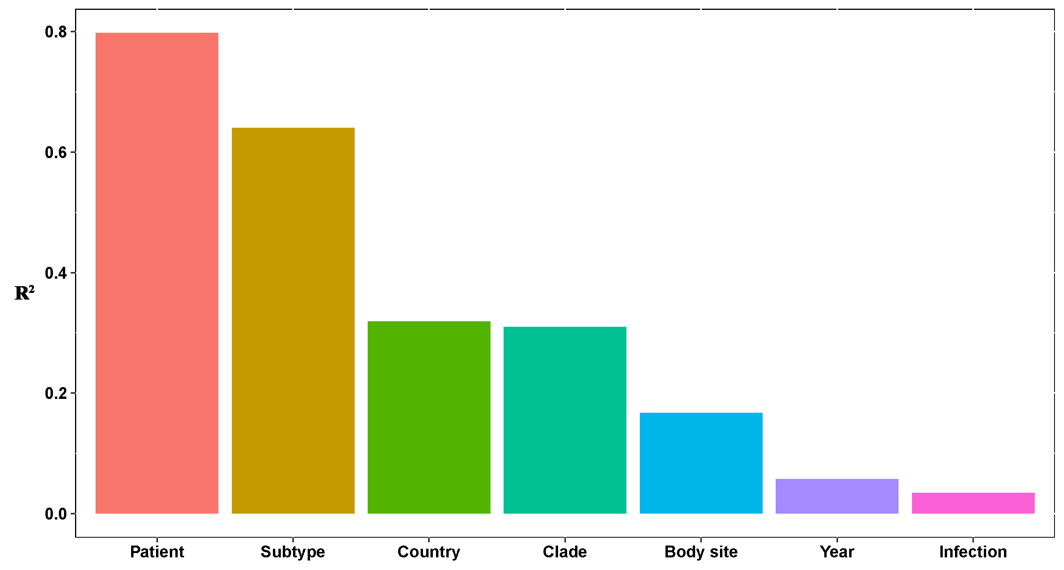
Fig. S15 The variable explanation for the phylogenetic distribution of isolates from patients, evaluated by distance-based redundancy analysis.

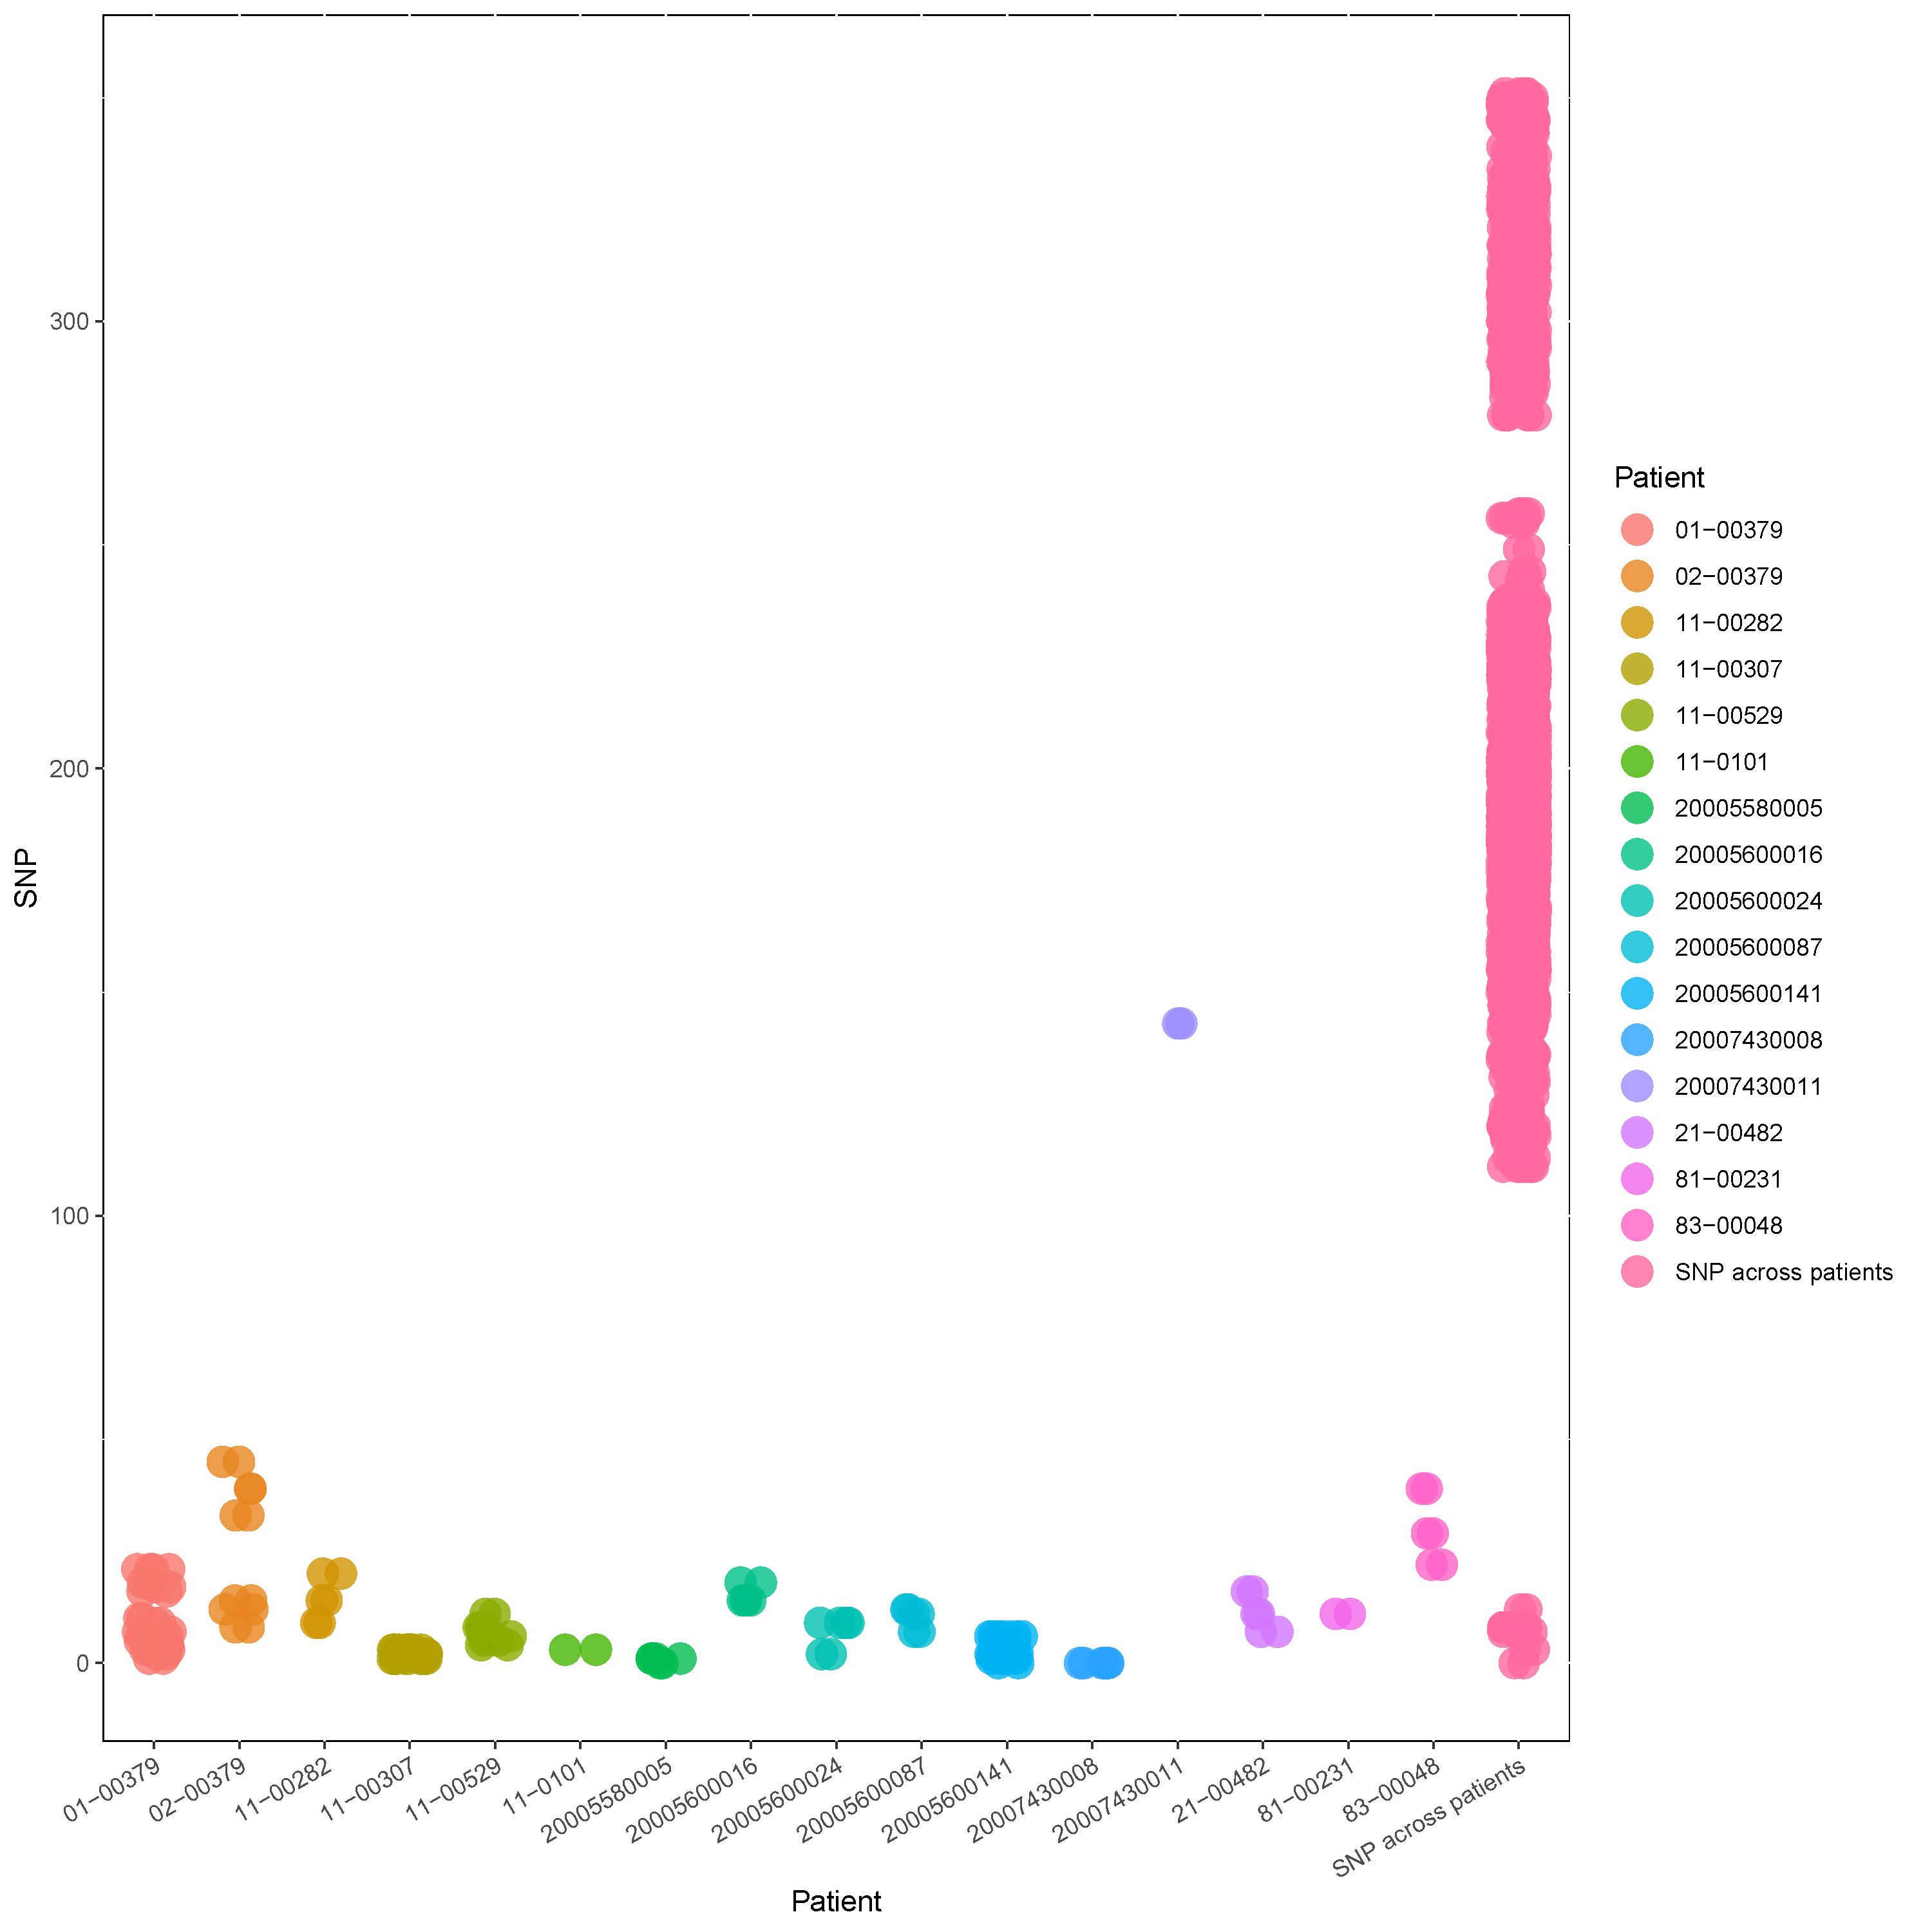
Fig. S16 SNP (Single-Nucleotide Polymorphism) dissimilarity across pairwise isolates within the same patient and across patients.

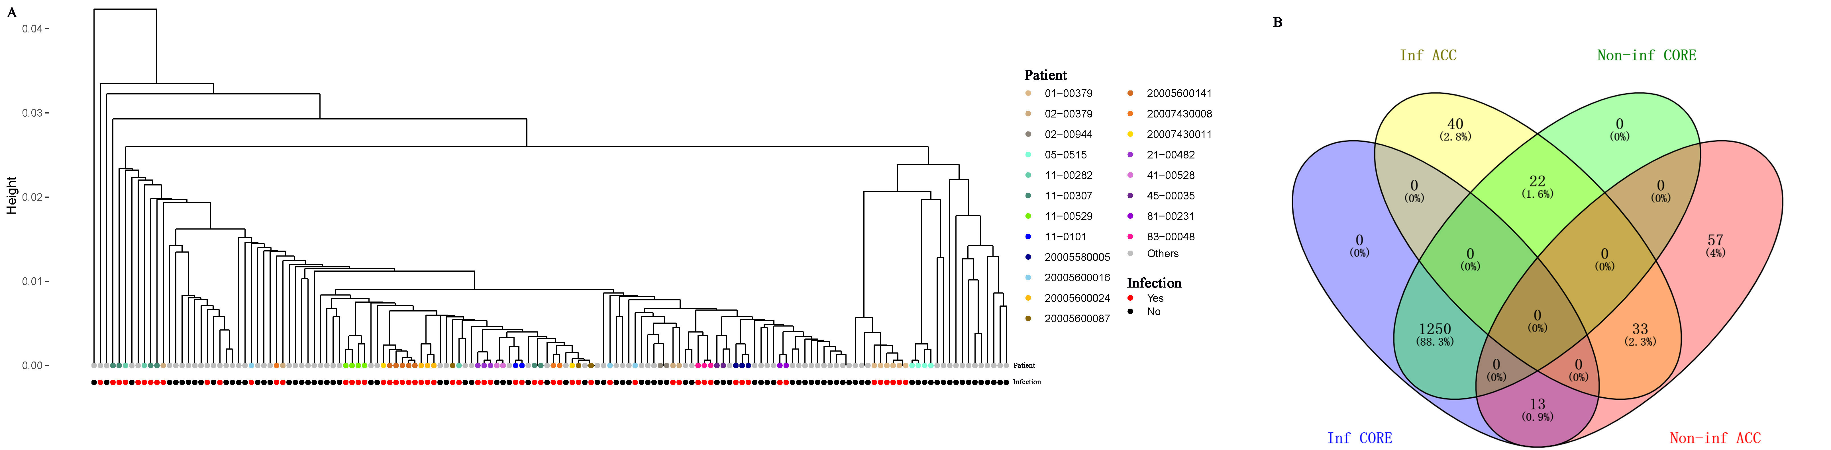
Fig. S17 The clustering of isolates from patients with and without ST398 infection, based on gene profiles of isolates (A). Points represent isolates. The overlap among core (Inf CORE) genes and accessory (Inf ACC) genes of infection isolates, and core (Non-inf CORE) genes and accessory (Non-inf ACC) genes of non-infection (colonized) isolates (B).

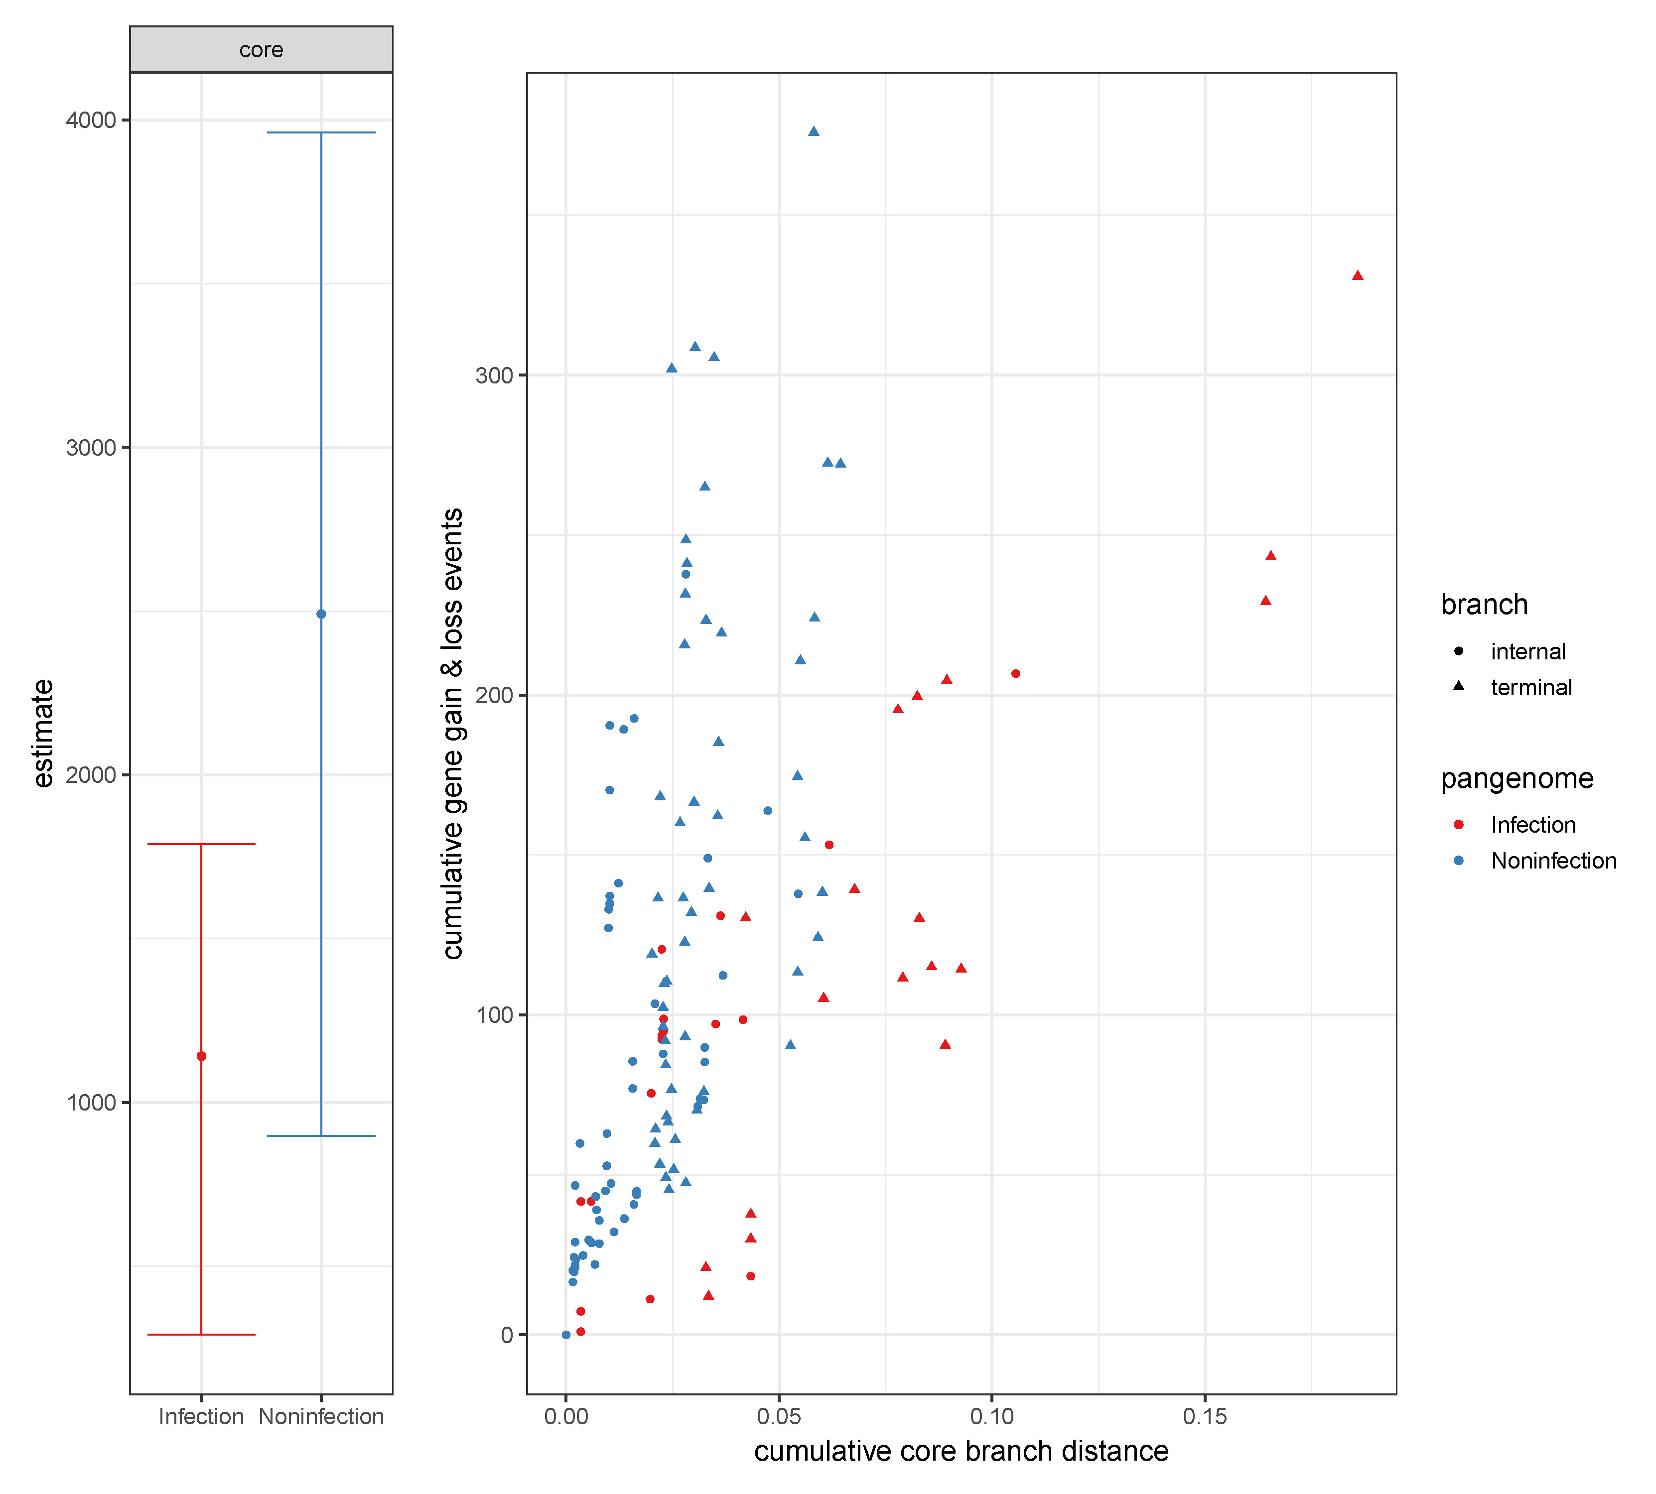
Fig. S18 The relationship between the cumulative number of gene gain and loss events and the cumulative branch length, separately in infection isolates and non-infection (colonized) isolates. P < 0.0001 in the core term indicates that non-infection isolates have a significantly higher rate of gene gain and loss than infection isolates. Only one isolate from each patient is used in the analysis.

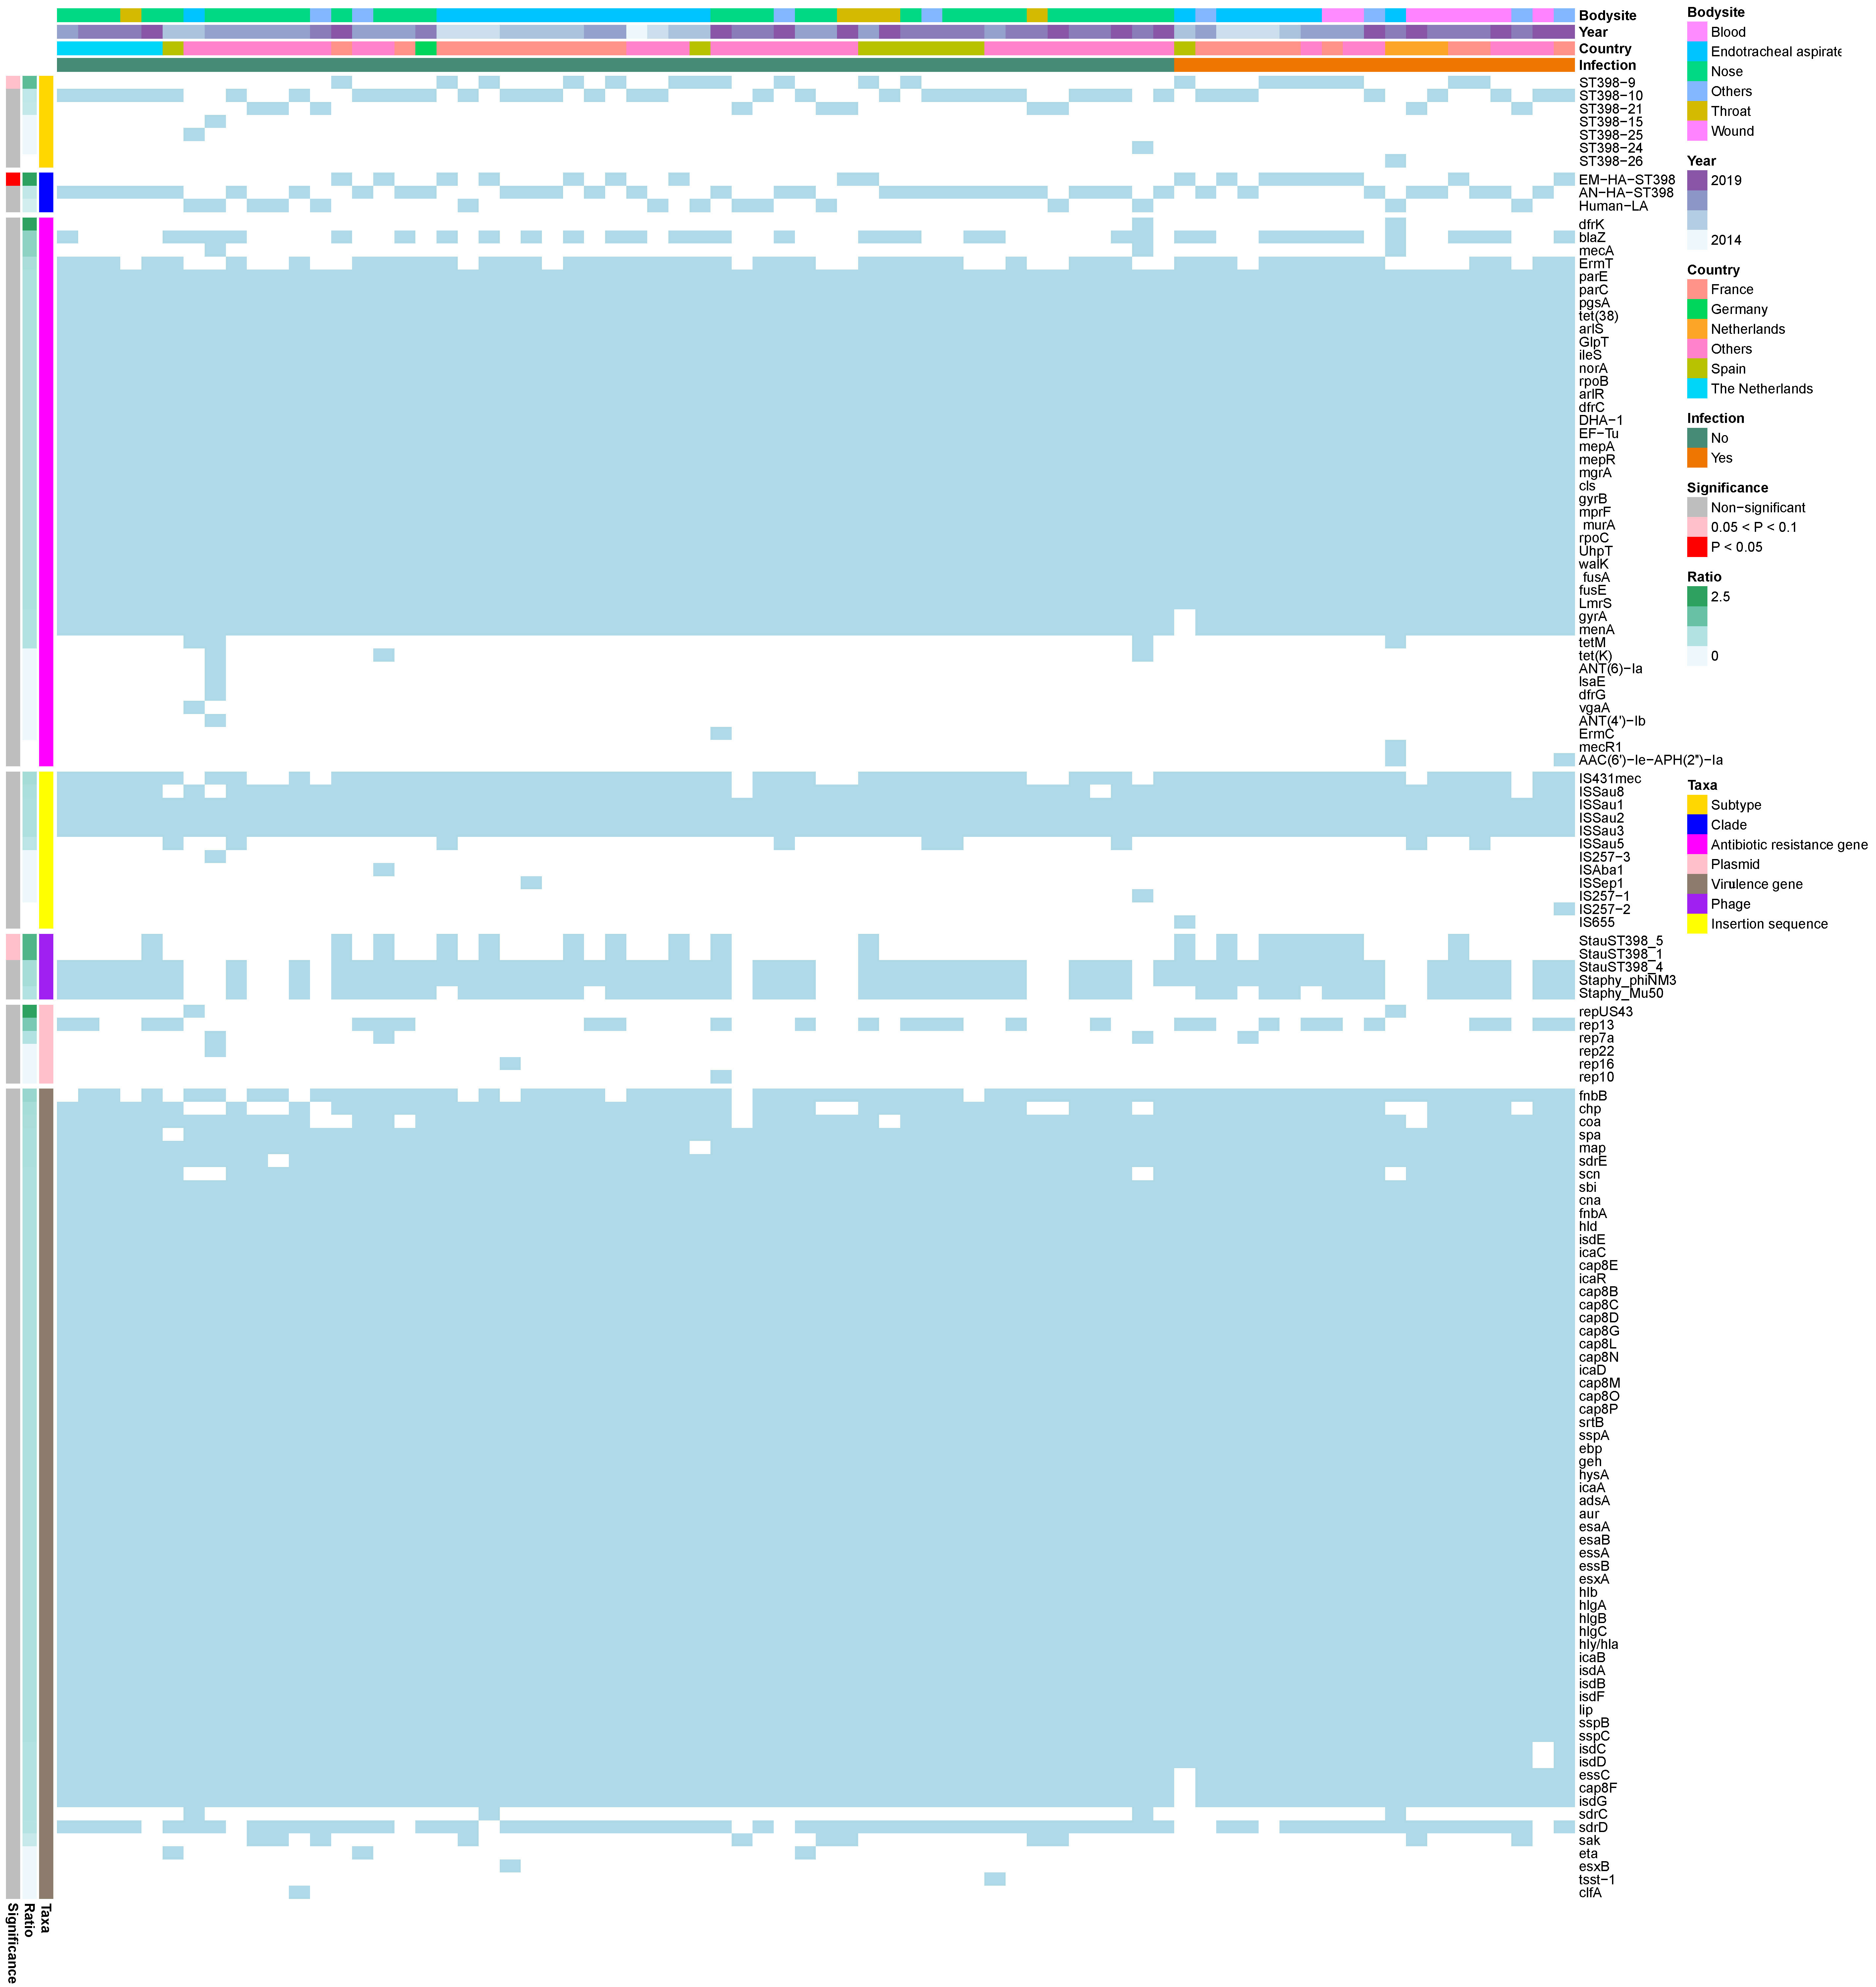
Fig. S19 Heatmap shows the distribution (skyblue: presence, white: absence) of subtypes, clades, antibiotic resistance genes, plasmids, virulence genes, phages, insertion sequences, across isolates from infected and non-infected patients collected from different body sites, countries and years. The ratio represents the comparison between the percentages of the taxa in infection and non-infection isolates. P values reflect the significance of correlations between the taxa and infection. Only one isolate from each patient is used in the analysis.

