Supplementary File
CT Image Analysis Using Grayscale Statistics to Categorise Severity of Lung Abnormalities of COVID-19 Patients

Sara Ghashghaei, David A. Wood, Erfan Sadatshojaei, Mansooreh Jalilpoor

Appendix 1. Visual scoring (VS) system applied to CT scan images
The VS scale applied (classes 0 to 4) to categorize lung abnormalities in COVID-19 Positive and COVID-19- negative patients is illustrated by selected grayscale image extracts as follows:
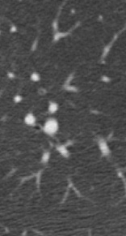
Score

0 Covid -ve: image extract with 45396 pixels

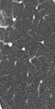

1 Covid +ve (no signs)
image extract with 7020 pixels

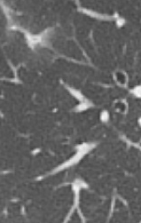

2 Covid +ve (minor visual signs)
image with 39909 pixels

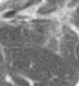

3 Covid +ve (substantial visual signs)
image with 27300 pixels

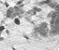

4 Covid +ve (severe visual signs)
image with 3402 pixels

