Supplementary Information
Supplementary Tables are all listed in Supplementary Data 1.
Supplementary Figures are listed in next pages.

Genome-scale co-occurrence and co-transcription networks reveal key microbial taxa in mangrove sediments

Yang Liu¹, Zhichao Zhou¹, Yuchun Yang², Meng Li¹*

¹ Shenzhen Key Laboratory of Marine Microbiome Engineering, Institute for Advanced Study, Shenzhen University, Shenzhen 518060, P. R. China
² State Key Laboratory of Biocontrol, School of Ecology, Sun Yat-sen University, Guangzhou 510275, P. R. China

*Corresponding author:
Prof. Meng Li
Tel: (+86) 755-26979250; email: limeng848@szu.edu.cn

Supplementary Figure 1 Linear regressions fitting the normalized genome abundance (genome copies per million reads) with normalized abundances of assembled 16S rRNA gene sequences at the phylum level

Supplementary Figure 2 Biogeochemical cycling of carbon, nitrogen, and sulfur capacities were inferred for the microbial communities in mangrove and mudflat sediments. The colors of arrows represent different modules within individual cycles. Numbers corresponding to the arrows are listed in a column indicating (1) the number of microorganisms inferred to be capable of the transformation, and their total relative abundance in the microbial community of the samples from (2) mangrove and (3) mudflat sediments respectively. The illustration is divided into surface and subsurface part of the sediments.

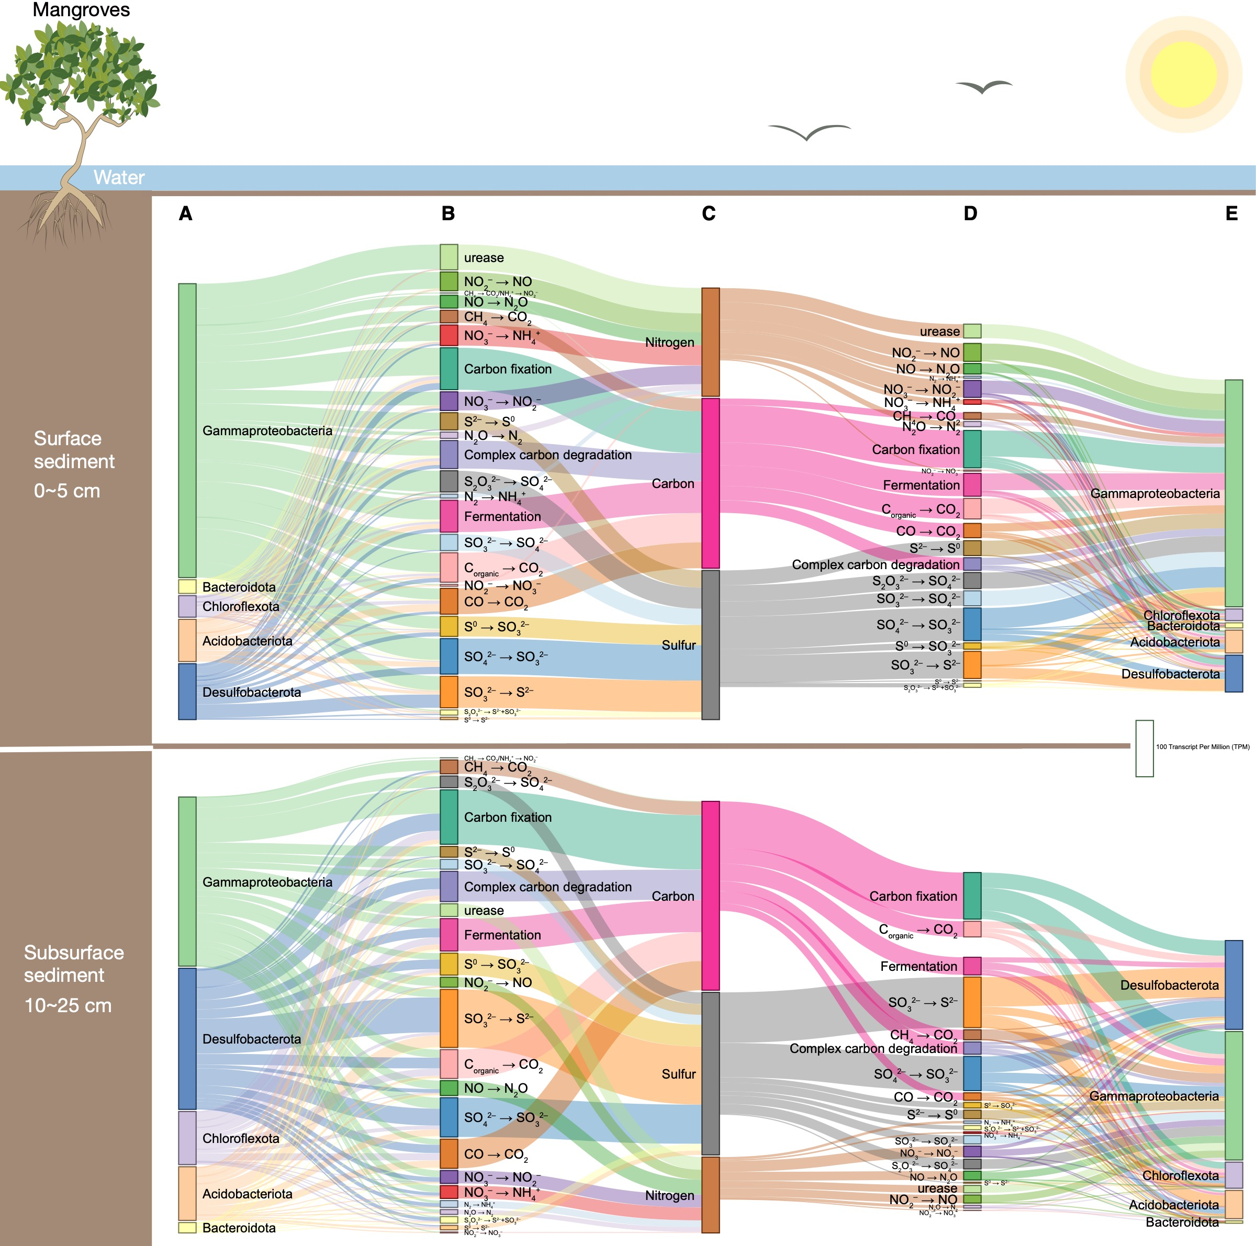
Supplementary Figure 3 Sankey diagram illustrates the interconnected metabolic capacity and transcriptomic activity network in surface and subsurface sediments of mangrove ecosystems. The vertical length of each color lump is the sum of the transcript per million (TPM) value of metabolic genes associated with different microbial lineages (A, E), metabolic modules (B, D), and elements (C). Metabolic capacity and transcriptomic activity are distinguished as left (A, B, C) and right (D, E) parts of the diagram, respectively. The microbial lineages (phylum or class level), which individually account for ≥5% of total abundance, are shown.

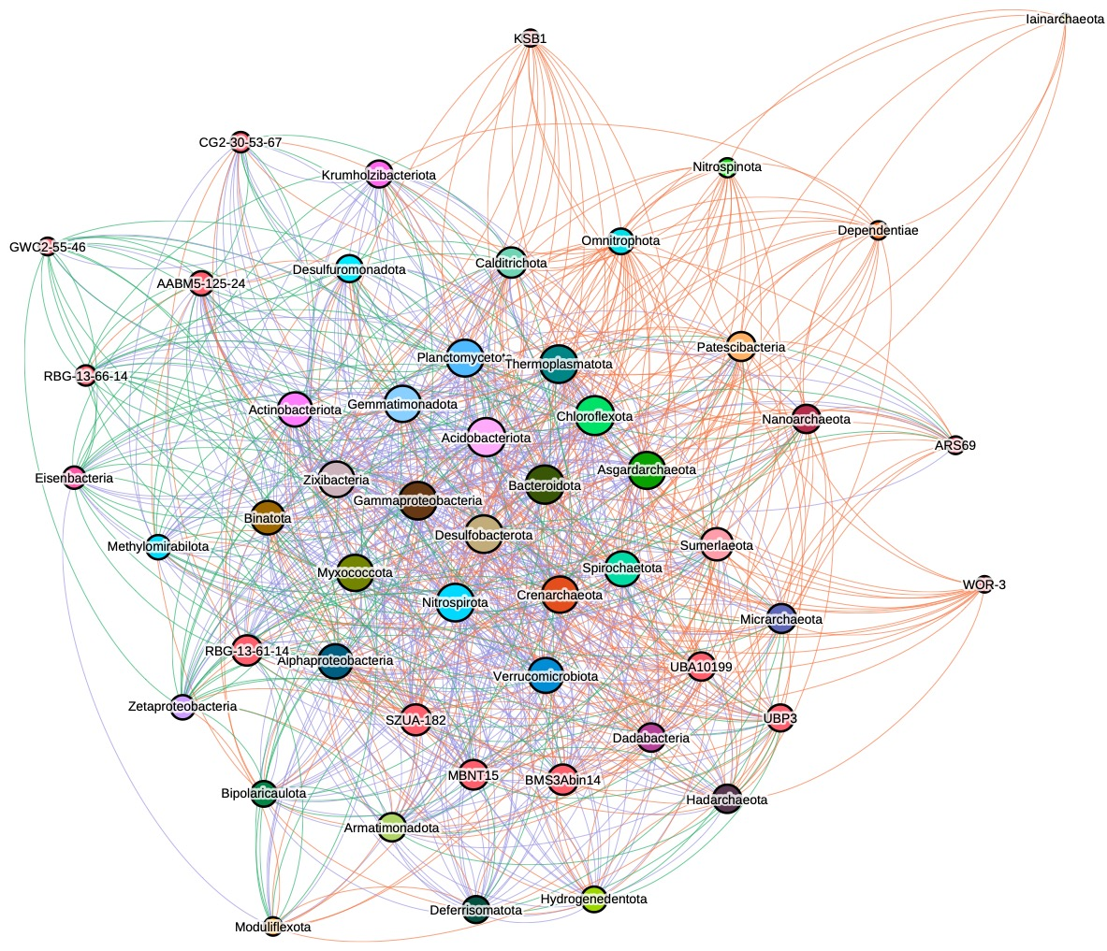
Supplementary Figure 4 Merged and collapsed the 5 co-occurrence and 5 co-transcription networks at phylum/class level. Nodes represent a phylum-level microbial group. Edge between the nodes indicate significant correlation. Edge colors from co-occurrence only, co-transcription only and both of them are orange, green and purple.

Supplementary Figure 5 Betweenness and degree centralization associated with different co-occurrence and co-transcription networks in different grouping. P values on the brackets are generated from Wilcox rank-sum test.

Supplementary Figure 6 Distribution of MAGs according to their network role evaluated by Zi and Pi values (see methods). Each dot represents a MAG.

Supplementary Figure 7 16S rRNA sequence identifies between deltaproteobacterial orders (a) and OrthoANI values between two Candidatus orders Ca. Mangledesulfobacterales and Ca. Acidulodesulfobacterales.

Supplementary Figure 8 The global distribution of Ca. Mangledesulfobacterales 16S rRNA sequences with identity > 97% and align length > 200bp” cutoff in NCBI SRA database.

