Appendix A1: Quantification of navigation performance

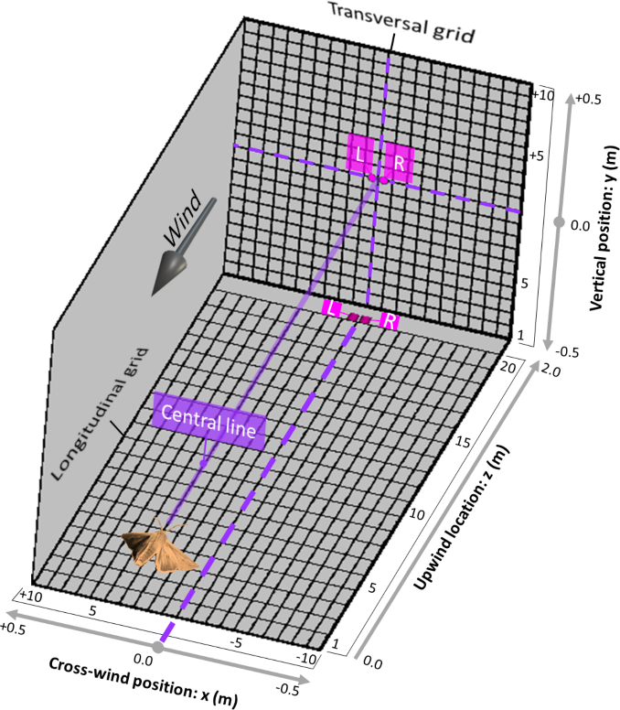
Figure S1. Quantification of navigation performance. A, the 3D experimental area of the wind tunnel (x,y,z) converted to 2D quadratic grid of longitudinal and transversal plans. Each of the three geometric components (x,y,z) is reticulated by 20 geometrical units: Longitudinal grid (x,y: 1.0, 2.0 m) is reticulated by 400 rectangles (rectangle size: 0.05X0.1 m). The transversal grid (x,y: 1.0, 1.0 m) is reticulated by 400 squares (square size: 0.05X0.05 m). Dashed purple lines represent the midline projections in each plane.

