Title: Thermal exposure risk in different life stages of Chinook salmon in the Nechako River system, British Columbia
Supplementary Information

CEQUEAU model: Modelling Nechako River water temperature
CEQUEAU is a hydrological and water temperature model that is semi-distributed (Khorsandi et al., 2022; Morin & Couillard, 1990; St-Hilaire et al., 2015) (Fig 1B). The hydrological module of CEQUEAU includes snowmelt and evapotranspiration formulations as well as conceptual water storage in two soil horizons, while the thermal module calculates the surface heat budget within each model grid cell. Land cover and topography are required as input physiographic data. The 10-meter resolution land cover data provided by ESRI, and the European Space Agency (ESA) (Karra et al., 2021; Zanaga et al., 2022) is used in this study, the NASA SRTM Digital Elevation Model (DEM) with a 30-meter resolution (Farr et al., 2007) is used for topography. Aside from physiographic data, meteorological data are also needed for the model, including daily solid and liquid precipitation and maximum and minimum daily air temperature.
To compute surface heat fluxes (incoming shortwave radiation, net longwave radiation, latent heat, and sensible heat), additional meteorological input variables such as solar radiation, wind velocity, vapour pressure, and cloud cover are used to calculate the heat budget. At each time step, the model also accounts for heat adverted from upstream, local runoff and interflow, as well as groundwater.
The physical characteristics of the watershed are accounted for by the model through decomposition into Elementary Representative Areas (ERA) of equal surface, referred to as “whole squares”. The ERA characteristics include altitude, forest cover percentage, and the percentage of lakes and wetlands coverage. To define water routing, the ERAs are further subdivided into a maximum of four “partial squares”, based on altitude, slopes, and water divides. At each time step (daily), a hydrological budget is calculated for each partial square, and water availability for runoff is apportioned proportionally to the partial square areas while identifying the downstream receiving partial square. In CEQUEAU, the hydrological module output is utilised as input for the thermal module. The thermal module computes various heat fluxes, such as direct shortwave radiation, latent heat, longwave radiation, convection, advection from upstream, local runoff, interflow, and groundwater inflows. The surface heat budget is calculated using Equation 1.:
$$∆H=H_{short}+H_{long}+H_{ET}+H_{sens}+H_{ups}+H_{downs}+H_{local}+H_{ground}$$ | (1)
Where$∆H$ is the change in overall heat for a CP (MJ); $H_{short}$ is incoming shortwave radiation; $H_{long}$ is heat gain/loss by longwave radiation; $H_{ET}$ is the latent heat loss (evaporation); $H_{sens}$ is the sensible heat gain/loss by convection; $H_{ups}$ and $H_{downs}$ are respectively the heat gain from upstream and heat loss to the downstream; $H_{local}$ is the heat from local runoff and interflow; and $H_{ground}$ is the heat term related to groundwater. Finally, the thermal module calculates water temperature change using the following equation:
$$∆T=\frac{∆H}{V.θ}$$ | (2)
where $∆T$ is the change in the water temperature (ᵒC); $V$ is the estimated water volume by the hydrological module ($m^{3}$), and $θ$ is the heat capacity of water (4.187$\frac{MJ}{m^{3}.°C}$) (Guy Morin & Paquet, 2007)..

CEQUEAU model: modelling historical temperature and future climate change scenarios.
To begin implementing CEQUEAU, the model's parameters must first be calibrated. The hydrological module is calibrated using observed streamflow data from hydrometric stations along the Nechako River. The thermal module is then calibrated using water temperature gauges located between the dam and Vanderhoof. The parameters are manually calibrated before applying an automatic calibration algorithm called the Covariance Matrix Adaptation Evolution Strategy (CMA-ES) (Hansen, 2006). Additionally, the multi-site temperature calibration method of Khorsandi et al. (2022) is used to adjust the parameters of the water temperature module.
To project future changes in the Nechako River water temperature and water flow, and to account for variability in CEQUEAU model output, data from eight General Circulation Models (GCMs), part of the Coupled Model Intercomparison Project Phase 6 (CMIP6) (Eyring et al., 2016), were used (Table 1). This ensemble approach is to quantify and capture uncertainty that may arise due to each model's assumptions and approximations. For this study, we examined two Shared Socio-economic Pathways (SSP) scenarios. These scenarios include SSP2-4.5 (the intermediate scenario), which describes a “middle of the road” scenario where the world follows historical, social, and economic trends (O’Neill et al., 2017); also, the radiative forcing level stabilizes at 4.5 W/m² before 2100. The second scenario is SSP5-8.5 (the high emission scenario), which describes a world with rapid economic growth and faith in competitive markets, innovation, and participatory societies (O'Neill et al., 2017), and the radiative forcing level increased at 8.5 W/m² by 2100 with no mitigation.
Each global climate model utilised the SSP forcings to provide meteorological variables required for the CEQUEAU model execution. These datasets underwent bias correction by applying the N-dimensional Multivariate Bias Correction algorithm (MBCn) (Cannon, 2018) on the reference period of 1981-2010, employing ERA5 data as the baseline dataset. The bias correction was then applied to the climate model data for each of the 8 climate models, two radiative forcing scenarios (4.5 and 8.5 W/m²), and horizon. The bias correction protocol was implemented at 3-hour intervals, providing a more accurate representation of the meteorological diurnal cycle and enhancing the precision of daily averages (Gatien et al., 2022). However, this also limited the number of available GCMs as not all GCMs in CMIP6 archive data at the sub-daily time step.
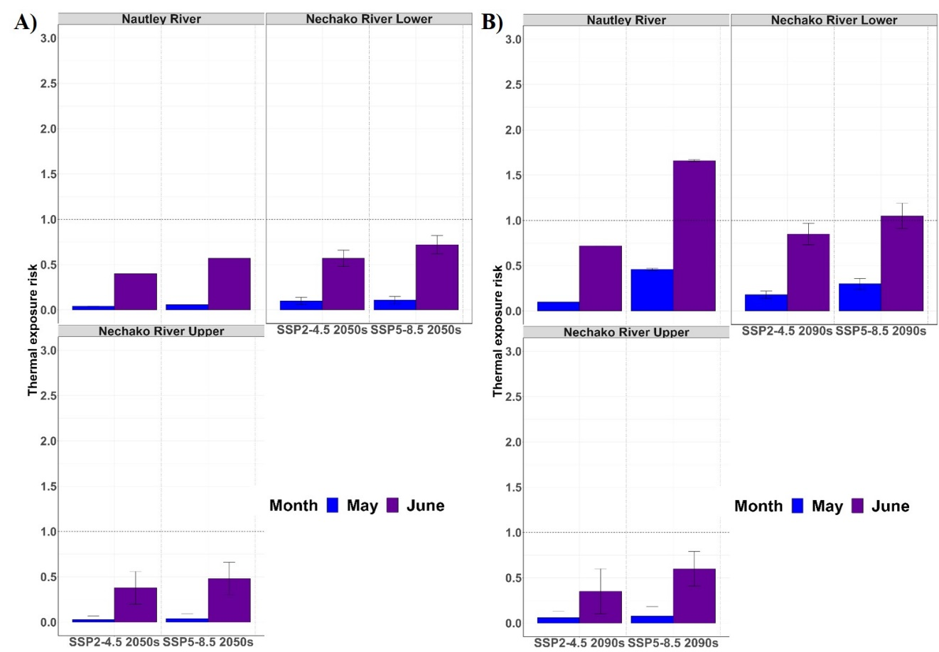
Fig. S1 The thermal exposure risk for Nechako River Chinook salmon life stages in Nechako River sections under SSP2-4.5 and SSP5-8.5 in the 2050s (average between 2050-2959) and 2090s (average between 2090 -2099) for fry life stage. The dotted line indicates an optimal thermal exposure risk of 1.

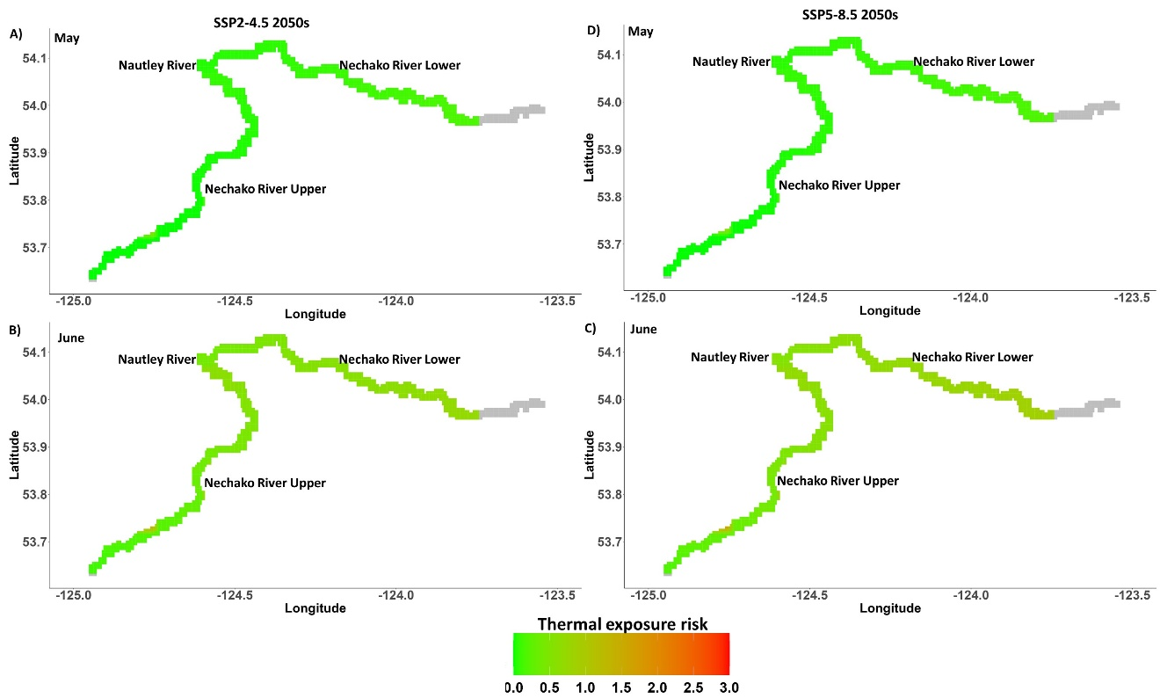
Fig. S2 Thermal exposure risk spatial map for Nechako River fry Chinook salmon under SSP2-4.5 and SSP5-8.5 in the 2050s (average 2050-2059) for May and June. In the 2050s: (A, B) under SSP2-4.5 and (C, D) under SSP5-8.5. Cool and warm colours represent low and high thermal exposure risk, respectively.

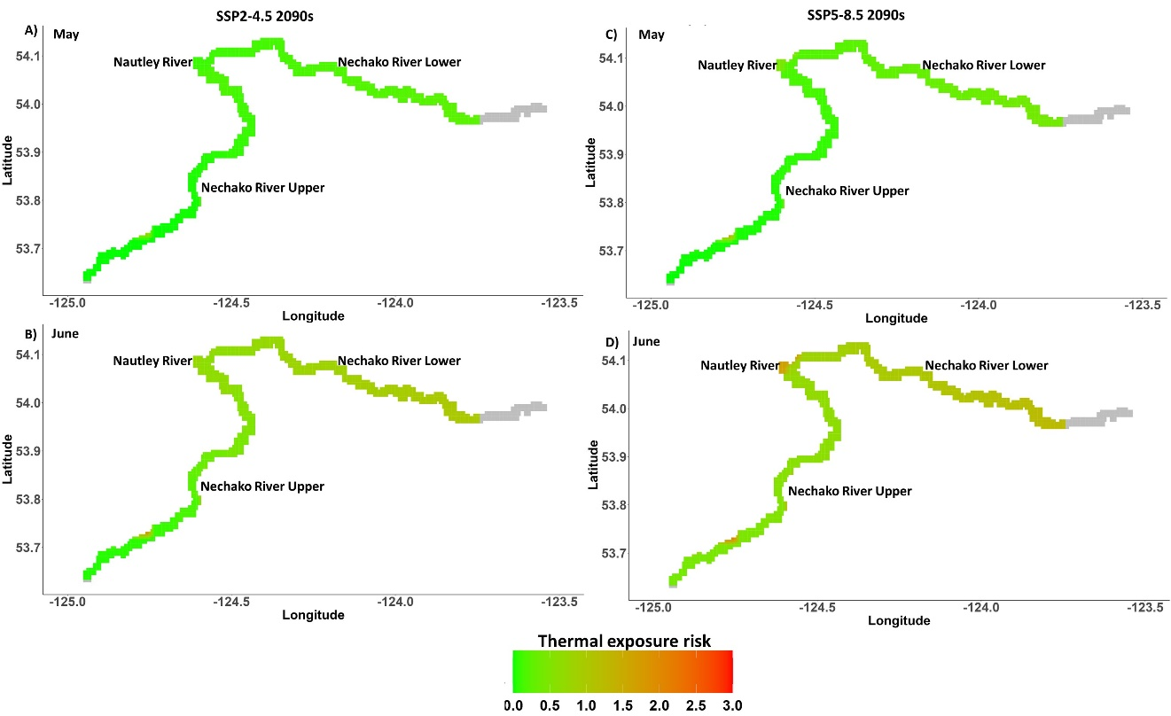Fig. S3 Thermal exposure risk spatial map for Nechako River fry Chinook salmon under SSP2-4.5 and SSP5-8.5 in the 2090s (average 2090-2099) for May and June. In the 2090s: (A, B) under SSP2-4.5 and (C, D) under SSP5-8.5. Cool and warm colours represent low and high thermal exposure risk, respectively.

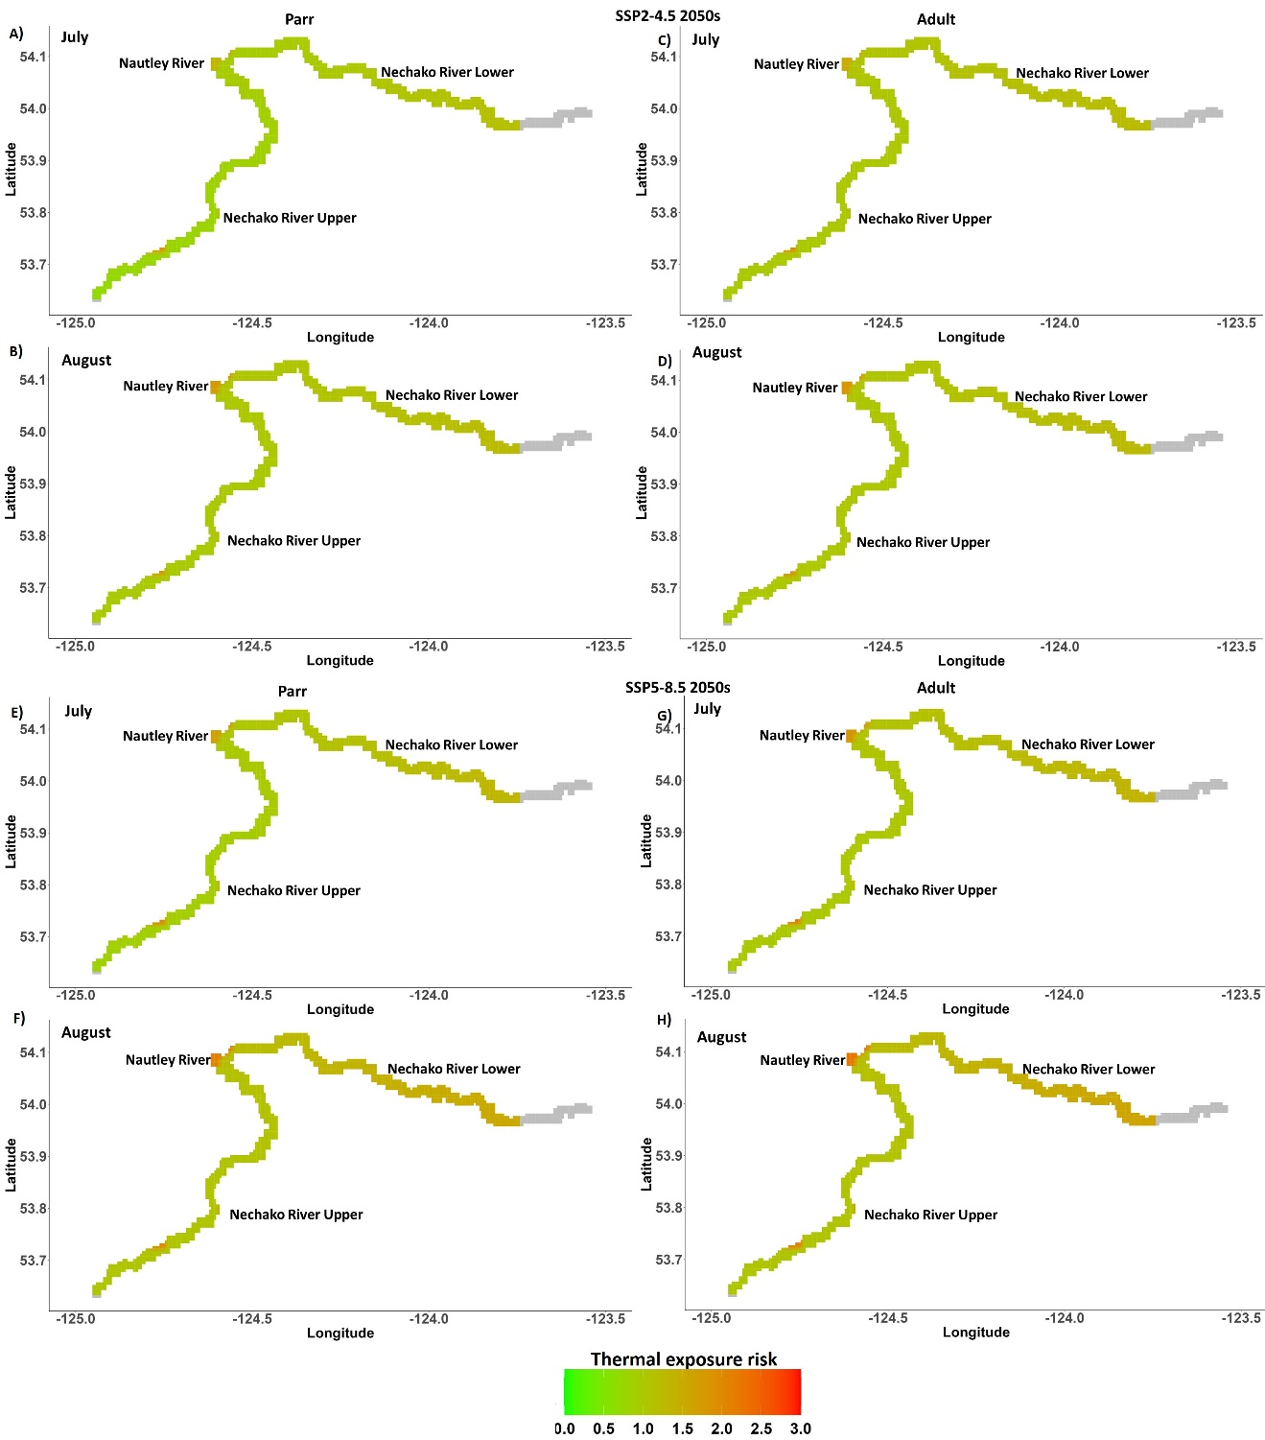Fig. S4 Thermal exposure risk spatial map for Nechako River Chinook salmon life stages; parr and adult under SSP2-4.5 and SSP5-8.5 in the 2050s (average 2050-2059) for the Summer Temperature Management Program (STMP) months (July and August). Under SSP2-4.5: (A, B) Parr life stage; (C, D) Adult life stage. Under SSP5-8.5: (E, F) Parr life stage; (G, H) Adult life stage. Cool and warm colours represent low and high thermal exposure risk, respectively.

Reference
Cannon, A. J. (2018). Multivariate quantile mapping bias correction: An N-dimensional probability density function transform for climate model simulations of multiple variables. Climate Dynamics, 50, 31–49.
Eyring, V., Bony, S., Meehl, G. A., Senior, C. A., Stevens, B., Stouffer, R. J., & Taylor, K. E. (2016). Overview of the Coupled Model Intercomparison Project Phase 6 (CMIP6) experimental design and organization. Geoscientific Model Development, 9(5), 1937–1958.
Farr, T. G., Rosen, P. A., Caro, E., Crippen, R., Duren, R., Hensley, S., Kobrick, M., Paller, M., Rodriguez, E., & Roth, L. (2007). The shuttle radar topography mission. Reviews of Geophysics, 45(2).
Gatien, P., Arsenault, R., Martel, J.-L., & St-Hilaire, A. (2022). Using the ERA5 and ERA5-Land reanalysis datasets for river water temperature modelling in a data-scarce region. Canadian Water Resources Journal/Revue Canadienne Des Ressources Hydriques, 1–18.
Hansen, N. (2006). The CMA evolution strategy: A comparing review. Towards a New Evolutionary Computation: Advances in the Estimation of Distribution Algorithms, 75–102.
Karra, K., Kontgis, C., Statman-Weil, Z., Mazzariello, J. C., Mathis, M., & Brumby, S. P. (2021). Global land use/land cover with Sentinel 2 and deep learning. 4704–4707.
Khorsandi, M., St-Hilaire, A., & Arsenault, R. (2022). Multisite calibration of a semi-distributed hydrologic and thermal model in a large Canadian watershed. Hydrological Sciences Journal, 67(14), 2147–2174.
Morin, G., & Couillard, D. (1990). Predicting river temperatures with a hydrological model. Encyclopedia of Fluid Mechanic, Surface and Groundwater Flow Phenomena, 10, 171–209.
O’Neill, B. C., Kriegler, E., Ebi, K. L., Kemp-Benedict, E., Riahi, K., Rothman, D. S., Van Ruijven, B. J., Van Vuuren, D. P., Birkmann, J., & Kok, K. (2017). The roads ahead: Narratives for shared socioeconomic pathways describing world futures in the 21st century. Global Environmental Change, 42, 169–180.
St-Hilaire, A., Boucher, M.-A., Chebana, F., Ouellet-Proulx, S., Zhou, Q. X., Larabi, S., Dugdale, S., & Latraverse, M. (2015). Breathing a new life to an older model: The CEQUEAU tool for flow and water temperature simulations and forecasting. Proceedings of the 22nd Canadian Hydrotechnical Conference.
Zanaga, D., Van De Kerchove, R., Daems, D., De Keersmaecker, W., Brockmann, C., Kirches, G., Wevers, J., Cartus, O., Santoro, M., & Fritz, S. (2022). ESA WorldCover 10 m 2021 v200.

