Model Description:

Air-sea exchange of elemental Hg (F_{eva}) is modeled as in in Soerensen et al.¹ ; F_{eva} is set equal to:
$$F_{eva}= k_{eva}\left({\left[{Hg}^{0}\right]}_{sea}×1000-\frac{{\left[{Hg}^{0}\right]}_{atm}}{H\left(S, T\right)}\right)$$
[equation S1]
Where [Hg⁰]sea is the Hg⁰ concentration in surface seawater (pM), [Hg⁰]atm is the Hg⁰ concentration in the air (also in pmole/L units), H is the unitless Henry’s Law constant and a function of temperature and salinity (Andersson et al., 2008)² and k_{eva} is the mass transfer coefficient (also called a “piston velocity”), calculated using the Nightingale et al. formulation.³

Atmospheric deposition of Hg²⁺ (F_{dep}, unit: ng L⁻¹ h⁻¹) is estimated using the GEOS-Chem atmospheric chemical transport model (version 13.1.2, DOI: https://doi.org/10.5281/zenodo.5075847).

The sinking flux of Hg (F_{sink}, unit: ng L⁻¹ h⁻¹) is modeled by multiplying particulate Hg by a particle deposition rate. The particle deposition rate (v_{dep}: m² d⁻¹ ) is calculated as export (mgC m⁻² d⁻¹) divide by particulate organic carbon (POC: mgC m⁻³) (Table S1).
$${F_{sink}= [Hg]}_{p} × v_{dep}$$
$$V_{dep}= \frac{export}{POC}$$
[equation S2]

The upwelling flux of Hg (F_{upwelling}, unit: ng L⁻¹ h⁻¹) is estimated by multiplying the vertical upwelling velocity of water by THg concentration in the intermediate seawater just below the model depth boundary. Upwelling velocity is estimated by dividing upwelling index (UI: m² d⁻¹) by upwelling cross-shore length (UL: m) (Table S1).
$$F_{upwelling}= \left[Hg\right]× v_{upwelling}$$

$$v_{upwelling= \frac{UI}{UL}}$$
[equation S3]

Hg export to and import from the neighboring ocean (F_{ex}, unit: ng L⁻¹ h⁻¹) is simplified and expressed as water mass exchange rate multiplied by the THg concentrations in the “upstream” water mass (flux in), or the THg concentration within the model domain (flux out). We follow the method of Liu et al. to simplify the water mass exchange rate by dividing domain water volume by water residence time.⁴
$$F_{ex}= \frac{\left[Hg\right]*V}{rt}$$
[equation S4]

The total Hg²⁺ and Hg⁰ concentration (unit: ng L⁻¹) in the seawater were calculated using the integration of fluxes with time (h), and particulate Hg²⁺ (unit: ng L⁻¹) was calculated using an equation based on the partitioning coefficient (K_{d}) equation ^{5, 6}. k_{red-Hg(II)} and k_{ox-Hg0} are the pseudo-first order reduction rate constant of Hg(II) and oxidation rate.⁴

$$\frac{∂[{Hg}^{0}]}{∂t}={-F}_{eva} + F_{upwelling}+ k_{red-Hg\left(II\right)}×[{Hg}^{2+}] - k_{ox-Hg0}×[Hg^{0}]+ F_{ex }$$

$$\frac{∂\left[t{Hg}^{2+}\right]}{∂t}=F_{dep} - F_{sink}+ F_{upwelling} - k_{red-Hg\left(II\right)}×[{Hg}^{2+}]+ k_{ox-Hg0}×[Hg^{0}] + F_{ex}$$

$${[Hg]}_{p}=\frac{\left[TP\right] × K_{d }× \left[{tHg}^{2+}\right] }{1+\left[TP\right] × K_{d }}$$
[equation S5]

Table S1 CCE Parameters
Parameter | Units | Distribution | Source
width | m | 77000
length | m | 188000
depth | m | 100
surface area | m² | 1.45×10⁹
water volume | m³ | 1.19×10¹¹
upwelling cross-shore length (UL) | m | 75000 | Zaba (2021)⁷
surface water temperature | °C | normal (13.15, 1.18) | P2107
wind velocity | m s⁻¹ | lognormal (1.27, 0.72) | CeNCOOSª
Shortwave radiation flux | W m-2 | normal (255, 35) | CeNCOOSª
upwelling index (UI) | m² s⁻¹ | gamma (0.97, 0.82 ) | CUTI ^{8, b}
water residence time | d | uniform (8, 18) | Liu (2019)⁹
NPP | mgC m⁻² d⁻¹ | upwelling: normal (1083, 403)  non-upwelling: normal (274, 57) | P2017
export | mgC m⁻² d⁻¹ | upwelling: normal (235, 49)  non-upwelling: 125 | P2017
POC | mg m⁻³ | upwelling: normal (9.53, 12.08)  non-upwelling: normal (0.98, 0.8) | P2017
DOC | mg L⁻¹ | normal (1.26, 0.09) | CCE-LTER
chlorophyll | mg m⁻³ | lognormal (-0.81, 1.48) | P2017
atmospheric Hg⁰ deposition | ng L⁻¹ h⁻¹ | uniform (1.88, 3.49)×10⁻⁶ | GEOS-Chem
atmospheric Hg²⁺ deposition | ng L⁻¹ h⁻¹ | uniform (0.8 ,1.48)×10⁻⁵ | GEOS-Chem
atmospheric Hg⁰ concentration | ng m⁻³ | 1.41 | Wesis-Penzias (2013)¹⁰
Hg²⁺ in neighbor ocean | ng L⁻¹ | normal (0.13, 0.04) | P2017
Hg⁰ in neighbor ocean | pmole L⁻¹ | normal (0.015, 0.0082) | P2017
Hg²⁺ in bottom ocean | ng L⁻¹ | normal (0.144,0.027) | P2017
Hg⁰ in bottom ocean | ng L⁻¹ | normal (0.015, 0.008) | P2017
Hg log K_{d} | L kg⁻¹ | normal (7, 0.18) | P2017
ª CeNCOOS: https://www.cencoos.org/
^{b} CUTI: https://mjacox.com/upwelling-indices/
Table S2 Simulated Hg budgets showing median values for upwelling and non-upwelling scenarios. A ‘0’ in non-parametric test indicates no significant difference between two scenarios, while a “1” indicates significant difference.
 | unit | upwelling (1.12 m d⁻¹) | non-upwelling | non-parametric test
atmospheric deposition | Mg yr⁻¹ | 0.1792 | 0.1785 | 0
water exchange | Mg yr⁻¹ | 0.5324 | 0.6692 | 1
Hg evasion | Mg yr⁻¹ | 0.0644 | 0.0355 | 1
dissolved Hg²⁺ | Mg | 0.1381 | 0.1564 | 1
particulate Hg²⁺ | Mg | 0.0074 | 0.0014 | 1
Hg⁰ | Mg | 0.0272 | 0.0198 | 1
upwelling input | Mg yr⁻¹ | 0.5355 | 0 | 1
sinking flux | Mg yr⁻¹ | 1.1449 | 0.693 | 1

Table S3 The summary of THg/C, MMHg/C, and MMHg/THg ratios in sinking particles.

regions | depth(m) | Hg/C (pg μg⁻¹) | MMHg/C (pg μg⁻¹) | MMHg/THg (%)
upwelling(Cycle 1) | 100 | 1.51 | 0.025 | 1.48
upwelling(Cycle 1) | 150 | 3.60 | NA | NA
upwelling(Cycle 2) | 100 | 1.38 | 0.021 | 1.42
upwelling(Cycle 2) | 150 | 2.95 | 0.106 | 3.36
open ocean(Cycle 3) | 150 | 6.88 | 0.030 | 0.40
open ocean(Cycle 3) | 440 | 4.98 | 0.222 | 4.11

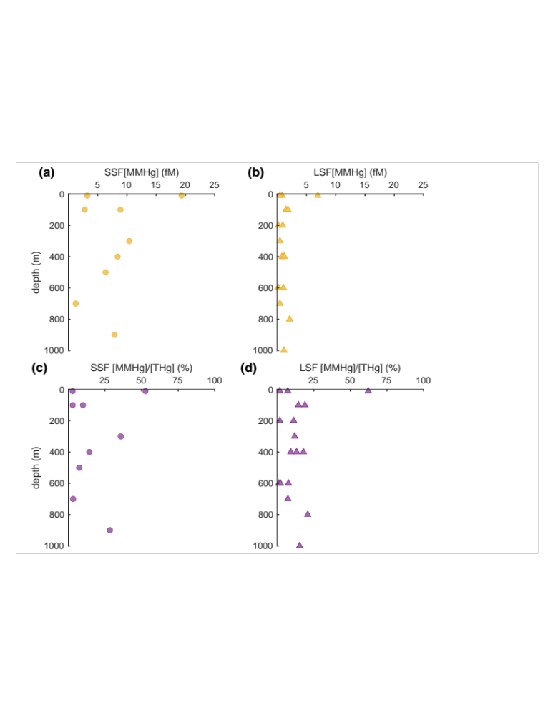
Figure S1 Profiles of MMHg concentration (fM) and MMHg/THg ratio (%) distribution with depth (m) for upwelling regions. Panel (a) and (b) in yellow are for MMHg concentrations in SSF and LSF individually; panel (c) and (d) in purple are for MMHg/THg ratios in the SSF and LSF individually. Circles represent SSF, while triangles represent LSF.

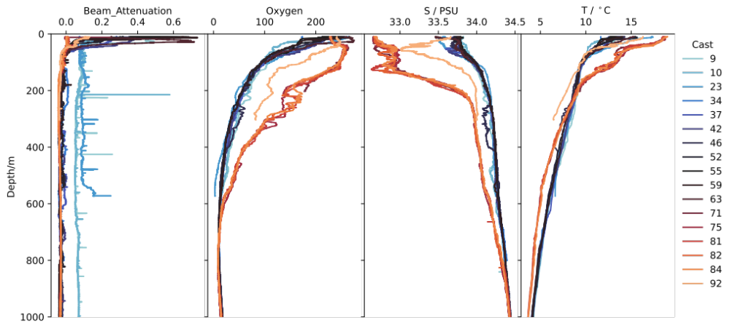

Figure S2 The beam attenuation profile, transitioning from blue to orange, signifies the shift from coastal upwelling (blue) to the open ocean (red).

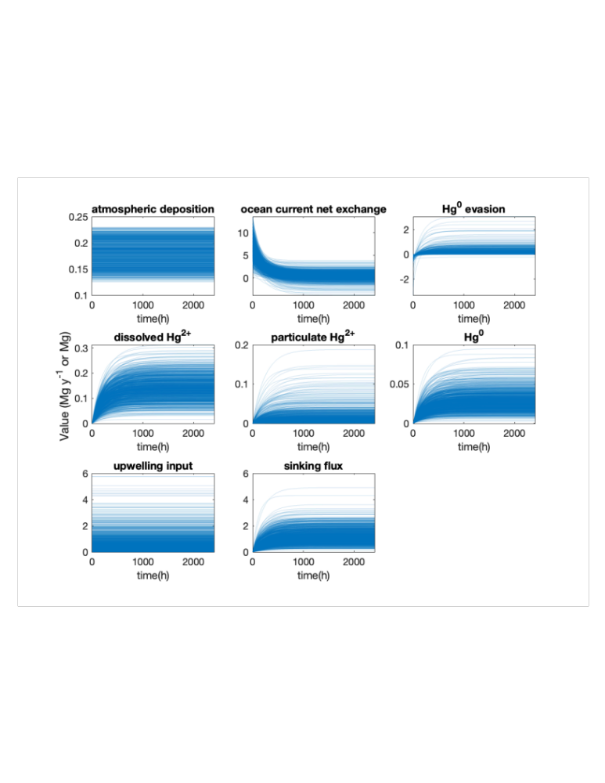

Figure S3 Monte Carlo simulation plots for selected variables.

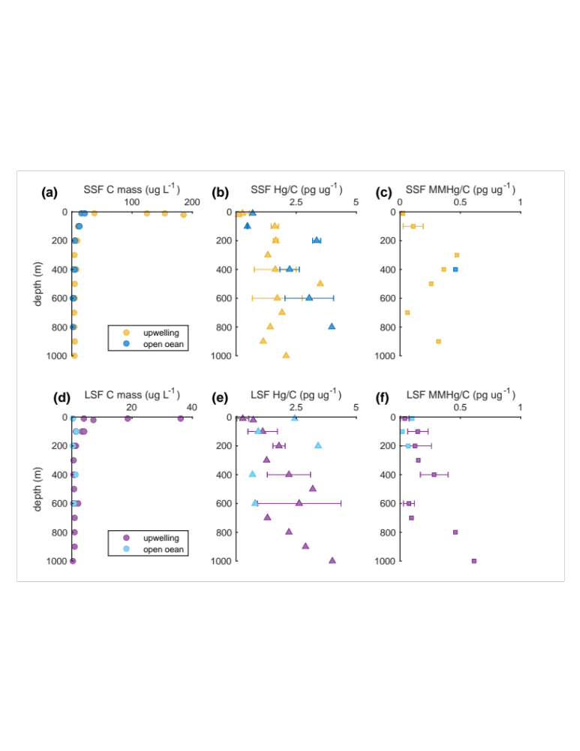
Figure S4
Profiles of carbon (C) mass (ug L⁻¹), THg to C ratio, and MMHg to C ratio (ng ug⁻¹) distribution with depth (m) in upwelling and open ocean. Panel (a), (b), and (c) are for the C mass, THg/C ratio, and MMHg/C ratio in SSF, respectively; panel (d), (e), and (f) are for the C mass, THg/C ratio, and MMHg/C in LSF. Error bars represents standard deviations.

Reference
1. Soerensen, A. L.; Sunderland, E. M.; Holmes, C. D.; Jacob, D. J.; Yantosca, R. M.; Skov, H.; Christensen, J. H.; Strode, S. A.; Mason, R. P., An improved global model for air-sea exchange of mercury: High concentrations over the North Atlantic. Environmental science & technology 2010, 44 (22), 8574-8580.
2. Andersson, M. E.; Gårdfeldt, K.; Wängberg, I.; Strömberg, D., Determination of Henry’s law constant for elemental mercury. Chemosphere 2008, 73 (4), 587-592.
3. Nightingale, P. D.; Malin, G.; Law, C. S.; Watson, A. J.; Liss, P. S.; Liddicoat, M. I.; Boutin, J.; Upstill‐Goddard, R. C., In situ evaluation of air‐sea gas exchange parameterizations using novel conservative and volatile tracers. Global Biogeochemical Cycles 2000, 14 (1), 373-387.
4. Liu, M.; Zhang, Q.; Maavara, T.; Liu, S.; Wang, X.; Raymond, P. A., Rivers as the largest source of mercury to coastal oceans worldwide. Nature Geoscience 2021, 14 (9), 672-677.
5. Bacon, M.; Spencer, D.; Brewer, P., 210Pb/226Ra and 210Po/210Pb disequilibria in seawater and suspended particulate matter. Earth and Planetary Science Letters 1976, 32 (2), 277-296.
6. Cui, X.; Lamborg, C. H.; Hammerschmidt, C. R.; Xiang, Y.; Lam, P. J., The Effect of Particle Composition and Concentration on the Partitioning Coefficient for Mercury in Three Ocean Basins. Frontiers in Environmental Chemistry 2021, 2.
7. Zaba, K. D.; Franks, P. J. S.; Ohman, M. D., The California Undercurrent as a Source of Upwelled Waters in a Coastal Filament. Journal of Geophysical Research: Oceans 2021, 126 (2).
8. Jacox, M. G.; Edwards, C. A.; Hazen, E. L.; Bograd, S. J., Coastal Upwelling Revisited: Ekman, Bakun, and Improved Upwelling Indices for the U.S. West Coast. Journal of Geophysical Research: Oceans 2018, 123 (10), 7332-7350.
9. Liu, X.; Dunne, J. P.; Stock, C. A.; Harrison, M. J.; Adcroft, A.; Resplandy, L., Simulating Water Residence Time in the Coastal Ocean: A Global Perspective. Geophysical Research Letters 2019, 46 (23), 13910-13919.
10. Weiss‐Penzias, P. S.; Williams, E. J.; Lerner, B. M.; Bates, T. S.; Gaston, C.; Prather, K.; Vlasenko, A.; Li, S. M., Shipboard measurements of gaseous elemental mercury along the coast of Central and Southern California. Journal of Geophysical Research: Atmospheres 2013, 118 (1), 208-219.

