Supplementary Information
Ablation Studies
Supplementary Table S1. The effect of using the UK Biobank pre-trained model.
Model | Trained from scratch | Pre-trained model
ResNet-V2 | 77.15 (0.30) | 82.59 (0.89)
Performance is reported as the F1 score (standard deviation between different seeds). The pre-trained UK Biobank model was a ResNet-V2 with the MTL approach. We employed the same architecture and MTL approach to train the SSL model from scratch using the MAP data.

Supplementary Table S2. The effect of customizing the SSL model for older adults using the MAP data.
Model's head | MAP | Without MAP
FC (without non-linearity) | 84.67 (0.44) | 82.55 (0.08)
FC (with non-linearity) | 84.74 (0.51) | 83.21 (0.45)
U-Net | 83.02 (0.86) | 83.90 (0.08)
Performance is reported as the F1 score (standard deviation between different seeds). In this table, we employed the combined model (i.e., pretrained UK Biobank model + additional model’s head) with the optimal SSL configuration, termed ElderNet. FC: Fully-connected.

Supplementary Table S3. The effect of the SSL approach.
Model's head | MTL | SimCLR
FC (without non-linearity) | 84.67 (0.44) | 84.52 (0.38)
FC (with non-linearity) | 84.74 (0.51) | 84.57 (0.76)
U-Net | 83.02 (0.86) | 84.28 (0.45)
Performance is reported as the F1 score (standard deviation between different seeds). FC: Fully-connected.

Supplementary Table S4. The effect of using SSL compared to supervised counterparts.
Model's head | ElderNet | Supervised
FC (without non-linearity) | 84.67 (0.44) | 79.08 (0.24)
FC (with non-linearity) | 84.74 (0.51) | 79.21 (0.31)
U-Net | 83.02 (0.86) | 78.77 (0.73)
Performance is reported as the F1 score (standard deviation between different seeds). In this table, we employed the same architecture (ResNet-V2 + additional model’s head), once using the ElderNet configuration and once by performing fine-tuning from scratch without utilizing the UK Biobank pre-trained model and the MAP data. FC: Fully-connected.

Supplementary Table S5. The effect of dense labeling.
Model | Window Labels | Dense Labeling
ElderNet | 84.74 (0.51) | 81.99 (0.41)
Performance reported as the F1 score (standard deviation between different seeds). The model employed for both labeling approaches is identical. The key distinction lies in the final layer of the model: in the first approach, it projects the output for each window, while in the dense labeling approach, it projects the output for each sample.

Supplementary Table S6. ElderNet setting.
Method | Optimizer | Learning-rate | Batch size | Epochs | Learning-rate Scheduler
MTL | Adam | 1e-4 | 6000 | 40 | Linear scaling with a 5-epoch warm-up
SimCLR | Adam | 1e-4 | 6000 | 40 | Cosine Decay with a 5-epoch warm-up
Each batch contains 1500 windows from 4 unique participants. The windows were sampled in proportion to their STD, as described in Yuan et al.³⁸. For the MTL, we employed linear scaling for the learning rate to align with the pre-trained UK Biobank model, which utilized MTL and linear scaling. For SimCLR, we utilized the cosine decay scheduler, as outlined in the original paper of this method³².

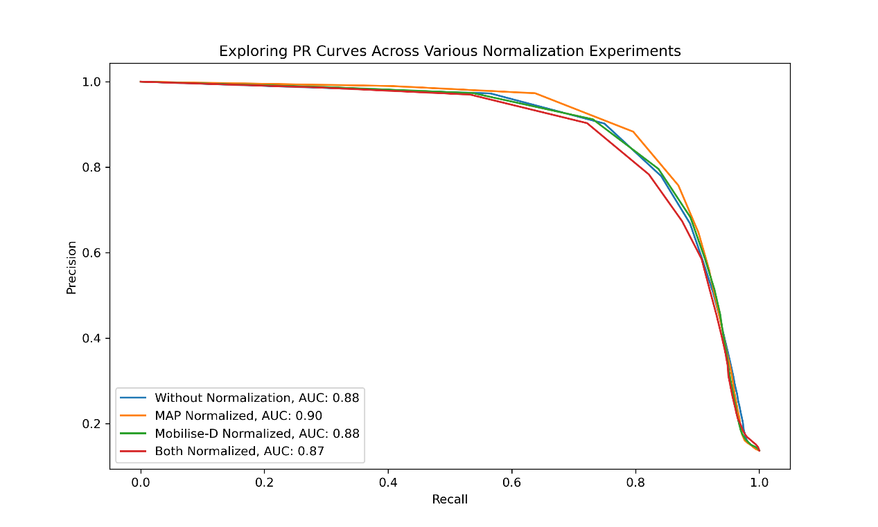
Supplementary Figure S1. Precision-Recall curves for different configurations of normalizations. Normalization was implemented per subject, making each axis of its acceleration signal zero-mean and a standard deviation of 1. AUC: Area under the curve.

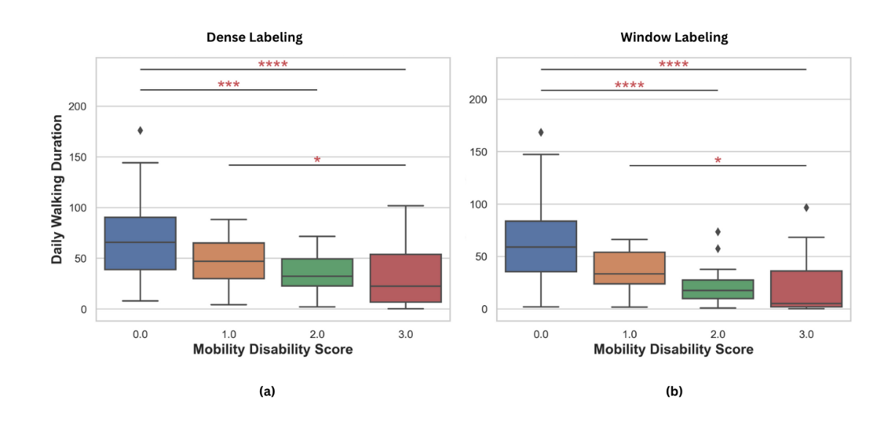
Supplementary Figure S2. a) On the left, it illustrates the estimated daily walking durations using a model that utilized dense labeling in the fine-tuning phase and provided a per-sample output. b) On the right, the figure represents the estimated walking duration using a model that outputs per-window predictions.

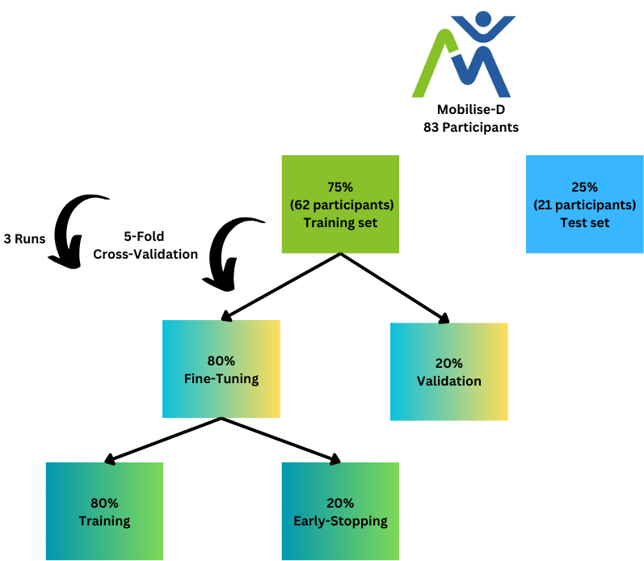
Supplementary Figure S3. Mobilise-D dataset flow. Initially, 75% of the participants were utilized to fine-tune the model for the development of a gait detection model. A 5-fold cross-validation approach was employed. During each fold, data was divided into 80% for training and 20% for validation. The model underwent training for 30 epochs, incorporating an early-stop mechanism that halted the training process if the loss on the set did not decrease for 5 consecutive epochs. Model performance evaluation was conducted on the validation set, and the final performance was calculated as the average across the 5 folds. This entire process was repeated three times for three different divisions of the cross-validation folds. The average of these three runs was then calculated. This approach allowed us to evaluate various model configurations and select the most effective one. Ultimately, the best configuration was applied to the 25% test set, comprising 21 participants, and compared against state-of-the-art models.

