Self-organizing neuromorphic nanowire networks are stochastic dynamical systems – Supplementary Information
Gianluca Milano^{1*}, Fabio Michieletti², Carlo Ricciardi,² Enrique Miranda³
¹Advanced Materials Metrology and Life Sciences Division, INRiM (Istituto Nazionale di Ricerca Metrologica), Strada delle Cacce 91, 10135 Torino, Italy.
²Department of Applied Science and Technology, Politecnico di Torino, C.so Duca degli Abruzzi 24, 10129 Torino, Italy.
³Departament d’Enginyeria Electrònica, Universitat Autònoma de Barcelona (UAB), 08193 Cerdanyola del Vallès, Spain

Email: g.milano@inrim.it

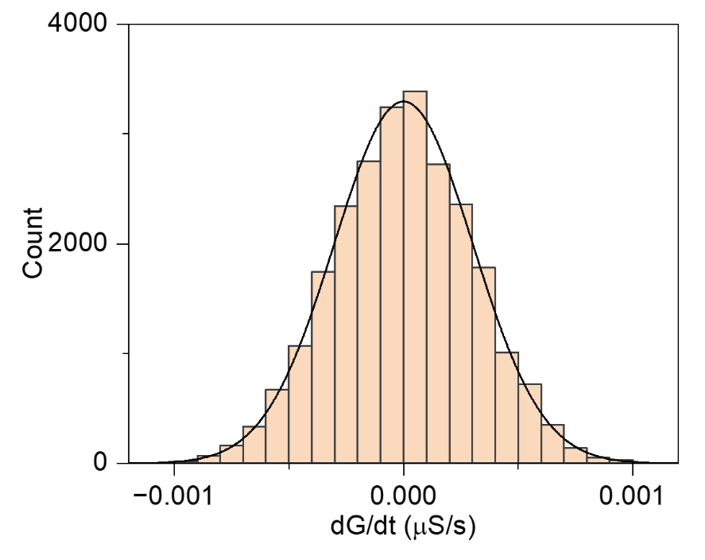
Supplementary Figure S1. Noise observed in a resistor. Histogram of $dG/dt$ fitted with a Gaussian distribution (black like) obtained by evaluating the time trace of conductance (~ 15000 s) of a discrete resistor with a resistance value of 27 kΩ comparable to the mean value of resistance observed in the stationary state of the NW network experimentally analyzed in Figure 3. Note that the conductance time trace in case of the discrete resistor have been measured by exploiting the same experimental setup and measurement protocol exploited for the characterization of the NW network. The standard deviation of $dG/dt$ observed in a discrete resistor is ~ $3∙{10}^{-10}$ S/s, two orders of magnitude lower than the standard deviation of $dG/dt$ of ~ $3∙{10}^{-8}$ observed in the Gaussian component of noise of the NW network (please refer to Figure 2e). This observation shows that the Gaussian component of noise observed in NW networks results from the physical substrate and does not rely on the measurement setup and/or measurement scheme.

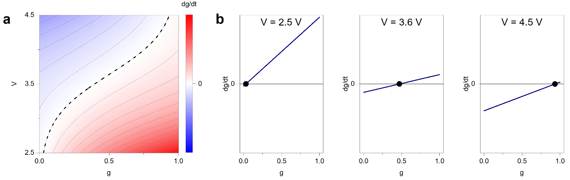
Supplementary Figure S2. Phase portrait of the nanoscale network dynamical system. a. Landscape of $dg/dt$ as a function of the normalized internal state of the network $g$ and applied voltage V. The black dashed line represents the curve $dg/dt$ = 0 that corresponds to the asymptotic attractor state of the system, where potential function assumes minimum values. b. Profiles of $dg/dt$ at fixed voltage bias, where the black dot reports the intersection of the profile with $dg/dt$ = 0 (attractor state).

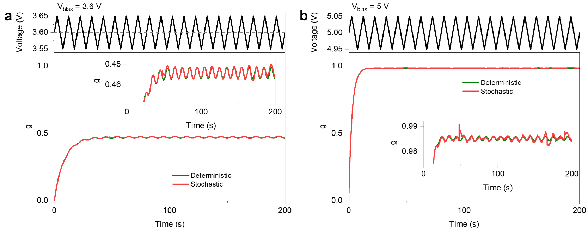
Supplementary Figure S3. Processing of the input signal through neuromorphic network dynamics – transient dynamics. Deterministic and stochastic evolution of the internal memory state of the NW network $g$ when stimulated with a triangular voltage waveform with amplitude of 50 mV (external signal), while applying a constant bias of a. 3.6 V and b. 5V by considering the ground state of the system as initial state. As can be observed, transient dynamics are induced by the applied constant bias to drive the system to a fixed-point attractor state where it’s possible to process the input signal. Insets show an enlarged view of the network response. Note that information processing based on fluctuations around a fixed-point attractor can be performed only after stabilization of the system near the attractor state induced by the voltage bias (operating regime). Data reported in Figure 7 are extracted from last 100 s of network dynamics where transient dynamics related to the constant bias are ended.

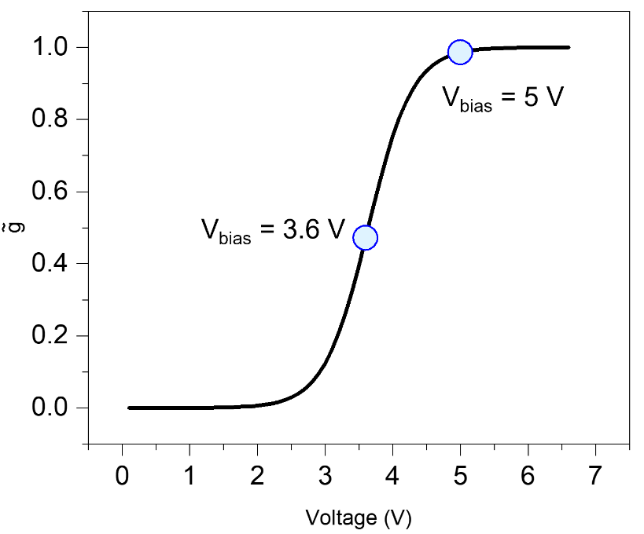
Supplementary Figure S4. Operating regimes of the network. Evolution of the internal memory stationary state attractor $\tilde{g}$ as a function of the applied voltage bias. Circles represents the fixed-point attractor in operational regimes considered in Figure 7. Note that the operating regime sustained by a bias of 3.6 V that drives the system near the sigmoidal-like transition of the attractor state expected in stationary conditions ($\tilde{g}$~ 0.5), while the operating regime sustained by a bias of 5 V drives the system to $\tilde{g}$close to 1

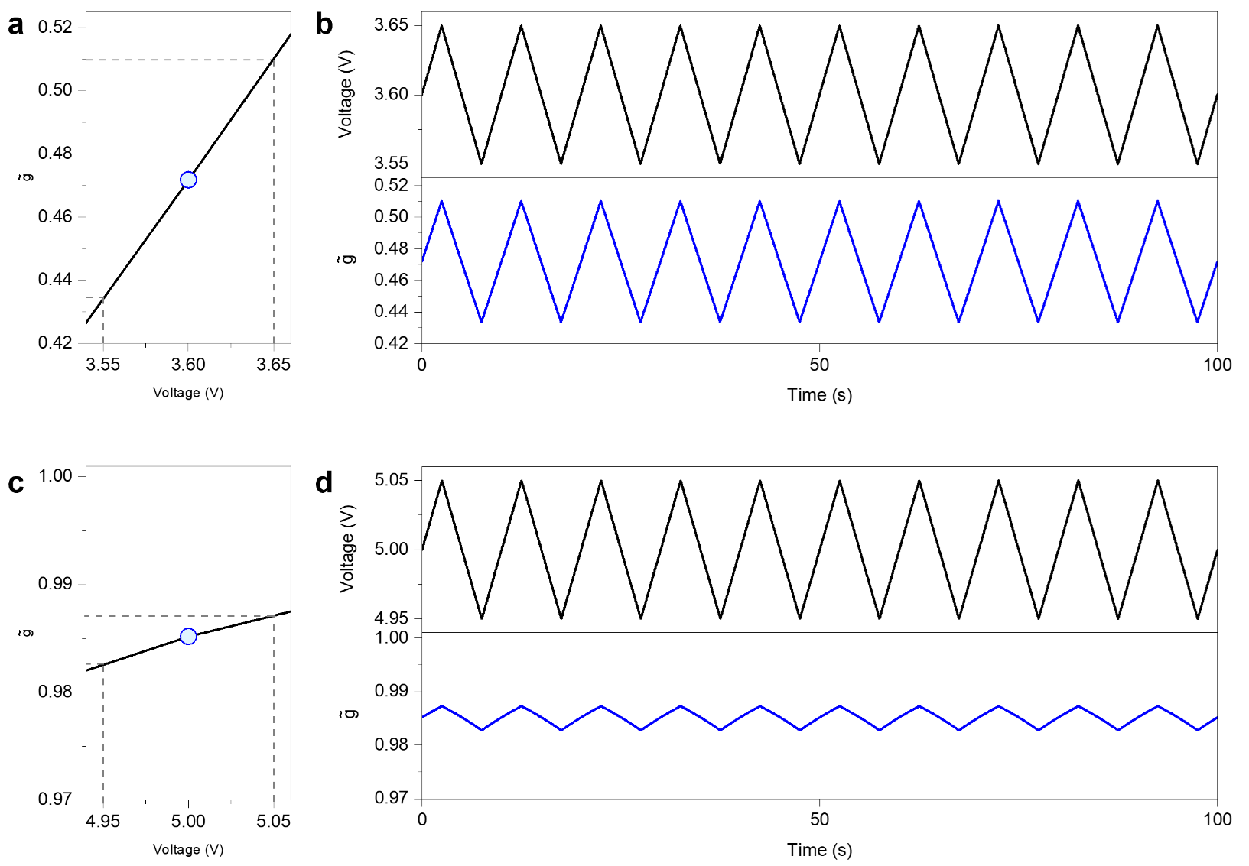
Supplementary Figure S5. Processing of the input signal through fluctuations of the attractor state. a. Attractor state of the system $\tilde{g}$in the operating regime sustained by a constant bias of 3.6 V (blue circle) and range of fluctuations of $\tilde{g}$when stimulated with a triangular voltage waveform with amplitude of 50 mV; b. corresponding fluctuations over time of the attractor state $\tilde{g}$. c. Attractor state of the system $\tilde{g}$in the operating regime sustained by a constant bias of 5 V (blue circle) and range of fluctuations of $\tilde{g}$when stimulated with a triangular voltage waveform with amplitude of 50 mV; d. corresponding fluctuations over time of the attractor state $\tilde{g}$. Fluctuations of $\tilde{g}$ over time are responsible for transient dynamics that can be exploited for nonlinearly process the input signal. Note that the operational regime sustained by a 3.6 V bias results in a larger range of $\tilde{g}$ fluctuations compared to the operational regime sustained by 5 V, enhancing in this case the dynamic response of the system.

