Extended data
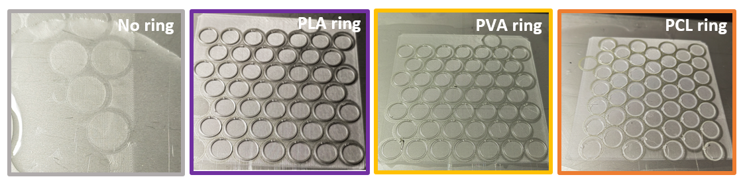
Extended data Fig. 1. Zoomed out pictures of laser cut and FDM reinforced MEW scaffolds with rings made of PLA, PVA and PCL.
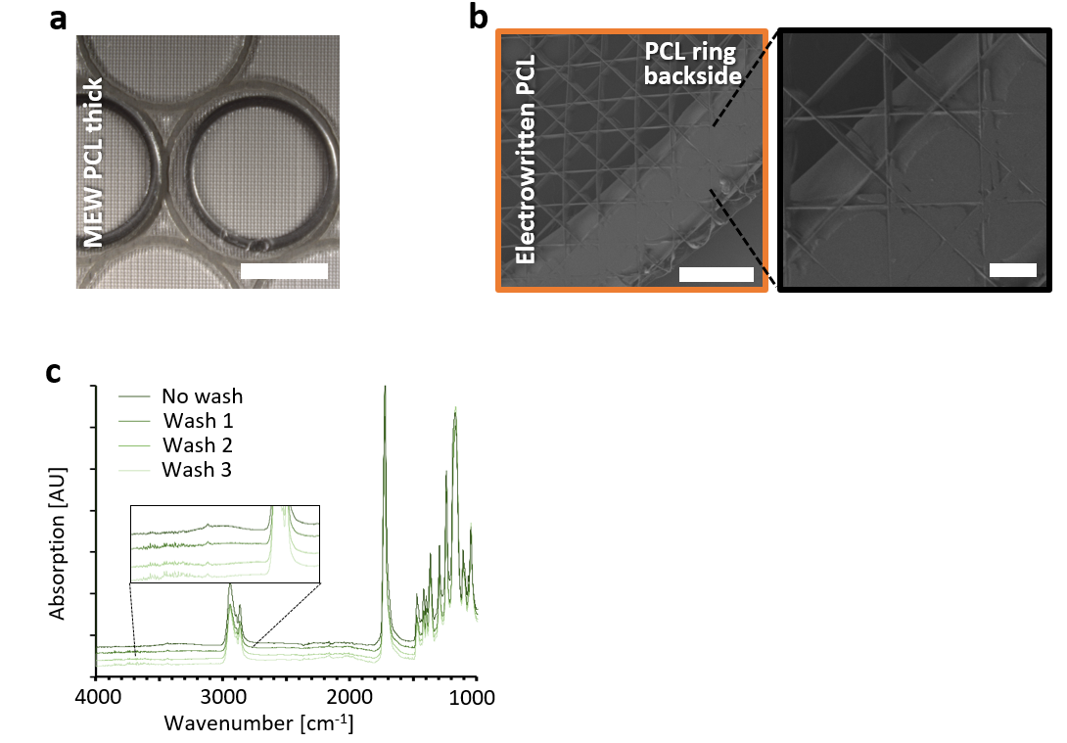
Extended data Fig. 2. (a) Thick MEW scaffold reinforced with PLA rings. (b) The backside of an electrowritten scaffold melted onto the PCL reinforcement ring. (c) FTIR spectra showing the removal of PVA from electrospun scaffolds after several washing steps in 70 % ethanol. Scale bar in (a) 5 mm, in magnification 100 µm and 400 µm in (b).

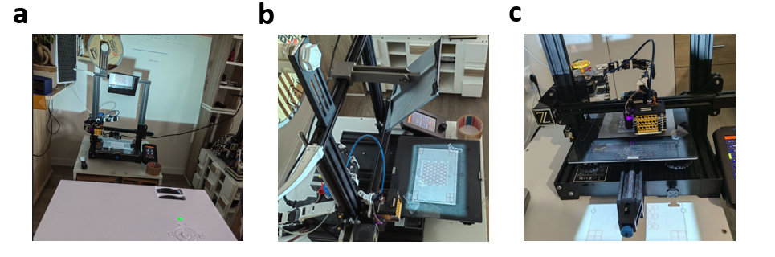
Extended data Fig. 3. (a) Actual setup of the FDM printing calibration using a projector, an image looking at the printer from behind the projector. (b) An image from the side of the printer showing the substrate on the metal plate and projected pattern aligned. (c) The printer printing atop the scaffold.
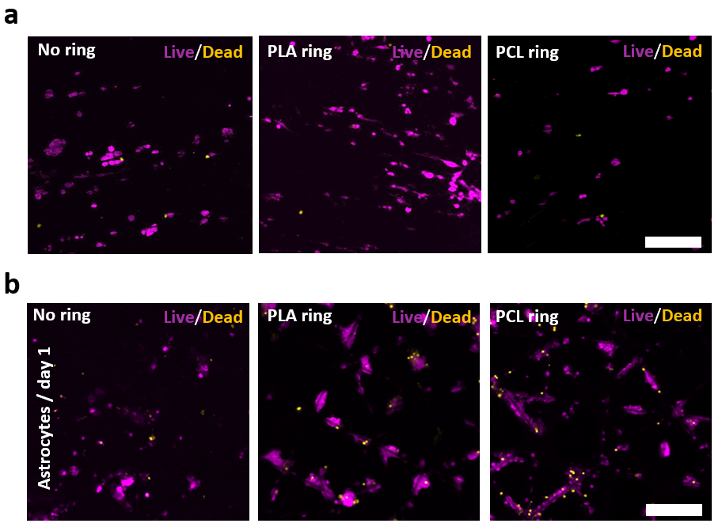
Extended data Fig. 4. (a) Live/dead of U87 on aligned electrospun PCL membranes without and with PLA/PCL reinforcement rings on day 1. (b) Astrocyte live/dead on MEW scaffolds without and with PLA/PCL reinforcement rings on day 1. Scale bar (a) 100 µm and (b) 200 µm.
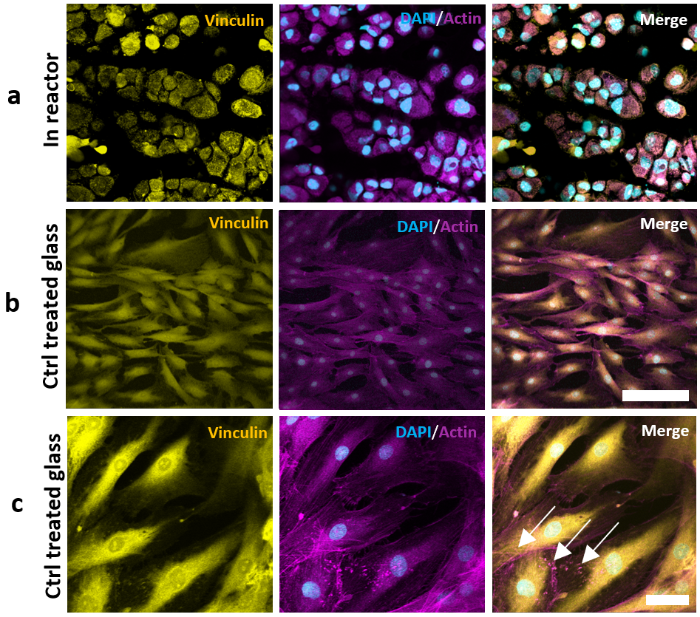
Extended data Fig. 5. (a) Vinculin/Actin staining of ASCs on the random electrospun PCL membrane in the bioreactor. (b) The same staining on a treated glass control. (c) Magnified images of locations on the glass slide showing focal adhesions. Scale bar (a, b) 50 µm and (c) 10 µm.

