Supplementary Materials
Highly Precise and Sensitive Approach for Direct Electrochemical Sensing of Inorganic Phosphate Using Zinc Ferrite Incorporated-Polyaniline Electrodes

Imran Khan^{1, 2*}, Anwar ul Haq Ali Shah ¹*, Salma Bilal ²

¹ Institute of Chemical Sciences, University of Peshawar, Peshawar 25120, Khyber Pakhtunkhwa, Pakistan
² Institute of Applied Materials Electrochemical Technologies (IAM-ET), Karlsruhe Institute of Technology, 76131, Karlsruhe, Germany
³ National Centre of Excellence in Physical Chemistry, University of Peshawar, Peshawar 25120, Khyber Pakhtunkhwa, Pakistan
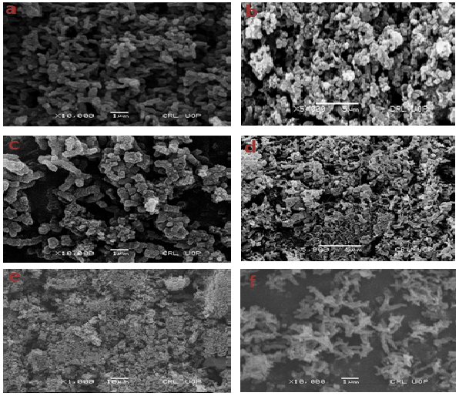
Figure S1. SEM images of (a) PANI@AuS before sensing, (b) PANI-ZnO@AuS before sensing, (c) PANI-Fe₂O₃@AuS before sensing, (d) PANI@AuS after sensing, (e) PANI-ZnO@AuS after sensing and (f) PANI-Fe₂O₃@AuS after sensing.

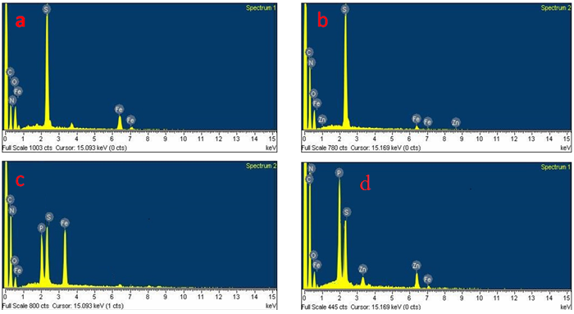
Figure S2. EDX patterns of (a) PANI-Fe₂O₃@AuS, (b) PANI-Fe₂O₄@AuS before sensing, (C) PANI-Fe₂O₃@AuS and (d) PANI-ZnFe₂O₄@AuS after sensing.

Figure S3. Potentiometric and amperometric sensing of PANI@AuS electrodes whereas (a) CVs recorded at different concentration phosphate solution, (b) linear relation of corresponding CVs, (c) CAMs at different phosphate concentration and (d) linear relation of corresponding CAMs.
Figure S4. Potentiometric and amperometric sensing of PANI-ZnO@AuS electrodes whereas (a) CVs recorded at different concentration phosphate solution, (b) linear relation of corresponding CVs, (c) CAMs at different phosphate concentration and (d) linear relation of corresponding CAMs.
Figure S5. Potentiometric and amperometric sensing of PANI-Fe₂O₃@AuS electrodes whereas (a) CVs recorded at different concentration phosphate solution, (b) linear relation of corresponding CVs, (c) CAMs at different phosphate concentration and (d) linear relation of corresponding CAMs.

Figure S6. UV-Vis spectra recorded for relative percent recovery.

Figure S7. CVs recorded for PANI-ZnFe₂O₄@AuS electrode at a scan rate of 50 mV/s in (a) 2x10⁻⁴ M sodium carbonate, (b) 2x10⁻⁴ M sodium fluoride, (c) 2x10⁻⁴ M sodium chloride, (d) 2x10⁻⁴ M sodium nitrate, (e) 2x10⁻⁴ M phosphate solution at different scan rates (from 5 mV/s to 50 mV/s) in the presence of interfering ions (f) comparative CVs of PANI-ZnFe₂O₄@AuS, PANI@AuS and bare gold electrode in 2x10⁻⁴ M phosphate solution containing interfering ions at 50 mV/s scan rate.

Figure S8. Potentiometric and amperometric techniques used for stability and reusability of PANI-ZnFe₂O₄@AuS sensor electrode. Whereas (a) CVs recorded at zero time, 1st, 2nd, 3rd and 4th week in 1M H₂SO₄ Solution when kept the electrode in open atmosphere for one month, (b) CVs recorded in 1M H₂SO₄ solution for stability test and (c) CAMs recorded in same concentration phosphate solution of 4x10⁻⁴M for reusability.

Figure S9. Nyquist plots of different sensor electrodes at V_{DC} = 200 mV in frequency range of 100 kHz to 0.01 kHz vs. SCE in 1 M H₂SO₄ solution (a) PANI@AuS before sensing, (b) PANI@AuS after sensing, (c) PANI-ZnO@AuS before sensing, (d) PANI-ZnO@AuS after sensing, (e) PANI-Fe₂O₃@AuS before sensing and (f) PANI-Fe₂O₃@AuS after sensing.

Table S1. Limit of detection of different electrodes calculated from amperometric data.
Name of Material | Slope  (m) | Standard deviation (σ) | Adj. R square  (R²) | Limit of detection (LOD)
PANI@AuS  PANI-ZnO@AuS | 1798  3071 | 0.001337  0.000715 | 0.93  0.899 | 2.23x10⁻⁶ M  6.98x10⁻⁷ M
PANI-Fe₂O₃@AuS  PANI-ZnFe₂O₄@AuS | 15738  142110 | 0.001808  0.01398 | 0.981  0.993 | 3.44x10⁻⁷ M  2.95x10⁻⁷ M

Table S2. Diffusion coefficient calculation for PANI-ZnFe₂O₄@AuS electrode using constant time interval of 120s, at different phosphate concentrations
Concentration  (M) | Time  S | Current  (A) | Diffusion coefficient  (cm²/s)
1x10⁻⁴ | 120 | 1.181x10⁻⁶ | 1.01x10⁻⁴
2x10⁻⁴ | 120 | 1.248x10⁻⁶ | 1.09x10⁻⁴
4x10⁻⁴ | 120 | 1.462x10⁻⁶ | 1.10x10⁻⁴
6x10⁻⁴ | 120 | 1.435x10⁻⁶ | 1.36x10⁻⁴
8x10⁻⁴ | 120 | 2.239x10⁻⁶ | 9.6x10⁻⁴

