Table of Contents:

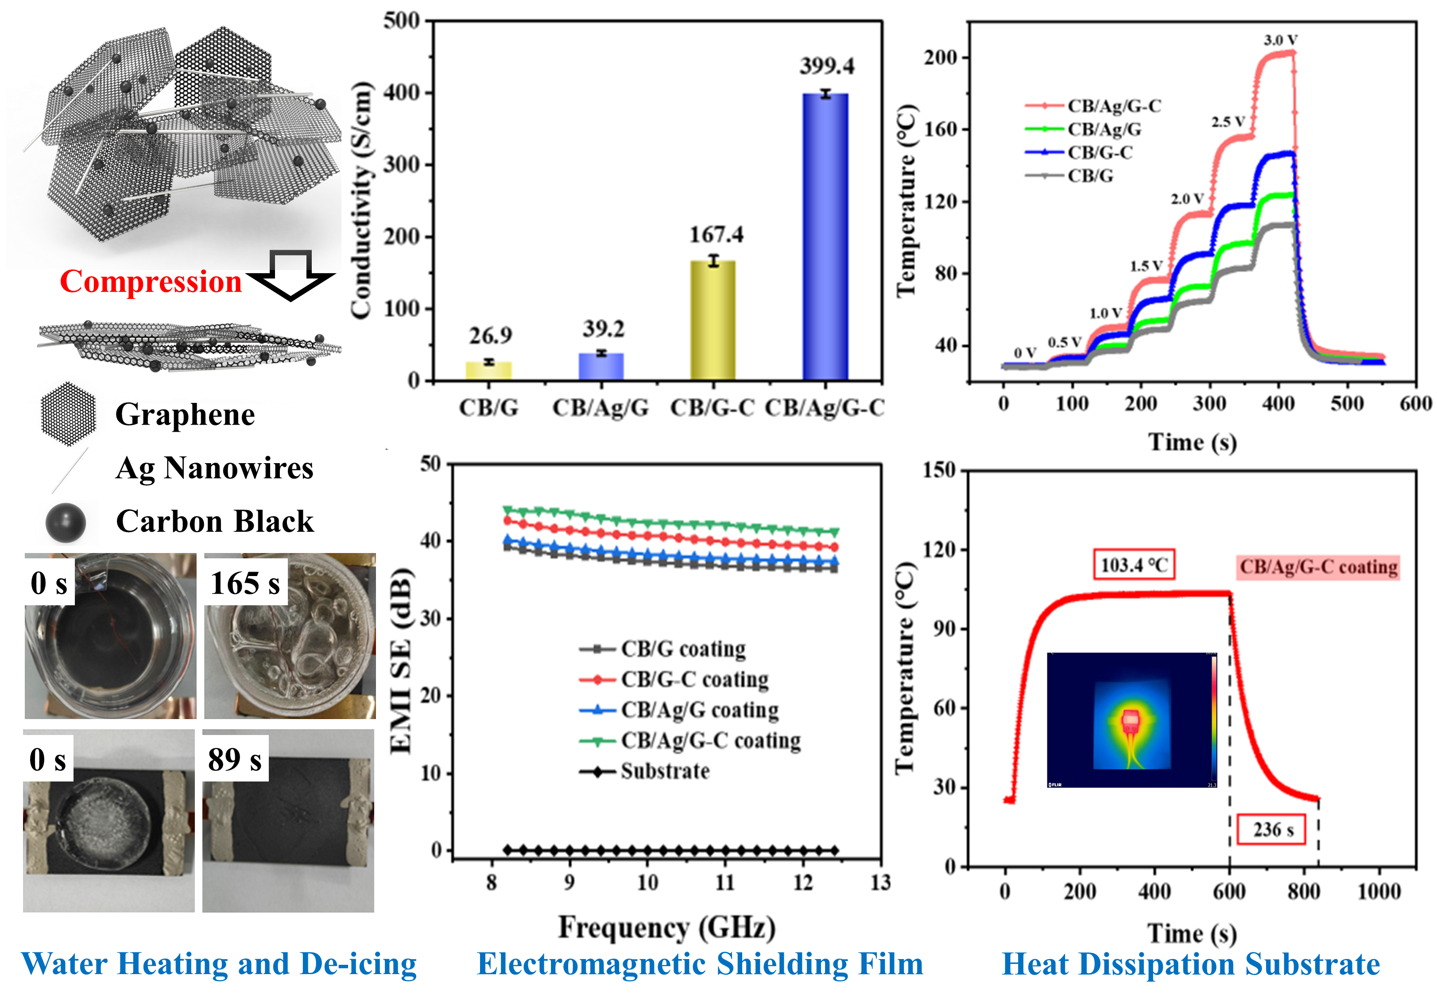

To overcome the challenge of constructing highly-conductive network with low contact resistance in graphene-based electrothermal films, we combined the respective characteristics of Ag nanowires and compression rolling treatment to constructe tightly stacked conductive three-dimensional networks for electrothermal performances. Our work is not only informative for electrothermal films appliactions, but also provides a referecne for large-scale commercial practical applications.

