Supplementary information for

Multifunctional and high-performance electrothermal films based on carbon black/Ag nanowires/graphene composites
Chaochao Gao^{1,2}, Wen Yu,^{1,2}* Zijian Wang^{1,2}, Zhenye Zhu¹, and Jiaheng Zhang¹*

¹ Research Centre of Printed Flexible Electronics, School of Materials Science and Engineering, Harbin Institute of Technology (Shenzhen), Shenzhen, China.
² These authors contributed equally: Chaochao Gao, Wen Yu, Zijian Wang.
E-mail: yuwen@hit.edu.cn, zhangjiaheng@hit.edu.cn

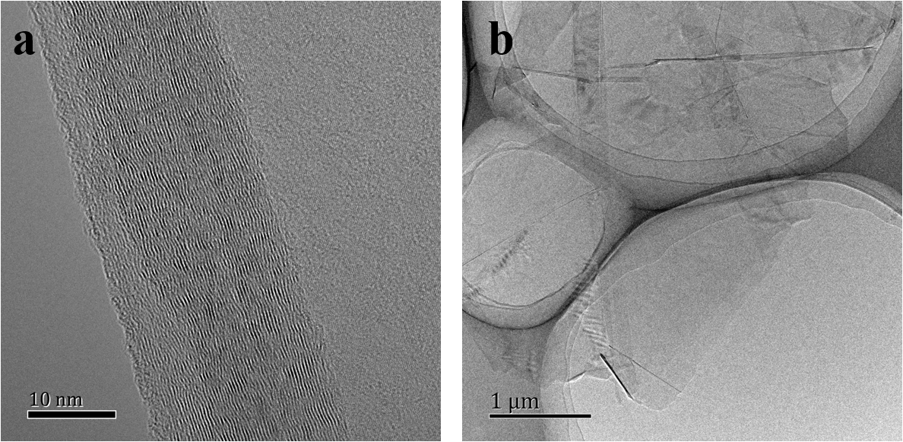
Fig. S1 TEM images of the samples. a original graphite. b obtained graphene.

Supplementary Note
The effect of Ag content on the conductivity of CB/Ag/G films was investigated and the results are shown in Table S1. The resistivity of the films decreases with increasing Ag mass fraction. This can be attributed to the fact that more AgNWs promote the connection of graphene nanosheets, which further reduces the contact resistance between the layers. The resistivity can be as low as 0.00125 Ω·cm when the Ag content is 2.64 wt%. The addion of more Ag is not considered in this paper considering the high conductivity and low cost. Unless otherwise stated, the Ag content of the films in this paper is 2.64 wt%.

Table S1. Resistivity of CB/Ag/G films with different mass fraction of Ag.
mass fraction of Ag  (wt%) | Resistivity (before rolling) (Ω·cm) | Resistivity (after rolling) (Ω·cm)
0 | 1.99311 | 0.26496
1.28 | 0.054 | 0.00245
2.64 | 0.03040 | 0.00125

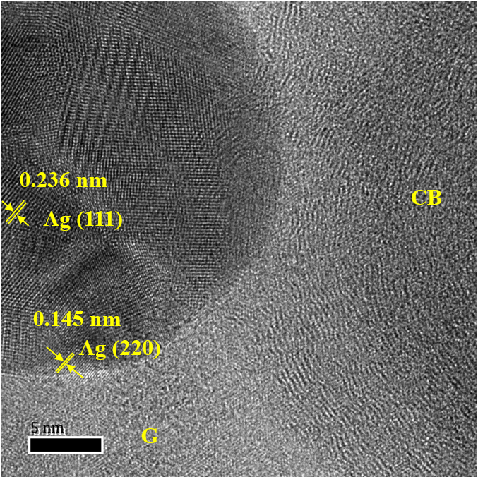
Fig. S2 TEM image of CB/Ag/G composite.

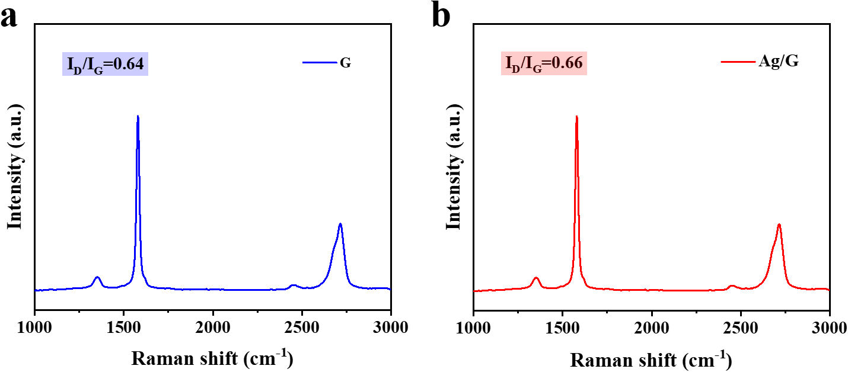
Fig. S3 Raman spectra of the samples obtained by liquid-phase exfoliation. a graphene. b Ag/G composite.

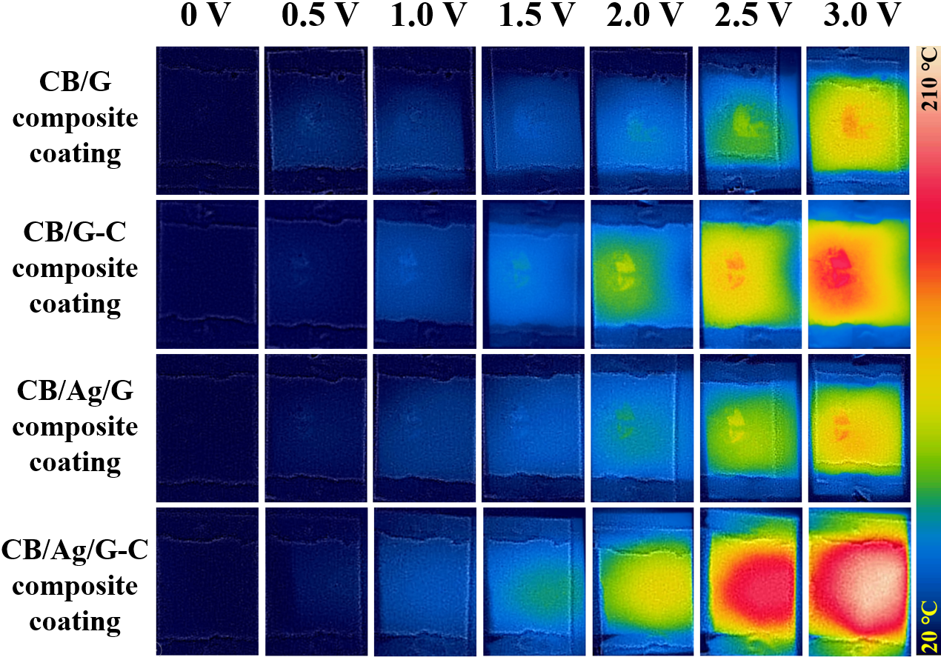
Fig. S4 Infrared thermal images of the CB/G, CB/G-C, CB/Ag/G and CB/Ag/G-C composite coatings at different temperature.

Fig. S5 The relationship between temperature and time of the CB/Ag/G-C composite coating running with 3.0 voltage.

Fig. S6 Resistivity retention of the CB/Ag/G-C composite coating in air during 10 days.

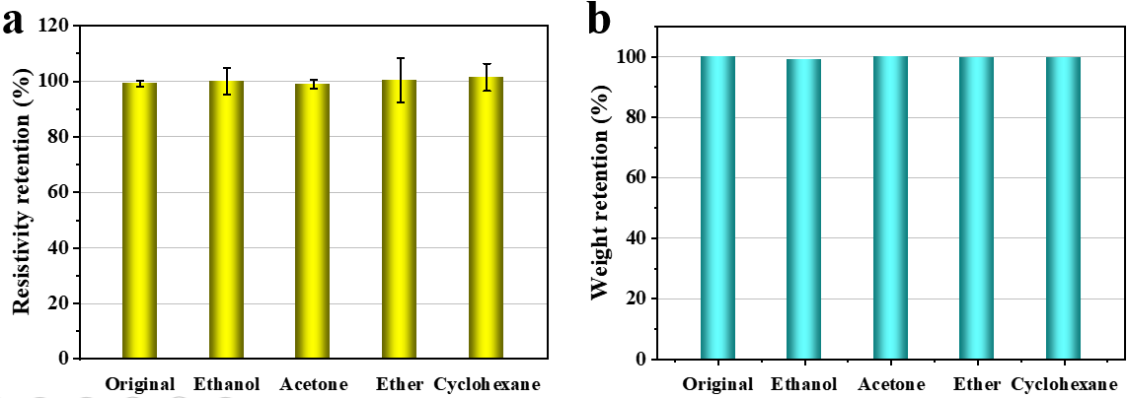
Fig. S7 Resistivity retention and weight retention of the CB/Ag/G-C composite coating after exposed in different organic solvents for 24 h.

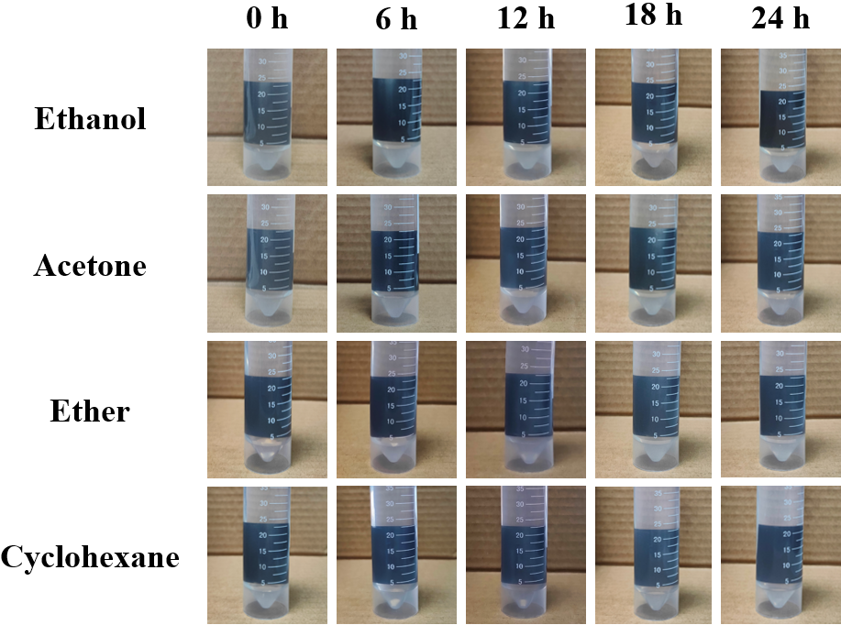
Fig. S8 Photograph of the CB/Ag/G flexible coating exposed in different organic solvents.

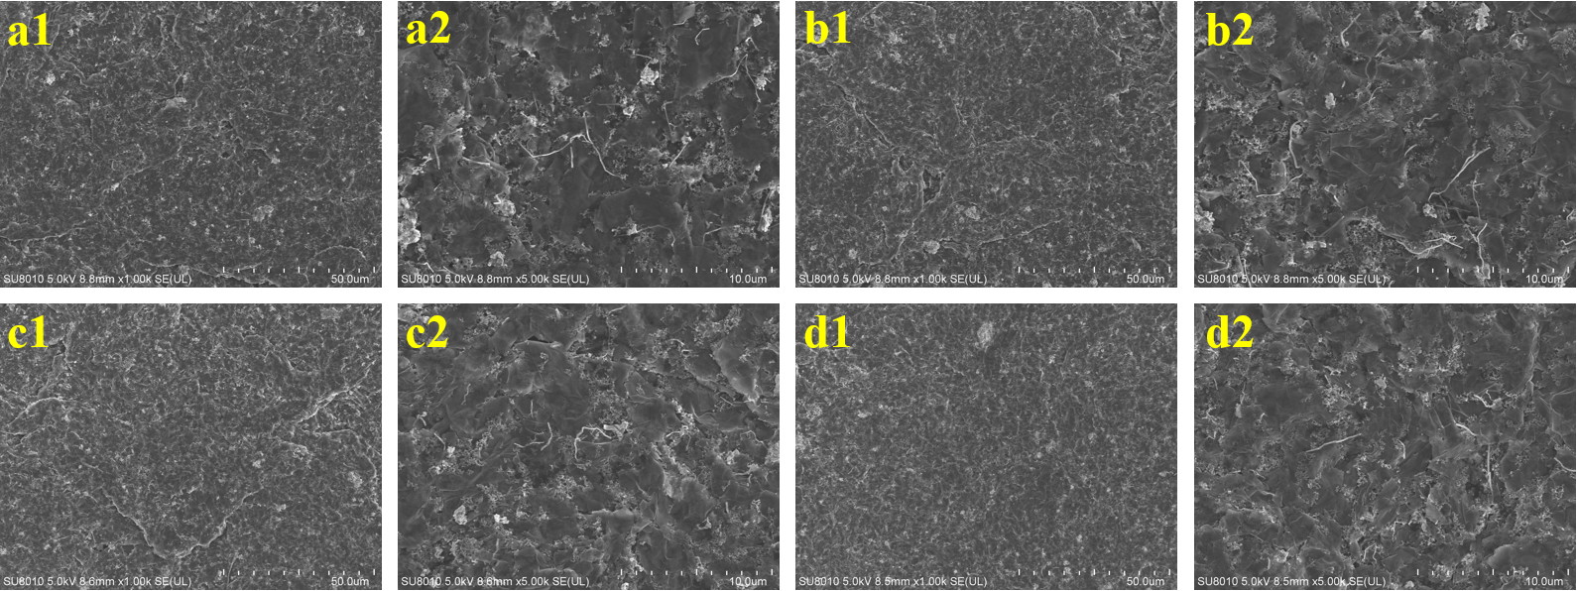
Fig. S9 Surface morphology of the CB/Ag/G-C composite coating after exposed in different solvents. a in ethanol. b in acetone. c in ether. d in cyclohexane.

