Online field measurements of Chlorothalonil show that volatilization is key to pesticide exposure
Benjamin Loubet¹*, Carole Bedos¹, Julien Kammer^{1,2}, Céline Decuq¹, Florence Lafouge¹, Baptiste Esnault¹, Raluca Ciuraru¹, Sandy Bsaibes³, Pauline Buysse¹, Enrique Barriuso¹, Maria Raffaella Vuolo⁴, Valérie Gros³
1 ECOSYS, INRAE, AgroParisTech, University Paris-Saclay, France
2 now at LCE, University Aix Marseille, CNRS, Marseille, France
3 LSCE, CEA, University Paris-Saclay, Gif-Sur-Yvette, France
4 Vuolo M R, Consulente ambientale Rome, Italy

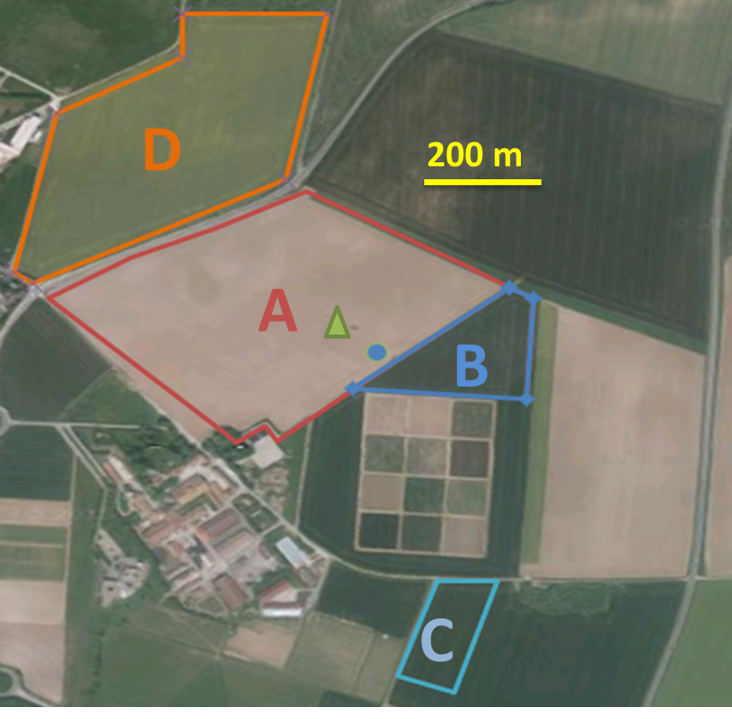
Supplementary Figure 1. Experimental site (A). Applied fields are shown in colours with letters A-D. The circle shows the PTR-QI-TOF-MS sampling location, and the triangle the TD-GC-MS gradient sampling location. A, B and C fields where applied the same day (16/04/2018), while field D was applied the 29/04/2018.

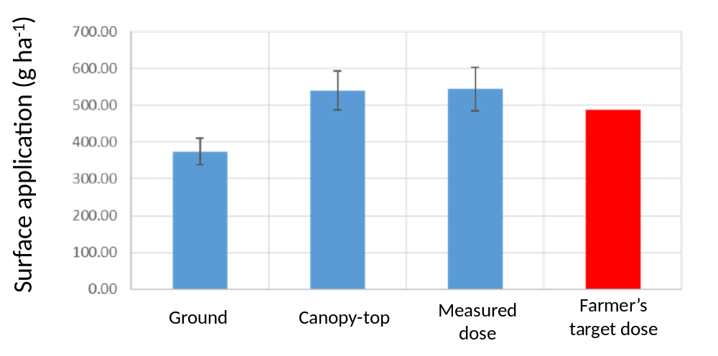
Supplementary Figure 2. Chlorothalonil dose applied as estimated by different means. Ground and canopy-top were estimated using filters (n = 12), while the measured dose was estimated by measuring the tank concentration (n = 4). The farmer’s target dose is the dose targeted by the farmer.

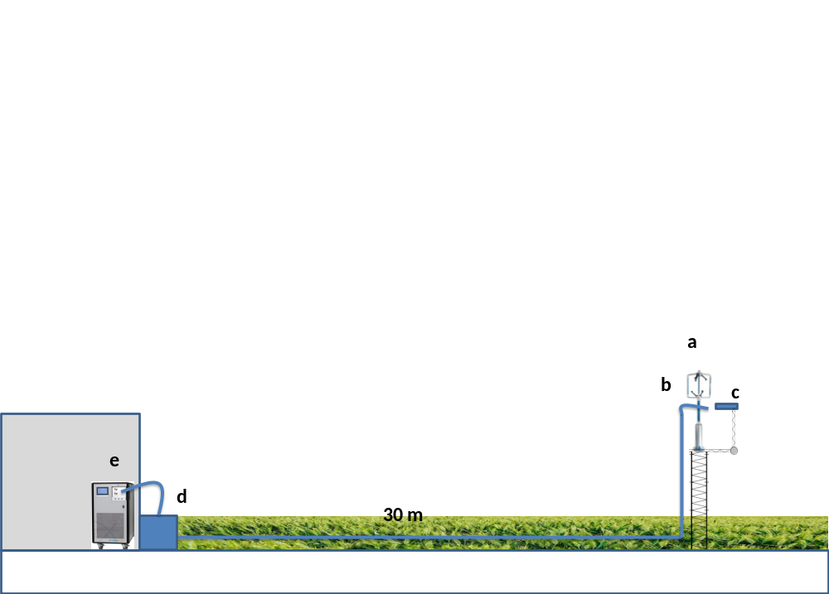
Supplementary Figure 3. Field PTR-QI-TOF-MS set up. a - ultrasonic anemometer. b – PTR-QI-TOF-MS sampling line. c – thermodesorption cartridge for GC-MS analysis. d – Pump for sampling line. e – PTR-QI-TOF-MS in its temperature-controlled field lab.

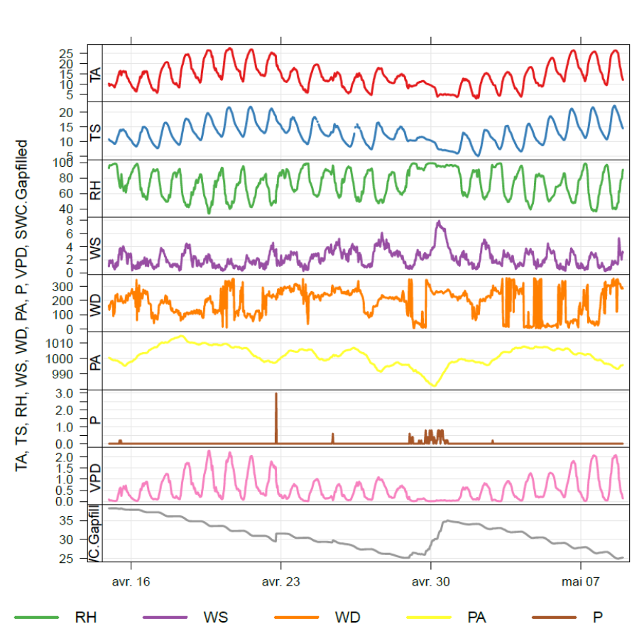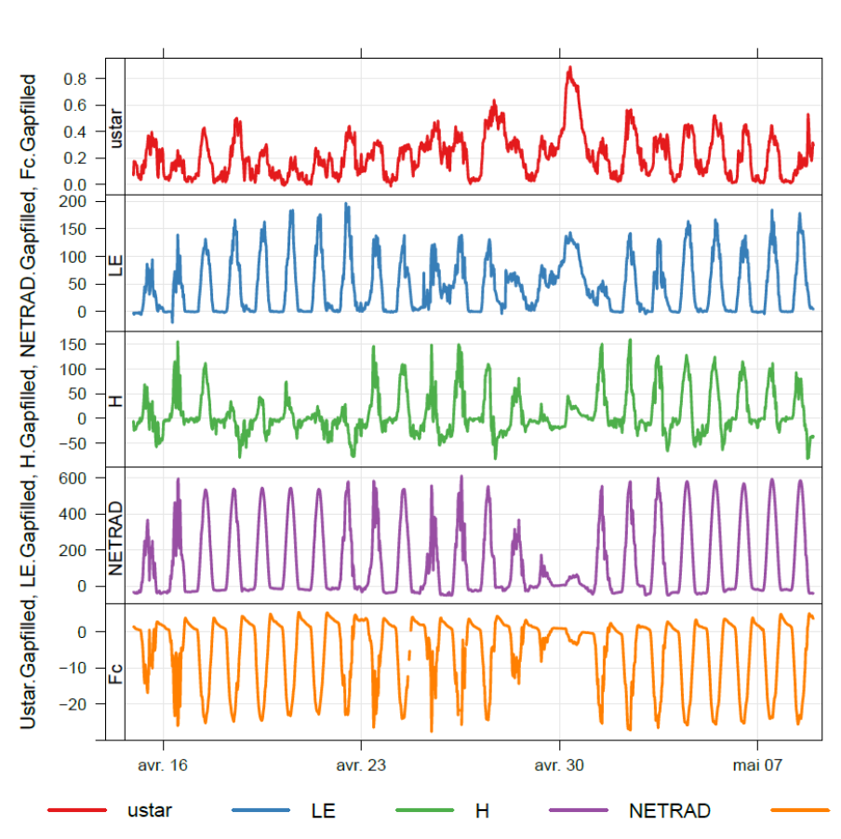
Supplementary Figure 4. meteorological conditions during the experiment. Air temperature (TA, °C), soil surface temperature (TS, °C), relative humidity ‘(RH, %), wind speed (WS, m s-1), wind direction (WD, deg/N), air pressure (PA, mbar), precipitation (P, mm), vapour pressure deficit (VPD, kPa), volumetric soil water content at 10 cm depth (SWC, %), friction velocity (ustar, ms s-1), latent heat flux (LE, W m-2), sensible heat flux (H, W m-2), net radiation (NETRAD, W m-2), CO2 flux (Fc, µmon m-2 s-1).

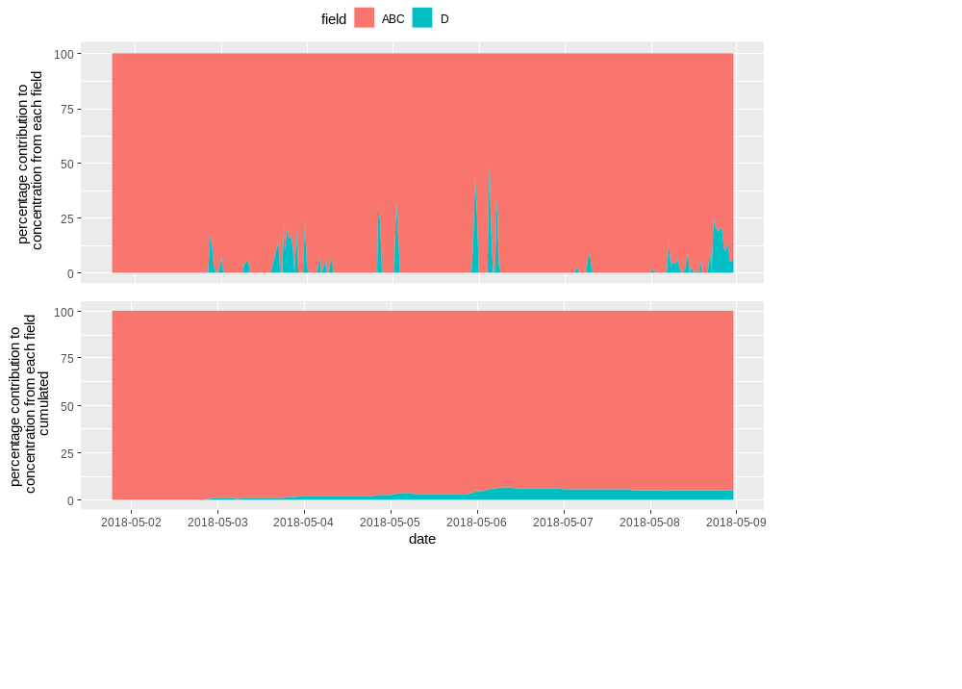
Supplementary Figure 5. Percentage contribution from fields D and ABC to the concentration footprint at the PTR-QI-TOF-MS measurement location over the last week of the campaign, after the field was applied. Assuming a similar source from each field, the cumulated contribution from field D to the Chlorothalonil concentration at the PTR-QI-TOF-MS location would represent less than 5.5% (bottom graph). The contribution from field D is scarce in time and mostly high during nights (top graph). When multiplied by a modelled flux simulated over that period and starting from the day of application of field D, we estimate that field D contribution to the measured concentration by the PTR-QI-TOF-MS would be less than 2%.

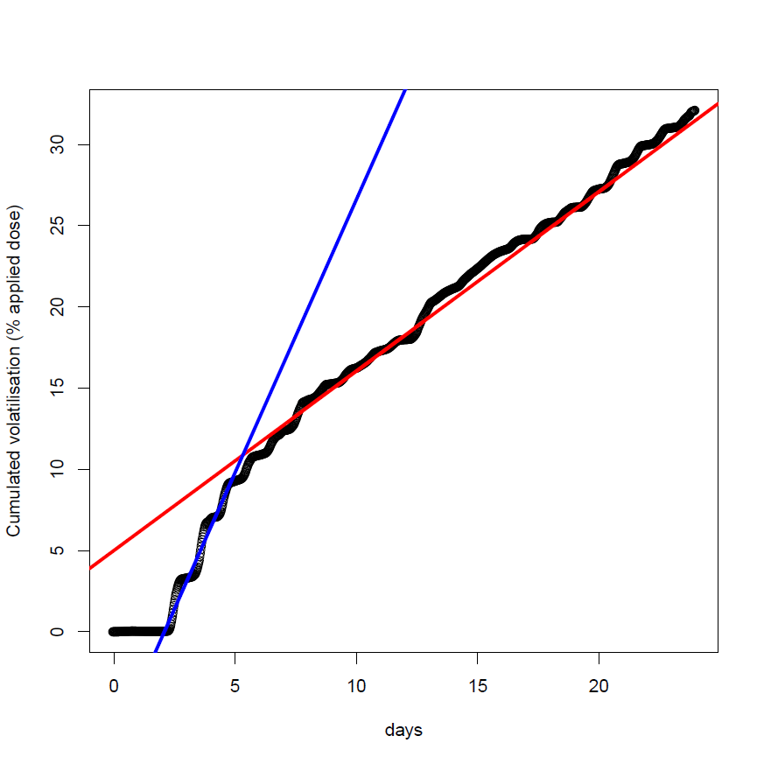
Supplementary Figure 6. Cumulated Chlorothalonil volatilisation flux (black dots) and fitted linear functions over the first 4 days (blue line) and over the rest of the campaign (red line). The blue line has a slope of 3.4% day⁻¹ and the red line a slope of 1.24% day⁻¹, where the percentage is the percentage of remaining Chlorothalonil.

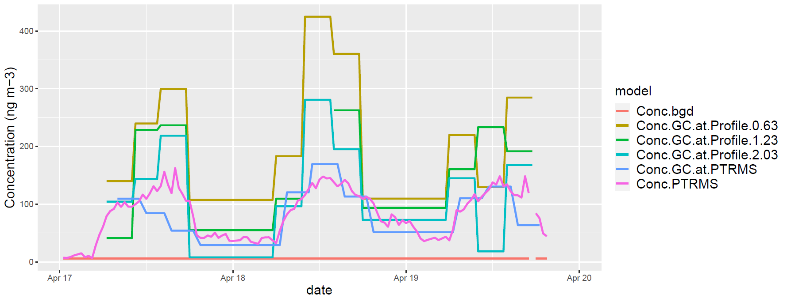
Supplementary Figure 7. Concentration of Chlorothalonil measured in the field at the TD-GC –MS and PTR-QI-TOF-MS locations with the two instruments. The TD-GC measurements were performed at three heights (0.63, 1.23 and 2.03 m above ground) at the TD-GC gradient mast location and at one height (1.9 m height) at the PTR-QI-TOF-MS mast location. The background concentration was estimated as the average concentration measured by the PTR-QI-TOF-MS before the Chlorothalonil application.

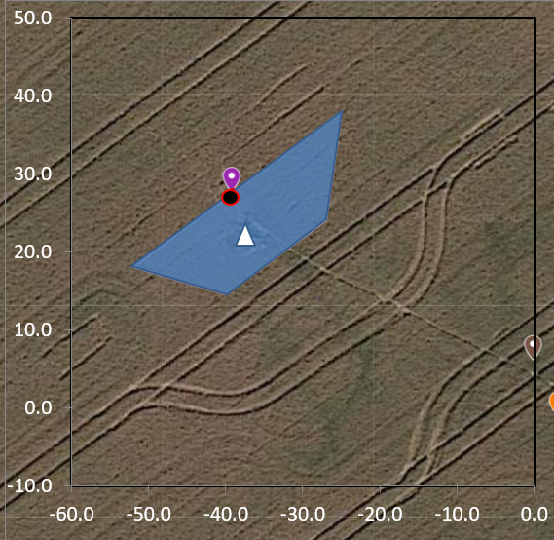
Supplementary Figure 8 Application exclusion zone (blue surface) and location of the GC aerodynamic gradient mast (purple locator and black and red circle). The tractor paths can be seen on the Google map photograph. The change in path to avoid the 5 m tall Eddy Covariance mast (white triangle) is clearly seen, resulting in the application exclusion zone evaluated by applying a distance of 24 m, which is half the application swath from the track (in blue). The exclusion zone is approximately 200 m² and is located right at the south-easterly edge of the GC mast. Scales are given in meters.

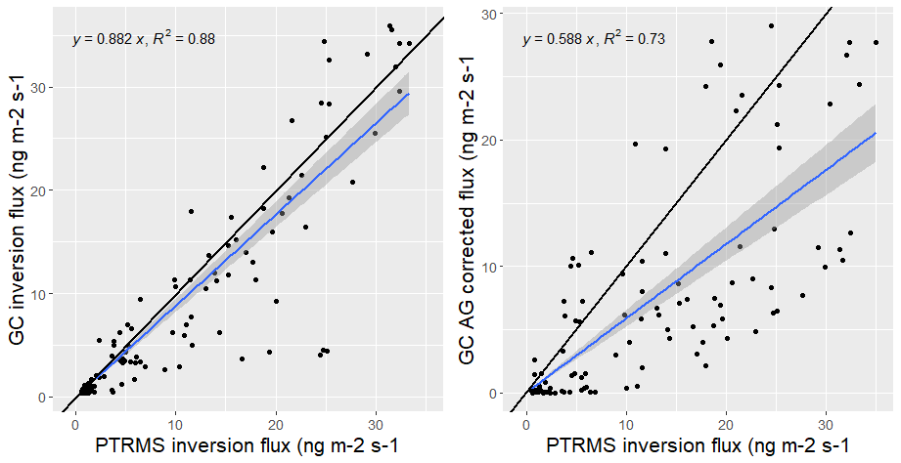
Supplementary Figure 9. GC inversion (left) and GC corrected gradient (right) Chlorothalonil fluxes versus PTR-QI-TOF-MS inversion flux. The GC inversion flux was computed using the inverse dispersion method and the Chlorothalonil concentration measured by the GC-MS at the GC-MS location at 1.25 m height above ground. The aerodynamic method was corrected to account for the application exclusion zone by using a footprint model (see methods).

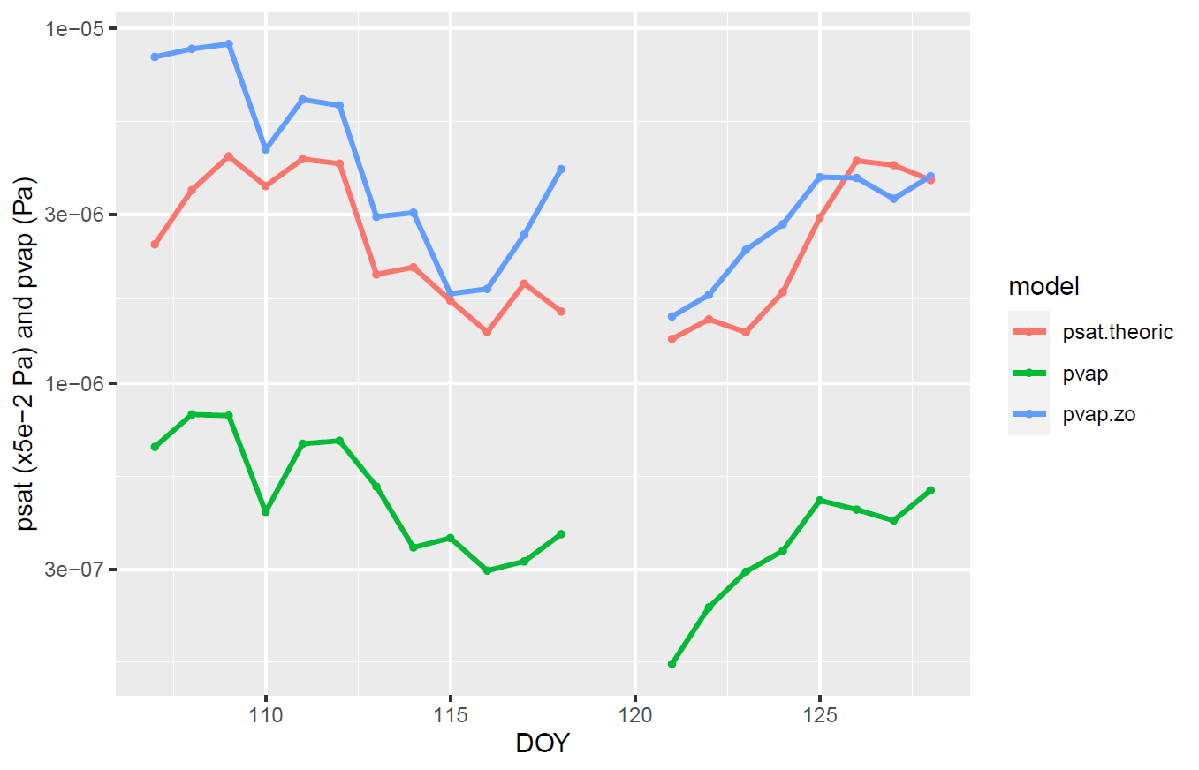
Supplementary Figure 10. Chlorothalonil vapour pressure at zm= 1.9 m above ground (pvap), at the canopy surface (pvap.zo) and saturated vapour pressure computed at air temperature (psat.theoric).

Supplementary Table 1. Chlorothalonil usage in France from 2009 to 2016

year | use  (T per year)
2009 | 984
2010 | 1213
2011 | 1320
2012 | 1084
2013 | 1091
2014 | 1293
2015 | 1448
2016 | 1710
Source: https://www.anses.fr/fr/system/files/Fiche_PPV_Chlorothalonil.pdf

Supplementary Table 2. Chlorothalonil physico-chemical characteristics used to compute the saturated vapour pressure.
Name | Reported value and [range] | Refs
Chemical formula | C8Cl4N2
Molecular weight (g mol⁻¹) | 265.9
Henry constant (Pa m³ mol⁻¹) | 2.50E-02 | ¹
Solubility in water (mg L⁻¹) | 8.10E-01 | ¹
Fraction of pesticide bound to water and leaf surface (log(K_{ow}), non-dimensional) | 2.94 | ¹
Partition coefficient between water and octanol, used as proxy of organic matter adsorption (K_{oc} in L g⁻¹) | 2.6 [0.3 – 6.1] | ¹
Half-life of the compound in the soil as measured in the lab (DT50_{soil} in day) | 3.5 [0.2 – 20] | ¹
Leaf wash off coefficient (k_{washoff} in mm⁻¹) | 0.05 | ²
Penetration rate of Chlorothalonil in the plant (k_{pen} in day⁻¹) | [0.13 – 0.24] | ^{1,2}
Pesticide Photodegradation by sun light | 0.14 | ¹
Saturation vapour pressure at a reference temperature | 7.65E-05 | ¹
Enthalpy of vaporization ${∆H}_{vap}$ (J mol⁻¹) | 95000 | ³
Enthalpy of dissolution ${∆H}_{d}$ (J mol⁻¹) | 27000 | ³

Supplementary Table 3. Parameter statistics used in the Monte Carlo quantification of the inverse dispersion modelling uncertainties.
Parameter | Units | Mean | SD | References
Roughness length Z₀ | m | 0.0035* | 0.0004* | Measured log normal distribution, based on estimation as in ⁴
Displacement height | m | 0.15 - 44# | 0.03 | Measured normal distribution, based on estimation as in ⁴
Target location (x,y,z) | (m, m, m) | - | (1,1,0.1) | GPS positioning error and soil roughness
Friction velocity u* | m s⁻¹ | measured | 14% of mean | Spatial variability as reported in ⁵
Wind direction | deg/N | Variable | 12.5 deg | Measured spatial standard deviation among 3 sensors
Obukhov length L | - | Variable | 40% of L | Assuming 14% error on both u* and H
lateral wind velocity sd | m s⁻¹ | Variable | 14% | Assumed similar in magnitude to u*
Concentration C | ng m⁻³ | Variable | 14% | Estimation based on calibration curve
bgd concentration $C_{bgd}$ | ng m⁻³ | 5.7 | 2.2 | Statistics of the concentration measured during 2 days before application
* log-normal distribution parameters (mean and variance). # varying value taken as $\frac{2}{3}h_{c}$, where $h_{c}$ is the canopy height.
Supplementary References
1 Lichiheb, N. et al. Measuring Leaf Penetration and Volatilization of Chlorothalonil and Epoxiconazole Applied on Wheat Leaves in a Laboratory-Scale Experiment. Journal of Environmental Quality 44, 1782-1790 (2015). https://doi.org:10.2134/jeq2015.03.0165
2 Leistra, M. & Van Den Berg, F. Volatilization of parathion and chlorothalonil from a potato crop simulated by the PEARL model. Environmental Science & Technology 41, 2243-2248 (2007). https://doi.org:10.1021/es0627242
3 Bedos, C. et al. Modelling pesticide volatilization after soil application using the mechanistic model Volt'Air. Atmos. Environ. 43, 3630-3639 (2009). https://doi.org:10.1016/j.atmosenv.2009.03.024
4 Loubet, B. et al. Investigating discrepancies in heat, CO2 fluxes and O-3 deposition velocity over maize as measured by the eddy-covariance and the aerodynamic gradient methods. Agric. For. Meteorol. 169, 35-50 (2013). https://doi.org:10.1016/j.agrformet.2012.09.010
5 Nemitz, E. et al. Intercomparison and assessment of turbulent and physiological exchange parameters of grassland. Biogeosciences 6, 1445-1466 (2009).

