SUPPLEMENTARY INFORMATION

Employing supramolecular chemistry strategies for the separation of mixtures of anisole and bromoanisole isomers

Benita Barton* and Ulrich Senekal

Department of Chemistry, PO Box 77000, Nelson Mandela University, Port Elizabeth, 6031, South Africa.
E-mail: benita.barton@mandela.ac.za

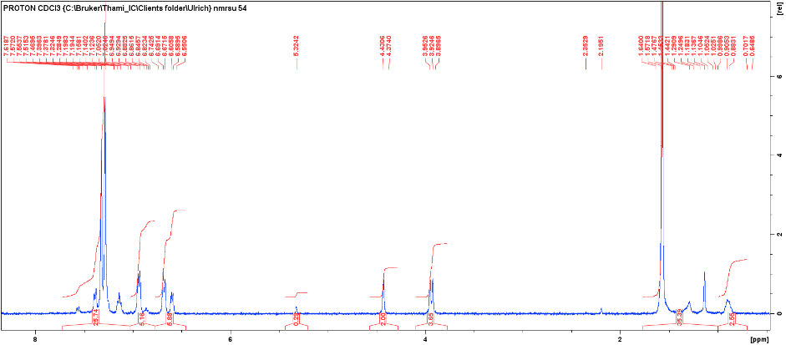
b)
a)
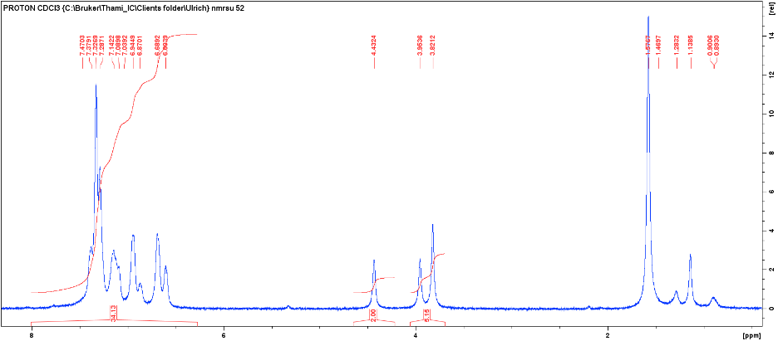
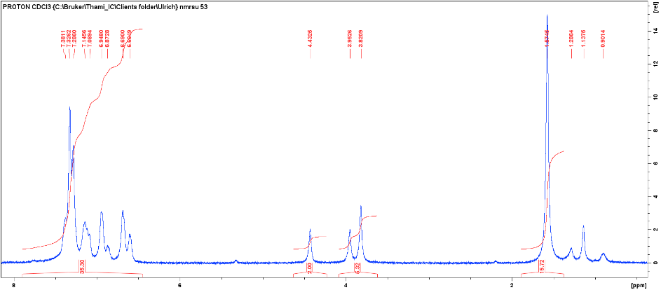
Figure S287. ¹H-NMR spectra of the single solvent experiment of 2-BA (a) and duplicated experiments of 3-BA (b) with H3
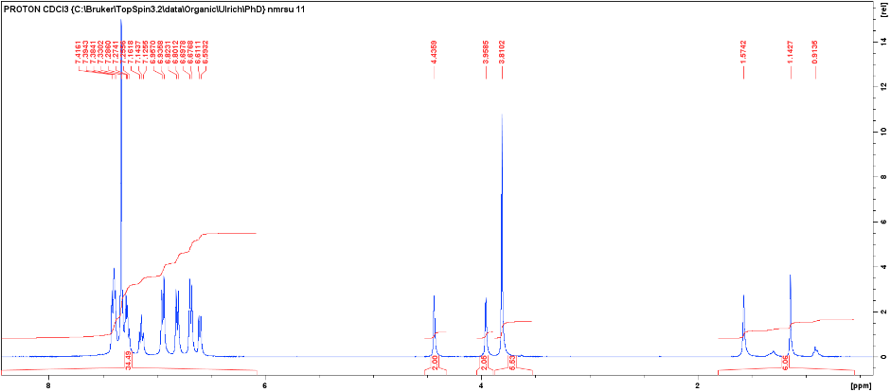
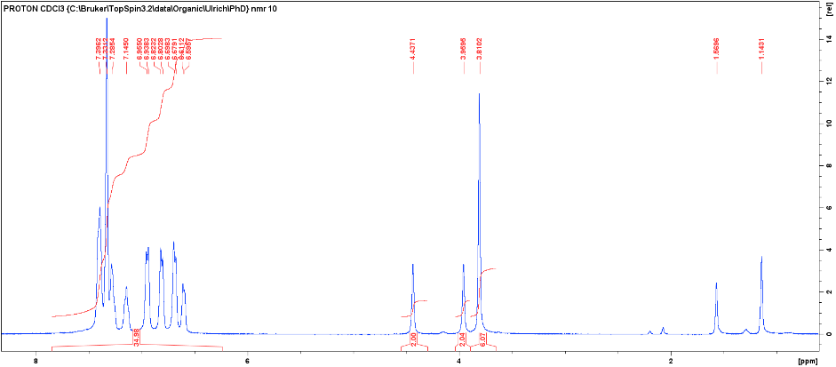
Figure S288. ¹H-NMR spectra of the duplicated single solvent experiments of 4-BA with H3
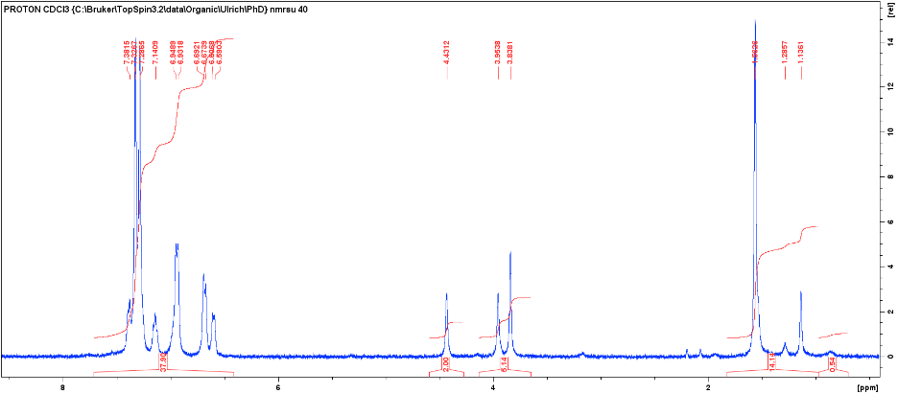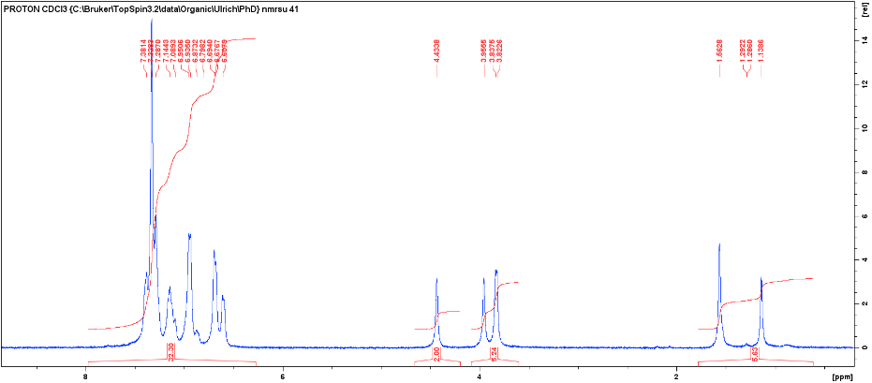
c)
b)
a)
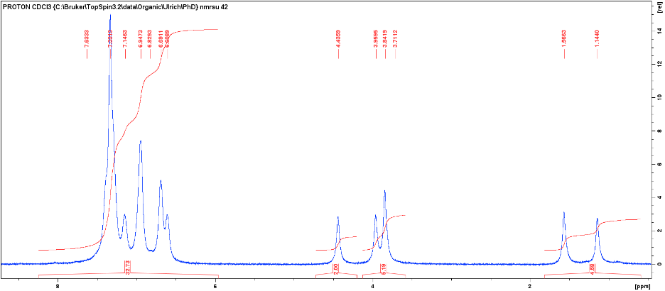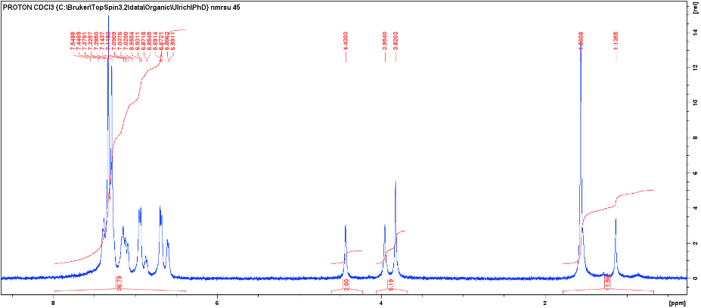
e)
d)
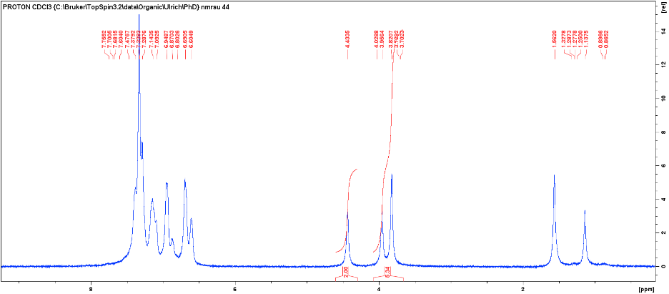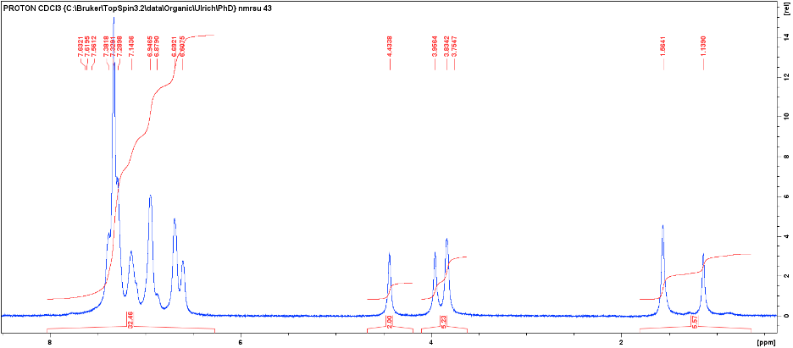
f)
Figure S289. Overall H:G ratios for the ANI/2-BA (a), ANI/3-BA (b), ANI/4-BA (c), 2-BA/3-BA (d), 3-BA/4-BA (e), and ANI/2-BA/3-BA (f) competition experiments with H3
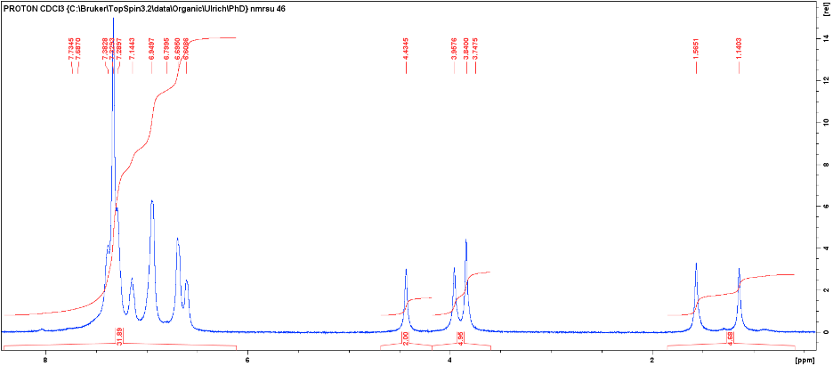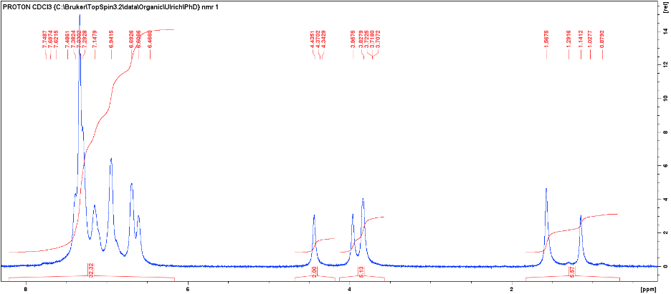
c)
b)
a)
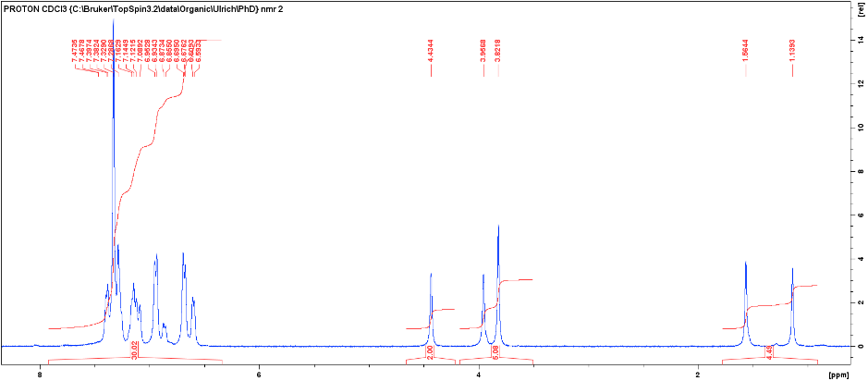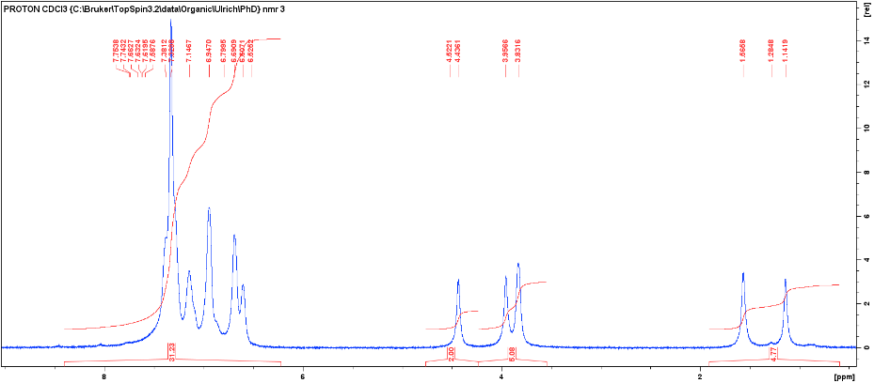
d)
Figure S290. Overall H:G ratios for the ANI/2-BA/4-BA (a), ANI/3-BA/4-BA (b), 2-BA/3-BA/4-BA (c), and ANI/2-BA/3-BA/4-BA (d) competition experiments with H3
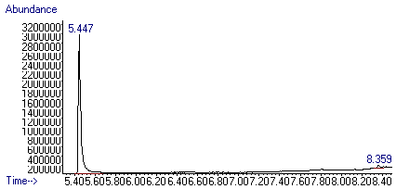
b)
a)
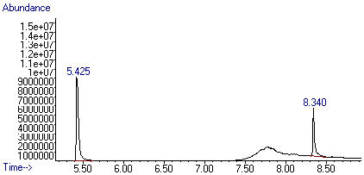
c)
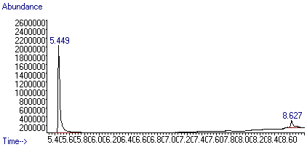
Figure S291. GC-MS chromatograms of ANI/2-BA (a), ANI/3-BA (b), and ANI/4-BA (c) binary guest mixtures with H3
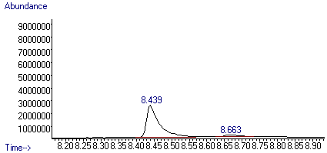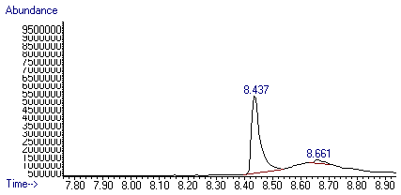
b)
a)
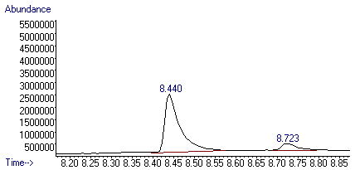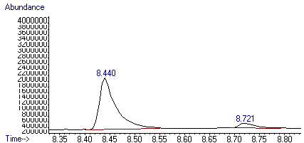
c)
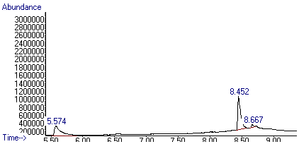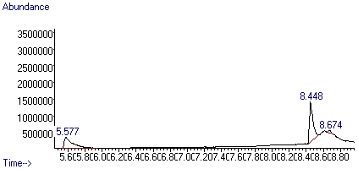
Figure S292. GC-MS chromatograms of 2-BA/3-BA (a), 3-BA/4-BA (b) binary, and ANI/2-BA/3-BA (c) ternary guest mixtures with H3
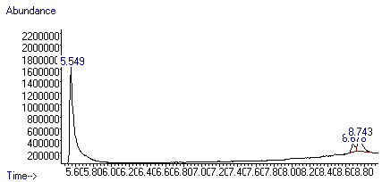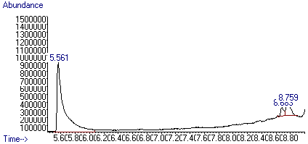
b)
a)
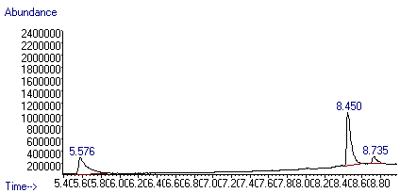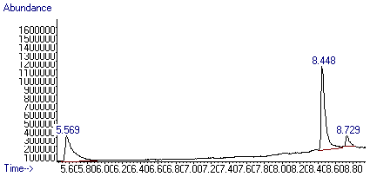
c)
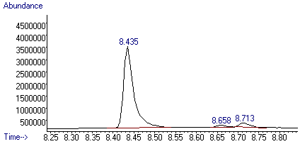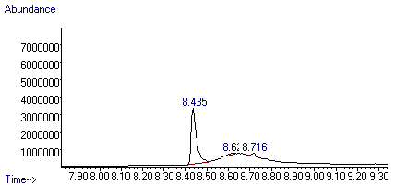
Figure S293. GC-MS chromatograms of ANI/2-BA/4-BA (a), ANI/3-BA/4-BA (b), and 2-BA/3-BA/4-BA (c) ternary guest mixtures with H3
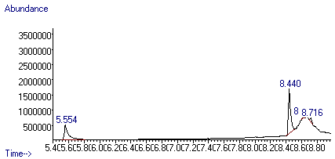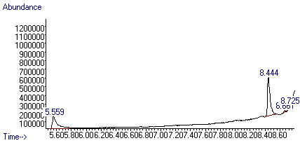
Figure S294. GC-MS chromatograms of ANI/2-BA/3-BA/4-BA quaternary guest mixture with H3

Table S59. Duplicate values obtained for the binary, ternary, and quaternary mixtures for H3 and anisole and the three bromoanisole guest isomers (ANI, 2-BA, 3-BA and 4-BA)
 |  |  |  | H3
ANI | 2-BA | 3-BA | 4-BA | Duplicate #1 | Duplicate #2 | e.s.d.s (%)
X | X |  |  | 97.5:2.5ª | – | –
X |  | X |  | 67.5:32.5ª | – | –
X |  |  | X | 90.7:9.3ª | – | –
 | X | X |  | 4.6:95.4 | 6.4:93.6 | (0.9)(0.9)
 | X |  | X | ^{b} | ^{b} | –
 |  | X | X | 89.7:10.3 | 91.1:8.9 | (0.7)(0.7)
X | X | X |  | 38.2:3.1:58.7 | 40.8:2.9:56.3 | (1.3)(0.1)(1.2)
X | X |  | X | 83.8:4.8:11.4 | 84.3:4.5:11.2 | (0.2)(0.1)(0.1)
X |  | X | X | 34.0:59.7:6.3 | 33.2:60.2:6.6 | (0.4)(0.3)(0.1)
 | X | X | X | 2.6:92.5:4.9 | 1.6:95.3:3.1 | (0.5)(1.4)(0.9)
X | X | X | X | 39.8:1.6:55.1:3.5 | 35.3:1.5:59.1:4.1 | (2.2)(0.1)(2.0)(0.3)
ªOnly a single data point was obtained for these experiments
^{b}A gel remained in the glass vial, no solid formed for GC or ¹H-NMR spectroscopy

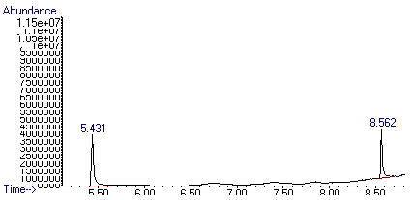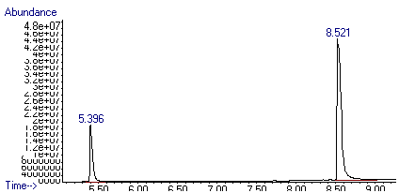
b)
a)
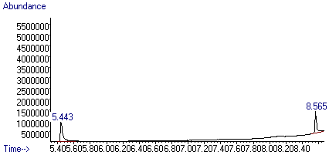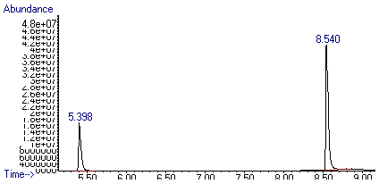
c)
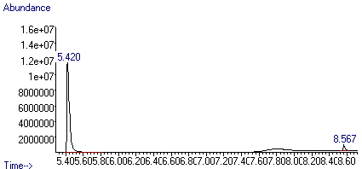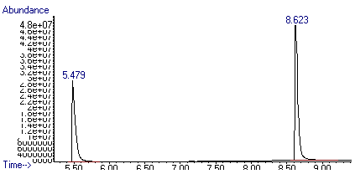
Figure S295. GC-MS chromatograms of the crystals (left) and mother liquor (right) for the 20:80 (a), 40:60 (b), and 50:50 (c) ANI/2-BA binary experiments with H3
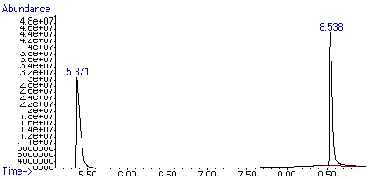
b)
a)
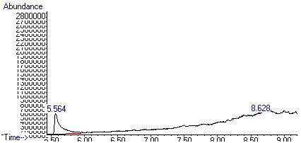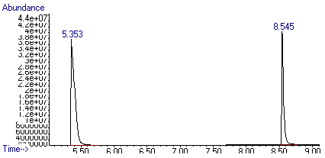
c)
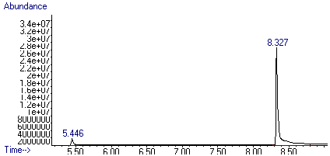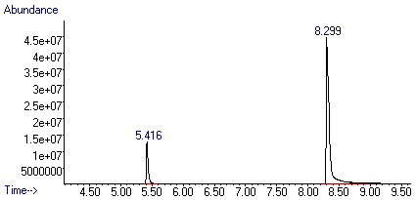
Figure S296. GC-MS chromatograms of the crystals (left) and mother liquor (right) for the 60:40 (a), 80:20 (b) ANI/2-BA, and 20:80 (c) ANI/3-BA binary experiments with H3
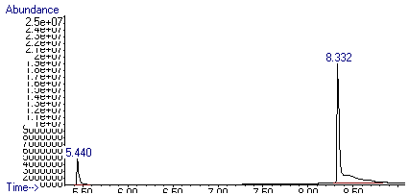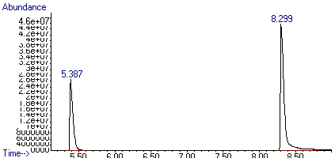
b)
a)
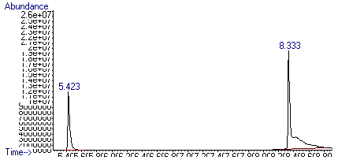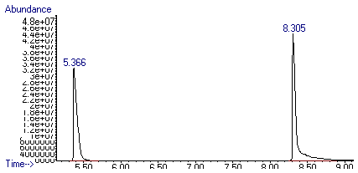
c)
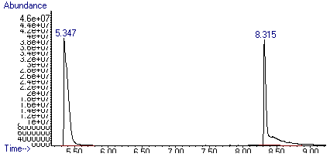
Figure S297. GC-MS chromatograms of the crystals (left) and mother liquor (right) for the 40:60 (a), 50:50 (b), and 60:40 (c) ANI/3-BA binary experiments with H3
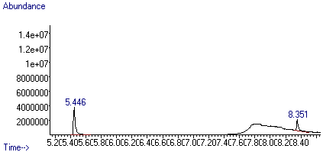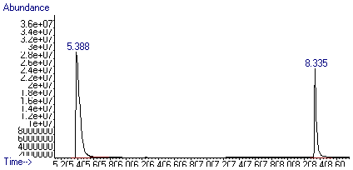
b)
a)
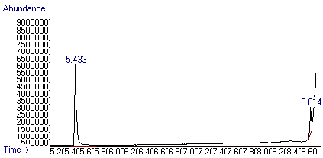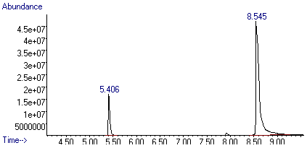
c)
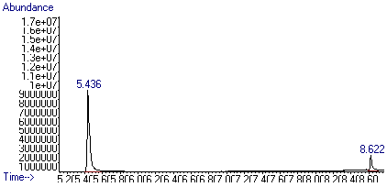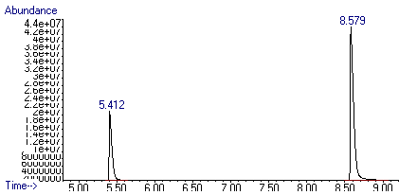
Figure S298. GC-MS chromatograms of the crystals (left) and mother liquor (right) for the 80:20 (a) ANI/3-BA, 20:80 (b), and 40:60 (c) ANI/4-BA binary experiments with H3
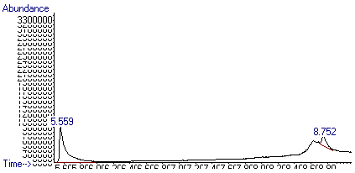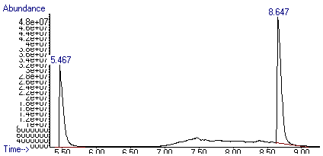
b)
a)
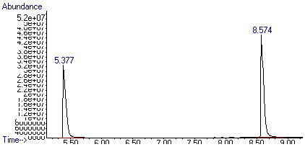
c)
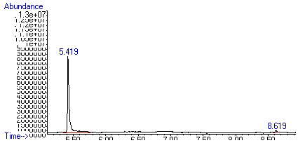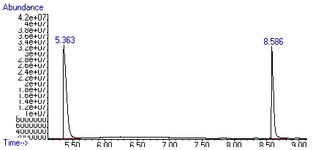
Figure S299. GC-MS chromatograms of the crystals (left) and mother liquor (right) for the 50:50 (a), 60:40 (b), and 80:20 (c) ANI/4-BA binary experiments with H3
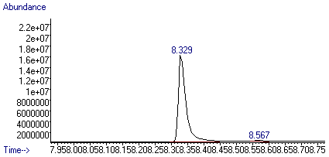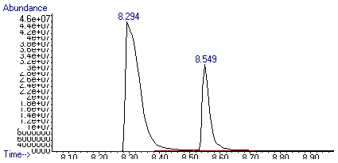
b)
a)
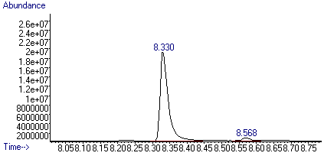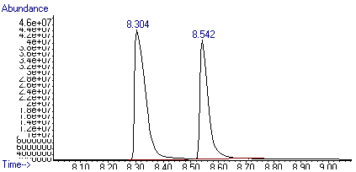
c)
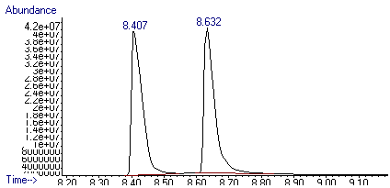
Figure S300. GC-MS chromatograms of the crystals (left) and mother liquor (right) for the 20:80 (a), 40:60 (b), and 50:50 (c) 2-BA/3-BA binary experiments with H3
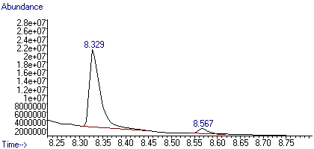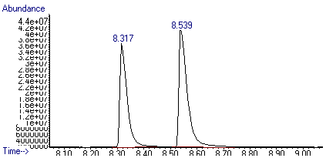
b)
a)
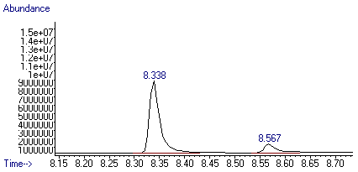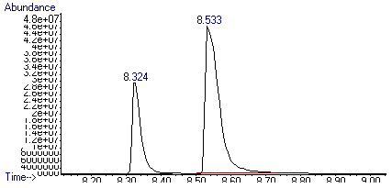
c)
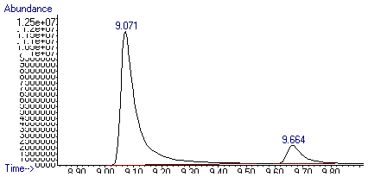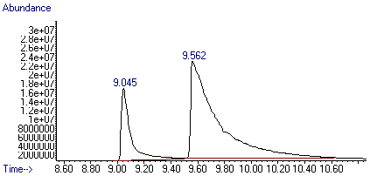
Figure S301. GC-MS chromatograms of the crystals (left) and mother liquor (right) for the 60:40 (a), 80:20 (b) 2-BA/3-BA, and 20:80 (c) 3-BA/4-BA binary experiments with H3
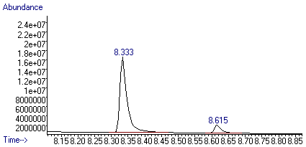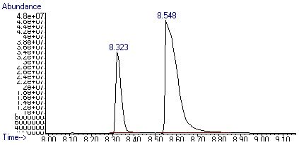
b)
a)
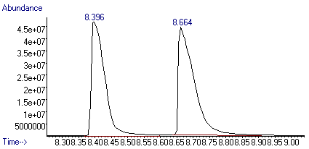
c)
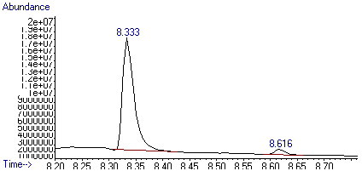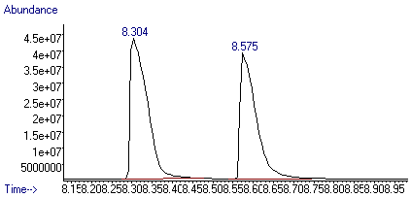
Figure S302. GC-MS chromatograms of the crystals (left) and mother liquor (right) for the 40:60 (a), 50:50 (b), and 60:40 (c) 3-BA/4-BA binary experiments with H3
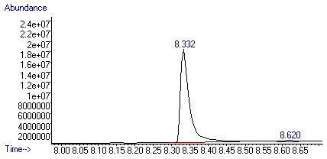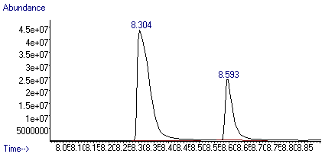
Figure S303. GC-MS chromatograms of the crystals (left) and mother liquor (right) for the 80:20 3-BA/4-BA binary experiment with H3

Table S60. Data points obtained for the guest/guest (anisole and bromoanisole isomers) mixtures with corresponding K values for H3
Binary mixture | Crystal G_{A}:G_{B} | Mother liquor G_{A}:G_{B} | K values
20:80 ANI/2-BA | 0.58:0.42 | 0.21:0.79 | 5.18
40:60 ANI/2-BA | 0.59:0.41 | 0.29:0.71 | 3.62
50:50 ANI/2-BA | 0.96:0.04 | 0.41:0.59 | 33.99
60:40 ANI/2-BA | 0.98:0.02 | 0.48:0.52 | 43.90
80:20 ANI/2-BA | 0.99:0.01 | 0.66:0.34 | 53.31
20:80 ANI/3-BA | 0.05:0.95 | 0.14:0.86 | 3.21
40:60 ANI/3-BA | 0.13:0.87 | 0.30:0.70 | 2.91
50:50 ANI/3-BA | 0.28:0.72 | 0.42:0.58 | 1.92
60:40 ANI/3-BA | 0.67:0.33 | 0.55:0.45 | 1.71
80:20 ANI/3-BA | 0.74:0.26 | 0.68:0.32 | 1.37
20:80 ANI/4-BA | 0.81:0.19 | 0.13:0.87 | 27.92
40:60 ANI/4-BA | 0.84:0.16 | 0.27:0.73 | 13.77
50:50 ANI/4-BA | 0.85:0.15 | 0.38:0.62 | 9.08
60:40 ANI/4-BA | 0.91:0.09 | 0.44:0.56 | 12.25
80:20 ANI/4-BA | 0.98:0.02 | 0.64:0.36 | 25.77
20:80 2-BA/3-BA | 0.02:0.98 | 0.26:0.74 | 21.61
40:60 2-BA/3-BA | 0.03:0.97 | 0.40:0.60 | 19.26
50:50 2-BA/3-BA | 0.06:0.94 | 0.50:0.50 | 14.84
60:40 2-BA/3-BA | 0.06:0.94 | 0.56:0.44 | 21.72
80:20 2-BA/3-BA | 0.14:0.86 | 0.71:0.29 | 15.94
20:80 3-BA/4-BA | 0.89:0.11 | 0.21:0.79 | 29.24
40:60 3-BA/4-BA | 0.89:0.11 | 0.29:0.71 | 20.30
50:50 3-BA/4-BA | 0.91:0.09 | 0.47:0.53 | 11.34
60:40 3-BA/4-BA | 0.95:0.05 | 0.54:0.46 | 17.27
80:20 3-BA/4-BA | 0.99:0.01 | 0.74:0.26 | 29.38

