Supplementary Material

Supplementary Tables
Variables | MST (months) | HR (95%CI) | P value
Low RUNX2+Low LAMC2 | 19.66
Low RUNX2+High LAMC2 | 16.37 | 1.194 (0.6816 to 2.092) | 0.5169
High RUNX2+Low LAMC2 | 23.08 | 0.855 (0.5011 to 1.459) | 0.5726
High RUNX2+High LAMC2 | 18.67 | 1.336 (0.7511 to 2.377) | 0.2879
Supplementary Table 1. Combined OS analysis of RUNX2 and LAMC2 expression in TCGA PAAD patients.
HR for the univariate Cox proportional hazards regression analysis.
Abbreviations: MST, median survival time; HR, hazard ratio; CI, confidence interval; PAAD, pancreatic adenocarcinoma.

Supplementary Table 2. Combined OS analysis of RUNX2 and LAMC2 expression in TCGA PAAD patients.
Variables | MST (months) | HR (95%CI) | P value
Low RUNX2+Low LAMC2 | 17.92
Low RUNX2+High LAMC2 | 12.92 | 1.663 (0.9453 to 2.927) | 0.048
High RUNX2+Low LAMC2 | 17.26 | 1.386 (0.8127 to 2.362) | 0.1983
High RUNX2+High LAMC2 | 13.05 | 1.831 (1.002 to 3.347) | 0.021
HR for the univariate Cox proportional hazards regression analysis.
Abbreviations: MST, median survival time; HR, hazard ratio; CI, confidence interval; PAAD, pancreatic adenocarcinoma.

Supplementary Figures
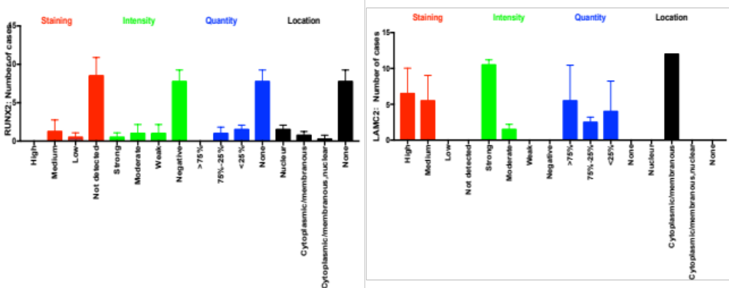
Supplementary Fig.1 The bar charts showed the summary (staining, intensity, quantity and location of RUNX2 and LAMC2) of IHC in PC patients.

