ANNEX

Questions of the survey analyzed in this paper.

Of the following energy-related problems, in your opinion, which are the two most important now in your country?

The type of resource used to produce energy

Power supply

Achieve energy independence

The cost of energy in general (electricity, gas, etc.)

The success of energy diversification

The environmental impacts associated with the production and use of energy

The development of renewable energy

Energy efficiency

I don't know / prefer not to answer
- Using a scale of 0= ”you have never heard about it” to 5= ”you know very well it”, please rate your knowledge about geothermal energy.

- Using a scale of 0=” you strongly disagree” to 5= ”you strongly agree”, please rate your acceptance for your country to produce geothermal energy in its territory.

- Please read the following text:

Geothermal energy consists of extracting the heat stored inside the Earth. Two types of geothermal energy exist: heat production and electricity production. The geothermal installation to produce heat consists of using wells or closed heat exchangers (probes) to get back heat stored in the ground. These installations allow, among other things, to heat single-family houses, business building, schools, and districts; furthermore, the same installation can be used in a reversed mode to cool the same building during hot weather. The depth of installation of these wells or heat exchangers varies between 50 cm and 2.5 km. According to the depth, a heat pump can be coupled with the geothermal system to bring enough heat or cooling to buildings. Geothermal resources also allow to produce electricity when temperatures at depth are high enough. A geothermal power plant consists in:
A. Drilling generally from 2 to 4 wells at a depth between 1 and 5 km;
B. Bringing the geothermal fluids from the production well to the steam turbine;
C. Reinjecting the geothermal fluids in the reservoir through the injection well.
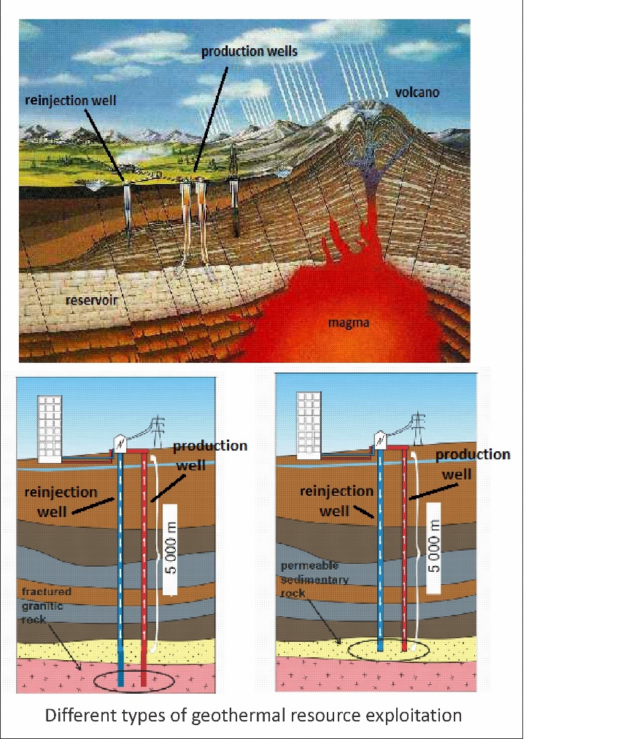
Figure 5. Scheme of deep geothermal energy development
Based on the previous reading, what is your opinion about the use of deep geothermal resources to generate electricity in your country?

a) Strongly agree
b) Somewhat agree
c) Somewhat disagree
d) Strongly disagree
e) I do not know / I prefer not to answer

- Please read the following text:
Within the framework of the geothermal energy for electricity generation, it is sometimes necessary to reactivate old networks of sealed natural rock fractures by injecting water to reopen them and allow deep fluid circulation. We are talking about stimulation.
When water is again able to circulate at depth, the pumped and reinjected water circulates in a loop and it is not necessary to stimulate again. In contact with hot rocks, the water warms enough to allow electricity generation or cogeneration (both heat and electricity) with heat exchangers and a steam turbine.

If stimulation would be required, what is your opinion about the development of a pilot project of deep geothermal energy in your country?
a) Strongly agree
b) Somewhat agree
c) Somewhat disagree
d) Strongly disagree
e) I do not know / I prefer not to answer

- For you, which of the following conditions must necessarily be fulfilled in order for you to be in favor of a pilot project on geothermal energy for the generation of electricity in your region?

- Guarantees in terms of the safety of the personnel and the communities near the plant
- A financial compensation to the nearby community
- Guarantees of respect for the landscape and protection of the environment
- Guarantees in terms of job creation or maintenance
- Information and community consultation
- That the project is carried out by a public entity (government, universities etc.)

